DriverPass Business Requirements Document
Andre Evans | CS 255 | October 4, 2026
Prepared for Jennifer, project lead. This document defines the first release of DriverPass and the schedule for designing, building, testing, and delivering it. Client requirements are based on the DriverPass interview (Southern New Hampshire University [SNHU], n.d.). Items labeled proposed require client approval.

System Components and Design

Purpose
- Provide DriverPass with a web-based system for customer registration, driving-lesson reservations, online instruction, practice tests, and progress reporting.
- Help students prepare for DMV driving tests through coordinated study and practical training while giving staff a reliable way to manage accounts, schedules, and business records.

System Background
- DriverPass wants to help customers prepare for the DMV driving test by combining online learning, practice tests, and behind-the-wheel instruction. Today it needs one coordinated way to manage enrollment, driver and vehicle assignments, reservations, and customer progress.
- The client team identifies Liam as the business owner, Ian as the IT officer, a secretary who handles calls and office visits, customers who book lessons online, and drivers whose lesson comments need to be recorded. Exact driver sign-in permissions require client confirmation.

Main System Components
- Customer/student portal: Customers create or access accounts, choose an available training package, book, change, or cancel two-hour driving lessons, and review their appointments and progress. Package Three also provides online classes and practice tests.
- Secretary workspace: The secretary registers customers who call or visit, assists with package enrollment, schedules or changes reservations, views the availability of cars and drivers, and updates approved customer details.
- Driver/instructor workspace (proposed): An authorized driver reviews assigned lessons and enters lesson times and comments. The interview requests these notes, but a separate instructor login and its specific access rights must be approved.
- Owner/management workspace: Liam can review business activity and student progress, disable a package for new enrollment, and print or export authorized reports so he can work with copies offline.
- IT administration: Ian manages accounts and access rights, resets or blocks employee accounts, maintains system settings, and oversees update notifications and operational issues.
- Reservation and fleet management: Shared scheduling functions connect each student to an available driver, car, lesson time, and pickup/drop-off location. They track package driving hours, prevent booking conflicts, and retain records of who makes each change.
- Learning, testing, and DMV updates: The online learning component provides course material and practice tests to eligible students, records scores and completion status, and alerts designated staff about updates from an approved DMV information source.
- Shared technical services: A browser-based interface connects to application logic, a central database, secure role-based access, activity logs, printable/downloadable reports, and proposed cloud hosting with managed backup. A card-payment service is proposed; its provider and the DMV connection method still need approval.

Objectives
- Automate student registration and driving-lesson scheduling, whether an appointment begins online or through the secretary.
- Track each student's account and package status, completed and remaining driving hours, instructor notes, practice-test results, and scheduled lesson dates.
- Track the drivers and ten cars used for lessons, keeping clear assignments and avoiding conflicting reservations.
- Support staff oversight with permission-based accounts, reservation-change history, current DMV learning materials, and printable or Excel-compatible reports.

Project Goals and Measures of Success
- Deliver a reliable, web-based service where customers can reserve, change, and cancel two-hour lessons and staff can perform the same scheduling tasks for callers or walk-ins.
- Offer the three starting packages: six driving hours; eight hours plus an in-person DMV rules lesson; or twelve hours plus an in-person lesson, online course material, and practice tests.
- Make online lessons, practice-test scores/status, lesson comments, and driving-hour progress visible to authorized users. Preserve an audit record that identifies who created, canceled, or last modified a reservation.
- Let Liam retrieve and print reports, permit offline review of downloaded records, and give Ian the tools needed to manage user access and block former employees.
- Improve customers' preparation for their DMV tests. Actual pass-rate improvement is an outcome to monitor rather than a guaranteed result; the client did not set a numerical target. Complete requirements verification and obtain client sign-off before delivery.

Requirements

Nonfunctional Requirements

Performance Requirements
- Run through the web, preferably in the cloud, with online access from computers and mobile devices. Customers and staff must see current availability after a committed reservation change.
- Proposed acceptance target: at least 95% of login, dashboard, and reservation requests complete within three seconds under a test load of 100 concurrent users. Confirm the load and measurement conditions with DriverPass before treating this as a contract requirement.
- Provide continuous access subject to planned maintenance and provider outages. Apply approved DMV content changes promptly after notification; schedule routine software updates to reduce disruption. Specific availability and update deadlines remain to be agreed.

Platform Constraints
- Use supported desktop and mobile browsers rather than requiring a particular customer operating system or a separate installed application. The proposed test matrix covers Chrome, Edge, Firefox, and Safari where available on Windows, macOS, iOS, and Android.
- Use a centralized database for accounts, enrollments, reservations, test attempts, and activity records. A managed relational database is proposed to support linked records and consistent booking transactions; no database product is specified by the client.
- Internet access is required to create or change live records. Reports must be downloadable in an Excel-compatible format for offline review; editing an exported file must not change the live database.

Accuracy and Precision
- Assign unique identifiers to users, reservations, cars, drivers, and test attempts. Never identify a student solely by name, since different students can share the same name.
- Proposed input rules: normalize usernames for case-insensitive lookup, keep passwords case-sensitive, validate required fields and dates, and display appointment times in the business time zone. Confirm that time zone during requirements approval.
- Calculate scores from the approved question version and answer key. Store test name, time taken, score, and status. Validate two-hour lessons and check student, driver, car, and package availability again when a booking is saved.
- Show validation errors immediately without saving partial reservations. Proposed monitoring alerts Ian when a backup fails, a DMV update cannot be retrieved, or repeated authentication failures suggest an attack; ordinary user errors stay in the user interface.

Adaptability
- Allow Ian to manage accounts and roles, reset access, and block former employees without code changes. Allow Liam to disable a package for new enrollment while preserving existing customer records.
- Separate package data, learning content, scheduling, and permissions so approved changes can be made without rewriting unrelated features. Adding or removing software modules requires a developer and is outside the first release.
- Test provider and browser updates before rollout. Ian needs administrative configuration and monitoring access, while the selected provider handles the contracted hosting and backup services.

Security
- Require a unique login and password and enforce permissions on the server. Customers access their own records; the secretary manages authorized customer bookings; drivers access assigned lesson information; Liam receives management functions; Ian administers accounts.
- Proposed controls include HTTPS for communication, secure password hashing, encrypted records and backups, session expiration, and multifactor authentication for privileged accounts. Hosting support does not replace DriverPass responsibility for account permissions.
- Provide automatic password recovery through a verified contact method and allow Ian to assist with resets. Proposed protection against repeated failed logins includes rate limiting, temporary lockout, and administrator alerts; thresholds require approval.
- Record the actor, action, timestamp, and affected reservation in protected audit records. Keep customer contact information, special-needs notes, and exports restricted to staff with a business need.
- Use a proposed payment provider to process card number, expiration date, and security code. Keep only a payment reference and masked card details in DriverPass; exclude security codes and full card data from stored customer records, reports, and logs.
- Use managed backups and verify restoration before launch. Backup frequency, retention, recovery time, and acceptable data loss must be agreed with the hosting provider and DriverPass.

Functional Requirements
- The system shall authenticate users and authorize actions according to the customer, secretary, driver, owner, and IT administrator roles. Driver permissions are a proposed implementation of the requested driver-note feature.
- The system shall allow a student or secretary to enter customer information, including first and last name, address, city, state, ZIP code, telephone number, and email, consistent with the interview and interface sketch.
- The system shall support secretary-assisted enrollment by telephone or office visit and associate each customer with an account and selected package.
- The system shall capture the card information requested during registration through a secure payment workflow and associate the resulting payment reference with the enrollment. The payment service and refund rules require confirmation.
- The system shall provide the three initial packages with six, eight, or twelve driving hours and the corresponding in-person and online learning access described in the interview.
- The system shall let Liam disable a package so that no additional customers enroll in it, while retaining existing enrollments and history.
- The system shall allow customers to create, modify, and cancel their own reservations online and allow the secretary to perform these actions for customers who call or visit.
- The system shall schedule every driving lesson for two hours and associate it with a customer, available driver, available car, date, start time, and end time.
- The system shall record the pickup location and use that same location for drop-off, as requested in the interview. Any later exception requires an approved rule change.
- The system shall reject overlapping active bookings for a student, driver, or car and reject bookings that exceed the driving hours available in the student’s package. Cancellation and hour-restoration rules must be approved before implementation.
- The system shall support the initial fleet of ten cars and their assigned drivers and let authorized staff view the student, driver, car, and time associated with each appointment.
- The system shall record who created, canceled, and most recently modified each reservation and retain a history of changes for printable activity reports.
- The system shall give eligible Package Three customers access to online class materials and practice tests and retain their test attempts and results.
- The system shall display each practice test’s name, time taken, score, and status as not taken, in progress, failed, or passed. The passing threshold must be supplied by DriverPass.
- The system shall allow authorized drivers to enter lesson comments and display lesson time, start hour, end hour, and comments with the student’s record.
- The system shall allow Ian to manage accounts, reset access, assign approved permissions, and block accounts, including those belonging to former employees.
- The system shall let customers automatically request a password reset through a verified recovery method without disclosing their existing password.
- The system shall receive DMV rules, policies, and sample-question updates through an agreed connection and notify designated staff when new material is available. Authorized staff shall review and publish approved content changes.
- The system shall let Liam and other authorized staff print activity reports and download authorized reports and information in an Excel-compatible format for offline use.
- The system shall provide a contact page for DriverPass and an authorized way for staff to contact students using the contact information on their accounts.

User Interface
- Provide a responsive browser layout with readable text, clear navigation, labeled fields, understandable errors, and keyboard-operable controls. Proposed dashboards should show only actions permitted for the signed-in role.
- Customer view: show profile information, package access, remaining driving hours, available lesson times, appointments, online learning, test progress, and driver notes. Ask for confirmation before cancellation and report whether each change succeeded.
- Follow Liam’s sketch with a logo, customer information, online test progress, driver notes, special-needs information, and driver/student photos. Restrict sensitive fields and confirm who may upload or view photos and special-needs notes.
- Secretary view: provide customer lookup, registration and enrollment forms, a scheduling calendar, driver/car assignments, and student contact tools for telephone and walk-in service.
- Driver view: provide assigned lessons, pickup/drop-off information, and a form for lesson comments. This is a proposed role-specific screen to support Liam’s requested notes.
- Owner view: provide printable activity and progress reports, Excel-compatible downloads, and a package-disable control. Ian’s view must provide account administration, role management, monitoring, and update notifications.

Assumptions
- Users have a supported browser and internet access, and DriverPass supplies accurate customer, driver, vehicle, and availability information. Staff receive basic training before launch.
- DriverPass supplies approved learning content, answer keys, passing thresholds, package prices, and policies for cancellations, refunds, and used driving hours before those features are finalized.
- A permitted DMV update source will be available. A direct API is not confirmed; Ian and the team must agree on an authorized feed or other supported connection and test it before committing to automated retrieval.
- A cloud provider and proposed payment and notification services will be selected within an approved budget. Their interfaces and service responsibilities are dependencies, not confirmed vendor commitments.
- Customer approval on March 10–11 does not require major redesign. Enough team capacity is available for overlapping design tasks, including Toni and Clark for interface research and John after March 1.

Limitations
- The system cannot create, modify, cancel, or synchronize live reservations, student accounts, or test results without an internet connection. Downloaded Excel-compatible reports can be reviewed offline but cannot directly update the central database.
- The first release cannot add or remove software modules through a nondeveloper control. Liam can disable an existing training package, but creating new module-based offerings requires later development.
- The first release is a browser-based service rather than a separate installed offline mobile app. It cannot provide a working live scheduling service during internet, cloud-hosting, or power outages.
- The system cannot reliably show new DMV rules or sample questions until the agreed source provides them and authorized staff approve the changes. It does not independently determine official DMV policy.
- The platform supports driver training but cannot guarantee that an individual student will pass a DMV test.

Project Constraints and Open Decisions
- The interview does not set a final development budget, production user count, cloud provider, backup/recovery targets, or detailed DMV integration method. These open decisions affect estimates and must be resolved with DriverPass before they become binding specifications.
- The planned schedule has little contingency for client-requested redesign, unavailable external services, or defects. If an approval, integration, or testing milestone slips, Jennifer will need to agree on revised dates with Liam.

Gantt Chart
- The schedule uses the interview’s final task table as the baseline: January 22 through May 10. No year is specified. Its dates differ from some verbal duration estimates, so the bars represent date windows rather than promised business-day totals (SNHU, n.d., Schedule Planning section).
- Requirements take priority. Activity diagrams start as individual use cases become ready on February 15; this is a staged dependency rather than waiting for every use case. Interface research is independent of the use cases, and class modeling waits for John’s March 1 return.
- All design work must be ready for customer approval on March 10–11. Approval gates interface construction, followed by database integration, business logic and permissions, testing, delivery, and sign-off.
- The shared dates March 24, April 27, and May 9 are proposed within-day handoffs: the relevant predecessor deliverable must be accepted before dependent work starts. System testing runs April 27–May 7 and includes functional, integration, security, browser, and customer acceptance checks plus defect correction.
- The plan assumes parallel design staffing and successful reviews. Jennifer should review progress and dependencies weekly and obtain a revised completion date when an approval or testing gate cannot be met.

Reference
Southern New Hampshire University. (n.d.). CS 255 DriverPass interview transcript [Course handout].

DriverPass Project Schedule
Figure 1. Revised Gantt chart using the 12 tasks, start dates, and end dates in the interview. Individual tasks appear on the left in chronological order. Dates are month/day because the transcript does not specify a year.
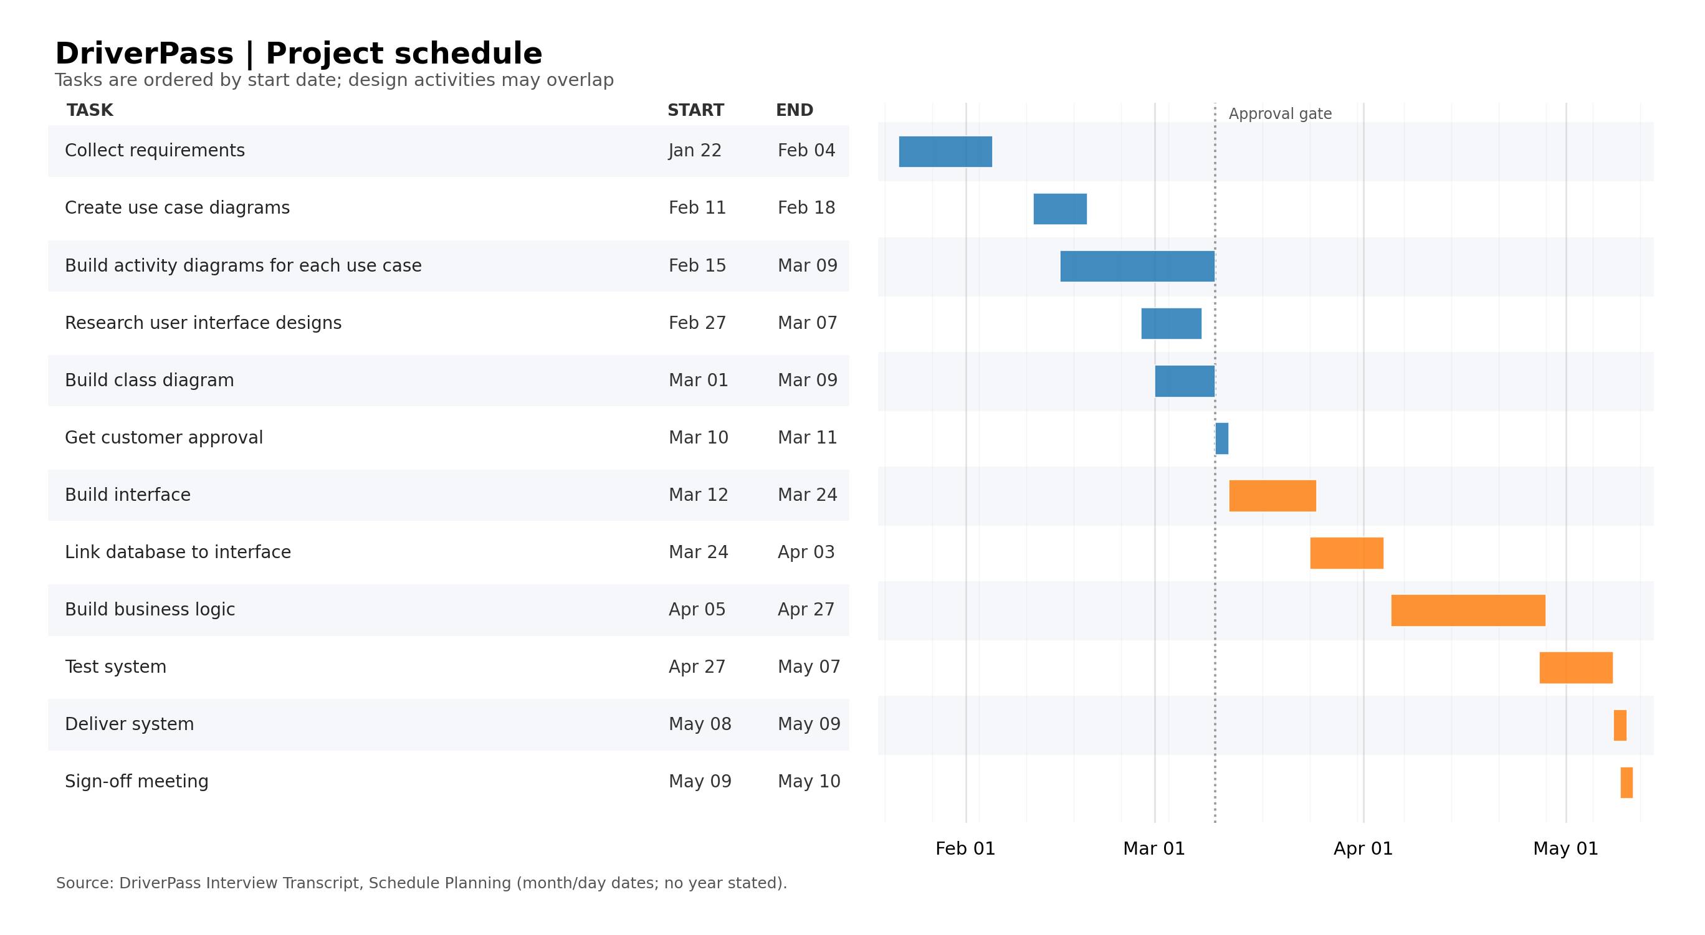
Dependencies: requirements lead to design tasks; customer approval on March 10–11 gates interface construction. Interface work precedes database integration, followed by business logic, testing, delivery, and sign-off. Activity diagrams, interface research, and class modeling can overlap as described in the schedule notes.

