DriverPass System Design Document
Andre Evans | CS 255 | Project Two | October 18, 2026
Prepared for Jennifer, Project Lead • Design derived from the corrected Project One business requirements document and DriverPass interview. Proposed items require DriverPass approval.

UML Diagrams
The system uses a blended approach: activity and sequence diagrams describe how tasks move through the system, while the use case and class diagrams describe roles and the information the system manages.

UML Use Case Diagram
The system supports customer, secretary, instructor, owner, and IT administrator roles. The DMV source is external. The dashed «include» link means each reservation change is logged. *Instructor access and DMV integration need confirmation.
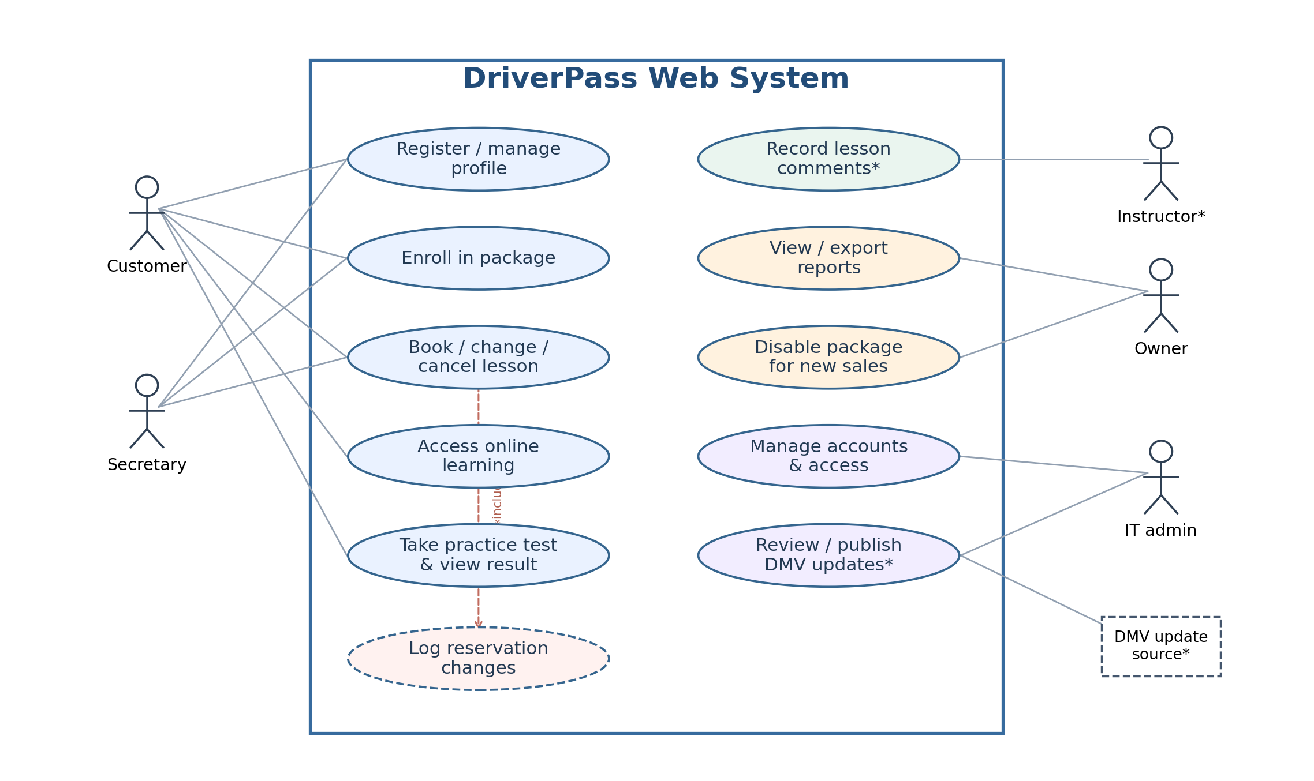
The customer signs in to manage a profile, enroll in a package, schedule lessons, or access learning tools. The secretary can assist with registration and bookings. Liam reviews reports and disables packages for new enrollment, while Ian administers access and approved DMV updates.

UML Activity Diagram 1 — Book a Driving Lesson
This workflow ensures every appointment is two hours long and checks the student’s purchased hours along with driver, car, and student availability. The availability check is repeated when the reservation is saved to avoid double-booking.
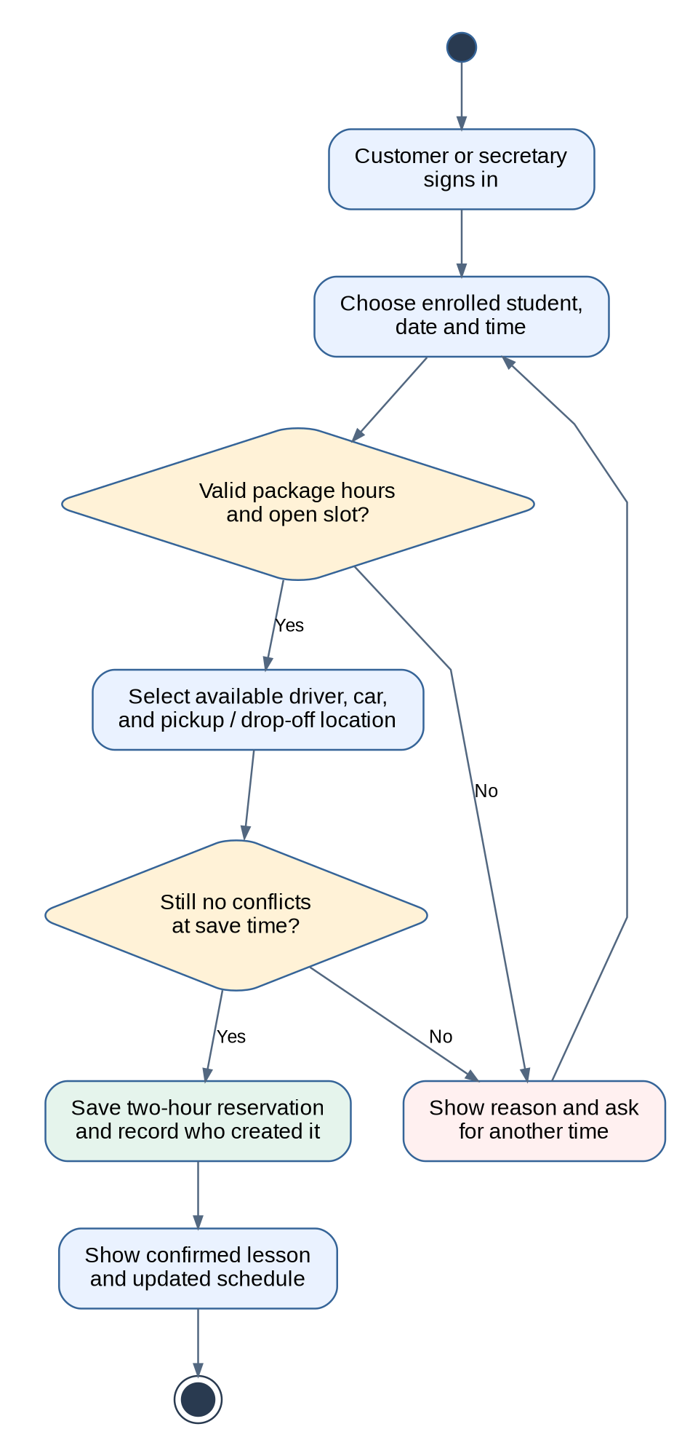
An unsuccessful validation does not create a partial booking. A successful reservation updates shared availability and records the responsible user.

UML Activity Diagram 2 — Take a Practice Test
This workflow checks that the customer is eligible for Package Three learning materials, then grades the completed test using the approved answer key and passing threshold.
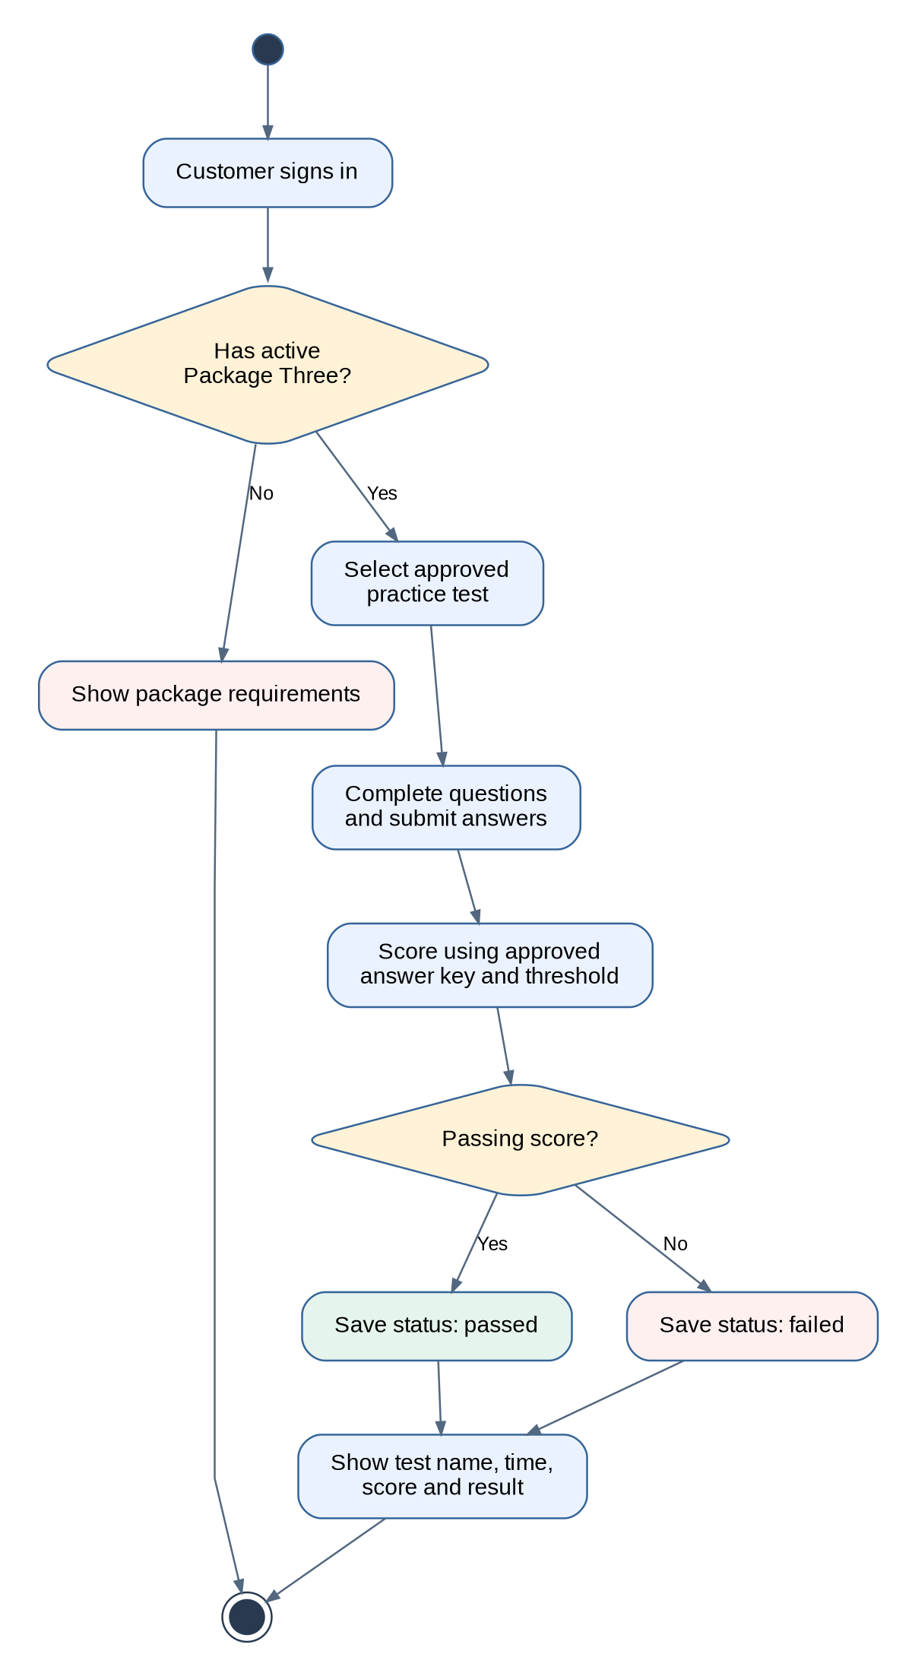
Each attempt stores the test version, score, elapsed time, and passed/failed status. DriverPass must supply the test content and official passing threshold.

UML Sequence Diagram — Book a Driving Lesson
The numbered messages show the order in which a customer or secretary, web portal, booking service, database, and audit service work together to confirm a reservation.
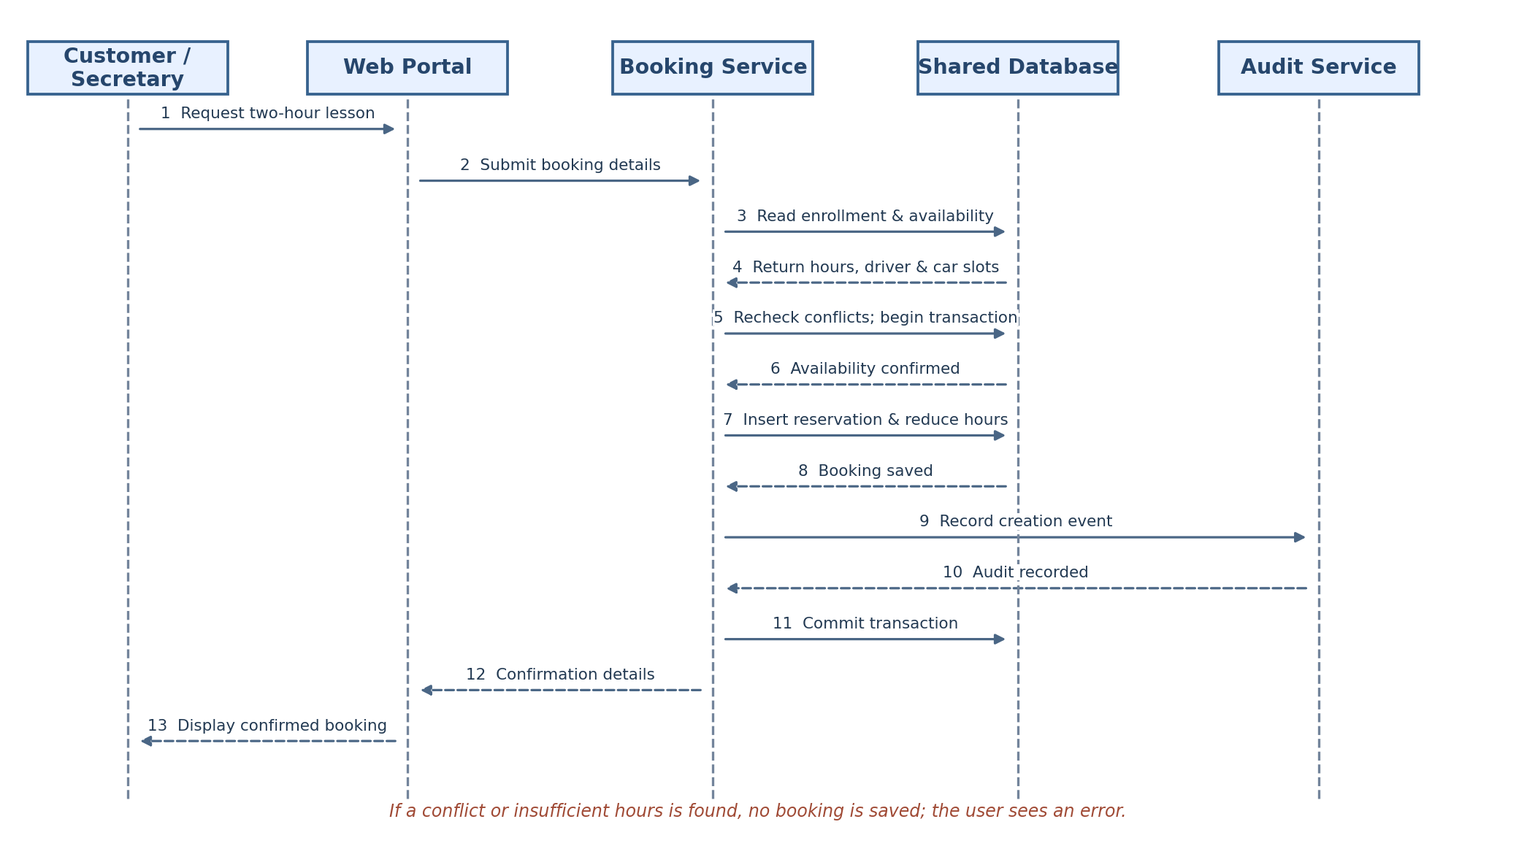
Technical note: Reservation creation, remaining-hour adjustment, and the protected audit record should be coordinated transactionally so a failed operation does not leave inconsistent data. The design returns an error without saving when validation fails.

UML Class Diagram
Each rectangle names a class and its representative attributes. Lines show relationships, including a student with multiple reservations and a booking linked to one driver and one vehicle. Cardinalities describe how many related records are permitted.
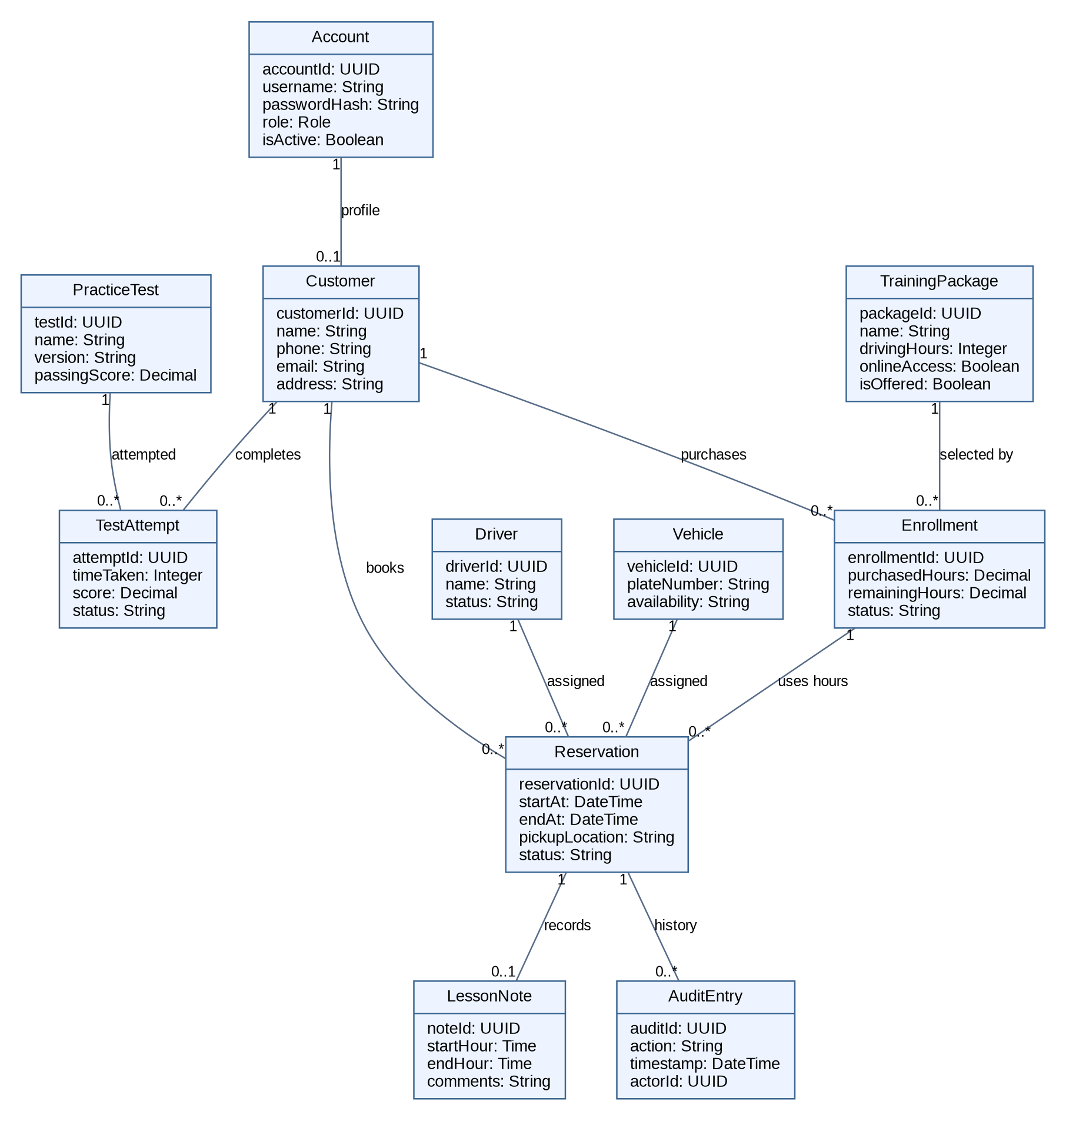
The Account role controls permissions; an Enrollment links a Customer with a TrainingPackage. A TestAttempt refers to one PracticeTest. AuditEntry stores reservation history. Additional implementation classes, such as question records, payment references, content updates, and access-control rules, can be added during detailed design.

Technical Requirements

Hardware and user devices
• Customers and staff will use existing supported computers, tablets, or smartphones with modern browsers and reliable internet. The secretary and Ian need office workstations; authorized staff need access to a printer for reports.
• The first release is a browser-based service; no customer-installed application or dedicated local server is required if DriverPass approves managed cloud hosting. The existing ten cars are operational assets whose identifiers and availability are stored in the system.

Software and development tools
• Build a responsive web interface for customers and role-specific staff views, a server-side application for enrollment, reservations, test scoring, user management, and reporting, and a shared relational database for linked records.
• Use Lucidchart for approved UML design models; use source control, automated functional and security testing, browser-compatibility testing, and a separate staging environment before deployment.
• The software must enforce two-hour lesson lengths, remaining driving hours, no overlapping bookings, authorized access to online tests, and separate controls for disabling new package sales without deleting existing enrollments.

Hosting and infrastructure
• Propose managed cloud application hosting, a managed relational database, HTTPS/TLS certificates, automatic deployment, backups, access logs, monitoring, and verified recovery procedures. Hosting provider, budget, retention periods, and recovery targets need agreement.
• Use centrally synchronized availability. Recheck student, driver, car, and package constraints in one database transaction immediately before committing a reservation; record the actor and timestamp in an audit trail.
• Allow Excel-compatible report exports for offline review while requiring internet access for any live changes. Keep approved DMV data imports separate from publishing so staff can review updates before customers see them.

Security and privacy
• Protect connections with HTTPS, hash passwords using a strong adaptive algorithm, encrypt sensitive stored data and backups, expire inactive sessions, and require multifactor authentication for privileged accounts (proposed controls).
• Enforce role-based permissions on the server. A customer sees their own records; the secretary handles authorized records; instructor access to assigned lessons is proposed; Liam views management reports; Ian manages accounts and can revoke former employees’ access.
• Maintain tamper-resistant event history for reservation creation, changes, and cancellation. Limit sensitive notes and exports to authorized staff, and avoid storing full payment-card numbers or security codes by using an approved payment provider (pending selection).

Testing and acceptance criteria
• Verify customer self-service and secretary-assisted booking, prevention of concurrent double-booking, driver/car assignment, accurate remaining-hour calculations, cancellation policies, role permissions, package changes, practice-test scoring, reports, and audit trails.
• Proposed nonfunctional target: at least 95% of login, dashboard, and reservation requests within three seconds under 100 concurrent users. This target is not yet approved. Test mainstream browsers and mobile layouts, restoration from backups, and expected security controls before client acceptance.

Dependencies, limitations, and decisions requiring approval
• DriverPass must confirm cancellation/hour-restoration rules, test passing thresholds, approved DMV update source and publishing process, instructor login permissions, package prices, payment and notification suppliers, the operating time zone, and backup/recovery service levels.
• No live booking or account updates are available offline. Exports do not synchronize edits back into the system. New modules require development rather than an owner toggle. Training may improve preparation but cannot guarantee a DMV pass.
Source: Andre Evans, DriverPass Business Requirements Document (corrected Project One, October 4, 2026); Southern New Hampshire University, CS 255 DriverPass Interview Transcript (n.d.).

