

Market Tracker

A service designed to help users track the variation of prices across different stores

André Graça, n.º 47224, e-mail: [a47224@alunos.isel.pt](mailto:a47224@alunos.isel.pt), tel.: 929130440

Daniel Caseiro, n.º 46052, e-mail: [a46052@alunos.isel.pt](mailto:a46052@alunos.isel.pt), tel.: 911124858

Diogo Santos, n.º 48459, e-mail: [a48459@alunos.isel.pt](mailto:a48459@alunos.isel.pt), tel.: 939046442

Supervisor: Filipe Freitas, e-mail: [filipe.freitas@isel.pt](mailto:filipe.freitas@isel.pt) 28 of February of 2024

# Introduction

This project aims to provide users with a web platform that facilitates the sharing of educational knowledge and resources among users. The platform will feature a user rating system that rewards high- quality content encouraging users to share valuable insights. Additionally, the platform will provide better content recommendations by taking into account user interests.

# System Requirements

## Functional Requirements

* + - Users can authenticate in our application Google´s OAuth 2.0 or by creating an account.
    - Users can check the graph of variation of price of a product during a period.
    - The system was designed for 2 types of users:
      * Partners:
        + Insert and update products, only the ones that belong to them.
        + Insert their stores in our DB.
        + Insert promotions across various products in their stores.
      * Clients:
        + Fill a Cart with products.
        + Rate and comment products.
        + Compare and search by filtering products by various keywords (e.g. brand, store, overall rating, etc…).
        + After completing the cart then can procced to generate a digital grocery list which will tell how much they will spend in each store and how much stores they need to go to fulfill the cart. They can also generate the lower total price of a basket.

## Non-Functional Requirements

## Optional Features

* + - Map application to tell the smallest route between each store.
    - Android application.

# Technologies

We plan to use a framework like SvelteKit [1] or NextJS [2] to serve application data and web pages. Both these frameworks run on top of the NodeJS [3] runtime allowing us to build a Web API on top of it as well. The programming language will be Typescript [4]. For storing user-submitted text files, images, PDF documents and quizzes we plan on using Google Cloud Storage [5]. The database we might use to persistently store application data is PostgreSQL [6].

# Risks

Some factors that might influence our speed on the project development are:

* Google Cloud Platform and SvelteKit/NextJS are technologies that we will have to spend some time exploring.
* We would like to attempt to improve the feed recommendations, showing users posts that are more likely to be of their interest. This is an area in which we have no experience.

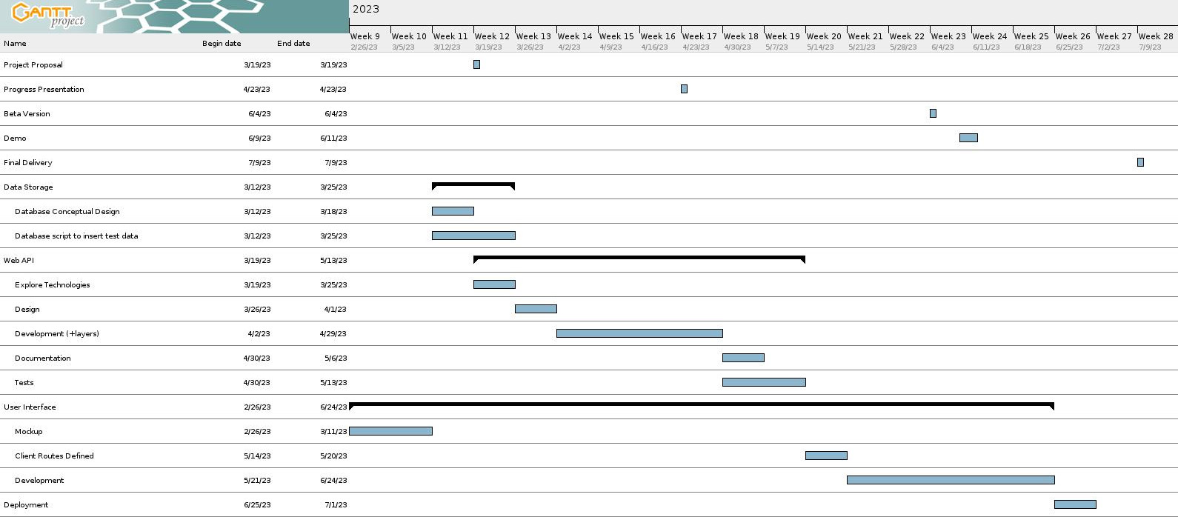

Figura 1: Gantt Chart Project Plan

# Referˆencias

1. https://kit.svelte.dev/ - sveltekit, cybernetically enhanced web apps, accessed 10 march 2023.
2. https://nextjs.org/ - nextjs, the react framework for the web, accessed 15 march 2023.
3. https://nodejs.org/en/ - nodejs, a cross-platform javascript runtime environment, accessed 10 march 2023.
4. h[ttps://www.t](http://www.typescriptlang.org/)yp[escriptlang.org/](http://www.typescriptlang.org/) - typescript, javascript with syntax for types, accessed 15 march 2023.
5. https://cloud.google.com/storage - google cloud storage, accessed 10 march 2023.
6. h[ttps://www.postgresql.org/](http://www.postgresql.org/) - postgresql, accessed 10 march 2023.