Supporting Information

A dynamic mathematical model for monoclonal antibody N-linked glycosylation and nucleotide sugar donor transport within a maturing Golgi apparatus

Ioscani Jimenez del Val, Judit M. Nagy and Cleo Kontoravdi
Department of Chemical Engineering and Chemical Technology, and Institute of Biomedical Engineering, Imperial College London, South Kensington Campus, London, SW7 2AZ

S1: Rate expression derivation
    - Michaelis-Menten kinetics
This rate expression derivation applies to the ManI and ManII enzymes (Moremen et al., 1991; Nishikawa et al., 1988; Tabas and Kornfeld, 1979; Velasco et al., 1993). In a Michaelis-Menten kinetic mechanism, the substrate binds to the enzyme to form an enzyme-substrate complex. Once the complex is formed, the rate-limiting step of the catalytic cycle occurs, thus yielding the product. In the case of the general reaction scheme shown in figure 8, it can be seen that ManI and ManII act on different substrates. Because of this, a competitive inhibition term will be added to the catalytic cycle. Additional underlying assumptions for this derivation are the following:

- Equilibrium is reached rapidly for all reactions.
- There is competitive inhibition through substrate analogues.
- There is product inhibition because the product of these reactions has high binding affinity to the enzyme because it is a subsequent reactant itself.
- The enzyme needs a water molecule to catalyse the reaction. Since the reaction occurs within an aqueous environment (lumen of the Golgi compartments), it is possible to assume that the enzymes are saturated with water, and hence, the availability of this component does not affect the reaction in any way.
- The rate-limiting step is assumed to be the chemical removal of the mannose residue from the oligosaccharide chain.
- The rate-limiting step is assumed to be irreversible given that the products from the reaction will participate in further reactions within the same Golgi compartment. This will maintain their concentrations low and greatly reduces the possibility of the reaction occurring in the opposite sense. Another factor that facilitates this assumption is that the enzymes are saturated with water. This also contributes to reducing the likelihood of a reverse reaction. Finally, the co-products of these reactions are mannose residues. These mannose molecules have little or no interaction with the enzyme, so it is quite unlikely for them to react in the opposite sense.

These assumptions lead to the following kinetic mechanism:

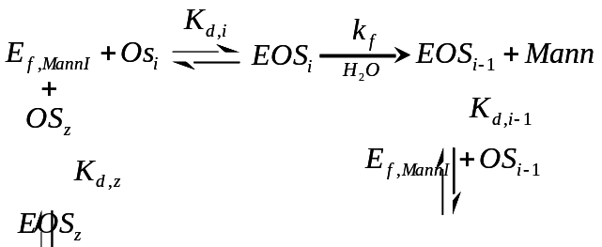

From this kinetic reaction mechanism we can derive the following mathematical expressions:

Dissociation constants:
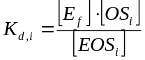 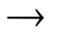 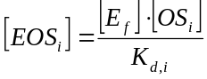 …Eq. 1
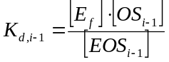 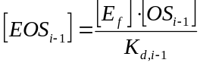 …Eq. 2
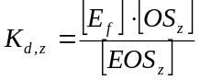 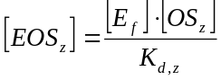 …Eq. 3

Total (or initial) enzyme balance:
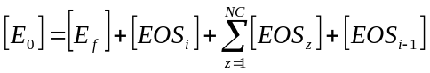 …Eq. 4

Combining the dissociation constant expressions with the enzyme balance:
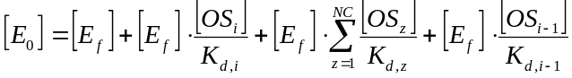

Solving for the free enzyme term:
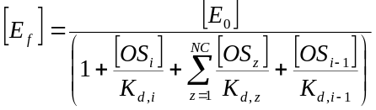 …Eq. 5

The reaction rate expression for the rate-limiting reaction is defined as:
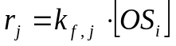 …Eq. 6

Combining Eq. 1 with Eq. 5:
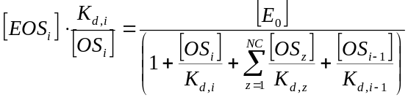 and solving for 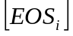:
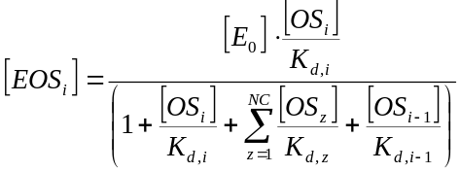 …Eq. 7

Combining Eq. 6 with Eq. 7:
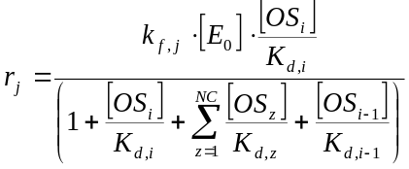 Finally, rearranging:

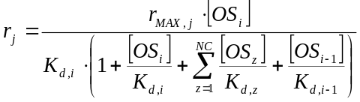, where 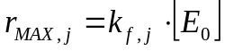 …Eq. 8

    - Sequential-order Bi-Bi kinetics
This rate expression derivation applies to the GnTI, GnTII and GalT enzymes (Bendiak and Schachter, 1987; Morrison and Ebner, 1971; Ramakrishnan et al., 2004; Unligil et al., 2000). Although the underlying concepts of this derivation are similar to Michaelis-Menten, Bi-Bi kinetics consider the binding of two substrates onto the enzyme for the reaction to occur. In sequential Bi-Bi kinetics, the order in which the substrates bind to the enzyme is important. For all three enzymes that catalyse reactions with this mechanism, the nucleotide sugar donor first binds to the enzyme and triggers a conformational change which creates the binding pocket for the oligosaccharide to bind. Thus the NSD binds first, and the oligosaccharide binds second. Because the enzyme undergoes a conformational change, the unbinding of the products from the enzyme occur in the inverse order: the oligosaccharide product dissociates from the enzyme, inducing the enzyme to recover its original configuration from which the by-product of the NSD (which for all of these reactions is UDP) can dissociate from the enzyme. Additional assumptions for the derivation of these kinetic expressions are the following:

- Equilibrium is reached rapidly for all reactions (Bendiak and Schachter, 1987).
- The kinetics of this reaction will be assumed as an ordered, sequential mechanism. In this case, the sugar donor must bind to the enzyme, once this occurs, the acceptor binds, and through the three species complex reacts to form product and by-product. Since the reaction is constrained to this order, the products complex must also dissociate in the corresponding order. The product oligosaccharide unbinds leaving a by-product enzyme complex which will dissociate to complete the catalytic cycle (Bendiak and Schachter, 1987).
- These enzymes may act on several different substrates along the N-glycosylation pathway. Hence, competitive inhibition from analogue acceptor oligosaccharide (OS_{z}) chains will be assumed.
- No excess of either of the substrates will be assumed which implies that the reaction rate will depend on the concentration of both substrates. (Enzyme is not assumed to be saturated with NSD).
- Dual product inhibition will be considered for this reaction given that many reports indicate that these enzymes have affinity for substrate analogues, which in some cases include reaction product analogues (Schachter, 2000).
- The rate-limiting step is assumed to be the transfer of the monosaccharide (GlcNAc or Gal) residue to the growing oligosaccharide chain.
- The rate-limiting step is assumed to be irreversible due to the consumption of energy during this step (Taylor and Drickamer 2006; Varki, 1999).

These considerations lead to the following reaction mechanism:

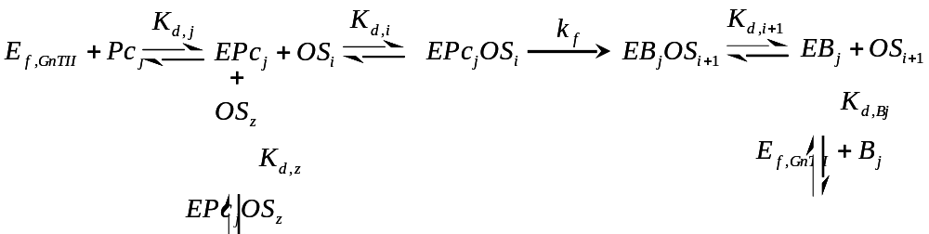

From this kinetic reaction mechanism we can derive the following mathematical expressions:

Dissociation constants:
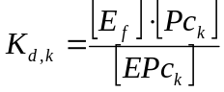 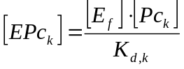 …Eq. 9
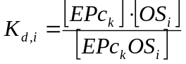 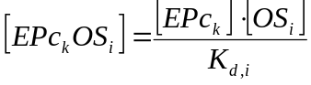 …Eq. 10
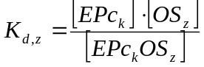 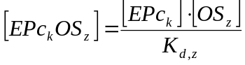 …Eq. 11
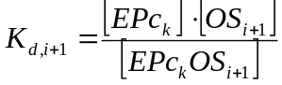 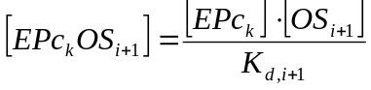 …Eq. 12
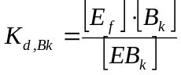 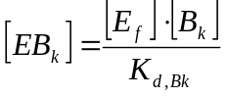 …Eq. 13

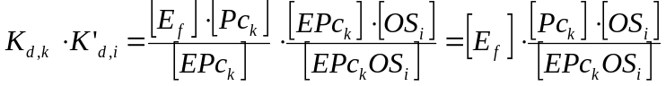 …Eq. 14

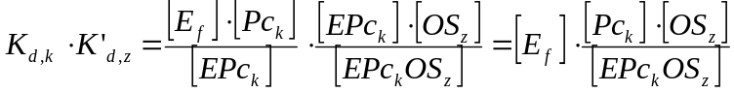 …Eq. 15

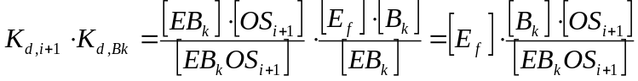 …Eq. 16

Total (or initial) enzyme balance:

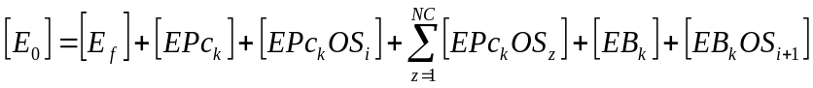 …Eq. 17

Combining the dissociation constant expressions with the enzyme balance:
…Eq. 18
Solving for the free enzyme term:
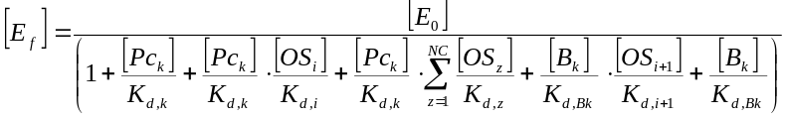 …Eq. 19

The reaction rate expression for the rate-limiting reaction is defined as:

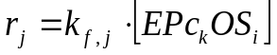 …Eq. 20

Combining Eq. 20 with Eq. 14:
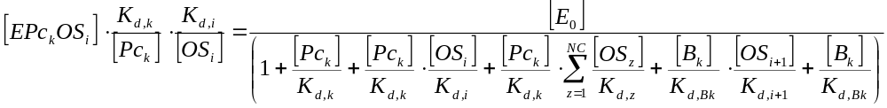

and solving for 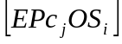:
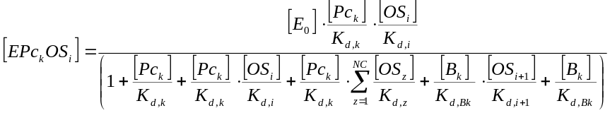 …Eq. 21

Substituting Eq. 21 into Eq. 20:
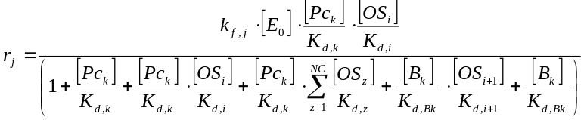

Rearranging:
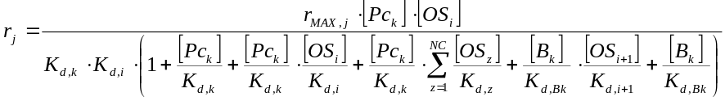…Eq. 22
Where 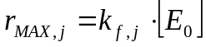

    - Random-order Bi-Bi kinetics
This rate equation derivation applies to the GnTIII, FucT and SiaT enzymes (Bendiak and Cook, 1982; Ihara et al., 2007; Ikeda et al., 2000). In this case, there is no conformation change in the enzyme, which means that both substrates can bind simultaneously to the enzyme. As with the previous cases, competitive inhibition will also be considered in this mechanism due to several substrates competing for the binding sites of the enzyme. This entails competitive inhibition, and when considering the random binding order, the resulting reaction mechanism is more complex than the previous two. Additional assumptions for the derivation of these kinetic expressions are the following:

- Equilibrium is reached rapidly for all reactions (Ikeda et al., 2000).
- These enzymes act on several substrates along the N-glycosylation pathway. Therefore, competitive inhibition from analogue acceptor oligosaccharide (OS_{z}) chains will be assumed.
- No disproportionate excess of one substrate with respect to the other is assumed within the Golgi compartments; hence, the reaction rate will depend on the concentrations of both species. (Enzyme is not assumed to be saturated with NSD).
- Dual product inhibition will be considered for this reaction given that both the products have affinity for the enzyme (Ikeda et al., 2000).
- The rate-limiting step is assumed to be the transfer of the monosaccharide residue to the growing oligosaccharide chain.
- Again, the rate-limiting step is assumed to be irreversible (Taylor and Drickamer 2006; Varki, 1999).

These assumptions lead to the following kinetic mechanism:

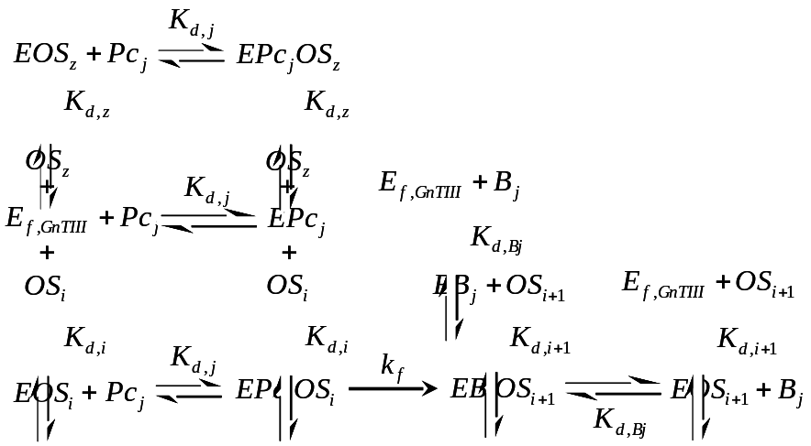

From this kinetic reaction mechanism we can derive the following mathematical expressions:

Dissociation constants:
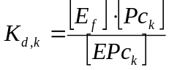 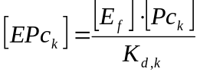 …Eq. 23
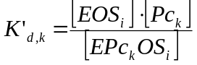 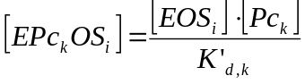 …Eq. 24
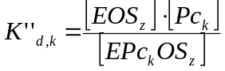 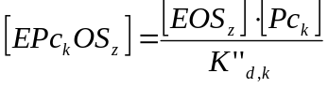 …Eq. 25
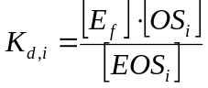 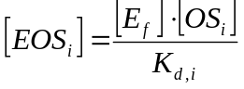 …Eq. 26
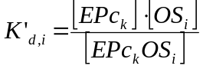 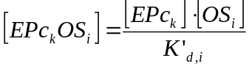 …Eq. 27
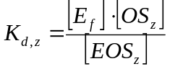 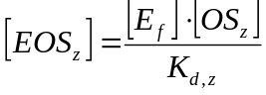 …Eq. 28
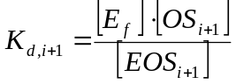 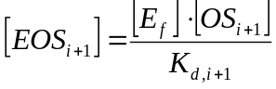 …Eq. 29
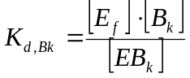 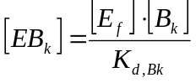 …Eq. 30

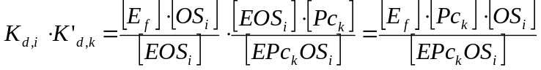 …Eq. 31

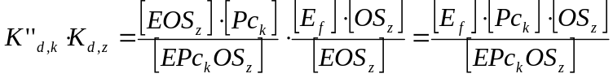 …Eq. 32

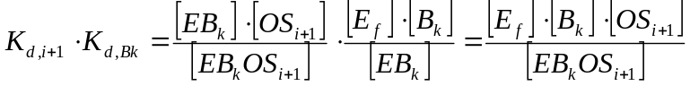 …Eq. 33

Total (or initial) enzyme balance:

…Eq. 34
Combining the dissociation constant expressions with the enzyme balance:

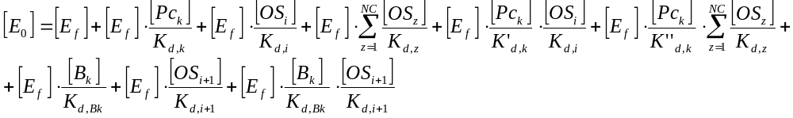…Eq. 35

Solving for the free enzyme term:

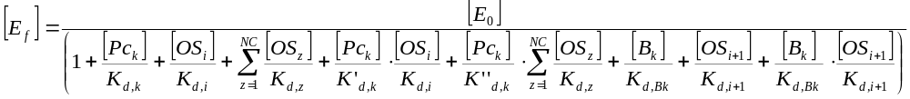 …Eq. 36

The reaction rate expression for the rate-limiting reaction is defined as:

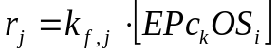 …Eq. 37

Combining Eq. 31 with Eq. 36:

and solving for :

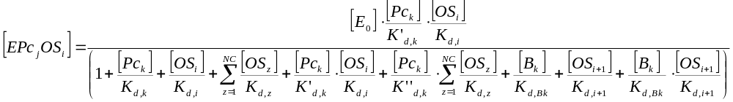 …Eq. 38

Substituting Eq. 38 into Eq. 37:
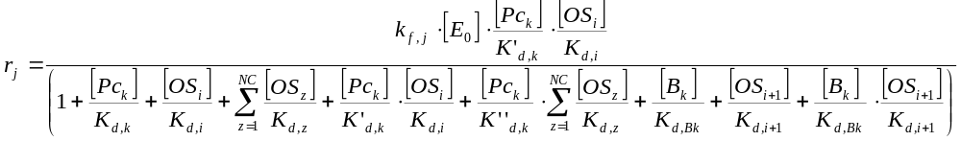
Rearranging:

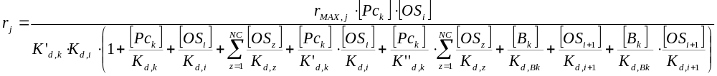 …Eq. 39
Where 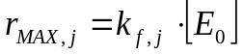
S2: Transport expression derivation

In order for transport to occur, the NSD must bind to the transport protein on the cytosolic side of the membrane and the dephosphorylated by-product must bind to the transport protein on the luminal side of the Golgi membrane. Additionally, it has been reported that the process can also occur in the opposite sense (Hirschberg et al., 1998; Waldman and Rudnick, 1990). In this case, the NSD must bind to the transport protein on the luminal side while a dephosphorylated by-product must bind to the cytosolic side of the Golgi. Given this information, we have proposed a gradient that determines the transport as:

…Eq. 40

If binding of the NSD and the dephosphorylated by-product are considered to be analogous to substrate binding in enzymes, we obtain the following kinetic mechanism:

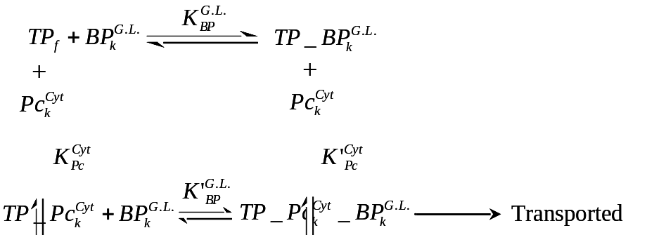

Using procedures analogous to enzyme derivations:

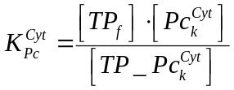 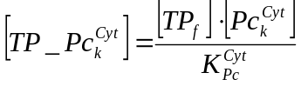 …Eq. 41
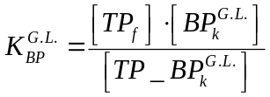 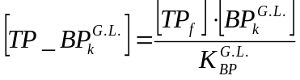 …Eq. 42
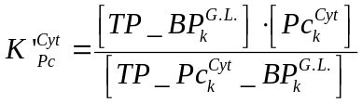 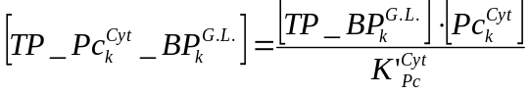 …Eq. 43
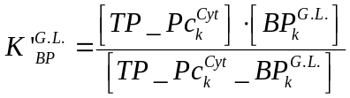 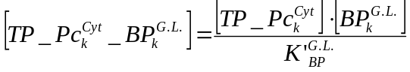 …Eq. 44

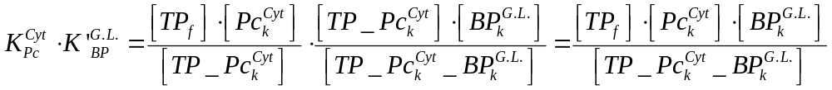 …Eq. 45

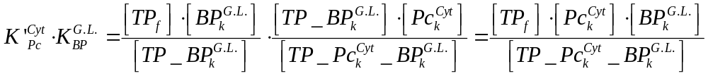 …Eq. 46

Total (or initial) transport protein balance:

…Eq. 47

Combining the dissociation constant expressions with the enzyme balance:

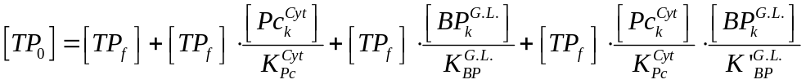 …Eq. 48

Solving for the free enzyme term:

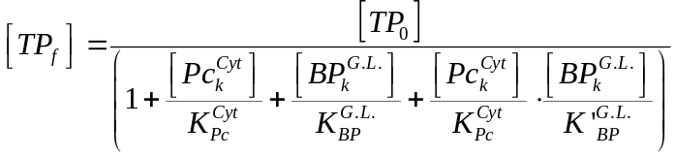 …Eq. 49

Combining equations 49 and 46 and solving for 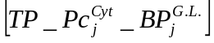:

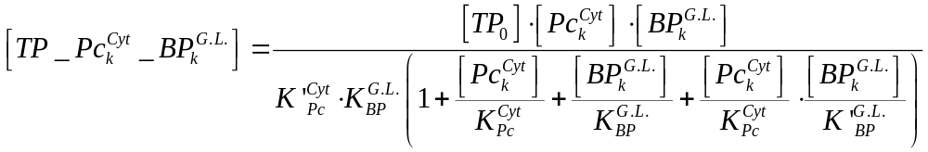
Simplifying:

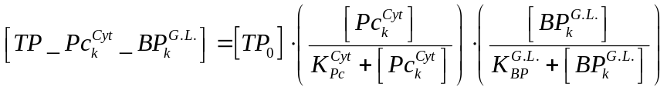 …Eq. 50

Considering that the same derivation can be followed for transport in the opposite direction:

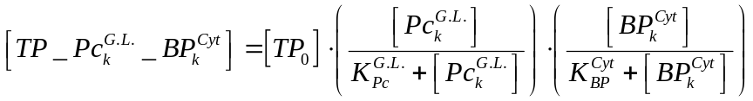 …Eq. 51

Substituting equations 55 and 56 into equation 45:
…Eq. 52

Finally, if we consider that by-product accumulation in the cytosol is limited given the dilution effect of going from a limited volume (Golgi cisternae) to a larger one (cytosol) and that the uptake of dephosphorylated nucleotides occurs readily in the cytosol through the nucleotide salvage pathways (Berg et al., 2002), the second term of equation 52 can be neglected so the final expression obtained is:

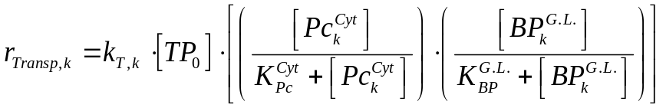 …Eq. 53

S3: Kinetic parameter derivation

- Enzyme turnover rates
The turnover rates have been estimated from the literature similarly to previous modeling studies. The maximum rate has usually been expressed in units of μmol mg_{prot}⁻¹ min⁻¹. In order to obtain the turnover rate in units of μmol_{prod} μmol_{enz}⁻¹ min⁻¹, the reported V_{max} has been multiplied by the molecular weight of the enzyme. This is valid only if the kinetic analysis has been performed with purified enzyme. The following table presents the reported V_{max} and the corresponding molecular weights for the enzymes considered in this work.

- Transport protein turnover rates
Gilchrist et al. (2006) performed a quantitative proteomic analysis of the secretory pathway in rat hepatocytes. In their study, the only NSD transport protein detected in the Golgi fraction is the UDP-GlcNAc transporter and was reported to account for 0.005116 % of all Golgi resident proteins. With this value, an average molecular weight of 60,600 g mol⁻¹ (also estimated from Gilchrist et al., 2006) and the maximum transport rate for TP₁ shown in table 6, a maximum turnover rate for this transport protein was estimated to be 1,084 min⁻¹. The remaining maximum transport turnover rates were derived from this value by assuming that the transport turnover rates are proportional to the reaction turnover rates.

- NSD concentration in cytosol and Golgi cisternae
The concentration of NSDs has been reported for overall cell volume and thus, their distribution between the Golgi apparatus and the cytosol is unknown. It has previously been reported that TPs have the ability to concentrate them up to 50-fold with respect to extraluminal concentrations (Hirschberg et al., 1998). A 40-fold increase in NSD concentration was assumed (similar to what Krambeck and Betenbaugh, 2005 assumed) and a material balance was performed to find the distribution of these components on the luminal and cytosolic side of Golgi cisternae.

S4: Rate of NSD consumption vs. rate of NSD transport into Golgi

The NSD transport parameters were estimated with the methodology presented in the parameter estimation section of the main paper. With the estimated parameters, simulations were performed in order to assess the performance of the estimated parameters. In the figure presented below, the profiles of NSD consumption and transport over the length of Golgi are shown. The lines represent the rate of NSD consumption and the symbols represent the rate of transport for each NSD into the Golgi along the length of the Golgi apparatus. The vertical dotted lines mark the zones where the maturing compartments are defined as either cis, medial, trans or trans Golgi network.
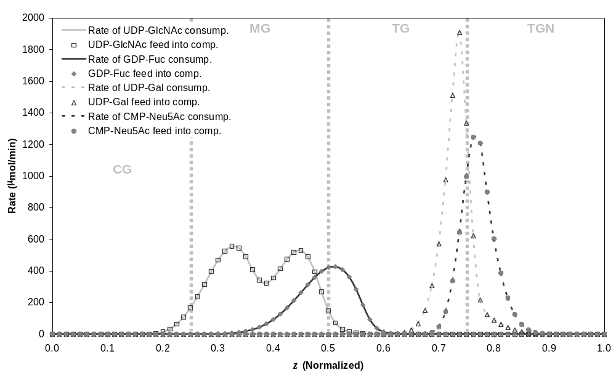

In the figure presented above, it is clear that the rate of NSD consumption overlaps with the NSD transport rate indicating that the obtained parameters achieve the conditions defined in the optimization methodology.
The implication behind both sets of data overlapping is that the transport of NSDs is not limiting. However, when the concentration of NSDs on the cytosolic side of the Golgi membranes is limited due to metabolic effects, transport is hindered (see equation 53 for NSD transport) and, only then would NSD availability inside Golgi limit the glycosylation reactions.
S5: Oligosaccharide profiles with respect to Golgi position (z) and time.

The Golgi apparatus was approximated as a plug flow reactor as was defined in figure 3. The material balances were defined as functions that depend both on time and length of the Golgi space. Plots representing the molar fraction profiles of early (A), intermediate (B) and terminal (C and D) oligosaccharides along Golgi length (z) and time are presented in figure 15.

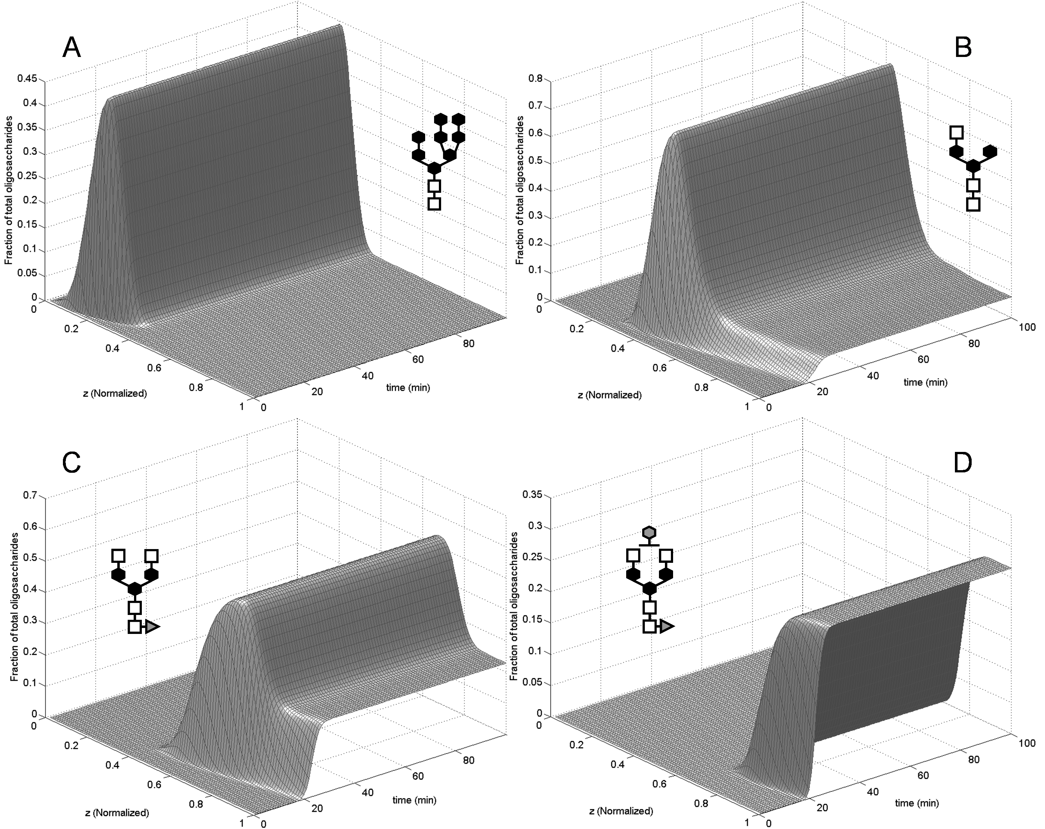
Calculated spatial and temporal oligosaccharide profiles within Golgi.
Panel A shows the molar fraction profile of an early oligosaccharide as a function of time and distance along the Golgi. Panel B corresponds to the profile of an intermediate oligosaccharide and panels C and D present the profiles of terminal oligosaccahrides.

The accumulation of species along the length of Golgi is clearly enzyme concentration dependent. Panel A in figure 15 shows an early, high mannose oligosaccharide whose concentration decreases along z due to the action of ManI. Panel B shows an oligosaccharide that accumulates due to the action of preceding enzymes (namely GnTI and ManII), but decreases further along z when other enzymes (GnTII and FucT) act on it. In contrast to panel A, this species is not completely consumed along z and reaches the end of Golgi, thus being “secreted” to the extracellular environment. Along the time axis of panel B, we see that the steady state concentration of this species is reached at approximately 30 minutes. Panels C and D have similar features to panel B given that they are also not depleted and reach the end of the Golgi space (z = 1). Again, the accumulation of both these species is dependent on where the enzymes that modify them appear along z. The enzymes that generate accumulation of the species presented in panel C are GnTII and FucT, and those responsible for the decline in concentration of this species along z is GalT. Panel D shows the product of the GalT-mediated addition of a galactose residue to the species shown in panel C. The time axis for both panels C and D is similar to that of panel B in that they all reach steady state at around 30 minutes.

The resulting oligosaccharide profiles along the Golgi compartment reflect the assumptions made to construct this model. Accumulation of intermediate species along the Golgi length depend on the concentration profiles of the enzymes, and the flow of material along the Golgi space is approximated to plug flow so that cisternal maturation is represented.

Supporting information references

Bendiak B, Cook GM. 1982. Kinetic parameters of a beta-D-galactoside alpha 2 leads to 6 sialyltransferase from embryonic chicken liver. Eur J Biochem 128:355-362.
Bendiak B, Schachter H. 1987a. Control of glycoprotein synthesis. Kinetic mechanism, substrate specificity, and inhibition characteristics of UDP-N-acetylglucosamine:alpha-D-mannoside beta 1-2 N-acetylglucosaminyltransferase II from rat liver. J Biol Chem 262:5784-5790.
Berg JM, Tymoczko JL, Stryer L. 2002. Biochemistry. New York:W. H. Freeman and Co. 974 p.
Gilchrist A, Au CE, Hiding J, Bell AW, Fernandez-Rodriguez J, Lesimple S, Nagaya H, Roy L, Gosline SJC, Hallett M, Paiement J, Kearney RE, Nilsson T, Bergeron JJM. 2006. Quantitative proteomics analysis of the secretory pathway. Cell 127:1265-1281.
Hirschberg CB, Robbins PW, Abeijon C. 1998. Transporters of nucleotide sugars, ATP, and nucleotide sulfate in the endoplasmic reticulum and Golgi apparatus. Annu Rev Biochem 67:49-69.
Ihara H, Ikeda Y, Toma S, Wang X, Suzuki T, Gu J, Miyoshi E, Tsukihara T, Honke K, Matsumoto A, Taniguchi ANaN. 2007. Crystal structure of mammalian alpha1,6-fucosyltransferase, FUT8. Glycobiology 17:455-466.
Ikeda Y, Koyota S, Ihara H, Yamaguchi Y, Tsuda HKaT, Sasai K, Taniguchi N. 2000. Kinetic basis for the donor nucleotide-sugar specificity of beta1, 4-N-acetylglucosaminyltransferase III. J Biochem 128:609-619.
Krambeck FJ, Betenbaugh MJ. 2005. A mathematical model of N-linked glycosylation. Biotechnol Bioeng 92:711-728.
Moremen KW, Touster O, Robbins PW. 1991. Novel purification of the catalytic domain of Golgi alpha-mannosidase II. Characterization and comparison with the intact enzyme. J Biol Chem 266:16876-16885.
Morrison JF, Ebner KE. 1971. Studies on galactosyltransferase. Kinetic investigations with N-acetylglucosamine as the galactosyl group acceptor. J Biol Chem 246:3977-3984.
Nishikawa Y, Pegg W, Paulsen H, Schachter H. 1988. Control of glycoprotein synthesis. Purification and characterization of rabbit liver UDP-N-acetylglucosamine:alpha-3-D-mannoside beta-1,2-N-acetylglucosaminyltransferase I. J Biol Chem 263:8270-8281.
Ramakrishnan B, Boeggeman E, Qasba,Velavan Ramasamy and Pradman K. 2004. Structure and catalytic cycle of beta-1,4-galactosyltransferase. Curr Opin Struct Biol 14:593-600.
Schachter H. 2000. The joys of HexNAc. The synthesis and function of N- and O-glycan branches. Glycoconj J 17:465-483.
Tabas I, Kornfeld S. 1979. Purification and characterization of a rat liver Golgi alpha-mannosidase capable of processing asparagine-linked oligosaccharides. J Biol Chem 254:11655-11663.
Taylor ME, Drickamer K. 2006. Introduction to Glycobiology. Oxford:Oxford University Press.
Unligil UM, Zhou S, Yuwaraj S, Sarkar M, Rini HSaJM. 2000. X-ray crystal structure of rabbit N-acetylglucosaminyltransferase I: catalytic mechanism and a new protein superfamily. EMBO J 19:5269-5280.
Varki A. 1999. Essentials of Glycobiology. Cold Spring Harbor, NY:Cold Spring Harbor Laboratory Press.
Velasco A, Hendricks L, Moremen KW, Touster DRTaO, Farquhar MG. 1993. Cell type-dependent variations in the subcellular distribution of alpha-mannosidase I and II. J Cell Biol 122:39-51.
Waldman BC, Rudnick G. 1990. UDP-GlcNAc transport across the Golgi membrane: electroneutral exchange for dianionic UMP. Biochemistry (N.Y.) 29:44-52.

