**--Setup Your Terminal**

source /CMC/ENVIRONMENT/modelsim.env

vlib work

**--Write Your VHDL Code**

**--Compile**

vcom vhdl_code.vhd

**--Simulate**

vsim vhdl_entity_name &

**--Do File**

nano vhdl_do_file.do

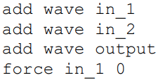

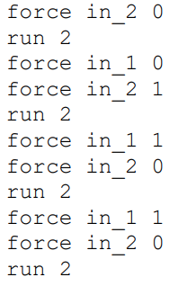

**--Simulate w/ Do File**

vsim -do ../current_location/vhdl_do_file.do vhdl_entity_name &

