Computer Architecture & Design

Coen 316

Lab Experiment #1

Andre Hei Wang Law

4017 5600

Section DN-X

Professor Dr. Fadi Alzouri

Performed on September 21, 2023

Due on October 5, 2023

“I certify that this submission is my original work and meets the Faculty’s Expectations of

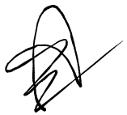Originality.”

**1) Introduction/Objectives**

The objective of the first Coen 316 lab is to design a 32-bit Arithmetic and Logic Unit (ALU) in VHDL, which will used in the development of a CPU across the five labs. The ALU is responsible for performing various arithmetic and logic operations on two 32-bit input operands, as determined by control signals. These control signals allow the ALU to execute operations such as addition, subtraction, logical AND, OR, XOR, and NOR. Additionally, it should be able to detect overflow conditions as well as zero conditions. Overall, the objective of this lab aims to design, simulate, and implement the ALU using VHDL which will be used to verify its correct functionality through simulation, and demonstrate its operation on a Nexys A7 FPGA board.

**2) Theory**

**ALU**: "Arithmetic and Logic Unit", it is a key component of a computer's central processing unit (CPU) responsible for performing arithmetic and logical operations.

**VHDL**: "VHSIC Hardware Description Language", it is a programming language used for describing the behavior and structure of electronic systems.

**FPGA**: "Field-Programmable Gate Array,", it is a programmable hardware device that allows users to configure digital circuits to perform specific tasks.

**CPU**: "Central Processing Unit", it is the primary component of a computer that executes instructions and performs calculations.

**MSB**: "Most Significant Bit", it refers to the leftmost (or highest-weighted) bit in a binary number.

**LSB**: "Least Significant Bit", it refers to the rightmost (or lowest-weighted) bit in a binary number.

**Overflow**: In the context of arithmetic operations, overflow occurs when the result of an operation exceeds the range that can be represented with the available number of bits.

**3) Tasks, Results and Discussion**

The following tasks are run by inputting DO codes found in the appendix. This section will show the results of each relevant input as well as discuss its behavior.

3.1) Output y, func = “00” (See appendix 5.2.1)

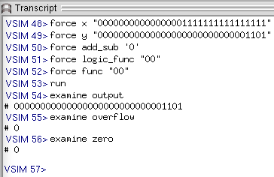

To test func = “00”, we first set “y” to be equal to 00000000000000000000000000001101 and we expect the output to always be equal to that regardless of the inputs of “add_sub” and “logic_func”. The first DO code of 5.2.1 tests the general output “y”, the second DO tests when changing “add_sub” while the third DO code tests when changing “logic_func”. In all three cases, the output is 00000000000000000000000000001101, thus func = “00” functions accordingly.

3.2) Output “000...MSB” of adder_subttract, func = “01” (See appendix 5.2.2)

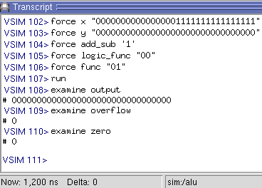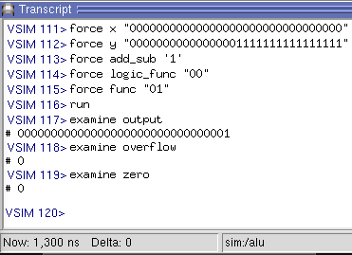

Func = ”01” sets a specified register to 1 if input “x” is smaller than input “y” and 0 otherwise. The left example has “x” greater than “y”, thus we expect an output of 0 in which we do. On the other hand, for the right example, the input “x” is smaller than the input “y”, thus we expect an output of 1 in which we do.

This behavior is obtained by performing “x – y” and checking the MSB of this result assuming it is a signed bit. If “x < y”, then this operation will yield a negative answer thus the MSB will be 1. If “x > y”, then this operation will yield a positive answer thus the MSB will be 0. This MSB will then be used in the func = “01” to determine the output of the system.

3.3) Output of adder_subtract, func = “10” (See appendix 5.2.3)

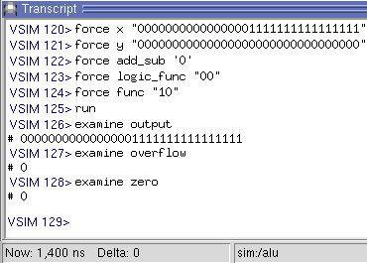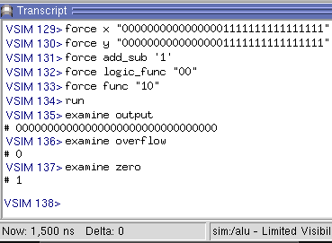

Given a set of “x” and “y” inputs, func = “10” will calculate the addition or the subtraction of the two inputs based on “add_sub”. In the left example, “add_sub” is ‘0’ which represents the addition operation. In the right example, “add_sub” is ‘1’ which represents the subtraction operation. In both cases, the results behave as expected.

3.4) Output of logic unit, func = “11” (See appendix 5.2.4)

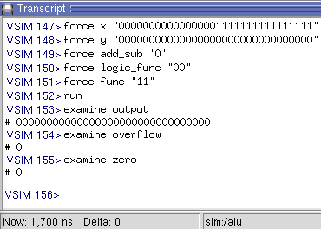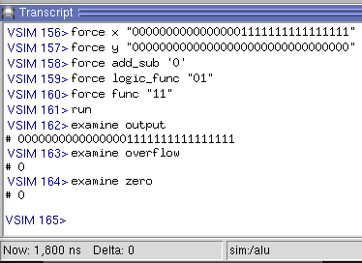

For the left example, given logic_func = “00”, the logic unit is an AND gate. Since input y is all zeros, the output also yields zeros. For the right example, logic_func = “01” which is an OR gate. The output being equal to input x as input y is all zeros.

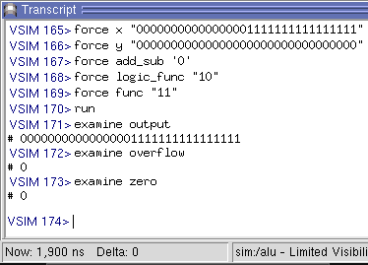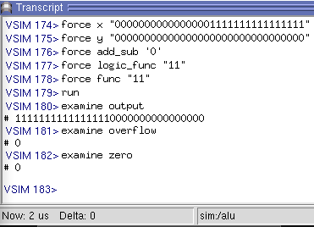

For the left example, given logic_func = “10”, the logic unit is an XOR gate which outputs 1 only when both inputs are the opposite and 0 when both inputs are the same. Here, x and y are the same in the first half and they are different in the second half, thus we expect full of zeros in the first half and full of ones in the second half which we do get based on the left image above. For the right example, logic_func = “11” which is an NOR gate. This gate will output 1 if and only if both inputs are zeros. For our inputs, both x and y have zeros in the first half which means we expect the output to yields ones in the first half and zeros in the second half in which we do.

3.5) Overflow (See appendix 5.2.5)

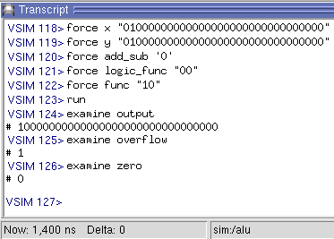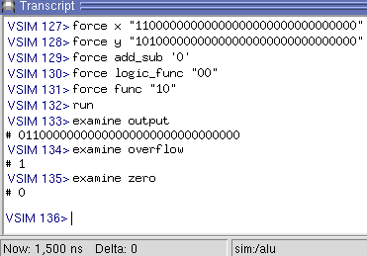

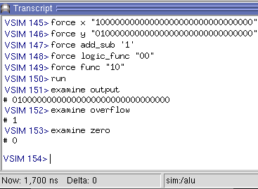 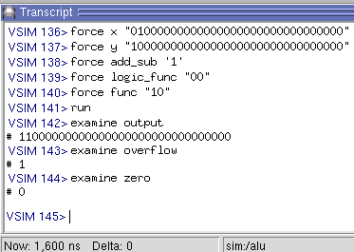

Top Left: Adding two positive num (x + y) and a negative result is obtained

Top Right: Adding two negative numbers (-x + -y) and a positive result is obtained

Bottom Left: Subtracting two operands of opposite sign (-x - y)

Bottom Right: Subtracting two operands of opposite sign (x - - y)

3.6) Zeros (See appendix 5.2.6)

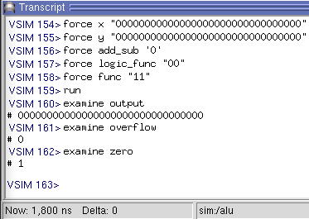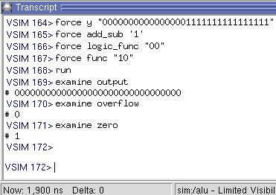

With func = “11”, the output of logic unit of x AND y yields all zeros due to x and y input being all zeros. As such, the zero is set to one (left image). With func = “10” and add_sub = ‘1’, we perform a subtraction between x and y, yielding zero. As such, zero is set to 1.

3.7) ModelSim Transcript

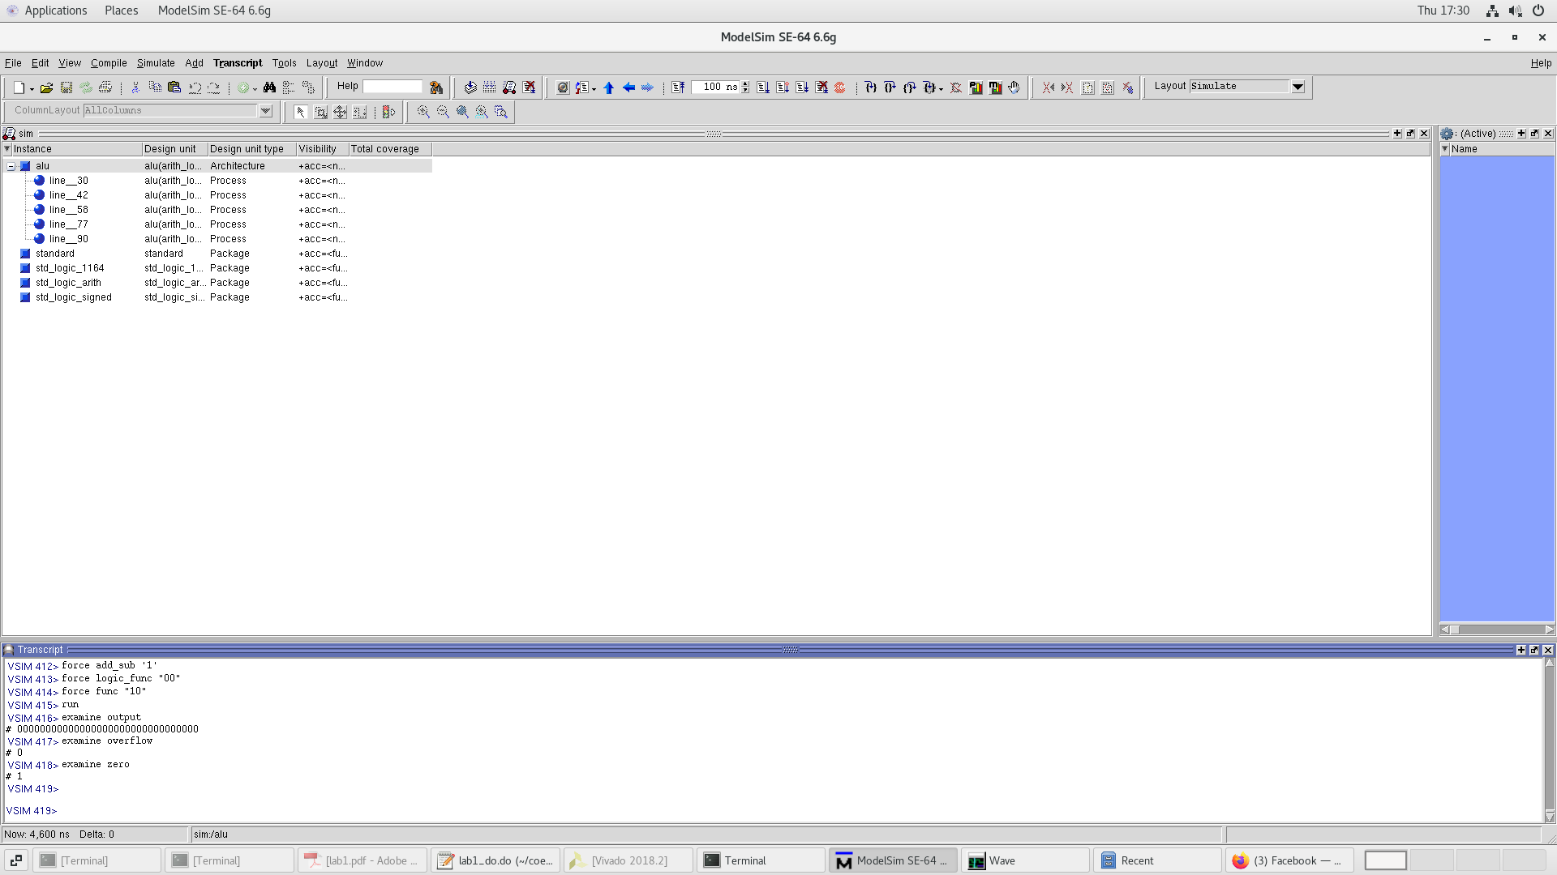

3.8) ModelSim Wave View

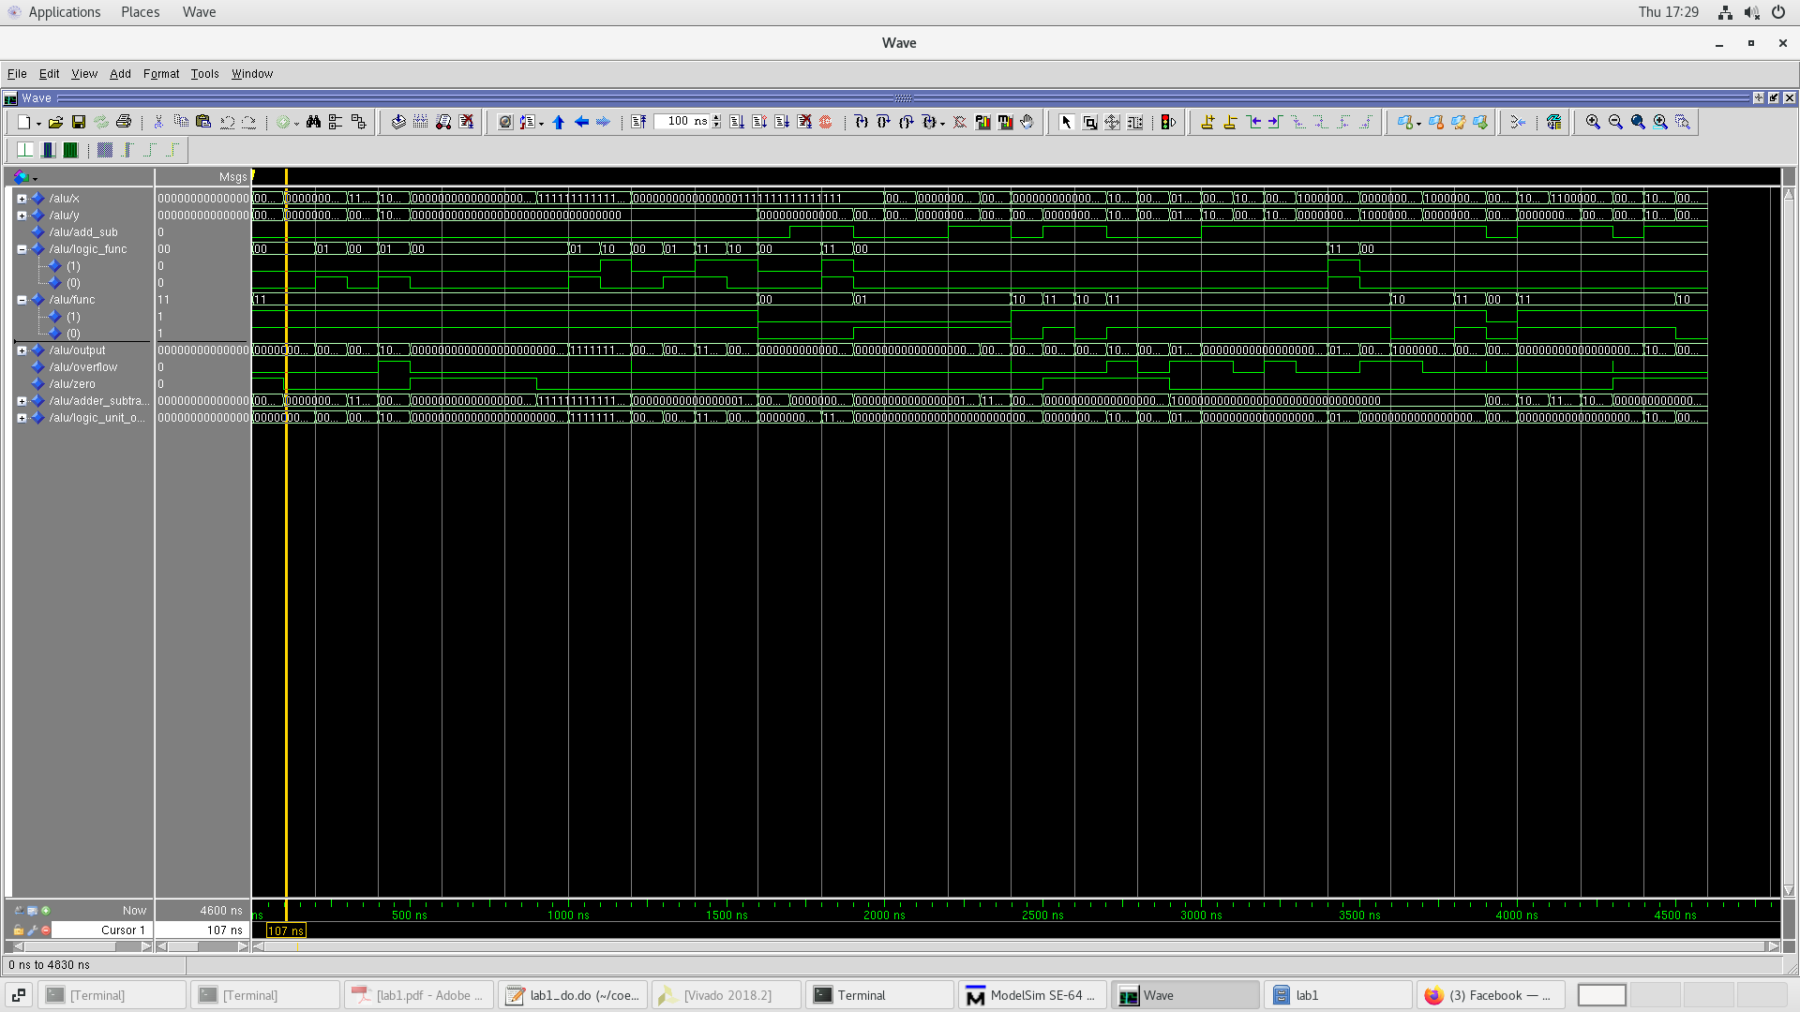

**4) Conclusions**

In conclusion, lab 1 of the course Coen 316 provided a comprehensive hands-on experience in designing, implementing and simulating a 32-bit Arithmetic and Logic Unit (ALU) using VHDL. This lab allows students to practice implementing various arithmetic and logic operations, to understand the difference between signed and unsigned bit as well as to detect overflows and zeros. Then, by simulating the design in ModelSim, it allowed the students to verify its output under various inputs, while the implementation on the Nexys A7 FPGA board demonstrated its practical functionality. In the end, this lab has provided valuable insights into digital design, FPGA-based hardware implementation, and the foundational components of a CPU, setting the foundation for the upcoming labs.

**5) Appendix**

**5.1) Code**

5.1.1) VHDL Code

-- coen 316 lab1  
-- Andre Hei Wang Law  
-- 4017 5600  
  
**library** IEEE;  
**use** IEEE.std_logic_1164.**all**;  
**use** ieee.std_logic_signed.**all**;  
  
**entity** alu **is**  
 **port** (  
 x, y: **in** std_logic_vector(31 **downto** 0); -- two input operands  
 add_sub: **in** std_logic; -- 0=add, 1=sub  
 logic_func: **in** std_logic_vector(1 **downto** 0); -- 00=AND, 01=OR, 10=XOR, 11=NOR  
 func: **in** std_logic_vector(1 **downto** 0); -- 00=lui, 01=setless, 10=arith, 11=logic  
 output: **out** std_logic_vector(31 **downto** 0);  
 overflow: **out** std_logic;  
 zero: **out** std_logic);  
**end** alu;  
  
**architecture** arith_logic_unit **of** alu **is**  
  
-- signal   
**signal** adder_subtract_output, logic_unit_output: std_logic_vector(31 **downto** 0);  
  
**begin**  
 -- adder_subtract (add_sub)  
 **process**(x, y, add_sub)  
 **begin**  
 -- check for addition or substraction  
 **if** add_sub = '0' **then**  
 adder_subtract_output <= x + y; -- addition  
 **elsif** add_sub = '1' **then**  
 adder_subtract_output <= x - y; -- substraction  
 **end** **if**;  
 **end** **process**;  
  
 -- LINE 40  
 -- logic unit (logic_func)  
 **process**(x, y, logic_func)  
 **begin**  
 -- check for logic (AND, OR, XOR, NOR)  
 **if** logic_func = "00" **then**  
 logic_unit_output <= x **AND** y; -- AND  
 **elsif** logic_func = "01" **then**  
 logic_unit_output <= x **OR** y; -- OR  
 **elsif** logic_func = "10" **then**  
 logic_unit_output <= x **XOR** y; -- XOR  
 **elsif** logic_func = "11" **then**  
 logic_unit_output <= x **NOR** y; -- NOR  
 **end** **if**;  
 **end** **process**;  
  
 -- mux (func)  
 **process**(y, adder_subtract_output, logic_unit_output, func)  
 **begin**  
 -- determines output  
 **if** func = "00" **then**  
 output <= y; -- y  
 **elsif** func = "01" **then**  
 -- output = 1 if x < y   
 -- output = 0 otherwise  
 -- “000...MSB” of adder_subttract  
 output <= "0000000000000000000000000000000" & adder_subtract_output(31);  
 **elsif** func = "10" **then**  
 output <= adder_subtract_output; -- output of adder_subtract  
 **elsif** func = "11" **then**  
 output <= logic_unit_output; -- output of logic unit  
 **end** **if**;  
 **end** **process**;  
  
 -- zero  
 **process**(adder_subtract_output)  
 **begin**  
 -- zero = 1 when output of the adder_subtract unit is all 0s  
 -- zero = 0 otherwise  
 **if** adder_subtract_output = "00000000000000000000000000000000" **then**  
 zero <= '1';  
 **else**  
 zero <= '0';  
 **end** **if**;  
 **end** **process**;  
  
 -- overflow  
 **process**(adder_subtract_output, add_sub, x, y)  
 **begin**  
 -- overflow = 1 when:   
 -- 1. Adding two positive num (x + y) and a negative result is obtained  
 -- 2. Adding two negative numbers (-x + -y) and a possitive result is obtained  
 -- 3. Substracting two operands of opposite sign (-x - y)   
 -- 4. Substracting two operands of opposite sign (x - -y)  
   
 -- 1. and 2. Addition  
 **if** add_sub = '0' **then**  
 **if** (x(31) = '0' **and** y(31) = '0' **and** adder_subtract_output(31) = '1') **or**  
 (x(31) = '1' **and** y(31) = '1' **and** adder_subtract_output(31) = '0') **then**  
 overflow <= '1'; -- Overflow detected  
 **else**  
 overflow <= '0'; -- No overflow  
 **end** **if**;  
 --overflow <= (not(x(31)) AND not(y(31)) AND adder_subtract_output(31)) OR (x(31) AND y(31) AND not(adder_subtract_output(31)));  
   
 -- 3. and 4. Substraction  
 **elsif** add_sub = '1' **then**  
 **if** (x(31) = '0' **and** y(31) = '1' **and** adder_subtract_output(31) = '1') **or**  
 (x(31) = '1' **and** y(31) = '0' **and** adder_subtract_output(31) = '0') **then**  
 overflow <= '1'; -- Overflow detected  
 **else**  
 overflow <= '0'; -- No overflow  
 **end** **if**;  
 --overflow <= (x(31) AND not(y(31)) AND not(adder_subtract_output(31))) OR (not(x(31)) AND y(31) AND adder_subtract_output(31));  
 **end** **if**;  
 **end** **process**;  
  
**end** arith_logic_unit;

5.1.2) Board Wrapper Version of the Original VHDL Code

-- coen 316 lab1  
-- Andre Hei Wang Law  
-- 4017 5600  
  
-- board wrapper version  
  
**library** IEEE;  
**use** IEEE.std_logic_1164.**all**;  
**use** ieee.std_logic_signed.**all**;  
  
**entity** alu_board **is**  
 **port** (  
 x_in, y_in: **in** std_logic_vector(3 **downto** 0); -- Input ports for low-order 4 bits of x and y  
 add_sub: **in** std_logic; -- 0=add, 1=sub  
 logic_func: **in** std_logic_vector(1 **downto** 0); -- 00=AND, 01=OR, 10=XOR, 11=NOR  
 func: **in** std_logic_vector(1 **downto** 0); -- 00=lui, 01=setless, 10=arith, 11=logic  
 output_out: **out** std_logic_vector(3 **downto** 0); -- Output port for low-order 4 bits of output  
 overflow: **out** std_logic;  
 zero: **out** std_logic);  
**end** alu_board ;  
  
**architecture** board_wrapper **of** alu_board **is**  
  
-- signal   
**signal** adder_subtract_output, logic_unit_output: std_logic_vector(31 **downto** 0);  
**signal** x, y, output : std_logic_vector(31 **downto** 0);  
  
**begin**  
 -- board wrapper   
 -- assign port inputs to internal signals x and y  
 x(3 **downto** 0) <= x_in(3) & x_in(2) & x_in(1) & x_in(0) ;  
 y(3 **downto** 0) <= y_in(3) & y_in(2) & y_in(1) & y_in(0) ;  
 x(31 **downto** 4) <= (**others** => '0');  
 y(31 **downto** 4) <= (**others** => '0');  
 output_out(3 **downto** 0) <= output(3 **downto** 0);  
  
 -- adder_subtract (add_sub)  
 **process**(x, y, add_sub)  
 **begin**  
 -- check for addition or substraction  
 **if** add_sub = '0' **then**  
 adder_subtract_output <= x + y; -- addition  
 **elsif** add_sub = '1' **then**  
 adder_subtract_output <= x - y; -- substraction  
 **end** **if**;  
 **end** **process**;  
  
 -- LINE 40  
 -- logic unit (logic_func)  
 **process**(x, y, logic_func)  
 **begin**  
 -- check for logic (AND, OR, XOR, NOR)  
 **if** logic_func = "00" **then**  
 logic_unit_output <= x **AND** y; -- AND  
 **elsif** logic_func = "01" **then**  
 logic_unit_output <= x **OR** y; -- OR  
 **elsif** logic_func = "10" **then**  
 logic_unit_output <= x **XOR** y; -- XOR  
 **elsif** logic_func = "11" **then**  
 logic_unit_output <= x **NOR** y; -- NOR  
 **end** **if**;  
 **end** **process**;  
  
 -- mux (func)  
 **process**(y, adder_subtract_output, logic_unit_output, func)  
 **begin**  
 -- determines output  
 **if** func = "00" **then**  
 output <= y; -- y  
 **elsif** func = "01" **then**  
 -- output = 1 if x < y   
 -- output = 0 otherwise  
 -- “000...MSB” of adder_subttract  
 output <= "0000000000000000000000000000000" & adder_subtract_output(31);  
 **elsif** func = "10" **then**  
 output <= adder_subtract_output; -- output of adder_subtract  
 **elsif** func = "11" **then**  
 output <= logic_unit_output; -- output of logic unit  
 **end** **if**;  
 **end** **process**;  
  
 -- zero  
 **process**(adder_subtract_output)  
 **begin**  
 -- zero = 1 when output of the adder_subtract unit is all 0s  
 -- zero = 0 otherwise  
 **if** adder_subtract_output = "00000000000000000000000000000000" **then**  
 zero <= '1';  
 **else**  
 zero <= '0';  
 **end** **if**;  
 **end** **process**;  
  
 -- overflow  
 **process**(adder_subtract_output, add_sub, x, y)  
 **begin**  
 -- overflow = 1 when:   
 -- 1. Adding two positive num (x + y) and a negative result is obtained  
 -- 2. Adding two negative numbers (-x + -y) and a possitive result is obtained  
 -- 3. Substracting two operands of opposite sign (-x - y)   
 -- 4. Substracting two operands of opposite sign (x - -y)  
   
 -- 1. and 2. Addition  
 **if** add_sub = '0' **then**  
 **if** (x(31) = '0' **and** y(31) = '0' **and** adder_subtract_output(31) = '1') **or**  
 (x(31) = '1' **and** y(31) = '1' **and** adder_subtract_output(31) = '0') **then**  
 overflow <= '1'; -- Overflow detected  
 **else**  
 overflow <= '0'; -- No overflow  
 **end** **if**;  
 --overflow <= (not(x(31)) AND not(y(31)) AND adder_subtract_output(31)) OR (x(31) AND y(31) AND not(adder_subtract_output(31)));  
   
 -- 3. and 4. Substraction  
 **elsif** add_sub = '1' **then**  
 **if** (x(31) = '0' **and** y(31) = '1' **and** adder_subtract_output(31) = '1') **or**  
 (x(31) = '1' **and** y(31) = '0' **and** adder_subtract_output(31) = '0') **then**  
 overflow <= '1'; -- Overflow detected  
 **else**  
 overflow <= '0'; -- No overflow  
 **end** **if**;  
 --overflow <= (x(31) AND not(y(31)) AND not(adder_subtract_output(31))) OR (not(x(31)) AND y(31) AND adder_subtract_output(31));  
 **end** **if**;  
 **end** **process**;  
  
**end** board_wrapper;

5.2.1) DO File to Test Various Output – y (func = “00”)

force x "00000000000000001111111111111111"  
force y "00000000000000000000000000001101"  
force add_sub '0'  
force logic_func "00"  
force func "00"  
run  
examine output  
examine overflow  
examine zero  
  
force x "00000000000000001111111111111111"  
force y "00000000000000000000000000001101"  
force add_sub '1'  
force logic_func "00"  
force func "00"  
run  
examine output  
examine overflow  
examine zero  
  
force x "00000000000000001111111111111111"  
force y "00000000000000000000000000001101"  
force add_sub '1'  
force logic_func "11"  
force func "00"  
run  
examine output  
examine overflow  
examine zero

5.2.2) DO File to Test Various Output – “000...MSB” of adder_subttract (func = “01”)

force x "00000000000000001111111111111111"  
force y "00000000000000000000000000000000"  
force add_sub '1'  
force logic_func "00"  
force func "01"  
run  
examine output  
examine overflow  
examine zero  
  
force x "00000000000000000000000000000000"  
force y "00000000000000001111111111111111"  
force add_sub '1'  
force logic_func "00"  
force func "01"  
run  
examine output  
examine overflow  
examine zero

5.2.3) DO File to Test Various Output – output of adder_subtract (func = “10”)

force x "00000000000000001111111111111111"  
force y "00000000000000000000000000000000"  
force add_sub '0'  
force logic_func "00"  
force func "10"  
run  
examine output  
examine overflow  
examine zero  
  
force x "00000000000000001111111111111111"  
force y "00000000000000001111111111111111"  
force add_sub '1'  
force logic_func "00"  
force func "10"  
run  
examine output  
examine overflow  
examine zero

5.2.4) DO File to Test Various Output – Logic unit, AND, OR, XOR, NOR (func = “11”)

force x "00000000000000001111111111111111"  
force y "00000000000000000000000000000000"  
force add_sub '0'  
force logic_func "00"  
force func "11"  
run  
examine output  
examine overflow  
examine zero  
  
force x "00000000000000001111111111111111"  
force y "00000000000000000000000000000000"  
force add_sub '0'  
force logic_func "01"  
force func "11"  
run  
examine output  
examine overflow  
examine zero  
  
force x "00000000000000001111111111111111"  
force y "00000000000000000000000000000000"  
force add_sub '0'  
force logic_func "10"  
force func "11"  
run  
examine output  
examine overflow  
examine zero  
  
force x "00000000000000001111111111111111"  
force y "00000000000000000000000000000000"  
force add_sub '0'  
force logic_func "11"  
force func "11"  
run  
examine output  
examine overflow  
examine zero

5.2.5) DO File to Test Various Output – Overflow (MSB = ‘1’)

force x "00000000000000000000000000000000"  
force y "01000000000000000000000000000000"  
force add_sub '0'  
force logic_func "00"  
force func "10"  
run  
examine output  
examine overflow  
examine zero  
  
force x "01000000000000000000000000000000"  
force y "01000000000000000000000000000000"  
force add_sub '0'  
force logic_func "00"  
force func "10"  
run  
examine output  
examine overflow  
examine zero  
  
force x "11000000000000000000000000000000"  
force y "10100000000000000000000000000000"  
force add_sub '0'  
force logic_func "00"  
force func "10"  
run  
examine output  
examine overflow  
examine zero  
  
force x "01000000000000000000000000000000"  
force y "10000000000000000000000000000000"  
force add_sub '1'  
force logic_func "00"  
force func "10"  
run  
examine output  
examine overflow  
examine zero  
  
force x "10000000000000000000000000000000"  
force y "01000000000000000000000000000000"  
force add_sub '1'  
force logic_func "00"  
force func "10"  
run  
examine output  
examine overflow  
examine zero

5.2.6) DO File to Test Various Output – Zero (add_sub = '1' and add_sub = '0')

force x "00000000000000000000000000000000"  
force y "00000000000000000000000000000000"  
force add_sub '0'  
force logic_func "00"  
force func "11"  
run  
examine output  
examine overflow  
examine zero  
  
force x "00000000000000001111111111111111"  
force y "00000000000000001111111111111111"  
force add_sub '1'  
force logic_func "00"  
force func "10"  
run  
examine output  
examine overflow  
examine zero

**5.3) Synthesis Log**

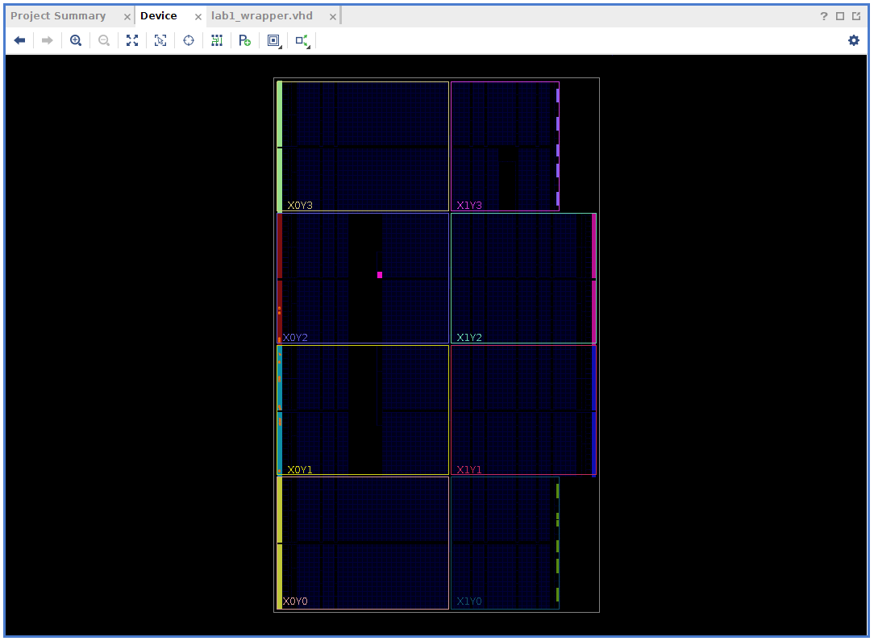

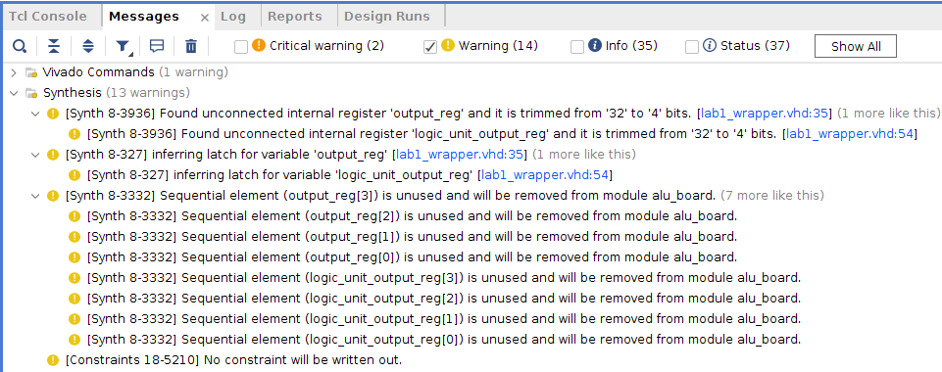

**Warning Discussion**: While there is no critical error, we have 13 warnings, in which most is about the unused inputs such as “output_reg”, “logic_unit_output_reg”. This doesn’t cause any problem to the functionality of this sytem.

*** Running vivado  
 with args -log alu_board.vds -m64 -product Vivado -mode batch -messageDb vivado.pb -notrace -source alu_board.tcl  
  
  
****** Vivado v2018.2 (64-bit)  
 **** SW Build 2258646 on Thu Jun 14 20:02:38 MDT 2018  
 **** IP Build 2256618 on Thu Jun 14 22:10:49 MDT 2018  
 ** Copyright 1986-2018 Xilinx, Inc. All Rights Reserved.  
  
source alu_board.tcl -notrace  
Command: synth_design -top alu_board -part xc7a100tcsg324-1  
Starting synth_design  
Attempting to **get** a license **for** feature 'Synthesis' **and**/**or** device 'xc7a100t'  
INFO: [Common 17-349] Got license **for** feature 'Synthesis' **and**/**or** device 'xc7a100t'  
INFO: Launching helper process **for** spawning children vivado processes  
INFO: Helper process launched with PID 28374   
---------------------------------------------------------------------------------  
Starting RTL Elaboration : Time (s): cpu = 00:00:02 ; elapsed = 00:00:04 . Memory (MB): peak = 1468.590 ; gain = 86.727 ; free physical = 81343 ; free virtual = 154593  
---------------------------------------------------------------------------------  
INFO: [Synth 8-638] synthesizing module 'alu_board' [/nfs/home/l/l_heiwan/coen316/lab1/lab1_wrapper.vhd:22]  
INFO: [Synth 8-256] done synthesizing module 'alu_board' (1#1) [/nfs/home/l/l_heiwan/coen316/lab1/lab1_wrapper.vhd:22]  
---------------------------------------------------------------------------------  
Finished RTL Elaboration : Time (s): cpu = 00:00:03 ; elapsed = 00:00:06 . Memory (MB): peak = 1513.230 ; gain = 131.367 ; free physical = 81356 ; free virtual = 154606  
---------------------------------------------------------------------------------  
  
Report Check Netlist:   
+------+------------------+-------+---------+-------+------------------+  
| |Item |Errors |Warnings |Status |Description |  
+------+------------------+-------+---------+-------+------------------+  
|1 |multi_driven_nets | 0| 0|Passed |Multi driven nets |  
+------+------------------+-------+---------+-------+------------------+  
---------------------------------------------------------------------------------  
Start Handling Custom Attributes  
---------------------------------------------------------------------------------  
---------------------------------------------------------------------------------  
Finished Handling Custom Attributes : Time (s): cpu = 00:00:03 ; elapsed = 00:00:06 . Memory (MB): peak = 1513.230 ; gain = 131.367 ; free physical = 81355 ; free virtual = 154605  
---------------------------------------------------------------------------------  
---------------------------------------------------------------------------------  
Finished RTL Optimization Phase 1 : Time (s): cpu = 00:00:03 ; elapsed = 00:00:06 . Memory (MB): peak = 1513.230 ; gain = 131.367 ; free physical = 81355 ; free virtual = 154605  
---------------------------------------------------------------------------------  
INFO: [Device 21-403] Loading part xc7a100tcsg324-1  
INFO: [Project 1-570] Preparing netlist **for** logic optimization  
  
Processing XDC Constraints  
Initializing timing engine  
Parsing XDC File [/nfs/home/l/l_heiwan/coen316/lab1/lab1_constraints.xdc]  
Finished Parsing XDC File [/nfs/home/l/l_heiwan/coen316/lab1/lab1_constraints.xdc]  
INFO: [Project 1-236] Implementation specific constraints were found **while** reading constraint file [/nfs/home/l/l_heiwan/coen316/lab1/lab1_constraints.xdc]. These constraints will be ignored **for** synthesis but will be used **in** implementation. Impacted constraints are listed **in** the file [.Xil/alu_board_propImpl.xdc].  
Resolution: To avoid **this** warning, move constraints listed **in** [.Xil/alu_board_propImpl.xdc] to another XDC file **and** exclude **this** new file **from** synthesis with the used_in_synthesis property (File Properties dialog **in** GUI) **and** re-run elaboration/synthesis.  
Completed Processing XDC Constraints  
  
INFO: [Project 1-111] Unisim Transformation Summary:  
No Unisim elements were transformed.  
  
Constraint Validation Runtime : Time (s): cpu = 00:00:00 ; elapsed = 00:00:00 . Memory (MB): peak = 1878.156 ; gain = 0.000 ; free physical = 81012 ; free virtual = 154263  
---------------------------------------------------------------------------------  
Finished Constraint Validation : Time (s): cpu = 00:00:16 ; elapsed = 00:01:08 . Memory (MB): peak = 1878.156 ; gain = 496.293 ; free physical = 81164 ; free virtual = 154414  
---------------------------------------------------------------------------------  
---------------------------------------------------------------------------------  
Start Loading Part **and** Timing Information  
---------------------------------------------------------------------------------  
Loading part: xc7a100tcsg324-1  
---------------------------------------------------------------------------------  
Finished Loading Part **and** Timing Information : Time (s): cpu = 00:00:16 ; elapsed = 00:01:08 . Memory (MB): peak = 1878.156 ; gain = 496.293 ; free physical = 81164 ; free virtual = 154414  
---------------------------------------------------------------------------------  
---------------------------------------------------------------------------------  
Start Applying 'set_property' XDC Constraints  
---------------------------------------------------------------------------------  
---------------------------------------------------------------------------------  
Finished applying 'set_property' XDC Constraints : Time (s): cpu = 00:00:16 ; elapsed = 00:01:08 . Memory (MB): peak = 1878.156 ; gain = 496.293 ; free physical = 81166 ; free virtual = 154416  
---------------------------------------------------------------------------------  
INFO: [Synth 8-5818] HDL ADVISOR - The operator resource <adder> **is** **shared**. To prevent sharing consider applying a KEEP on the output of the operator [/nfs/home/l/l_heiwan/coen316/lab1/lab1_wrapper.vhd:41]  
WARNING: [Synth 8-3936] Found unconnected internal register 'output_reg' **and** it **is** trimmed **from** '32' to '4' bits. [/nfs/home/l/l_heiwan/coen316/lab1/lab1_wrapper.vhd:35]  
WARNING: [Synth 8-3936] Found unconnected internal register 'logic_unit_output_reg' **and** it **is** trimmed **from** '32' to '4' bits. [/nfs/home/l/l_heiwan/coen316/lab1/lab1_wrapper.vhd:54]  
WARNING: [Synth 8-327] inferring latch **for** variable 'output_reg' [/nfs/home/l/l_heiwan/coen316/lab1/lab1_wrapper.vhd:35]  
WARNING: [Synth 8-327] inferring latch **for** variable 'logic_unit_output_reg' [/nfs/home/l/l_heiwan/coen316/lab1/lab1_wrapper.vhd:54]  
---------------------------------------------------------------------------------  
Finished RTL Optimization Phase 2 : Time (s): cpu = 00:00:16 ; elapsed = 00:01:08 . Memory (MB): peak = 1878.156 ; gain = 496.293 ; free physical = 81157 ; free virtual = 154408  
---------------------------------------------------------------------------------  
  
Report RTL Partitions:   
+-+--------------+------------+----------+  
| |RTL Partition |Replication |Instances |  
+-+--------------+------------+----------+  
+-+--------------+------------+----------+  
---------------------------------------------------------------------------------  
Start RTL Component Statistics   
---------------------------------------------------------------------------------  
Detailed RTL Component Info :   
+---Adders :   
 3 Input 32 Bit Adders := 1   
+---XORs :   
 2 Input 4 Bit XORs := 1   
+---Muxes :   
 2 Input 32 Bit Muxes := 1   
 4 Input 4 Bit Muxes := 2   
 2 Input 1 Bit Muxes := 1   
 4 Input 1 Bit Muxes := 2   
---------------------------------------------------------------------------------  
Finished RTL Component Statistics   
---------------------------------------------------------------------------------  
---------------------------------------------------------------------------------  
Start RTL Hierarchical Component Statistics   
---------------------------------------------------------------------------------  
Hierarchical RTL Component report   
Module alu_board   
Detailed RTL Component Info :   
+---Adders :   
 3 Input 32 Bit Adders := 1   
+---XORs :   
 2 Input 4 Bit XORs := 1   
+---Muxes :   
 2 Input 32 Bit Muxes := 1   
 4 Input 4 Bit Muxes := 2   
 2 Input 1 Bit Muxes := 1   
 4 Input 1 Bit Muxes := 2   
---------------------------------------------------------------------------------  
Finished RTL Hierarchical Component Statistics  
---------------------------------------------------------------------------------  
---------------------------------------------------------------------------------  
Start Part Resource Summary  
---------------------------------------------------------------------------------  
Part Resources:  
DSPs: 240 (col length:80)  
BRAMs: 270 (col length: RAMB18 80 RAMB36 40)  
---------------------------------------------------------------------------------  
Finished Part Resource Summary  
---------------------------------------------------------------------------------  
---------------------------------------------------------------------------------  
Start Cross Boundary **and** Area Optimization  
---------------------------------------------------------------------------------  
Warning: Parallel synthesis criteria **is** **not** met   
WARNING: [Synth 8-3332] Sequential element (output_reg[3]) **is** unused **and** will be removed **from** module alu_board.  
WARNING: [Synth 8-3332] Sequential element (output_reg[2]) **is** unused **and** will be removed **from** module alu_board.  
WARNING: [Synth 8-3332] Sequential element (output_reg[1]) **is** unused **and** will be removed **from** module alu_board.  
WARNING: [Synth 8-3332] Sequential element (output_reg[0]) **is** unused **and** will be removed **from** module alu_board.  
WARNING: [Synth 8-3332] Sequential element (logic_unit_output_reg[3]) **is** unused **and** will be removed **from** module alu_board.  
WARNING: [Synth 8-3332] Sequential element (logic_unit_output_reg[2]) **is** unused **and** will be removed **from** module alu_board.  
WARNING: [Synth 8-3332] Sequential element (logic_unit_output_reg[1]) **is** unused **and** will be removed **from** module alu_board.  
WARNING: [Synth 8-3332] Sequential element (logic_unit_output_reg[0]) **is** unused **and** will be removed **from** module alu_board.  
---------------------------------------------------------------------------------  
Finished Cross Boundary **and** Area Optimization : Time (s): cpu = 00:00:16 ; elapsed = 00:01:09 . Memory (MB): peak = 1878.156 ; gain = 496.293 ; free physical = 81136 ; free virtual = 154388  
---------------------------------------------------------------------------------  
  
Report RTL Partitions:   
+-+--------------+------------+----------+  
| |RTL Partition |Replication |Instances |  
+-+--------------+------------+----------+  
+-+--------------+------------+----------+  
---------------------------------------------------------------------------------  
Start Applying XDC Timing Constraints  
---------------------------------------------------------------------------------  
---------------------------------------------------------------------------------  
Finished Applying XDC Timing Constraints : Time (s): cpu = 00:00:23 ; elapsed = 00:01:27 . Memory (MB): peak = 1878.156 ; gain = 496.293 ; free physical = 81019 ; free virtual = 154271  
---------------------------------------------------------------------------------  
---------------------------------------------------------------------------------  
Start Timing Optimization  
---------------------------------------------------------------------------------  
---------------------------------------------------------------------------------  
Finished Timing Optimization : Time (s): cpu = 00:00:23 ; elapsed = 00:01:27 . Memory (MB): peak = 1878.156 ; gain = 496.293 ; free physical = 81019 ; free virtual = 154271  
---------------------------------------------------------------------------------  
  
Report RTL Partitions:   
+-+--------------+------------+----------+  
| |RTL Partition |Replication |Instances |  
+-+--------------+------------+----------+  
+-+--------------+------------+----------+  
---------------------------------------------------------------------------------  
Start Technology Mapping  
---------------------------------------------------------------------------------  
---------------------------------------------------------------------------------  
Finished Technology Mapping : Time (s): cpu = 00:00:23 ; elapsed = 00:01:27 . Memory (MB): peak = 1878.156 ; gain = 496.293 ; free physical = 81019 ; free virtual = 154271  
---------------------------------------------------------------------------------  
  
Report RTL Partitions:   
+-+--------------+------------+----------+  
| |RTL Partition |Replication |Instances |  
+-+--------------+------------+----------+  
+-+--------------+------------+----------+  
---------------------------------------------------------------------------------  
Start IO Insertion  
---------------------------------------------------------------------------------  
---------------------------------------------------------------------------------  
Start Flattening Before IO Insertion  
---------------------------------------------------------------------------------  
---------------------------------------------------------------------------------  
Finished Flattening Before IO Insertion  
---------------------------------------------------------------------------------  
---------------------------------------------------------------------------------  
Start Final Netlist Cleanup  
---------------------------------------------------------------------------------  
---------------------------------------------------------------------------------  
Finished Final Netlist Cleanup  
---------------------------------------------------------------------------------  
---------------------------------------------------------------------------------  
Finished IO Insertion : Time (s): cpu = 00:00:24 ; elapsed = 00:01:28 . Memory (MB): peak = 1878.156 ; gain = 496.293 ; free physical = 81019 ; free virtual = 154271  
---------------------------------------------------------------------------------  
  
Report Check Netlist:   
+------+------------------+-------+---------+-------+------------------+  
| |Item |Errors |Warnings |Status |Description |  
+------+------------------+-------+---------+-------+------------------+  
|1 |multi_driven_nets | 0| 0|Passed |Multi driven nets |  
+------+------------------+-------+---------+-------+------------------+  
---------------------------------------------------------------------------------  
Start Renaming Generated Instances  
---------------------------------------------------------------------------------  
---------------------------------------------------------------------------------  
Finished Renaming Generated Instances : Time (s): cpu = 00:00:24 ; elapsed = 00:01:28 . Memory (MB): peak = 1878.156 ; gain = 496.293 ; free physical = 81019 ; free virtual = 154271  
---------------------------------------------------------------------------------  
  
Report RTL Partitions:   
+-+--------------+------------+----------+  
| |RTL Partition |Replication |Instances |  
+-+--------------+------------+----------+  
+-+--------------+------------+----------+  
---------------------------------------------------------------------------------  
Start Rebuilding User Hierarchy  
---------------------------------------------------------------------------------  
---------------------------------------------------------------------------------  
Finished Rebuilding User Hierarchy : Time (s): cpu = 00:00:24 ; elapsed = 00:01:28 . Memory (MB): peak = 1878.156 ; gain = 496.293 ; free physical = 81019 ; free virtual = 154271  
---------------------------------------------------------------------------------  
---------------------------------------------------------------------------------  
Start Renaming Generated Ports  
---------------------------------------------------------------------------------  
---------------------------------------------------------------------------------  
Finished Renaming Generated Ports : Time (s): cpu = 00:00:24 ; elapsed = 00:01:28 . Memory (MB): peak = 1878.156 ; gain = 496.293 ; free physical = 81019 ; free virtual = 154271  
---------------------------------------------------------------------------------  
---------------------------------------------------------------------------------  
Start Handling Custom Attributes  
---------------------------------------------------------------------------------  
---------------------------------------------------------------------------------  
Finished Handling Custom Attributes : Time (s): cpu = 00:00:24 ; elapsed = 00:01:28 . Memory (MB): peak = 1878.156 ; gain = 496.293 ; free physical = 81019 ; free virtual = 154271  
---------------------------------------------------------------------------------  
---------------------------------------------------------------------------------  
Start Renaming Generated Nets  
---------------------------------------------------------------------------------  
---------------------------------------------------------------------------------  
Finished Renaming Generated Nets : Time (s): cpu = 00:00:24 ; elapsed = 00:01:28 . Memory (MB): peak = 1878.156 ; gain = 496.293 ; free physical = 81019 ; free virtual = 154271  
---------------------------------------------------------------------------------  
---------------------------------------------------------------------------------  
Start Writing Synthesis Report  
---------------------------------------------------------------------------------  
  
Report BlackBoxes:   
+-+--------------+----------+  
| |BlackBox name |Instances |  
+-+--------------+----------+  
+-+--------------+----------+  
  
Report Cell Usage:   
+------+-----+------+  
| |Cell |Count |  
+------+-----+------+  
|1 |LUT4 | 3|  
|2 |LUT5 | 6|  
|3 |LUT6 | 7|  
|4 |IBUF | 13|  
|5 |OBUF | 6|  
+------+-----+------+  
  
Report Instance Areas:   
+------+---------+-------+------+  
| |Instance |Module |Cells |  
+------+---------+-------+------+  
|1 |top | | 35|  
+------+---------+-------+------+  
---------------------------------------------------------------------------------  
Finished Writing Synthesis Report : Time (s): cpu = 00:00:24 ; elapsed = 00:01:28 . Memory (MB): peak = 1878.156 ; gain = 496.293 ; free physical = 81019 ; free virtual = 154271  
---------------------------------------------------------------------------------  
Synthesis finished with 0 errors, 0 critical warnings **and** 12 warnings.  
Synthesis Optimization Runtime : Time (s): cpu = 00:00:13 ; elapsed = 00:00:30 . Memory (MB): peak = 1878.156 ; gain = 131.367 ; free physical = 81073 ; free virtual = 154325  
Synthesis Optimization Complete : Time (s): cpu = 00:00:24 ; elapsed = 00:01:28 . Memory (MB): peak = 1878.156 ; gain = 496.293 ; free physical = 81083 ; free virtual = 154335  
INFO: [Project 1-571] Translating synthesized netlist  
INFO: [Netlist 29-17] Analyzing 13 Unisim elements **for** replacement  
INFO: [Netlist 29-28] Unisim Transformation completed **in** 0 CPU seconds  
INFO: [Project 1-570] Preparing netlist **for** logic optimization  
INFO: [Opt 31-138] Pushed 0 inverter(s) to 0 load pin(s).  
INFO: [Project 1-111] Unisim Transformation Summary:  
No Unisim elements were transformed.  
  
INFO: [Common 17-83] Releasing license: Synthesis  
15 Infos, 12 Warnings, 0 Critical Warnings **and** 0 Errors encountered.  
synth_design completed successfully  
synth_design: Time (s): cpu = 00:00:26 ; elapsed = 00:01:30 . Memory (MB): peak = 1908.801 ; gain = 539.664 ; free physical = 81063 ; free virtual = 154315  
WARNING: [Constraints 18-5210] No constraint will be written **out**.  
INFO: [Common 17-1381] The checkpoint '/nfs/home/l/l_heiwan/coen316/lab1/vivado_test_v2/vivado_leb1_v2/vivado_leb1_v2.runs/synth_1/alu_board.dcp' has been generated.  
INFO: [runtcl-4] Executing : report_utilization -file alu_board_utilization_synth.rpt -pb alu_board_utilization_synth.pb  
report_utilization: Time (s): cpu = 00:00:00.05 ; elapsed = 00:00:00.12 . Memory (MB): peak = 1932.820 ; gain = 0.000 ; free physical = 81066 ; free virtual = 154318  
INFO: [Common 17-206] Exiting Vivado at Wed Oct 4 17:58:37 2023...

**5.4) Implementation Log**

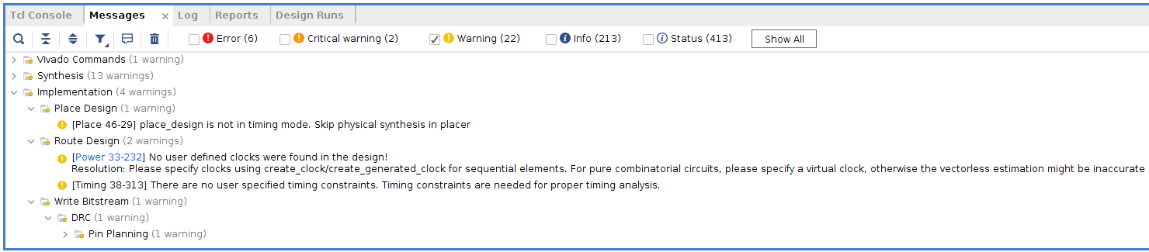

**Warning Discussion**: For the implementation log, we have 22 warnings. The warnings are about the lack of timing mode, user defined clock as well as timing constraints. Due to that, our system may not behave as expected in terms of timing and performance which may result in many issues when we generate the Bitstream.

*** Running vivado  
 **with** args -log alu_board.vdi -applog -m64 -product Vivado -messageDb vivado.pb -mode batch -source alu_board.tcl -notrace  
  
  
****** Vivado v2018.2 (64-bit)  
 **** SW Build 2258646 on Thu Jun 14 20:02:38 MDT 2018  
 **** IP Build 2256618 on Thu Jun 14 22:10:49 MDT 2018  
 ** Copyright 1986-2018 Xilinx, Inc. All Rights Reserved.  
  
source alu_board.tcl -notrace  
Command: link_design -top alu_board -part xc7a100tcsg324-1  
Design is defaulting to srcset: sources_1  
Design is defaulting to constrset: constrs_1  
INFO: [Netlist 29-17] Analyzing 13 Unisim elements for replacement  
INFO: [Netlist 29-28] Unisim Transformation completed **in** 0 CPU seconds  
INFO: [Project 1-479] Netlist was created **with** Vivado 2018.2  
INFO: [Device 21-403] Loading part xc7a100tcsg324-1  
INFO: [Project 1-570] Preparing netlist for logic optimization  
Parsing XDC File [/nfs/home/l/l_heiwan/coen316/lab1/lab1_constraints.xdc]  
CRITICAL WARNING: [Common 17-69] Command failed: 'H18' is not a valid site or package pin name. [/nfs/home/l/l_heiwan/coen316/lab1/lab1_constraints.xdc:21]  
Finished Parsing XDC File [/nfs/home/l/l_heiwan/coen316/lab1/lab1_constraints.xdc]  
INFO: [Opt 31-138] Pushed 0 inverter(s) to 0 load pin(s).  
INFO: [Project 1-111] Unisim Transformation Summary:  
No Unisim elements were transformed.  
  
7 Infos, 0 Warnings, 1 Critical Warnings and 0 Errors encountered.  
link_design completed successfully  
link_design: Time (s): cpu = 00:00:11 ; elapsed = 00:00:58 . Memory (MB): peak = 1702.559 ; gain = 328.414 ; free physical = 81127 ; free virtual = 154417  
Command: opt_design  
Attempting to get a license for feature 'Implementation' and/or device 'xc7a100t'  
INFO: [Common 17-349] Got license for feature 'Implementation' and/or device 'xc7a100t'  
Running DRC as a precondition to command opt_design  
  
Starting DRC Task  
INFO: [DRC 23-27] Running DRC **with** 8 threads  
INFO: [Project 1-461] DRC finished **with** 0 Errors  
INFO: [Project 1-462] Please refer to the DRC report (report_drc) for more information.  
  
Time (s): cpu = 00:00:01 ; elapsed = 00:00:04 . Memory (MB): peak = 1777.586 ; gain = 75.027 ; free physical = 81124 ; free virtual = 154414  
  
Starting Cache Timing Information Task  
INFO: [Timing 38-35] Done setting XDC timing constraints.  
Ending Cache Timing Information Task | Checksum: 1ba47c1aa  
  
Time (s): cpu = 00:00:15 ; elapsed = 00:01:10 . Memory (MB): peak = 2219.082 ; gain = 441.496 ; free physical = 80705 ; free virtual = 153995  
  
Starting Logic Optimization Task  
  
Phase 1 Retarget  
INFO: [Opt 31-138] Pushed 0 inverter(s) to 0 load pin(s).  
INFO: [Opt 31-49] Retargeted 0 cell(s).  
Phase 1 Retarget | Checksum: 1ba47c1aa  
  
Time (s): cpu = 00:00:00.01 ; elapsed = 00:00:00.02 . Memory (MB): peak = 2219.082 ; gain = 0.000 ; free physical = 80730 ; free virtual = 154020  
INFO: [Opt 31-389] Phase Retarget created 0 cells and removed 0 cells  
  
Phase 2 Constant propagation  
INFO: [Opt 31-138] Pushed 0 inverter(s) to 0 load pin(s).  
Phase 2 Constant propagation | Checksum: 1ba47c1aa  
  
Time (s): cpu = 00:00:00.01 ; elapsed = 00:00:00.02 . Memory (MB): peak = 2219.082 ; gain = 0.000 ; free physical = 80730 ; free virtual = 154020  
INFO: [Opt 31-389] Phase Constant propagation created 0 cells and removed 0 cells  
  
Phase 3 Sweep  
Phase 3 Sweep | Checksum: 1ba47c1aa  
  
Time (s): cpu = 00:00:00.01 ; elapsed = 00:00:00.03 . Memory (MB): peak = 2219.082 ; gain = 0.000 ; free physical = 80730 ; free virtual = 154020  
INFO: [Opt 31-389] Phase Sweep created 0 cells and removed 0 cells  
  
Phase 4 BUFG optimization  
Phase 4 BUFG optimization | Checksum: 1ba47c1aa  
  
Time (s): cpu = 00:00:00.02 ; elapsed = 00:00:00.03 . Memory (MB): peak = 2219.082 ; gain = 0.000 ; free physical = 80730 ; free virtual = 154020  
INFO: [Opt 31-662] Phase BUFG optimization created 0 cells of which 0 are BUFGs and removed 0 cells.  
  
Phase 5 Shift Register Optimization  
Phase 5 Shift Register Optimization | Checksum: 1ba47c1aa  
  
Time (s): cpu = 00:00:00.02 ; elapsed = 00:00:00.03 . Memory (MB): peak = 2219.082 ; gain = 0.000 ; free physical = 80730 ; free virtual = 154020  
INFO: [Opt 31-389] Phase Shift Register Optimization created 0 cells and removed 0 cells  
  
Phase 6 Post Processing Netlist  
Phase 6 Post Processing Netlist | Checksum: 1ba47c1aa  
  
Time (s): cpu = 00:00:00.02 ; elapsed = 00:00:00.03 . Memory (MB): peak = 2219.082 ; gain = 0.000 ; free physical = 80730 ; free virtual = 154020  
INFO: [Opt 31-389] Phase Post Processing Netlist created 0 cells and removed 0 cells  
  
Starting Connectivity Check Task  
  
Time (s): cpu = 00:00:00 ; elapsed = 00:00:00 . Memory (MB): peak = 2219.082 ; gain = 0.000 ; free physical = 80730 ; free virtual = 154020  
Ending Logic Optimization Task | Checksum: 1ba47c1aa  
  
Time (s): cpu = 00:00:00.02 ; elapsed = 00:00:00.03 . Memory (MB): peak = 2219.082 ; gain = 0.000 ; free physical = 80730 ; free virtual = 154020  
  
Starting Power Optimization Task  
INFO: [Pwropt 34-132] Skipping clock gating for clocks **with** a period < 2.00 ns.  
Ending Power Optimization Task | Checksum: 1ba47c1aa  
  
Time (s): cpu = 00:00:00.01 ; elapsed = 00:00:00.05 . Memory (MB): peak = 2219.086 ; gain = 0.004 ; free physical = 80730 ; free virtual = 154020  
  
Starting Final Cleanup Task  
Ending Final Cleanup Task | Checksum: 1ba47c1aa  
  
Time (s): cpu = 00:00:00 ; elapsed = 00:00:00 . Memory (MB): peak = 2219.086 ; gain = 0.000 ; free physical = 80730 ; free virtual = 154020  
INFO: [Common 17-83] Releasing license: Implementation  
23 Infos, 0 Warnings, 1 Critical Warnings and 0 Errors encountered.  
opt_design completed successfully  
opt_design: Time (s): cpu = 00:00:17 ; elapsed = 00:01:14 . Memory (MB): peak = 2219.086 ; gain = 516.527 ; free physical = 80730 ; free virtual = 154020  
INFO: [Timing 38-480] Writing timing data to binary archive.  
Writing placer database...  
Writing XDEF routing.  
Writing XDEF routing logical nets.  
Writing XDEF routing special nets.  
Write XDEF Complete: Time (s): cpu = 00:00:00.03 ; elapsed = 00:00:00.02 . Memory (MB): peak = 2251.102 ; gain = 0.004 ; free physical = 80727 ; free virtual = 154018  
INFO: [Common 17-1381] The checkpoint '/nfs/home/l/l_heiwan/coen316/lab1/vivado_test_v2/vivado_leb1_v2/vivado_leb1_v2.runs/impl_1/alu_board_opt.dcp' has been generated.  
INFO: [runtcl-4] Executing : report_drc -file alu_board_drc_opted.rpt -pb alu_board_drc_opted.pb -rpx alu_board_drc_opted.rpx  
Command: report_drc -file alu_board_drc_opted.rpt -pb alu_board_drc_opted.pb -rpx alu_board_drc_opted.rpx  
INFO: [IP_Flow 19-234] Refreshing IP repositories  
INFO: [IP_Flow 19-1704] No user IP repositories specified  
INFO: [IP_Flow 19-2313] Loaded Vivado IP repository '/CMC/tools/xilinx/Vivado_2018.2/Vivado/2018.2/data/ip'.  
INFO: [DRC 23-27] Running DRC **with** 8 threads  
INFO: [Coretcl 2-168] The results of DRC are **in** file /nfs/home/l/l_heiwan/coen316/lab1/vivado_test_v2/vivado_leb1_v2/vivado_leb1_v2.runs/impl_1/alu_board_drc_opted.rpt.  
report_drc completed successfully  
report_drc: Time (s): cpu = 00:00:04 ; elapsed = 00:00:07 . Memory (MB): peak = 2323.137 ; gain = 72.027 ; free physical = 80699 ; free virtual = 153990  
Command: place_design  
Attempting to get a license for feature 'Implementation' and/or device 'xc7a100t'  
INFO: [Common 17-349] Got license for feature 'Implementation' and/or device 'xc7a100t'  
INFO: [DRC 23-27] Running DRC **with** 8 threads  
INFO: [Vivado_Tcl 4-198] DRC finished **with** 0 Errors  
INFO: [Vivado_Tcl 4-199] Please refer to the DRC report (report_drc) for more information.  
Running DRC as a precondition to command place_design  
INFO: [DRC 23-27] Running DRC **with** 8 threads  
INFO: [Vivado_Tcl 4-198] DRC finished **with** 0 Errors  
INFO: [Vivado_Tcl 4-199] Please refer to the DRC report (report_drc) for more information.  
  
Starting Placer Task  
INFO: [Place 30-611] Multithreading enabled for place_design using a maximum of 8 CPUs  
  
Phase 1 Placer Initialization  
  
Phase 1.1 Placer Initialization Netlist Sorting  
Netlist sorting complete. Time (s): cpu = 00:00:00 ; elapsed = 00:00:00 . Memory (MB): peak = 2323.137 ; gain = 0.000 ; free physical = 80694 ; free virtual = 153984  
Phase 1.1 Placer Initialization Netlist Sorting | Checksum: 11f970856  
  
Time (s): cpu = 00:00:00.01 ; elapsed = 00:00:00.03 . Memory (MB): peak = 2323.137 ; gain = 0.000 ; free physical = 80694 ; free virtual = 153984  
Netlist sorting complete. Time (s): cpu = 00:00:00 ; elapsed = 00:00:00 . Memory (MB): peak = 2323.137 ; gain = 0.000 ; free physical = 80694 ; free virtual = 153984  
  
Phase 1.2 IO Placement/ Clock Placement/ Build Placer Device  
INFO: [Timing 38-35] Done setting XDC timing constraints.  
Phase 1.2 IO Placement/ Clock Placement/ Build Placer Device | Checksum: ef51f4b0  
  
Time (s): cpu = 00:00:00.62 ; elapsed = 00:00:00.55 . Memory (MB): peak = 2323.137 ; gain = 0.000 ; free physical = 80688 ; free virtual = 153980  
  
Phase 1.3 Build Placer Netlist Model  
Phase 1.3 Build Placer Netlist Model | Checksum: 139371e35  
  
Time (s): cpu = 00:00:00.66 ; elapsed = 00:00:00.58 . Memory (MB): peak = 2323.137 ; gain = 0.000 ; free physical = 80688 ; free virtual = 153980  
  
Phase 1.4 Constrain Clocks/Macros  
Phase 1.4 Constrain Clocks/Macros | Checksum: 139371e35  
  
Time (s): cpu = 00:00:00.67 ; elapsed = 00:00:00.58 . Memory (MB): peak = 2323.137 ; gain = 0.000 ; free physical = 80688 ; free virtual = 153980  
Phase 1 Placer Initialization | Checksum: 139371e35  
  
Time (s): cpu = 00:00:00.67 ; elapsed = 00:00:00.58 . Memory (MB): peak = 2323.137 ; gain = 0.000 ; free physical = 80688 ; free virtual = 153980  
  
Phase 2 Global Placement  
  
Phase 2.1 Floorplanning  
Phase 2.1 Floorplanning | Checksum: 139371e35  
  
Time (s): cpu = 00:00:00.70 ; elapsed = 00:00:00.61 . Memory (MB): peak = 2323.137 ; gain = 0.000 ; free physical = 80686 ; free virtual = 153978  
WARNING: [Place 46-29] place_design is not **in** timing mode. Skip physical synthesis **in** placer  
Phase 2 Global Placement | Checksum: 13ef44abb  
  
Time (s): cpu = 00:00:03 ; elapsed = 00:00:01 . Memory (MB): peak = 2402.160 ; gain = 79.023 ; free physical = 80655 ; free virtual = 153946  
  
Phase 3 Detail Placement  
  
Phase 3.1 Commit Multi Column Macros  
Phase 3.1 Commit Multi Column Macros | Checksum: 13ef44abb  
  
Time (s): cpu = 00:00:03 ; elapsed = 00:00:01 . Memory (MB): peak = 2402.160 ; gain = 79.023 ; free physical = 80655 ; free virtual = 153946  
  
Phase 3.2 Commit Most Macros & LUTRAMs  
Phase 3.2 Commit Most Macros & LUTRAMs | Checksum: 1782f7d91  
  
Time (s): cpu = 00:00:03 ; elapsed = 00:00:01 . Memory (MB): peak = 2402.160 ; gain = 79.023 ; free physical = 80654 ; free virtual = 153946  
  
Phase 3.3 Area Swap Optimization  
Phase 3.3 Area Swap Optimization | Checksum: 15db6ed33  
  
Time (s): cpu = 00:00:03 ; elapsed = 00:00:01 . Memory (MB): peak = 2402.160 ; gain = 79.023 ; free physical = 80654 ; free virtual = 153945  
  
Phase 3.4 Pipeline Register Optimization  
Phase 3.4 Pipeline Register Optimization | Checksum: 15db6ed33  
  
Time (s): cpu = 00:00:03 ; elapsed = 00:00:01 . Memory (MB): peak = 2402.160 ; gain = 79.023 ; free physical = 80654 ; free virtual = 153945  
  
Phase 3.5 Small Shape Detail Placement  
Phase 3.5 Small Shape Detail Placement | Checksum: 26336c14f  
  
Time (s): cpu = 00:00:03 ; elapsed = 00:00:01 . Memory (MB): peak = 2402.160 ; gain = 79.023 ; free physical = 80650 ; free virtual = 153942  
  
Phase 3.6 Re-assign LUT pins  
Phase 3.6 Re-assign LUT pins | Checksum: 26336c14f  
  
Time (s): cpu = 00:00:03 ; elapsed = 00:00:01 . Memory (MB): peak = 2402.160 ; gain = 79.023 ; free physical = 80650 ; free virtual = 153942  
  
Phase 3.7 Pipeline Register Optimization  
Phase 3.7 Pipeline Register Optimization | Checksum: 26336c14f  
  
Time (s): cpu = 00:00:03 ; elapsed = 00:00:01 . Memory (MB): peak = 2402.160 ; gain = 79.023 ; free physical = 80650 ; free virtual = 153942  
Phase 3 Detail Placement | Checksum: 26336c14f  
  
Time (s): cpu = 00:00:03 ; elapsed = 00:00:01 . Memory (MB): peak = 2402.160 ; gain = 79.023 ; free physical = 80650 ; free virtual = 153942  
  
Phase 4 Post Placement Optimization and Clean-Up  
  
Phase 4.1 Post Commit Optimization  
Phase 4.1 Post Commit Optimization | Checksum: 26336c14f  
  
Time (s): cpu = 00:00:03 ; elapsed = 00:00:01 . Memory (MB): peak = 2402.160 ; gain = 79.023 ; free physical = 80650 ; free virtual = 153942  
  
Phase 4.2 Post Placement Cleanup  
Phase 4.2 Post Placement Cleanup | Checksum: 26336c14f  
  
Time (s): cpu = 00:00:03 ; elapsed = 00:00:01 . Memory (MB): peak = 2402.160 ; gain = 79.023 ; free physical = 80652 ; free virtual = 153944  
  
Phase 4.3 Placer Reporting  
Phase 4.3 Placer Reporting | Checksum: 26336c14f  
  
Time (s): cpu = 00:00:03 ; elapsed = 00:00:01 . Memory (MB): peak = 2402.160 ; gain = 79.023 ; free physical = 80652 ; free virtual = 153944  
  
Phase 4.4 Final Placement Cleanup  
Phase 4.4 Final Placement Cleanup | Checksum: 26336c14f  
  
Time (s): cpu = 00:00:03 ; elapsed = 00:00:01 . Memory (MB): peak = 2402.160 ; gain = 79.023 ; free physical = 80652 ; free virtual = 153944  
Phase 4 Post Placement Optimization and Clean-Up | Checksum: 26336c14f  
  
Time (s): cpu = 00:00:03 ; elapsed = 00:00:01 . Memory (MB): peak = 2402.160 ; gain = 79.023 ; free physical = 80652 ; free virtual = 153944  
Ending Placer Task | Checksum: 164242381  
  
Time (s): cpu = 00:00:03 ; elapsed = 00:00:01 . Memory (MB): peak = 2402.160 ; gain = 79.023 ; free physical = 80670 ; free virtual = 153962  
INFO: [Common 17-83] Releasing license: Implementation  
41 Infos, 1 Warnings, 1 Critical Warnings and 0 Errors encountered.  
place_design completed successfully  
place_design: Time (s): cpu = 00:00:05 ; elapsed = 00:00:05 . Memory (MB): peak = 2402.160 ; gain = 79.023 ; free physical = 80670 ; free virtual = 153962  
INFO: [Timing 38-480] Writing timing data to binary archive.  
Writing placer database...  
Writing XDEF routing.  
Writing XDEF routing logical nets.  
Writing XDEF routing special nets.  
Write XDEF Complete: Time (s): cpu = 00:00:00.03 ; elapsed = 00:00:00.02 . Memory (MB): peak = 2402.160 ; gain = 0.000 ; free physical = 80670 ; free virtual = 153963  
INFO: [Common 17-1381] The checkpoint '/nfs/home/l/l_heiwan/coen316/lab1/vivado_test_v2/vivado_leb1_v2/vivado_leb1_v2.runs/impl_1/alu_board_placed.dcp' has been generated.  
INFO: [runtcl-4] Executing : report_io -file alu_board_io_placed.rpt  
report_io: Time (s): cpu = 00:00:00.08 ; elapsed = 00:00:00.17 . Memory (MB): peak = 2402.160 ; gain = 0.000 ; free physical = 80671 ; free virtual = 153963  
INFO: [runtcl-4] Executing : report_utilization -file alu_board_utilization_placed.rpt -pb alu_board_utilization_placed.pb  
report_utilization: Time (s): cpu = 00:00:00.05 ; elapsed = 00:00:00.13 . Memory (MB): peak = 2402.160 ; gain = 0.000 ; free physical = 80675 ; free virtual = 153966  
INFO: [runtcl-4] Executing : report_control_sets -verbose -file alu_board_control_sets_placed.rpt  
report_control_sets: Time (s): cpu = 00:00:00.03 ; elapsed = 00:00:00.10 . Memory (MB): peak = 2402.160 ; gain = 0.000 ; free physical = 80677 ; free virtual = 153969  
Command: route_design  
Attempting to get a license for feature 'Implementation' and/or device 'xc7a100t'  
INFO: [Common 17-349] Got license for feature 'Implementation' and/or device 'xc7a100t'  
Running DRC as a precondition to command route_design  
INFO: [DRC 23-27] Running DRC **with** 8 threads  
INFO: [Vivado_Tcl 4-198] DRC finished **with** 0 Errors  
INFO: [Vivado_Tcl 4-199] Please refer to the DRC report (report_drc) for more information.  
  
  
Starting Routing Task  
INFO: [Route 35-254] Multithreading enabled for route_design using a maximum of 8 CPUs  
Checksum: PlaceDB: a1bd30de ConstDB: 0 ShapeSum: c266f2a3 RouteDB: 0  
  
Phase 1 Build RT Design  
Phase 1 Build RT Design | Checksum: 9cb15b26  
  
Time (s): cpu = 00:00:24 ; elapsed = 00:00:20 . Memory (MB): peak = 2442.766 ; gain = 40.605 ; free physical = 80536 ; free virtual = 153829  
Post Restoration Checksum: NetGraph: 72390a4d NumContArr: 2a7850d9 Constraints: 0 Timing: 0  
  
Phase 2 Router Initialization  
INFO: [Route 35-64] No timing constraints were detected. The router will operate **in** resource-optimization mode.  
  
Phase 2.1 Fix Topology Constraints  
Phase 2.1 Fix Topology Constraints | Checksum: 9cb15b26  
  
Time (s): cpu = 00:00:25 ; elapsed = 00:00:20 . Memory (MB): peak = 2448.754 ; gain = 46.594 ; free physical = 80504 ; free virtual = 153797  
  
Phase 2.2 Pre Route Cleanup  
Phase 2.2 Pre Route Cleanup | Checksum: 9cb15b26  
  
Time (s): cpu = 00:00:25 ; elapsed = 00:00:20 . Memory (MB): peak = 2448.754 ; gain = 46.594 ; free physical = 80504 ; free virtual = 153797  
 Number of Nodes **with** overlaps = 0  
Phase 2 Router Initialization | Checksum: e9bf0ed7  
  
Time (s): cpu = 00:00:25 ; elapsed = 00:00:20 . Memory (MB): peak = 2456.020 ; gain = 53.859 ; free physical = 80502 ; free virtual = 153794  
  
Phase 3 Initial Routing  
Phase 3 Initial Routing | Checksum: 1ae1173b4  
  
Time (s): cpu = 00:00:25 ; elapsed = 00:00:21 . Memory (MB): peak = 2456.020 ; gain = 53.859 ; free physical = 80500 ; free virtual = 153792  
  
Phase 4 Rip-up And Reroute  
  
Phase 4.1 Global Iteration 0  
 Number of Nodes **with** overlaps = 1  
 Number of Nodes **with** overlaps = 0  
Phase 4.1 Global Iteration 0 | Checksum: e1852293  
  
Time (s): cpu = 00:00:25 ; elapsed = 00:00:21 . Memory (MB): peak = 2456.020 ; gain = 53.859 ; free physical = 80500 ; free virtual = 153792  
Phase 4 Rip-up And Reroute | Checksum: e1852293  
  
Time (s): cpu = 00:00:25 ; elapsed = 00:00:21 . Memory (MB): peak = 2456.020 ; gain = 53.859 ; free physical = 80500 ; free virtual = 153792  
  
Phase 5 Delay and Skew Optimization  
Phase 5 Delay and Skew Optimization | Checksum: e1852293  
  
Time (s): cpu = 00:00:25 ; elapsed = 00:00:21 . Memory (MB): peak = 2456.020 ; gain = 53.859 ; free physical = 80500 ; free virtual = 153792  
  
Phase 6 Post Hold Fix  
  
Phase 6.1 Hold Fix Iter  
Phase 6.1 Hold Fix Iter | Checksum: e1852293  
  
Time (s): cpu = 00:00:25 ; elapsed = 00:00:21 . Memory (MB): peak = 2456.020 ; gain = 53.859 ; free physical = 80500 ; free virtual = 153792  
Phase 6 Post Hold Fix | Checksum: e1852293  
  
Time (s): cpu = 00:00:25 ; elapsed = 00:00:21 . Memory (MB): peak = 2456.020 ; gain = 53.859 ; free physical = 80500 ; free virtual = 153792  
  
Phase 7 Route finalize  
  
Router Utilization Summary  
 Global Vertical Routing Utilization = 0.0322932 %  
 Global Horizontal Routing Utilization = 0.004973 %  
 Routable Net Status*  
 *Does not include unroutable nets such as driverless and loadless.  
 Run report_route_status for detailed report.  
 Number of Failed Nets = 0  
 Number of Unrouted Nets = 0  
 Number of Partially Routed Nets = 0  
 Number of Node Overlaps = 0  
  
Congestion Report  
North Dir 1x1 Area, Max Cong = 21.6216%, No Congested Regions.  
South Dir 1x1 Area, Max Cong = 16.2162%, No Congested Regions.  
East Dir 1x1 Area, Max Cong = 5.88235%, No Congested Regions.  
West Dir 1x1 Area, Max Cong = 5.88235%, No Congested Regions.  
  
------------------------------  
Reporting congestion hotspots  
------------------------------  
Direction: North  
----------------  
Congested clusters found at Level 0  
Effective congestion level: 0 Aspect Ratio: 1 Sparse Ratio: 0  
Direction: South  
----------------  
Congested clusters found at Level 0  
Effective congestion level: 0 Aspect Ratio: 1 Sparse Ratio: 0  
Direction: East  
----------------  
Congested clusters found at Level 0  
Effective congestion level: 0 Aspect Ratio: 1 Sparse Ratio: 0  
Direction: West  
----------------  
Congested clusters found at Level 0  
Effective congestion level: 0 Aspect Ratio: 1 Sparse Ratio: 0  
  
Phase 7 Route finalize | Checksum: e1852293  
  
Time (s): cpu = 00:00:25 ; elapsed = 00:00:21 . Memory (MB): peak = 2456.020 ; gain = 53.859 ; free physical = 80499 ; free virtual = 153791  
  
Phase 8 Verifying routed nets  
  
 Verification completed successfully  
Phase 8 Verifying routed nets | Checksum: e1852293  
  
Time (s): cpu = 00:00:25 ; elapsed = 00:00:21 . Memory (MB): peak = 2458.020 ; gain = 55.859 ; free physical = 80498 ; free virtual = 153790  
  
Phase 9 Depositing Routes  
Phase 9 Depositing Routes | Checksum: 110efca31  
  
Time (s): cpu = 00:00:25 ; elapsed = 00:00:21 . Memory (MB): peak = 2458.020 ; gain = 55.859 ; free physical = 80499 ; free virtual = 153791  
INFO: [Route 35-16] Router Completed Successfully  
  
Time (s): cpu = 00:00:25 ; elapsed = 00:00:21 . Memory (MB): peak = 2458.020 ; gain = 55.859 ; free physical = 80532 ; free virtual = 153824  
  
Routing Is Done.  
INFO: [Common 17-83] Releasing license: Implementation  
54 Infos, 1 Warnings, 1 Critical Warnings and 0 Errors encountered.  
route_design completed successfully  
route_design: Time (s): cpu = 00:00:27 ; elapsed = 00:00:25 . Memory (MB): peak = 2458.020 ; gain = 55.859 ; free physical = 80532 ; free virtual = 153824  
INFO: [Timing 38-480] Writing timing data to binary archive.  
Writing placer database...  
Writing XDEF routing.  
Writing XDEF routing logical nets.  
Writing XDEF routing special nets.  
Write XDEF Complete: Time (s): cpu = 00:00:00.04 ; elapsed = 00:00:00.03 . Memory (MB): peak = 2458.020 ; gain = 0.000 ; free physical = 80531 ; free virtual = 153824  
INFO: [Common 17-1381] The checkpoint '/nfs/home/l/l_heiwan/coen316/lab1/vivado_test_v2/vivado_leb1_v2/vivado_leb1_v2.runs/impl_1/alu_board_routed.dcp' has been generated.  
INFO: [runtcl-4] Executing : report_drc -file alu_board_drc_routed.rpt -pb alu_board_drc_routed.pb -rpx alu_board_drc_routed.rpx  
Command: report_drc -file alu_board_drc_routed.rpt -pb alu_board_drc_routed.pb -rpx alu_board_drc_routed.rpx  
INFO: [DRC 23-27] Running DRC **with** 8 threads  
INFO: [Coretcl 2-168] The results of DRC are **in** file /nfs/home/l/l_heiwan/coen316/lab1/vivado_test_v2/vivado_leb1_v2/vivado_leb1_v2.runs/impl_1/alu_board_drc_routed.rpt.  
report_drc completed successfully  
INFO: [runtcl-4] Executing : report_methodology -file alu_board_methodology_drc_routed.rpt -pb alu_board_methodology_drc_routed.pb -rpx alu_board_methodology_drc_routed.rpx  
Command: report_methodology -file alu_board_methodology_drc_routed.rpt -pb alu_board_methodology_drc_routed.pb -rpx alu_board_methodology_drc_routed.rpx  
INFO: [Timing 38-35] Done setting XDC timing constraints.  
INFO: [Timing 38-35] Done setting XDC timing constraints.  
INFO: [DRC 23-133] Running Methodology **with** 8 threads  
INFO: [Coretcl 2-1520] The results of Report Methodology are **in** file /nfs/home/l/l_heiwan/coen316/lab1/vivado_test_v2/vivado_leb1_v2/vivado_leb1_v2.runs/impl_1/alu_board_methodology_drc_routed.rpt.  
report_methodology completed successfully  
INFO: [runtcl-4] Executing : report_power -file alu_board_power_routed.rpt -pb alu_board_power_summary_routed.pb -rpx alu_board_power_routed.rpx  
Command: report_power -file alu_board_power_routed.rpt -pb alu_board_power_summary_routed.pb -rpx alu_board_power_routed.rpx  
WARNING: [Power 33-232] No user defined clocks were found **in** the design!  
Resolution: Please specify clocks using create_clock/create_generated_clock for sequential elements. For pure combinatorial circuits, please specify a virtual clock, otherwise the vectorless estimation might be inaccurate  
INFO: [Timing 38-35] Done setting XDC timing constraints.  
Running Vector-less Activity Propagation...  
  
Finished Running Vector-less Activity Propagation  
66 Infos, 2 Warnings, 1 Critical Warnings and 0 Errors encountered.  
report_power failed  
INFO: [runtcl-4] Executing : report_route_status -file alu_board_route_status.rpt -pb alu_board_route_status.pb  
INFO: [runtcl-4] Executing : report_timing_summary -max_paths 10 -file alu_board_timing_summary_routed.rpt -pb alu_board_timing_summary_routed.pb -rpx alu_board_timing_summary_routed.rpx -warn_on_violation   
INFO: [Timing 38-91] UpdateTimingParams: Speed grade: -1, Delay Type: min_max, Timing Stage: Requireds.  
INFO: [Timing 38-191] Multithreading enabled for timing update using a maximum of 8 CPUs  
WARNING: [Timing 38-313] There are no user specified timing constraints. Timing constraints are needed for proper timing analysis.  
INFO: [runtcl-4] Executing : report_incremental_reuse -file alu_board_incremental_reuse_routed.rpt  
INFO: [Vivado_Tcl 4-545] No incremental reuse to report, no incremental placement and routing data was found.  
INFO: [runtcl-4] Executing : report_clock_utilization -file alu_board_clock_utilization_routed.rpt  
INFO: [runtcl-4] Executing : report_bus_skew -warn_on_violation -file alu_board_bus_skew_routed.rpt -pb alu_board_bus_skew_routed.pb -rpx alu_board_bus_skew_routed.rpx  
INFO: [Timing 38-91] UpdateTimingParams: Speed grade: -1, Delay Type: min_max, Timing Stage: Requireds.  
INFO: [Timing 38-191] Multithreading enabled for timing update using a maximum of 8 CPUs  
INFO: [Common 17-206] Exiting Vivado at Wed Oct 4 18:02:15 2023...  
  
*** Running vivado  
 **with** args -log alu_board.vdi -applog -m64 -product Vivado -messageDb vivado.pb -mode batch -source alu_board.tcl -notrace  
  
  
****** Vivado v2018.2 (64-bit)  
 **** SW Build 2258646 on Thu Jun 14 20:02:38 MDT 2018  
 **** IP Build 2256618 on Thu Jun 14 22:10:49 MDT 2018  
 ** Copyright 1986-2018 Xilinx, Inc. All Rights Reserved.  
  
source alu_board.tcl -notrace  
Command: open_checkpoint alu_board_routed.dcp  
  
Starting open_checkpoint Task  
  
Time (s): cpu = 00:00:00.07 ; elapsed = 00:00:00.23 . Memory (MB): peak = 1343.129 ; gain = 0.000 ; free physical = 81447 ; free virtual = 154741  
INFO: [Netlist 29-17] Analyzing 13 Unisim elements for replacement  
INFO: [Netlist 29-28] Unisim Transformation completed **in** 0 CPU seconds  
INFO: [Project 1-479] Netlist was created **with** Vivado 2018.2  
INFO: [Device 21-403] Loading part xc7a100tcsg324-1  
INFO: [Project 1-570] Preparing netlist for logic optimization  
INFO: [Timing 38-478] Restoring timing data from binary archive.  
INFO: [Timing 38-479] Binary timing data restore complete.  
INFO: [Project 1-856] Restoring constraints from binary archive.  
INFO: [Project 1-853] Binary constraint restore complete.  
Reading XDEF placement.  
Reading placer database...  
Reading XDEF routing.  
Read XDEF File: Time (s): cpu = 00:00:00.13 ; elapsed = 00:00:00.39 . Memory (MB): peak = 2128.250 ; gain = 0.004 ; free physical = 80718 ; free virtual = 154012  
Restored from archive | CPU: 0.390000 secs | Memory: 0.965797 MB |  
Finished XDEF File Restore: Time (s): cpu = 00:00:00.13 ; elapsed = 00:00:00.40 . Memory (MB): peak = 2128.250 ; gain = 0.004 ; free physical = 80718 ; free virtual = 154012  
INFO: [Project 1-111] Unisim Transformation Summary:  
No Unisim elements were transformed.  
  
INFO: [Project 1-604] Checkpoint was created **with** Vivado v2018.2 (64-bit) build 2258646  
open_checkpoint: Time (s): cpu = 00:00:26 ; elapsed = 00:02:07 . Memory (MB): peak = 2128.250 ; gain = 785.125 ; free physical = 80718 ; free virtual = 154012  
Command: write_bitstream -force alu_board.bit  
Attempting to get a license for feature 'Implementation' and/or device 'xc7a100t'  
INFO: [Common 17-349] Got license for feature 'Implementation' and/or device 'xc7a100t'  
Running DRC as a precondition to command write_bitstream  
INFO: [IP_Flow 19-234] Refreshing IP repositories  
INFO: [IP_Flow 19-1704] No user IP repositories specified  
INFO: [IP_Flow 19-2313] Loaded Vivado IP repository '/CMC/tools/xilinx/Vivado_2018.2/Vivado/2018.2/data/ip'.  
INFO: [DRC 23-27] Running DRC **with** 8 threads  
ERROR: [DRC NSTD-1] Unspecified I/O Standard: 5 out of 19 logical ports use I/O standard (IOSTANDARD) value 'DEFAULT', instead of a user assigned specific value. This may cause I/O contention or incompatibility **with** the board power or connectivity affecting performance, signal integrity or **in** extreme cases cause damage to the device or the components to which it is connected. To correct this violation, specify all I/O standards. This design will fail to generate a bitstream unless all logical ports have a user specified I/O standard value defined. To allow bitstream creation **with** unspecified I/O standard values (not recommended), use this command: set_property SEVERITY {Warning} [get_drc_checks NSTD-1]. NOTE: When using the Vivado Runs infrastructure (e.g. launch_runs Tcl command), add this command to a .tcl file and add that file as a pre-hook for write_bitstream step for the implementation run. Problem ports: y_in[3:0], and zero.  
ERROR: [DRC UCIO-1] Unconstrained Logical Port: 5 out of 19 logical ports have no user assigned specific location constraint (LOC). This may cause I/O contention or incompatibility **with** the board power or connectivity affecting performance, signal integrity or **in** extreme cases cause damage to the device or the components to which it is connected. To correct this violation, specify all pin locations. This design will fail to generate a bitstream unless all logical ports have a user specified site LOC constraint defined. To allow bitstream creation **with** unspecified pin locations (not recommended), use this command: set_property SEVERITY {Warning} [get_drc_checks UCIO-1]. NOTE: When using the Vivado Runs infrastructure (e.g. launch_runs Tcl command), add this command to a .tcl file and add that file as a pre-hook for write_bitstream step for the implementation run. Problem ports: y_in[3:0], and zero.  
WARNING: [DRC CFGBVS-1] Missing CFGBVS and CONFIG_VOLTAGE Design Properties: Neither the CFGBVS nor CONFIG_VOLTAGE voltage property is set **in** the current_design. Configuration bank voltage select (CFGBVS) must be set to VCCO or GND, and CONFIG_VOLTAGE must be set to the correct configuration voltage, **in** order to determine the I/O voltage support for the pins **in** bank 0. It is suggested to specify these either using the 'Edit Device Properties' function **in** the GUI or directly **in** the XDC file using the following syntax:  
  
 set_property CFGBVS value1 [current_design]  
 #where value1 is either VCCO or GND  
  
 set_property CONFIG_VOLTAGE value2 [current_design]  
 #where value2 is the voltage provided to configuration bank 0  
  
Refer to the device configuration user guide for more information.  
INFO: [Vivado 12-3199] DRC finished **with** 2 Errors, 1 Warnings  
INFO: [Vivado 12-3200] Please refer to the DRC report (report_drc) for more information.  
ERROR: [Vivado 12-1345] Error(s) found during DRC. Bitgen not run.  
INFO: [Common 17-83] Releasing license: Implementation  
19 Infos, 1 Warnings, 0 Critical Warnings and 3 Errors encountered.  
write_bitstream failed  
write_bitstream: Time (s): cpu = 00:00:04 ; elapsed = 00:00:08 . Memory (MB): peak = 2328.301 ; gain = 200.051 ; free physical = 80674 ; free virtual = 153968  
ERROR: [Common 17-39] 'write_bitstream' failed due to earlier errors.  
  
INFO: [Common 17-206] Exiting Vivado at Wed Oct 4 18:04:58 2023...

**5.5) Constrain .xdc File**

# Vivado does not support old UCF syntax  
# must use XDC syntax  
set_property -**dict** { PACKAGE_PIN **J15** IOSTANDARD LVCMOS33 } [ get_ports { **add_sub** }];  
set_property -**dict** { PACKAGE_PIN L16 IOSTANDARD LVCMOS33 } [ get_ports { x_in[0] } ] ;  
set_property -**dict** { PACKAGE_PIN M13 IOSTANDARD LVCMOS33 } [ get_ports { x_in[1] } ] ;  
set_property -**dict** { PACKAGE_PIN K15 IOSTANDARD LVCMOS33 } [ get_ports { x_in[2] } ] ;  
set_property -**dict** { PACKAGE_PIN H17 IOSTANDARD LVCMOS33 } [ get_ports { x_in[3] } ] ;  
  
set_property -**dict** { PACKAGE_PIN **J14** IOSTANDARD LVCMOS33 } [ get_ports { logic_func[0] }];  
set_property -**dict** { PACKAGE_PIN T9 IOSTANDARD LVCMOS33 } [ get_ports { logic_func[1] } ] ;  
  
set_property -**dict** { PACKAGE_PIN R18 IOSTANDARD LVCMOS33 } [ get_ports { func[0] } ];  
set_property -**dict** { PACKAGE_PIN P17 IOSTANDARD LVCMOS33 } [ get_ports { func[1] } ] ;  
  
set_property -**dict** { PACKAGE_PIN R17 IOSTANDARD LVCMOS33 } [ get_ports { output_out[0] } ];  
set_property -**dict** { PACKAGE_PIN R16 IOSTANDARD LVCMOS33 } [ get_ports { output_out[1] } ] ;  
set_property -**dict** { PACKAGE_PIN T14 IOSTANDARD LVCMOS33 } [ get_ports { output_out[2] } ] ;  
set_property -**dict** { PACKAGE_PIN T15 IOSTANDARD LVCMOS33 } [ get_ports { output_out[3] } ] ;  
  
set_property -**dict** { PACKAGE_PIN L14 IOSTANDARD LVCMOS33 } [ get_ports { overflow } ] ;  
set_property -**dict** { PACKAGE_PIN H18 IOSTANDARD LVCMOS33 } [ get_ports { zero } ] ;