Andre Hei Wang Law

40175600

L_HEIWAN

COEN 353 - Assignment 1

**PART I:**

**a) Code**

**CREATE** **TABLE** donors(  
 donorID INT(100) **NOT** NULL AUTO_INCREMENT,  
 firstName VARCHAR(100) **NOT** NULL,  
 lastName VARCHAR(100) **NOT** NULL,  
 middleInitial VARCHAR(1) **NOT** NULL,  
 dateOfBirth DATE,  
 address VARCHAR(100) **NOT** NULL,  
 city VARCHAR(100) **NOT** NULL,  
 postalCode VARCHAR(100) **NOT** NULL,  
 province VARCHAR(100) **NOT** NULL,  
 gender VARCHAR(100) **NOT** NULL,  
 SSN VARCHAR(100) **NOT** NULL,  
 PRIMARY **KEY**(donorID)  
);

**CREATE** **TABLE** donations (  
 dID INT(100) **NOT** NULL AUTO_INCREMENT,  
 donorID INT(100),  
 date DATE,  
 **type** VARCHAR(100),  
 amount DECIMAL(20, 2),  
 PRIMARY **KEY**(dID),  
 **FOREIGN** **KEY** (donorID) **REFERENCES** donors(donorID)  
);

**CREATE** **TABLE** products (  
 pID INT(100) **NOT** NULL AUTO_INCREMENT,  
 description VARCHAR(100),  
 date DATE,  
 price DECIMAL(20, 2),  
 weight DECIMAL(20, 2),  
 isInStock BOOLEAN,  
 PRIMARY **KEY**(pID)  
);

**CREATE** **TABLE** sales (  
 **sID** INT(100) **NOT** NULL AUTO_INCREMENT,  
 date DATE,  
 amount DECIMAL(20, 2),  
 deliveryFee DECIMAL(20, 2),  
 PRIMARY **KEY**(**sID**)  
);

**CREATE** **TABLE** salesItems (  
 **sID** INT(100) **NOT** NULL AUTO_INCREMENT,  
 pID INT(100) **NOT** NULL,  
 **FOREIGN** **KEY** (**sID**) **REFERENCES** sales(**sID**),  
 **FOREIGN** **KEY** (pID) **REFERENCES** products(pID),  
 PRIMARY **KEY** (**sID**, pID)  
);

**a) Results**

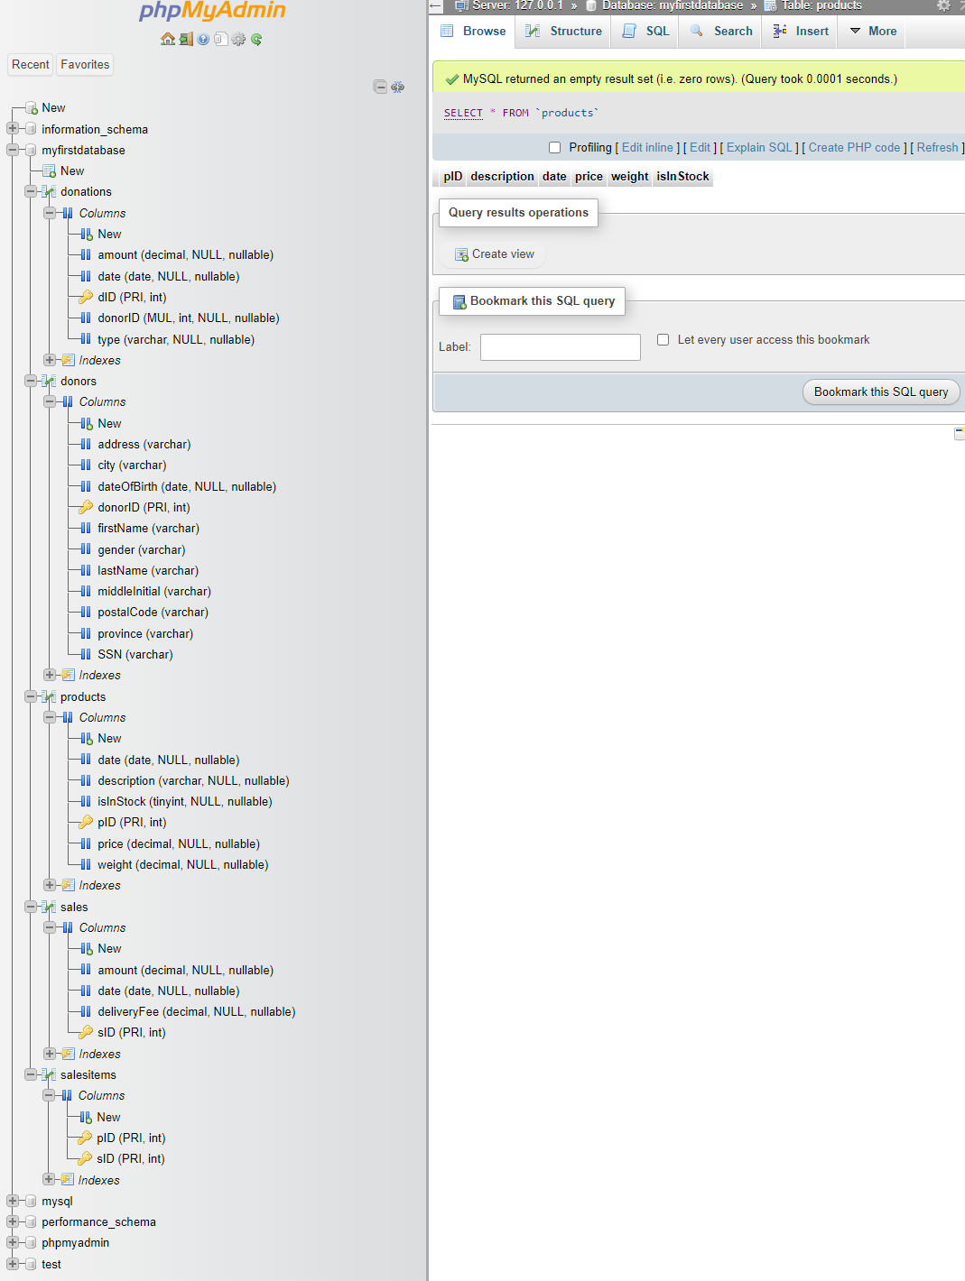

**b) Code**

**ALTER** **TABLE** donors  
**DROP** **COLUMN** middleInitial;

**b) Results**

-Before

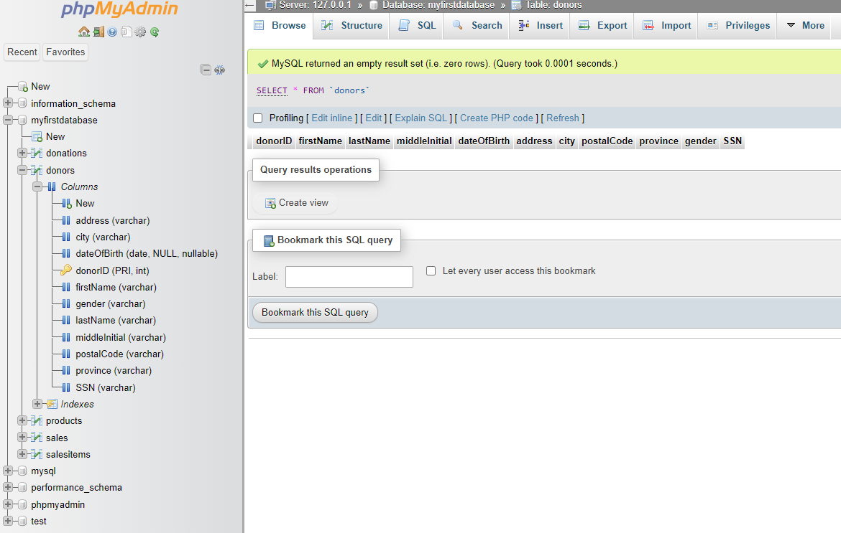

-After

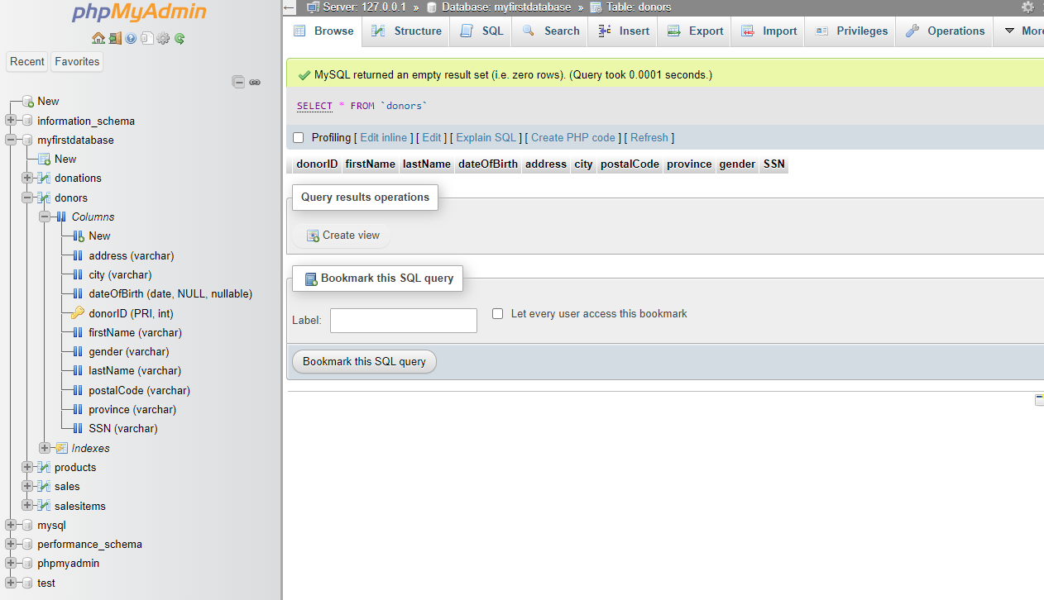

**c) Code**

**ALTER** **TABLE** donors  
**ADD** phone VARCHAR(100) **DEFAULT** 'unknown',  
**ADD** email VARCHAR(100) **DEFAULT** 'unknown';

**c) Results**

-Before

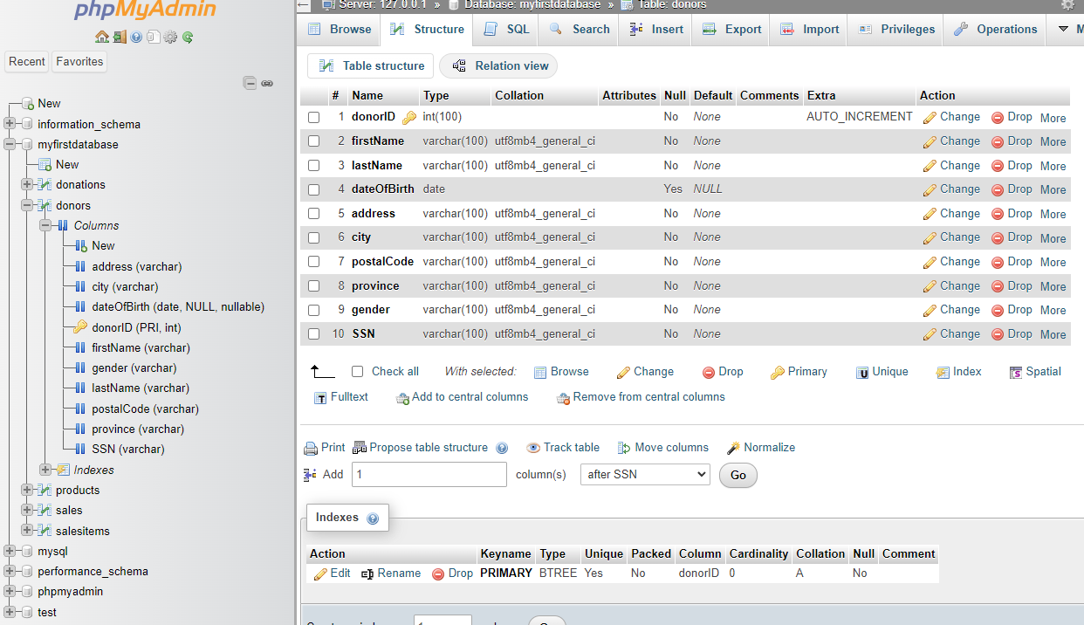

-After

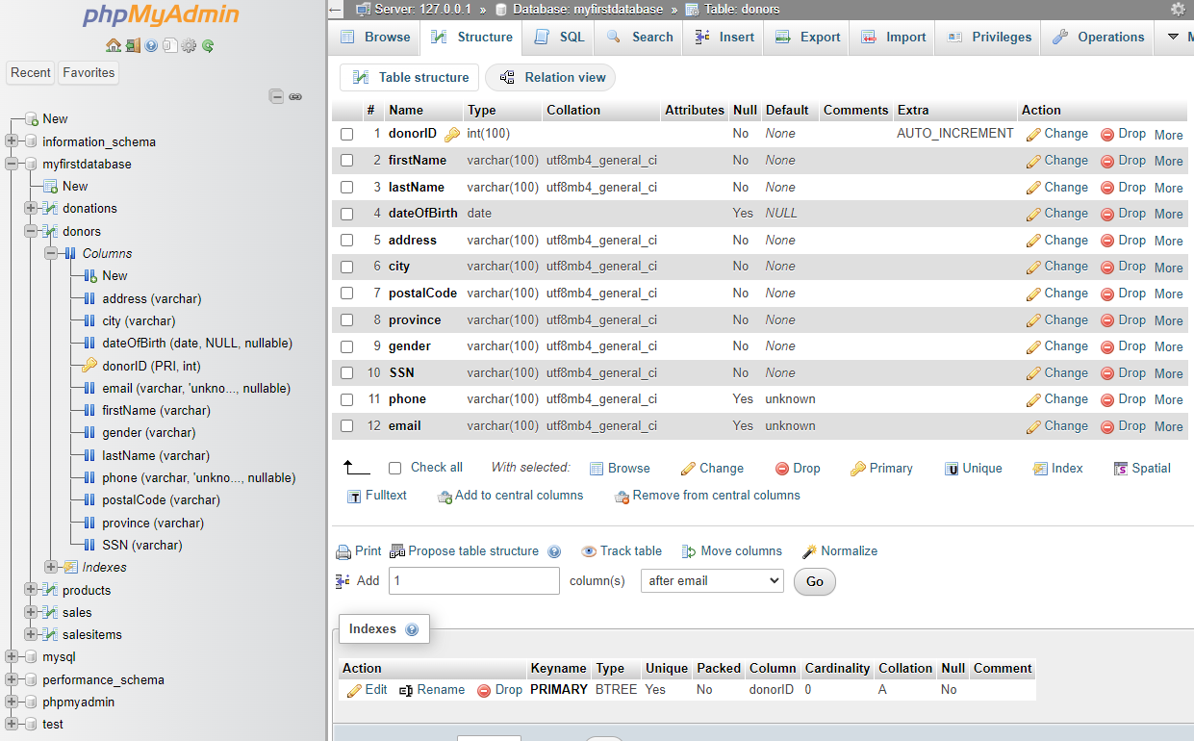

**d) Code**

**INSERT** **INTO** products (pID, description, date, price, weight, isInStock)  
**VALUES** (1, 'product_1', '2023-07-13', 1.00, 100.00, false);  
  
**INSERT** **INTO** products (pID, description, date, price, weight, isInStock)  
**VALUES** (2, 'product_2', '2023-07-14', 10.00, 10.00, true);  
  
**INSERT** **INTO** products (pID, description, date, price, weight, isInStock)  
**VALUES** (3, 'product_3', '2023-07-15', 100.00, 1.00, true);

**d) Results**

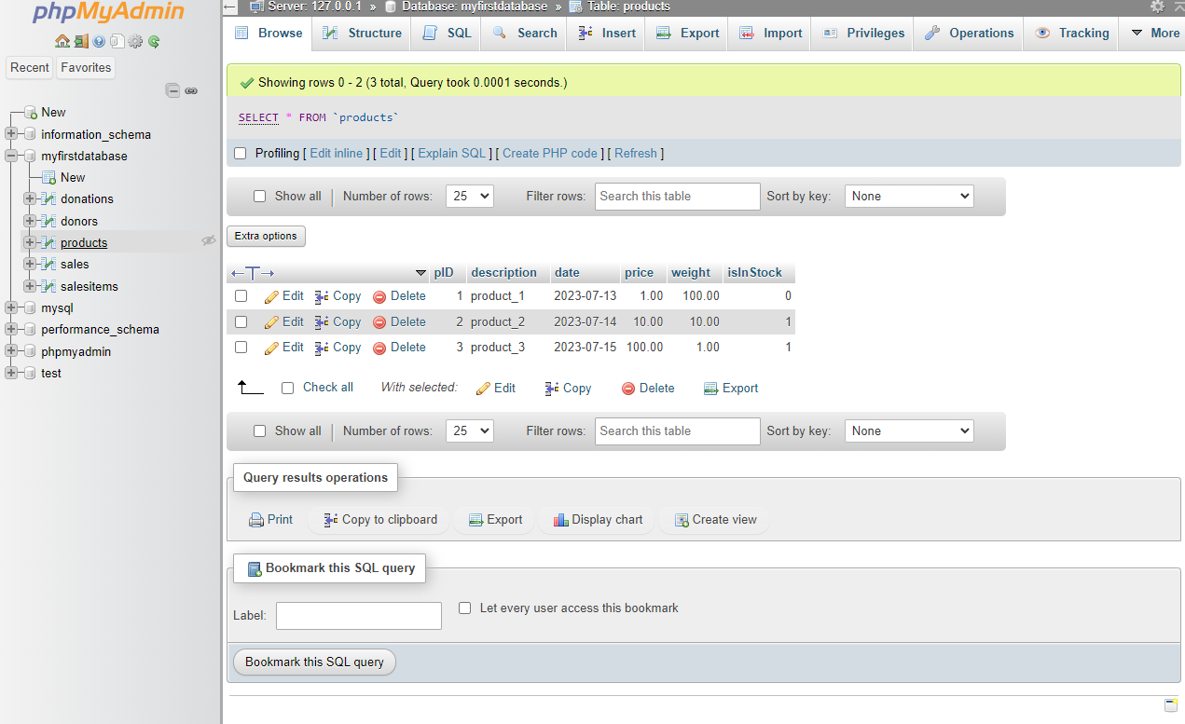

**e) Code**

**DELETE** **FROM** products;

**e) Results**

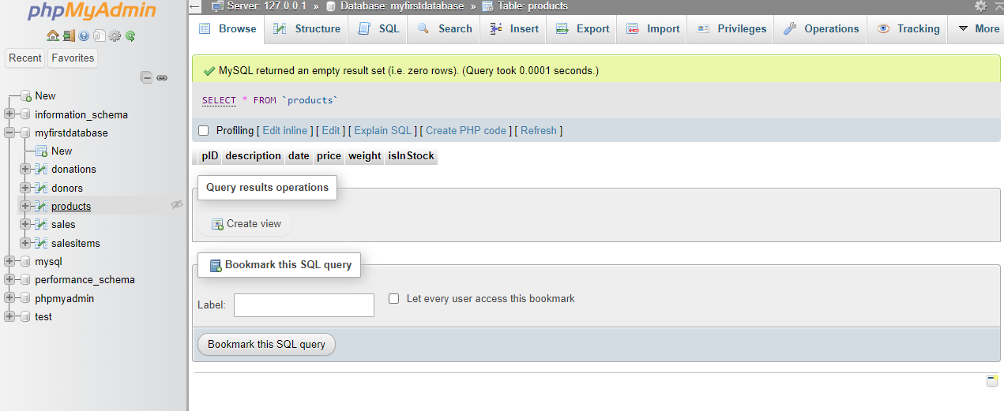

**f) Code**

**DROP** **TABLE** salesItems;  
**DROP** **TABLE** sales;  
**DROP** **TABLE** products;  
**DROP** **TABLE** donations;  
**DROP** **TABLE** donors;

**f) Results**

-Before

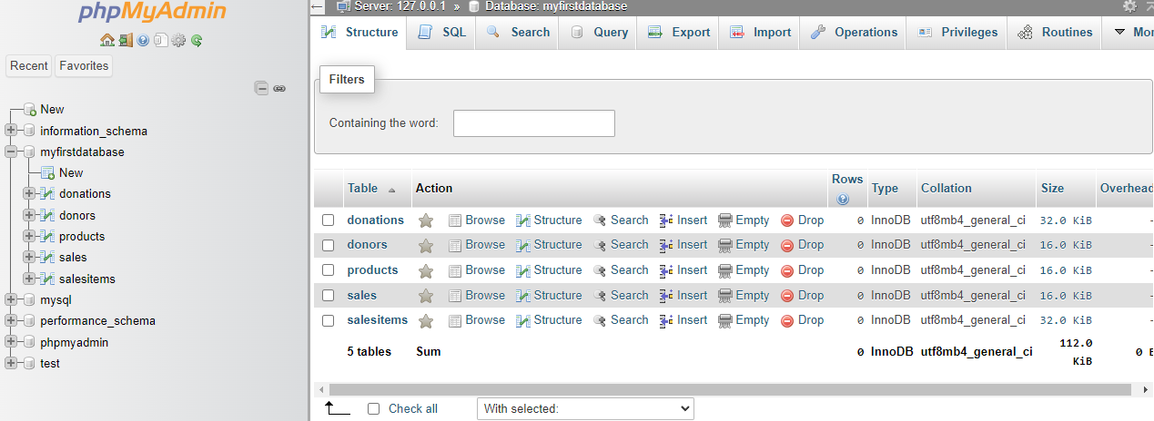

-After

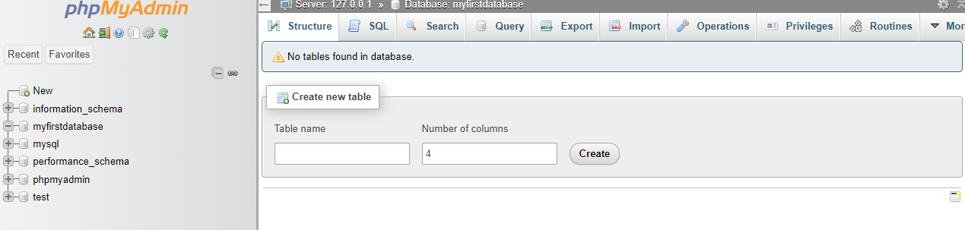

**PART II:**

**a) Code**

**SELECT** donorID, firstName, lastName, dateOfBirth, phone, email, SSN  
**FROM** donors  
**WHERE** gender = 'Female' **AND** province = 'Québec';

**a) Results**

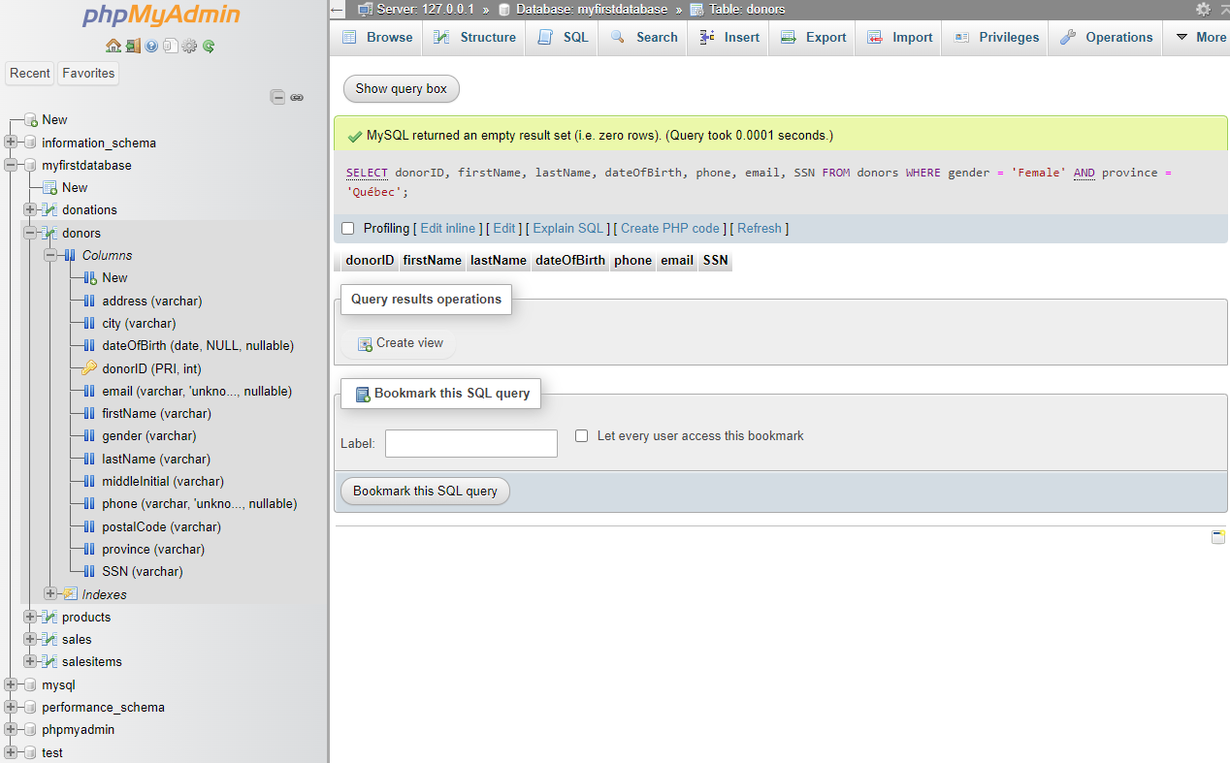

**b) Code**

**SELECT** salesItem.sID, salesItem.pID, product.description, product.price, product.weight  
**FROM** salesItems salesItem   
**JOIN** sales sale **ON** sale.sID = salesItem.sID  
**JOIN** products product **ON** product.pID = salesItem.pID  
**WHERE** sale.date = '2023-07-01' **AND** sale.deliveryFee > 0;

**b) Results**

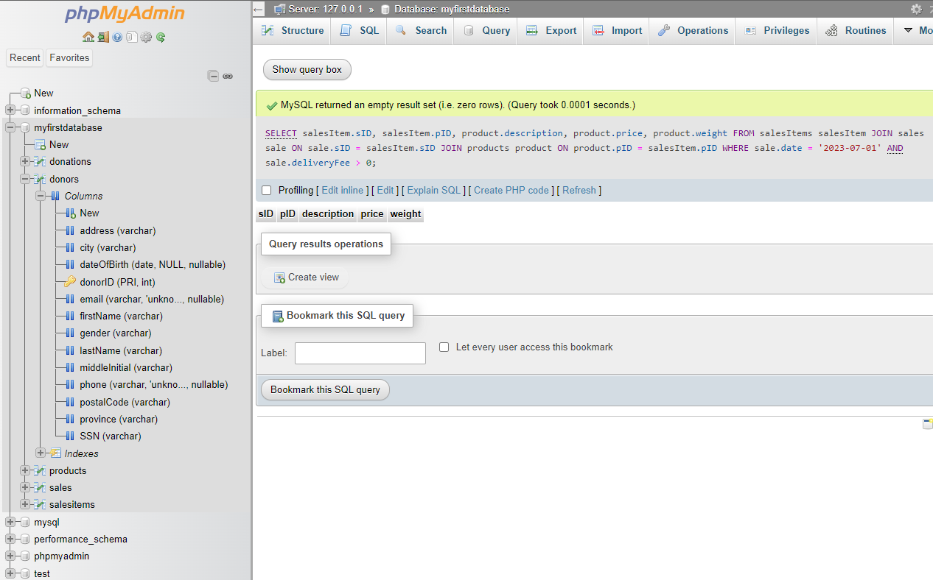

**c) Code**

**SELECT** **SUM**(deliveryFee) **AS** allDeliveryFees  
**FROM** sales  
**WHERE** date >= '2023-06-01' **AND** date <= '2023-06-30';

**c) Results**

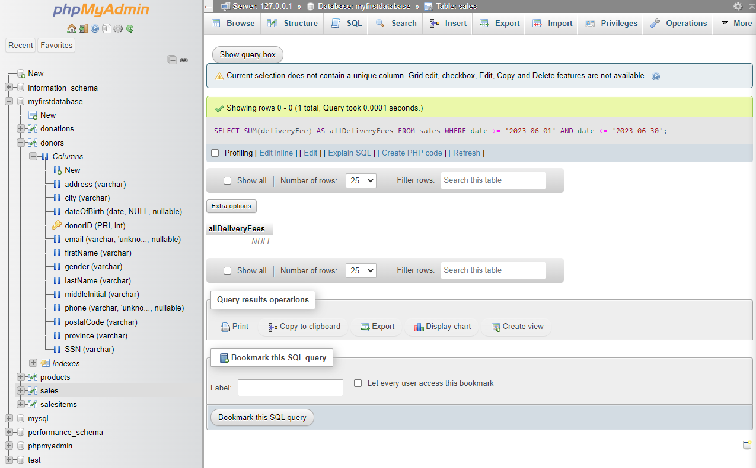

**d) Code**

**SELECT** **MONTH**(date) **AS** **month**, **COUNT**(*) **AS** allSales, **SUM**(amount) **AS** allAmount, **SUM**(deliveryFee) **AS** allDeliveryFees  
**FROM** sales  
**WHERE** date >= '2022-01-01' **AND** date <= '2023-12-31'  
**GROUP** **BY** **MONTH**(date);

**d) Results**

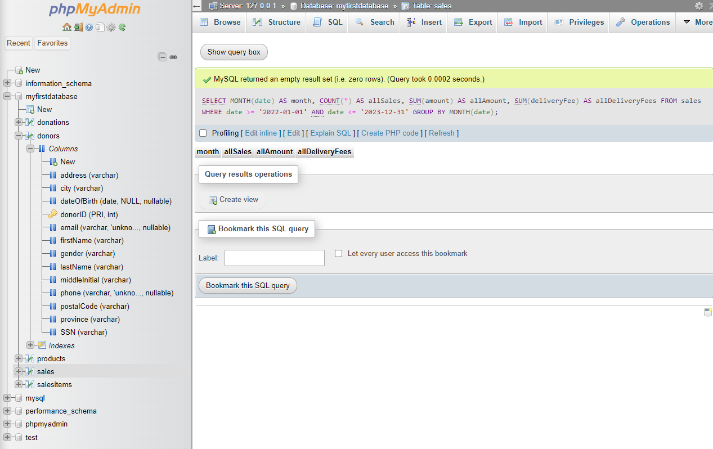

**e) Code**

**SELECT** donor.donorID, donor.gender, donor.firstName, donor.lastName, SUM(donation.amount) **AS** allDonations  
**FROM** donors donor  
**JOIN** donations donation **ON** donation.donorID = donor.donorID  
**WHERE** donor.city = 'Montréal' **AND** donation.date >= '2022-01-01' **AND** donation.date <= '2023-12-31'  
**GROUP** **BY** donor.donorID, donor.firstName, donor.lastName  
**ORDER** **BY** donor.gender **ASC**, donor.lastName **ASC**, donor.firstName **ASC**;

**e) Results**

