Andre Hei Wang Law

4017 5600

L_HEIWAN

Comp 353 Assignment 3

Question 1:

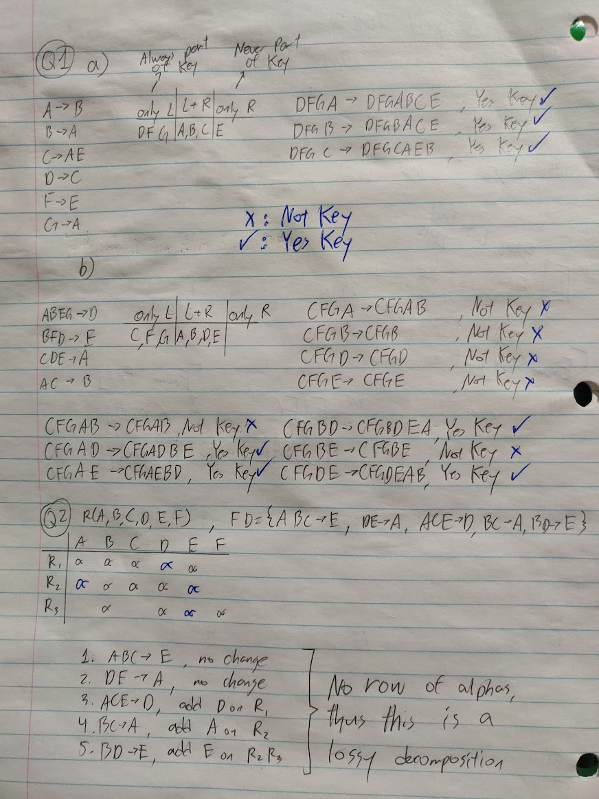

Question 2:



Question 3:

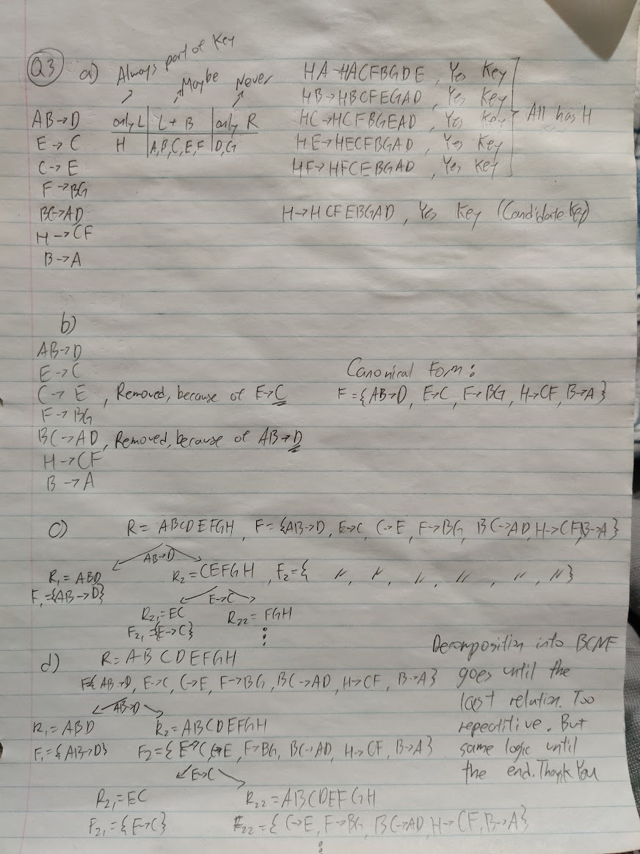

Question 4:

a)

a = π type, gender, locName, name ((Animals ⋈ Admission) ⋈[dateAdmitted >= 20 January 2021 AND dateAdmitted <= 20 February 2021](Adoption ⋈ Adopter))

b)

adopted = π aID (Animals ⋈ Adoption)  
multi_adopted = π aID ((adopted) ⋈ π aID (adopted))   
b = π aID, type, gender, chipNo (Animals ⋈ multi_adopted)

c)

adopters = π SIN, name, phone (Adopter)  
adopters_locations = adopters ⋈ Admission ⋈ HSO_Location  
c = adopters ⋈[province ≠ province](Adoption ⋈ Admission ⋈ HSO_Location)

d)

f_animals = π aID (Animals | gender = "Female")  
adopters_f_animals = π SIN ((Adoption ⋈ Animals) ⋈ f_animals)  
adopters_only_f_animals = adopters_f_animals - π SIN (Adoption ⋈ π SIN, aID (Adoption ⋈ (f_animals - Animals)))  
d = adopters ⋈ adopters_only_f_animals

e)

all_type = π type (Animals)  
adopters = π SIN, name, phone (Adopter)  
adopters_with_all_type = adopters ÷ π SIN (Adoption ⋈ all_type)  
e = adopters ⋈ adopters_with_all_type