Andre Hei Wang Law - 4017 5600

**1) Comparison of the Scheduling Algorithms:**

First-Come, First Served (FCFS):

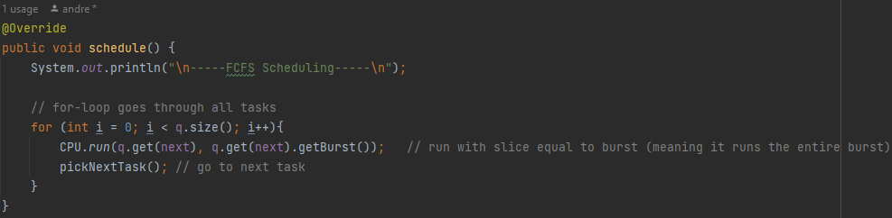

Shorted-Job-First (SJF):

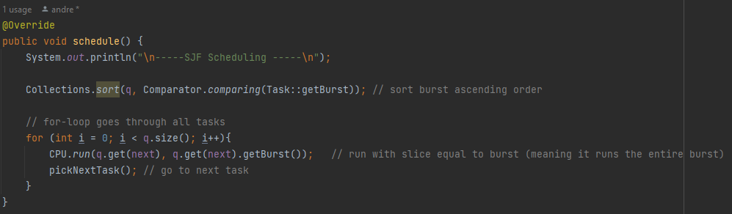

Priority Scheduling (PS):

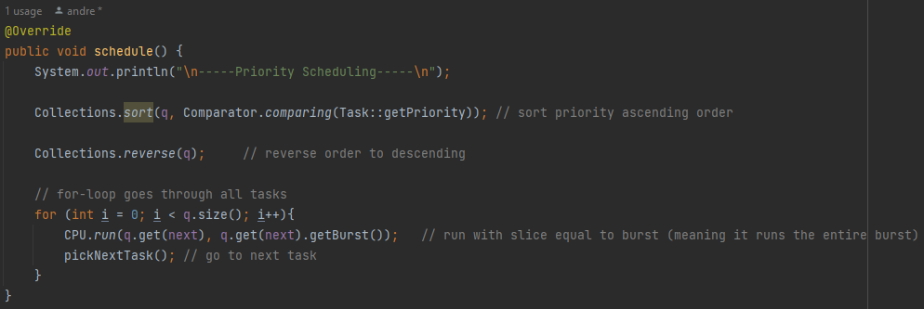

Found-Robin (RR):

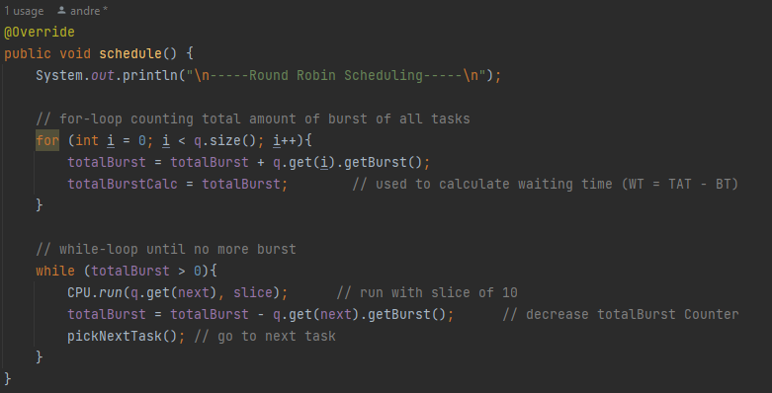

Fair Share (FS):

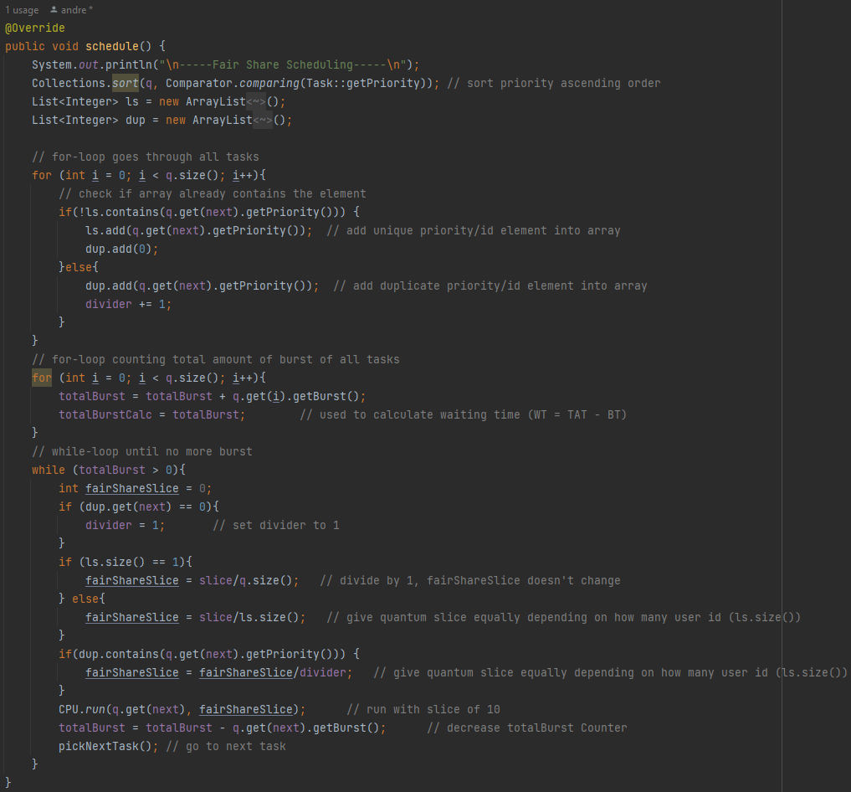

**2) Advantages and Drawbacks:**

First-Come, First Served (FCFS):

**Advantages**: Simple to implement; no starvation; fairness.

**Drawbacks**: Poor response time; convoy effect; inefficient use of resources.

Shorted-Job-First (SJF):

**Advantages**: Reduces average waiting time and turnaround time; efficient use of resources.

**Drawbacks**: Prediction of CPU burst time is difficult; may lead to starvation of long processes.

Priority Scheduling (PS):

**Advantages**: Allows priority to be given to important processes; reduces response time of important processes.

**Drawbacks**: Low priority processes may face starvation; may result in low priority processes not completing.

Found-Robin (RR):

**Advantages**: Time slice given to each process, ensuring each process gets a fair share of CPU time; efficient use of resources.

**Drawbacks**: Large time quantum may lead to poor response time; small time quantum may lead to high overhead.

Fair Share (FS):

**Advantages**: Ensures fair distribution of CPU time among all processes; prevents any single process from dominating the system.

**Drawbacks**: Overhead may be high; not suitable for systems with time-sensitive tasks.

3) Average Waiting and Turnaround Time:

First-Come, First Served (FCFS):

|  |  |  |
| --- | --- | --- |
| book.txt | schedule.txt | rr-schedule.txt |
|  |  |  |

Shorted-Job-First (SJF):

|  |  |  |
| --- | --- | --- |
| book.txt | schedule.txt | rr-schedule.txt |
|  |  |  |

Priority Scheduling (PS):

|  |  |  |
| --- | --- | --- |
| book.txt | schedule.txt | rr-schedule.txt |
|  |  |  |

Round-Robin (RR):

|  |  |  |
| --- | --- | --- |
| book.txt | schedule.txt | rr-schedule.txt |
|  |  |  |

Fair Share (FS):

|  |  |  |
| --- | --- | --- |
| book.txt | schedule.txt | rr-schedule.txt |
|  |  |  |