% Andre Hei Wang Law

% 4017 5600

% Lab 1 Question 1

clear

subplot(1, 2, 1)

r = 1 : 10 % radius from 1 to 10

vol = (4/3).*pi.*(r.^3) % volume of sphere

plot(r, vol) % plot of volume vs radius

hold on

sur = 4.*pi.*(r.^3) % surface area of a sphere

plot(r, sur) % plot of surface vs radius

hold off

title("Volume (blue) and Surface (red) of a Sphere as a Function of it's Radius")

xlabel("Radius")

ylabel("Volume and Surface Area of a Sphere")

subplot(1, 2, 2)

r = 1 : 10 % radius from 1 to 10

vol2 = r.^3 % volume of square

plot(r, vol2) % plot of volume vs radius

hold on

sur2 = 6.*(r.^2) % surface area of a sphere

plot(r, sur2) % plot of surface vs radius

hold off

title("Volume (blue) and Surface (red) of a Square as a Function of it's Radius")

xlabel("Radius")

ylabel("Volume and Surface Area of a Square")

>> lab1_q1

r =

1 2 3 4 5 6 7 8 9 10

vol =

1.0e+03 *

Columns 1 through 6

0.004188790204786 0.033510321638291 0.113097335529233 0.268082573106329 0.523598775598299 0.904778684233860

Columns 7 through 10

1.436755040241732 2.144660584850632 3.053628059289279 4.188790204786391

sur =

1.0e+04 *

Columns 1 through 6

0.001256637061436 0.010053096491487 0.033929200658770 0.080424771931899 0.157079632679490 0.271433605270158

Columns 7 through 10

0.431026512072520 0.643398175455190 0.916088417786784 1.256637061435917

r =

1 2 3 4 5 6 7 8 9 10

vol2 =

1 8 27 64 125 216 343 512 729 1000

sur2 =

6 24 54 96 150 216 294 384 486 600

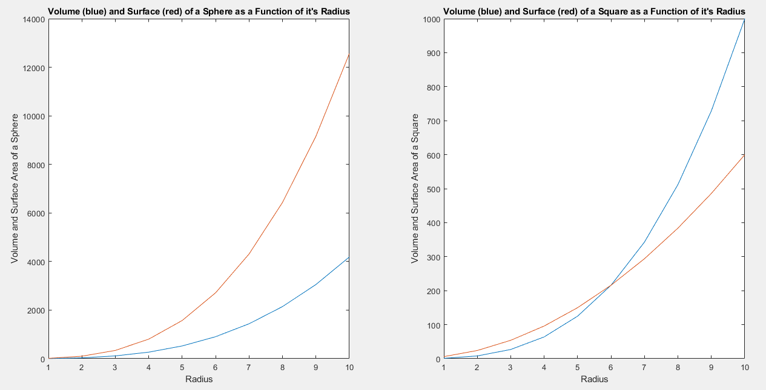

% Andre Hei Wang Law

% 4017 5600

% Lab 1 Question 2

clear

subplot(2, 2, 1)

x = -5 : 4

vec1 = zeros(1,10) %size of array

vec1(2) = 1 % 2nd element will be 1

vec1(3) = 1 % 3rd element will be 1

stem(x, vec1)

title("Stem Plots of First Vector")

xlabel("X-axis from -5 to 4")

ylabel("Zeros Except Two Chosen Elements")

subplot(2, 2, 2)

x = -5 : 4

vec1 = ones(1,10) %size of array

n = 4 % arbitrary number

vec1(1:n) = 0

stem(x, vec1)

title("Stem Plots of Second Vector")

xlabel("X-axis from -5 to 4")

ylabel("First 'n' elements being 0, remainder all ones")

subplot(2, 2, 3)

x = 0 : 10

vec1 = zeros(1,11) % size of array

vec1(4) = 1 % 4nd element will be 1

vec1(5) = 1 % 5rd element will be 1

stem(x, vec1)

title("Stem Plots of First Vector")

xlabel("X-axis from 0 to 10")

ylabel("Zeros Except Two Chosen Elements")

subplot(2, 2, 4)

x = 0 : 10

vec1 = ones(1,11) % size of array

n = 7 % arbitrary number

vec1(1:n) = 0

stem(x, vec1)

title("Stem Plots of Second Vector")

xlabel("X-axis from 0 to 10")

ylabel("First 'n' elements equal to 0, remainder all ones")

>> lab1_q2

x =

-5 -4 -3 -2 -1 0 1 2 3 4

vec1 =

0 0 0 0 0 0 0 0 0 0

vec1 =

0 1 0 0 0 0 0 0 0 0

vec1 =

0 1 1 0 0 0 0 0 0 0

x =

-5 -4 -3 -2 -1 0 1 2 3 4

vec1 =

1 1 1 1 1 1 1 1 1 1

n =

4

vec1 =

0 0 0 0 1 1 1 1 1 1

x =

0 1 2 3 4 5 6 7 8 9 10

vec1 =

0 0 0 0 0 0 0 0 0 0 0

vec1 =

0 0 0 1 0 0 0 0 0 0 0

vec1 =

0 0 0 1 1 0 0 0 0 0 0

x =

0 1 2 3 4 5 6 7 8 9 10

vec1 =

1 1 1 1 1 1 1 1 1 1 1

n =

7

vec1 =

0 0 0 0 0 0 0 1 1 1 1

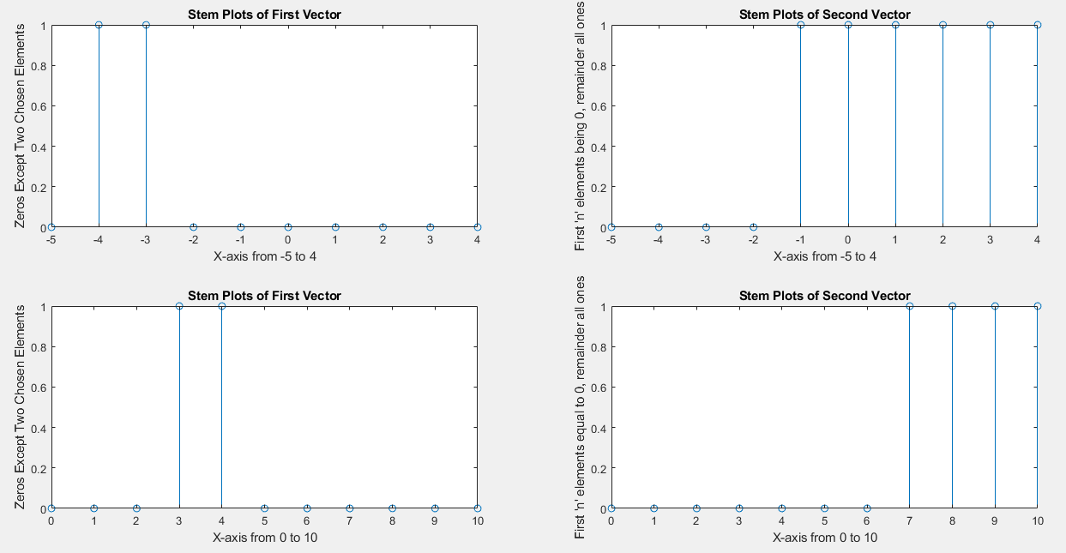

% Andre Hei Wang Law

% 4017 5600

% Lab 1 Question 3

clear

% i) X[n] is periodic if X[n+T]=x[n]

n1 = 1

xi1 = cos((2.*pi)/n1); % n = 1

n2 = 1+1024

xi2 = cos((2.*pi)/n2); % n = 1 + 1024

format long

y1 = xi1-xi2;

display(y1);

% ii) Same as (i), bu we use 3.14 rather than pi

n1 = 1

xii1 = cos((2.*3.14)/n1); % n = 1

n2 = 1+1024

xii2 = cos((2.*3.14)/n2); % n = 1 + 1024

format long

y2 = xii1-xii2;

display(y2);

% iii) Determine if two signals are Equal

niii = 1

xiii1 = cos(pi./4.*niii+pi./3);

xiii2 = cos(9.*pi./4.*niii+pi./3);

format long

y3 = xiii1-xiii2;

display(y3);

>> lab1_q3

n1 =

1

n2 =

1025

y1 =

1.878800427557170e-05

n1 =

1

n2 =

1025

y2 =

1.369587310406928e-05

niii =

1

y3 =

-4.440892098500626e-16

% Andre Hei Wang Law

% 4017 5600

% Lab 1 Question 4

clear

filename = 'my_big_array.txt'

my_big_array = load(filename)

>> lab1_q4

filename =

'my_big_array.txt'

my_big_array =

1 2 3 4 5 6 7 8 9 10

11 12 13 14 15 16 17 18 19 20

21 22 23 23 24 26 27 28 29 30

31 32 33 34 35 36 37 38 39 40

41 42 43 44 45 46 47 48 49 50

51 52 53 54 55 56 57 58 59 60

61 62 62 64 65 66 67 68 69 70

71 72 72 74 75 76 77 78 79 80

81 82 83 84 85 86 87 88 89 90

91 92 93 94 95 96 97 98 99 100

