Fundamentals of Control Systems

Elec 372

Lab Experiment #1

Andre Hei Wang Law

4017 5600

Section UJ-X

TA: Saba Sanami

TA Email: [sabasanami272@gmail.com](mailto:sabasanami272@gmail.com)

Professor: Amir Aghdam

Performed on January 30, 2024

Due on February 13, 2024

“I certify that this submission is my original work and meets the Faculty’s Expectations of

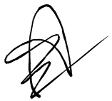Originality.”

Andre Hei Wang Law

4017 5600

12/02/2024

**1) Objectives**

The primary objective of the first lab of the course Elec 372 is to familiarize ourselves with the experiment systems. For example, students will be introduced to the ECP Model 220 system as well as the software needed to produce a system response. Students will also perform basic MATLAB computation of an open-loop and closed-loop response system. As such, this allows for the student to get hands on experience on using Elec 372 laboratory equipment.

**2) Theory**

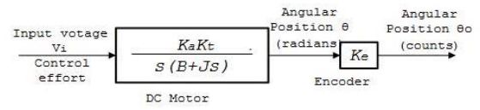

Open-Loop Diagram

Kt: Torque constant

Ka: Tran-conductance gain

J: Total inertial of turntable system

B: Viscous fiction

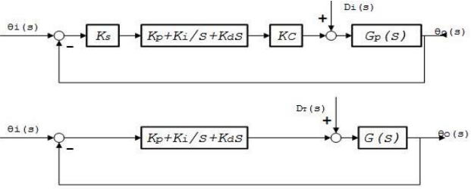

Closed-Loop Diagram

Ks: Controller software gain

Kc: D-to-A converter (DAC) gain

Ke: Encoder gain

Ka: Servo-amplifier gain

Kt: Servomotor torque constant

**3) Tasks / Results / Discussions**

3.1) Closed-Loop Test

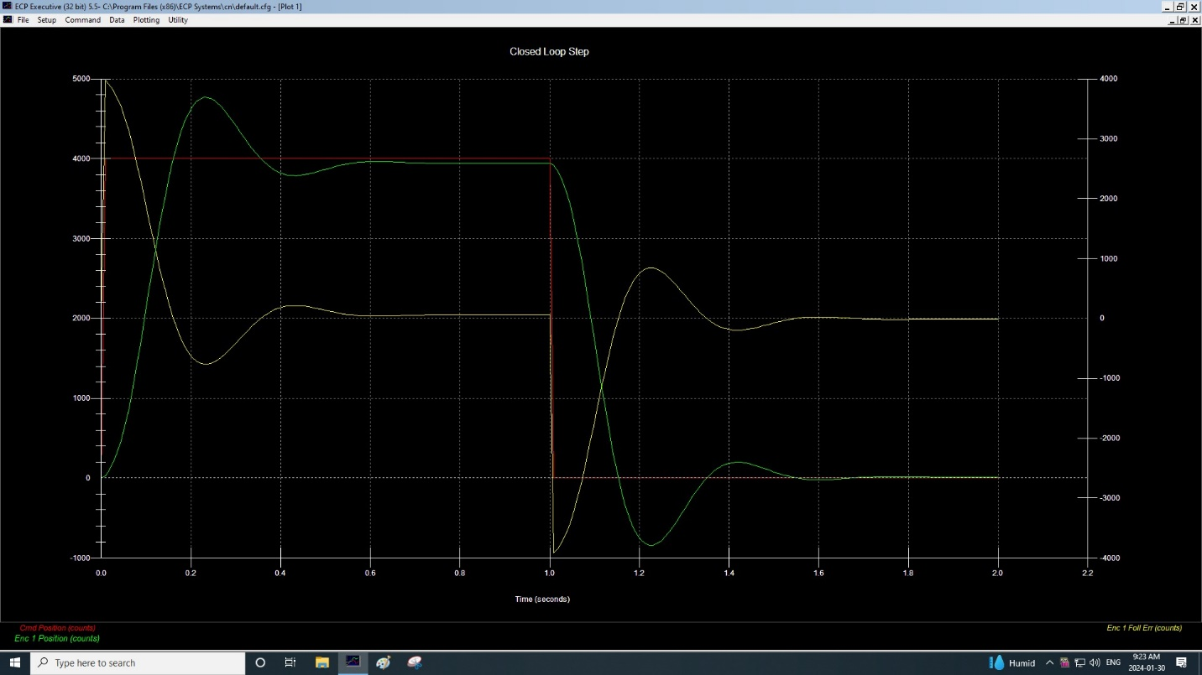

Figure 1.

This figure is the plot of Commanded Position and Encoder #1 Position in relation to Encoder #1 Error of a closed-loop system. The important point to notice is that the yellow line behaves in opposite to the green line. These represents the error and position respectively. In addition, in a steady state, the error value approaches 0 as noticed from time 0.6 and from time 1.6.

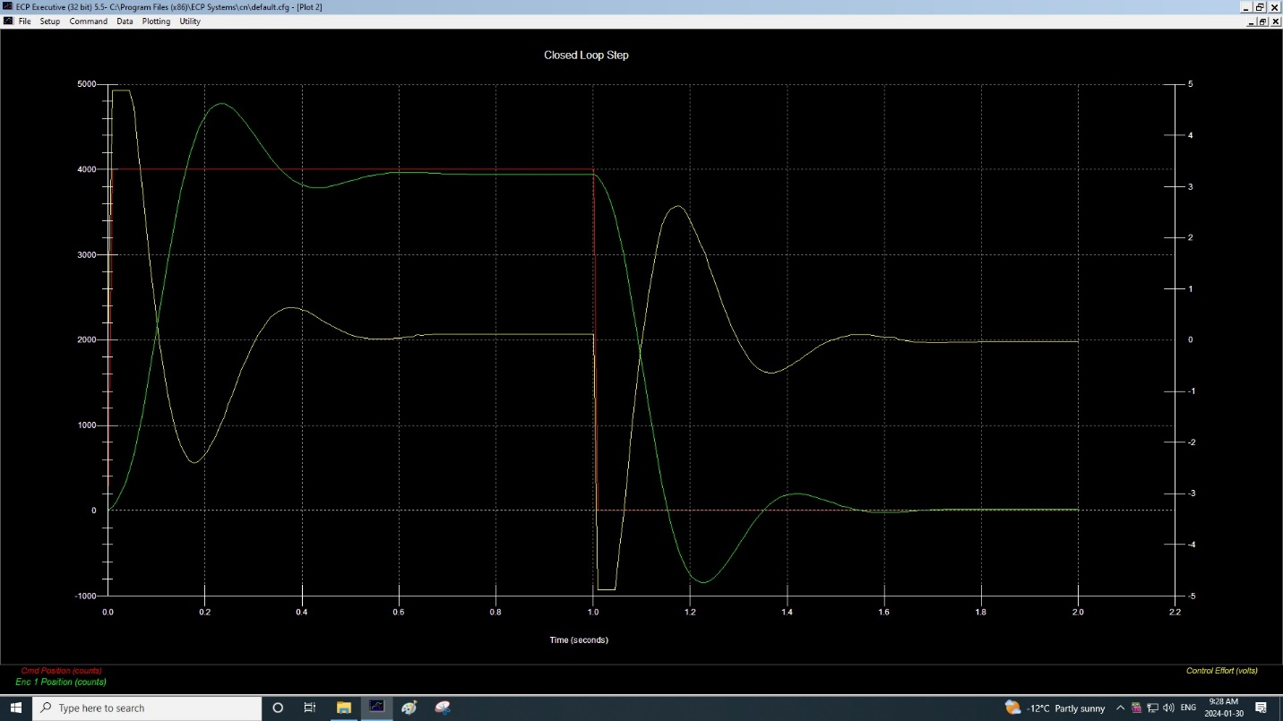

Figure 2.

This figure is the plot of Commanded Position and Encoder #1 Position in relation to Control Effort of a closed-loop system. While it looks very similar to figure 1, a difference lies in the control effort which appears to have a time shift compared to the error value. This is due to the fact that the control effort anticipates the output variation.

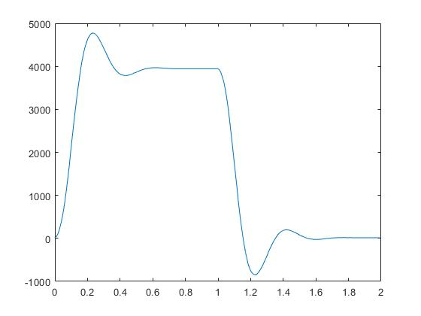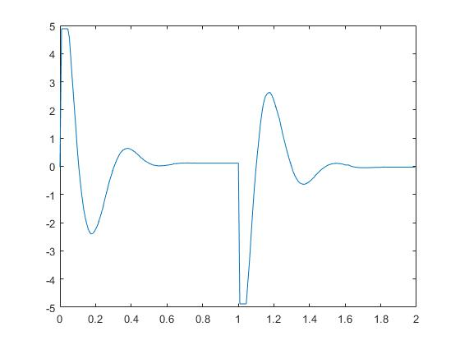

Figure 3 and Figure 4.

These two figures are MATLAB simulation that can be compared to the two ECP plots from figure 1 and figure 2. Notice that curve of figure 3 (left one) is similar to the Position while the curve of figure 4 (right one) is similar to the Control Effect.

3.2) Open-Loop Step Response MATLAB Simulation

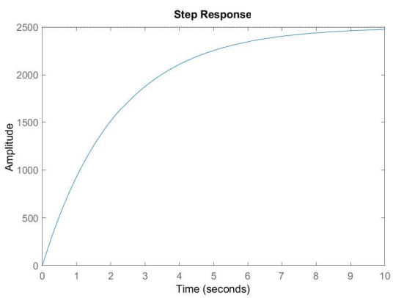 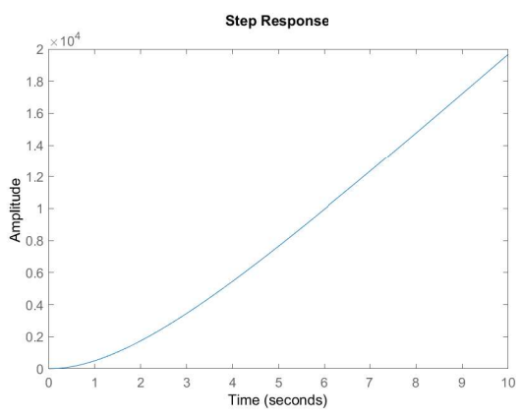

Figure 5 and Figure 6

These two figures represent the MATLAB simulation of the step response of an open-loop DC motor system. Figure 4 (left one) is velocity in terms of time, while figure 5 (right one) is the position in terms of time

3.3) Open-Loop Step Response

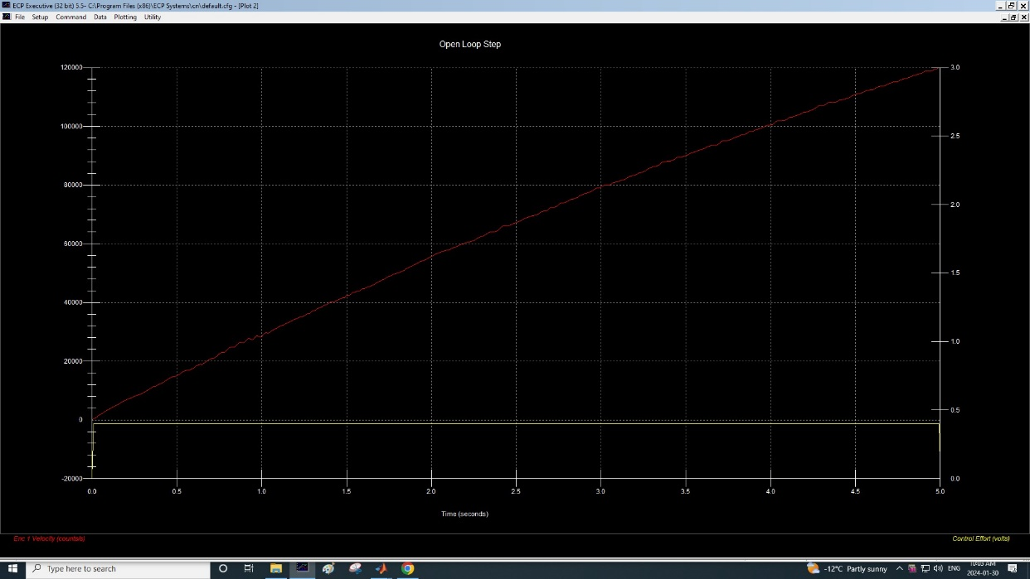

Figure 7.

This figure is a simulation of an open-loop encoder #1 velocity in relation to time using MATLAB. This corresponds to a step response of an open-loop DC motor.

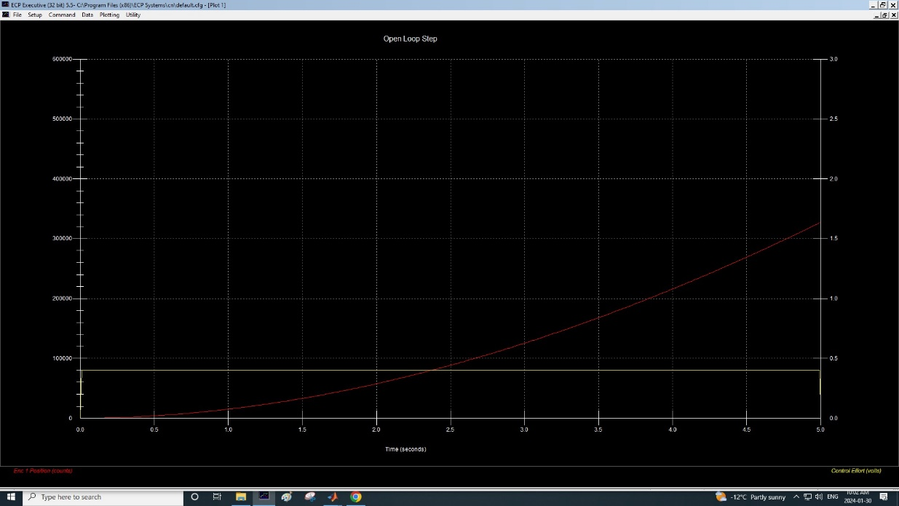

Figure 8.

This figure represents a MATLAB simulation of an open-loop encoder #1 position in relation to time. This corresponds to a step response of an open-loop DC motor.

**4) Questions**

4.1) Note how the error varies in the opposite direction of the output and approaches zero in the steady state. (closed-loop)

Based on figure 1, the command position refers to the red line. The encoder #1 position refers to the green line. The encoder #1 error refers to the yellow line. It can be observed based on the above plot that the error value behaves opposite to the encoder #1 position, such that when the green line increases, the yellow line decreases. Then, we also notice that given enough time, the encoder #1 error value will oscillate and approach 0 in a steady state. This happens twice, first when the command position was at value 4000 and encoder #1 error is 0 from time 0.6, second when the command position was at value of 0 and encoder #1 error is 0 from time 1.6.

4.2) Note how the CE, which is the input to the servomotor, varies in a manner similar to that of the error, but anticipates the output variation with an observable lead time. The CE is the input whenever the system is operated in the open-loop mode. (closed-loop)

Based on figure 2, it can be observed that the value and pattern of control effort is very similar to Encoder #1 error of figure 1. Their have similar behavior where they opposite the Encoder #1 position. However, a small difference is that control effort has a slight time shift where it predicts the output variation. This can be noticed by how it changes before #1 position.

**5) Conclusions**

In conclusion, for the first Elec 372 experiment, students achieved a fundamental understanding of control system analysis and MATLAB computation by performing tests with the ECP Model 220 system. Then, through working on an open-loop and closed-loop responses, students could analyse the effect and differences given various input parameters. In the end, this lab experiment gave students hands on experiences which will be needed for upcoming labs.

**6) Appendix**

6.1) sinesweep220.m MATLAB Code

K = 5.0;   
B = 0.002;  
J = 0.0043;  
  
s = tf('s');  
dcm_s = K/(J*s+B);  
dcm_p = dcm_s/s;  
  
ltiview('step', dcm_s, 0:0.1:10);  
  
ltiview('step',dcm_p, 0:0.1:10);

6.2) Exported Raw MATLAB Data

Sample Time Commanded Pos Encoder 1 Pos Encoder 2 Pos Control Effort  
  
[ 0 0.000 4000 14 4 -0.0275;  
 1 0.009 4000 39 4 4.8840;  
 2 0.018 4000 104 12 4.8840;  
 3 0.027 4000 196 33 4.8840;  
 4 0.035 4000 312 67 4.8840;  
 5 0.044 4000 464 109 4.8840;  
 6 0.053 4000 654 155 4.5488;  
 7 0.062 4000 880 209 3.7283;  
 8 0.071 4000 1136 273 2.9249;  
 9 0.080 4000 1416 346 2.1410;  
 10 0.089 4000 1712 425 1.3822;  
 11 0.097 4000 2021 506 0.6361;  
 12 0.106 4000 2335 586 -0.0513;  
 13 0.115 4000 2646 666 -0.6105;  
 14 0.124 4000 2946 743 -1.0971;  
 15 0.133 4000 3232 817 -1.5104;  
 16 0.142 4000 3499 886 -1.8315;  
 17 0.151 4000 3742 950 -2.0611;  
 18 0.159 4000 3962 1007 -2.2387;  
 19 0.168 4000 4156 1056 -2.3584;  
 20 0.177 4000 4323 1096 -2.4011;  
 21 0.186 4000 4462 1129 -2.3755;  
 22 0.195 4000 4572 1157 -2.2906;  
 23 0.204 4000 4657 1179 -2.1874;  
 24 0.213 4000 4717 1195 -2.0543;  
 25 0.221 4000 4756 1204 -1.8950;  
 26 0.230 4000 4773 1208 -1.7033;  
 27 0.239 4000 4771 1208 -1.5177;  
 28 0.248 4000 4750 1203 -1.2595;  
 29 0.257 4000 4715 1193 -1.0397;  
 30 0.266 4000 4668 1180 -0.8205;  
 31 0.274 4000 4612 1166 -0.6087;  
 32 0.283 4000 4549 1149 -0.4151;  
 33 0.292 4000 4481 1131 -0.2326;  
 34 0.301 4000 4410 1113 -0.0537;  
 35 0.310 4000 4337 1094 0.0965;  
 36 0.319 4000 4266 1075 0.2332;  
 37 0.328 4000 4196 1057 0.3504;  
 38 0.336 4000 4129 1040 0.4493;  
 39 0.345 4000 4067 1024 0.5214;  
 40 0.354 4000 4010 1010 0.5763;  
 41 0.363 4000 3959 997 0.6129;  
 42 0.372 4000 3915 985 0.6337;  
 43 0.381 4000 3878 976 0.6368;  
 44 0.390 4000 3847 968 0.6276;  
 45 0.398 4000 3823 962 0.6007;  
 46 0.407 4000 3805 958 0.5672;  
 47 0.416 4000 3794 955 0.5311;  
 48 0.425 4000 3788 953 0.4780;  
 49 0.434 4000 3786 953 0.4353;  
 50 0.443 4000 3789 953 0.3816;  
 51 0.452 4000 3796 955 0.3248;  
 52 0.460 4000 3805 957 0.2814;  
 53 0.469 4000 3817 960 0.2332;  
 54 0.478 4000 3831 963 0.1911;  
 55 0.487 4000 3845 967 0.1551;  
 56 0.496 4000 3859 971 0.1215;  
 57 0.505 4000 3874 974 0.0910;  
 58 0.514 4000 3888 978 0.0684;  
 59 0.522 4000 3902 981 0.0501;  
 60 0.531 4000 3914 985 0.0379;  
 61 0.540 4000 3925 988 0.0293;  
 62 0.549 4000 3935 990 0.0195;  
 63 0.558 4000 3944 992 0.0201;  
 64 0.567 4000 3951 994 0.0189;  
 65 0.576 4000 3957 996 0.0232;  
 66 0.584 4000 3962 997 0.0244;  
 67 0.593 4000 3965 997 0.0330;  
 68 0.602 4000 3967 998 0.0433;  
 69 0.611 4000 3968 998 0.0488;  
 70 0.620 4000 3968 998 0.0623;  
 71 0.629 4000 3968 998 0.0623;  
 72 0.638 4000 3966 998 0.0983;  
 73 0.646 4000 3964 998 0.0940;  
 74 0.655 4000 3961 998 0.0971;  
 75 0.664 4000 3959 998 0.1062;  
 76 0.673 4000 3956 997 0.1111;  
 77 0.682 4000 3954 996 0.1117;  
 78 0.691 4000 3952 995 0.1190;  
 79 0.699 4000 3950 995 0.1172;  
 80 0.708 4000 3948 994 0.1197;  
 81 0.717 4000 3947 994 0.1197;  
 82 0.726 4000 3945 994 0.1197;  
 83 0.735 4000 3944 994 0.1160;  
 84 0.744 4000 3944 993 0.1129;  
 85 0.753 4000 3943 993 0.1184;  
 86 0.761 4000 3943 993 0.1166;  
 87 0.770 4000 3943 993 0.1111;  
 88 0.779 4000 3943 993 0.1111;  
 89 0.788 4000 3943 993 0.1111;  
 90 0.797 4000 3943 993 0.1111;  
 91 0.806 4000 3943 993 0.1111;  
 92 0.815 4000 3943 993 0.1111;  
 93 0.823 4000 3943 993 0.1111;  
 94 0.832 4000 3943 993 0.1111;  
 95 0.841 4000 3943 993 0.1111;  
 96 0.850 4000 3943 993 0.1111;  
 97 0.859 4000 3943 993 0.1111;  
 98 0.868 4000 3943 993 0.1111;  
 99 0.877 4000 3943 993 0.1111;  
 100 0.885 4000 3943 993 0.1111;  
 101 0.894 4000 3943 993 0.1111;  
 102 0.903 4000 3943 993 0.1111;  
 103 0.912 4000 3943 993 0.1111;  
 104 0.921 4000 3943 993 0.1111;  
 105 0.930 4000 3943 993 0.1111;  
 106 0.939 4000 3943 993 0.1111;  
 107 0.947 4000 3943 993 0.1111;  
 108 0.956 4000 3943 993 0.1111;  
 109 0.965 4000 3943 993 0.1111;  
 110 0.974 4000 3943 993 0.1111;  
 111 0.983 4000 3943 993 0.1111;  
 112 0.992 4000 3943 993 0.1111;  
 113 1.001 4000 3943 993 0.1111;  
 114 1.009 0 3918 993 -4.8840;  
 115 1.018 0 3849 985 -4.8840;  
 116 1.027 0 3751 962 -4.8840;  
 117 1.036 0 3625 926 -4.8840;  
 118 1.045 0 3457 882 -4.8840;  
 119 1.054 0 3246 831 -4.1361;  
 120 1.063 0 3007 771 -3.3901;  
 121 1.071 0 2741 702 -2.5830;  
 122 1.080 0 2447 626 -1.7143;  
 123 1.089 0 2134 546 -0.8974;  
 124 1.098 0 1814 463 -0.2027;  
 125 1.107 0 1496 379 0.4096;  
 126 1.116 0 1184 296 0.9652;  
 127 1.124 0 880 217 1.4670;  
 128 1.133 0 589 143 1.9011;  
 129 1.142 0 317 75 2.2479;  
 130 1.151 0 72 12 2.4530;  
 131 1.160 0 -143 -45 2.5519;  
 132 1.169 0 -329 -93 2.6105;  
 133 1.178 0 -487 -131 2.6197;  
 134 1.186 0 -614 -162 2.5531;  
 135 1.195 0 -711 -185 2.4219;  
 136 1.204 0 -779 -202 2.2534;  
 137 1.213 0 -821 -213 2.0678;  
 138 1.222 0 -842 -217 1.8700;  
 139 1.231 0 -843 -218 1.6893;  
 140 1.240 0 -825 -213 1.4231;  
 141 1.248 0 -790 -204 1.1886;  
 142 1.257 0 -742 -191 0.9591;  
 143 1.266 0 -684 -176 0.7295;  
 144 1.275 0 -617 -158 0.5098;  
 145 1.284 0 -544 -139 0.3010;  
 146 1.293 0 -468 -119 0.1178;  
 147 1.302 0 -390 -99 -0.0592;  
 148 1.310 0 -311 -79 -0.2155;  
 149 1.319 0 -235 -59 -0.3443;  
 150 1.328 0 -162 -41 -0.4469;  
 151 1.337 0 -95 -23 -0.5324;  
 152 1.346 0 -33 -8 -0.5879;  
 153 1.355 0 22 6 -0.6233;  
 154 1.364 0 69 18 -0.6355;  
 155 1.372 0 109 29 -0.6368;  
 156 1.381 0 141 37 -0.6166;  
 157 1.390 0 166 43 -0.5842;  
 158 1.399 0 183 47 -0.5421;  
 159 1.408 0 194 50 -0.4921;  
 160 1.417 0 198 51 -0.4353;  
 161 1.426 0 198 51 -0.3871;  
 162 1.434 0 193 51 -0.3107;  
 163 1.443 0 183 48 -0.2619;  
 164 1.452 0 170 45 -0.2057;  
 165 1.461 0 155 41 -0.1453;  
 166 1.470 0 139 37 -0.0971;  
 167 1.479 0 121 32 -0.0556;  
 168 1.488 0 104 27 -0.0171;  
 169 1.496 0 86 23 0.0165;  
 170 1.505 0 69 19 0.0415;  
 171 1.514 0 53 14 0.0653;  
 172 1.523 0 38 11 0.0830;  
 173 1.532 0 24 7 0.0965;  
 174 1.541 0 12 4 0.1001;  
 175 1.549 0 2 2 0.1093;  
 176 1.558 0 -7 -1 0.1020;  
 177 1.567 0 -13 -2 0.0983;  
 178 1.576 0 -18 -4 0.0897;  
 179 1.585 0 -22 -5 0.0794;  
 180 1.594 0 -24 -5 0.0629;  
 181 1.603 0 -24 -5 0.0482;  
 182 1.611 0 -24 -5 0.0464;  
 183 1.620 0 -22 -5 0.0464;  
 184 1.629 0 -20 -5 0.0122;  
 185 1.638 0 -17 -5 -0.0018;  
 186 1.647 0 -13 -3 -0.0177;  
 187 1.656 0 -9 -3 -0.0269;  
 188 1.665 0 -5 -1 -0.0330;  
 189 1.673 0 -1 -0 -0.0421;  
 190 1.682 0 3 1 -0.0470;  
 191 1.691 0 6 1 -0.0476;  
 192 1.700 0 9 2 -0.0482;  
 193 1.709 0 12 3 -0.0476;  
 194 1.718 0 14 3 -0.0495;  
 195 1.727 0 15 4 -0.0488;  
 196 1.735 0 16 4 -0.0440;  
 197 1.744 0 17 4 -0.0446;  
 198 1.753 0 17 4 -0.0379;  
 199 1.762 0 18 5 -0.0421;  
 200 1.771 0 18 5 -0.0354;  
 201 1.780 0 18 5 -0.0354;  
 202 1.789 0 17 5 -0.0354;  
 203 1.797 0 17 5 -0.0324;  
 204 1.806 0 17 5 -0.0324;  
 205 1.815 0 16 5 -0.0269;  
 206 1.824 0 15 5 -0.0244;  
 207 1.833 0 15 5 -0.0281;  
 208 1.842 0 15 5 -0.0299;  
 209 1.851 0 15 5 -0.0299;  
 210 1.859 0 15 5 -0.0299;  
 211 1.868 0 15 5 -0.0299;  
 212 1.877 0 15 5 -0.0299;  
 213 1.886 0 15 5 -0.0299;  
 214 1.895 0 15 5 -0.0299;  
 215 1.904 0 15 5 -0.0299;  
 216 1.913 0 15 5 -0.0299;  
 217 1.921 0 15 5 -0.0299;  
 218 1.930 0 15 5 -0.0299;  
 219 1.939 0 15 5 -0.0299;  
 220 1.948 0 15 5 -0.0299;  
 221 1.957 0 15 5 -0.0299;  
 222 1.966 0 15 5 -0.0299;  
 223 1.974 0 15 5 -0.0299;  
 224 1.983 0 15 5 -0.0299;  
 225 1.992 0 15 5 -0.0299]