Fundamentals of Control Systems

Elec 372

Lab Experiment #2

Andre Hei Wang Law

4017 5600

Section UJ-X

TA: Saba Sanami

TA Email: [sabasanami272@gmail.com](mailto:sabasanami272@gmail.com)

Professor: Amir Aghdam

Performed on February 13, 2024

Due on March 5, 2024

“I certify that this submission is my original work and meets the Faculty’s Expectations of

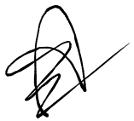Originality.”

Andre Hei Wang Law

4017 5600

05/03/2024

**1) Objectives**

For the second lab experiment of the course Elec 372, students are tasked to perform system identification on a mechanical first-order system to determine its inertia, damping and gain (J, B, K) parameters. The experiment will involve open-loop and closed-loop response on a DC motor. They will also perform calculations on the system model and verifying the model using MATLAB. As such, these theoretical predictions and the experimental results will allow for students to compare data which deepens their understanding on the fundamentals of control systems.

**2) Theory**

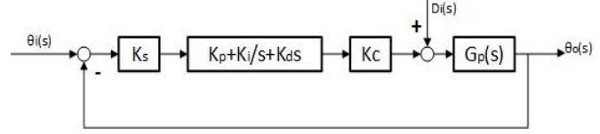

Figure 2.1

The above figure represents a ECP 220 system block diagram of a closed-loop configuration. A PI+V controller configuration is considered as the “default” configuration as it allows for a good control of closed-loop system parameters.

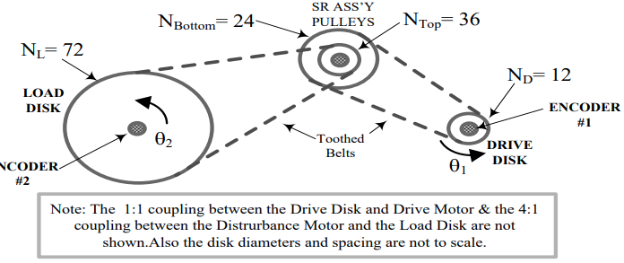

Figure 2.2

The figure 2.2 demonstrates the rotation inertia ratio between disks. The letter of the above figure represents:

**D**: The drive, inertia specified by the manufacturer is 4(10)-4kgm2

**L**: The load, inertia specified by the manufacturer is 65(10)-4kgm2

**SR**: The SR disks, inertia specified by the manufacturer is 78(10)-6kgm2

**w**: the additional inertia of the weights fixed to the driver and the load disks

**3) Tasks / Results / Discussions**

3.1) EVALUATION OF J AND K USING OPEN-LOOP VELOCITY OUTPUT

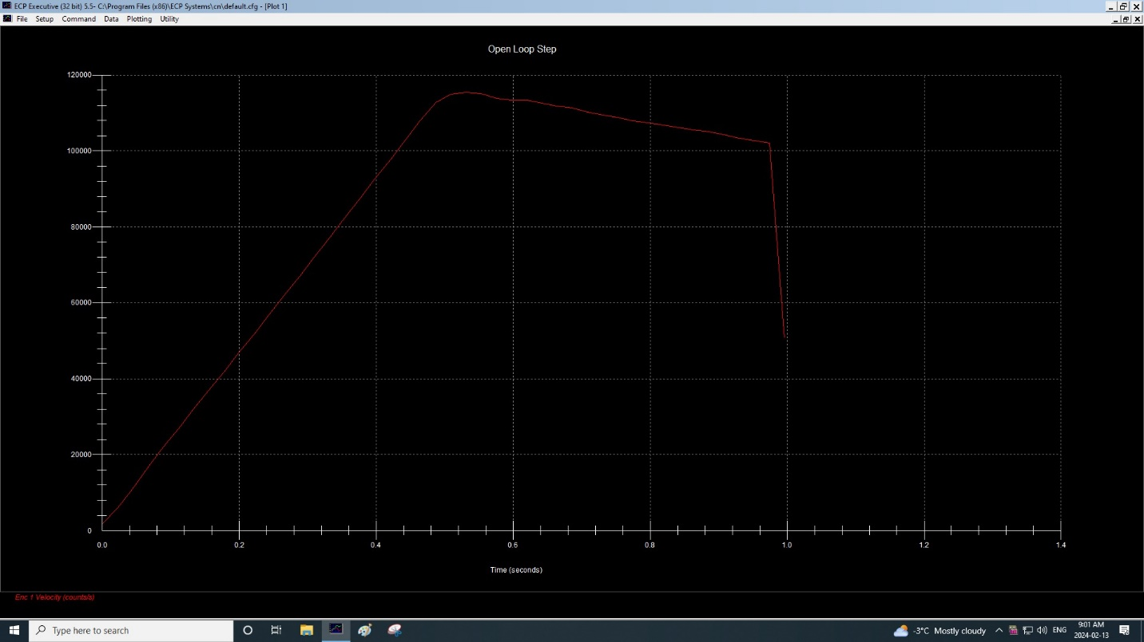

Figure 3.1.1

The left axis is Encoder #1 velocity and the x axis is time in seconds. Notice that the large linear increase of velocity on the y axis at the start represents a constant acceleration. Around time 0.5 seconds, we reach the maximum and the velocity decreases. This occurs because the step reverse and the “overload” circuit disable the system at this point.

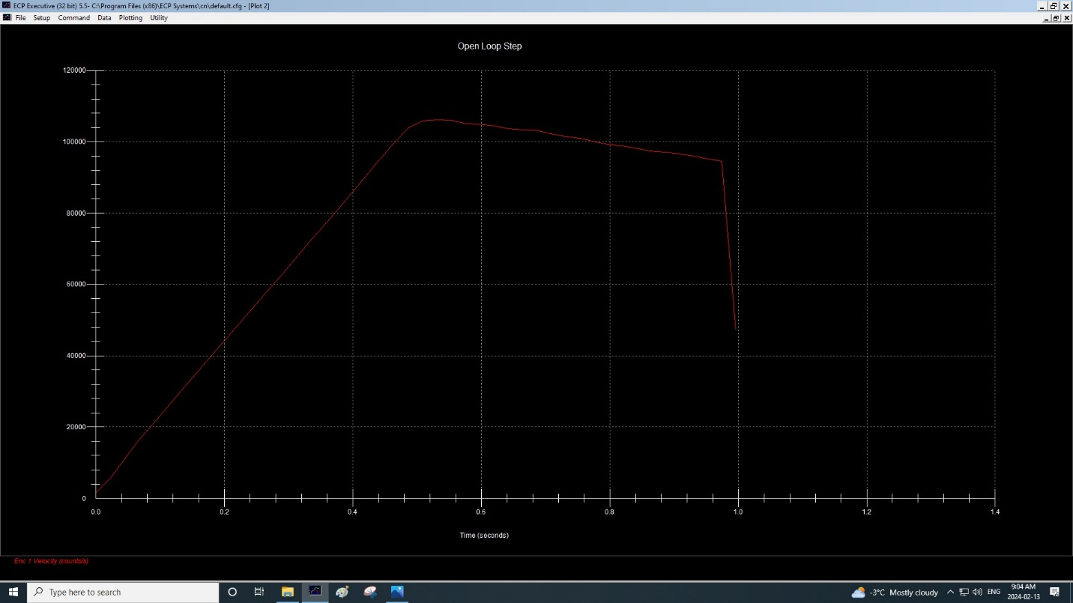

Figure 3.1.2

This is similar is obtain by performing the exact same procedure as the one before it, however we added an additional weight to the system. Notice how the shape of the graph of figure 3.2 is very similar to figure 3.1. Both increases linearly and both stops around 0.5 seconds. However, a major difference is the peak. For the non-weighted system, the peak reached around 116000, while the weighted system could only reach 106000. This means that had a higher velocity or acceleration rate compared to the weighted system.

Using Equation (4.4), determine the value of J and compare the value obtained with the calculated nominal value given in sections (4.2.1) and (4.2.2) and find the % error.

The experimental value of J is calculated as such:

The % error is calculated as such:

The percent error is around 51%. It is unavoidable that we obtain a high percent error since the values of y and x used to calculated a1 and a2 are rough estimates.

Using the determined value of J, find KaKtKe using Equation (4.3). Multiply this value by KsKc to obtain K (see section 4.2.1) for the equipment at your lab station.

The value of K obtained by using the determined value of J is 3.39.

3.2) EVALUATION OF J AND K USING OPEN-LOOP POSITION OUTPUT

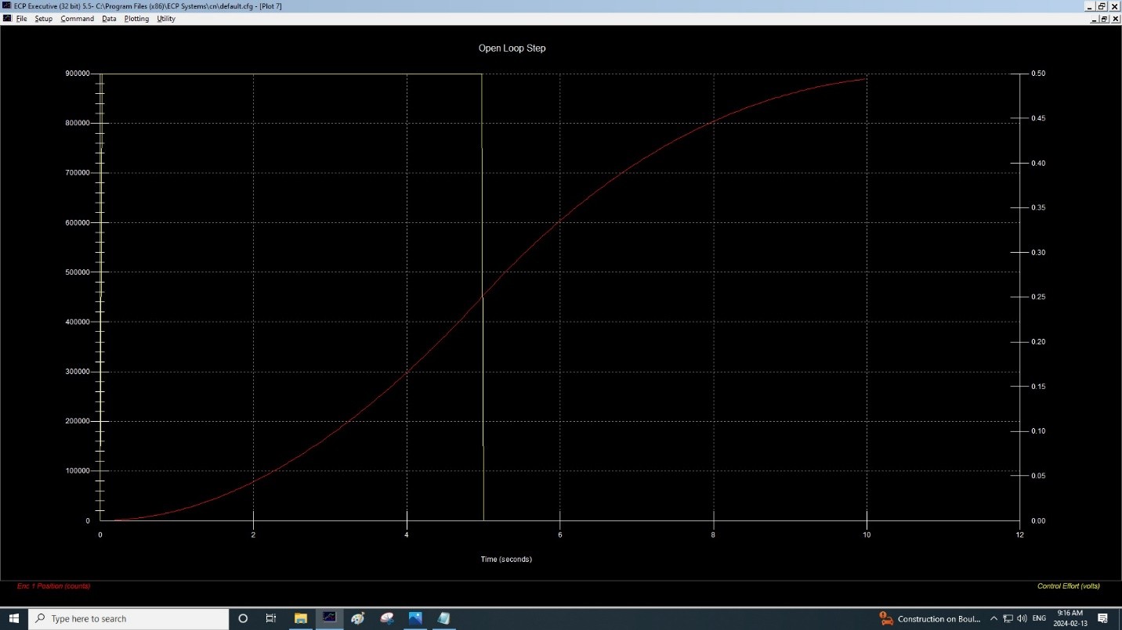

Figure 3.2.1

The left axis is encoder #1 position while CE is the right axis with both in relation to time on the x axis. This can be visually seen with the red line (position) and the yellow line (CE).

Determine the slope S of the line (in Counts/sec) and the time-axis intercept τ (sec).

Convert from counts to radians:

From the displayed time-axis intercept, determine the time-constant τ = J/B from x-axis intercept.

Based on figure 3.2.1, the intercept is at 2 seconds.

Determine J:

As such, the experimental value of J is 3.565*10-3 and B is 1.7825*10-3.

Compare with the determined value of 4.3.1 and obtain the average value:

The value of J in 4.3.1 is 2.8*10-3.

The value earlier is J is 3.565*10-3.

As such, the average value of J is 3.1825*10-3.

Percentage Error:

The percentage error is around 33%.

Record the average value of J, and the values of B and K obtained, these values are to be used in

subsequent lab work.

Average of J: 3.1825*10-3 kgm2

B: 1.7825*10-3 Nm/radian

K: 3.39 Nm/radian

3.3) SYSTEM IDENTIFICATION VIA THE OPEN-LOOP RESPONSE TO A SINE SWEEP INPUT

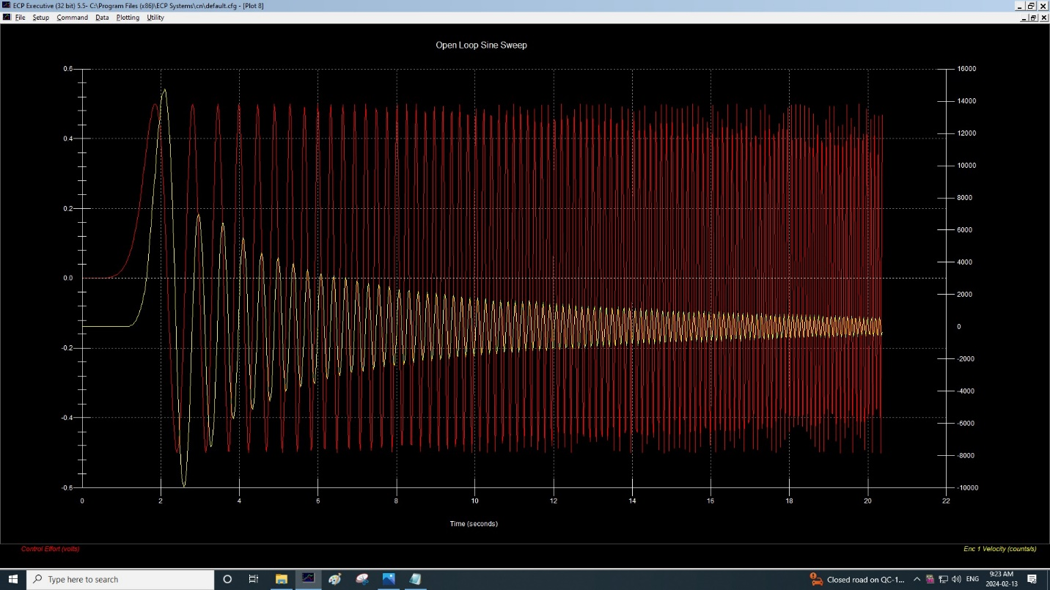

Figure 3.3.1

The above figure has CE displayed on the left axis and encoder #1 velocity on the right axis with both dependent on times in seconds. This is an open-loop system with sweep input of 0.1 to 10Hz and 0.5 volt with sweep time of 20 seconds.

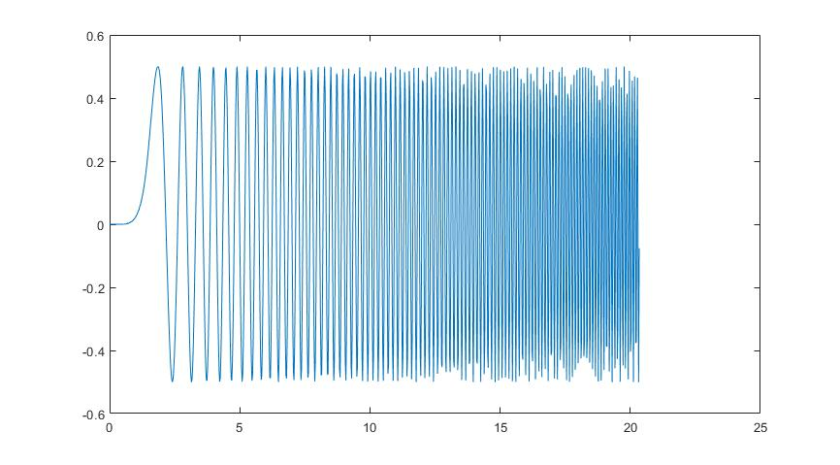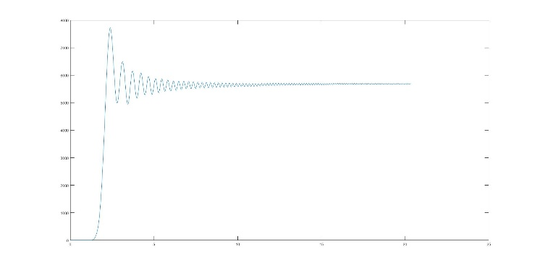

Figure 3.3.2

The above figure represents the MATLAB model obtained when running the MATLAB code found in the appendix. We can observe that figure 3.3.1 and 3.3.2 are the exact same. The left MATLAB figure is the red line CE, while the right figure is the yellow velocity.

3.4) SYSTEM IDENTIFICATION VIA CLOSED-LOOP SYSTEM RESPONSE

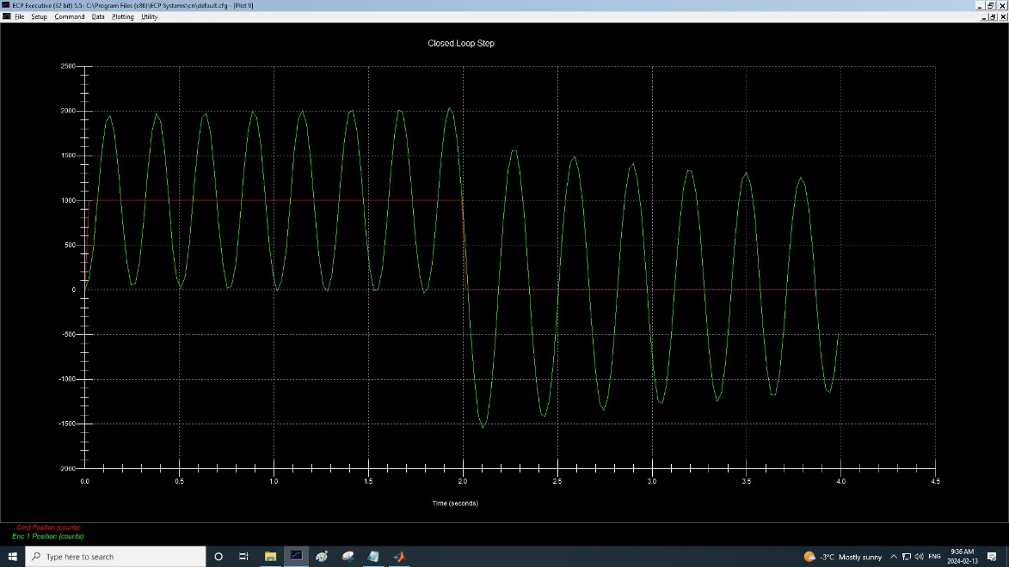

Figure 3.4.1

The commanded position and encoder #1 position are both on the left axis. The algorithm input is Kp = 1, Kd = 0 and Ki = 0.

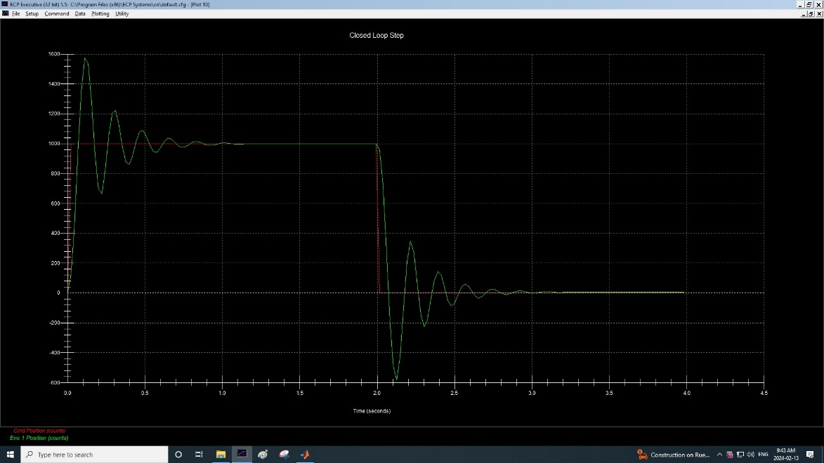

Figure 3.4.2

The system was running exactly the same except that we changed the algorithm input to Kp = 1, Kd = 0.01 and Ki = 0.

Their MATLAB simulation counterparts are as follows:

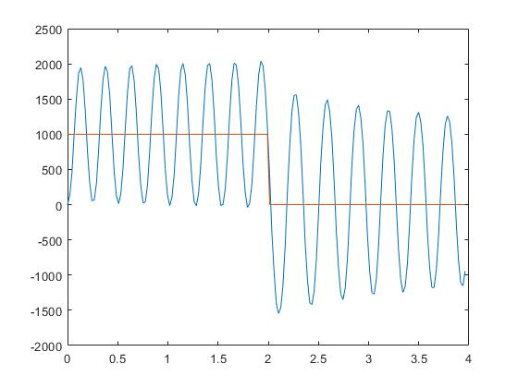

Figure 3.4.3

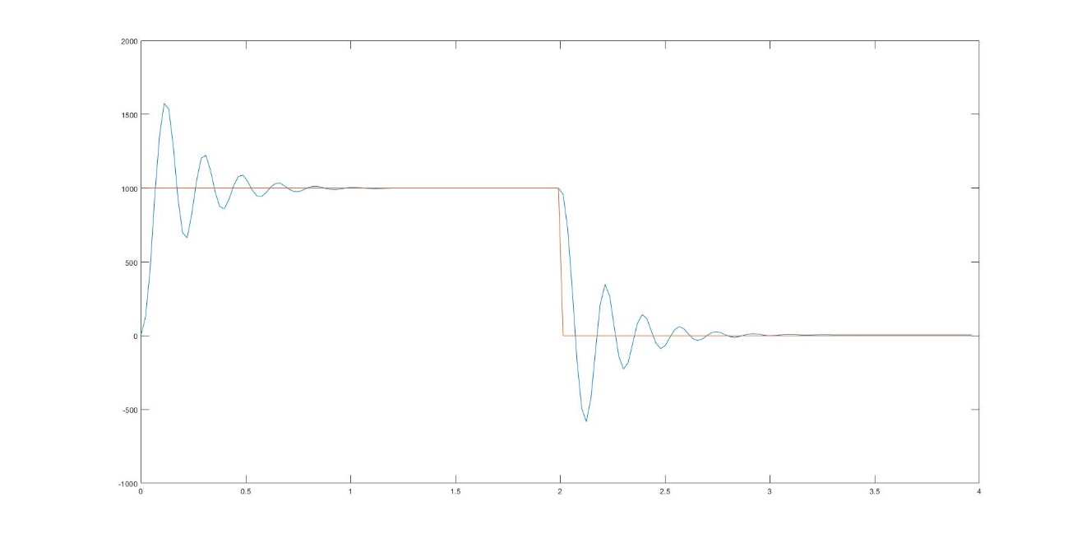

Figure 4.3.4

It can be observed that their MATLAB counterparts are very similar, thus proving that our experimental and theoretical systems are behaving accordingly. Given these sounds results, we can calculate and find the first-order transfer functions.

Calculate system the open-loop transfer function (OLTF) with the determined values of K, J and B from open-loop tests in section 4.3.2 and 4.3.3.

Obtain the OLTF in MATLAB by the data of the closed-loop test., then calculate K, B and J.

Given this equation, we can find K = 6623, B = 28.07 and J = 1.

Compare these models

For this experiment, we have obtained models from the lab equipment as well as the simulation done through MATLAB. It can be observed from those figures that both types of models are similar. While we might encounter slight differences when observing specific data points, the general tendencies are similar.

Write a brief summary about how the lab equipment might facilitate a better understanding of control systems

Theory learned during lectures can only go so far. The best method to encapsulates theory is through practice. As such, by having students perform the experiment by themselves, they are able to grasp the topic and understand it better. In other words, lab equipment allows for experimentations which in turn facilitate a better understanding. In the end, this approach bridges the theory with practical application as it provides hands-on experience.

**4) Questions**

None

**5) Conclusions**

In conclusion, the students performed experiments on system identification and control system analysis of an open-loop and closed-loop response systems. We observed the effect of inertia, damping coefficient and gain. Then, by performing both the experiment with the lab equipment and a simulation through MATLAB, students are able to compare plots and analyse the effect due to changes in parameters.

**6) Appendix**

MATLAB Code used for this lab:

time = data(:,2);  
y = data(:,4);  
u = data(:,6);  
dy = diff(**y**);  
dy(**end** + 1) = dy(**end**);  
zf = iddata(**dy**,u,0.00884);  
tfl = tfest(**zf**,1,0);  
plot(**time**, y);  
plot(**time**, u);

time = data(:,2);  
y = data(:,4);  
u = data(:,6);  
dy = diff(**y**);  
dy(**end** + 1) = dy(**end**);  
zf = iddata(**dy**,u,0.00884);  
tfl = tfest(**zf**,1,0);  
plot(**time**, y);  
plot(**time**, u);

time = data(:,2);  
y = data(:,4);  
u = data(:,3);  
zf = iddata(**y**,u,0.00884);  
Tfd2 = tfest(**zf**,2,0);  
  
plot(**time**, y);  
hold on;  
plot(**time**, u);

Sample example of gather raw data used in MATLAB

Sample Time Commanded Pos Encoder 1 Pos Encoder 2 Pos Control Effort  
  
[ 0 0.000 1000 0 0 0.0000;  
 1 0.022 1000 125 12 4.8840;  
 2 0.044 1000 445 95 4.0611;  
 3 0.066 1000 942 229 -1.3022;  
 4 0.089 1000 1354 355 -4.7595;  
 5 0.111 1000 1574 409 -4.8840;  
 6 0.133 1000 1537 405 -4.8565;  
 7 0.155 1000 1278 334 -1.5201;  
 8 0.177 1000 929 234 1.9359;  
 9 0.199 1000 698 160 3.6044;  
 10 0.221 1000 663 152 3.1746;  
 11 0.243 1000 829 198 0.9225;  
 12 0.266 1000 1053 262 -1.3352;  
 13 0.288 1000 1204 307 -2.4066;  
 14 0.310 1000 1222 315 -2.0977;  
 15 0.332 1000 1121 286 -0.7070;  
 16 0.354 1000 976 246 0.7552;  
 17 0.376 1000 875 217 1.5079;  
 18 0.398 1000 860 211 1.3272;  
 19 0.421 1000 926 230 0.4164;  
 20 0.443 1000 1018 255 -0.5055;  
 21 0.465 1000 1080 272 -0.9542;  
 22 0.487 1000 1088 275 -0.8474;  
 23 0.509 1000 1046 263 -0.2521;  
 24 0.531 1000 987 248 0.3358;  
 25 0.553 1000 948 237 0.6215;  
 26 0.576 1000 943 235 0.5714;  
 27 0.598 1000 971 242 0.1551;  
 28 0.620 1000 1008 252 -0.2125;  
 29 0.642 1000 1032 259 -0.3822;  
 30 0.664 1000 1034 260 -0.3462;  
 31 0.686 1000 1015 255 -0.0714;  
 32 0.708 1000 992 249 0.1593;  
 33 0.730 1000 977 245 0.2637;  
 34 0.753 1000 976 244 0.2393;  
 35 0.775 1000 988 247 0.0562;  
 36 0.797 1000 1003 251 -0.0836;  
 37 0.819 1000 1012 253 -0.1477;  
 38 0.841 1000 1013 254 -0.1313;  
 39 0.863 1000 1006 253 -0.0220;  
 40 0.885 1000 996 250 0.0659;  
 41 0.908 1000 991 248 0.1136;  
 42 0.930 1000 990 248 0.1026;  
 43 0.952 1000 994 248 0.0379;  
 44 0.974 1000 1000 250 -0.0214;  
 45 0.996 1000 1004 251 -0.0476;  
 46 1.018 1000 1004 251 -0.0433;  
 47 1.040 1000 1003 251 0.0024;  
 48 1.063 1000 1000 251 0.0147;  
 49 1.085 1000 998 251 0.0311;  
 50 1.107 1000 997 251 0.0385;  
 51 1.129 1000 997 251 0.0342;  
 52 1.151 1000 998 251 0.0195;  
 53 1.173 1000 999 251 0.0012;  
 54 1.195 1000 1000 251 -0.0079;  
 55 1.217 1000 1000 251 -0.0043;  
 56 1.240 1000 1000 251 -0.0043;  
 57 1.262 1000 1000 251 -0.0043;  
 58 1.284 1000 1000 251 -0.0043;  
 59 1.306 1000 1000 251 -0.0043;  
 60 1.328 1000 1000 251 -0.0043;  
 61 1.350 1000 1000 251 -0.0043;  
 62 1.372 1000 1000 251 -0.0043;  
 63 1.395 1000 1000 251 -0.0043;  
 64 1.417 1000 1000 251 -0.0043;  
 65 1.439 1000 1000 251 -0.0043;  
 66 1.461 1000 1000 251 -0.0043;  
 67 1.483 1000 1000 251 -0.0043;  
 68 1.505 1000 1000 251 -0.0043;  
 69 1.527 1000 1000 251 -0.0043;  
 70 1.549 1000 1000 251 -0.0043;  
 71 1.572 1000 1000 251 -0.0043;  
 72 1.594 1000 1000 251 -0.0043;  
 73 1.616 1000 1000 251 -0.0043;  
 74 1.638 1000 1000 251 -0.0043;  
 75 1.660 1000 1000 251 -0.0043;  
 76 1.682 1000 1000 251 -0.0043;  
 77 1.704 1000 1000 251 -0.0043;  
 78 1.727 1000 1000 251 -0.0043;  
 79 1.749 1000 1000 251 -0.0043;  
 80 1.771 1000 1000 251 -0.0043;  
 81 1.793 1000 1000 251 -0.0043;  
 82 1.815 1000 1000 251 -0.0043;  
 83 1.837 1000 1000 251 -0.0043;  
 84 1.859 1000 1000 251 -0.0043;  
 85 1.882 1000 1000 251 -0.0043;  
 86 1.904 1000 1000 251 -0.0043;  
 87 1.926 1000 1000 251 -0.0043;  
 88 1.948 1000 1000 251 -0.0043;  
 89 1.970 1000 1000 251 -0.0043;  
 90 1.992 1000 1000 251 -0.0043;  
 91 2.014 0 958 250 -4.8840;  
 92 2.036 0 724 199 -4.8840;  
 93 2.059 0 286 86 -0.9280;  
 94 2.081 0 -182 -54 3.3529;  
 95 2.103 0 -494 -143 4.8840;  
 96 2.125 0 -583 -163 4.8840;  
 97 2.147 0 -423 -124 3.3303;  
 98 2.169 0 -98 -30 -0.3254;  
 99 2.191 0 211 62 -3.0531;  
 100 2.214 0 347 102 -3.6783;  
 101 2.236 0 269 81 -2.0940;  
 102 2.258 0 58 20 0.2411;  
 103 2.280 0 -141 -36 2.0238;  
 104 2.302 0 -226 -63 2.3748;  
 105 2.324 0 -184 -51 1.4927;  
 106 2.346 0 -52 -15 -0.0183;  
 107 2.368 0 81 22 -1.2289;  
 108 2.391 0 143 40 -1.5263;  
 109 2.413 0 117 34 -0.9420;  
 110 2.435 0 32 10 0.0293;  
 111 2.457 0 -51 -12 0.7668;  
 112 2.479 0 -87 -22 0.9274;  
 113 2.501 0 -68 -18 0.5281;  
 114 2.523 0 -12 -3 -0.1007;  
 115 2.546 0 40 12 -0.5574;  
 116 2.568 0 62 18 -0.6380;  
 117 2.590 0 47 15 -0.3700;  
 118 2.612 0 11 5 0.0421;  
 119 2.634 0 -21 -4 0.3053;  
 120 2.656 0 -33 -7 0.3407;  
 121 2.678 0 -22 -6 0.1538;  
 122 2.701 0 1 1 -0.1062;  
 123 2.723 0 21 6 -0.2741;  
 124 2.745 0 27 8 -0.2680;  
 125 2.767 0 20 8 -0.1526;  
 126 2.789 0 5 3 0.0110;  
 127 2.811 0 -7 0 0.1068;  
 128 2.833 0 -11 -1 0.1026;  
 129 2.855 0 -6 -1 0.0354;  
 130 2.878 0 4 1 -0.0769;  
 131 2.900 0 11 4 -0.1386;  
 132 2.922 0 13 5 -0.1313;  
 133 2.944 0 11 5 -0.0958;  
 134 2.966 0 5 4 -0.0281;  
 135 2.988 0 1 2 -0.0049;  
 136 3.010 0 1 2 -0.0049;  
 137 3.033 0 2 2 -0.0531;  
 138 3.055 0 6 2 -0.0672;  
 139 3.077 0 7 2 -0.0726;  
 140 3.099 0 7 2 -0.0726;  
 141 3.121 0 7 2 -0.0726;  
 142 3.143 0 5 2 -0.0379;  
 143 3.165 0 4 2 -0.0324;  
 144 3.188 0 4 2 -0.0342;  
 145 3.210 0 5 2 -0.0824;  
 146 3.232 0 6 2 -0.0653;  
 147 3.254 0 6 2 -0.0672;  
 148 3.276 0 6 2 -0.0629;  
 149 3.298 0 5 2 -0.0488;  
 150 3.320 0 5 2 -0.0488;  
 151 3.342 0 5 2 -0.0488;  
 152 3.365 0 5 2 -0.0488;  
 153 3.387 0 5 2 -0.0488;  
 154 3.409 0 5 2 -0.0488;  
 155 3.431 0 5 2 -0.0488;  
 156 3.453 0 5 2 -0.0488;  
 157 3.475 0 5 2 -0.0488;  
 158 3.497 0 5 2 -0.0488;  
 159 3.520 0 5 2 -0.0488;  
 160 3.542 0 5 2 -0.0488;  
 161 3.564 0 5 2 -0.0488;  
 162 3.586 0 5 2 -0.0488;  
 163 3.608 0 5 2 -0.0488;  
 164 3.630 0 5 2 -0.0488;  
 165 3.652 0 5 2 -0.0488;  
 166 3.674 0 5 2 -0.0488;  
 167 3.697 0 5 2 -0.0488;  
 168 3.719 0 5 2 -0.0488;  
 169 3.741 0 5 2 -0.0488;  
 170 3.763 0 5 2 -0.0488;  
 171 3.785 0 5 2 -0.0488;  
 172 3.807 0 5 2 -0.0488;  
 173 3.829 0 5 2 -0.0488;  
 174 3.852 0 5 2 -0.0488;  
 175 3.874 0 5 2 -0.0488;  
 176 3.896 0 5 2 -0.0488;  
 177 3.918 0 5 2 -0.0488;  
 178 3.940 0 5 2 -0.0488;  
 179 3.962 0 5 2 -0.0488]