Fundamentals of Control Systems

Elec 372

Lab Experiment #3

Andre Hei Wang Law

4017 5600

Section UJ-X

TA: Saba Sanami

TA Email: [sabasanami272@gmail.com](mailto:sabasanami272@gmail.com)

Professor: Amir Aghdam

Performed on March 5, 2024

Due on March 19, 2024

Table of Contents

**1) Objectives** 3

**2) Theory** 3

**3) Tasks / Results / Discussions** 4

3.1 PID Control Tasks 4

3.2 Steady State Error Analysis 11

3.3 Disturbance Attenuation 15

**4) Conclusions** 17

**5) Appendix** 17

“I certify that this submission is my original work and meets the Faculty’s Expectations of

Originality.”

Andre Hei Wang Law

4017 5600

19/03/2024

# **1) Objectives**

The objective of the third experiment of the course Elec 372 is to understand the principles behind improving system performance through PB, PI and PID control. Students will also perform experiment to learn about the elimination of a steady state error due to a disturbance input.

# **2) Theory**

**PID-Control**: Proportional Integral Derivative Control serves to integrate an error signal in order to reduce or eliminate steady state output offset. It improves performance and maintains stability.

**Steady State Error**: This analysis can be examined based on the final value theorem and error coefficients which depends on the type of system as well as the input signals (step, ramp, parabolic, etc.). All systems have different requirements of control to reduce steady state error.

**Disturbance Control**: The disturbance input is reduced based on PI control. We are able to analyse the disturbance transfer function to observe the impact of loop gain on disturbance rejection.

# **3) Tasks / Results / Discussions**

## 3.1 PID Control Tasks

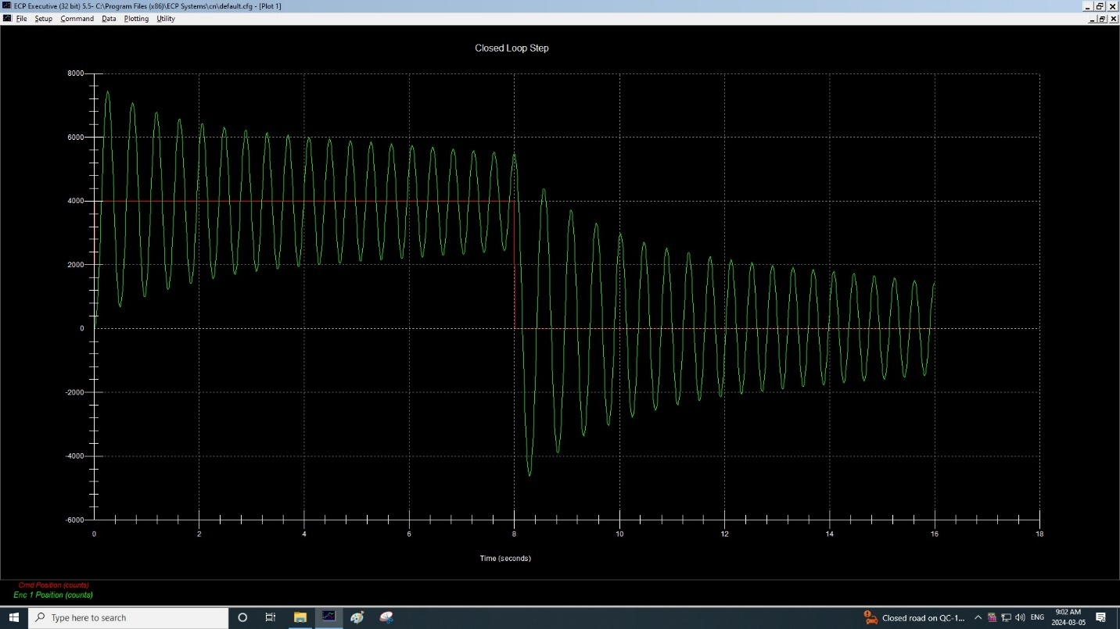Figure 3.1.1 PI-Control

Percentage Overshoot = (ymax-yss)/yss=(7500-4000)/4000=87.5%

Tp ≈ 0.15s

ωd = π/Tp = 20.94 rad/s

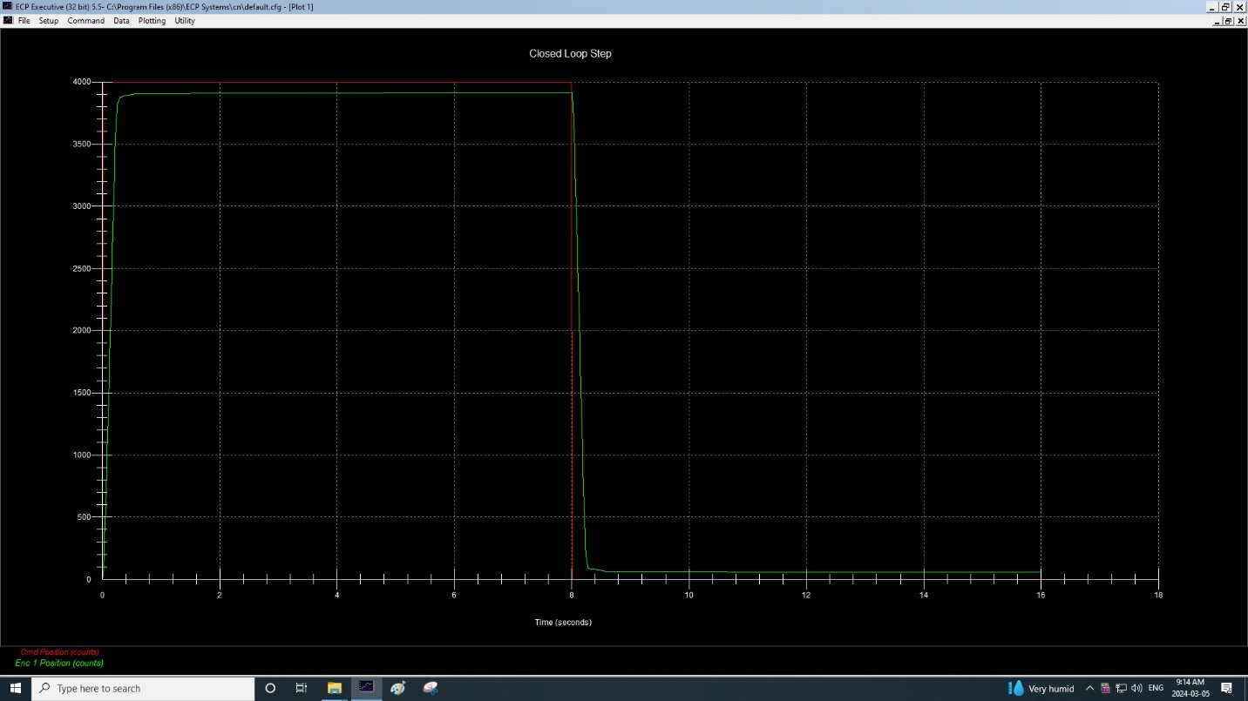Figure 3.1.2 PI-Control with Viscous Friction

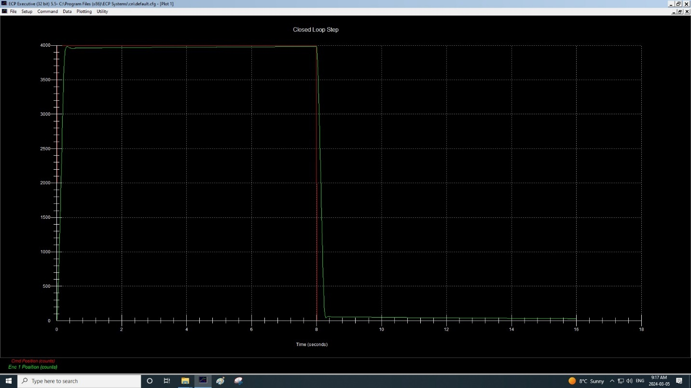Figure 3.1.3 (Ki = 0.02) PI-Control with adjusted Ki

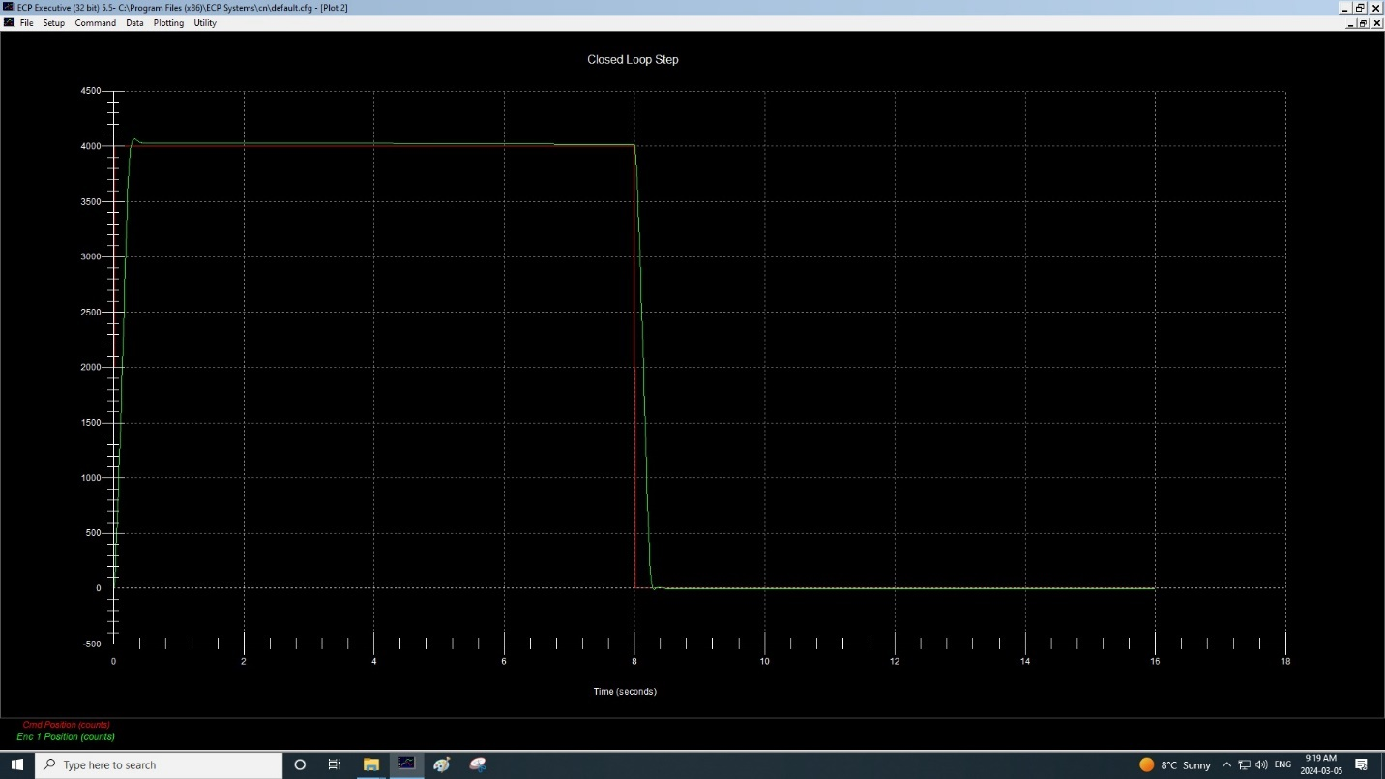Figure 3.1.4 (Ki = 0.04) PI-Control with adjusted Ki

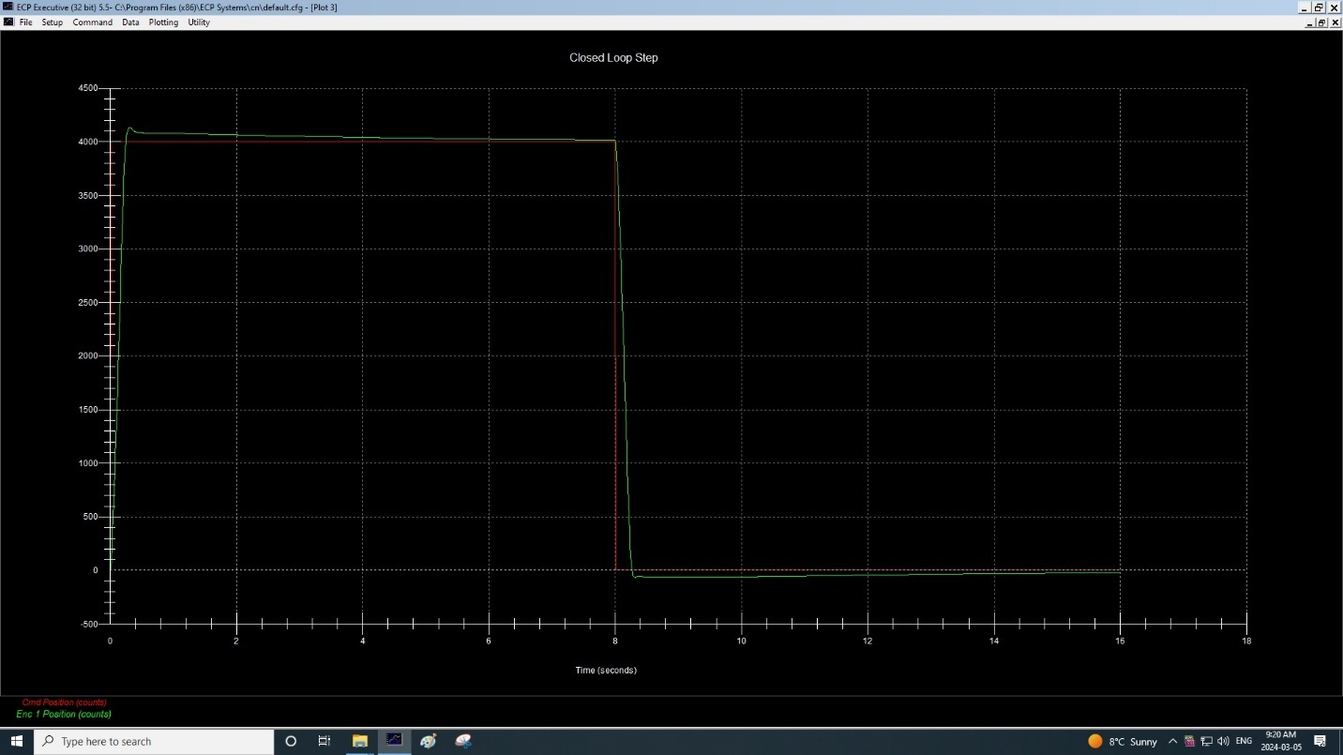Figure 3.1.5 (Ki = 0.06) PI-Control with adjusted Ki

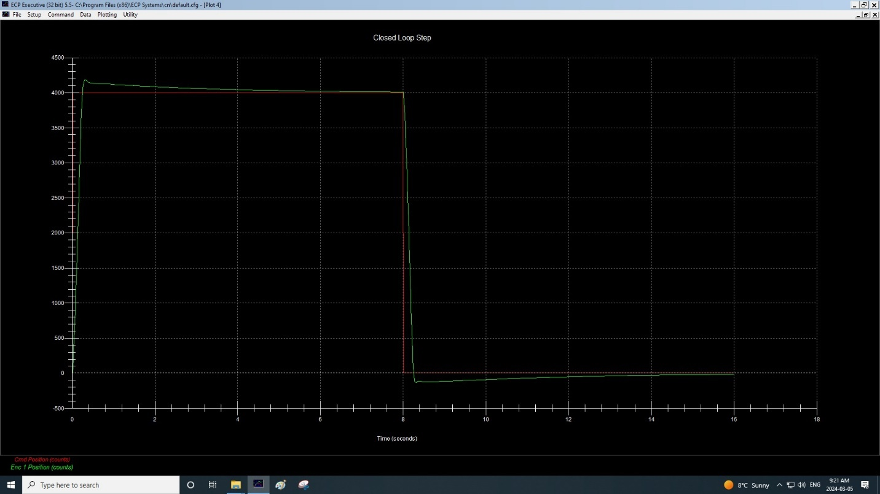Figure 3.1.6 (Ki = 0.08) PI-Control with adjusted Ki

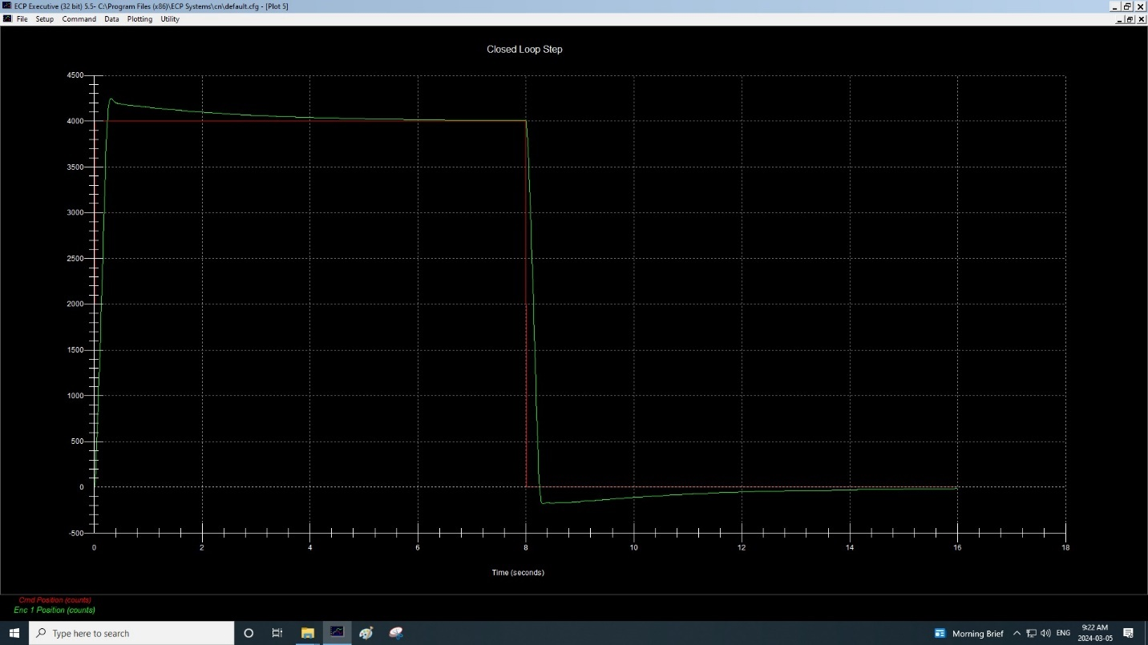Figure 3.1.7 (Ki = 0.1) PI-Control with adjusted Ki

For the above 7 figures, they represent the results obtained by performing task 5.3.1 PI-CONTROL of the lab manual. This section investigates the effectiveness of PI control in reducing steady state error for a closed loop system. We tested a system with proportional control, followed by integral feedback. Then, Figure 3.1.3 through Figure 3.1.7, we increased the integral gain Ki to find the optimal value which minimizes steady state error. So, value of Ki = 0.04 minimizes the steady state error.

**Results**

Describe the effect of increase in Ki on the offset error and on the overshoot.

Increasing Ki will reduce system offset error, but it also increases overshoot. Observing Figure 3.1.3 (Ki = 0.02), we can notice that it has a slight offset error. However, by increasing Ki to 0.04 such as Figure 3.1.4 (Ki = 0.04), notice how the offset error is reduced. As for the overshoot, observe Figure 3.1.7 (Ki = 0.1) which has a significant higher overshoot compared to Figure 3.1.4 due to its higher Ki value.

Derive the CLTF for the PID system (#1 in Figure 5.1) and obtain the relation between coefficients required for stability.

Using the values of B and K from page 7 of my own lab experiment 2, we have:

J: 3.1825*10-3 kgm2 or 0.0031825

B: 1.7825*10-3 Nm/radian or 0.0017825

K: 3.39 Nm/radian

(3.1825*10-3)s2 + (1.7825*10-3)s + 0.1356 = as3 + bs2 + cs + d

Know that no root will have a positive real part if the condition bc>ad is satisfied. In this case, bc is equal to a positive number while ad is equal to zero, thus this condition is satisfied. As such, no root will be a positive real part.

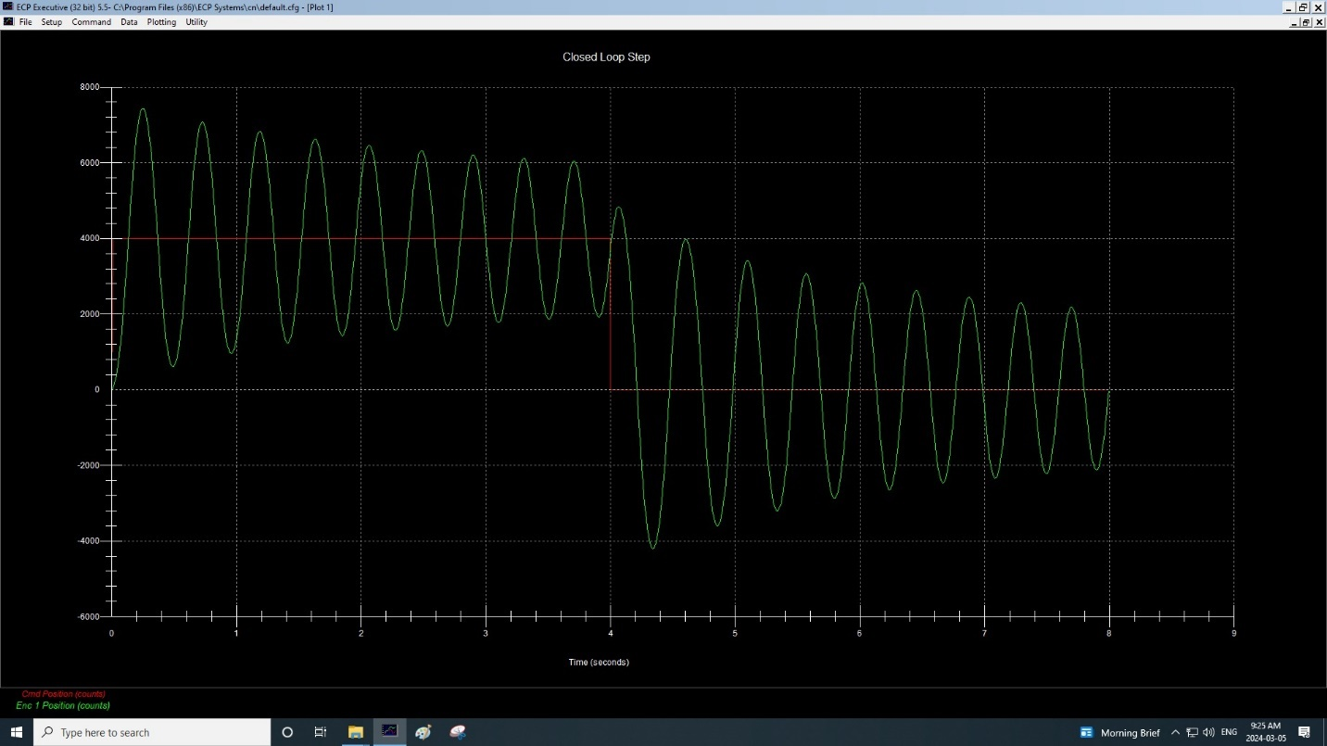Figure 3.1.8 PID-Control

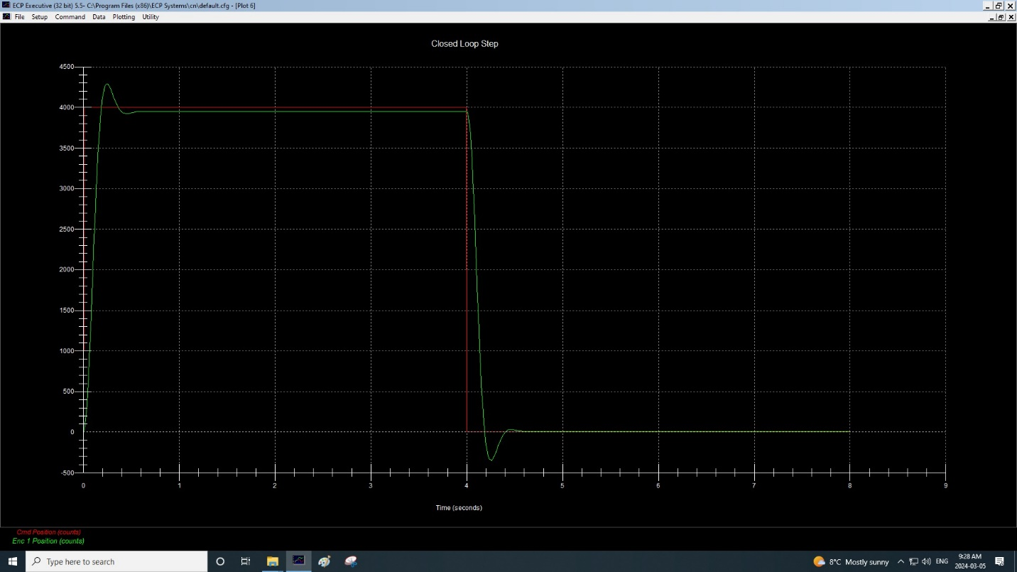Figure 3.1.9 (Kd = 0.014) PID-Control with increase in Kd (desired overshoot)

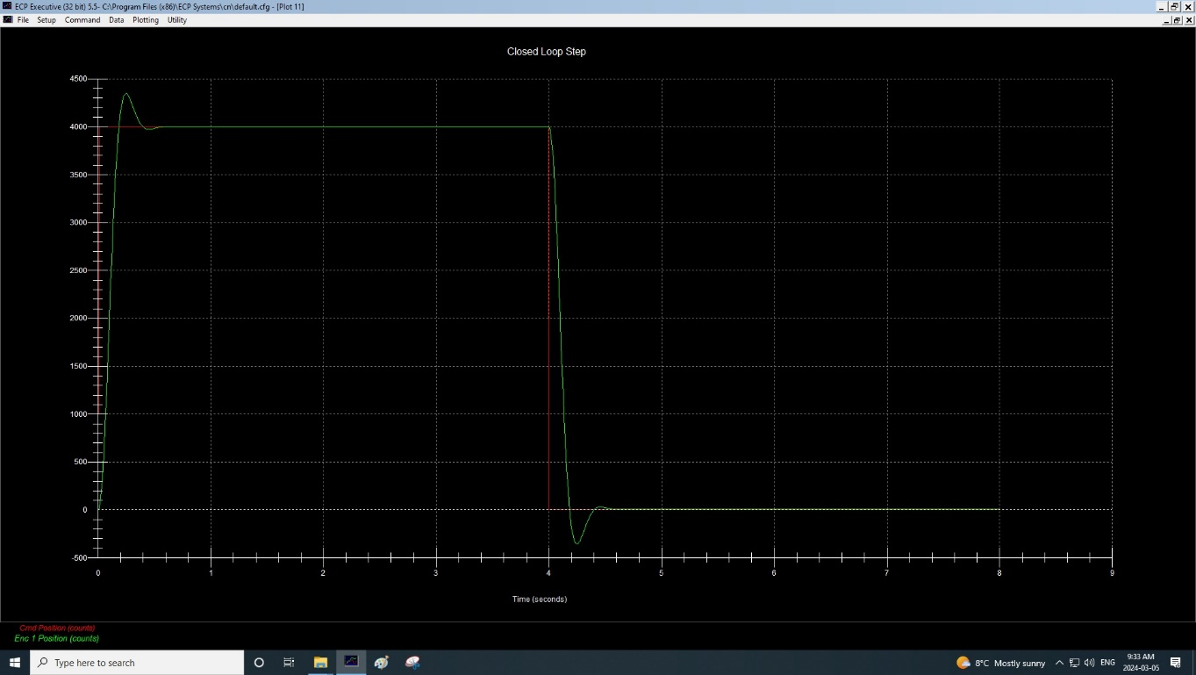Figure 3.1.10 (Ki = 0.03) PID-Control with increase in Ki (desired offset)

Tabulate your choice of controller coefficients for PID control.

|  |  |  |  |  |  |  |
| --- | --- | --- | --- | --- | --- | --- |
|  | Kp | Ki | Kd | Step Size | Dwell Time | Rep |
| Fig 3.1.8 | 0.2 | 0 | 0 | 4000 | 4000 | 1 |
| Fig 3.1.9 | 0.2 | 0 | 0.014 | 4000 | 4000 | 1 |
| Fig 3.1.10 | 0.2 | 0.03 | 0.014 | 4000 | 4000 | 1 |

## 3.2 Steady State Error Analysis

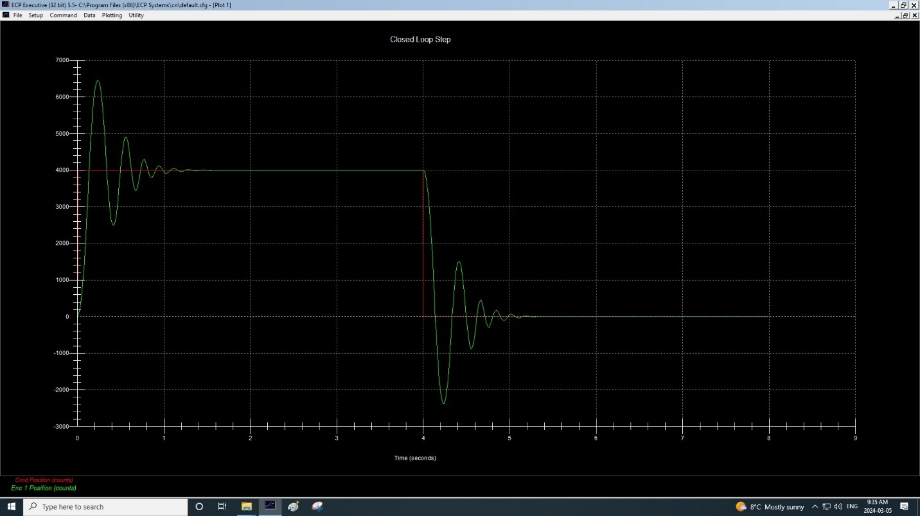Figure 3.2.1 Step Signal with PD

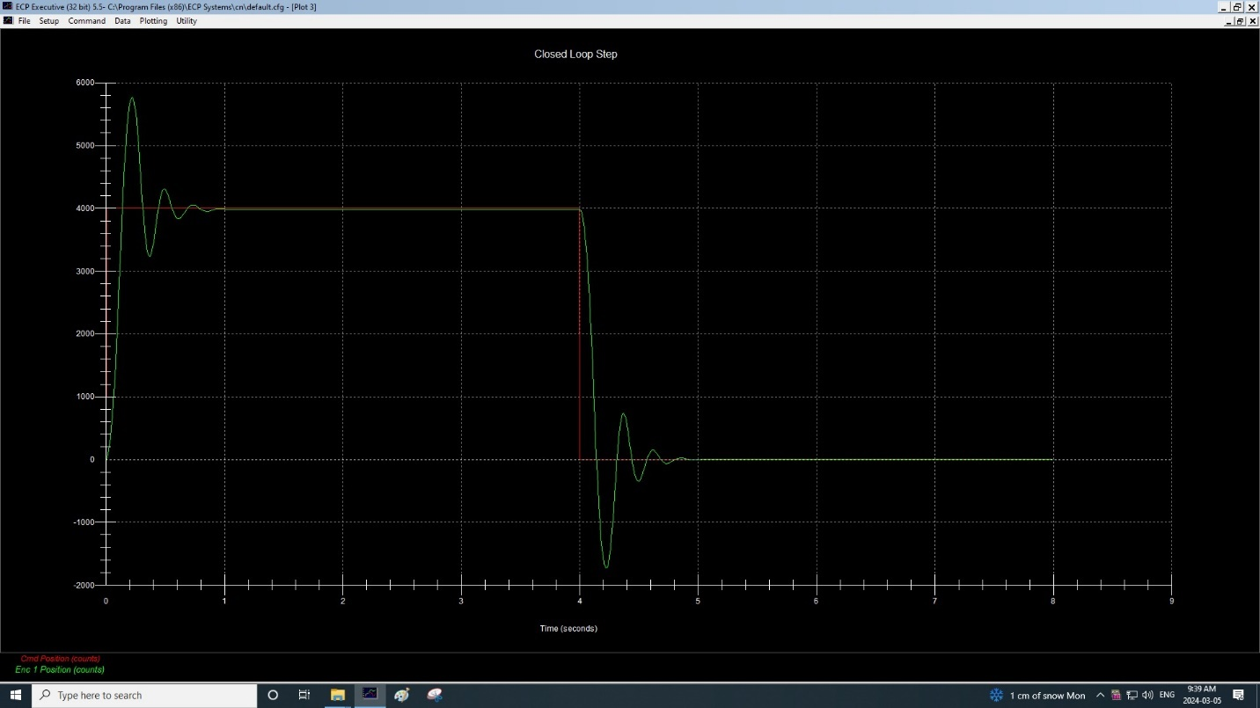Figure 3.2.2 (Kp = 0.5) Step Signal with PD

Percentage Overshoot = (ymax-yss)/yss=(5800-4000)/4000=45%

Tp ≈ 0.2s

ωd = π/Tp = 5π rad/s

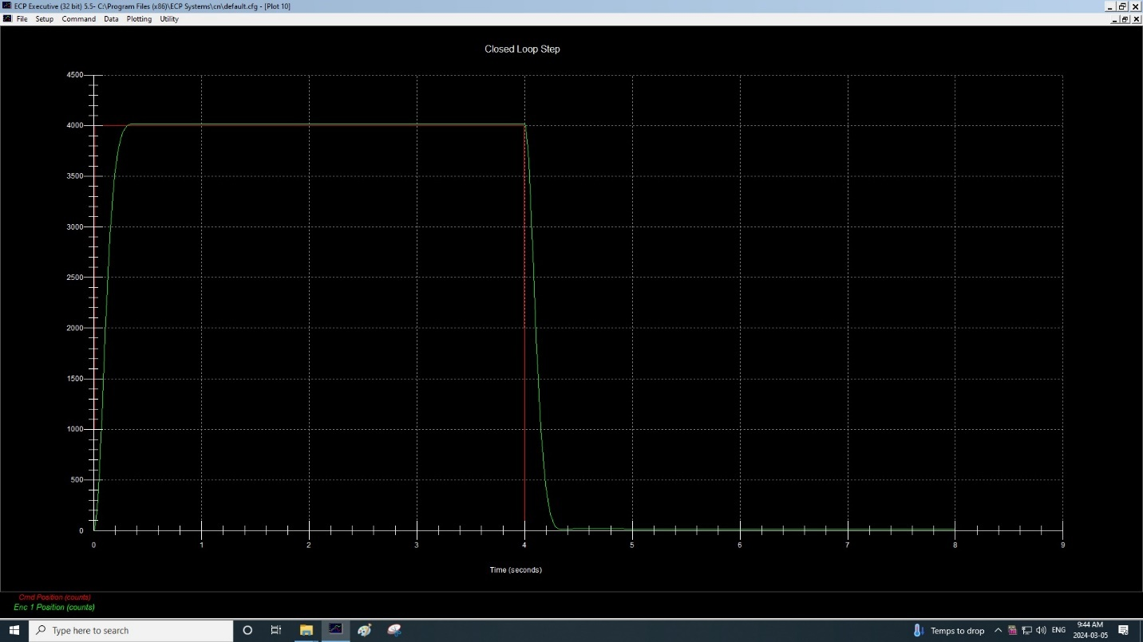Figure 3.2.3 (Kp = 0.2, Kd = 0.02, Ki = 0.05) Step Signal with Stable PD

This first and second figure have a high percentage offset which can be seen by how unstable it looks. For figure 3.2.3, we changed the input values until the system is stable such that the values are Kp = 0.2, Kd = 0.02, Ki = 0.05. This can be observed by how similar its pattern is to the step signal that rises to 4000 and drops to 0 every 4 seconds.

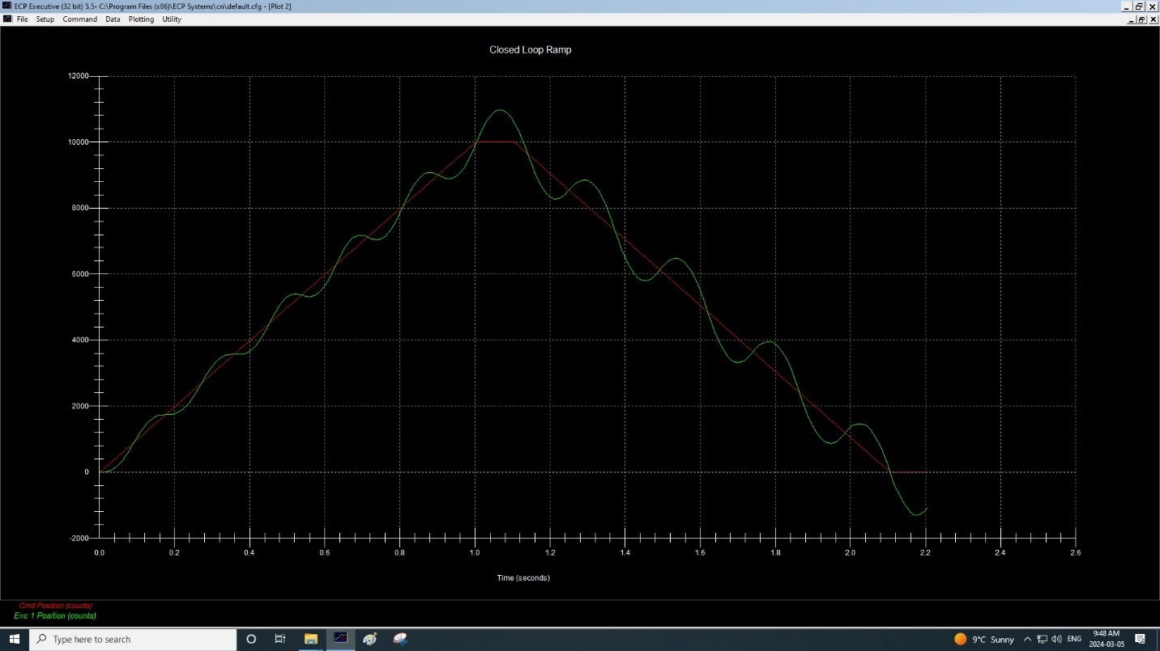Figure 3.2.4 Ramp Signal (PI + Velocity Feedback)

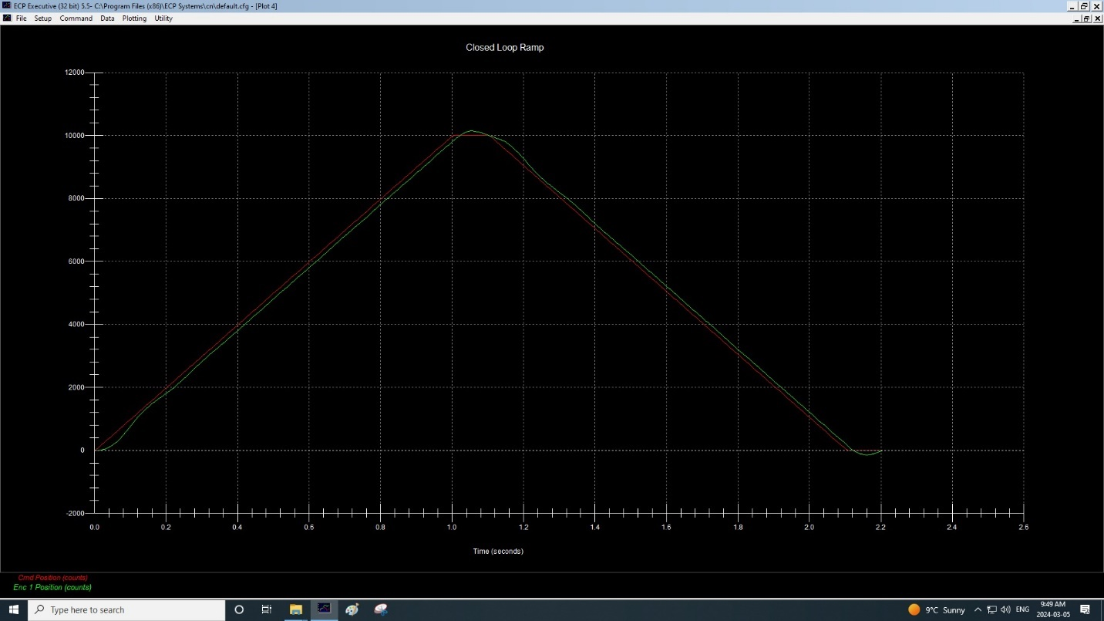Figure 3.2.5 Ramp Signal (PID)

Based on figure 3.2.5, we have two points for the red line, P1(0.4, 4000) and P2(0.6, 6000) and two other points for the green line, P3(0.5, 4800) and P4(0.42, 4000).

Equation of rising part of the red line:

Equation of rising part of the green line:

We can confirm that both lines are parallel. The steady state step error is then the difference between the intercept of the red and green line which is 200.

**RESULTS**

Is there any change in the step response between the two cases?

Both Figure 3.1.10 and Figure 3.2.3 are step response which are set to have the least amount of offset. However, notice that Figure 3.1.10 which is the PID configuration has a higher overshoot than Figure 3.2.3 which is the PI + velocity feedback configuration.

What is the difference in the ramp response between the two cases?

As for the difference in the ramp response, it can be analysed that the ramp response with PID controller has better performance than PI + velocity feedback controller. This is due to the fact that it has a better reduced steady state error. This can be seen from Figure 3.2.4 and Figure 3.2.5 where Figure 3.2.5 has a clearer rising and falling slope.

Show velocity error-coefficients for the configurations #1 (PID) and #2 (PI+V).

PID - Closed loop transfer function:

T(s)=((KKp+KKds)G(s))/(1+(KKp+KKds)G(s))

PI+V - Closed loop transfer function:

T(s)=((KKp+KKi/s)G(s))/(1+(KKp+KKi/s)G(s))

To find Kvel, we use the steady state error equation:

ess(ramp)=1/kvel

Thus,

Kvel(PID) = KKp/B

Kvel(PI+V) = KKp/(B+KKd)

## 3.3 Disturbance Attenuation

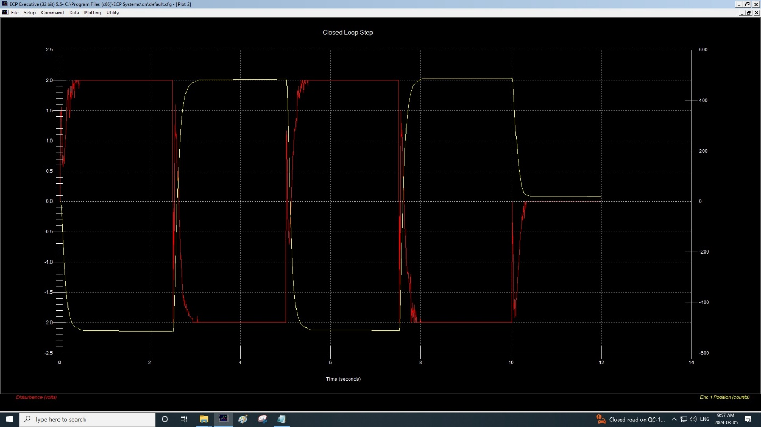Figure 3.3.1 Disturbance Step

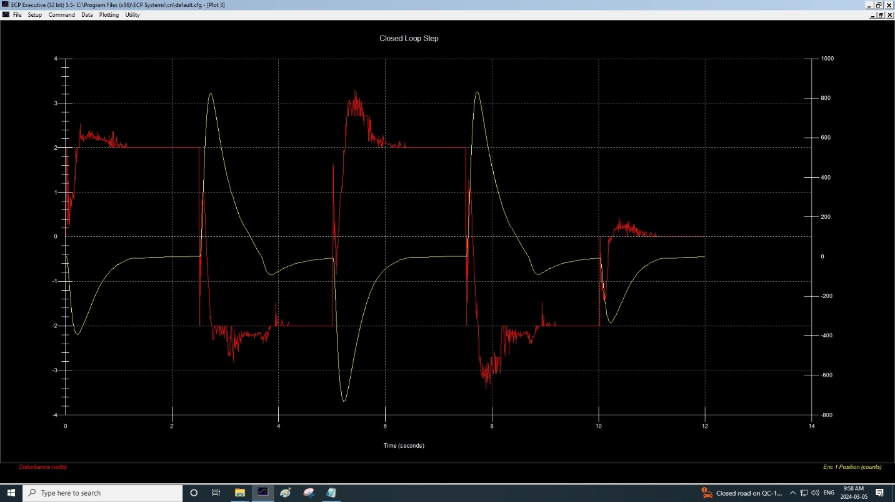Figure 3.3.2 Disturbance Step with Ki = 0.6

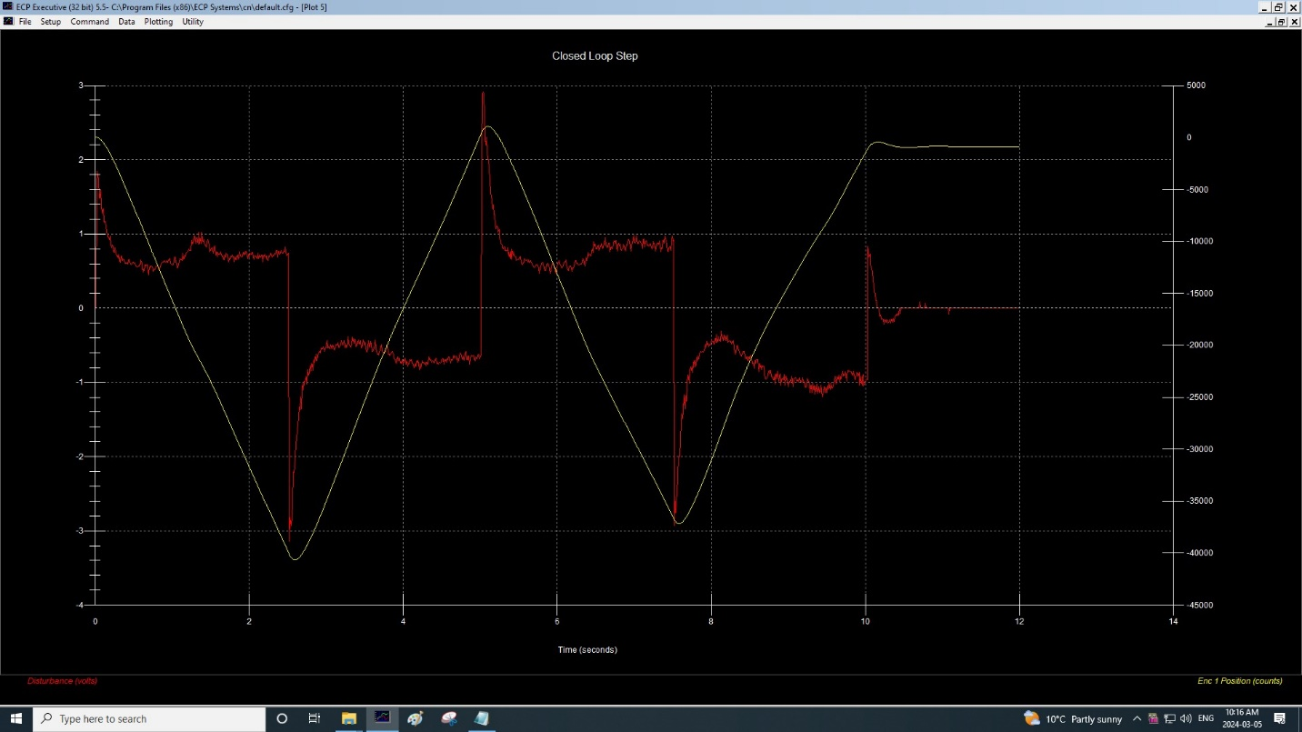Figure 3.3.3 Disturbance Step with Ki = 0.3

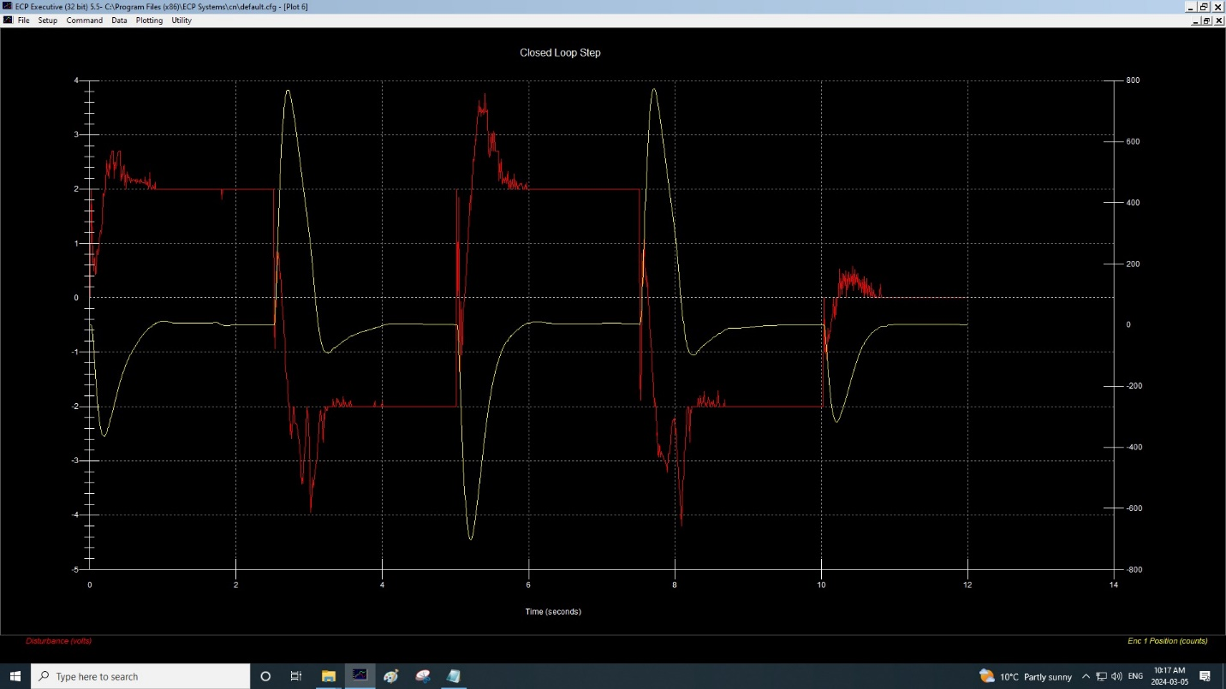Figure 3.3.4 Disturbance Step with Ki = 0.9

# **4) Conclusions**

In conclusion, the third Elec 372 experiment was performed to explore what kind of effect PID Control had on system performance. Mainly, it can be used to reduce steady state errors while also effectively attenuating disturbance. Then, it was observed that the integral and derivative terms of a controller coefficients is used to achieve optimal system response and improve stability. As such, the analysis of steady state errors under various input conditions allowed the students to better grasp design optimization and methods to reduce disturbance.

# **5) Appendix**

None