Andre J Plath

Professor David Olson

CS364 Information Management

April 3, 2018

Lab 1 Linux Fun

I-II. Connecting to a Linux Machine:

SSH into server and entered password. Changed password upon first log-in. Used “**passwd**” command to change password. The **passwd** command changes the user's password.

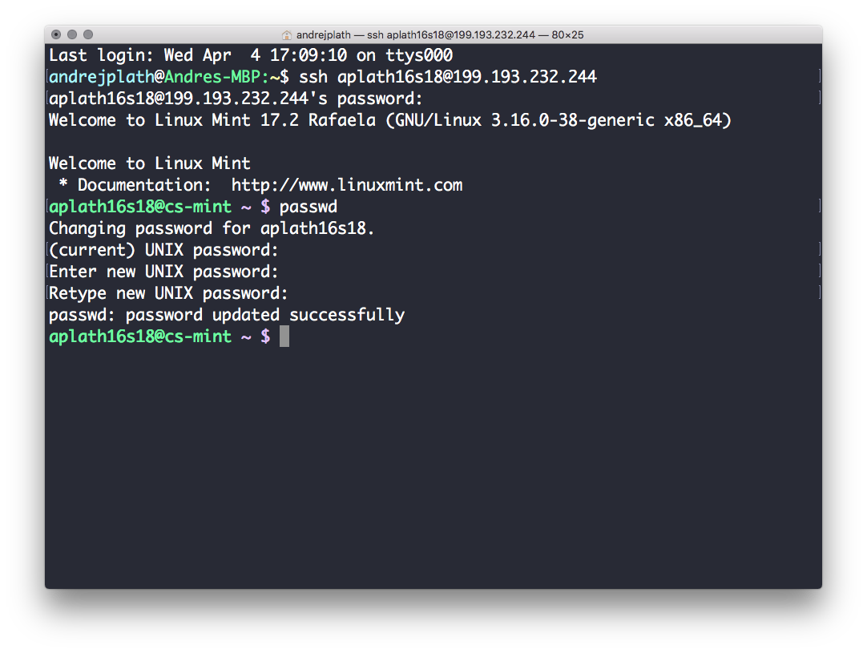

III. Basic User Commands:

1. Used the “**cat**” command to create a new txt file. The command is for viewing and adding to text files. Used “**CTRL-Z**” to save file but also can use “**CTRL-D**” for same outcome.

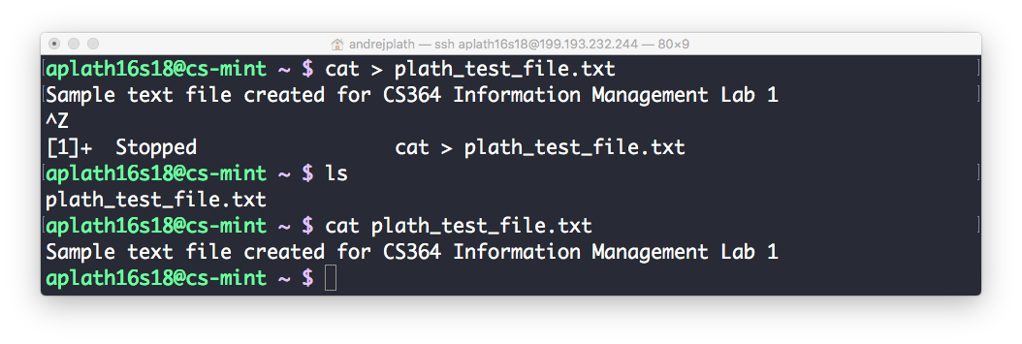

1. Used “**cd**” to change directory. The **cd** command allows you to change directories. Used “**ls**” command to list contents of directory. **The ls** command shows you the files in your current directory. Used “**cd**”to return to previous directory.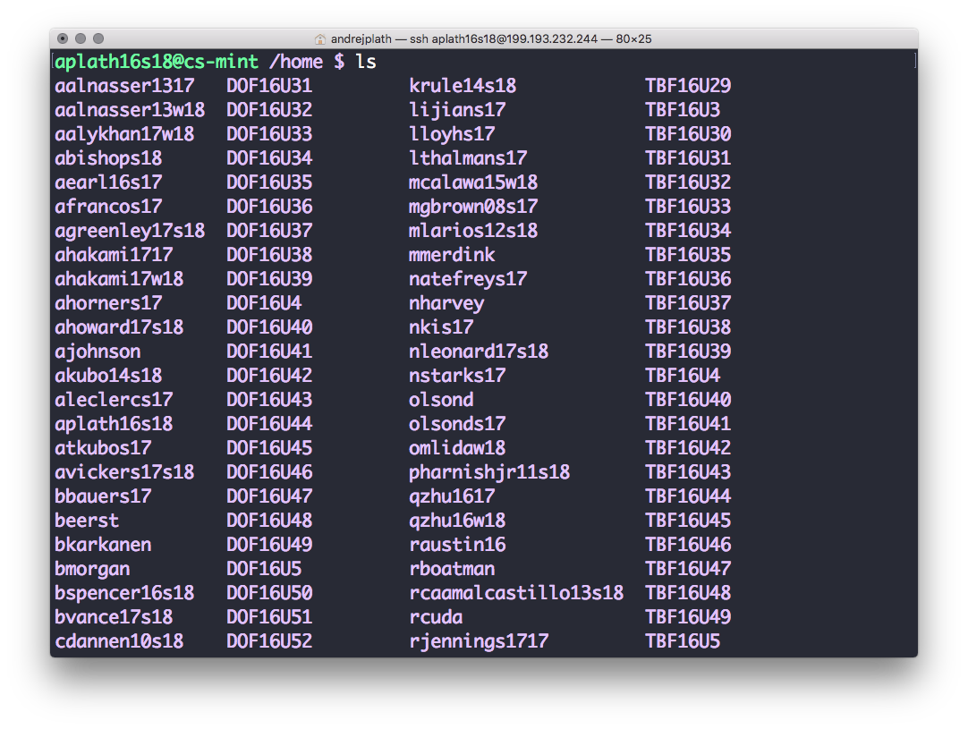
2. Used “**cat**” command with the name of txt file to output content of file.



1. Used “**rm**“ command to delete test txt file. The **rm** command is used to remove or delete a file in your directory.

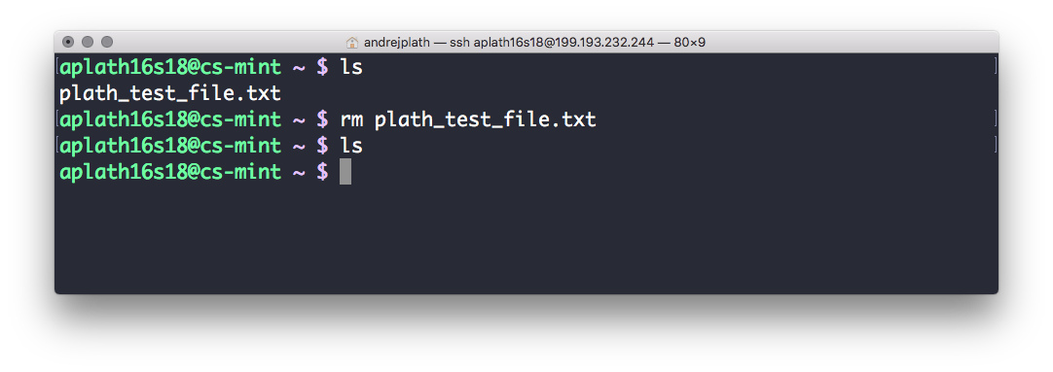

1. Used “**top**” command to display information on the Linux system, running processes, and system resources, including the CPU, RAM, swap usage, and total number of tasks being run. Used “**q**” to quit.

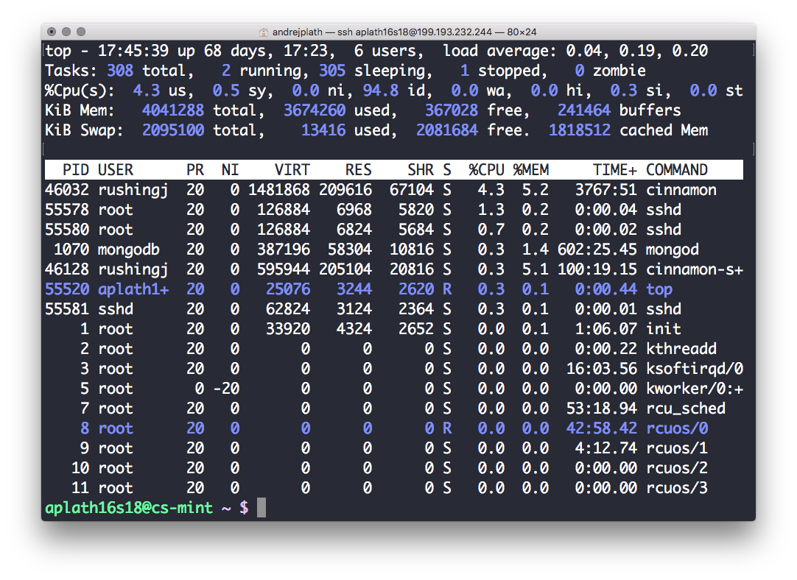

1. Used “**clear”** to clear screen of content.

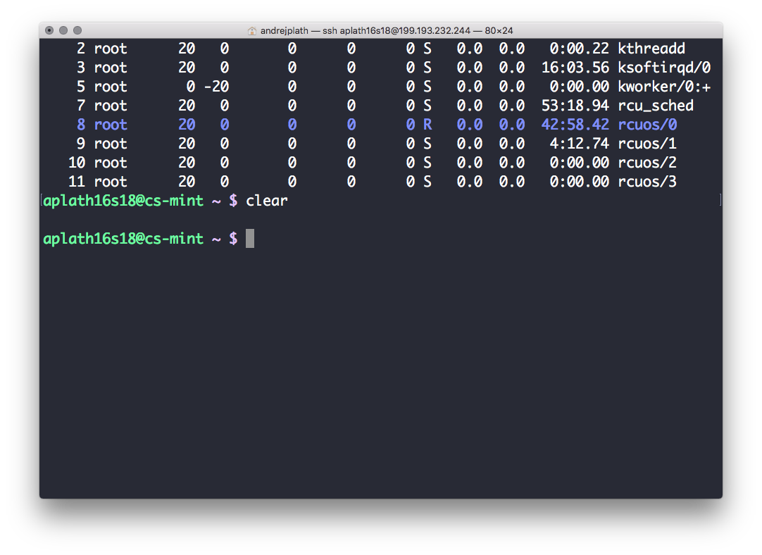

1. Used the “**who**” command. The **who** command tells you who is currently logged into the machine.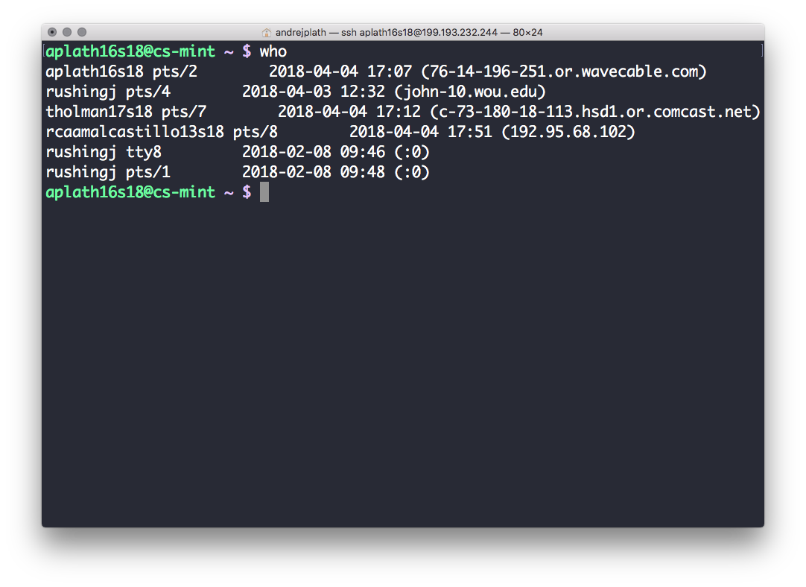
2. Used “**lspci**” command. command lists all PCI buses and devices connected to them. This commonly includes network cards and sound cards.

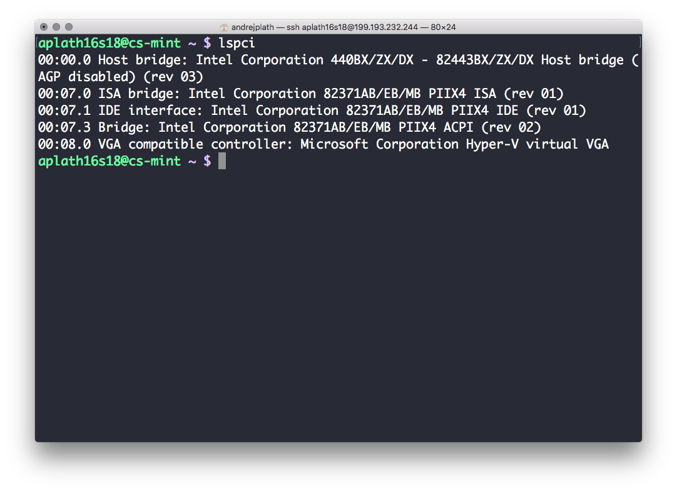

IV. Cooler Commands:

1. “**banner**” command can print banners. No options and can print only 10 characters at most.

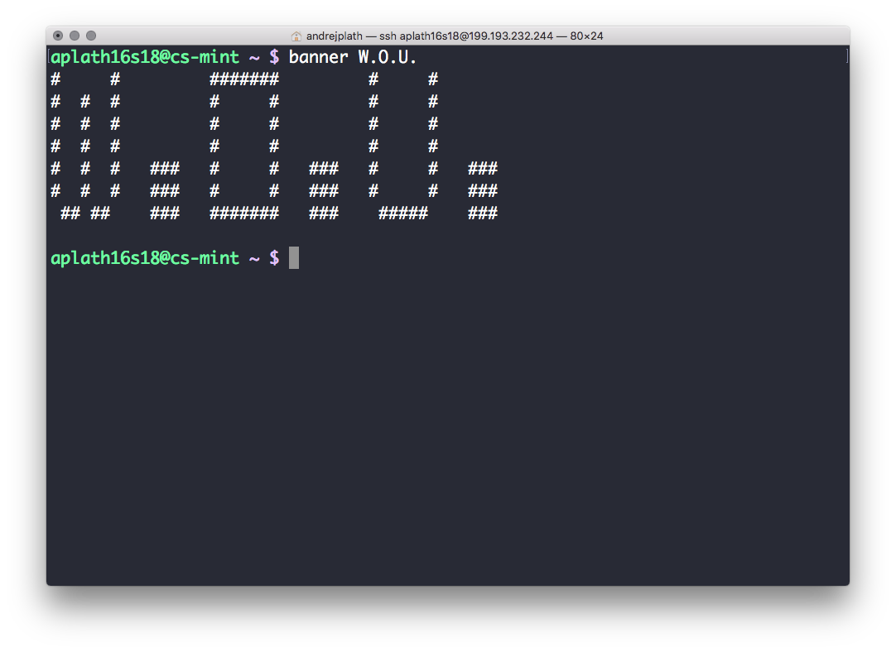

1. “**fortune**” command will put up a random, but hopefully sensible quote, or your fortune for the day.

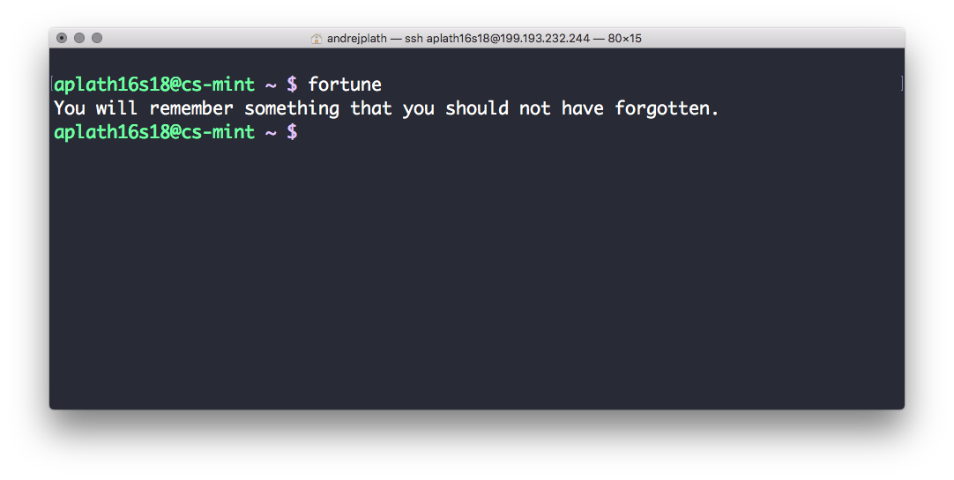

1. “**rev**” command will print the reverse of whatever you type in. First run rev, then start typing one sentence at a time.

