Andre J Plath

Professor Yanwei Wu

CS365 Operating Systems and Networking

January 30, 2018

CS365 Operating Systems and Networking Lab 2

Part I:

Code included in zip file and screenshot attached:

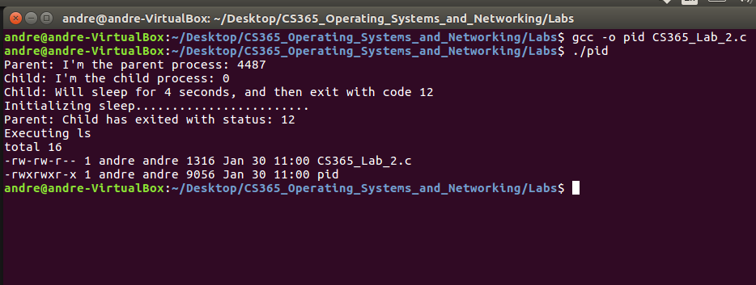

Part II

Code was given to student and screenshot documented:

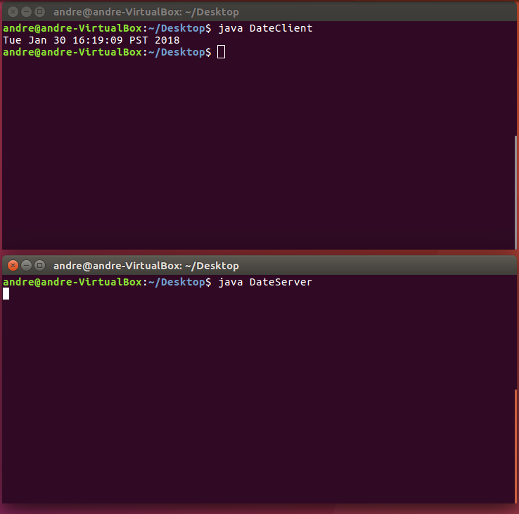

Part III

Code included in zip and screenshot documented:

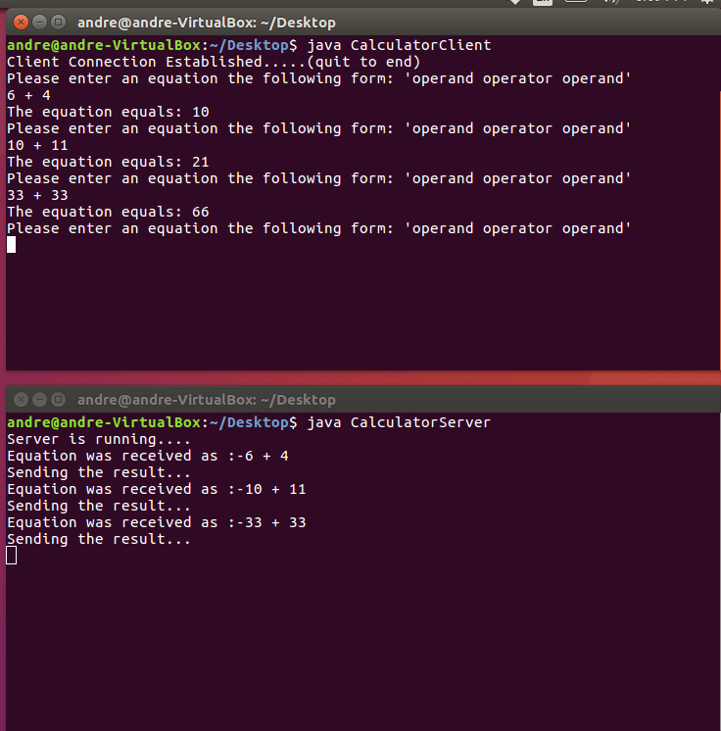

Part IV