Andre J Plath

Professor Yanwei Wu

CS365 Operating Systems and Networking

February 13, 2018

CS365 operating Systems and Networking Lab 3

Part I Producer and Consumer (Multithread):

• Implement the code from Figures 4.13, 4.14, 4.15 Screenshot

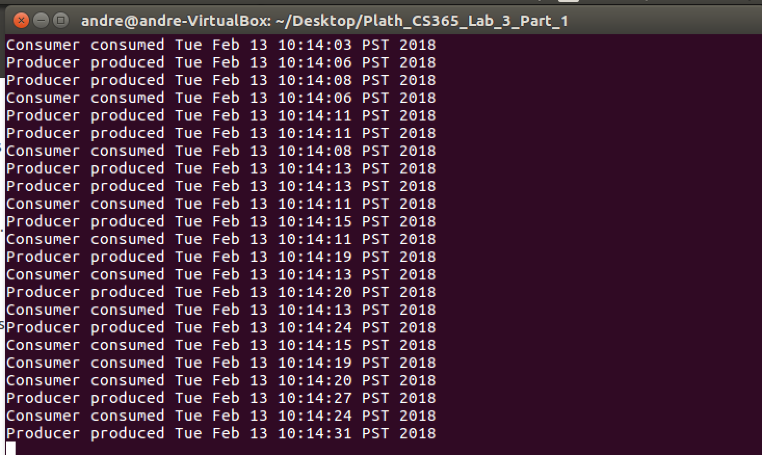

Part II Producer and Consumer (Semaphore):

• Implement the code from Figures 6.9 – 6.14 Screenshot

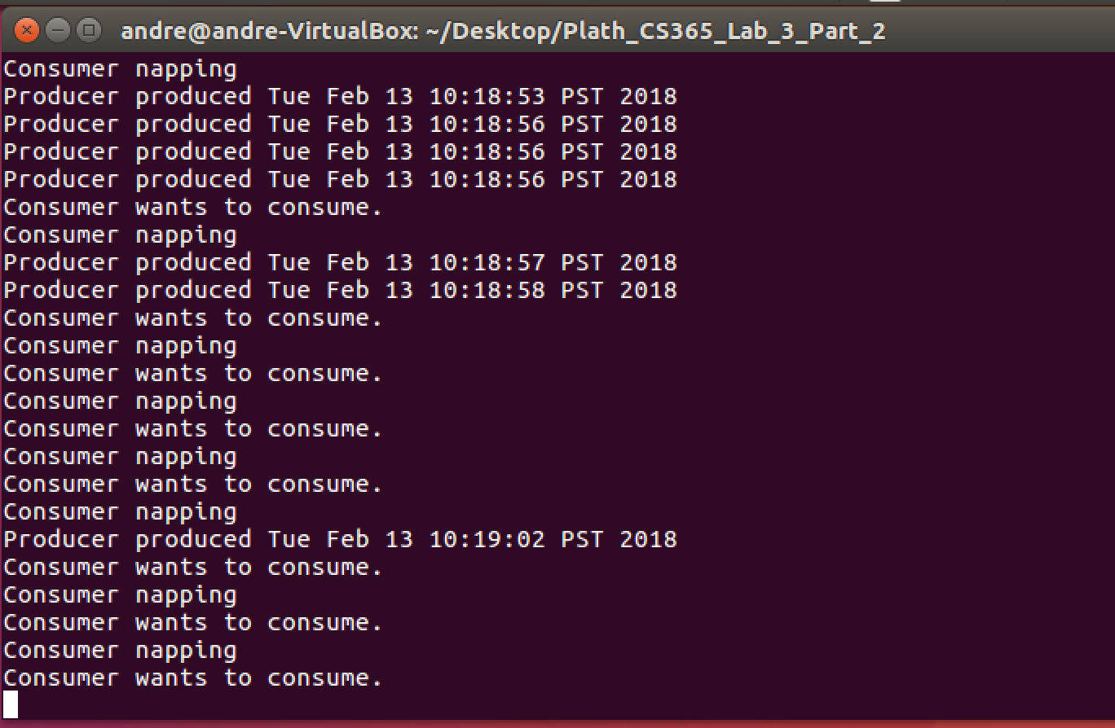

Part III GUI –Revise Part II:

(GUI was extra credit and was not done. However, the two attributes were added.)

• Add two attributes to the Bounded Buffer Class, producerSleep and consumerSleep, to set the sleep time of producer and consumer.

• Create with get() and set()methods for each.

