
Transformation Quality Assurance Framework
Independent Quality Assurance for Complex Transformation Programmes in the Age of AI, Cloud and Accelerated Digitalisation
An ITsPeople Whitepaper | 2026

Executive Summary
Boards today face an unprecedented paradox: the pressure to transform at speed has never been higher, while the cost of failed transformations — in operational disruption, attrition and reputational damage — has grown exponentially. AI, cloud-native platforms and continuous delivery are compressing timelines, but they also introduce probabilistic behaviour, shared accountability with platform vendors and new categories of risk that traditional project assurance was never designed to address.
The ITsPeople Transformation Quality Assurance Framework (TQA-F) is an integrated, independent assurance methodology built for exactly this environment. It gives executive boards an objective, quantitative and continuously updated view of programme health across eight dimensions — from strategy and governance to data, adoption and value realisation — and provides a formal go / no-go mandate at every tollgate. The result is transformation at speed, without compromising auditability, traceability or outcome certainty.
“Quality assurance is only effective when the assuring party has no loyalty conflict with the delivery party. Independence is not optional — it is the precondition for a trustworthy quality verdict.” — TQA-F Principle 1


Why Traditional Assurance Falls Short
Three technological shifts are redefining the context in which transformation programmes operate — and each exposes a structural weakness in conventional quality management.

Artificial Intelligence
Where traditional implementations configure deterministic business rules, AI-driven systems introduce probabilistic logic into core processes. The assurance question shifts from “does the system do what we configured?” to “does the system produce reliable outcomes under varying conditions?” Model reliability, data bias, explainability and ethical accountability become first-class quality concerns.

Cloud-Native Architectures
In SaaS and PaaS environments, a significant part of the technical stack is owned by the provider, updates are pushed centrally and customisation is bounded to configuration. Ownership of quality is now shared, and the assurance question becomes: “have we configured correctly within a continuously evolving platform?”

Accelerated Delivery
DevOps, continuous delivery and agile methods compress release cycles. A separate test phase at the end of a programme is structurally inadequate. Assurance must move in lock-step with delivery, without sacrificing depth or independence.

The ITsPeople TQA Framework
The TQA-F is an integrated methodology for independent quality assurance on complex transformation programmes. It does not replace delivery or project management; it runs in parallel to the implementation and provides the steering committee with an objective, real-time view of actual quality status. It answers three fundamental board-level questions: are we building the right thing, are we building it right, and will the organisation be able to sustain the benefits?
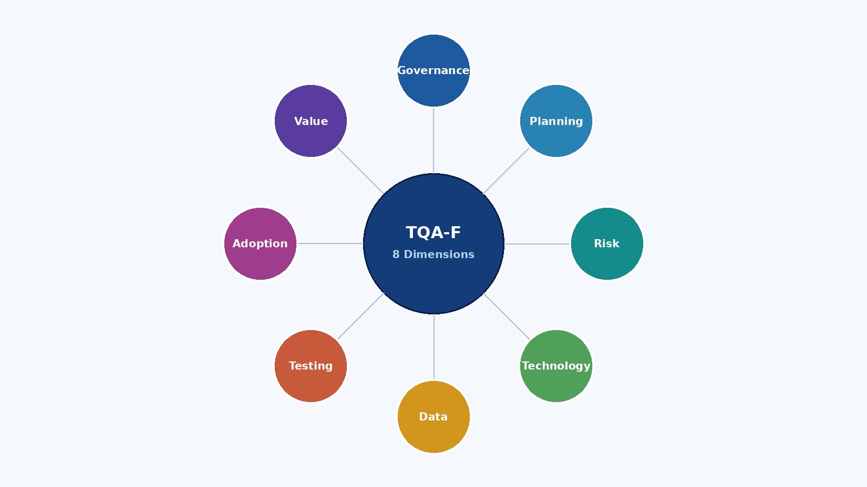
Figure 1 — The eight quality dimensions of the TQA-F, anchored around an independent assurance core.

Eight Quality Dimensions
Every tollgate is assessed simultaneously across eight dimensions, each with defined RAG thresholds and quantitative indicators:
- Governance & Steering — programme authority, decision quality, escalation paths.
- Planning & Progress — realism of plan, critical path integrity, dependency management.
- Risk & Blocker Management — currency of the risk log, mitigation effectiveness.
- Technical Quality — configuration, integration complexity, architectural integrity.
- Data Quality & Migration — objective Data Quality Score (DQS) across six measurable dimensions.
- Test & Acceptance — ISTQB-aligned coverage, defect containment, entry and exit criteria.
- Change & Adoption — Prosci ADKAR indices per user group, resistance hotspots.
- Value Realisation & Sustainment — benefit tracking, hypercare readiness, KPI delivery.

Five Integrated Assurance Modules
The framework delivers these dimensions through five modules that operate in parallel and converge at every tollgate: Governance Assurance, Programme Health Checks, Test Assurance, Change Assurance and Value & Benefits Assurance. Together they provide full-spectrum assurance from day one of mobilisation until sustained benefit realisation after go-live.
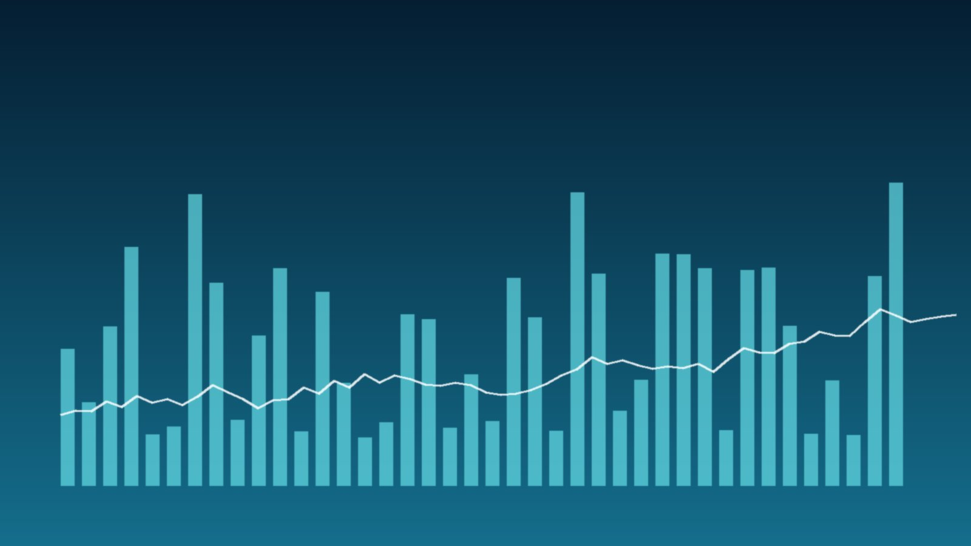

What Independence Delivers to the Board
The most distinctive feature of the TQA-F is the structural independence of the assurance function. The QA Lead and QA Consultant are not part of the delivery team, report directly to the steering committee and have a formal mandate to issue a no-go advice. They assess every tollgate decision independently and in writing, with unrestricted access to all programme reporting.
For executive boards, this translates into four concrete outcomes:
- Certainty — a single, quantitative source of truth on programme health, refreshed continuously through the QA dashboard.
- Early warning — issues in strategy, data or adoption are surfaced weeks or months before they materialise as delivery failures.
- Decision confidence — every tollgate decision is supported by an independent, evidence-based go / no-go advice.
- Auditability — a complete, traceable record of decisions, risks and mitigations that stands up to regulatory and internal-audit scrutiny.

Proven Across Sectors
The TQA-F is sector-agnostic and has been validated across ERP core replacements, HRM and payroll transformations, workforce management, cloud ERP and SaaS migrations, data and analytics transformations, healthcare and public-sector programmes, and post-merger IT integrations. It is designed for programmes where at least three of the following apply: multi-year horizon, multi-vendor landscape, mission-critical processes, regulated environment, or board-level strategic importance.

Partner with ITsPeople
ITsPeople is a consulting firm specialised in digital transformation and strategic management for major accounts. We combine deep methodological rigour with an approachable, hands-on style — empowering organisations to strengthen their market position through strategic, data-driven solutions in AI, IoT, cloud and advanced data architectures.
If you are preparing, running or recovering a complex transformation programme and want independent certainty on its trajectory, we welcome a conversation.
ITsPeople | www.itspeople.nl | info@itspeople.nl

