IS117 – Exam 1

HTML5 – Boiler Plate Diagram – You can use the image or go to the repository to view the code. https://github.com/h5bp/html5-boilerplate/blob/master/index.html

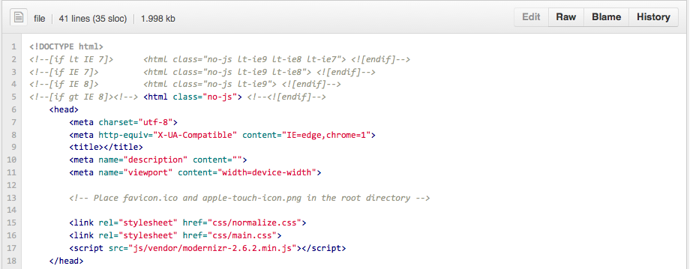
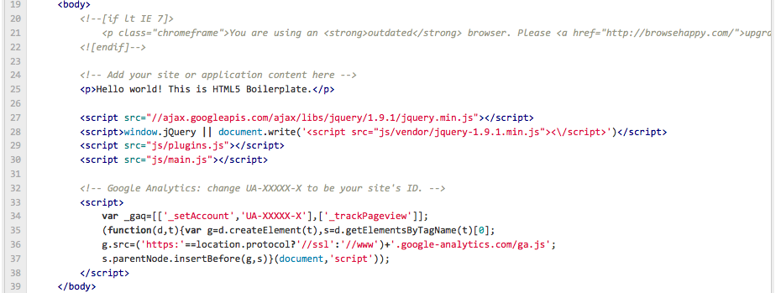

I will ask the question and indicate the line number. Please answer it briefly in only one sentence or less.

HTML Questions 2 Points Each:

- What does line 1 do?
- What are lines 2-4 for?
- What is line 7 for?
- What is line 9 for?
- What is line 15 for?
- What is line 16 for?
- What is line 17 for?
- What happens if the IE 6 browser views this page? What line causes it to happen?
- Why are many of the JS files loaded at the end of the page?
- What is a CDN and which line(s) in the page use one?

HTML Questions 5 Points Each

1. Identify the proper names for the two parts of this HTML statement:

Part 2
Part 1

<a href=http://www.google.com>Google</a>

2. Write 5 HTML tags not in the image above and what they do.

3 Points Each - CSS Questions

h2 { color: #666; }

- What is the proper css identification / naming convention for : “H2” ?
- What is the proper css identification / naming convention for: color: #666; ?
- What is the proper css identification / naming convention for: color:
- What is the proper css identification / naming convention for: #666?
- What does the H2 element used for?

Git Questions 1 Point Each:

- What is GIT?
- How do you think you would use GIT in the future?
- Why use version control when writing a program?
- What does the command gitinit do?
- What does the command git add do?
- What does this command do: git commit –m “my first commit”
- What does this command do: git push origin master
- What is origin in the previous command?
- What is master in the previous command?
- Explain what this command is doing:

git remote add origin git@github.com:h5bp/html5-boilerplate.git

Layout Creation – 20 Points Total

Using Adobe Illustrator create a layout for a website using the golden ratio horizontally and vertically. The width of the layout should be 960px and you should use the golden ratio to determine the height of the website. Just use a wire frame that includes the lines associated with the major regions. You do not need to include links or be detailed. I expect to see 3-4 instances of the golden ratio being used within the layout. Export a PNG or GIF file of your layout and paste it into your test.

Typography Questions – 15 Points (5 Points Each)

- Name an example of a Serif and Sans Serif Font?
- What is the difference between a Sans Serif font and a Serif font?
- What font is used for New York City street signs?

Audience Analysis – 10 Points

Analyze the following website and identify what is being done correctly and indicate what you would change. Think about how this website is and is not being used as a billboard. Identify any layout patterns such as golden ratio or equal spacing. What are the primary links? You should visit the website to fully see how it appears to visitors.

http://www.simpleremovals.co.uk/home

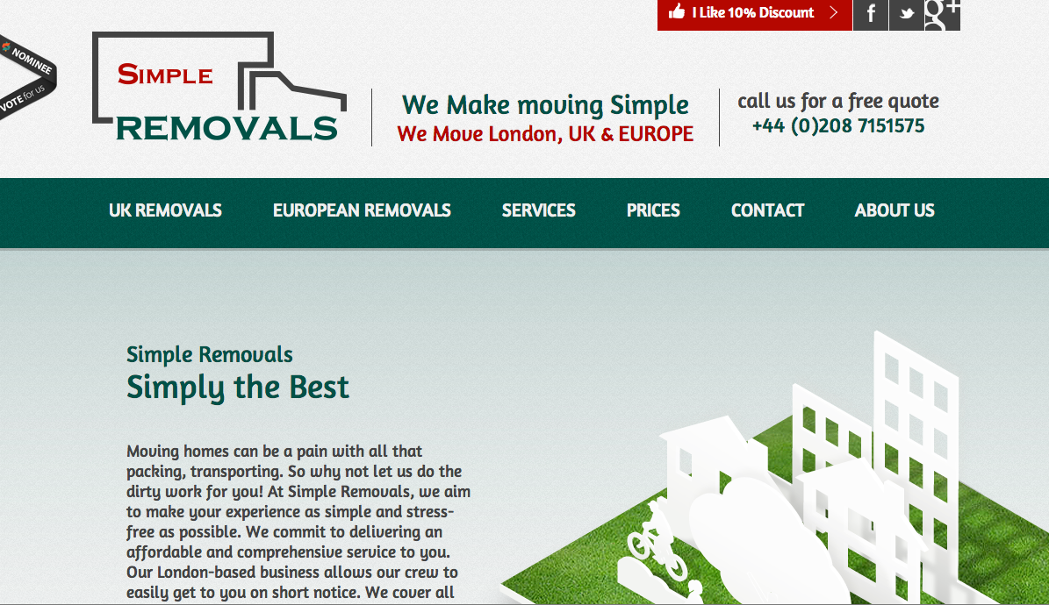

Exam 1 Answer Sheet

You Name: ________Andre Lawrence________________________

HTML Questions - 20 - Points
1. Define the document type as HTML
2. Dictates to render the page with no javascript if detected browser is IE8,IE7, or less than IE7
3. Sets the character set for the browser to the standard unified text format
4. The text inside the title tags would be displayed on the top of the browser window or tab that the page is opened in
5. Removes browser specific pre-formatting
6.
7.
8. User is told they are on an outdated browser and given a link to upgrade to a compatible browser. This is done in line 21
9.
10. A CDN is a content delivery network

HTML Questions - 10 - Points
1. <a> is the element and href is the attribute
2. <ol> create an ordered list, <ul> creates an unordered list, <li> creates a list element, <img> adds an image,<br> adds a line break

CSS Questions - 15 - Points
1. Target
2.
3.
4.
5. To target and apply the CSS to all H2 elements in the HTML

GIT Questions - 10 - Points
1. A public repository for a developers work
2. I would use GIT in the future as a portfolio to showcase my work and abilities
3. Version control allows multiple people to work on a project simultaneously and allows you to revert back to older versions if issues arise
4. GITINT initializes the GIT repository
5. GITADD add a file to the directory
6. Commits the changes made to a file and adds the comment “My first Commit”
7.
8.
9.
10.

Layout – 20 – Points

Insert PNG/GIF here


Typography Questions – 15 Points

1. Algerian (serif) and Arial (sans serif)
2. Serif fonts have decorative feet at the bottom sans serif dont
3. Clearview

Audience Analysis – 10 – Points

What is being done correctly is the use of the golden ratio in the navigation and logo section and in the division of their content section where they display text and images. I think the identify their primary navigation links (UK Removals, European Removals, Services, Prices, Contact, About Us) and place them in a goo location for their audience to quickly get to

What I don't like about the layout is that it is really long and forces the user to continuously scroll to get to the information they want and doesn't identify what information is included in the page so the user could scroll all the way down and not see what they want. Also they give no indication that the user should continue to scroll for more information

How I would fix this page is limit content to one page and have a sub navigation whenever the user clicks on a section of the main navigation. Each section of the sub navigation will contain a part of the old page where the user had to continuously scroll

And example of this would be when the user selects "UK Removals" in the navigation, a sub navigation would appear with the following sections: London and UK removals, Domestic Removals, Office Removals, Prices. Each subnav section would house the associated current page data

Link to Github with a repository and commit made during the testing period:

5 Bonus Points

