Tutorial for importing Excel sheets to Monday.com and transferring requests

When you log into Monday.com (using a member’s account), you’ll see this main screen. Find and click on the profile circle icon in the bottom left corner.

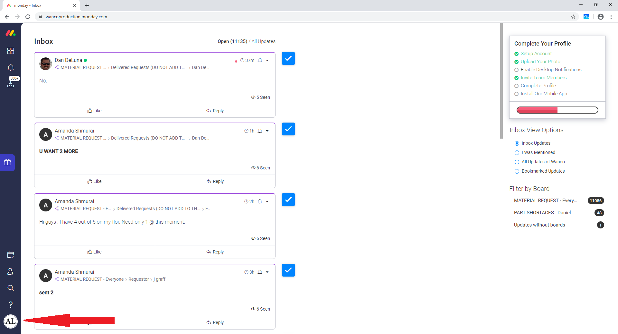

After clicking on the icon, a small menu will appear. Click on the “Import data” section.

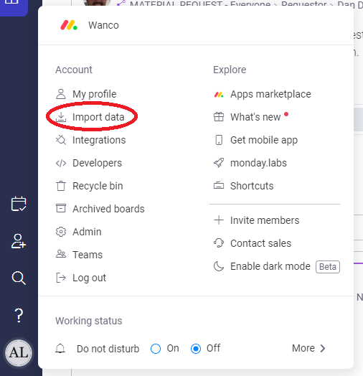

On this new page, click on the Excel icon to import an Excel sheet.

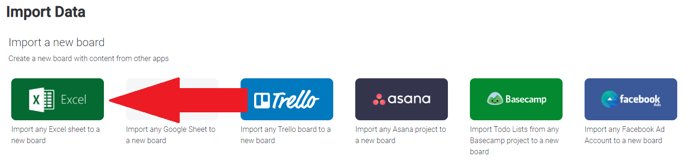

Either drag and drop the Excel sheet into the box or locate it via computer browse.

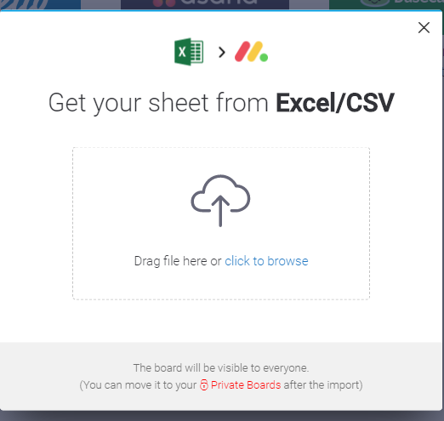

Importing data from Excel will create a new “board” on Monday.com. A board is where “pulses” or just rows of information is put up so everyone can see it. The weird/awful thing about Monday.com is that you can only import the first column of data to an existing board. If you want to import everything on an Excel sheet to Monday, you have to create a new board. This is the reason why we can’t directly import Excel data to the main request board. Anyway, now it’s time to customize the new board because there are some things you have to adjust.

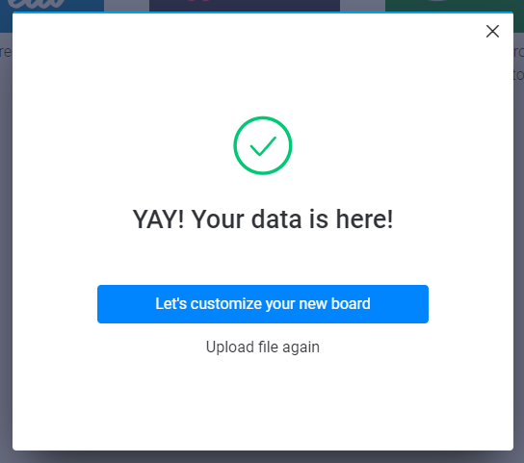

Click the next button twice since you don’t need to worry about steps 1 and 2 of customizing the board. Step 1 is asking which sheet row you want to determine the columns headers. Step 2 is asking which column you want to be the very first one on the board. The program already puts the appropriate row and column in the “correct place” before importation. That’s why you can just click next twice as opposed to selecting certain boxes.

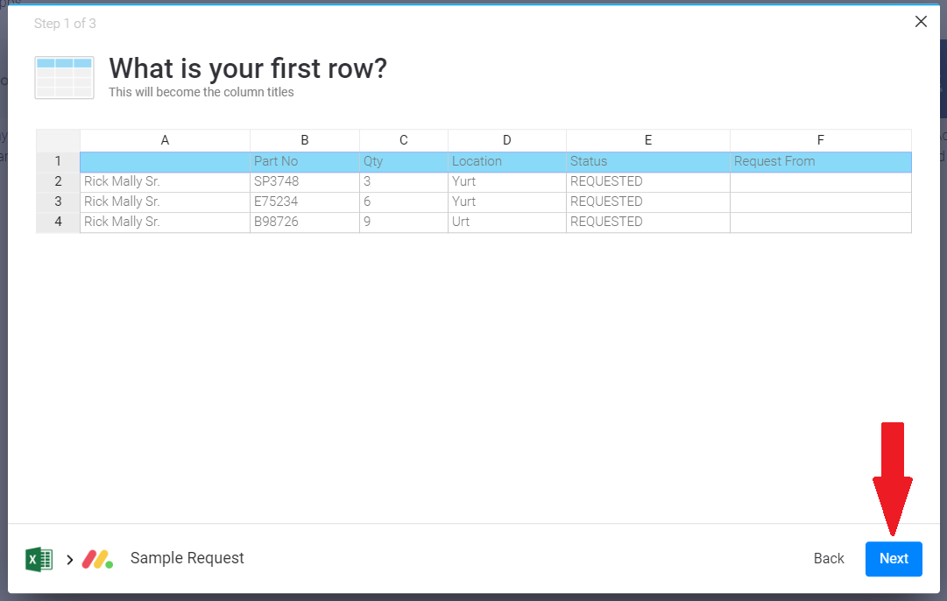

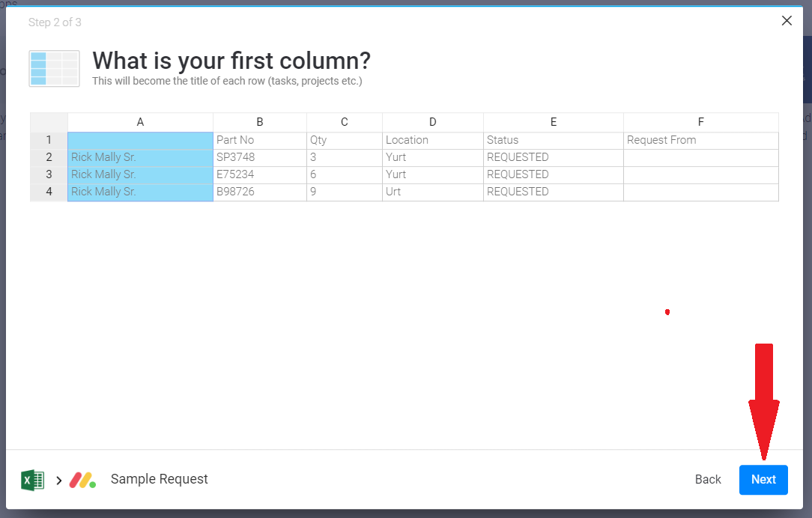

As for step 3, you have to change the types of the columns. Change Part No, Qty, and Location to Text Columns and Status and Request from to Status Columns.

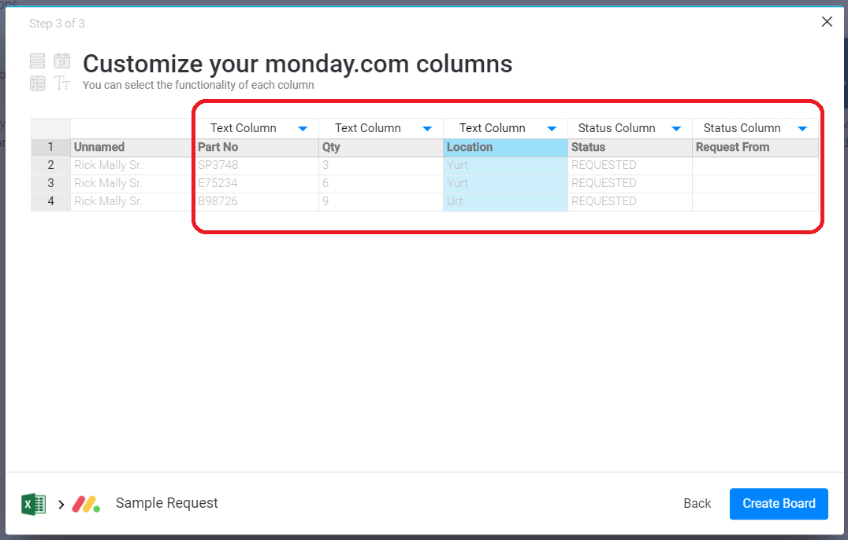

You’ve now finished your board. The next step is to select all of the rows. Click on the small green circle with a white triangle pointing down.

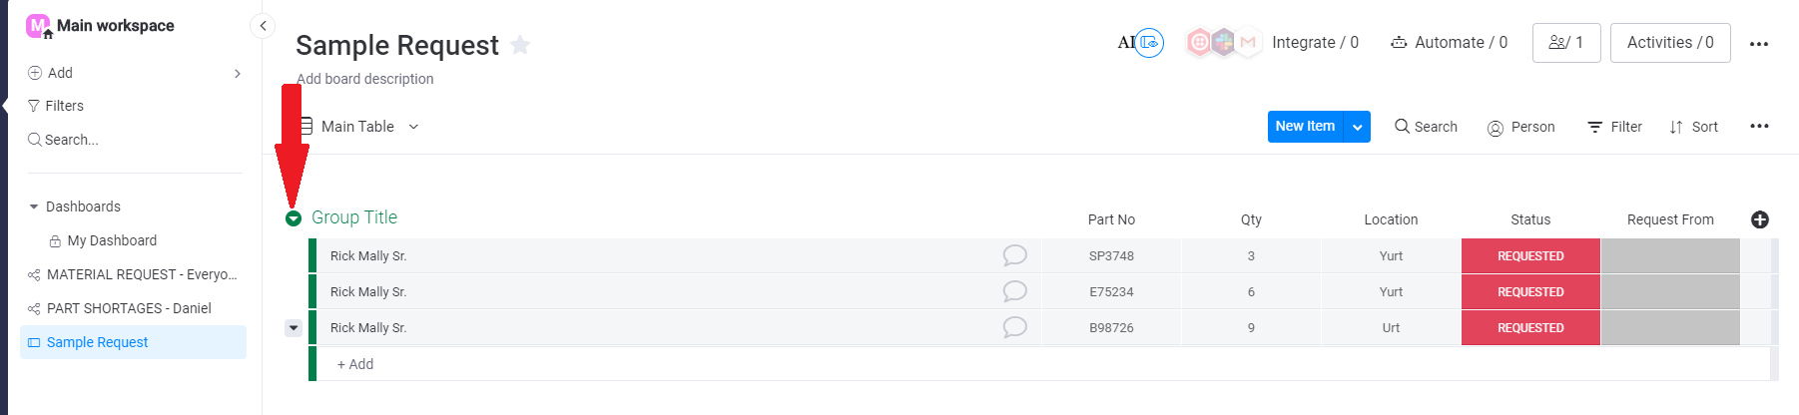

Doing this will bring up a small menu. Click on the “Select all Items” option.

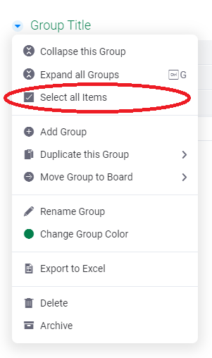

Once all rows have been selected, look at the bottom of the screen for the “Move to” button. What follows is a series of steps to transfer all the currently selected rows of the new board to the existing Material Request board.

(For this tutorial I duplicated the Material Request board so I can move the rows to the duplicate instead of the real one. When you move your rows, move them to the real Material Request Board)



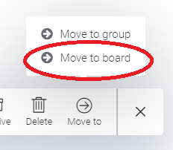

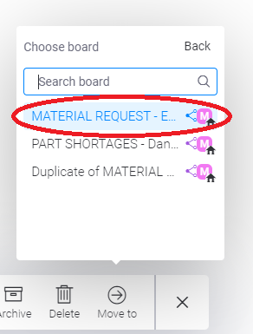

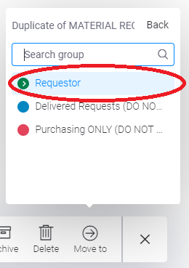

Remember to delete the new board you created now that it’s empty. This is done so Monday.com isn’t visually cluttered by multiple unnecessary boards and also because the payment plan only allows us to have so many boards. Right-click on the board’s name on the left hand list to find the delete option.

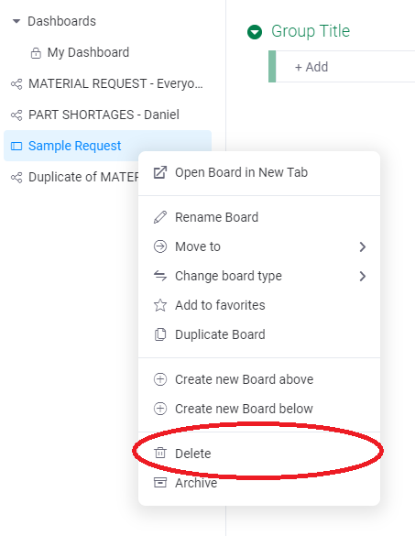

The last thing you need to do is change some of your rows’ values. In the “Deliver to” column, select which general area you want the part sent to. If you’re requesting a part that’s not from the Stockroom, change that by clicking the data in the “Request from” column.

