Distributed Memory Machines and Programming
By Andre Lewis – Florida International University
Course: COT4431 / Fall 2025

Q1. Is there a limit on how much parallelism can be exploited using shared-memory architectures using OpenMP? Does programming using MPI solve the problem? Explain.
When we push OpenMP on a shared-memory machine, the performance eventually hits the ceiling. In my own understanding, the limit comes down to memory bandwidth, cache-coherency traffic, and threads constantly fighting over the same shared resources. Even when the CPU has many cores, all the threads still pull data from one shared memory space. At some point the overhead becomes larger than the benefit. Research basically shows the same thing — as threads increase, performance often plateaus or even drops because of synchronization and NUMA effects (Dai et al., 2021).
Another challenge is that OpenMP lives inside a single node, so scaling beyond that node just isn’t OpenMP’s job. MPI, on the other hand, avoids the shared-memory bottleneck because every process has its own private memory. Processes talk through explicit messages, which gives us predictable performance and less interference across nodes. MPI doesn’t magically remove all overhead, communication cost still matters, but it absolutely solves the single shared memory wall that OpenMP hits.
Figure 1. Shared memory (OpenMP)
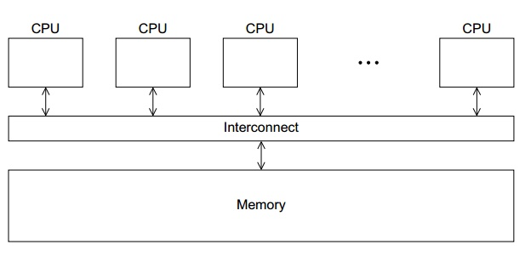

Figure 2. Distributed – Memory (MPI)
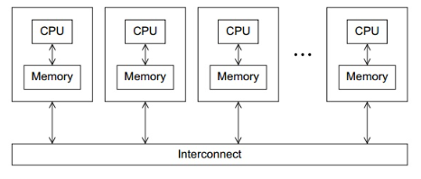
Argument: OpenMP hits limits due to hardware contention; MPI avoids these limits by scaling across independent memory spaces.
Evidence: Nature article (Dai et al., 2021) describes similar bottlenecks when GPU/CPU pipelines saturate shared resources during high-throughput searches.
Counter-Evidence: For small shared-memory systems (like 8–16 cores), OpenMP can outperform MPI because the communication overhead of MPI is not free.

Q2. Why does synchronization lead to smaller speedup and less scalable algorithms compared to when synchronization is not used? Why?
Synchronization forces threads or processes to pause until others catch up. In real systems, especially multicore architectures, threads never run at the same speed. Any barrier or lock turns into a slowest-thread-wins situation because everyone else must wait at that point. Figure 2 illustrates this clearly: the faster threads reach the barrier first and waste cycles waiting for the slowest one before they can continue.
When synchronization appears inside a tight loop, it becomes a performance bottleneck. Instead of cores doing useful work, they spend that time stalled or flushing memory. This is why algorithms that rely heavily on locks or frequent barriers typically show much lower speedups than algorithms that avoid shared data or use local buffers.
The Nature article reinforced this idea when describing GPU/CPU cooperation. The GPU was able to achieve high fragment-ion search throughput only because the design minimized race conditions and used race-free updates, which reduced synchronization overhead (Dai et al., 2021).

Figure 2. Synchronization bottleneck
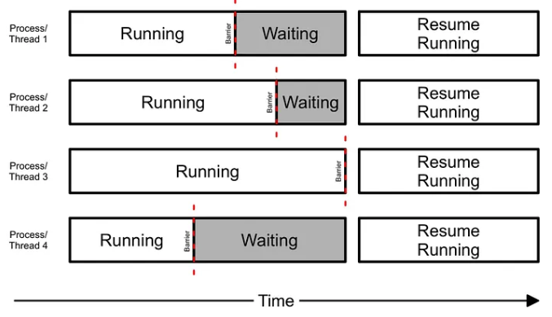
Argument: Synchronization reduces effective parallel work by forcing idle periods.
Evidence: Textbook HPC theory + Dai et al. (2021) demonstrating race-free parallel updates improve scalability.
Counter-Evidence: Some algorithms (like reductions or prefix sums) require synchronization for correctness, so the overhead is unavoidable.
Q3. What is the difference between bisection width and the diameter of a network topology for distributed-memory architecture?
In simple terms:
- Bisection Width = tells us how much bandwidth a distributed memory network can support under heavy communication. It’s the minimum number of links you must cut to split the network into two equal halves.
- Diameter = describes worst-case latency. It is the longest shortest path between any two nodes, meaning how many hops a message must take in the worst case.
Bisection width is a bandwidth metric;
Diameter is a latency metric.
Both matters differently depending on your workload. Large data shuffles (like MPI All-to-All) depend heavily on bisection width. Algorithms with many point-to-point messages care more about diameter.

Figure 3. Concept
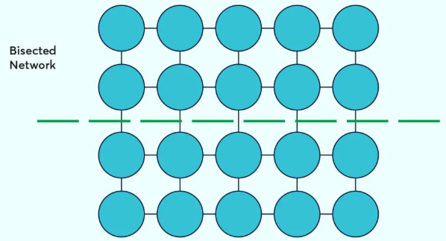
The dashed green line shows a bisection, which cuts the network into two equal halves and represents how many links must be cut. The diameter is shown by the longest shortest path between two nodes (for example, a corner-to-corner path in this mesh). Bisection width reflects bandwidth across the network, while diameter reflects worst-case latency.
Q4. Draw and write the bisection width and diameters for the following network topologies.
A. Ring Topology
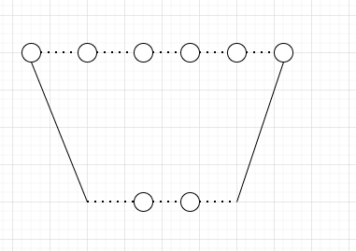
- Bisection Width: 2
- Diameter: $LN/2$

B. Mesh (k × k)
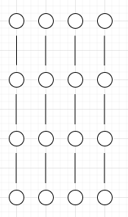
- Bisection Width: 2k
- Diameter: k(k-1)
C. Two-Dimensional Torus (k × k)
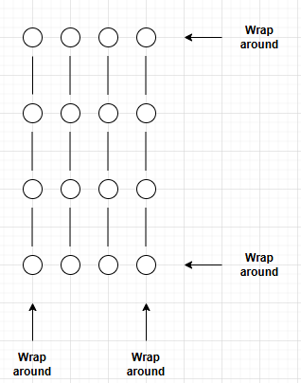
- Bisection Width: 2k
- Diameter: k

D. Hypercube (d-dimensional)
4D example:
0000 — 0001 — 0011 — 0010 — 0000
| | | |
1000 — 1001 — 1011 — 1010 — 1000

0100 — 0101 — 0111 — 0110 — 0100
| | | |
1100 — 1101 — 1111 — 1110 — 1100

- Bisection Width: 2^(d-1)
- Diameter: d

Q5. With the help of diagrams, show the following data movement strategies that can be implemented using MPI
- MPI_Broadcast
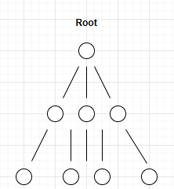

- MPI_Scatter
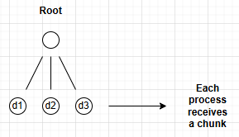

- MPI_Gather
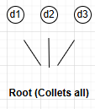

- MPI_Allgather
Every process sends data → everyone ends up with full dataset

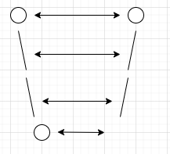

- MPI_All-to-All
Every process sends different data to every other process

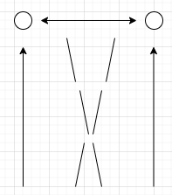
References
Dai, C., et al. (2021). GPU-accelerated open modification spectral library searching using approximate nearest neighbor indexing. Nature Computational Science, 1, 452–463. https://www.nature.com/articles/s43588-021-00113-z
Saeed, F. (2025). Applied Parallel Computing Lecture Notes. Florida International University.
Hennessy, J., & Patterson, D. (2019). Computer Architecture: A Quantitative Approach. Morgan Kaufmann.
Desai, J. (2021). Barrier synchronization in threads. Medium. https://medium.com/@jaydesai36/barrier-synchronization-in-threads-3c56f947047

