Programming for Computer games 2017

Home Assignment

Question 1 a:

Select 2 game engines - Unity and Unreal Engine

Unreal Engine: 1 - support and update mechanism of all engines with new tools.

2- Compatible with diverse operating platforms.

3- A lot of help and several tutorials you can find.

4- There is a feature which makes it very easy to use.

Unity – 1: Easy to use

2: It is ranked as the best license

3: Great community support

4: It’s Free

Unity is the best game engine which is free and it’s very easy to use.

Question 1 b:

Unity: In unity u can use C# and its 4 Features are - :

1. Dynamic Programming - (dynamic use to compile the object)
2. Optional Parameters
3. Named Arguments (Lookup for methods)
4. Generic covariance

Unreal Engine: uses C++.

1. Compiler Switches (
2. Lambda (Using *this)
3. Syntax Cleanup
4. Data Types ( std::any /optional/byte etc)

Question 2: a:

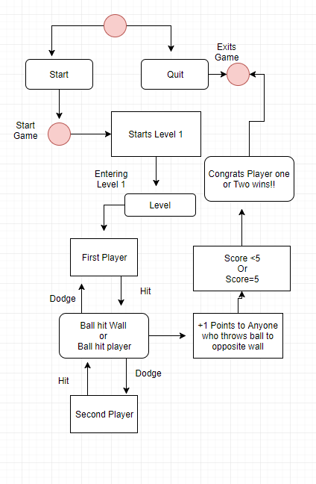

Question 2b.

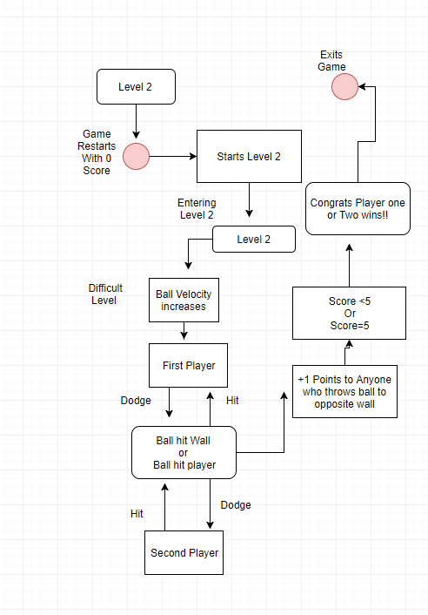

**Question 3:**

**Compression Media Files**

Compression is needed in a video and audio files because they consume more disk space compared to document files. So it will reduce the number of bits needed to store data. Compression is an essential for us and it can save us time, reduce memory and also space. Nonetheless compression can make things possible when before it wasn’t due to hardware or storage resources. The most popular types of file formats that are used to be compressed are (ZIP, JPEG, GIF, and PNG).

