|  |
| --- |
| **What gamification elements can improve users social, physical and mental health when using fitness and well-being apps** |
| 6001 CEM Individual Project  BSc Computer Science |
| **Andre Marques Rodrigues**  Student ID: 10448760  Supervisor: Mr. Mark Elshaw  Submission date: 04/2023 |

# 1 - Abstract

Exercise has been shown to have numerous benefits for physical, mental and social health. Well-being and fitness have become increasingly popular in recent years, although there is still a gap in understanding which gamification elements work in promoting engagement adherence to healthy behaviours.

The aim of this study is identifying and exploring the effectiveness of gamification elements in fitness and well-being. The project will consist of three phases. Firstly, a survey will be conducted to collect data from students’ past experiences with fitness apps. Based on the results of this survey, a demonstration app will be developed, with the goal of encouraging users to engage with fitness and well-being activities on a regular basis. Lastly, a second survey will be performed after some respondents experience this demonstration app in order to determine which gamification elements were most effective in keeping users engaged with the app.

The findings of this study will contribute to the development of fitness and well-being apps, with the goal of promoting engagement and adherence to healthy habits. It is important to better understand which gamification elements are most effective in promoting these habits in order to improve the overall health of individuals.

This paper addresses a gap in understanding in the effectiveness of gamification elements in promoting engagement and adherence to healthy habits in fitness and well-being apps.

Contents

1 - Abstract 3

2 - Introduction 8

3 - Literature Review 8

3.1 - Introduction 9

3.2 - Impact of fitness apps on the users 9

3.3 - Gamification elements and types of Gamification 9

3.4 - User psychology when utilizing fitness apps 11

3.5 - Notifications and their impact 12

4 - Methodology 13

5 - First Survey Analysis 14

5.1 - Data Visualization 14

5.2 - Discussion of the results 19

5.3 - Outcomes from the first survey 20

5.3.1 - User-friendly interface 20

5.3.2 - Personalization 20

5.3.3 - Gamification 20

5.3.4 - Social feature (also gamification) 20

5.3.5 - Motivational quotes 21

6 - Mock App 21

6.1 - Design choices 21

7 – Use Case Diagram 25

8 - Implementation 25

8.1 - Login page 25

8.2 - First time logging in page 26

8.3 - Main page 28

8.4 - Quote of the day 29

8.5 - Today’s workout card component 29

8.6 - Social card component 30

8.7 - Workout page 32

8.8 - Social page 33

9 - Second survey analysis 34

9.1 - Tasks 34

9.2 - Data Visualization 34

9.3 - Outcomes of the second survey 38

9.3.1 - User-friendly interface 38

9.3.2 - Personalization 39

9.3.3 - Gamification and social features 39

9.3.4 - Motivational quotes 39

10 – Conclusion 39

10.1 - Critical Evaluation 39

10.2 - Compare with the literature 40

10.3 - Reflection 41

10.4 - Social and legal implication 41

10.5 - Future work 42

11 - Project management 42

12 - Log Book 45

13 - References 47

Table of figures

Figure 1 - People that only used apps once by year. Statista 5

Figure 2 - "Have you ever used fitness or mental health related apps?", Data Visualization 11

Figure 3 - "For how long have you used them for?" , Data Visualization 12

Figure 4 - "Did any app related to fitnss or mental well-being that you used have annoying and repeatin notifications? ", Data Visualization 12

Figure 5 - "Did any of the mentioned apps compared you to your friends in any metric?", Data Visualization 13

Figure 6 - "How much did that comparison feature matter at all to you?", Data Visualization 13

Figure 7 - "How much did the fitness app improve your physical and mental well-being?", Data Visualization 14

Figure 8 - "How often would you exercise with the app instead of doing any other physical activity?", Data Visualization 14

Figure 9 - "Have you ever talked with friends about fitness apps or apps that aim to improve your mental well-being?", Data Visualization 15

Figure 10 - "Did you ever felt encouraged to try one of this apps?", Data Visualization 15

Figure 11 - Log in page Design 18

Figure 12 - First time Log In Page Design 18

Figure 13 - Main Page Design 19

Figure 14 - Workout page Design 19

Figure 15 - Social Page Design 20

Figure 16 - Use Case Diagram 21

Figure 17 - Log In Page 22

Figure 18 - First Time Log In Personalization Questions Page 23

Figure 19 - Main Page 24

Figure 20 - Today's Workout Component 26

Figure 21 - Social card component 26

Figure 22 - Workout Page 28

Figure 23 - Social Page 29

Figure 24 - "From the experience how would you rate the display of the app?", Data Visualization 30

Figure 25 - "How would you rate the feature of choosing what information can be displayed as public or private?", Data Visualization 31

Figure 26 - "Did you appreciate the personalization the app would provide?", Data Visualization 31

Figure 27 - "Would you feel motivated with the way the app presented works to you if this was a final product?", Data Visualization 32

Figure 28 - "Would the social customizable challenges motivate you to get challenged and challenge your friends?", Data Visualization 33

Figure 29 - "Would the fact of having an account level that is improvable help you stay motivated?", Data Visualization 33

Figure 30 - "How much did the motivational quotes matter to you?", Data Visualization 34

Figure 31 - Personal KanBan Week 1 39

Figure 32 - Personal KanBan Week 3 39

Figure 33 - Personal Kanban week 6 40

Figure 34 - Personal Kanban week 7 40

Figure 35 - Personal Kanban week 12 41

# 2 - Introduction

As technology continues to permeate all aspects of people’s lives, it is not surprising that more and more people are turning to mobile apps for their fitness and well-being needs. In fact, a 2021 report by Statista found that 96% of smartphone users gave at least one health or fitness app installed on their device. While this trend is encouraging, it is important to understand whether these apps are truly effective in promoting healthy habits over the long term. (L. Ceci et al 2022)

Unfortunately, research suggest that many users of fitness and well-being apps only stick with them for short periods of time. According with Statista you can see that in 2019 the percentage of people that only used an app once was 25%. (L. Ceci et al 2022)

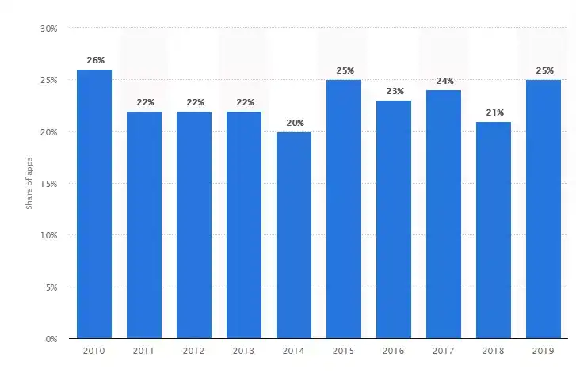

Figure 1 - People that only used apps once by year. Statista

This is where this project comes in. The aim is to identify and explore the gamification elements that work in fitness and mental well-being apps, and to determine whether these elements can be used to increase user engagement over long periods of time. While gamification has been used in a variety of settings, there is little research in its effectiveness in fitness and well-being apps.

A research involving two separate surveys and a demonstration app will be presented in the following project. This project will provide valuable insights into the factors to the effectiveness of gamification elements. These insights can inform developers of future apps that will successfully engage users and promote healthy habits.

# 3 - Literature Review

In a broad sense mobile app development is the process of creating software applications that run on a mobile device, and a typical mobile application uses a network connection to work with remote computing resources. Mobile apps were first introduced in the early 90s in a device called Psion EPOC that brought the first recognisable apps. Fast forward to today and there are various options to develop apps in various operating systems (Ios, Android, windows Phone, BlackBerry, etc). Also there options of developing apps with Non-Native Application Environments using common web-based languages like HTML5, CSS and JavaScript. (Digital, M. (2016) *The current state of Mobile Application Development*, *Manifesto*). With the development of apps, the term “Gamification” which is thought to be coined by British computer programmer and inventor Nick Pelling, brought to the table to application of game-like elements to all kinds of apps in order to sustain users and to improve the overall user experience, through user’s psychology and UI elements that relate to typical elements of game playing. (Chitroda, H. (2022) *A brief history on Gamification*, *KNOLSKAPE*).

## 3.1 - Introduction

With the continued expansion of application development, it is important to understand what makes an app a good tool to develop a life style of physical exercise that can benefit the users’ mental health and physical shape. However, there is plenty of evidence that suggest that fitness apps are not something that users maintain for long periods of times. The following literature review seeks to understand the impact of gamification on this fitness apps and what aspects of an app are able to maintain the user intent to keep using it.

## 3.2 - Impact of fitness apps on the users

(Lee, H et al 2016) The authors of this paper investigate the effects of a mindfulness meditation app on subjective well-being. The study involved 223 individuals that were randomly assigned to a group that used the app or a control group. The results of the paper show that participants that used the meditation app displayed significant improvements in subjective well-being. This improvements include increases in life satisfaction, positive affect, and mindfulness. In addition, the app users stated having reduced symptoms of depression and anxiety.

The authors conclude with this study, that a mindfulness meditation app can be an effective tool for improving well-being, in particular life satisfaction, positive effect, and mindfulness, and can also improve reducing symptoms of depression and anxiety. This findings suggest that technology-based interventions such as well-being apps may be a role to play in promoting mental health and well-being.

## 3.3 - Gamification elements and types of Gamification

(Yin, S et al 2021) There are various definitions of gamification, some of these, focus on the game design namely what elements of design can be used in the sense of gamification. The first study goes over the literature done on the matter. The authors after revising the literature done on gamification elements and definitions start introducing, the main objective of this study which is to determinate the correlation between gamification elements and user satisfaction. The authors start by collecting online reviews and explain how the data utilised in this paper was gathered. It is stated that the authors explored the fitness apps market to offer an insight into the performance of gamification, and they also looked into the online reviews of said apps. After the data was collect the authors explain how they constructed vocabulary and they designed the questionnaire, for the actual analysis of the data collected the authors, through quality classification according to the kano model and a quantitively user satisfaction score calculation, provided by the overall assessment. In order to understand the impact of gamification in user satisfaction the authors divide the gamification elements into four dimensions: Progress path, Feedback and reward, social connection, and Interface and user experience. Within this four dimension there are multiple elements that construct them, for example the Social Connection dimension is structed being 26% Feed, 40% Leader Board and 32% Community. This percentages were obtained by asking the users to choose their favourite said sub-element inside each dimension. This process of compartmentalising the Gamification dimension divided the sub-elements in order of impact for the users. Through extensive analysis the authors conclude that the different dimension impact user satisfaction in distinct ways. The progress path dimension contributes not negatively on user satisfaction. The feedback and reward dimension presented a stable and positive influence on user satisfaction. The social connection dimension. The social dimension pointed to the limitation of the existing designs because it showed an indifference on user satisfaction. The last dimension, interface and user experience indicated that only when outstanding design was present could the user experience be better therefore impacting positively on user satisfaction, the authors stated that developers and researchers should be cautious while designing this dimensions’ elements. This study remarkably presents a correlation between gamification elements and user satisfaction. From this study I can get a better understanding of gamification factors and their impact on user satisfaction which will be important for the development of the app.

(Yoeh, R et al 2022) This study integrates two major theories in behaviour prediction, theory of planned behaviour (TPB) and theory of normative social behaviour (TNSB), to better understand how different psychosocial components motivate the use of mobile fitness apps. The authors state that TNSB provides a unique perspective on how social factors affect people’s behaviours and intentions. They said it is particularly useful in the context of mobile fitness apps because app use is becoming increasingly social in nature. The authors before starting the analysis state that despite of there being strong evidence for the importance of social influence the normative factors in predicting mobile fitness app use remains inconclusive. With this said the authors propose an integration of TNSB’s key propositions into TPB for a more nuanced explanation of motivation factors driving fitness app use. The authors performed a self-administered online survey with undergraduate students at a large public university in Singapore. Through an analysis of this online survey, the results show that participants’ outcome expectations, descriptive norms (what most people in a group think, feel, or do.), and perceived norms (the social pressure one feels to perform or not perform a particular behaviour) behavioural control predicted their intention to use mobile fitness apps, but not injective norms (behaviours that one is expected to follow and expects others to follow in a given social situation). This study is relevant to construct an understanding on how components of social influence affect the possibility of users adopting a mobile fitness app. While the inclusion of TNSB predictions into TPB accounted for only 1.8% additional variance in the use intention of users, findings reveal an interactive pattern between descriptive norms an group identification on mobile fitness apps. After analysing this study, I can utilize the knowledge of the users’ psychology to better understand the audience (Target) of the app.

## 3.4 - User psychology when utilizing fitness apps

(Tu,R et al 2019) In regard to gamification of fitness apps most of the gamification aims at making the apps more fun to the users, however the authors argue that this may not be effective enough to motivate users to sustain their efforts. Instead, the authors propose a different approach, making the apps more social suggesting it may provide better value and effectiveness in promoting consumers’ participation in physical activity. The authors end up stating two different hypothesis. The first one is “Compared with consumers using the fitness app with game elements focusing on emotional value, those using the app with game elements focusing on social value have better performance in walking”. The other is “ Compared with consumers using the fitness app with elements focusing on emotional value, those using the app with game elements focusing on social value have higher intentions to continue using the app.”. A longitudinal study was conducted where participants were to be assigned one of two apps and in a period of seven weeks their progress would be tracked. The sample was a total of 144 undergraduate students, aging from 19 to 24, being 67% women and 33% man, from a business school in a public university in China. The two apps used in the study chosen by the authors were Walkup and WeChat Sports which are apps where gamification is present in different ways. While WeChat Sports involves the fitness in a social ranking Walkup involves the fitness in fun achievements and objectives. The results presented in the end of the study indicated that, even though making the fitness app more fun can encourage consumers to adopt physical activity, making it more social can be affective in sustaining routines of healthy fitness habits. This study presents a different and interesting argument for the use of social gamification in regards to the sustaining of the users’ routines and healthy physical exercises instead of the usual gamification aimed at making fitness apps fun. From this study it will be important to retain the knowledge of the differences between the gamification aimed to create “fun” for the user, and the gamification aimed to socialize apps.

(Romeo, A et al 2019) This study aims to determinate the effectiveness of smartphone apps for increasing objectively measured physical activity in adults. The author of this study used a total of 7 different databases (EMBASE, EmCare, MEDLINE, Scopus, Sport Discus, The Cochrane Library, and Web of Science) searched from 2007 to 2018 and through different meta-analysis tools and methods they came to the following results. Smartphone apps produced a nonsignificant increase in participants average steps per day with a mean difference of only 476.75 steps per day between the control group and the others. Although this was noted it is state that through the study was found that programs with a duration of less than 3 months were more effective than apps evaluated across more than 3 months. Another interesting result is that physical apps that target activity in isolation were more effective than apps that targeted physical activity in combination with diet. The authors end by concluding that the effectiveness of smartphone apps increase physical activity and apps are more effective in short term (up to 3 months). This study not only presents evidence that fitness apps work but also gives us relevant information such as the time frame the user is more engaged with an app since his first use. After reading and analysing this study it is important to retain the information on how users experience an app since the start until they give up on its use. There is still a chance to improve upon this study since the authors state in the conclusion that future research is needed to understand the time course of intervention effects and to investigate strategies to sustain intervention effects over time.

(Vaghefi, I et al 2019) In regards to mHealth the authors of this study aimed to understand the continued use of mHealth apps and the individuals’ decisions to this behaviour. The authors preformed a qualitative longitudinal study on the continued use of mHealth apps and collected data by interviews (pre-use and post-use) and collecting diaries from 17 participants in a span of over two weeks.

With the study the authors were able to identify two dimensions that help explain continued use of this mHealth. This dimensions being: the user’s assessment of mHealth apps and its capabilities (User Experience) and their persistence at their goals (User Intent). The authors also present key factors that influence users’ assessment of a mHealth app. This key factors being: Interface design, navigation, notifications, data collection methods and tools, goal management, depth of knowledge, system rules, actionable recommendations, and user system fit. The authors also identified four possible outcomes after a user experiences an app, this possible outcomes being: To abandon use, To limit use, To switch app or to continue use.

Through the extensive analysis of the data collected the authors were able to conclude that the factors identified combined with the user experience and the user’s intent one of the possible outcomes will happen. This study is a great indicator of what can help with the problem most apps face now a days, which is users giving up on their use after a period of time. With this I can retain knowledge on what could fix this problem for the development of my app.

## 3.5 - Notifications and their impact

(Atilla Wohllebe, 2020) Notifications are an important factor of developing an app since they aim to keep the user engaged and interested in utilising the app for longer periods of time. A important problem that needs to be addressed when it comes to notifications is the repetitiveness of them and the frequency they are pushed to the user. It is important to balance the frequency of notifications since too little can make the user forget the app and too many can disturb the use of the app making it annoying to even have it installed. The author of this study applies the PRISMA scheme to do a systemic review on how frequency affect consumer acceptance of push notifications. The author searched for specific terms papers since 2017-2020 and got a total of 18,725 potentially relevant scientific papers. A total of 17 relevant articles were finally considered in the qualitative synthesis. The author concluded that, although a clear and ideal frequency for sending push notifications cannot be quantified, push notifications are a central element for activating and binding app users. It is important to note that, there is a broad consensus that with the increase in the frequency of push notifications, app usage also increases. Also, each notification means a disruption or interruption for the users. The author ends by stating that the tolerance of users seems to increase with the intensity of their own app usage and added value of the content. This could mean that if a user is interested in the particular app he is using he does not mind a higher frequency of push notifications.

The continued study of mobile fitness apps, combines user psychology and gamification to better understand why most users feel in the need of ceasing the continued use of said apps after a short period of time. It is important to understand both user psychology and gamification elements related to this kinds of apps since the combination of this two fields can led to an important tool in improving people’s lifestyle. However, with the already collected data and studies it would be important to combine the already known aspects of both field to create an app that could work and stay present in a user’s life for a long period of time.

# 4 - Methodology

The aim of this project is to identify and explore what gamification elements work in fitness and mental being apps. Since there are is little research on this topic, because even though, this kind of apps are growing in popularity there is still a gap in understanding on how they work and why they work.

For the project management, personal Kanban will be used. Personal Kanban is a productivity and visualization tool for solo projects. This tool is compatible with agile and I will be using personal Kanban to make sure the tasks are planned and timed. Normally personal Kanban is divided into three columns “To do”, “Doing” and “Done”. This will be the will I will devise my work. The board will be done in Excel and it will be updated weekly.

The project will consist of 3 phases. Firstly a survey will be designed using Google Forms to collect data on students' experiences with fitness and well-being apps. The survey will include questions about which gamification elements worked for them and which did not, and also some questions on what the overall experience was like. The survey will be distributed to 39 students and the data will be analysed using the Google forms summary tool to determine which gamification elements were most effective in keeping users engaged with fitness and well-being apps.

Based on the results of the survey, the second phase will be developing a mock app using Vue.js and Vite, with package management handled by Yarn. Vue.js is a progressive JavaScript framework for building interfaces, while Vite is a fast build tool for modern web applications. Vue and Vite were chosen because they are lightweight and efficient, making them ideal for building a demonstration app quickly. The app will be designed to encourage users to engage with fitness and well-being activities on a regular basis, using the gamification elements found to be most effective based on the survey results. Yarn will be used as a package manager to manage the app’s dependencies and ensure a smooth development experience.

After the development of the mock app is finalized five students will be asked to experience and will be instructed to go through the app using all the features that were implemented from the conclusions of the first survey. In the end of this experience feedback will be collected through a survey on its usability and the effectiveness of the gamification elements. The goal will be to determine which gamification elements were most effective in keeping users engaged with the app. Finally the results will be compared with the findings of the initial survey to draw conclusions on what gamification elements work on fitness and well-being apps.

In conclusion, this study will use surveys and user testing to investigate the effectiveness of gamification elements in fitness and well-being apps. The results of the study can inform the development of future apps in this domain, with the goal of promoting engagement and adherence to healthy behaviours.

# 5 - First Survey Analysis

The first survey had the aim to better understand the public opinion on fitness and mental wellbeing apps, and to understand what features had a positive impact on the applicant’s experience and what features had a negative impact. The tool used to perform this survey was google forms. Google forms has a good and easy UI which makes the applicants more likely to respond, also google forms has an automated analysis of information with pie graphs and column graph which helps with the analyses. The survey was conducted with 39 undergraduate students in Coventry University aged from 18 to 26. It’s important to note that 39 is a very small sample therefor the data won’t be real when analysed to a greater extent, but since the applicants have very similar ages and “app acceptance” this data analysis can be an indicator of the potential state of opinions on fitness apps and mental wellbeing apps that young adults have.

## 5.1 - Data Visualization

The data gathered show that there is a high acceptance and integration of fitness and wellbeing apps in the lives of the respondents. When asked " Have you ever used fitness or mental health related apps?” 89.5% of the respondents said yes and 10.5% said no.

Figure 2 - "Have you ever used fitness or mental health related apps?", Data Visualization

One of the main problems with this kind of apps that is well documented in the literature is the continued use of them for long periods of time. The data gathered reflects that problem since 26.5% have used the apps only once or twice and only 11.8% have used them for more than 3 months.

Figure 3 - "For how long have you used them for?" , Data Visualization

Apps have notifications to remind the user of various things (a new message, a new update, limited offers… etc), however notifications can get repetitive after a while and this repetitiveness can negatively affect the experience of the user. When asked “Did any app related to fitness or mental wellbeing that you used have annoying and repeating notifications? “ the results where:

Figure 4 - "Did any app related to fitness or mental well-being that you used have annoying and repeating notifications? ", Data Visualization

Normally fitness apps are design to reward the user when he puts the work in and achieves his/her goals, but there are some that use a social aspect to keep the user engaged comparing his/her progress with his/her friends. When asked “Did any of the mentioned apps compared you to your friends in any metric? (Ex: number of steps, scoreboards… etc)” the respondents answered:

Figure 5 - "Did any of the mentioned apps compared you to your friends in any metric?", Data Visualization

Even though the majority said no to the last question there still was the need to understand the experience of those that answered yes since this social aspect could be important to implement in this project therefor the respondent were asked “(If yes) how much did that comparison feature matter at all to you?” and the following results were obtained:

Figure 6 - "How much did that comparison feature matter at all to you?", Data Visualization

Now that the users were asked about some factors of the apps, its needed that they rate the overall experience in order to check if there are improvements that can be made. When asked “How much did the fitness app improve your physical and mental wellbeing? (Please rate the experience from 1-5)” the users answered the results were:

Figure 7 - "How much did the fitness app improve your physical and mental well-being?", Data Visualization

Even though the users had the app, this could just be a tool to exercise from time to time or the only tool that the users were using while they had it. When asked “How often would you exercise with the app instead of doing any other physical activity?” the respondents answered as follows:

Figure 8 - "How often would you exercise with the app instead of doing any other physical activity?", Data Visualization

These apps get to the users by either advertisements or conversations. When asked “Have you ever talked with friends about fitness apps or apps that aim to improve your mental wellbeing?” the users replied:

Figure 9 - "Have you ever talked with friends about fitness apps or apps that aim to improve your mental well-being?", Data Visualization

Since more than 50% of the users said that they have talked with friends about this kind of apps it would be interesting to understand if this conversation were encouraging them to try or not. When asked “Did you ever felt encouraged to try one of this apps?” the respondents said:

Figure 10 - "Did you ever felt encouraged to try one of this apps?", Data Visualization

## 5.2 - Discussion of the results

With the data collected from the first survey, it was found that the vast majority of users have tried this type of apps before, with an acceptance rate of 89.5%. However,26.5% of respondents used the app only once or twice which could indicate the need for improvements in user experience. Possible factors contributing to this include false advertising, poor UI design and intrusive and repetitive ads.

The findings indicate that the social aspect of the app plays a significant role in engagement. Of the 13% of respondents who experienced apps with some sort of social comparison, only 38.5% did not care about it, and only one person out of the 39 respondents said this feature of the app demotivated their progression.

When respondents were asked to rate their overall experience on a scale of 1 to 5, the mean answer was 3 indicating that there is room for improving the quality of apps. However, it was also found that while users were not utilizing the app for long periods of time when they were using it, users were primarily exercising to through the app. This suggests that apps with a larger variety of exercises can engage users enough to make the app their primary form of exercise.

When it comes to written feedback, respondents provided further support for our findings, with one respondent stating, “Th good ones have ads unless a subscription is made and the amount of notifications is annoying”. More of the written feedback will be explored in the next section to identify specific gamification elements that worked for those who enjoyed the experience and understand what went wrong for those who did not.

Overall the analysis of the survey data provides valuable insights into the factors that contribute to the effectiveness of gamification elements in fitness and well-being apps. These insights can inform the development of future apps that successfully engage users and promote healthy habits.

# 5.3 - Outcomes from the first survey

Based on the data gathered from the first survey, it seems that people generally appreciate fitness apps that help them track their progress provide, provide personalised content, have a user-friendly interface, and offer gamification features that do not compare you to other users. Some respondents mentioned the importance of interactive elements, motivational quotes, and social features.

### 5.3.1 - User-friendly interface

Based on the feedback from respondents, it seems that people generally appreciate fitness apps that help them track their progress, provide personalized content, have a user-friendly interface. The written feedback and the data support that a good UI is important. One of the respondents stated “he layout of the app was important too. I never really used them for long, most of the times I forgot I had them on my phone.”.

### 5.3.2 - Personalization

When analysing the data of the survey it seems that people appreciate apps that brings to them some kind of personalization. With this the mock app should have some questions at the start to set a workout made for the personal goals of the user. With this personalization the UI also will be cleaner since there will be only one workout displayed per day that the user can do. The written feedback also supports the choice of this feature since one the respondents stated “When I first installed the app I was very motivated for those 2 months but then I got bored and wasn't seeing any improvement. The exercises were too general and didn't seem to have any logical order, so I gave up and uninstalled the app.”.

### 5.3.3 - Gamification

When it comes to what gamification elements will be implemented the apps it is clear which ones work from the respondents answers. The mock app will have a progress bar that relates to the level of your account. A user can earn experience points to improve their level by completing workouts or winning social challenges (next topic on this list). Some of the respondents stated that something like this was missing, that the need to track progress in an interactive way was felt. One of the respondents even stated the he, himself was doing the tracking of his progress because the app, even though it had good exercises the progress tracking was not there “Workout apps are pretty good. I use one to mainly keep track of my progress in terms of increasing exercises and log weight gains.”

### 5.3.4 - Social feature (also gamification)

After analysing the data its clear the apps that incorporate social features have more success then others. However when asked “Did any of the mentioned apps compared you to your friends in any metric?“ , those that said yes, when asked “(If yes) how much did that comparison feature matter at all to you?” only 1 person said this feature demotivated his progress, when in contrast 46.2% said it mattered for them. With this the app will have a social feature were you can create a challenge and send it to a friend, this way the personalization increases, there is no public comparison and people can engage with each other in a healthy way. The written feedback also supports this with one of the respondents stating “Sometimes I use these kinds of apps, but the most effective features that make people use apps longer include a user-friendly interface, personalization, relevant content, gamification, and social features.”

### 5.3.5 - Motivational quotes

Fitness apps provide users with content but since the user has to be able to put it work in order to experience improvements in their lives some times this can be challenging. With this said the app will have motivational quotes displayed in the home page that will change daily this can help users with motivation to keep them coming back for workouts. This also improves the overall content of the app. The written feedback also supports the use of motivational quotes with one of the respondents stating “The motivational quotes.” Relating to what was good about a fitness app, and another that proved that the lack of motivation was felt stating “I was using apps when I was a teenager since everyone then was starting to exercise because of insecurities etc I don't like apps because I feel obligated if I don't do them but it's hard to stay motivated if you work out at home/alone.”

# 6 - Mock App

## 6.1 - Design choices

The following section describes the design choices of the app. This is a sketch of what the demo should have for each page. The choices relate to the feedback and the data that was gathered from the first survey.

**LOGIN PAGE:**

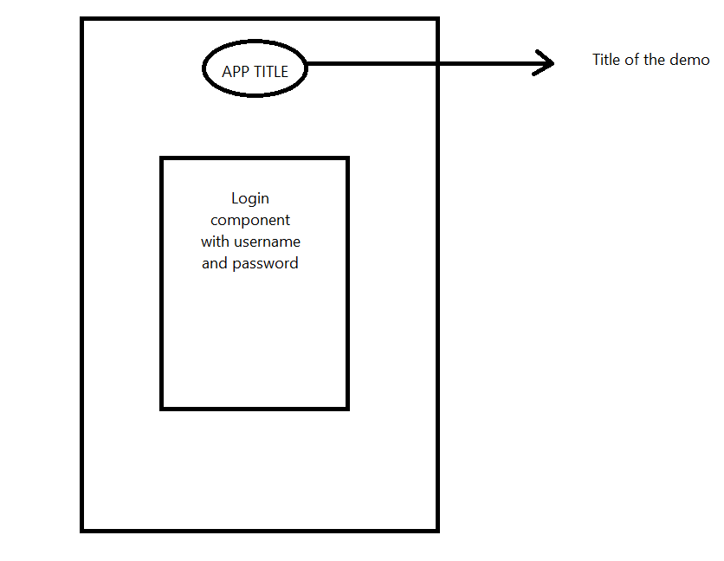

Figure 11 - Log in page Design

**FIRST TIME LOG IN:**

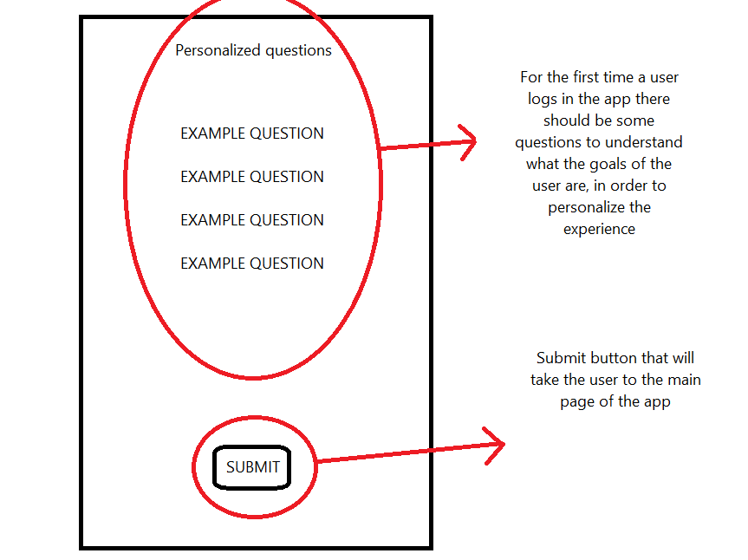

Figure 12 - First time Log In Page Design

**MAIN PAGE:**

Figure 13 - Main Page Design

**WORKOUT PAGE:**

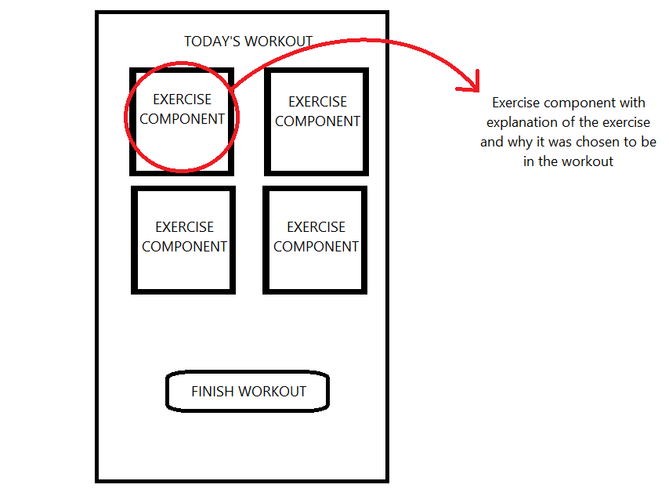

Figure - Workout page Design

**SOCIAL PAGE:**

Figure 15 - Social Page Design

# 7 – Use Case Diagram

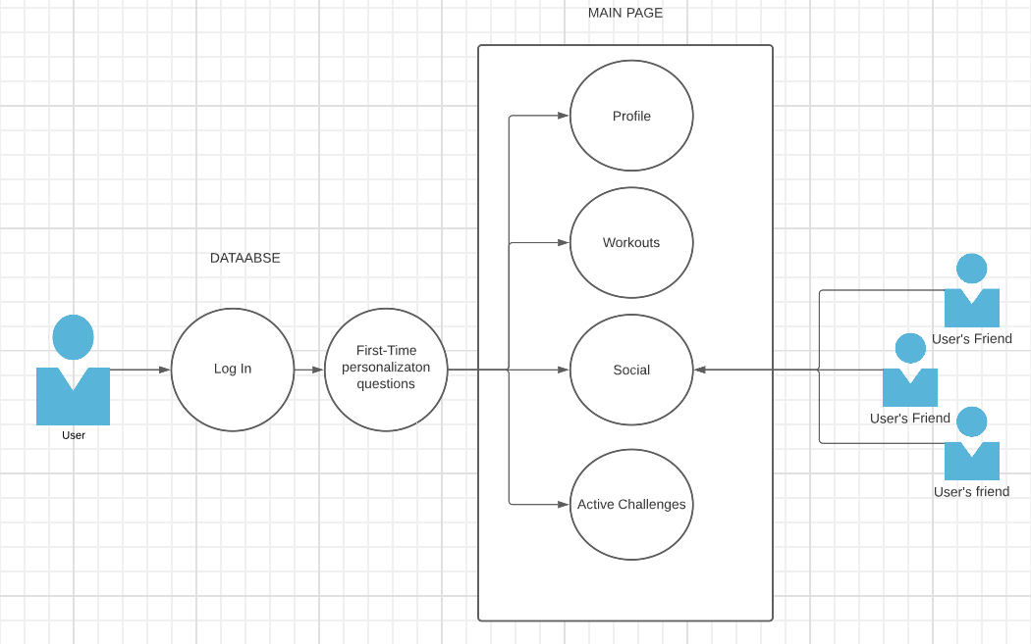

Figure 16 - Use Case Diagram

# 8 - Implementation

This demonstration app was built with vue.js and Vite. Vue.js. Vue.js is a progressive JavaScript framework for building interfaces, while Vite is a fast build tool for modern web applications. Vue and Vite were chosen because they are lightweight and efficient, making them ideal for building a demonstration app quickly. For the managing of the project yarn was used as the package manager. In this section the main components will be showed and for the most important ones code will be supplied.

The entire project is in the following GitHub repository:

<https://github.coventry.ac.uk/lagomarqua/Demonstration-app-6001CEM>

## 8.1 - First time logging in page

When it’s the first time a user logs in, the first element that was extracted from the first survey is introduced. This are some questions that will aim to assess what are the goals of fitness of the user, and will take in consideration the answers to improve the workouts that will display in the future. This questions were chosen but it would be interesting to understand what are the questions that work the best when it comes to personalization if this app was ever to be built in its entirety.

Note that the last question is a multiple answer question with the following possible answers: “Lose weight”, “Gain weight “or “Improve resistance”.

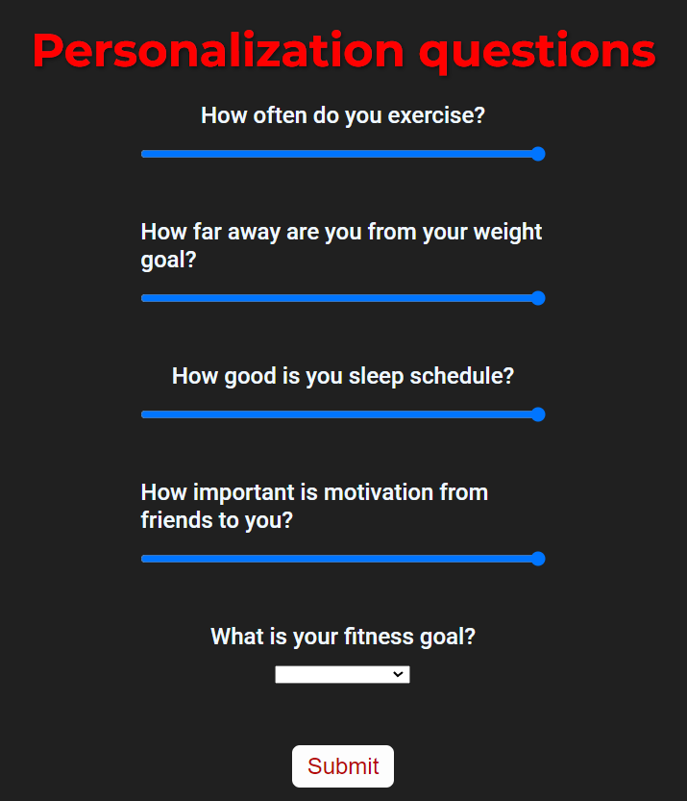

Figure 18 - First Time Log In Personalization Questions Page

For this page the following code was implemented to create a list of the questions:

<script>

**export** **default** {

data() {

**return** {

questions: [

"How often do you exercise?",

"How far away are you from your weight goal?",

"How good is you sleep schedule?",

"How important is motivation from friends to you?",

"What is your fitness goal?"

],

selectedOption: **null**

}

},

methods: {

submitAnswers() {

**this**.$router.replace('/mainpage')

}

}

}

</script>

## 8.2 - Main page

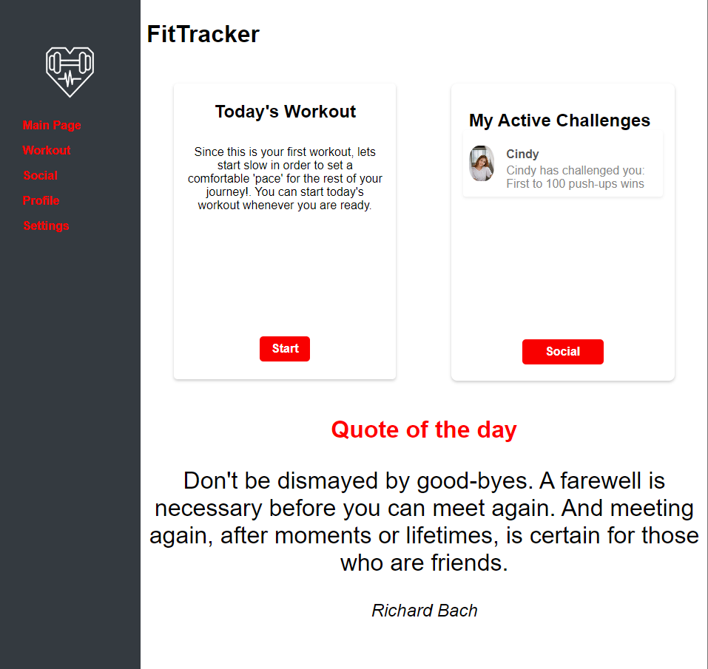

Figure 19 - Main Page

In the main page we can see most of the components displayed. A dynamic navbar was created to facilitate the navigation for the user. The “Today’s Workout” and the “My active Challenges” components are displayed in the centre of the page. The “Quote of the day” is displayed under those two components. All of this components will be explained one by one since they are the elements that were implemented from the first survey. When the main page was built a navigation bar component was made this is simply a bar with a list of the pages available for the users. The following code presented relates to this component:

<nav class="navbar">

<div class="navbar-logo">

<img class="logo-img" src="../assets/logo.png" alt="Logo" />

</div>

<ul class="navbar-menu">

<li class="navbar-item">

<router-link to="/mainpage">Main Page</router-link>

</li>

<li class="navbar-item">

<router-link to="/workout">Workout</router-link>

</li>

<li class="navbar-item">

<router-link to="/social">Social</router-link>

</li>

<li class="navbar-item">

<router-link to="/ProfileView">Profile</router-link>

</li>

<li class="navbar-item">

<router-link to="/settings">Settings</router-link>

</li>

## 8.3 - Quote of the day

The quote of the day displays a new quote every time a user arrives at the main page of the app, since the workouts are supposed to be done daily this will provide the user with a boost of motivation for the workouts that he/she has to do.

The code for this component is the integration of a third party API (Application Programming Interface). The following code snippet was implemented to do so:

<script>

**export** **default** {

name: 'MotivationalQuote',

data() {

**return** {

quote: '',

author: '',

};

},

mounted() {

fetch('https://api.quotable.io/random')

.then(response => response.json())

.then(data => {

**this**.quote = data.content;

**this**.author = data.author;

})

.**catch**(error => {

console.error(error);

});

}

};

<script/>

## 8.4 - Today’s workout card component

The today’s workout component was built to serve as a gateway to the workout page. This component consists of a title and a small description of the workout that will be presented that day. The component was built as a “card” to follow the overall theme of the app.

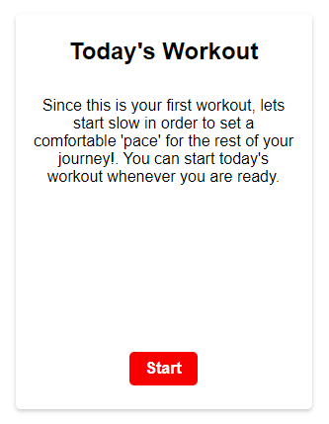

Figure 20 - Today's Workout Component

## 8.5 - Social card component

Just like the today’s workout component this component serves as a gateway to the social page and the active challenge page. Within the card the active challenges are displayed. In these active challenge there is a small description of the challenge, the avatar and the username of the account that has sent the user the challenge.

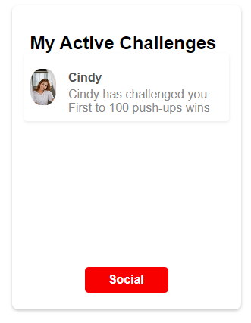

Figure 21 - Social card component

This is the code that creates the content inside of the card component. There is data that is returned to the rest of the component from this <script></script> section. This data refers to the username, avatar and a small description of the user Cindy that sent a challenge to the user.

**import** defaultAvatar from '../assets/StockProfile.jpg'

**export** **default** {

name: 'SocialCard',

props: {

title: {

type: String,

required: **true**

}

},

data() {

**return** {

defaultAvatar: defaultAvatar,

challenge: {

id: **1**,

username: 'Cindy',

userAvatar: '',

description: 'Cindy has challenged you: First to 100 push-ups wins'

}

}

},

methods: {

goToChallenge() {

**this**.$router.replace('/activeChallenge')

},

gotosocial(){

**this**.$router.replace('/social')

}

}

}

## 8.6 - Workout page

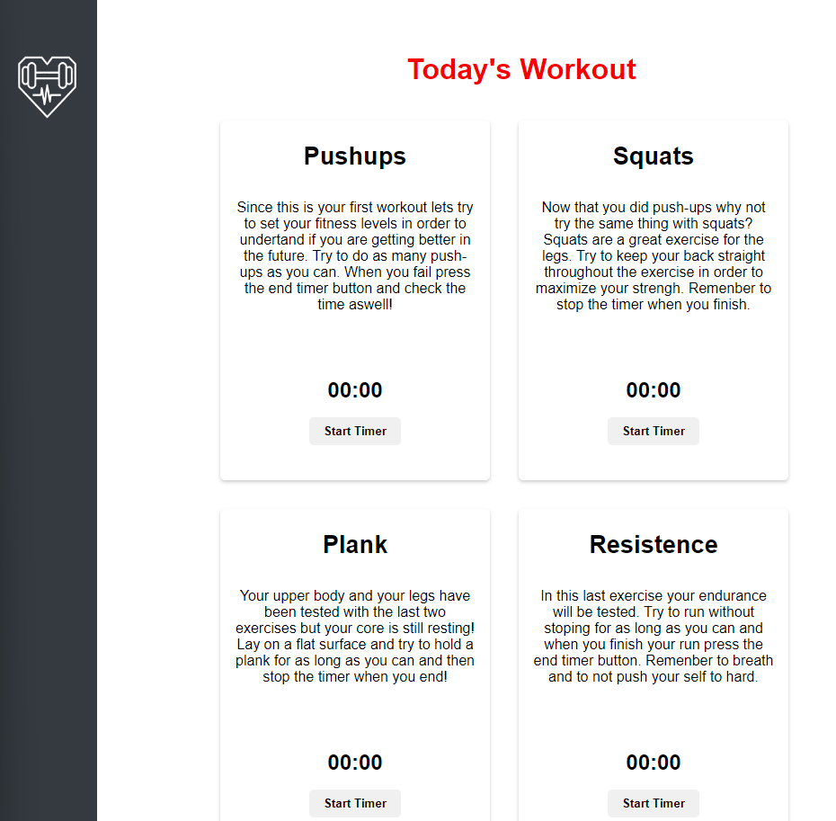

Figure 22 - Workout Page

This page is where the daily workouts are presented. The page has a list of exercises that are components built to match the theme of the app and they consist of the exercise title and a small explanation and description of the exercise. The user can chose to do the exercises in order or to skip around exercises. The user can also finish the workout whenever he wants since the finish workout button at the end of the page is accessible throughout the workout.

## 8.7 - Social page

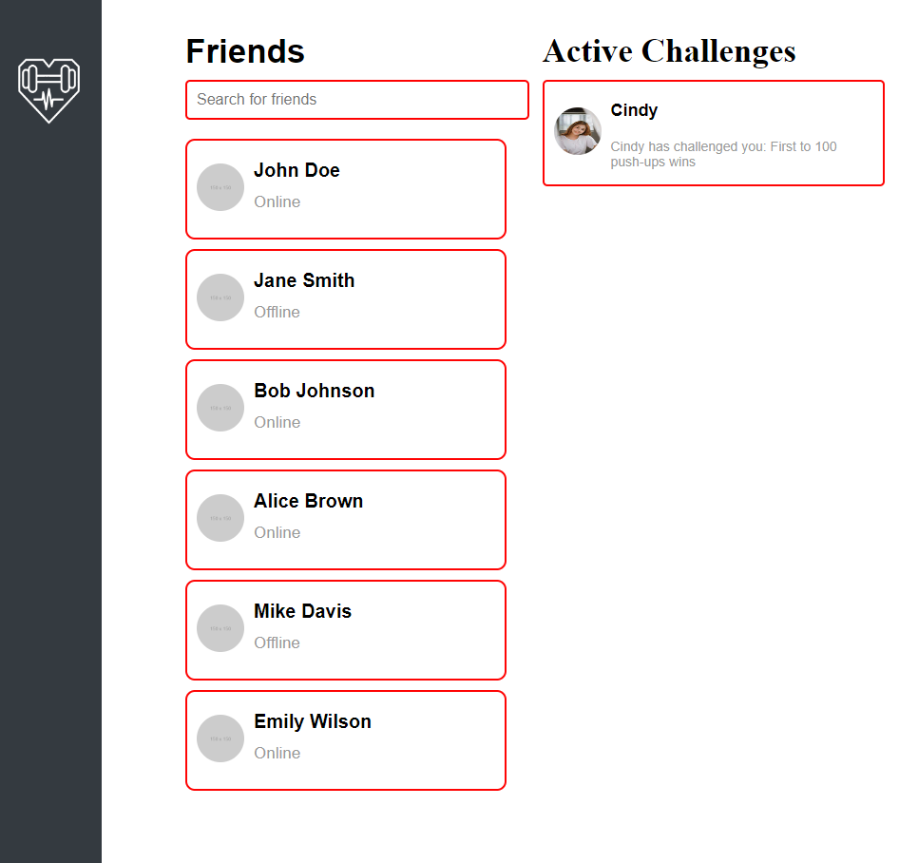

Figure 23 - Social Page

This page displays the friends that the user has and the active challenges that he/she received. This page serves as a way for the user to interact with others, and to organise their challenges.

# 9 - Second survey analysis

The second survey had the objective of understanding how the elements that were chosen to be implemented in the demonstration app were appreciated. The tools used to perform this survey was google forms and the demonstration app. This survey was conducted with 5 students in Coventry University aged from 20 to 21. The survey was presented to the respondents after they performed tasks in the demonstration app this was done in order to assure that all the respondents experienced every feature implemented.

## 9.1 - Tasks

Since the app is developed this tasks were proposed to the respondents in order to make sure they can cover everything that was developed throughout the interview

Task 1: Login and answer the personalization questions.

Task 2: Complete your profile.

Task 3: Try the todays workout.

Task 4: Check out the social page.

Task 5: Go back to the homepage to see the active challenges you have and do them.

## 9.2 - Data Visualization

In order to ask about every feature the questions were about one of the features that the users experienced. The first question of the survey was “From the experience, how would you rate the display of the app (UI)?” and the respondents answered:

Figure 24 - "From the experience how would you rate the display of the app?", Data Visualization

When asked “How would you rate the feature of choosing what information can be displayed as public or private?” the respondents answered:

Figure 25 - "How would you rate the feature of choosing what information can be displayed as public or private?", Data Visualization

When asked “Did you appreciate the personalization the app would provide?” the answers were as follows:

Figure 26 - "Did you appreciate the personalization the app would provide?", Data Visualization

Since the respondents experienced the demonstration app and not a final and finished product the potential of this demonstration app is something that the respondents can express. When asked “Would you feel motivated with the way app presented works to you if it was a final product?” they answered:

Figure 27 - "Would you feel motivated with the way the app presented works to you if this was a final product?", Data Visualization

When asked “Would the social customizable challenges motivate you to get challenged and challenge your friends?” the respondents answered:

Figure 28 - "Would the social customizable challenges motivate you to get challenged and challenge your friends?", Data Visualization

When asked “Would the fact of having an account level that is improvable help you stay motivated?” the respondents answered:

Figure - "Would the fact of having an account level that is improvable help you stay motivated?", Data Visualization

When asked “How much did he motivational quotes care to you?” the respondents answered:

Figure 30 - "How much did the motivational quotes matter to you?", Data Visualization

## 9.3 - Outcomes of the second survey

Based on the data gathered from the second survey, it seems that the respondents appreciated the features that were implemented and across all of them their potential for a hypothetical final product was acknowledged. The implementation of the features in the demonstration app was a success but it’s important to understand that this second survey was performed with a small sample of respondents which can diminish the importance of the answers because when scaled to a bigger sample the answers can change.

The written feedback also supports the claim that the features were well chosen, one of the respondents stated “In overall the app elements presented were good in order for the user to enjoy the experience, and created a good environment, so the user can continue using the app.”, when asked “What is your opinion of the proposed app elements?” .

The written feedback also aims to better understand if the features that the respondents used were better or worse than the ones presented in the apps that they have used. This is important since if an app was to be developed with the features of the demonstration app it still had to compete with other apps on the market. When asked to write about the overall experience compared to apps that the respondents used before, one of the respondents stated “I enjoyed the personalization that the demonstration app aims to have, it is something that I felt missing in other fitness apps”.

### 9.3.1 - User-friendly interface

One of the outcomes from the first survey was the importance of a good and user-friendly interface. From the data gathered in this second survey it seems that this was well achieved. Further exploration of the theme chosen in terms of front-end development would be necessary to implement an even better UI in the finalized app.

### 9.3.2 - Personalization

Another outcome from the first survey regards personalization. Two features of personalization were implemented in the demonstration app. The first being the option of choosing what information can be displayed as public or what information the user wants to keep private. This feature was appreciated by the respondents since all of them rated it with a 5 out of 5. The second personalization feature that was implemented was the “personalization questions” that are presented after the user logs in the app for the first time. Overall the users also appreciated this feature. In the future, if the finalized product was to be developed, there would be a need to study what question should be asked and what content should displayed for the different answers.

### 9.3.3 - Gamification and social features

One of the main outcomes from the first survey relates to gamification and the social aspect of the app. To achieve this three features were implemented in the demonstration app: A progress bar regarding the level of the user’s account, customizable challenges with friends and a social page with the profiles of all the friends of the user. The customizable challenges are the core gamification feature of the app since it gives the user a gamification experience without publicly comparing their fitness status with others. This features was greatly appreciated by the respondents. The other gamification feature is the progress bar displayed in the user’s profile and it seems that, although most apps have this, the respondents still appreciated the integration of this feature in the demonstration. In the future it would be important to further customize the challenges and reward the users that actually challenge and are challenged by friends with badges to make the social aspect of the app feel rewarding.

### 9.3.4 - Motivational quotes

From a written feedback of the first survey a feature that helps the users keep motivated with quotes from various historical figures was implemented. This feature, although seeming small, affected the respondents. The appreciation of the feature was positive and when asked to write about the overall experience compared with apps that the users used before one of the respondents stated “I like the motivational quotes”, this indicates that this small feature is missing from other apps. In the future it would be important to make the API fetch only happen once per day since the motivational quotes are daily.

# 10 – Conclusion

## 10.1 - Critical Evaluation

In conclusion, the objectives of the paper were successfully met, as evidenced by the positive impact of the gamification elements on the user experience of the second survey. The second survey showed an overall positive appreciation of all the gamification elements chosen and, an interest from the respondents in utilising an app with the gamification elements that were studied presented. The research question “what gamification elements can improve user’s social, physical, and mental health?” was addressed effectively through the implementation of gamification elements like the progress bar of the user’s account level and the social customizable challenges. These elements were found to be effective in enhancing the user experience, although there is a need to expand upon them.

The findings of the second survey support the conclusion that these gamification elements work well. However, it was unexpected and interesting to find non-gamification elements like the daily motivational quotes were positively received by users and enhanced their overall experience.

The demonstration app successfully served its purpose of testing the chosen gamification elements, and the overall development of the app was successful. These results suggest that a well-implemented gamification strategy can improve the user experience of an application and contribute to the use’s social, physical and mental health.

Future research should explore additional gamification elements to further enhance the user experience and improve the use’s overall health and well-being.

The research paper provides a competent and successful study of gamification elements for improving user’s physical, social and mental health. However, there are still areas that could benefit from improvement. For example, the sample size for the surveys was small, making the outcomes less reliable compared with the overall population. In addition, the demonstration app could have included more backend features and content to improve the user experience and make it last longer. Also, including more gamification elements in the demo app could have allowed for more in depth comparisons between them and their impact on user appreciation and experience.

Despite these limitations, the structure of the paper follows a logical and well-thought-out plan. The first survey helped identify gamification elements that have worked for the respondents in the past, which were then implemented in the demonstration app. Lastly, the feedback from the second survey post-experiencing the app helped determine the effectiveness of the chosen gamification elements for enhancing use’s health and wellbeing, there is room for improvement in future research.

## 10.2 - Compare with the literature

The literature review and the survey outcomes provide valuable insights on the effectiveness of technology-based interventions, gamification elements, psychosocial components, and social features promoting mental and physical well-being through fitness apps.

The outcomes of this project focus on the user experience of a demonstration fitness app and show that the features that were implemented in the app were well-received by the small sample of respondents. The user-friendly interface and personalization features were appreciated by the respondents, and the gamification and social features were effective in promoting engagement and motivation. The motivational quotes feature was also appreciated and found to be missing in other apps of this kind.

Overall, the literature review and the outcomes presented on this paper suggest that technology- based interventions, gamification elements and social components can be effective in promoting mental and physical well-being through fitness apps. Future research should continue to explore the effectiveness of these features and their impact on the user engagement, motivation and satisfaction. In addition , the study of front-end development is crucial for improving the UI of fitness apps and enhancing the user experience.

## 10.3 - Reflection

Reflection on working on this project, I can say that it was a positive experience overall. One major aspect of the project was the use of the Vue.js framework, for the first time. However, the demonstration app provided a great introduction on the framework, and despite being my first project using it, I found the work to be gratifying and it went smoothly.

Another aspect of this project that was required some adjustments was the time constraints. Even though I was initially concerned about the challenge of writing a big project in my second language, the only significant setback I face was the literature review taking longer than expected. However, with careful planning and time management, I was able to complete the project within the settled timeframe.

Overall, I am very happy with the work that I have produced. This project allowed me to develop new skills, such as conduction surveys and using Google Forms for the first time. Although it was the first time doing surveys, I did what was to be expected and utilising Google Forms was simpler than what I initially anticipated.

In conclusion, this project was an enriching experience that helped me develop new skills and gain valuable knowledge. I am excited to continue learning and exploring new technologies and tools in future projects.

## 10.4 - Social and legal implication

The social and legal implications of the research conducted must be taken into consideration to ensure that the study was ethical and did not infringe on the rights of the participants.

Firstly, it is important to note that the work followed an ethical code, and no personal data was collected or shared from the respondents of both surveys. This ensures that the privacy and anonymity of the participants were protected throughout the research process.

Furthermore, the work was not intended to harm anyone in any way, and all participants were informed of the purpose and scope of the research prior to their participation. This ensure that participants were fully aware of the nature of the study and could make an informed decision on whether to participate or not.

In terms of the impact of the work done, the research aimed to provide the population with some information on gamification elements and to improve upon the research done in this field of study. This information is valuable to fitness app developers and users alike, as it can help to promote the use of such apps in fitness and mental well-being, as well as social well-being.

It is important to note that the demonstration app was fully conducted with front-end code, meaning that no personal data was requested from the respondents that experienced it. This ensured that the privacy of the participants was protected, and there were no legal implications in terms of data protection.

Overall, the study was conducted in an ethical and responsible manner, with no legal implications arising from the research process. The results of this study are valuable to fitness app developers and users, and it is hoped that they will help promote the use of gamification elements in such apps for the benefit of user’s physical mental, and social well-being.

## 10.5 - Future work

Based on the findings of the project, there are several areas of potential future work to improve the effectiveness of gamification elements in well-being apps. For example applying the gamification elements that have been shown to be effective in the study, such as customizable challenges and the progression bars with rewards. These elements can be integrated into future fitness apps to increase user engagement and motivation.

Another potential future work is to set up the database and back-end of the app to being the demonstration app to its full potential final product. This can include features such as tracking user progress and providing personalized recommendations based on their fitness goals and preferences.

Furthermore, getting in contact with a fitness expert can help to further improve the content of the app. The expert can provide insights on the most effective exercises, workouts, and fitness regiments.

Overall, the future works section highlights the potential for future research and development in the field of gamification in fitness and well-being apps. By continuing to refine and improve these apps, we can help individuals maintain a healthy lifestyle and achieve their fitness goals.

# 11 - Project management

The tool chosen to plan this project was the creation of a personal Kanban. Personal Kanban is a productivity and time management system inspired by the Kanban methodology used in manufacturing and software development. It involves using a board, typically divided into columns ladled “To do”, “Doing” and “Done”, to visualize and manage tasks and workflow. (Anon 2016)

The tasks were displayed on a excel spreadsheet and the table was to be updated every time a task was either completed or postponed. The personal Kanban in the very first week was as follows:

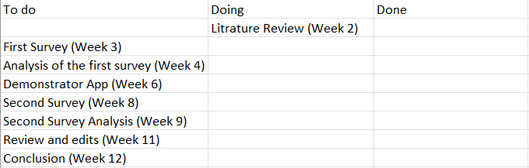

Figure 31 - Personal KanBan Week 1

In brakets in front of each task the expected deadline was written. This was a way of pressuring the work to be done and structered.

Althought it seemed to be good plan like most project some personal deadlines were not completed as you can see in week 3:

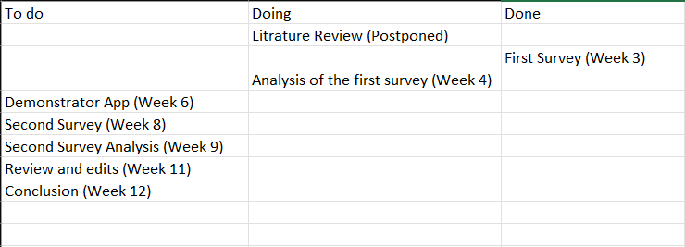

Figure 32 - Personal KanBan Week 3

#

For the demonstration app, starting in week 6 and ending in week 8, I decided to divide it in to more subtasks in order to keep track of the development of the app. The following figure represents the updated personal Kanban.

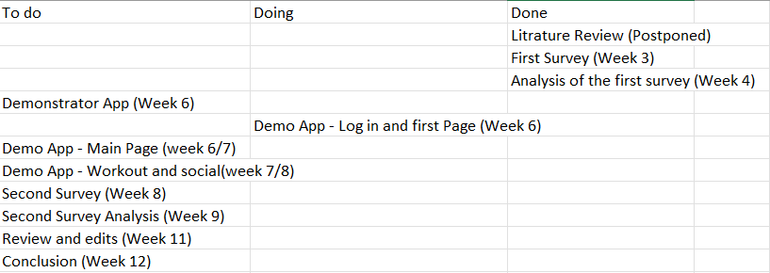

Figure 33 - Personal Kanban week 6

As you can see I have myself three weeks to the demonstration app. The first week (week 6) I am supposed to do the log in page and the first time logging in questions page. The second week (week 6/7) and if I am able to finish and still have time in the first I will do the Main page. Lastly I will have two weeks to do the workout and social aspects of the app (week 7/8).

I did complete the app in time, meeting all the deadlines set for myself. The following figure represents the personal kanban updated after the development of the app:

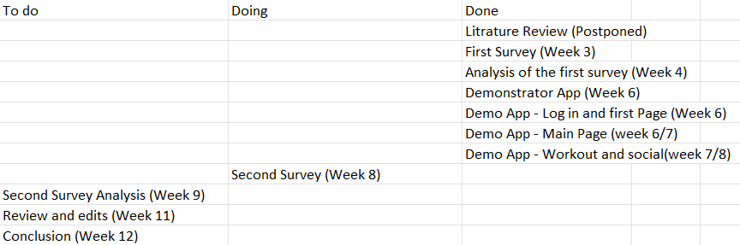

Figure 34 - Personal Kanban week 7

The last update I did was switching what was set to be done on week 11 and week 12. I understood that doing the conclusion first and then doing the review and editing would make more sense therefore the updated personal kanban for week 12 is as follows:

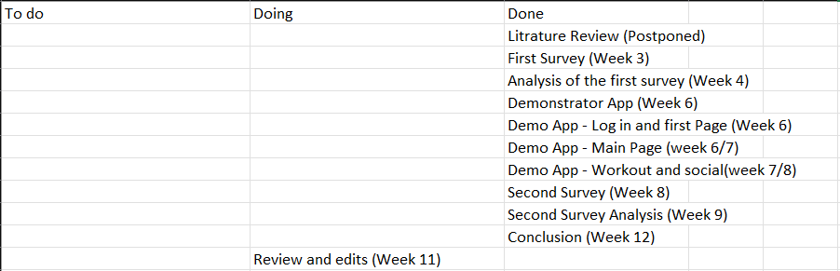

Figure 35 - Personal Kanban week 12

With all the content done it was easier to edit and review my work.

# 12 - Log Book

**Week 1**

Meeting – Reviewed the plan and set goals for the first two weeks

**Week 2**

Started reviewing the initial literature review and started researching new paper to extend upon the work done.

Meeting – Planned to create a log book which will help with project management and debated the execution of the first survey.

**Week 3**

The first survey was created the questions aim to reflect on areas that can be explored in the mock app that is going to be created

Meeting – Discussion about the questions chosen for the survey and discussion about the plan for next week

**Week 4**

Meeting – Discussion about the implementation of the first survey. And the analysation that will be done on the data gathered.

The analyses of the first survey was conducted and almost finalized. Aiming to start figuring out what the mock app will have as gamification elements.

**Week 5**

Meeting – Discussion about the final touches to be done in the literature review. Developing ideas for the demonstration app utilizing the outcomes of the first survey.

The methodology was done in this week.

**Week 6**

Meeting – Discussion about the state of the methodology and about the development of the demonstration app.

The development for the demonstration app started and the final touches of the methodology was done this week.

**Week 7**

Meeting – Discussion about the development of the demonstration app.

Further development of the demonstration app was done. Development of the features also started.

**Week 8**

Meeting – Discussion about the second survey. What questions are going to be asked, what tasks are going to be proposed and how many people will be asked to perform the survey.

Started the second survey preparation, questions and talked with the future respondents

**Week 9**

Meeting – Discussion of the data gathered from the second survey. Discussion about the further analysis needed regarding the data gathered.

Finished the second survey started the analysis of the data gathered

**Week 10**

Meeting - Discussion of the analysis of the second survey that was done. Discussion of the work done so far.

Redid the methodology improving it with some feedback from the tutor.

**Week 11**

Meeting – Discussion of the editing that needs to be done regarding table of contents, table of figures and the footer and header.

Writing the conclusion of the project and the introduction.

**Week 12**

Meeting – Last discussion about the work done and what needs to be done in editing

Final touches and submission.

# 13 - References

1. Anon. (2016) *The Essential Guide to Personal Kanban* [online]available from <https://www.smartsheet.com/using-personal-kanban-find-new-job-jumpstart-your-career-or-accomplish-more-your-current-role> [8 April 2023]
2. Chitroda, H. (2022) *A brief history on Gamification*, *KNOLSKAPE*. Available at: https://knolskape.com/blog/brief-history-gamification/ (Accessed: January 28, 2023
3. Digital, M. (2016) *The current state of Mobile Application Development*, *Manifesto)*. Available at: https://manifesto.co.uk/state-of-mobile-application-development/ (Accessed: January 28, 2023
4. Lee, H.E. and Cho, J. (2016) “What motivates users to continue using diet and fitness apps? application of the uses and gratifications approach,” *Health Communication*, 32(12), pp. 1445–1453. Available at: https://doi.org/10.1080/10410236.2016.1167998.
5. Mitchell, N. (2022) *University has been a lonely place for students – survey*, *University World News*. Available at: https://www.universityworldnews.com/post.php?story=20220609110221496 (Accessed: December 1, 2022).
6. NHS (2022) *Obesity statistics - House of Commons Library*, *commonslibrary.parliament.uk*. House of Commons Libary. Available at: https://commonslibrary.parliament.uk/research-briefings/sn03336/ (Accessed: December 1, 2022).
7. Published by L. Ceci and 13, M. (2022) *Annual Number of Mobile App Downloads Worldwide by Region 2023* [online]available from <https://www.statista.com/statistics/266488/forecast-of-mobile-app-downloads/> [8 April 2023]
8. Published by L. Ceci and 7, J. (2021) *Mobile Apps That Have Been Used Only Once 2019* [online]available from <https://www.statista.com/statistics/271628/percentage-of-apps-used-once-in-the-us/> [8 April 2023]
9. Romeo, A., Edney, S., Plotnikoff, R., Curtis, R., Ryan, J., Sanders, I., Crozier, A., and Maher, C. (2019) “Can Smartphone Apps Increase Physical Activity? Systematic Review and Meta-Analysis”. *Journal of Medical Internet Research*21 (3)
10. Tu, R., Hsieh, P., and Feng, W. (2019) “Walking for Fun or for ‘Likes’? the Impacts of Different Gamification Orientations of Fitness Apps on Consumers’ Physical Activities”. *Sport Management Review*22 (5), 682–693
11. Vaghefi, I. and Tulu, B. (2019) “The Continued Use of Mobile Health Apps: Insights from a Longitudinal Study”. *JMIR mHealth and uHealth*7 (8)
12. Wohllebe, A. (2020) “Consumer acceptance of APP push notifications: Systematic review on the influence of frequency,” *International Journal of Interactive Mobile Technologies (iJIM)*, 14(13), p. 36. Available at: https://doi.org/10.3991/ijim.v14i13.14563.
    1. Yeoh, R., Kim, H.K., Kang, H., Lin, Y.A., Ho, A.D., and Ho, K.F. (2022) “What Determines Intentions to Use Mobile Fitness Apps? the Independent and Joint Influence of Social Norms”. *International Journal of Human–Computer Interaction*1–10
13. Yin, S., Cai, X., Wang, Z., Zhang, Y., Luo, S., and Ma, J. (2021) “Impact of Gamification Elements on User Satisfaction in Health and Fitness Applications: A Comprehensive Approach Based on the Kano Model”. *Computers in Human Behavior*128, 107106