DVWA
installing DVWA iso using virtualbox
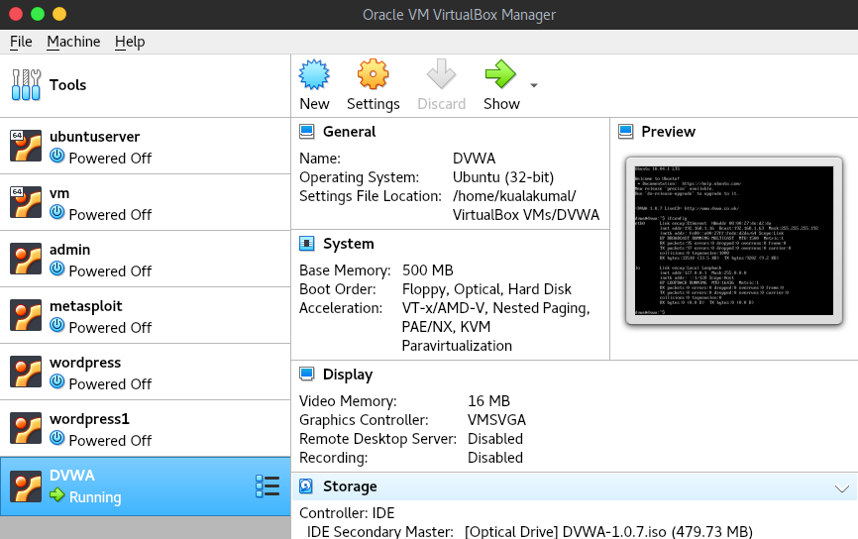

you can open DVWA using virtualbox and typing ifconfig
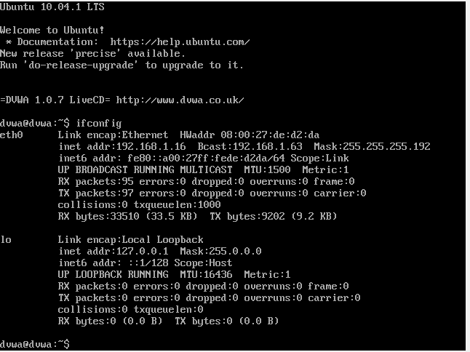

you can acces ip uaing web browser and login username:admin passworrd:password
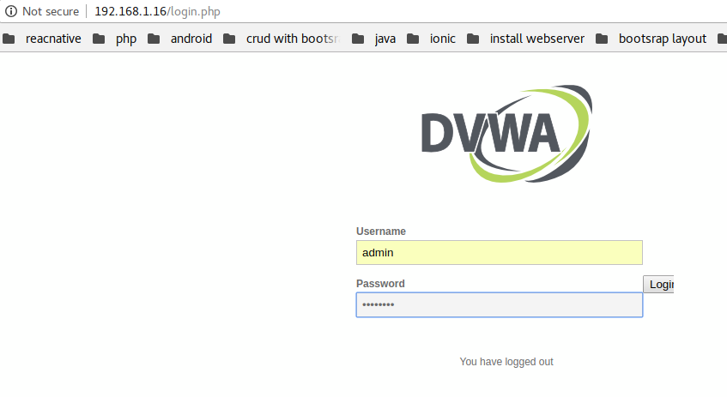
you can setting DVWA set level low
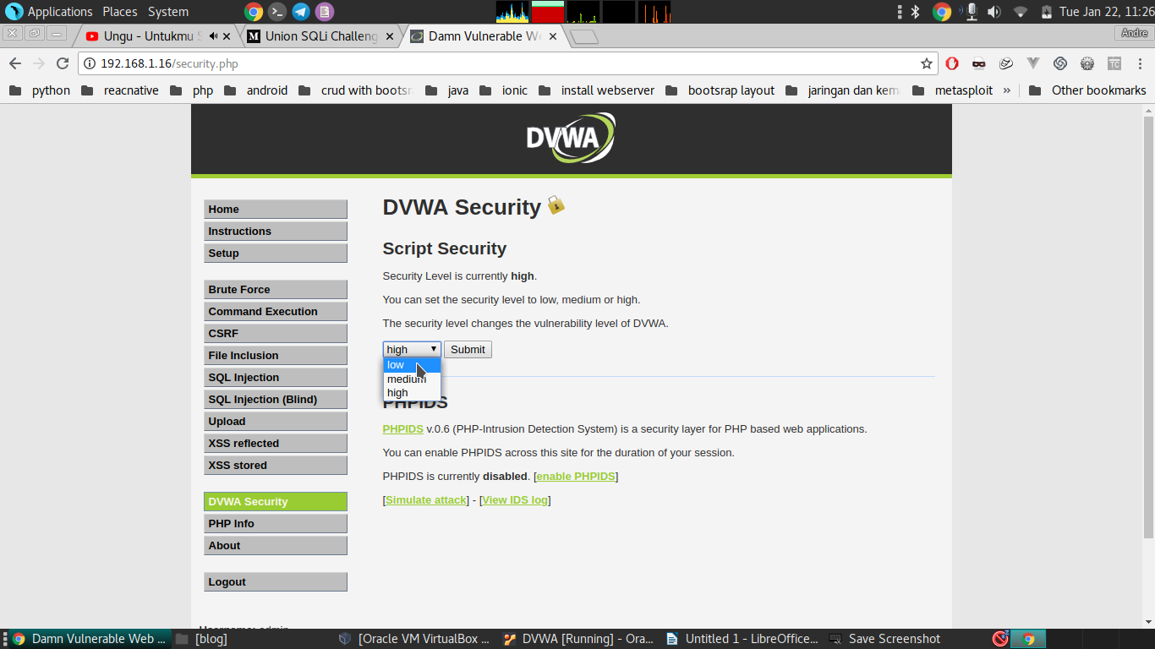

level 1
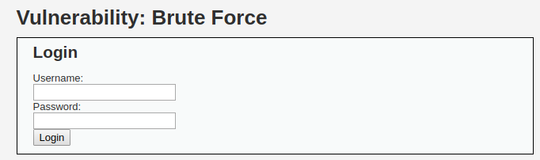
you can view page source code
