1.Vulnerabilities proFTPD

Scanning using nmap

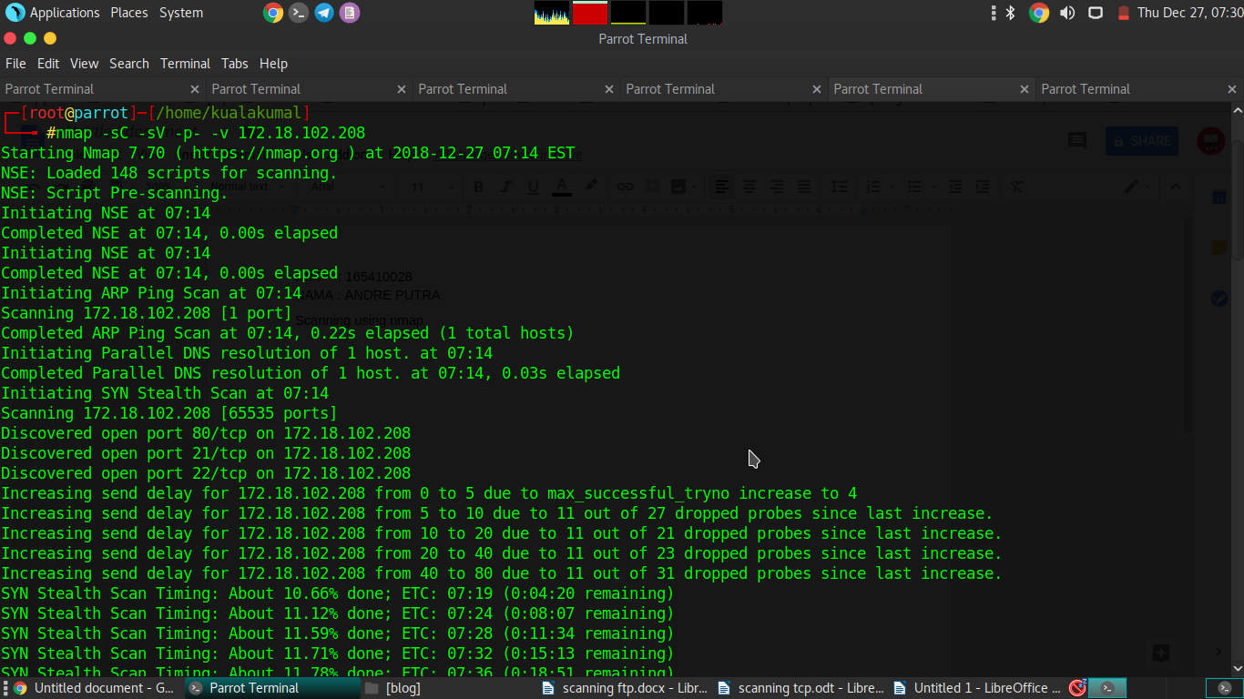

Open msfconsole

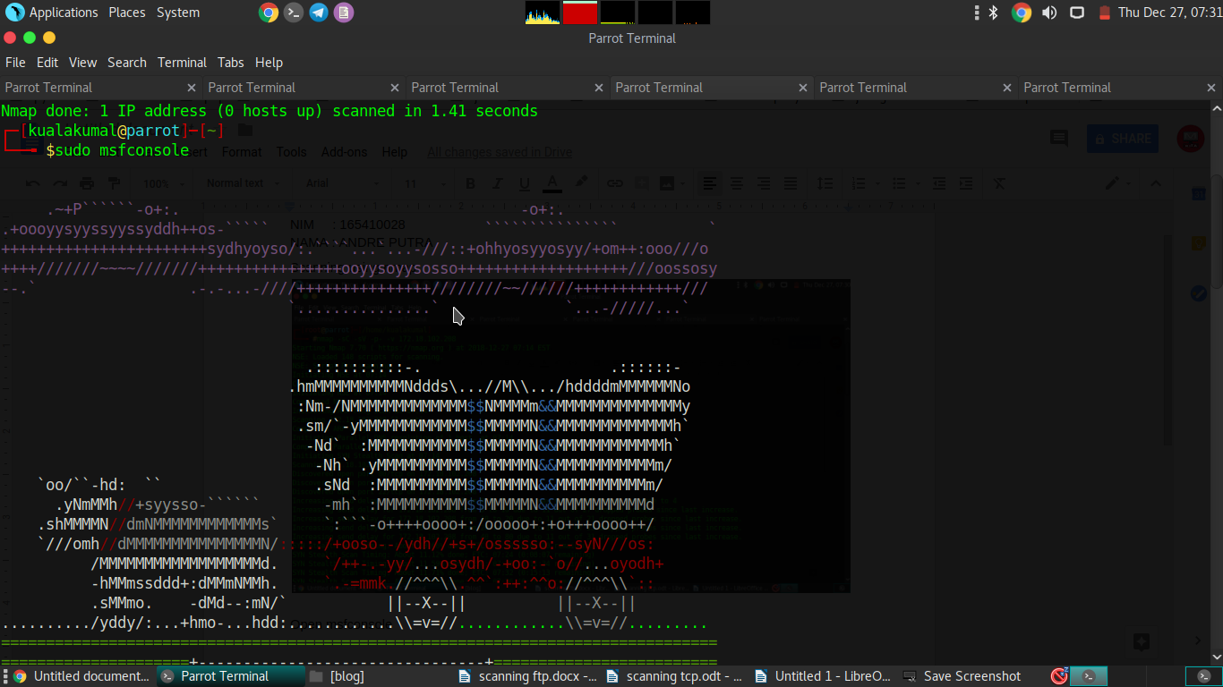

Searchg module proFTPD in metasploit

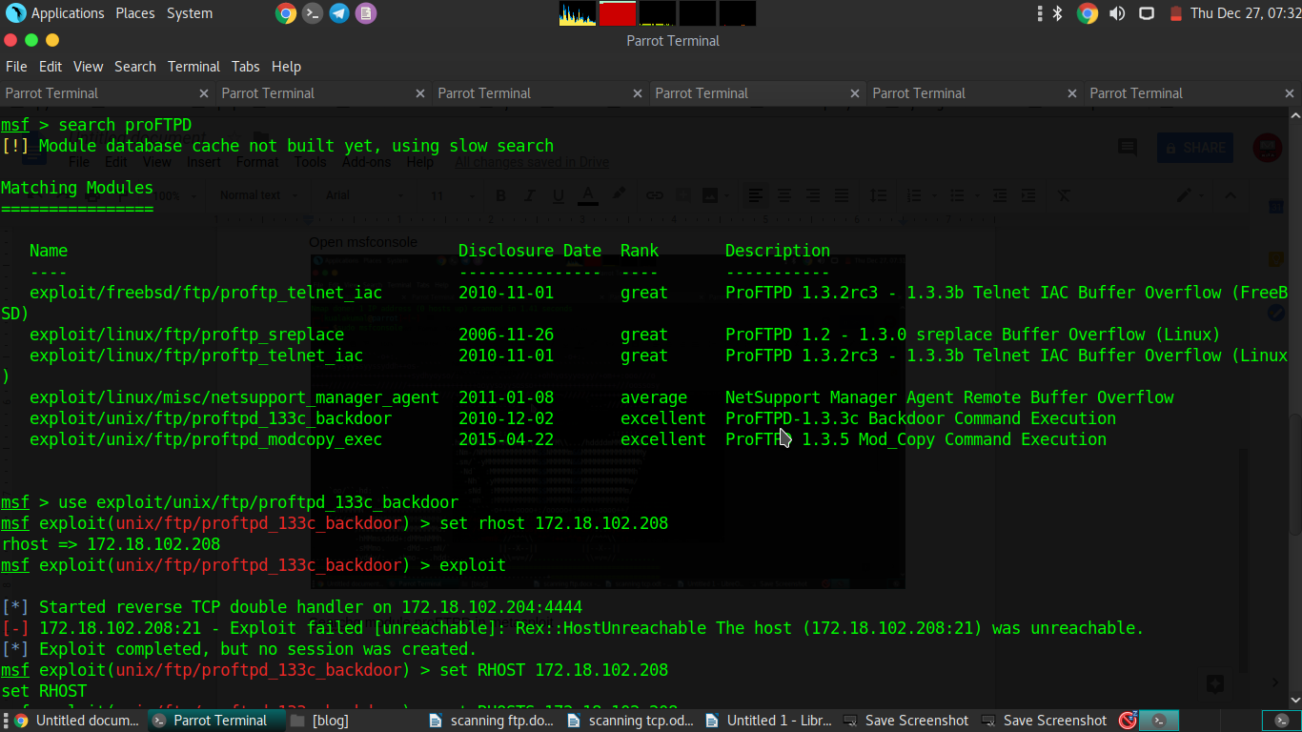

Chose module exploit/unix/ftp/proftpd_133c_backdoor and setting rhost target and running exploit

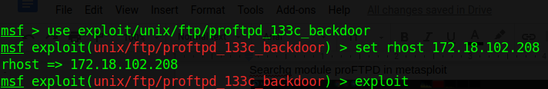

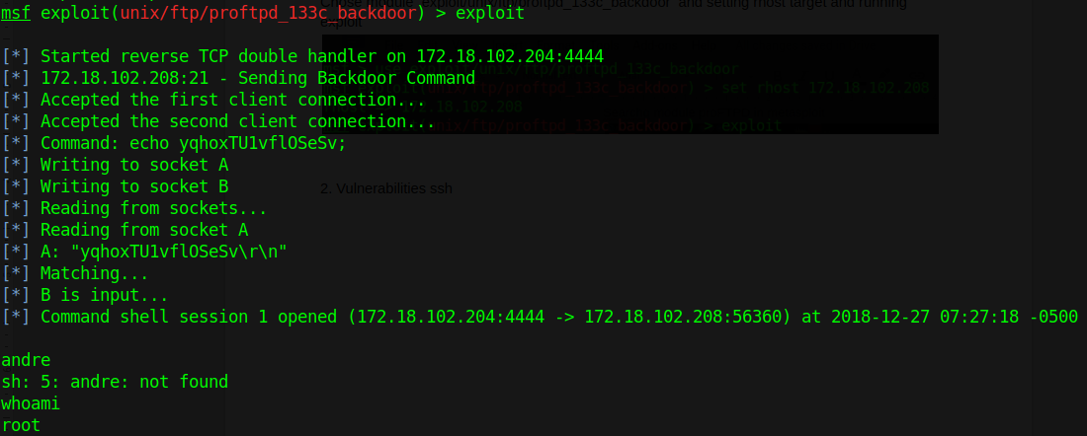

2. Vulnerabilities ssh