Mysql Client/Server Protocol
（based on 5.6.17）

Overview
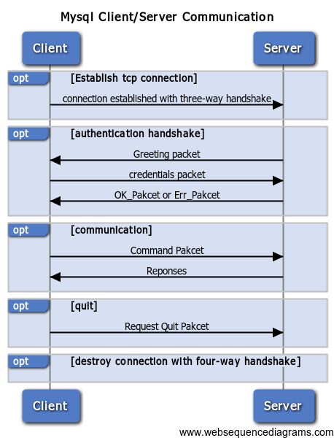
The server listens for connections on a TCP/IP port or a local socket.
When a client connects, a handshake and authentication are performed. If successful,the session begins.
The client sends a command,and the server responds with a data set or a message appropriate for the type of command that was sent.
When the client is finished,it sends a special command telling the server it is done,and the session is terminated.

TCP Dump
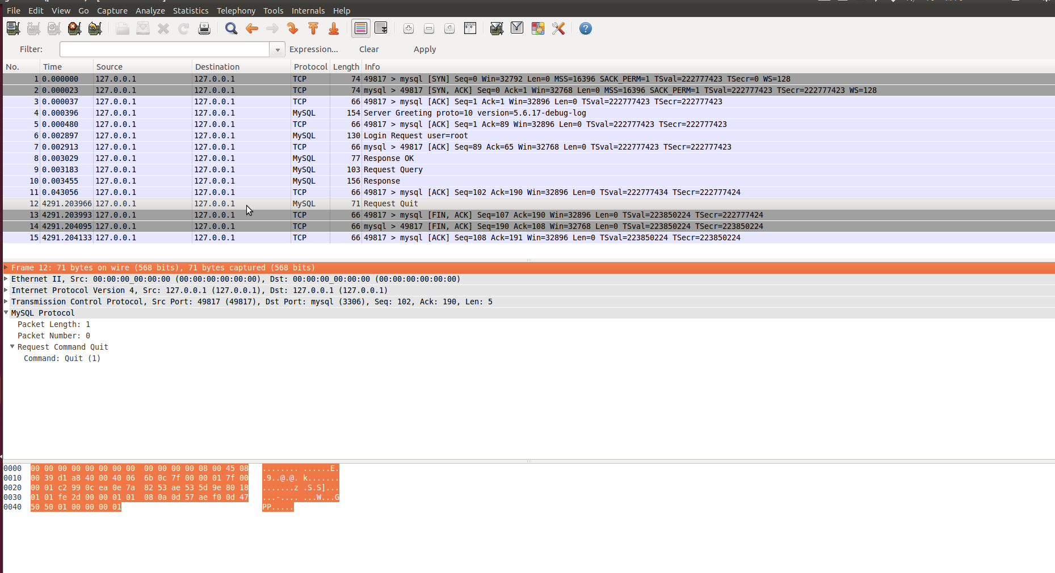

Process flow

Step1:Establish tcp connection
- Establish tcp connection with three-way handshake

Step2:Mysql:Authentication Handshake
- Server->Client:Handshake initialization packet(greeting packet)
- Client->Server:Response with a credentials packet
- Server->Client: accepts connection with OK_Packet or reject it with ERR_Packet

Step 3:Mysql:Communication between client and server
- Client->Server:Command packet
- Server->Client:Server Responses including:
- OK Packet
- Error Pakcet
- EOF Pakcet
- Result Set Pakcets

Step 4:mysql Quit
Client->Server：Request Quit

Step 5:Destroy Connection
Destroy Connection with four-way handshake

Pakcet Format

Categories
Two types of packets depends on the capabilities during handshake stage
- compressed
- noncompressed
Two categories divided by sender
- commands sent by client
- responses returned by the server, divided into four categories:
- data packets,
- end-of-data-stream packets
- success report(OK) packets
- Error message packets

Common Header
Common four-byte header for uncompressed packets:
Offset | Length | Description
0 | 3 | Packet body length stored(16MB )
3 | 1 | Packet sequence number. The sequence numbers are rest with each new command.

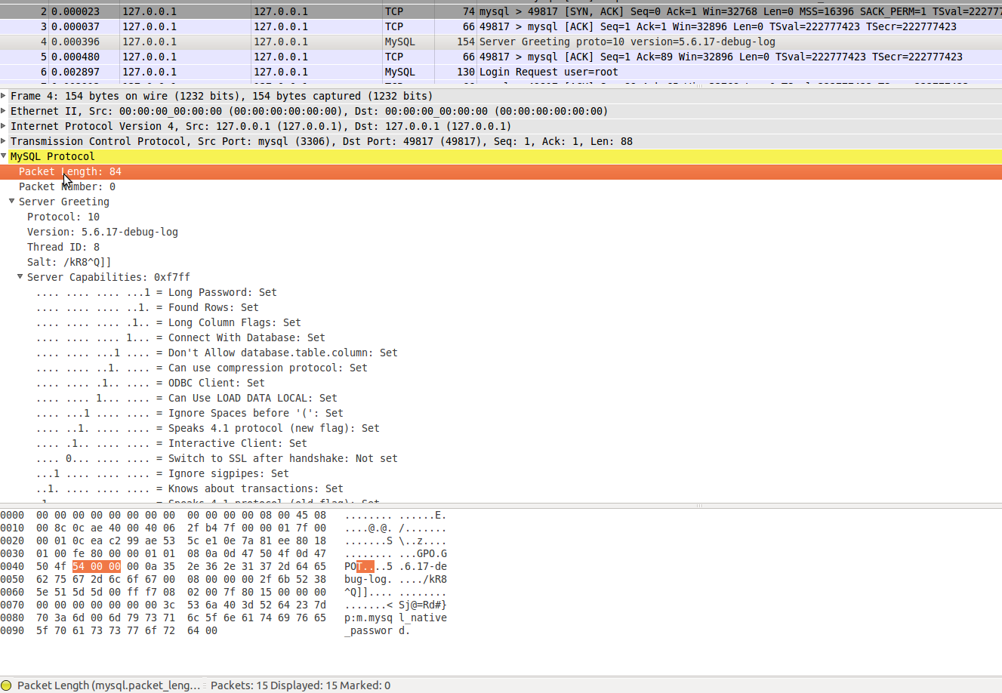
A compressed packet will have an additional 3-byte field,containing the length of the compressed packet body part that follows.

Authentication Handshake
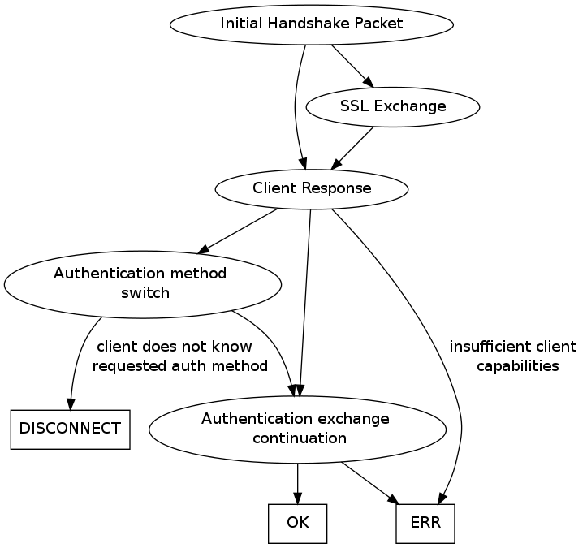
The session between a client and a server begins with an authenticating handshake.
Before it can begin, the server checks whether the host that the client is connecting from is even allowed to connect to this server. If it is not, an error message packet is sent to the client notifying it that the host is not allowed to connect.

Greeting Packet
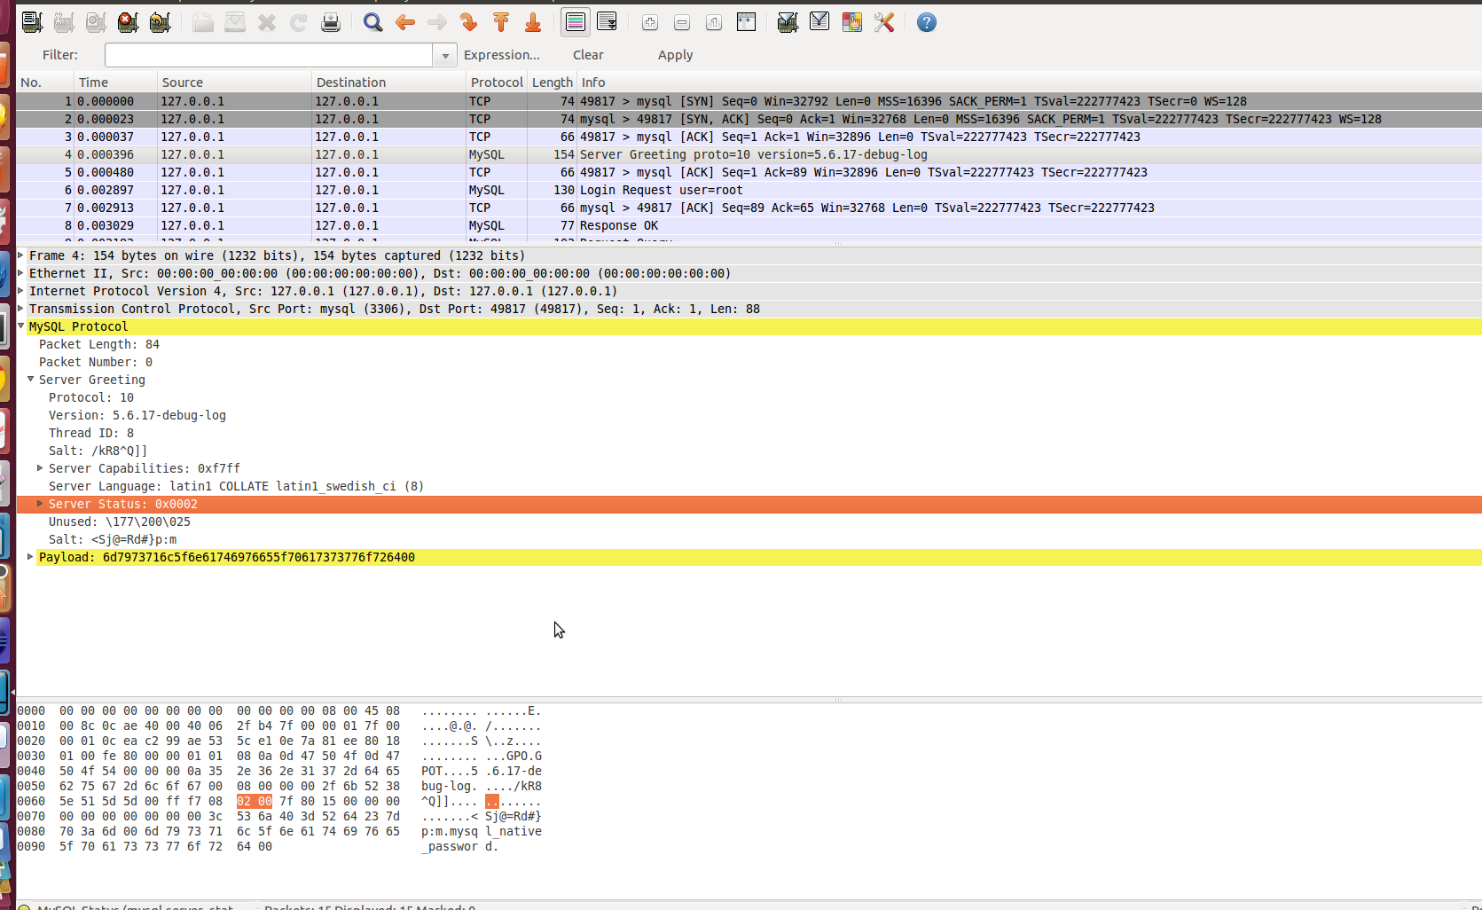
In the case of successful host verification, the server sends a greeting packet with the standard 4-byte header, the packet sequence number set to 0, and the body in the format shown bellow:

offset in the body | Length | Description
0 | 1 | Protocol version number.
1 | ver_len = strlen(server_version) + 1 | Zero-terminated server version string.
ver_len+1 | 4 | Thread ID. Internal Mysql ID of the thread that is handling this connection.
ver_len + 5 | 9 | Salt. Zero-terminated string: the first 8 bytes of the 20-byte rand seed string(caused by the version compatibility)
ver_len+14 | 2 | Server Capabilities
ver_len+16 | 1 | Server Languate.Default character set code,or more precisely,the code of the default collation
ver_len+17 | 2 | Server Status.Reports whether the server is in transaction or autocommit mode.if there are additional results from a multisatement query,or if a good index(or some index) was used for query optimization...
ver_len+19 | 13 | Unused.Reserved for future use
ver_len + 32 | 13 | Salt:the rest of the random seed string terminated with a zero byte.

Credentials packet
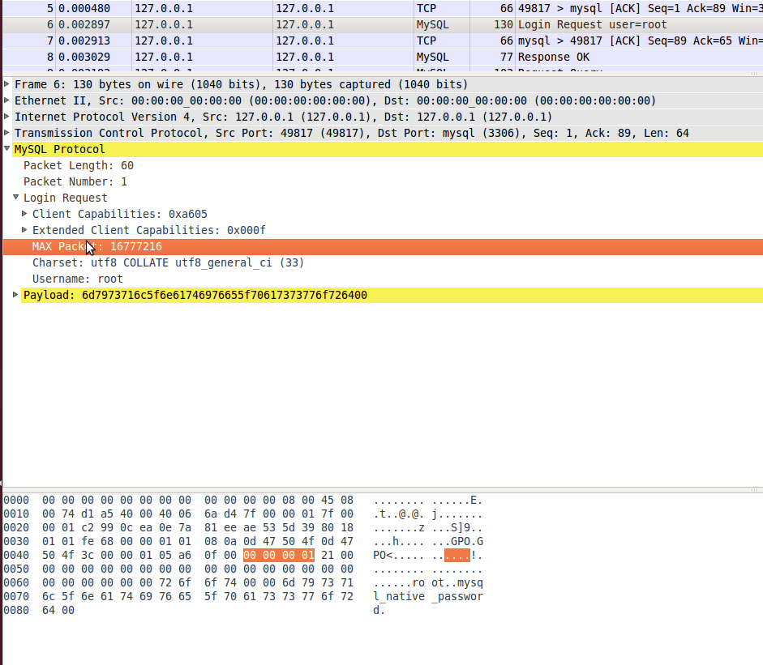
The client responds with a credentials packet
Offset in the body | Length | Description
0 | 2 | Client capabilities
3 | 2 | Extended Client Capabilities.
5 | 4 | Max Packet. Maximum packet length that the client is willing to send or receive.Zero values means the client imposes no restrictions of its own in addition to what is already there in protocol
10 | 1 | Charset,default character set (or more precisely,collation) code of the client
12 |  | Username,name of the SQL account which client wants to log in. this string should be interpreted using the character set indicated by character set field

Protocol Capabilities Bit Mask
During the authentication handshake,the client and the server exchange information on what the other is able or willing to do.This enables them to adjust their expectations of their peer and not send the data in some unsupported format. The exchange of information is accomplished through fields containing the bit mask of protocol capabilities.
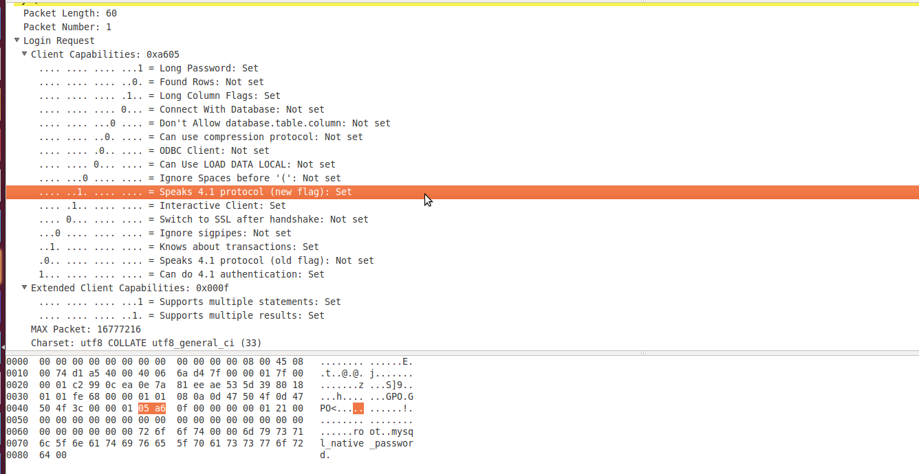

Command packet
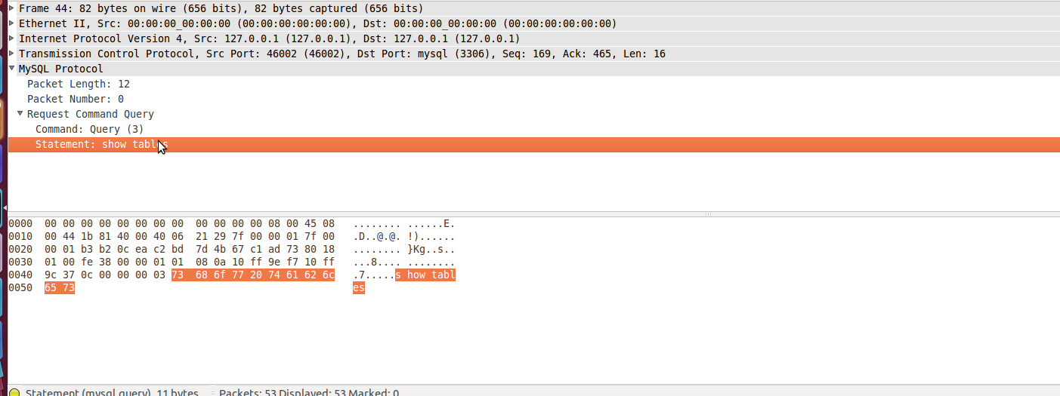
Once the authentication is complete,the client begins sending commands to the server using command packets,the body of a command packet is documented as following:
Offset in the body | Length | Description
0 | 1 | Command code
1 | For the noncompressed pakcet,total packet length from the header-1.For the compressed packet,the compressed body length-1 | The argument of the command,if present.

The Command codes are defined in include/mysql_com.h:
/*
You should add new commands to the end of this list, otherwise old
servers won't be able to handle them as 'unsupported'.
*/

enum enum_server_command
{
COM_SLEEP, COM_QUIT, COM_INIT_DB, COM_QUERY, COM_FIELD_LIST,
COM_CREATE_DB, COM_DROP_DB, COM_REFRESH, COM_SHUTDOWN, COM_STATISTICS,
COM_PROCESS_INFO, COM_CONNECT, COM_PROCESS_KILL, COM_DEBUG, COM_PING,
COM_TIME, COM_DELAYED_INSERT, COM_CHANGE_USER, COM_BINLOG_DUMP,
COM_TABLE_DUMP, COM_CONNECT_OUT, COM_REGISTER_SLAVE,
COM_STMT_PREPARE, COM_STMT_EXECUTE, COM_STMT_SEND_LONG_DATA, COM_STMT_CLOSE,
COM_STMT_RESET, COM_SET_OPTION, COM_STMT_FETCH, COM_DAEMON,
COM_BINLOG_DUMP_GTID,
/* don't forget to update const char *command_name[] in sql_parse.cc */

/* Must be last */
COM_END
};

The command-handling logic can be found in the switch statement of dispatch_commond() in sql/sql_parse.cc,to long to show..
Command Phase
Hex | Constant Name | Argument description | Command Description | Return
00 | COM_SLEEP | No argument | Internal server command,Nerver sent by a client | ERR_Packet
01 | COM_QUIT | No argument | Tells the server that the client wants to close the connection(mysql_close()) | Either a connection close or a OK_Packet
02 | COM_INIT_DB | A string containing the name of the database | Change the default schema of the connection(mysql_select_db()) | OK_Packet  or ERR_Packet
03 | COM_QUERY | A string containing the query | Used to send the server a text-based query that is executed immediately(mysql_query). | COM_QUERY_Response(https://dev.mysql.com/doc/internals/en/com-query-response.html  )
04 | COM_FIELD_LIST | A string containing the name of the table | Get the column definitions of a table(mysql_list_fields) | COM_FIELD_LIST Response(https://dev.mysql.com/doc/internals/en/com-field-list-response.html  )
05 | COM_CREATE_DB | A string containing the name of the database | Create a new database with the specified name | OK_Packet  or ERR_Packet
06 | COM_DROP_DB | Schema name | Drop a schema | OK_Packet  or ERR_Packet
07 | COM_REFRESH | A byte containing the bit mask of reloading operations | Tells the server to refresh the table cache,retate the logs,reread the access control tables,clear the re host name lookup cache,reset the status variables to 0,clear the replication master logs, or reset the replication slave depending on the options in the bit mask, Issued by the Client API call mysql_refresh() | OK_Packet or ERR_Packet
08 | COM_SHUTDOWN | No argument | Shut down the server(mysql_shutdown) | EOF_Packet or  ERR_Packet
09 | COM_STATISTICS | No argument | Tells the server to send back a string containing a brief status report (mysql_stat)
0a | COM_PROCESS_INFO | No argument | Get a list of active threads | A protocol Text::Resultset or ERR_Packet
0b | COM_CONNECT |  | Internal server command,Nerver sent by a client
0c | COM_PROCESS_KILL | A 4-byte integer with the low byte first containing the MySql ID of the thread to be terminated | Tells the server to terminate the connection by the argument(mysql_kill). | OK_Packet  Or ERR_Packet
0d | COM_DEBUG | No argument | Tells the server to dump some debugging information into its error log(mysql_dump_debug_info)
0e | COM_PING | No argument | Tells the server to respond with an OK packet(mysql_ping)
0f | COM_TIME | No argument | Internal server command,Nerver sent by a client
10 | COM_DELAYED_INSERT |  | An internal command in server | ERR_Packet
11 | COM_CHANGE_USER | - Usename  - auth_plugin_data_len  - auth_plugin_data  - schema  - character_set  - auth_plugin_name  - connect_attrs_len | Change the user of the current connection and reset the connection state. | Authentication Method Switch Request Packet or ERR_Packet
12 | COM_BINLOG_DUMP | A byte sequence in the following format:4-byte integer for the offset,2-byte integer for the flags,4-byte integer for the slave server ID,and a string for the log name. | Tells the server to send a continuous feed of the replication master log events starting at the specified offset in the specified log. Used by the replication slave,and in the mysqlbinlog command-line utility. | Binlog network stream  A ERR_Packet  EOF_Packet
13 | COM_TABLE_DUMP | database_len  database name  table_len  tablename | Dump a table | A table dump or ERR_Packet
14 | COM_CONNECT_OUT |  | Internal command in the server
15 | COM_REGISTER_SLAVE | A byte sequence in the following format:4-byte integer for the server ID,then a sequence of 1 byte-length prefixed strings in the following order:slave hostname,slave user to connect as,slave user password.Then a 2-byte slave user port,4-byte replication recovery rank,and another 4-byte field that is currently unused. | Register a slave at the master.Should be sent before requesting a binlog events
16 | COM_STMT_PREPARE | A string containing the statement | Tells the server to prepare the statement specified by the argument(mysql_stmt_prepare). | COM_STMT_PREPARE_OK on success,ERR_Packet otherwise
17 | COM_STMT_EXECUTE | A byte sequence in the following format:4-byte statement ID, 1 byte for flags,and 4-byte iteration count. | Tells the server to execute the statement referenced by the statement ID(mysql_stmt_excute) | COM_STMT_EXECUTE Response
18 | COM_STMT_SEND_LONG_DATA |  | Send the data for a column.Repeating to send it,appends the data to the parameter.
19 | COM_STMT_CLOSE |  | Deallocates a prepared statement
1a | COM_STMT_RESET |  | Reset the data of a prepared statement which was accumulated with COM_STMT_SEND_LONG_DATA | OK_Packet  or ERR_Packet
1b | COM_SET_OPTION |  | Allows to enable and disable Client_multi_statements  for the current connection.
1c | COM_STMT_FETCH |  | Fetch rows from a existing resultset after a COM_STMT_EXECUTE
1d | COM_DAEMON |  | Internal command
1e | COM_BINLOG_DUMP_GTID |  | Requet the binlog network stream | A Binlog Network Stream or an ERR_Packet
1f | COM_RESET_CONNECTION |  | Resets the session state.

COM_QUERY_Response:https://dev.mysql.com/doc/internals/en/com-query-response.html

Server Responses

Data Field
TODO

OK Packet
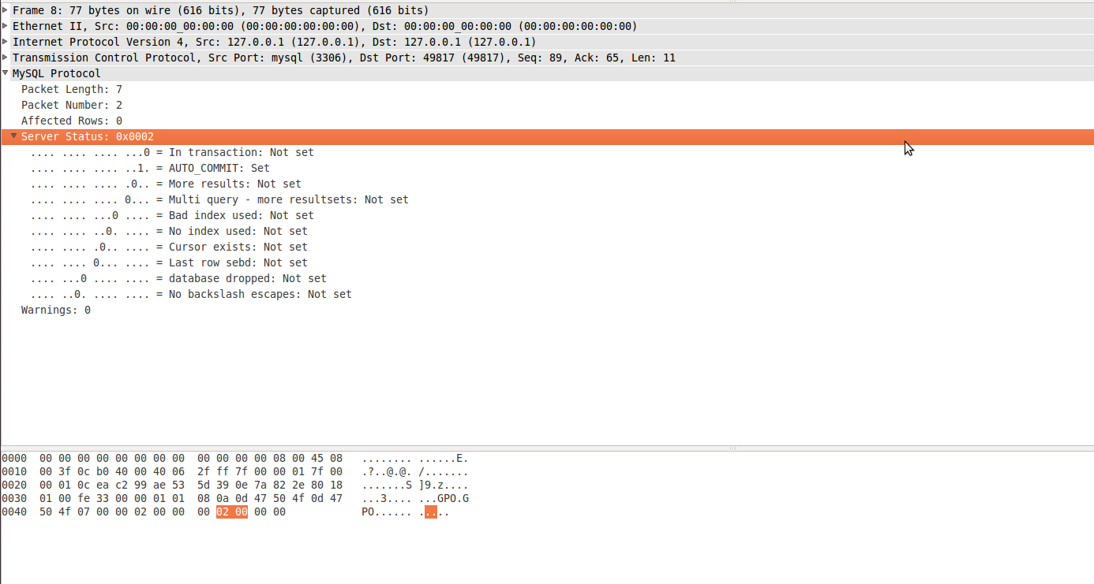
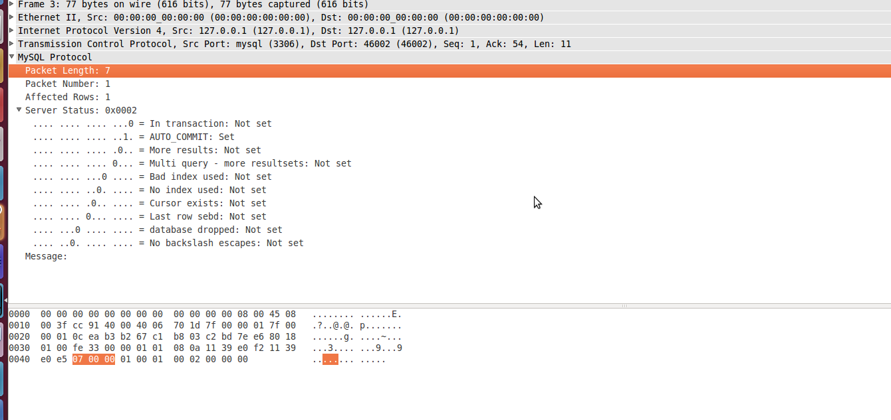

Format of server's OK pakcet:
Offset in the body | Length | Description
0 | 1 | A byte with the value (0) indicating that the packet has no fields
1 | rows_len(1byte) | The number of records that the query has changed.
1+rows_len | id_len(1byte) | The value of the generated auto-increment ID for the primary key. Set to 0 if not applicable in the context.
1+rows_len+id_len | 2 | Server status bit mask
3+rows_len+id_len | 2 | The number of warnings the last command has generated
5+rows_len+id_len | Msglen | An optional field for the status message if one is present in the standard data field format with the field length followed by field value,which in this case is a character string

Sql/protocol.cc
/**
A default implementation of "OK" packet response to the client.

Currently this implementation is re-used by both network-oriented
protocols -- the binary and text one. They do not differ
in their OK packet format, which allows for a significant simplification
on client side.
*/

bool Protocol::send_ok(uint server_status, uint statement_warn_count,
ulonglong affected_rows, ulonglong last_insert_id,
const char *message)
{
DBUG_ENTER("Protocol::send_ok");
const bool retval=
net_send_ok(thd, server_status, statement_warn_count,
affected_rows, last_insert_id, message);
DBUG_RETURN(retval);
}

Error Packet
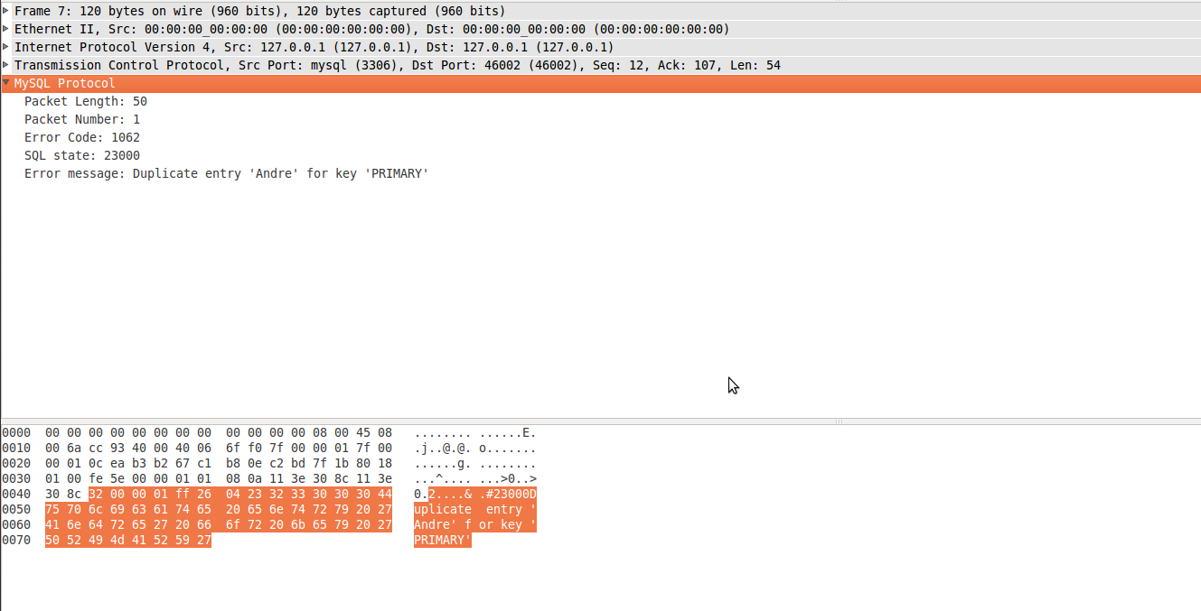
When something goes wrong with the processing of a command,the server responds with a error packet
Offset in the body | Length | Description
0 | 1 | A byte containing 255 as an error message
1 | 2 | The error code
3 | 1 | '#' the sql-state marker
4 | 5 | Sql-state
9 |  | Human readable error message

EOF Packet
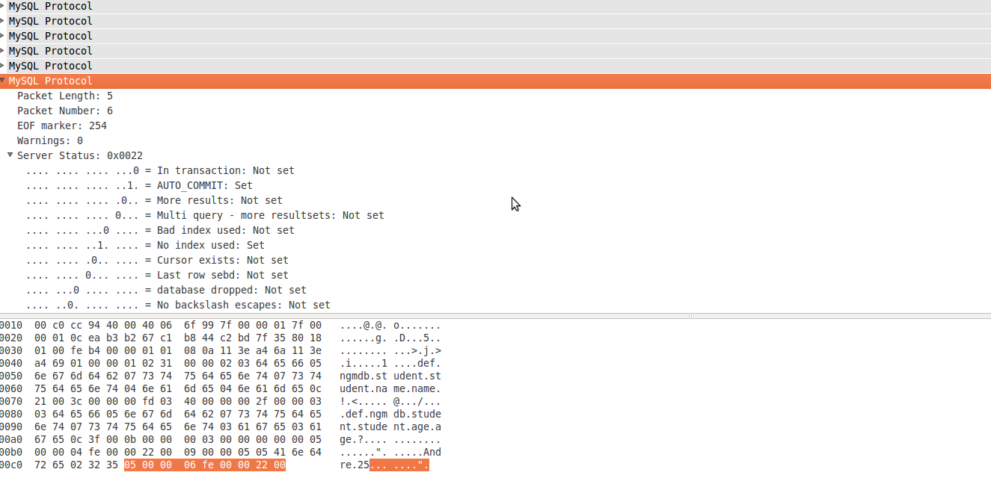
The EOF packet is used to communicate a number of messages:
- End of field information data in a result set
- End of row data in a result set
- Server acknowledgement of COM_SHUTDOWN
- Server reporting success in response to COM_SET_OPTION and COM_DEBUG
Packet Format:
Offset in the body | Length | Description
0 | 1 | Byte with 254 indicate is an EOF packet
1 | 2 | Number of warnings
3 | 2 | Server status bit mask

Result Set Packet
TODO

Refer:https://dev.mysql.com/doc/internals/en/overview.html

