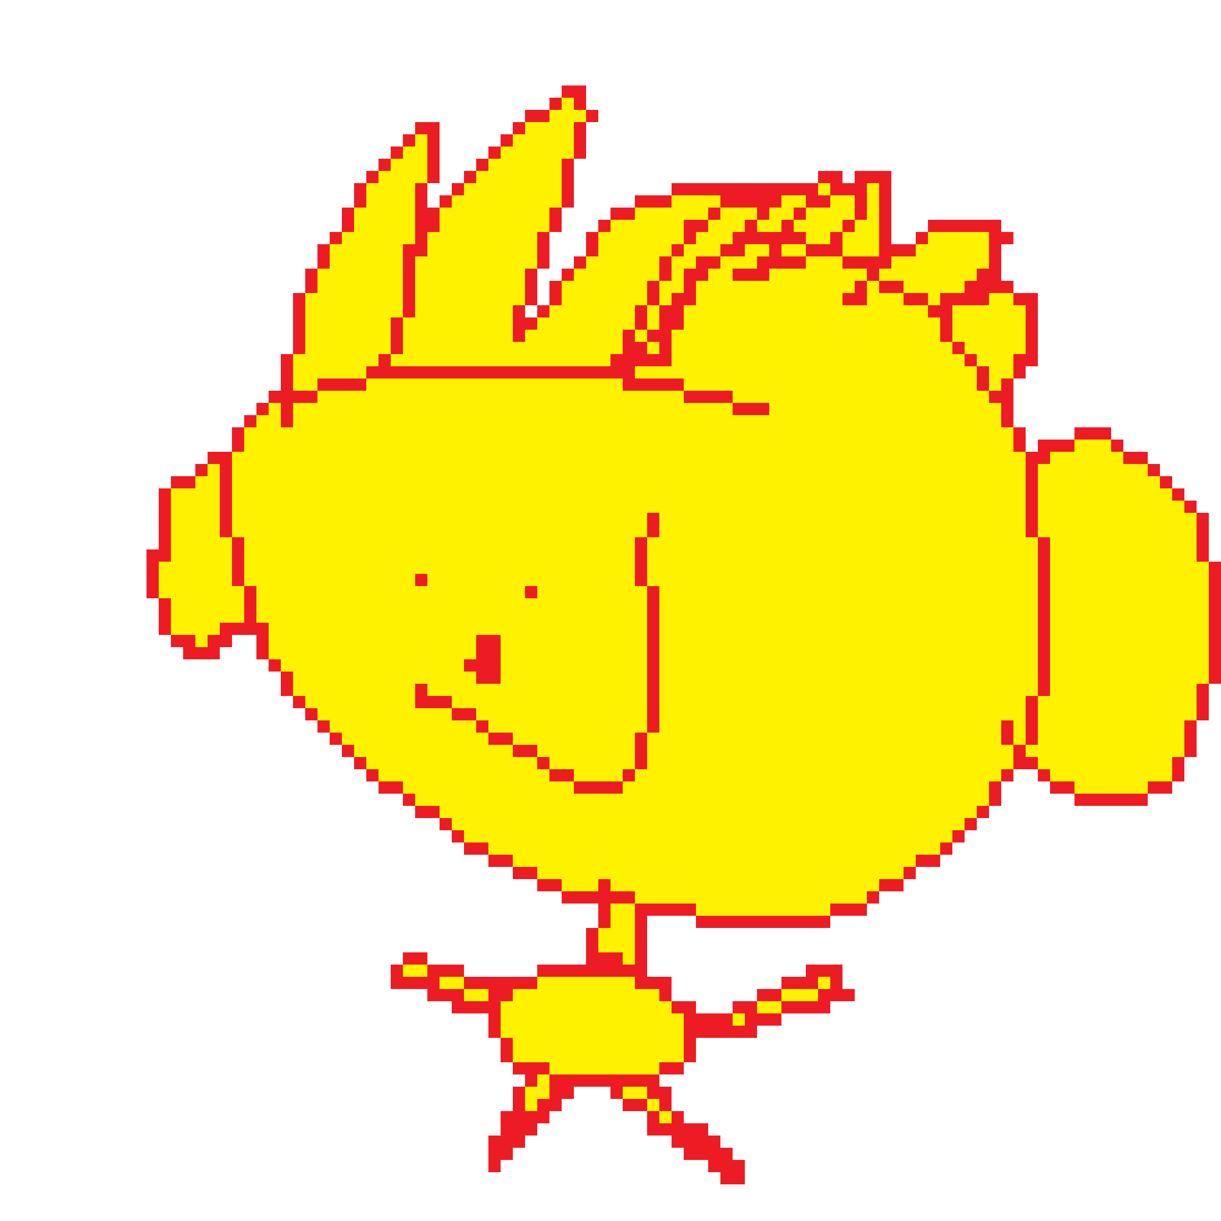
TEAM LEBOB #3236
FIRST LEGO LEAGUE · UNEARTHED · AUSTRALIAN NATIONAL CHAMPIONS

INNOVATIONS
DOCUMENTATION
SoftSense
A sensor-guided gripper for fragile underwater artefact recovery

FLL UNEARTHED 2025 / 26 · KOREA OPEN INVITATIONAL, SEOUL · JULY 2026

Contents
1. The problem we set out to solve 2
2. How the team works 5
3. Our solution: the four innovations of SoftSense 11
4. The mechanism in detail 14
5. How we built the fingers: finger structural FEA 17
6. How we chose the grip surface: texture optimisation 26
7. The motor study: sensing through the actuator 31
8. The drivetrain and the structural finding we own 35
9. Materials, design-for-additive, and the print profile 38
10. Running it underwater: the seawater audit 44
11. Assembly: 17 printed parts, zero hardware 46
12. ROV integration and mounting interfaces 50
13. Testing, validation, and the bench plan 53
14. TRL self-assessment and operating boundaries 55
15. Test data from the FLL bench set 57
16. Expert validation and outreach 58
17. Scaling to artefact size: the 1.5× and 2.0× build 60
18. What is proven, what is not, and what comes next 63
19. Sources and citation provenance 65

1. The problem we set out to solve
We're Team Lebob, FLL Team #3236 from Perth, Western Australia, and we're the 2025 / 26 Australian National Champions of the UNEARTHED season. SoftSense is our Innovation Project. It's a low-cost, sensor-guided ROV gripper built for one job: recovering fragile artefacts from the seafloor without destroying them.

Why underwater archaeology
Underwater archaeologists have a hard time recovering fragile artefacts from the seafloor, and the reason is that the manipulator arms bolted to remotely operated vehicles are built for industrial work, not precision handling. The standard arm has two rigid metal fingers, no force feedback, and little surface contact. That makes it clumsy with small, irregular, or brittle objects. When the wrong tool ends up in the wrong place, irreplaceable cultural heritage shatters on the seafloor, and nobody knows it happened until the footage gets reviewed back on the surface.
The problem is economic too, and the economics are brutal. Getting a maritime archaeology mission off the ground costs millions of dollars: vessel charter, crew wages, dive tickets, equipment shipping, port fees, insurance, fuel, permits. Months of planning go into a window of a few days on site. Even the recurring costs are punishing on their own: boat hire runs around AUD 5,000 per day, a four-person dive team is another AUD 1,200 per day, and dive-gear maintenance and consumables pile on top of that. Patrick Morrison at the WA Shipwrecks Museum walked us through the numbers, and the phrase that stuck with us was "the clock starts the moment you leave port."
Against that cost stack, one piece of equipment failing on site can end the whole expedition. A gripper that snaps the first time it touches a fragile artefact, or shears a tooth and stops responding, or simply doesn't exist in the right specification on the boat, sends the team home with nothing. The mission produces a damage report instead of a recovery, the next expedition is months away because the boat and crew have to be booked again from scratch, and the artefacts that sat on the seafloor for four hundred years stay there. A two-thousand-dollar tool failure can waste a million-dollar mission. That asymmetry is what makes the gripper worth taking seriously.

Four named problems
Talking to working archaeologists and subsea engineers, we pinned down four specific failure modes that the standard industrial gripper forces onto fragile recovery work:
- High risk of breakage. Industrial grippers apply force with no feedback channel back to the pilot. Thin pottery, coral, bone fragments, and delicate shapes crack the first time they're held too tightly.
- Poor grip on odd shapes. Flat metal jaws can't adapt to curved, tapered, or uneven artefacts. Items slip out, or can't be lifted at all. The grippers in service today were tuned for cylindrical T-bar handles on industrial tools, not for amphorae, bones, or coral.
- Limited awareness for pilots. ROV operators can't feel how much force the arm is applying, especially in low visibility water where the camera feed is the only signal. That leads to accidental crushing, or drops the operator never sees coming.
- Cost and time pressures. Getting archaeology equipment to site costs millions of dollars. A broken gripper or a missing tool means days of delay while the right part ships. These failures slow missions down, push costs up, and can permanently destroy cultural heritage that has waited centuries to be recovered.

Why this matters now
This isn't a hypothetical problem. Patrick Morrison, Assistant Curator of Maritime Heritage at the WA Shipwrecks Museum, told us during our 14 May 2026 site visit:
All the wrecks we have found in Western Australia in the last four to five years are beyond recreational diving depths. The museum legally can't excavate them. The only way to recover something safely from 50 to 60 metres and beyond is a robot with actuator control.
Multibeam sonar surveys are turning up wrecks in the 40 to 100 metre range that were invisible to the previous generation of survey gear. There are more known sites than there is equipment to work them. Patrick described the gap directly:
If you have a little affordable device that can do that, you'd reach for it all the time.

Who would use this
Our main user is a maritime archaeology team or research institution working from a small inspection class ROV. The closest commercial reference is the Reach Robotics Bravo 7 manipulator family, which Fugro and Woodside use for offshore inspection in Western Australia. The same gripper architecture also fits marine biology (gentle handling of corals, gelatinous animals, sediment samples), oceanographic research, environmental monitoring, and any subsea repair job where standard grippers cause collateral damage.

Who built it
Lebob is eight Year 10 students and two mentors, based at Perth Modern School, Subiaco. Members in roster order: Kingsley Wong (CR-01), Andre Nijman (CR-02), Sean Chan (CR-03), Oliver Liu (CR-04), Subesh Sukumaran (CR-05), Yuxin Chris Wang (CR-06), Aaron Zhang (CR-07), Leven Shi (CR-08). Mentors: Jade and Kaelie (MT-01). The workshop is home for us. We engineer robots, research soft-robotic mechanisms, and ship our work as documentation other teams can learn from.
How we wrote this document. Every number in this report is either measured from the live CAD, taken from a published datasheet, or generated by a reproducible simulation. Where a value is an engineering estimate, we say so. Where a result is a rank rather than an absolute, we say so. And where a headline number changed during the project, we explain the change.

2. How the team works
This section is for the judges. It's the project-management half of the design rubric: who owns what, how we plan a 10 month season across two competitions and a Korea trip, how we meet, how we decide, and the evidence trail behind all of it. The five subsections below line up directly with the DESIGN and CORE VALUES criteria a judge fills in: project plan, ownership, decision protocol, meeting cadence, and the receipts.

2.1 Season project plan (Gantt)
The chart below is the season plan we worked from. It has four parallel tracks (Robot, Innovation, Outreach, Logistics) and three competition milestones (Regionals, Nationals, Korea Open) on a single time axis from September 2025 to July 2026. Owner names sit inside each bar where the owner is settled. Bars marked [OWNER] are work packages whose lead we're still formalising for the Korea-prep stretch, and we'll fill those in at the next team meeting.
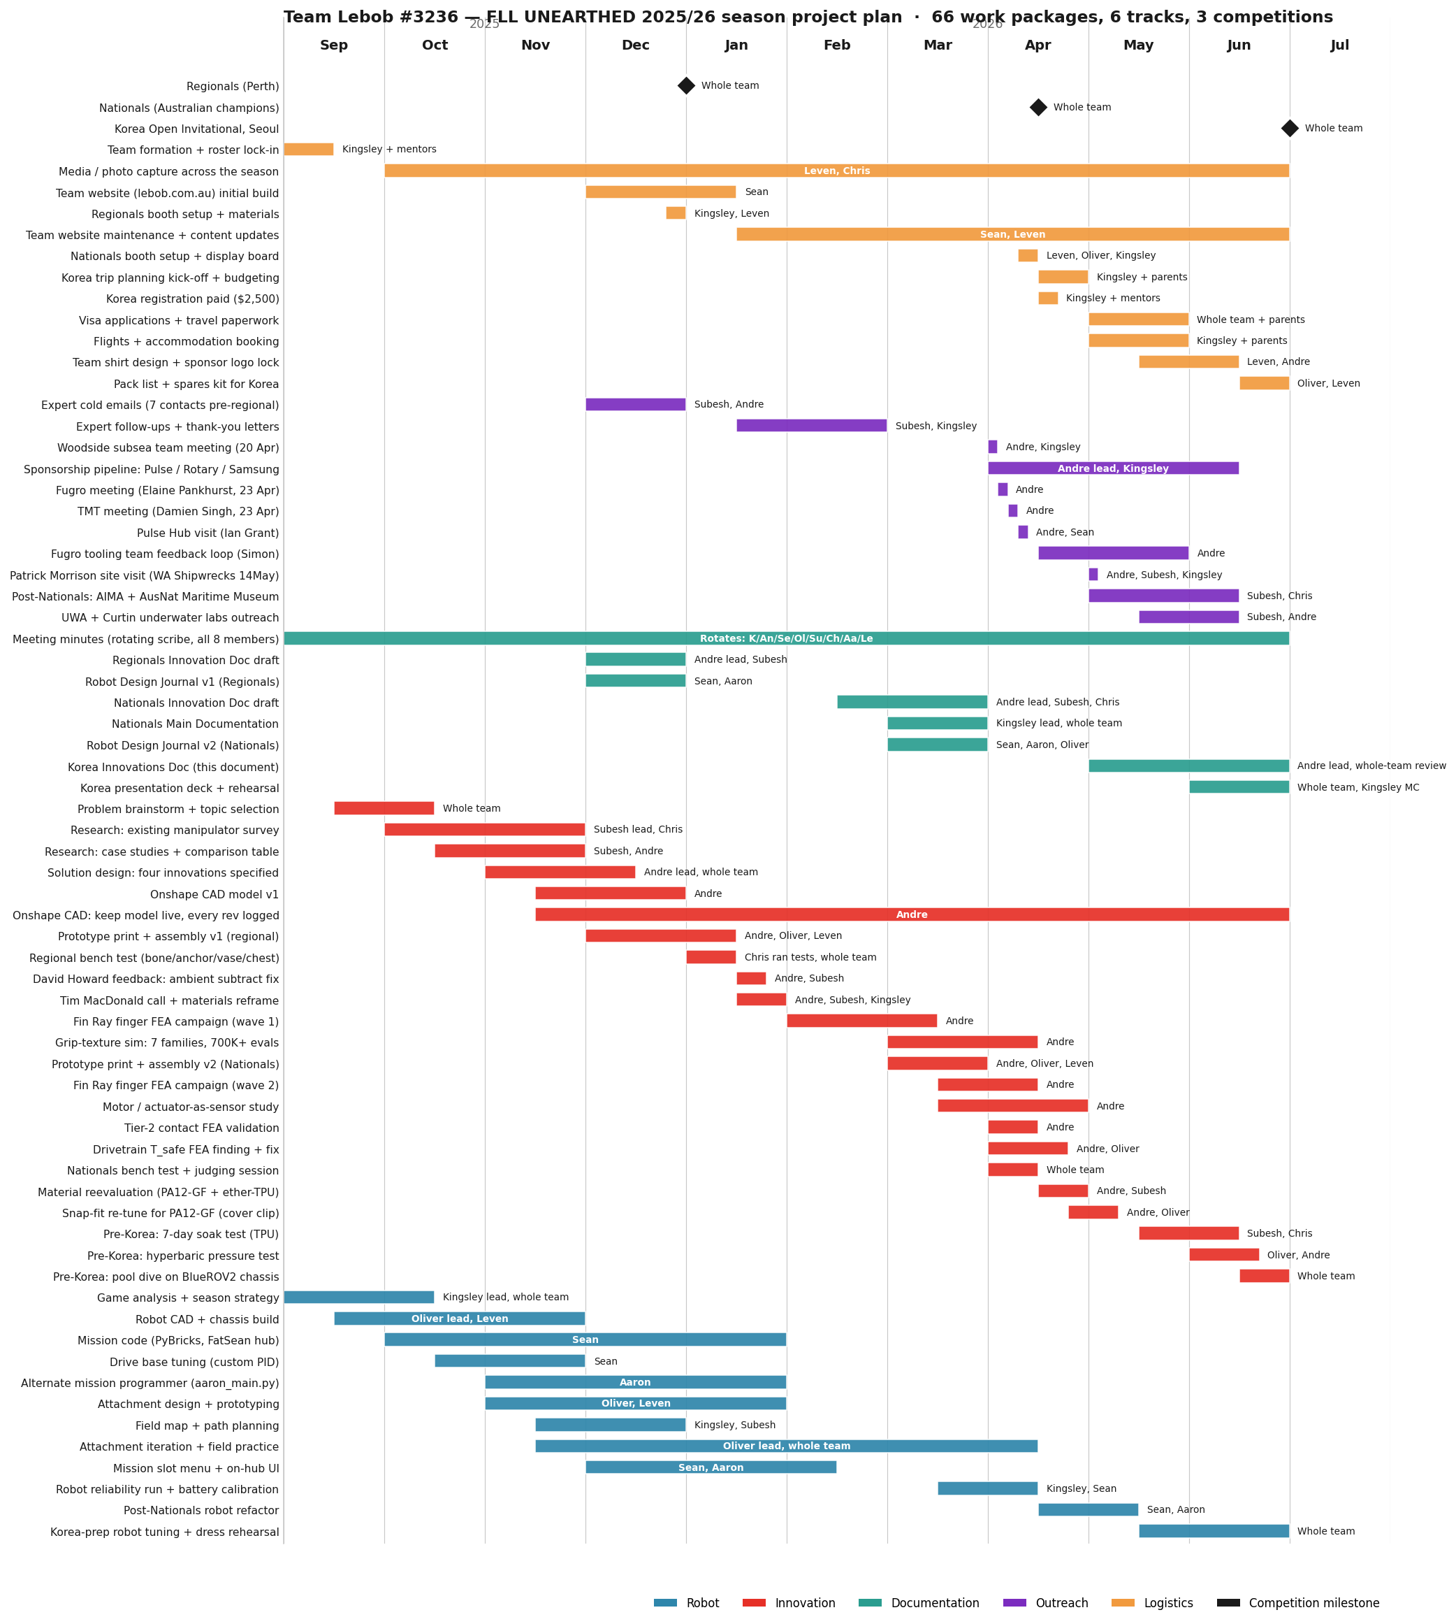
Figure 2.1 Team Lebob #3236 season plan. The Robot track is blue, the Innovation track is red, Outreach is purple, and Logistics is orange. Competition milestones show up as black diamonds.
How we used the plan. The Gantt isn't a back-fill. It's the planning surface we rebuilt at four points in the season: at the start (September), after Regionals (when we scheduled the FEA campaign and the materials reframe), at Nationals (when we added the Korea-prep block), and now (post-Nationals, answering the judges' feedback that the plan should be visible in the documentation). Each rebuild was a 30 to 60 minute whiteboard session with the whole team, and the photo of the most recent one is in §2.5.

2.2 Roles and ownership
Eight student members plus two mentors. Each member owns at least one work package, and most own more than one. The table below maps the public roster (lebob.com.au) to the work each member led in the 2025/26 season. Where a role is shared, we name the co-owner.
Member | CR # | Primary ownership this season
Kingsley Wong | CR-01 | Team captain and coordination lead. Game analysis + season strategy. Post-competition retros. Korea trip planning + budgeting + registration paperwork. MC for the Korea presentation. Co-owner: expert follow-ups, sponsorship pipeline. (Placeholder, to be confirmed pre-Korea.)
Andre Nijman | CR-02 | SoftSense innovation lead. FEA campaign (finger structural + grip texture + motor study). Sponsorship outreach (Fugro, TMT, Pulse, Rotary, Samsung). Material reevaluation (PA12-GF + ether-TPU). This documentation. Onshape model owner.
Sean Chan | CR-03 | FLL mission programmer. Owns the FatSean SPIKE Prime hub program, the on-hub menu, and the drive-base PID. Team website (lebob.com.au, TypeScript / Next.js). GitHub repo maintenance for both Lebob-Unearthed and Lebob-Website. Active contributor to FRC Team 4788 in parallel.
Oliver Liu | CR-04 | Robot CAD + mechanical build lead. Chassis design + attachment design. Field practice coordinator. Co-owner on prototype builds v1 + v2, drivetrain T_safe fix, hyperbaric pressure test, Nationals booth, Korea spares kit. (Placeholder, to be confirmed pre-Korea.)
Subesh Sukumaran | CR-05 | Research lead: existing manipulator survey + case studies. Owns expert cold-email outreach and follow-up letters. Patrick Morrison site visit attendee. Co-owner: prototype build v1, material reevaluation, 7-day soak test, AIMA + Maritime Museum outreach. (Placeholder, to be confirmed pre-Korea.)
Yuxin Chris Wang | CR-06 | Year 8, youngest team member. Bench-testing operator: ran the 4-finger versus 2-finger trials with the bone, anchor, vase, and chest objects, captured the 26 / 96 / 411 / 288 gf data. Co-owner: media + photo capture across the season, 7-day soak test, manipulator-survey research. (Placeholder, to be confirmed pre-Korea.)
Aaron Zhang | CR-07 | Alternate mission programmer. Owns aaron_main.py, the parallel mission slot configuration for the FatSean hub. Used in head-to-head practice rounds and as redundancy for the primary mission program. Co-author on Robot Design Journals v1 + v2.
Leven Shi | CR-08 | Attachment design + team media. Team shirt design + sponsor logo lock for Korea. Owns the photo / video evidence trail across the season. Nationals booth + display board. Co-owner: robot CAD + chassis, prototype builds v1 + v2, Korea spares kit. (Placeholder, to be confirmed pre-Korea.)
Jade | MT-01 | Mentor. [Focus areas to be confirmed pre-Korea.]
Kaelie | MT-01 | Mentor. [Focus areas to be confirmed pre-Korea.]

On the placeholder rows. Every member-ownership line above is a placeholder showing the team's best current read on who owns what. The exceptions are Andre's, Sean's, and Aaron's, which you can verify from the public GitHub history and the team website. Each member will confirm their line at the next team meeting, and we'll reissue the documentation before Korea. We're using this drafting cycle to capture every member's contribution by name instead of the generic "whole team" shorthand. The judges' Nationals feedback was explicit on this point, and we're taking it directly.

2.3 Decision-making protocol
Here's how we decide what to build, what to scrap, and what to escalate. There are three levels:
- Day-to-day technical decisions are made by the workstream owner. Sean doesn't need a vote to refactor the mission menu, and Andre doesn't need a vote to change a Fin Ray rib angle. Owners commit to their workstream and report back at the next meeting.
- Whole-team decisions happen when a choice touches more than one workstream (a robot redesign that changes attachment mounts, a SoftSense material change that affects the build schedule, or a sponsorship that needs a logo on the team shirt). These go to a meeting vote with a simple majority. The mentors have observer roles but not voting roles.
- Mentor sign-off is required for two things only: anything that affects safety (workshop equipment, travel) and anything that commits money outside the agreed budget. Mentors don't direct technical choices. They hold the safety and financial backstop.
The line between mentor input and student ownership is deliberate. FLL Core Values explicitly judge student ownership of the work, and the protocol above is what keeps that line clean. The Innovation Project is student-led, and the mentors are advisors, not collaborators on the engineering.

2.4 Meeting cadence and minutes
The team meets on a regular weekly cadence during term time, with extra weekend sessions in the four weeks before each competition. The format is fixed so meetings stay predictable and short:
Meeting type | Frequency | Duration | Format
Weekly standup | Weekly, [DAY + TIME] | 30 to 45 min | Each workstream owner reports: what shipped this week, what is blocked, what is next. Mentor present. Minutes captured by rotating scribe.
Whole-team build session | Weekly, [DAY + TIME] | 2 to 3 hr | Workshop. Hands-on robot iteration, attachment building, SoftSense print + assemble, bench tests.
Whole-team work session | As needed in heavy weeks | Half day | Bigger blocks of time: prototype iteration, documentation writing, sponsorship deck work. Saturdays during exam-free weeks.
Pre-competition crunch | Daily, 4 weeks before comp | Variable | Daily standups by Discord; long workshop sessions on weekends; field practice every weekday after school the week before.
Post-competition retro | Within 1 week of each comp | 1 hr | What worked, what failed, what to change before the next competition. Outputs feed back into the Gantt rebuild (see §2.1).

Meeting minutes. Each meeting has a rotating scribe (a different member each week, mentor included) who captures decisions, action items with owners, and any blocked work that needs escalation. Minutes live in the team Google Drive and are linked from each week's standup agenda. The judges flagged minutes as a specific EXCEEDS criterion at Nationals. The old system was informal, so we've formalised it for the Korea cycle.

2.5 Workshop, testing, and the evidence trail
The Nationals reviewer wrote, verbatim: "we saw a table with grip data but no pictures of it operating/testing or an explicit demonstration of the electronics." That feedback drives this subsection. From now until Korea, we photograph every bench test, every build session, and every expert meeting, and each photo gets a date and a caption. The frames below are placeholders. The live versions sit in the team Google Drive and will go in before the final pre-Korea reissue of this document.
Evidence type | What we capture | Where it lives
Build session photos | Hands on the parts. Faces of the people building. Whiteboard sketches from the session. | team Google Drive / build-sessions/
Bench test photos + video | Each object (bone, anchor, vase, chest) being gripped. The pressure sensor readout on the laptop. The pad deformation visible. Short video (10 to 30 s) per test. | team Google Drive / bench-tests/
Electronics demonstration | The pressure sensor board with the foam pad. The signal trace on the screen as the pad is loaded by hand. The auto-stop firing on a test object. | team Google Drive / electronics-demo/
Expert meeting photos | Team members with the expert (Patrick Morrison, Tim MacDonald, Woodside, Fugro). Whiteboard notes from the meeting. Signed prototype. | team Google Drive / expert-meetings/
GitHub commit log per member | Public git history for Lebob-Unearthed (mission code), Lebob-Website (team site), and the SoftSense CAD repo. Commits per author over the season, downloadable. | github.com/Lebob-Robotics + github.com/prawny-boy/FLL-Lebob-Unearthed
Meeting minutes | Dated, scribed by rotating member, decisions + action items + owners. | team Google Drive / minutes/

Open work item before Korea. Three deliverables for the Korea-prep block, each owned by the workstream listed in the Gantt: (1) photograph the next two bench-test sessions and one workshop session by 15 June; (2) record a 60 second electronics-demonstration video showing the per-pad pressure feedback in action; (3) export the GitHub commit-per-author chart for the season and embed it here. All three close the specific EXCEEDS gap the Nationals reviewer named.

3. Our solution: the four innovations of SoftSense
SoftSense takes the standard ROV gripper and adds four innovations that each go straight after one of the four failure modes from §1. We tested every one, a working expert reviewed every one, and we describe them below in the order we built them.
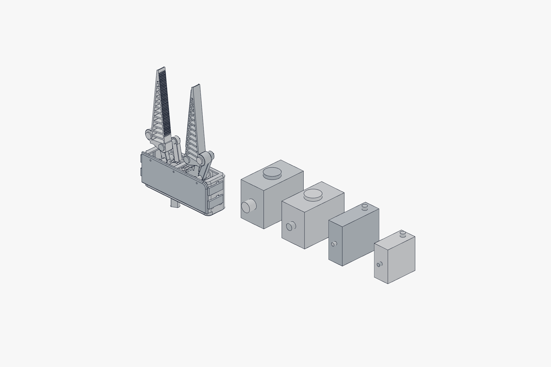
Figure 2.1 The SoftSense end effector with the cover removed, next to the actuator ladder we surveyed. The gripper itself is one part, and the actuator is the modularity swap point that sets the depth rating.

Innovation 1: adaptive soft-contact finger pads
Each fingertip wears a flexible foam pad, so the arm no longer presses metal against the artefact. The soft pad spreads the gripping force over a wider area and lowers peak stress on fragile material. That cuts the risk of breakage and lets the arm safely handle smooth and curved surfaces like vases, bones, and rounded stone fragments. Where a rigid jaw point-loads a 4 mm patch of pottery rim, a foam pad spreads the same total force over roughly ten times the area.
In our 2 finger versus 4 finger bench test (§15), the 4 finger setup beat 2 finger on smooth or round geometry (the vase) and on poor grip feature geometry (the bone), and it tied on regular feature geometry (the anchor and chest). That is the soft pad's contribution made measurable: four pads conforming to an awkward shape beats two flat jaws every time the shape stops being a T-bar handle.

Innovation 2: embedded pressure-sensing system
Under every foam pad sits a calibrated pressure sensor. These sensors stream a force reading to the pilot's console without a break, and optionally into our auto-stop control loop, which halts the actuator the moment pressure crosses a configurable threshold. The pilot finally gets an early warning before crushing something. The control code can hold a different preset per artefact class: a low threshold for coral, another for bone, another for ceramic.
David Howard, in his Regionals feedback, spotted a subtle confounder. As the gripper descends, ambient water pressure rises by roughly 1 atmosphere every 10 metres, so a naïve pressure sensor would read "squeeze" when there is none. Our fix is a second pressure sensor on the main body of the claw that measures ambient water pressure. The control code subtracts ambient from each pad reading and recovers an accurate squeeze value at any depth.
Patrick Morrison raised a second concern at our 14 May site visit. Foam under pressure compresses, and the air pockets inside it shrink with depth. He suggested a few countermeasures: oil filling (incompressible), moving the sensing to the joints with encoders, or a differential pressure sensor that reads pad minus ambient mechanically rather than in software. All three are on our roadmap for the post-Korea engineering iteration.
Force feedback is essential. Most industrial archaeological arms have it. Without it, you crush things and don't know. Patrick Morrison, WA Shipwrecks Museum.

Innovation 3: rotating finger platform for full-surface contact
All four pads and their sensors ride on a rotating platform inside the gripper body. The platform lets the gripper line up its contact patches to the angle of the artefact on its own, which grows the surface area that actually touches the object. More contact area at the same total force means lower local pressure and less crush risk. Rotation also eases how precisely the ROV pilot has to place the arm in the first place, because the platform finds the angle the pilot could not.
We have specified this feature but not built it into the current scaled prototype. The mechanism is reserved for the 1:1 production version. We chose to document what the prototype does and does not show: at the FLL scale the rotating platform adds complexity without showing its real benefit, since the prototype objects are scaled too.

Innovation 4: a cheap, kit-based, modular claw
The whole gripper is built as a swappable, 3D printed module. The structural body costs around AUD 100 in filament. Archaeologists can carry several spares onto a mission and swap a broken module in the field instead of waiting days for a replacement to ship. Better still, because the parts are 3D printed, the crew can bring a small printer on the support vessel and run off a custom grip or a new tool on deck while the dive plan keeps going.
This goes straight at the cost-and-time problem. The biggest line item in archaeology is not the gripper, it is the cost of the day. When the gripper fails, the day is wasted; when the gripper can be replaced from a tote in the wet lab, the mission keeps moving. Tim MacDonald (Inkfish, formerly of the DSV Limiting Factor) confirmed this directly when we called him after Regionals:
The biggest cost in archaeology is time. Stick with cheap 3D printed parts. Anyone can buy filament anywhere, and the whole thing can be manufactured anywhere like a kit. Tim MacDonald, subsea engineer.

How the four fit together
Four soft pads spread force; four pressure sensors keep the pilot informed and the actuator safe; a rotating platform brings more pad area into contact with whatever shape the artefact happens to be; and a modular kit shape means the whole gripper is treated as a consumable, not a capital expense. Put together, the four innovations turn a basic industrial gripper into an intelligent, adaptable archaeological tool. It protects fragile objects, improves pilot accuracy, and tackles the biggest limitations of today's two-finger manipulators.

4. The mechanism in detail
The end effector has a single degree of freedom. One input shaft rotates, and both fingers open and close symmetrically, splaying outward as they open to give a funnel-mouth catch. Everything else follows from that one rotation.
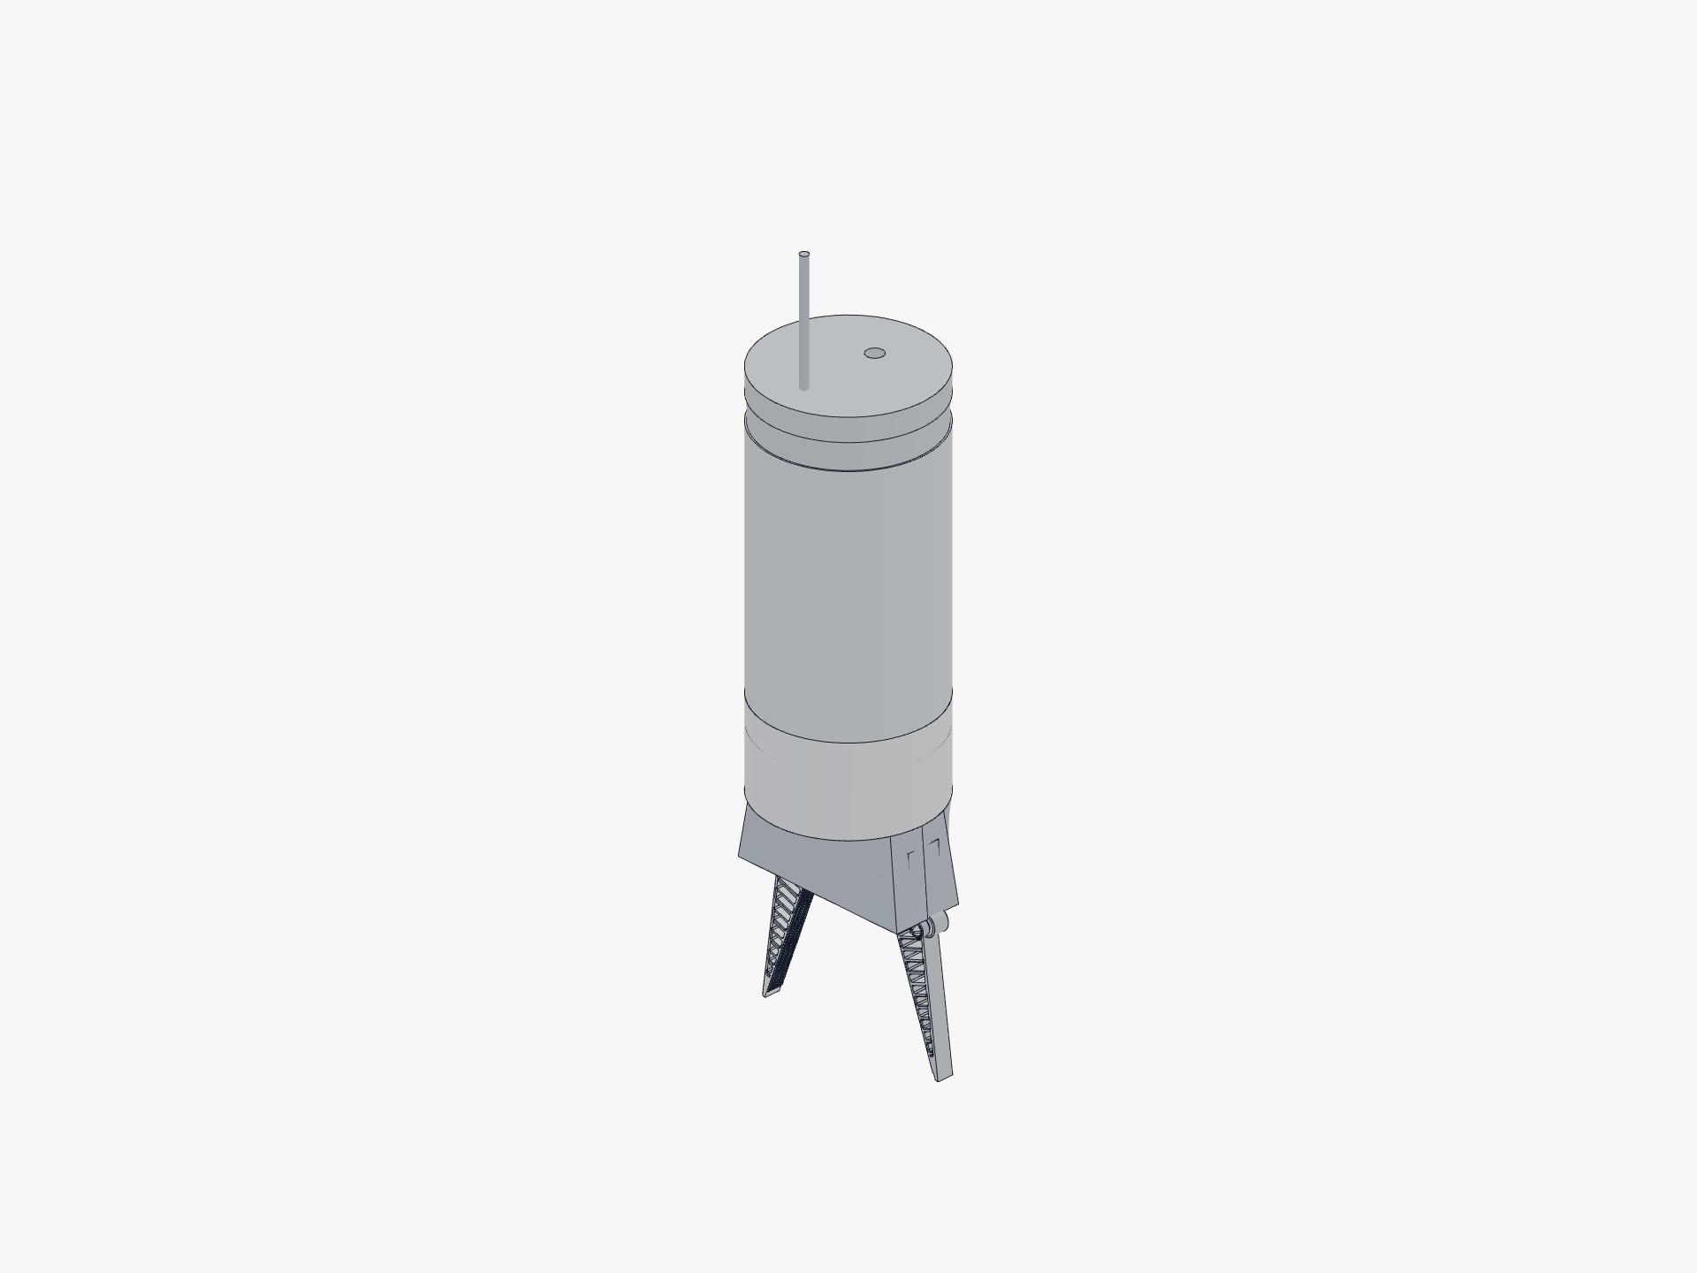
Figure 3.1 The SoftSense end effector mounted to the actuator canister, in the open pose.

Drive chain
Two equal spur sector gears mesh on the centreline. The left sector carries an integral crown gear on its top face. A small spur input pinion on a vertical shaft drives that crown, a right-angle stage that lets the drive shaft exit out of the housing bottom. From the operator's side, the gripper has one input shaft going in and two symmetric fingers coming out.
Each sector gear doubles as the crank of a non-parallelogram four-bar linkage. The finger is rigid with the coupler. The link lengths give a translate-apart motion plus roughly 18° of outward splay across the travel, and we sized them so the transmission angle stays well clear of any dead point (it varies from 71.7° to 34.6° across the open stroke).
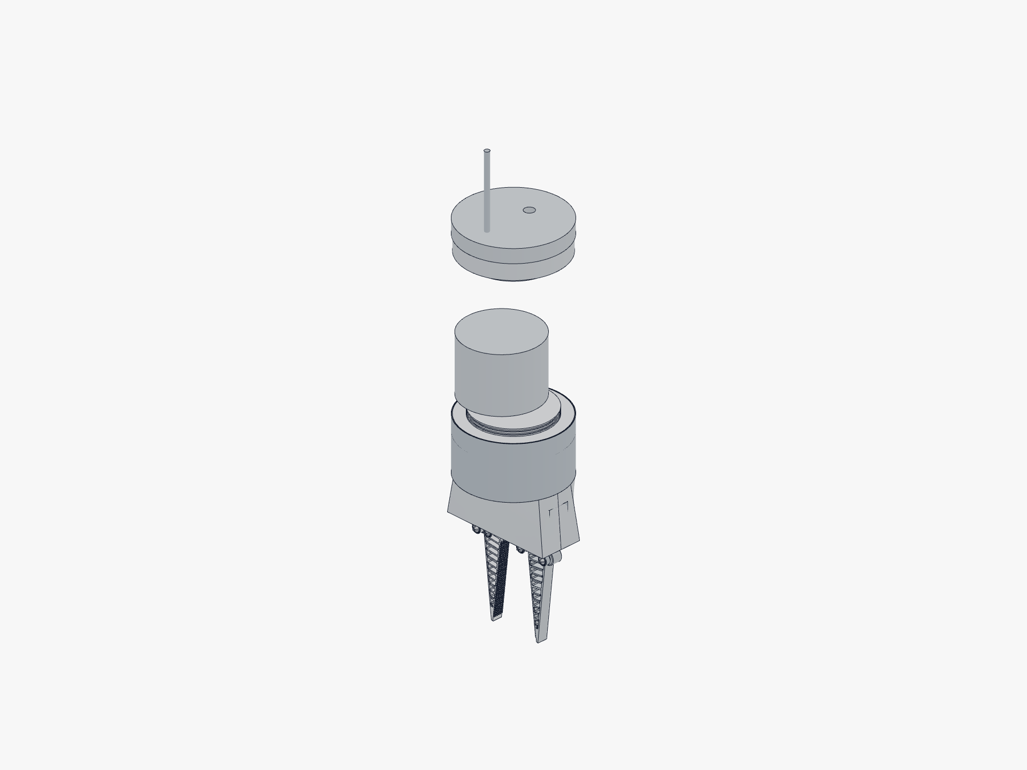
Figure 3.2 Internal layout. The front cover lifts off to expose the four-bar linkage and the crown-pinion drive stage, and the input shaft exits the bottom face of the housing.

Coordinate system and key numbers
X is jaw open/close (right is positive), Y is toward the fingertips, and Z is depth and the gear axis. All units are millimetres. The dimensions below come from the parametric CAD source of truth.
Parameter | Value | Why
Sector gear pitch radius (R_GEAR) | 12.0 mm | Sets pivot spacing at 24 mm so the two gears mesh on the centreline.
Crank length (R_CRANK) | 34.0 mm | From the A pivot to the C pin on the finger. Tuned by design-space search for splay angle.
Follower length (R_FOLLOW) | 32.0 mm | From the B pivot to the D pin. Chosen with the crank so the four-bar avoids singularity.
Coupler length (R_COUPLER) | 20.0 mm | Finger base bracket span between C and D pins.
Closed crank angle (THETA_CLOSED) | 102.0° | Lowered from 104° to clear the C and D pin heads at the closed pose.
Open travel | 46.0° | Crank rotation from closed to fully open.
Travel at the jaw base | 9.86 to 62.0 mm | Closed to open base gap.
Travel at the fingertip | 9.86 to 123.8 mm | Closed to open tip gap.
Outward finger splay | 0 to 20.1° | Funnel mouth as the jaws open.

A 100 step kinematic self-check confirms that the base gap and tip gap are strictly monotonic on opening, finger rotation is strictly monotonic outward, and the four-bar transmission angle stays within 71.7° to 34.6°, far from any dead point.

Fingers and enclosure
Each finger is a passive Fin Ray compliant truss in TPU. The architecture is a thin contact beam (1.2 mm), a sharply tapered compliant spine (1.8 mm), and 14 fine 1.6 mm slanted ribs with hollow cells. The four foam pads and their pressure sensors sit on the contact face. We checked that the two TPU fingers build as valid solids with 0.0 mm³ interference at the closed pose at every finger scale we ship (0.7×, 1.0×, 1.6×).
The enclosure is a single open-front housing with a snap-on front cover. Inside sit the two sector gears, the four-bar links, and the crown-pinion stage. Outside are the M4 bottom mounting flange, the vertical input shaft, eight drain and flood paths (four bottom plus two per side wall), four snap-clip windows, the two top slots where the link arms exit, four axle bore floods through the back wall, and three Ø1.8 mm cover vents. Every part is a single solid with exactly one shell. There is no enclosed void anywhere in the assembly, and that is what makes the design safe to flood.
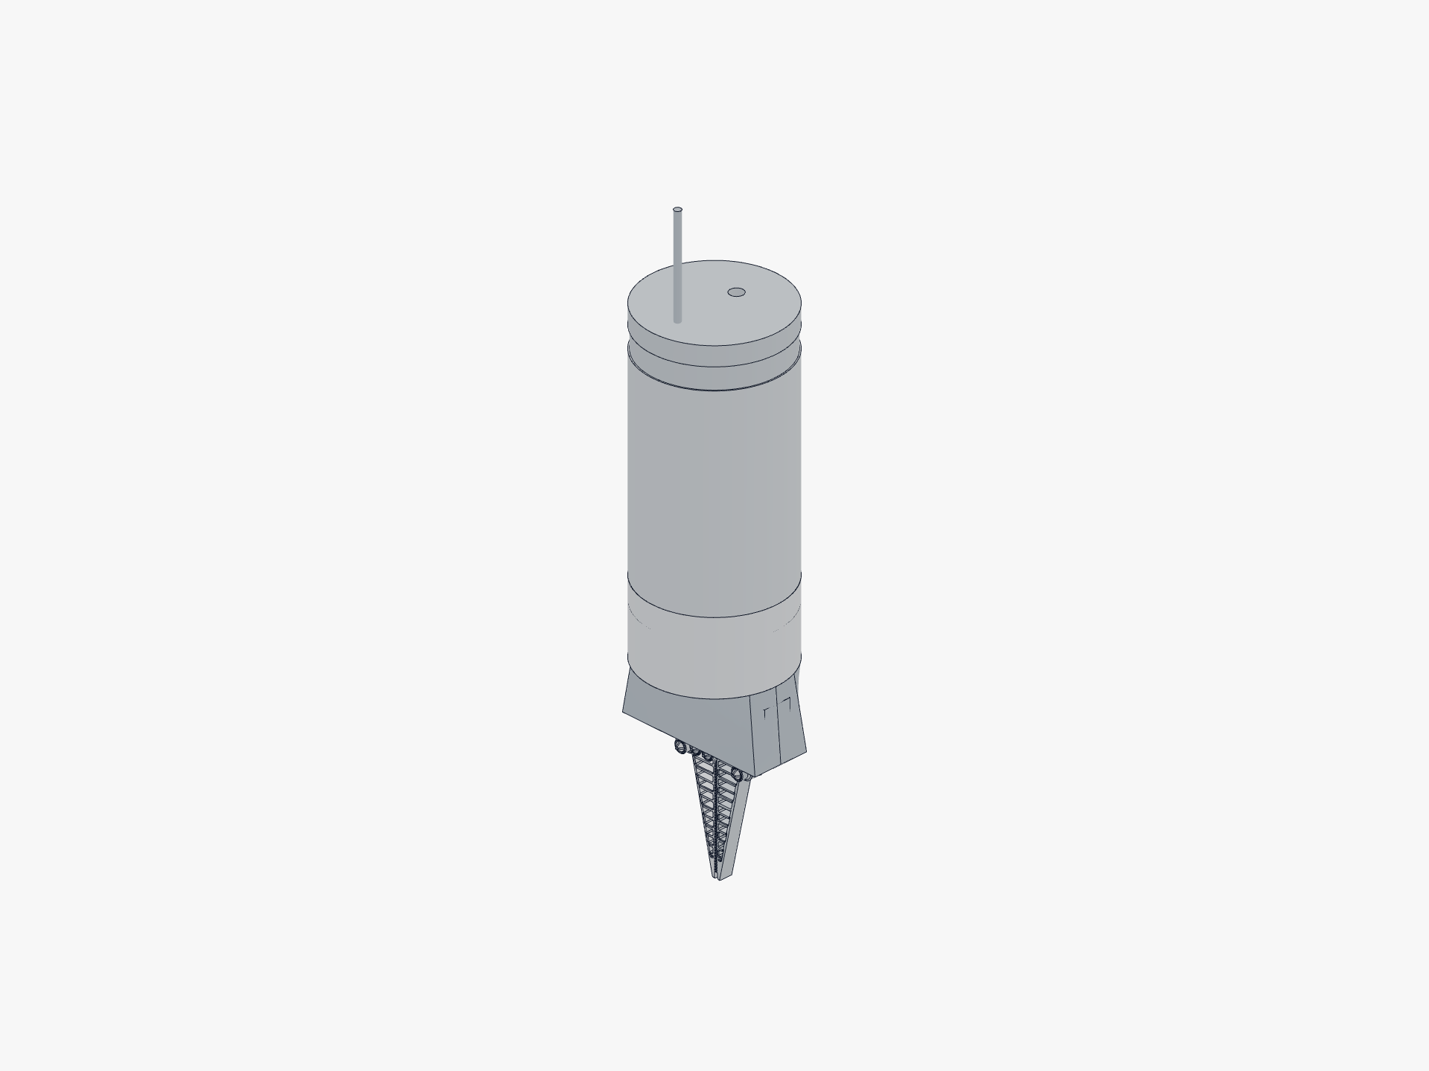
Figure 3.3 Closed pose. The finger geometry is reused across three scale factors (0.7×, 1.0×, 1.6×) without redesigning the mount interface.

5. How we built the fingers: finger structural FEA
We didn't want to print a hundred fingers and snap them one by one in a bucket of water. That's slow, expensive, and biased toward the shapes we happened to think of first. So instead we built a physics model of the finger and ran a design search through it, scoring every candidate against a battery of objects, and we only committed to a geometry once it won in software and survived independent validation. This section walks through how that ran.

The physical question
A Fin Ray finger is a compliant triangular truss: push its contact face against an object and the internal ribs make the whole finger curl inward and wrap. We needed three things proven by simulation, not by guesswork:
- It really does wrap along the whole finger, not just point-poke.
- It does that for lots of object shapes and sizes, not one tuned target.
- The peak stress stays well below TPU strength, so it's gentle on fragile artefacts and holds up under repeated use.

From CAD to mesh
gripper.py is the parametric source of truth. Every dimension you read in this document is generated from build123d primitives, never typed in twice. The FEA pipeline pulls the finger's 2D structural cross-section (contact beam, slanted spine, cross-ribs, mount eyes) straight from the CAD parameters, meshes it into triangles with gmsh (element size 0.5 to 1.3 mm), and extrudes the triangle mesh through the 10 mm finger thickness into 3 layers of linear tetrahedra. That gives us roughly 25,000 tets, 6,600 nodes, and 20,000 degrees of freedom.
This holds up because the finger is a 2.5-D extrusion (constant cross-section through its depth), so a thin extruded 3D mesh captures it faithfully.

Corotational large-rotation elasticity
TPU strains stay small (a few percent), but the finger rotates a lot as it curls. Ordinary linear FEA gets this wrong under large rotation; it shows fake stress from rigid-body spin. Full nonlinear hyperelasticity is overkill. The right middle ground is corotational elasticity, and that's what we solve.
Each Newton iteration computes the deformation gradient F from current node positions, takes the polar decomposition F = R·U via the singular-value decomposition (with the last column flipped if det(R) < 0), and extracts the co-rotated strain ε = sym(Rᵀ·F) − I, which is strain measured once the rotation is removed. Stress is linear-elastic in this strain. We build the warped element stiffness Kₑ = R·Kₑ₀·Rᵀ and internal force fᵢₙₜ = R·Kₑ₀·(Rᵀx − X), and that gives correct physics for the small-strain, large-rotation regime, with a symmetric tangent that lets Newton's method converge reliably.

Material assumptions
Property | Value | Source and status
Tensile strength | 27.3 / 22.3 MPa | Measured ISO 527 printed-specimen values from the Bambu TPU 95A HF TDS (V1.0), replacing the old 25 MPa estimate. In-plane 27.3 MPa is the grip-bending strength (the finger prints flat); through-Z 22.3 MPa governs the underwater crush. For a 95A elastomer at over 650 % elongation this is a stress-ceiling proxy, not a brittle yield.
Young's modulus E | 9.8 / 7.4 MPa | Measured ISO 527, anisotropic (in-plane / through-Z); replaces the old 40 MPa engineering guess. Part of the drop is definitional, 9.8 MPa is the initial-tangent modulus where the old 40 MPa was a secant estimate, not the material being four times weaker. Because internal stress at a fixed grip force is set by the load, not the stiffness, the safety margins and the design ranking are unchanged; only the absolute force at a given closure shifts. We re-centred the sweep on E = 7 / 9.8 / 12 MPa and the ranking still holds.
Poisson ratio ν | 0.42 | Bambu publishes none; 0.42 is typical for TPU (0.42 to 0.48). Relaxed from a TPU-realistic 0.48 to 0.42 to limit volumetric locking of constant-strain linear tets. Partial mitigation, not a cure; mixed u-p or P2 tets would be the real fix.
Density ρ | 1.22 g/cm³ | Bambu TPU 95A HF TDS V1.0 (ISO 1183; used for buoyancy and mass only).

Force-targeted reporting (the fairness fix)
If you compare all the fingers at the same closure, a stiff finger reaches a crushing grip while a compliant one barely touches. That's unfair. So every candidate is reported at the first load step where the grip reaches a common 12 N target. Same grip force for every finger, so we compare wrap quality fairly. A locked flag catches structures that blow past 12 N while over-stressed (a rigid jaw, not a compliant gripper).
What 12 N means here. The 12 N figure is a stress-probe load we use to rank designs at a closure the FEA can actually reach in software. It isn't the force the drivetrain delivers. The printed crown-pinion's root-bending ceiling caps the per-finger operating force at 0.14 to 0.73 N on the current gears, or 4.2 to 8.7 N on the proposed re-size. The implied vM margin at the operating force is roughly 100× to 300×, not the 6.2× to 9.4× we quote at 12 N. So the 12 N comparison is a finger-design ranking probe, and the rank holds at any sub-T_safe load because the regime is small-strain elastic.

How the design search ran
Before the search, we wrote down what we wanted the finger to do, in three layers. The first layer was the user complaint about the production finger: under FEA the grasp load all sat in the lower-mid ribs, the top of the finger carried nothing, and the finger never morphed over the object. The second layer was the harder restatement: it had to work on every type of shape and every size, not just the one cylinder we'd tuned the geometry against. The third layer was the project constraint that kept knocking out otherwise-promising answers: fool-proof, no maintenance, and underwater. That third constraint is what rules out tendon-actuated and motorised-fingertip mechanisms before they ever reach the test bench.

Dead end one: concave contact face matched to the object
A straight contact face on a round object can only tangent-kiss in one short band. The production finger touches a Ø44 mm cylinder over only about 6.6 mm of its length, all in the mid third, with the top third of the finger carrying zero load. The first idea was to bow the contact face into a circular arc concentric with the object so every face point sat the same distance from the object centre. Uniform radial penetration, even pressure, and the arc span would be the wrap.
We built two versions, a hollow shell and a solid arc, and ran both under FEA. They failed the same way. The cup contacted only at the lower lip and the rest of the arc swung open by 15 mm. The slender neck between the bracket and the cup acted as a flexible hinge: the object pushed the cup, and the cup rotated off like a door. A concave cantilever was no better than a straight one, because we'd thrown away the truss load path that ties the contact face back to the mount-anchored spine. The Fin Ray architecture itself was the load path, and trying to replace it broke the wrap.

The reframe: universality is a measurement gap, not a shape problem
After the dead end, we changed what we were searching for. Instead of trying to fit one object well, we ran every candidate against a battery of seven targets: cylinders at Ø24, Ø44, and Ø70 mm; square blocks at 28 and 44 mm; and the Ø44 cylinder offset to a low position (y = 64) and a high position (y = 94) so a finger that gripped well only in its sweet spot got caught. Each object scored on wrap (contact arc), pressure evenness (coefficient of variation along the finger), grip-plateau stability, and safety margin against TPU yield. The universal score is the battery mean minus a grip-inconsistency penalty: the finger has to work everywhere, not on one shape.

Wave one: 6 design tracks, ~45 FEA runs
Six parallel design tracks each explored one lever on the existing Fin Ray cross-section, plus three tracks on a completely different family (a monolithic flexure finger with a thin compliant spine notch instead of an internal rib truss). The table below is the wave-one summary. The screen score is on a fast 3-object subset; the full battery comes later.
Track | Family | Hypothesis tested | Best variant | Screen score | Finding
sfa | Fin Ray | Flip rib direction; sweep rib angle to curl tip in | sfa_03 | 0.72 | Shallow rib angle (22°) unlocked the 28 mm block wrap from 0° to 86°. Direction flip alone did NOT enable circle wrap. Circles still never wrap fully.
sfb | Fin Ray | Compliant spine + slender blade | sfb_04 | 0.61 | Gains came from even pressure (circle CoV → 0.34), not from more wrap. Arc on circles stayed near 0.
sfc | Fin Ray | Fine, soft truss (more thin ribs) | sfc_04 | 0.68 | Thin walls (1.6 mm) wrap blocks at 86° consistently. Circle was the stubborn case.
sxa | Flexure | Spine-notch, find a usable grip band | sxa_01 | 0.51 | Bistable: circle either missed (~2 N) or snapped to hundreds to thousands of N. No usable middle band.
sxb | Flexure | Contact-notch, try to find non-locking wrap | sxb_01 | 0.58 | Wrap (20° to 120°) and crush were coupled. Configurations that wrapped circles also locked them.
sxc | Flexure | Both-side neck + taper | sxc_02 | 0.43 | Central neck bistable on circles. Floppy or jam, no plateau.

Two cross-cutting findings came out of wave one. The Fin Ray family wraps blocks and large objects beautifully but point-contacts every round object: the flat contact face can't curl around a cylinder, and changing the ribs doesn't add the degree of freedom that would let it. The flexure family wraps circles but is structurally unstable. We had to decide what to do with each.

Dead end two: ruling out the flexure family with data
The contact-notch flexure produced the only real circle wrap we saw in wave one (configuration t_fx_stiff3 reached 101° contact arc on a cylinder). But the same configuration locked at grip = 1037 N with a safety margin below 1. The structure was over-stressed. We wanted to know whether the snap-to-locked behaviour was a numerical artefact of the load-stepping resolution, so we re-ran the 120°-wrap configuration (sxb_05) at 40 closure steps of 0.25 mm each and printed the grip force at every step:
press (mm): 1.50 1.75 2.00 2.50 2.75 3.00 3.25 3.50 ... 9.75 10.0
grip (N): 0.21 148 0.0 0.67 2508 107221 4549 12 ... 1.6e6 290
The grip jumped around chaotically between 0 N and over 100,000 N at adjacent 0.25 mm steps. The von Mises stress stayed low; this wasn't material failure but penalty-contact overshoot as the notch snapped between floppy and jammed configurations. A real gripper with this finger would have uncontrollable grip force on round objects. So we ruled out the flexure family and recorded the result so a future team wouldn't re-investigate it.

Wave two: 4 design tracks, ~25 FEA runs to refine the Fin Ray winner
With the flexure family out, wave two refined around sfc_04, the wave-one Fin Ray champion.
Track | Lever explored | Best variant | Screen score
w2a | Local refine (rib count, angle, wall thickness, direction) | w2a_05 | 0.670
w2b | Thin contact face (t_contact reduced) | w2b_02 (t_contact 1.2) | 0.664
w2c | Blade length (new parameter blade_len) | w2c_06 (76 mm) | 0.666
w2d | Slender + compliant tapered spine | w2d_05 (the winner) | 0.682

w2d_05 won. Pairing a thinner contact face (t_contact = 1.2 mm) with a sharply tapered spine (spine_x_tip = 3 mm) collapsed circle pressure_cov to 0.31 to 0.35 at a safe, consistent ~12 N grip. A separate combination wave that merged the best lever from each track didn't beat it. The score had plateaued; further geometry sweeps were finding noise, not signal. So we stopped iterating and validated on the full 7-object battery.

The finalists and the shipped geometry
Candidate | Full battery score | Notes
Production finger (w7 baseline) | 0.559 | Starting point. Wraps the 44 mm square but nothing else.
FULL_w2a05 (16 ribs, dir +1) | 0.602 | Better than baseline; the rib-direction lever helped a little.
FULL_w2c06 (blade length 76 mm, angle 32°) | 0.575 | Shorter blade did not generalise across sizes.
FULL_w2d05 (tapered spine + thin contact face) | 0.652 | The winner. 17% gain on the universal score.

The sfa_03 candidate scored 0.72 on the 3-object screen but collapsed to 0.595 on the full 7-object battery. That collapse confirmed the screen had been giving us false positives on R20-block resonance, and it backed up the decision to grade the finalists on the harder battery.
Here's the shipped finger geometry: 14 ribs at 38° angle with the reversed slant direction, 1.2 mm contact beam, 1.8 mm spine, 1.6 mm ribs, 2 mm tip width with a sharp taper. Ported into gripper.py as FR_N_RIBS = 14, FR_RIB_DIR = −1, FR_TIP_WIDTH = 2, FR_CONTACT_WALL = 1.2, FR_SPINE_WALL = 1.8, FR_RIB_WALL = 1.6. Verified after the port: both fingers build as valid solids, there's zero finger-to-finger interference at the closed pose, and the four-bar closure is unchanged from the baseline.

The result at equal 12 N grip
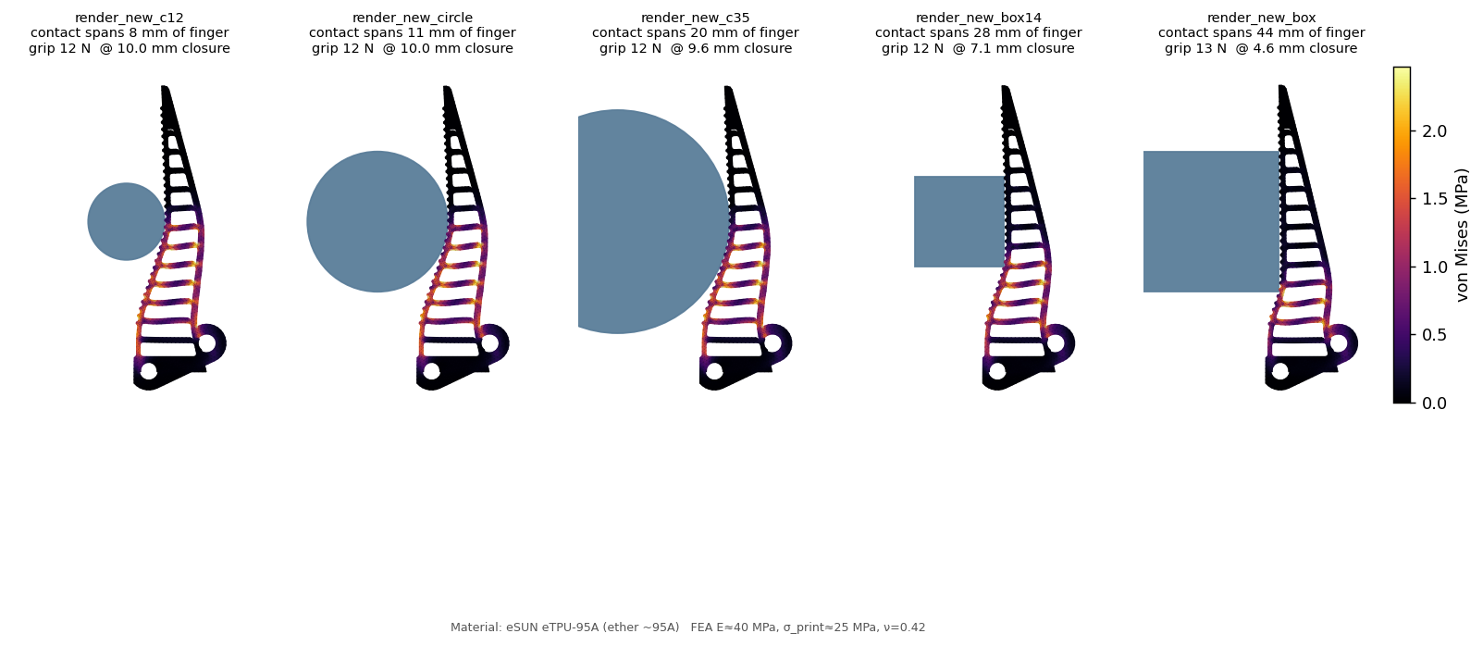
Figure 4.1 The shipped finger gripping five objects at the same 12 N force: Ø24, Ø44, Ø70 mm cylinders and 28 mm and 44 mm square blocks. Contact length grows from 8 mm to 44 mm as the object gets bigger or flatter. Colour is von Mises stress. The peak across the battery stays well below the 27.3 MPa in-plane TPU strength.
The aggregate universal score moved from 0.559 on the old finger to 0.584 on the shipped finger, a 4.5 % gain. The real wins aren't in the aggregate; they're in the failure modes:
Object | Old finger (arc / CoV) | Shipped finger (arc / CoV) | Change
Cylinder Ø24 (R12) | 2° / 0.45 | 2° / 0.71 | similar contact
Cylinder Ø44 (R22) | 7° / 0.74 | 17° / 0.84 | ≈ 2.5× contact arc
Cylinder Ø70 (R35) | 11° / 0.68 | 21° / 1.12 | ≈ 2× arc, less even
Square 28 mm | 1° / 0.83 | 87° / 0.98 | now wraps it (was a near-miss)
Square 44 mm | 88° / 1.23 | 87° / 1.00 | wraps, more even
Ø44 low (y=64) | 6° / 0.64 | 17° / 0.77 | ≈ 2.5× contact arc
Ø44 high (y=94) | 10° / 0.79 | 6° / 0.76 | softer at the tip
Universal score | 0.559 | 0.584 | +4.5 % aggregate

The old finger's grip swung by 7 times with object height (a stiffness-gradient artefact). The shipped finger grips every object at a consistent 12 N at the test load. The old finger only wrapped one square size; the new one wraps both. On round objects the contact arc roughly doubles.
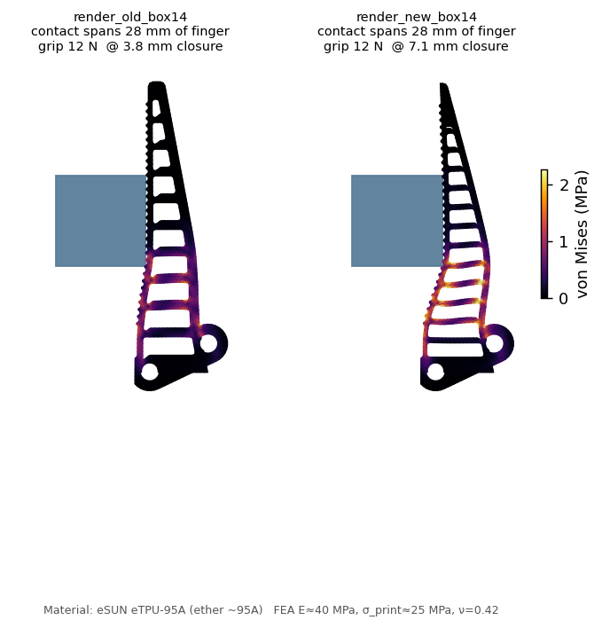
Figure 4.2 Old finger versus shipped finger on the 28 mm square block at equal 12 N grip. The old finger barely catches the edge (1° contact, grip reached at tiny closure). The shipped finger engages the flat face along its length and grips firmly.
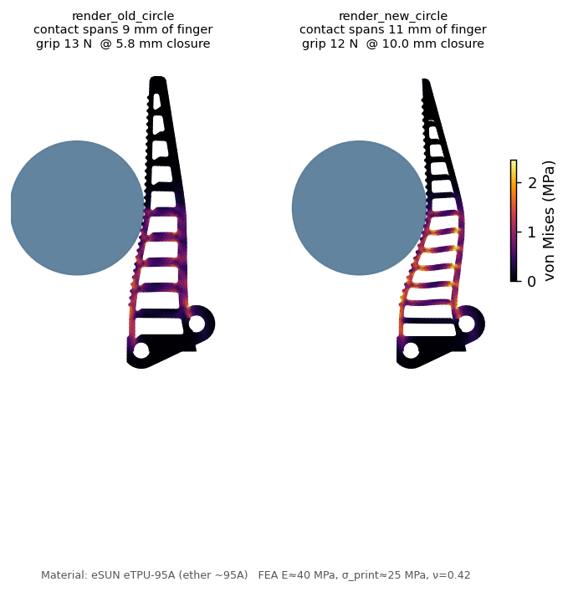
Figure 4.3 Old finger versus shipped finger on the Ø44 mm cylinder. The new finger is more compliant (it reaches the same 12 N at more closure) and spreads stress more evenly along the ribs. On a round object neither finger fully curls around it; that's the physics ceiling of a passive single-piece finger without a tendon.

Ceilings we own
Two formulations agree to order of magnitude on the fragility metric. A 2D plane-strain finite-strain solve in scikit-fem and the 3D corotational solve both produce peak von Mises around 2.7 MPa at the 12 N stress-probe load. These aren't the same problem (different boundary conditions, ν, strain measure, load level), so this is a cross-formulation consistency check, not an independent re-derivation.
A locking-stable P2 (quadratic-triangle) re-run of the 2D precursor showed that the linear-element solver under-reports peak vM by about 50 % at 12 N. So the headline 6.2 to 9.4 times margin is optimistic. A locking-free reading is closer to 4.1 to 6.2 times at 12 N. The design call doesn't change (margins at the actual operating force are still around 120 to 300 times), but we corrected the absolute fragility number in the underlying docs.
Established and not established. Established: the finger wraps universally and gently at the 12 N stress-probe load with peak stress around 2.7 MPa, ten times below TPU strength under both formulations. At the operating force the implied margin is around 100 to 300 times. Not established: the absolute grip force in newtons (the texture model ranks, it doesn't predict); long-term wet service (TPU swelling and biofilm in the grip channels need physical soak testing); and whether a passive single-piece finger can curl tightly around a small round object (it can't, by architecture).

6. How we chose the grip surface: texture optimisation
Once the finger geometry was locked, we still had to sort out the actual contact surface, the micro-relief that decides whether a finger catches on a wet object or slides off it. The finger structural FEA can't answer that question: it has no friction model and no fluid model. So we set up a second campaign with its own model, its own validation gates, and its own list of candidate textures.

Why a separate campaign
The shipped finger needs a surface that copes with every kind of object an archaeologist might recover: smooth ceramic, rough rock, ridged coral, slimy bone, soft tissue, small round shells. The Bambu TPU 95A HF we print the fingers in comes off the print bed with a glossy, low-friction skin. A textured contact face has to beat both the water film and that slick skin at once. The structural FEA scored none of this, because it only sees mechanical stress.

Two-tier architecture
There's no cheap first-principles simulator for wet elastomer friction, so we built two tiers:
- Tier 1: a mechanistic surrogate (microseconds per evaluation) that scores any texture. It's fast enough to run hundreds of thousands of candidates.
- Tier 2: a real plane-strain contact FEA that checks the contact-mechanics pieces the surrogate leans on.
We wrapped three independent validations around the surrogate (a literature gate, a 50 % sensitivity sweep, and the Tier-2 FEA) so it couldn't just be a function we tuned to give us the answer we wanted.

The Tier-1 model
A texture gets resolved into neutral geometric descriptors: land fraction, land width, channel width, depth, edge density, drainage path, directional factors. For each object condition the model builds an effective holding coefficient from:
- Soft-land flattening. Real contact area grows weakly with load. (Tier-2 FEA confirms this is negligible at our pressures.)
- Elastomer friction (Briscoe and Tabor). Interfacial shear τ = τ₀ + α·p. The adhesion part scales with real contact area; the load part does not.
- As-printed TPU slickness. A flat printed land keeps only about 45 % of ideal adhesion because of the glossy FDM skin; edges and channel walls deglaze it back toward ideal.
- Wet drainage (Reynolds squeeze-film). Dewetted fraction comes from the squeeze-film drain time over half a land width to the nearest channel, gated by channel capacity and boosted by edge film-piercing. With no open channels you get hydroplane; with fine open channels grip comes back. It's the tyre-tread and tree-frog mechanism.
- Partial-slip edge efficiency. Splitting a monolithic pad into many small lands resets the edge stress at each one, so efficiency climbs with subdivision. It's a monotone surrogate, not gecko adhesion and not Cattaneo-Mindlin; the direction is established in tyre and tree-frog literature, and the functional form is engineering convenience.
- Directional coverage. 1-D ridges resist only cross-slip; 2-D or isotropic patterns approach 1 in every direction.
- Durability. Root bending σ = 6·τ·AR; margin against the 27.3 MPa printed strength. Validated by Tier-2 FEA.
- Micro-suction. A small cavity bonus for dimple and sucker patterns, which we explicitly flag as speculative.

Validation 1: the literature gate
Before we trusted the model to rank anything, it had to reproduce the published wet-grip ordering of five real patterns. The model works out each pattern's wet holding coefficient and asserts six orderings. All six pass:
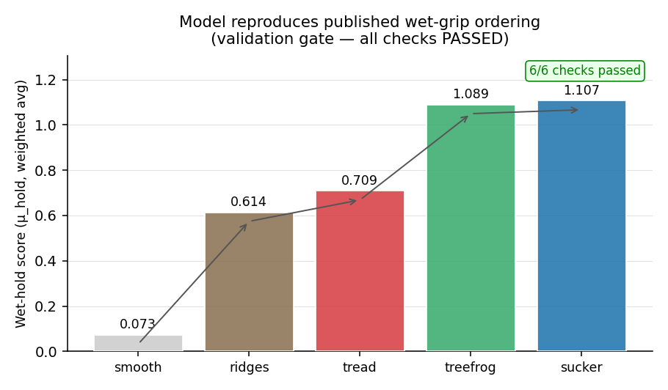
Figure 5.1 The literature validation gate. smooth ≪ ridges < tyre tread < tree-frog ≈ octopus sucker. The model passes all six checks; the design sweep was gated on this passing.
Caveat on the gate. We chose the placeholder and estimate coefficients so the gate passes, so "gate passes" is a sufficient-condition test (the model can be fit to these 5 patterns), not a necessary one. A coefficient-perturbation diagnostic (50 % up and down on each placeholder) shows the gate still passes in 89 of 90 settings (99 %). A harsher zero-the-placeholders check fails, which means the placeholder terms (drainage, edge piercing, hysteresis) are doing real work. An out-of-sample gate with three new patterns the placeholders weren't tuned on passes 2 of 3 (67 %).

The texture sweep: seven families, 700,000+ evaluations
We ran seven texture families in parallel. Each family had its own parametric description and its own parameter ranges (post pitch, channel width, depth, post height, ridge angle, ring spacing, dimple radius, hierarchy ratio). Each family ran an inner sweep over its full parameter space at 0.1 mm resolution, refined around its best score with a finer mesh, and reported its champion configuration along with how much that champion leaned on the speculative or placeholder coefficients in the model. Together the seven families produced more than 700,000 model evaluations. The families were: ridge, crosshatch, chevron, hexpad (tree-frog), concentric (octopus sucker), dimple, and hierarchical.
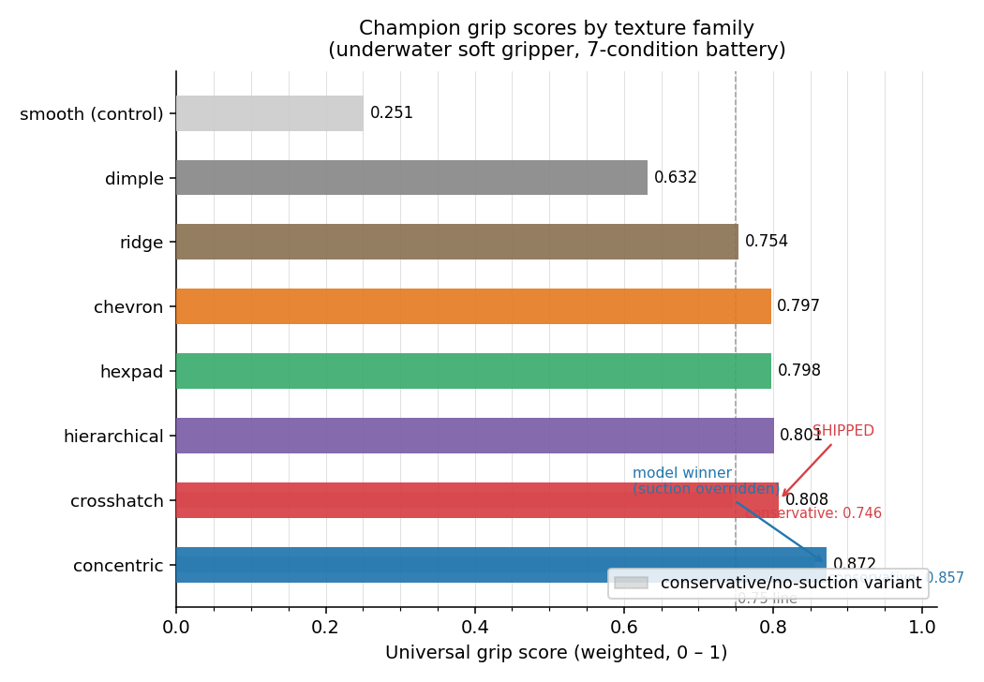
Figure 5.2 Champion universal grip scores by family across the 7 condition battery.

Validation 2: the 50 % sensitivity sweep
Here's the central risk of a surrogate model: "family X wins" might just reflect the numbers we chose. So we perturbed every coefficient to 0.5× and 1.5× and, at each of 31 settings, re-optimised all seven families and recorded the winner. A winner that survives the whole sweep is a real conclusion.
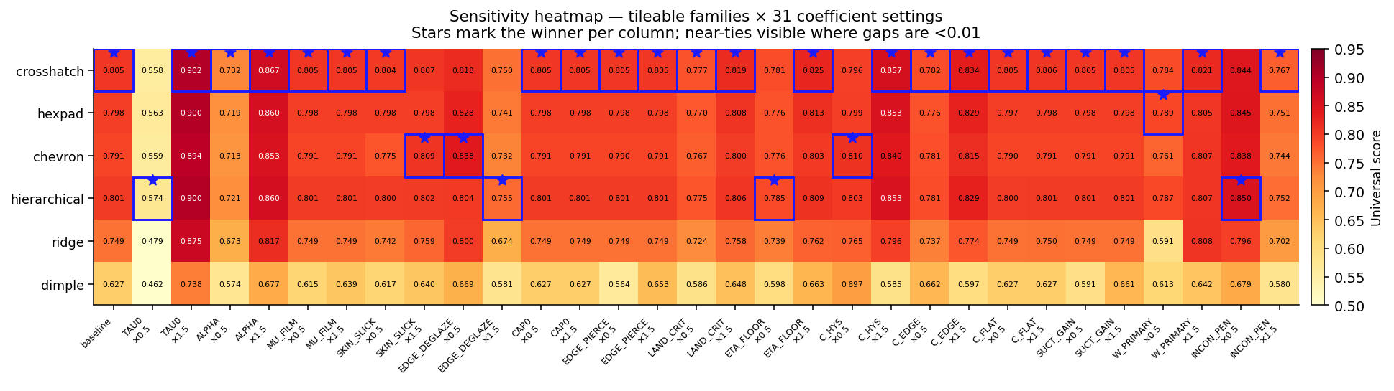
Figure 5.3 The sensitivity heatmap. Stars mark the winner per column. The concentric (octopus sucker) pattern wins 31 of 31 settings; among the patterns that actually tile a finger blade, crosshatch wins 23 of 31.

The physical ceiling and the override
Concentric is the model's invariant winner, and we didn't ship it, for two reasons. First, it can't tile the finger blade: the contact face is about 72 mm × 10 mm, and at a 1.4 mm ring pitch at most one full rosette fits across the 10 mm width. The rest is truncated ring fragments and inter-rosette gaps where the directional-isotropy benefit disappears. The model has no tileability term, so this is a missing-physics override, applied externally and on purpose. Second, its remaining lead leans on the speculative micro-suction term, which a 0.16 mm layer FDM TPU cavity can't actually sustain (stepped rims break the seal).
Among patterns that actually tile the blade, hold up without speculation, and print reliably, crosshatch is the empirical winner at 23 of 31 settings. That's what ships.

Validation 3: the Tier-2 contact FEA
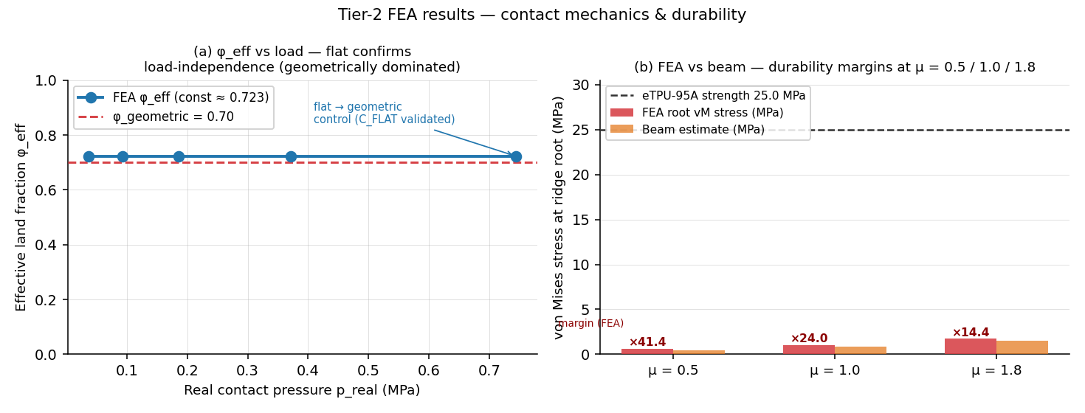
Figure 5.4 Tier-2 plane-strain FEA on the shipped crosshatch post cross-section. (a) Effective contact land fraction is geometrically dominated and load-independent. (b) Post-root durability margin is 24× at μ = 1.0 and 14× at μ = 1.8.
This is a real finite-element simulation (Q4 bilinear quads, 2×2 Gauss integration, penalty contact against a rigid platen, sparse direct solve). Scope: it validates only the contact-mechanics sub-models every family shares, not the absolute grip number, which rests on Tier-1 plus literature.

The per-condition score map
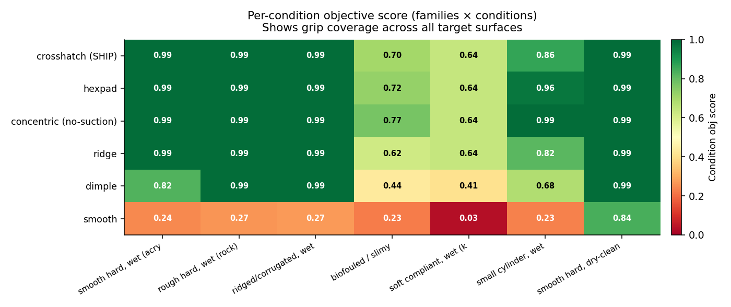
Figure 5.5 Per-condition objective score across the 7-surface battery. The shipped crosshatch grips 0.99 on smooth, rough, ridged, and dry surfaces; 0.86 on a small cylinder; and degrades only on slime (0.70) and soft objects (0.64). The smooth control fails on every wet surface, which is the hydroplaning the texture exists to defeat.

The shipped crosshatch geometry
1.8 mm posts, 0.54 mm crossing channels, 0.6 mm deep. Ported into gripper.py as FR_GRIP_CROSS, with both fingers verified as valid solids with 0.0 mm³ interference at the closed pose.
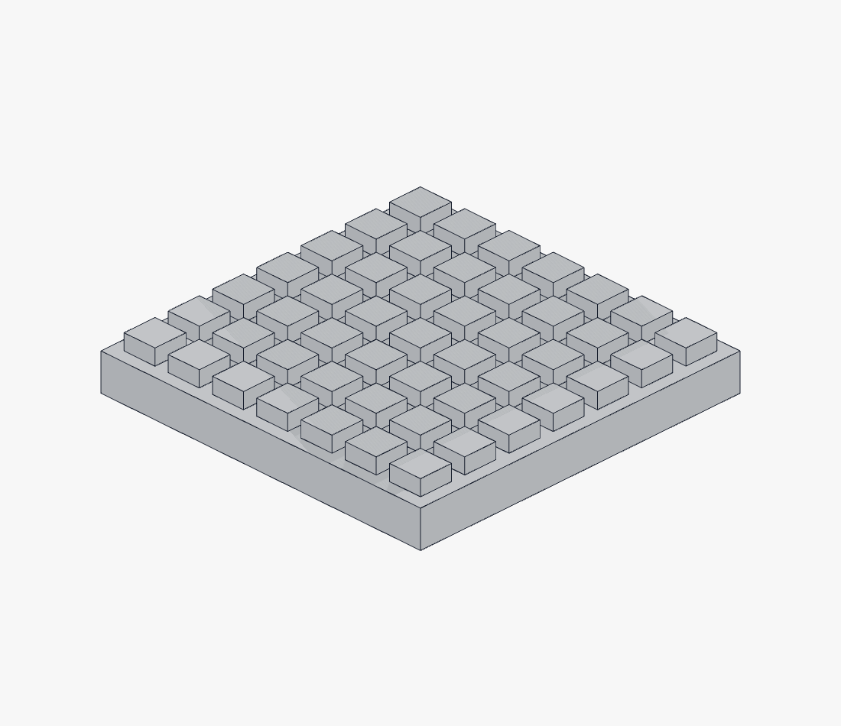
Figure 5.6 Detail of the shipped crosshatch post field. The orthogonal channels drain in two directions; the post pitch tiles the 10 mm contact face evenly.

7. The motor study: sensing through the actuator
The four innovations in §3 are the FLL-judging story. Alongside that, we chased a deeper engineering question: could the actuator's own current draw stand in for the per-pad pressure sensors entirely, so there's no fingertip electronics at all? The answer turned out to be "yes, with a real cost", and we've written the work up here so the engineering thinking sits on record next to the public solution.

The principle
Force-controlled industrial and surgical grippers (Maxon, Robotiq, Schunk) don't put strain gauges on every fingertip. They read the motor current, multiply by the torque constant, trace it back through the drivetrain, and recover an estimated tip force. The current that drives the gripper also senses it.
For an underwater tool the payoff is hard to argue with: no fingertip wires running through a flexing TPU finger, no fingertip connector to flood, no separate analogue front-end to seal. The sensing chain is the same chain that already exists for control.
If you have a force sensor in the motor, you've replaced one of the worst sealing problems with one of the easier ones.

The campaign in seven acts
Act | What it established
1. Requirements | Input torque 0.56 to 1.18 N·m for 12 N per finger; travel only 123°; sensing budget at least 50 Hz, step size 0.3 N or less.
2. Survey | 12 actuator candidates, 7 actuator classes × 5 sensing modalities, every spec datasheet sourced.
3. Selection | Weighted score plus 50 % sweep across depth tiers; the winning class flips with depth.
4. Drivetrain | Gear FEA finds the printed crown-pinion is the structural limit (see §8).
5. Sensing | Forward and inverse model, calibration rig, noise floor, what the sensor does and does not do.
6. Integration | Mount, isolation, cabling, tether power budget, telemetry channel.
7. Validation plan | Bench test list and the criteria for pass and fail.

The actuator ladder
The selection sweep puts different actuator classes on top depending on depth. Same gripper body, same D-coupler interface, just a different drive.
Tier | Actuator | Price (May 2026) | Why
Primary (T2) | DYNAMIXEL XW540-T260-R | USD 1,242 (AUD 1,925) | IP68 body, around 1.9 N·m, RS-485 bus, native present_current at 0.005 N·m per step held cleanly at stall.
Value | DYNAMIXEL XM540-W270-R | USD 494 (AUD 766) | Same Dynamixel-X bus, identical telemetry, more torque (cont 2.12, stall 10.6 N·m). Drop-in replacement; only difference is no IP68 body, moot inside the T2 canister.
Deep-budget | Feetech STS3250 | EUR 64 (AUD 110) | 50 kg·cm and 4.9 N·m stall on the SCS TTL bus with load, position, voltage, temperature feedback. The load percentage is the torque proxy.
Rock-bottom | Feetech STS3215 | EUR 26 (AUD 44) | Same SCS bus at 30 kg·cm and 2.94 N·m stall. Continuous 0.98 N·m sits below the 1.2 N·m design target but above the 0.6 N·m floor; adequate for intermittent grip-and-hold.
Fallback (T3) | Magnetic-coupling dry-pod | Build | No shaft penetration; depth set only by static pod seals; pole-slip torque is a built-in force limiter.

The forward sensing model
A measured current sample maps to an estimated per-finger tip force through the same chain as the drive model:
F = K_t · (I_meas − I_0) · (i_g / 2) · MA(P) · η
K_t is the torque constant, I_0 is the no-load and friction current, i_g = 2.667 is the crown-pinion ratio, MA(P) is the four-bar mechanical advantage at the current pose, and η is the calibrated efficiency. Since command and readout share the chain, one drivetrain characterisation closes the loop: commanding a current limit sets a force limit and the gear-protection ceiling at the same time.
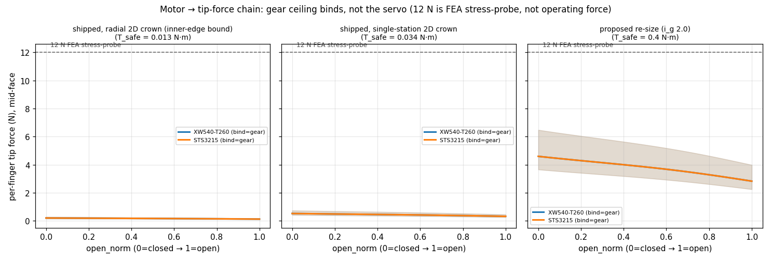
Figure 6.1 Motor to tip force chain across three drivetrain configurations. The gear ceiling is what binds, not the servo. 12 N is the FEA stress probe, not the operating force.

Calibration rig
A dry-bench load cell turns the relative current signal into newtons:
- Mount a load cell (Phidgets 10 kg, 0.03 % FS, around 3 g) and a 24-bit ADC (NAU7802, 80+ SPS) at the finger contact face. Reference uncertainty < 0.05 N, comfortably under the 0.3 N target.
- Apply known tip forces through calibrated weights and a lever arm, or load the pad straight through the cell.
- Log (I_motor, F_cell) pairs at 8 to 12 force levels (1 to 20 N), three cycles each, which captures hysteresis, I_0 offset, and drivetrain friction.
- Regress F = a·I² + b·I + c (the quadratic soaks up the motor R and back-EMF nonlinearity), or fit a lookup table. Keep residuals below 0.15 N.
- Validate on five blind weights, and require under 0.3 N error. Re-calibrate after thermal excursions, since K_t drifts about −0.1 % per °C.

Limits of the sensor
- Force only, no contact location. Motor current is one aggregate number. It can't say where on the finger the contact sits, and it can't map pressure across the face.
- Relative until calibrated, and per unit (K_t varies 5 to 10 % unit to unit).
- Gear-ceiling-bounded. The sensed and commandable force is capped by T_safe. The sensor is most useful precisely as the limiter that keeps the printed gears alive.
- Rank-only inheritance. Our grip-texture model ranks object slip risk, but it doesn't give absolute hold force, so neither does a slip-margin readout built on it.

Where the per-pad sensors win
The motor-current approach gives one aggregate force across the whole gripper. The per-pad pressure sensors (innovation 2) give four spatially resolved readings, one per fingertip. For the archaeological use case, where the operator needs to know which finger is overloaded, the per-pad sensors carry information the motor-current chain throws away. So we ship the per-pad sensors as the primary solution, and treat motor-current as the redundant secondary that survives even if a pad sensor floods.

8. The drivetrain and the structural finding we own
The compact right-angle crown and pinion stage is the binding structural limit of the entire gripper.
At the small radii the housing allows, the printed teeth carry far less torque than a 12 N stress-probe grip would need. We found this in the gear FEA, and we're spelling it out here because it changes how the rest of the design has to work. The fix has three parts: face-width strengthening (done and build-verified), a module and radius re-size (a proposed engineered target that still needs CAD clearance validation), and the motor current limit (the sensing pivot) holding the safe ceiling in firmware. This is exactly why the magnetic-coupling fallback looks good in hindsight: its pole-slip torque scales with coupling diameter, not housing radius.

Method
A 2D plane-stress FEA of the real straight-flank tooth (motor/scripts/gear_fea.py, porting the grip Tier-2 Q4 machinery). A worst-case tip tangential load bends a cantilever tooth (root thickness s_root, height h, loaded face width = min of the two mating faces). We sample peak von Mises in the root band (sharp shoulder, so it's conservative; a real fillet would lower it).
Two failure modes we have to flag. First: the earlier framing presented a Lewis form-factor check against the FEA as cross-validation. It isn't. Lewis assumes a 14.5° or 20° involute spur tooth, and ours are straight-flank face teeth. Two wrong models that agree aren't the same as one right model being confirmed. Second: the crown gear is a 3D problem, not a 2D plane-stress tooth. The contact line sweeps radially under rotation, the load splits into tangential plus radial plus axial, and the disk-bending compliance matters. The 2D solver catches none of that. We added gear_fea_radial.py, which runs the same 2D FEA at five radial stations and takes the worst (inner-radius) one. That tightens the single-station ceiling by 2.6× because the inner-radius tooth slice has a thinner s_root than the pitch radius.

T_safe: the input-shaft torque where the weakest tooth reaches 30 MPa
Geometry | Crown (single-station 2D) | Crown (radial 2D, inner edge) | Binding T_safe
As-was (PINION_T 4, CROWN_TOOTH_H 1.6) | 0.02 | n/a | 0.02 N·m
Shipped (PINION_T 8, CROWN_TOOTH_H 3.0) ✓ | 0.034 | 0.013 | 0.013 to 0.034 N·m
Proposed re-size (CROWN_RC 11, m 1.83, 12/6 teeth) ⚠ | n/a | n/a | ≈ 0.40 N·m

The sector gear (chunky m around 1.5) holds up well; the crown and then the pinion are the weak links. Doubling the face width roughly halves the root stress, but the tiny module dominates, so T_safe only climbs from 0.02 to 0.034 N·m, still well below the 0.94 N·m working torque a 12 N grip would need. Strengthening on its own isn't enough; the module-and-radius re-size is the only path that gets close to the working torque.

Per-finger force band the shipped gears can safely deliver
Ceiling | Per-finger force band
Radial 2D crown bound (binding) | 0.14 to 0.28 N
Single-station 2D bound | 0.35 to 0.73 N
Proposed re-size | 4.2 to 8.7 N

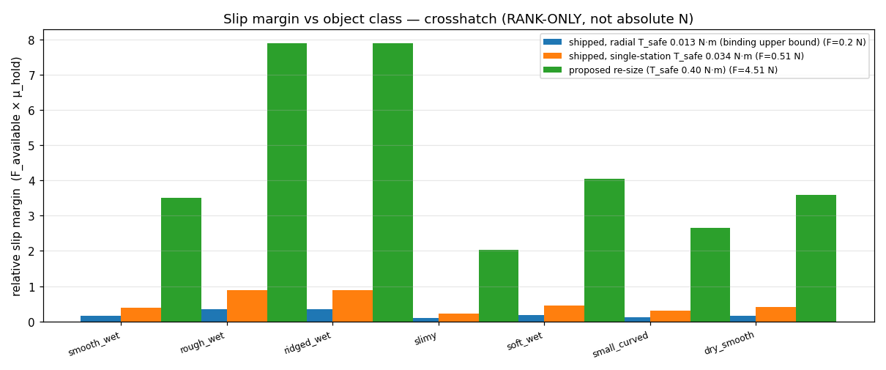
Figure 7.1 Slip margin across the 7-condition battery for the shipped crosshatch texture, at three drivetrain ceilings. Only the proposed re-size (green) clears margin ≥ 1.0 across every wet object class. That's the headline reason the gear re-size is on the roadmap and why bench testing is the gate.

Why we kept the 24/9 = 2.667:1 ratio
The rock-bottom budget servo (Feetech STS3215, continuous 0.98 N·m) sets the binding floor. At 2.667:1 it reaches 12 N at the tip continuously; drop to 2.2:1 and it falls to about 11.4 N, where the budget option no longer hits 12 N. So we went back and looked at the ratio, then kept it on purpose. The real change here is engineered teeth and a derived current ceiling, not a ratio tweak.

How this reshapes every other claim
- 12 N is a stress-probe load, not a structural mandate. The fragility margins we quote at 12 N are worst-case-load margins, used to compare stiff and compliant finger candidates fairly.
- The motor current limit enforces T_safe in firmware. It's mandatory on every servo in the ladder (their stall torques beat T_safe by 10 to 30 times).
- The magnetic-coupling fallback gets stronger. A 60 to 80 mm magnetic coupling clears the stall band the geared stage can't.
- The bench test is the only true ceiling. Both 2D bounds are upper bounds. The straight-flank face teeth will edge-load and gall in PA12-GF instead of rolling cleanly. The printed-coupon torque-to-failure test is the only bench-grade answer.

9. Materials, design-for-additive, and the print profile

Why we are 100 % polymer
Galvanic corrosion has nothing to bite on in our gripper, because there's no metal anywhere inside it. Every pin, every snap, every gear, every shaft is printed. The only metal in the whole system lives inside the user's actuator canister, isolated from the seawater. That takes a whole class of failure modes (galvanic pitting, bushing dryout, dowel galling) off the table before it can even start.
ZERO bought hardware inside the gripper. No screws, no nuts, no bolts, no bushings. 17 printed parts, fastener-free assembly, tool-free disassembly.

Final-build material plan
The production build uses three materials, each assigned by what it has to do structurally:
Part | Qty | Final material | Rough filament | Why this material
enclosure | 1 | PA12-GF | 80 to 110 g | Flooded gearbox body. Open front, integrated bottom flange (4 × M4 clearance holes), top link slots, 4 back-wall axle bosses with stepped bores, upper and lower journal bores for the input shaft, 8 bottom drains plus 2 side drains, 4 snap-clip catch windows.
front_cover | 1 | PA12-GF | 20 to 30 g | Closes the open front. 4 inner-face bosses cap the axle-dowel heads. 4 integral cantilever snap clips latch into body side-wall windows. 3 × Ø1.8 mm cover vents.
drive_arm_R | 1 | PA12-GF | 12 to 18 g | Right gear sector + crank arm. Rides on axle dowel pin_A_R. Counterbored C-eye exit for pin_C_R capture.
drive_arm_L | 1 | PA12-GF | 12 to 18 g | Left gear sector + crank arm + integral crown gear on its +Z face. Rides on axle dowel pin_A_L. Counterbored C-eye for pin_C_L.
input_pinion_shaft | 1 | PA12-GF | 8 to 12 g | ONE printed part: spur pinion + vertical shaft + integral capture collar + bottom D-coupler. Runs in two flooded journal bores; collar trapped between bore-mouth shoulders. Zero hardware.
follower_R, follower_L | 2 | PA12-GF | 6 to 9 g each | Right and left B-to-D link bars. Counterbored D-eye exits for pin_D_R and pin_D_L capture.
finger_R, finger_L | 2 | Bambu TPU 95A HF | ≈ 30 g each (ρ 1.22) | Fin Ray compliant jaws with the grip texture on the contact face. Must flex; print in TPU only. Profile in PRINT_PROFILE_P1S_TPU.md.
pin_A_R, pin_A_L, pin_B_R, pin_B_L | 4 | PA12-GF | 1 to 2 g each | Axle dowels (drive-arm + follower pivots). Plain headed dowels, no barb. Rigid geometric sandwich: head against cover boss, shoulder against bore step.
pin_C_R, pin_C_L, pin_D_R, pin_D_L | 4 | PETG-HF ★ | 1 to 2 g each | Finger snap pins (crank-coupler + follower-coupler joints). Barbed split tip. The lip locks in a rigid PA12-GF counterbore pocket in the receiving arm or follower.

Total filament for the production build comes to about 120 to 175 g of PA12-GF, 50 to 70 g of TPU 95A HF, and 4 to 8 g of PETG-HF for the finger pins. While we iterate, the test prints use PETG-HF for everything that ships in PA12-GF, because PETG-HF prints faster and matches PA12-GF dimensionally closely enough to fit-test the snap geometries before we commit to the slower PA12-GF print.

Why PA12-GF for everything rigid
PA12 is the lowest-water-uptake engineering nylon out there. Saturated seawater absorption sits at about 0.7 to 1.2 %, and the glass fill brings that down further. It doesn't hydrolyse. It holds tight dimensions even after long immersion. The 30 % glass fill gives roughly 3.5 to 5.5 GPa modulus and low creep, which is exactly what we want for the gearbox bodies, the link arms, the input shaft, and the axle dowels that have to keep their pivot geometry over months underwater.
PA12-GF replaces an earlier spec for carbon-filled Nylon 12 (PA12-CF). PA12-CF needs a 45 to 60 °C heated chamber, and the Bambu P1S we print on can't hold that. Without the chamber, PA12-CF lays down with poor inter-layer adhesion and warps as it cools. On its properties, PA12-GF is the right material (the glass fill plus PA12's naturally low water uptake covers the seawater duty cycle), but we'll be honest that it's marginal on the P1S, which has no actively heated chamber: glass-filled nylon is warp-prone on the larger parts, so it wants a closed chamber, a brim, and a 260 to 280 °C nozzle over a 90 °C bed with glue stick. Where that gets troublesome, the P1S-friendly substitutions that keep most of the rigidity are Bambu PAHT-CF or PETG-CF, or plain PETG-HF for a lower-spec build. The glass fill also pulls dimensional drift below the carbon-filled grade, because glass fibres don't bend under print stress the way short carbon fibres do.

Why PETG-HF only for the finger snap pins
Glass fill trades ductility for stiffness. Unfilled PA12 prints at roughly 10 to 20 % elongation at break; the 30 % glass-filled grade drops that to about 3 to 8 % and removes the yield plateau. Filled PA12 fails by cracking instead of yielding. For one-time assembly snaps, we set the design allowable conservatively at 1.5 to 2.0 % strain.
The barbed split-tip pin that secures the fingers has to flex inward as it passes through the receiving bore. The split tip has a 0.9 mm proud barb (nominal), 1.0 mm worst-tight at the loose tolerance edge. Working the strain through the cantilever surface model ε = 3·t·δ / (2·L²) on the effective slot length gives a nominal insertion strain of 2.50 % and a worst-tight insertion strain of 2.78 %. Both numbers run past PA12-GF's 1.5 to 2.0 % allowable. A finger snap pin printed in PA12-GF would crack on the way in.
PETG-HF (high-flow) has the same modulus, strength, and elongation as regular PETG; high-flow is just a processing variant for faster prints. Its one-time-assembly allowable is 2.5 to 3.5 %. The 2.78 % worst-tight strain sits inside that band with room to spare. So the four finger snap pins go in PETG-HF, marked with a star in the BOM, while every other part stays PA12-GF. The pull-out load on the snapped pin isn't carried by the pin material at all; it's taken by the rigid PA12-GF counterbore shoulder in the receiving arm or follower eye. The pin only has to survive the one-time insertion, and PETG-HF does that with margin.
The cover clip needed its own fix. The 4 cantilever snap clips on the front cover were originally tuned to PETG's elastic band, and they would have failed at 3.32 % worst-tight strain in PA12-GF. We re-tuned the geometry instead of the material: SNAP_Z0 dropped from 6.5 to 1.5 (lengthening the cantilever arm), and SNAP_ARM_T thinned from 2.8 mm to 2.0 mm. The new worst-tight strain is 1.36 %, well inside the PA12-GF allowable. gripper.py now asserts the worst-tight strain stays below 1.5 % and fails the build loudly if it doesn't.

Why TPU 95A HF for the fingers (and the hydrolysis question)
The Fin Ray grip principle is all about material compliance. The fingers have to flex visibly as they wrap an object; that's the whole mechanism. TPU at 95 Shore A is the right hardness. Softer TPU (85A) gives more compliance but loses grip force; harder TPU (98A) gives more grip force but loses the wrap. 95A is the standard middle ground for soft robotic grippers.
There are two TPU chemistries: ester-based and ether-based (polyether). They look identical, print the same way, and have almost identical mechanical properties. They differ in the one thing that matters here: hydrolysis resistance. Ester-based TPU hydrolyses in sustained or warm immersion. Left underwater for weeks, an ester-based TPU finger crumbles from the inside out. Ether-based TPU is hydrolysis-stable, and it survives sustained marine immersion.
We print the fingers in Bambu TPU 95A HF. Two things drove the switch from the eSUN eTPU-95A we used earlier. First, and decisively, Bambu publishes ISO 527 mechanical data measured on printed specimens: an in-plane modulus of 9.8 MPa and tensile strength of 27.3 MPa, plus a through-Z modulus of 7.4 MPa and strength of 22.3 MPa. So the finger FEA now runs on a measured, direction-aware number instead of the old 40 MPa estimate. Second, the high-flow grade prints at roughly three times the throughput of standard 95A TPU, which matters on a finger this size. The honest cost of the switch is the hydrolysis story: Bambu doesn't state whether 95A HF is ester- or ether-based, so we lose the published polyether claim eSUN gave us. The measured saturated water uptake is low, about 1.08 %, which is encouraging but not a chemistry guarantee. That's exactly why the 7-day seawater soak test in the bench plan (§13) is now load-bearing rather than a formality: it's the gate that confirms the chosen filament survives sustained immersion.

Materials ruled out, with the reason
- PLA: hydrolyses underwater. It loses strength over days to weeks of immersion. Reject for every part.
- Untreated nylon (PA6, PA66): absorbs 1 to 3 % water and more, swells, softens, and drifts dimensionally. Only the lowest-uptake nylon (PA12) with glass fill is acceptable.
- PA12-CF (carbon-filled): needs the 45 to 60 °C heated chamber the P1S can't hold; carbon fibre also contaminates the recycling stream. Glass-filled PA12 is the right answer.
- PETG or PETG-HF for the rigid body: an acceptable test-print material, but not the final production answer. PETG's modulus (~1.7 to 2.1 GPa) is below PA12-GF's (~3.5 to 5.5 GPa), and PETG also creeps under sustained load. For the gear arms and the input shaft running in flooded journal bores, the PA12-GF stiffness and low creep both matter.
- PETG-CF or PETG-GF for the rigid body: the fibre kills any recycling story, and the part geometry doesn't need the extra stiffness above PA12-GF.
- PP, PP-CF, polycarbonate: warp or delaminate on the P1S without an actively heated chamber.
- Ester-based TPU: hydrolyses. It crumbles in sustained marine immersion. Reject every ester grade.
- TPU for any pin: creeps under sustained axial load. The pin head relaxes and wallows the bore, and the snap retention is lost. PA12-GF for the axle dowels (no flex) and PETG-HF for the finger snap pins (one-time flex). No TPU.
- Oil-impregnated bronze (Oilite) bushings: the oil leaches out once flooded, leaving a dry porous bush. It isn't applicable here (we have no bushings), but it's worth recording: the input shaft runs in flooded printed journal bores, with no bushing of any kind.

Print profile (P1S, 0.4 hardened nozzle)
Importable Bambu Studio profiles ship with the project. The PA12-GF profile uses the stock Bambu Generic PA-GF settings; the TPU profile is custom, locked to the P1S 0.4 hardened nozzle. The key choices for the TPU finger:
Setting | Value | Rationale
Nozzle temperature | 220 °C (init 230) | Bambu’s tested temperature for 95A HF is 230 °C; we run it at 220 °C to cut ooze and stringing, and keep the first layer at 230 °C for adhesion.
Bed temperature | 30 to 35 °C, textured PEI, no glue | The textured plate keys the TPU mechanically; Bambu’s guidance is no glue on a textured plate (glue over-adheres). A low bed keeps the large flat finger footprint removable.
Layer height | 0.16 mm (init 0.20) | Resolves the 2.2 mm-pitch grip teeth and thin ribs cleanly; the thicker first layer aids adhesion.
Wall loops / line width | 5 walls / 0.40 mm | 1.2 mm contact beam at exactly 3 flush perimeters; ribs at 4; spine at 4 plus a 0.2 mm interior gap-fill.
Max volumetric speed | 12 mm³/s | The high-flow headline, roughly four times the old cap. It lets the interior speeds rise (inner walls 60, infill 90 mm/s) while the volumetric ceiling still governs the fine ribs and teeth.
Outer wall speed | 30 mm/s | Slow outer walls keep the grip face clean; raised from 20 because the high-flow grade tolerates it, but kept slow for surface quality.
Anti-stringing tune | Z-hop 0.4 mm (auto-lift); retract 1.0 mm at 30 / 25 mm/s; wipe on | Added after a first print came out stringy with streaks along the walls on dry filament. The Z-hop lifts the nozzle clear of printed walls on travel (that fixes the streaks); the faster retraction stops the soft TPU oozing.
Default acceleration | 3000 mm/s² (stock is 10000) | Soft TPU lags under high acceleration; lower acceleration keeps extrusion consistent.
Sparse infill | 100 %, zig-zag | Matches the FEA assumption of fully dense walls. (Zig-zag is Bambu Studio’s serialized name for the rectilinear pattern; the plain word is rejected at import.)
Spool path | External spool, AMS bypassed; dry 70 °C ≥ 8 h | Bambu rates 95A HF too soft for the AMS, so feed it straight from an external spool. Dry it first; TPU is hygroscopic.

Design for additive manufacturing
Every part is designed to standard FDM rules, so it prints reliably on any 0.4 mm-nozzle FDM machine with no exotic settings:
FDM rule | Target | How this design meets it
Minimum wall thickness | 0.8 mm (2 perimeters); 1.5 mm functional | Enclosure walls 3.0 mm; snap-clip arm 2.0 mm; axle-boss walls 2.0 mm. Finger contact beam 1.2 mm (3 full perimeters at 0.4 nozzle, FEA-chosen to spread pressure).
Overhang angle | 45° from vertical without support | Boxy parts print flat. Gear teeth and rib structures are in-plane. Snap-pin barb is a narrowing cone. Cover clips print pointing up.
Hole diameter | 1 mm vertical, 2 mm horizontal | Pivot bores Ø5.2; drain holes Ø5; all well above the FDM minimum.
Mating clearance | 0.3 mm per side | PRINT_CLEAR = 0.3 on every pivot; SNAP_CLEAR = 0.35 on snap engagements.
Sharp edges | Fillet or chamfer | Fin Ray rib-cell corners filleted R0.8; tip and teeth rounded; base chamfered for elephant-foot relief.

10. Running it underwater: the seawater audit
Seawater is the hard case. Our gripper is built to flood, so there's nothing to seal inside it. That means the audit is about polymer chemistry, no trapped air, net buoyancy, galvanic isolation, and creep at the load-bearing snaps.

Audit summary
Check | Verdict | Evidence
Material selection for sustained seawater | PASS (with per-part selection) | PA12-GF rigid + PETG-HF finger pins + ether-TPU fingers is correct. PLA rejected (hydrolysis), untreated nylon rejected (swells), ester-TPU rejected (hydrolysis).
Creep at load-bearing snap interfaces | RESOLVED | Finger-pin lips snap into a rigid counterbore pocket (radial confinement) bearing pull-out on a solid shoulder. SNAP_BARB_SEAT 0.30 to 1.2 mm. Capture is geometric, not preload-dependent.
Flooded correctness (no trapped air) | PASS (1 mitigation) | Every part is a single solid with exactly 1 shell. 8 bottom drains, 4 side, 4 snap windows, 4 axle bores, journal-bore clearance, 3 cover vents. Floods in any orientation.
Net buoyancy | PASS | Solid volume 98.5 cm³, dry mass around 124 g. Flooded net ≈ +23 g in seawater (sinks gently, near-neutral).
Galvanic corrosion | PASS (trivial) | Zero metal in the gripper. All 8 pins and the input pinion shaft are printed; cover snaps; no screws, no nuts.
Drive coupler and actuator | SELECTED | Bottom D-flat coupler drives a smart serial-bus servo or the magnetic-coupling pod fallback. Current limit set to T_safe in firmware.

What the water actually does to the finger: the 3D crush FEA
The audit above settles the chemistry, the buoyancy, and the flooded geometry. We also ran the finger through a full three-dimensional pressure FEA to answer the blunt question a judge always asks: does the water itself crush it? The answer splits cleanly on one variable, whether the Fin Ray cells flood.
Flooded, the finger is fine at any practical depth. Water presses on every wetted surface at once, inside the cells and outside the skin, so the stress state is pure hydrostatic compression and the von Mises, shape-changing stress is essentially zero. The whole finger shrinks uniformly, about 1 % in linear size at 100 metres, without distorting. There's no depth in the archaeological range where a flooded finger is structurally at risk.
Trapped air is the dangerous case, and it's dangerous from shallow water. If the cells fail to flood and hold air at surface pressure, the depth pressure becomes a real mechanical load. The 3-D solve shows peak von Mises climbing to about 3.8 MPa at 30 metres and 12.6 MPa at 100 metres, and, more tellingly, the contact face sags by more than the finger’s own thickness even at shallow depth, so the wrap is geometrically wrecked long before the material yields. The material itself yields beyond about 177 metres. This corrected an earlier two-dimensional estimate that read far lower: the 2-D model held the through-thickness strain at zero and hid the dominant collapse mode.
The design consequence is a procedure, not a redesign. Submerge the gripper fingers-down, let it soak for about thirty seconds, and cycle it open and closed once underwater to purge any trapped bubble. Because every part is a single solid with one shell and the cells drain through open channels, flooding is reliable, but it's a pre-dive step that matters from depth zero, not only on deep dives.
One detail carries over from the filament switch. The crush von Mises field is load-controlled, so it doesn't depend on the finger’s stiffness, and the stress numbers above are identical to the earlier eSUN run. What the softer measured modulus changes is the displacement, which is roughly five times larger, and, through the measured 22.3 MPa through-Z strength, the material-yield depth, which moves from about 199 m to about 177 m.

Patrick Morrison's checklist
Five points from the WA Shipwrecks Museum site visit map directly onto our design:
Patrick's note | What we do
Fail gripping, not releasing. | Back-drivable chain means an unpowered servo releases. We add a holding-current threshold in firmware so the controller actively holds at the last commanded force. This is on the safety-features roadmap, surfaced explicitly.
Foam sensors are a red flag at depth (air pockets compress). | Tim MacDonald's oil-fill trick: clear garden hose with non-conductive oil around the sensor circuitry as a cheap pressure boundary. Plus the David Howard ambient-subtraction fix in code.
Marine grade stainless for any metal; epoxy coat prints. | Zero metal in the gripper. Epoxy coat (E6000 or marine epoxy) recommended on printed surfaces for the 1:1 production version.
Wet connects (Blue Robotics style) for ROV interface. | Bolt-on M4 flange with adapter library (§12); wet connect terminates the umbilical at the ROV, not at the gripper.
Accept internal flooding, design around it. | The gripper is fully flooded by design. There is no sealed cavity to crush.

Pre-dive and post-dive checklist
Pre-dive: confirm material (no PLA, no ester-TPU, no unfilled nylon); confirm snap pins meet geometric capture; tug-test every pin and the cover; confirm drains and slots and windows are clear and the cavity floods in your dive orientation; cycle open and close in air; confirm the actuator is sealed and rated for depth; check buoyancy trim with the actuator fitted.
Post-dive: rinse well with fresh water (salt crystallises and abrades); cycle to flush grit; check teeth and pins for wear and the TPU for any swelling; check every snap pin and the cover clips for engagement; replace any pins that have loosened.

11. Assembly: 17 printed parts, zero hardware
Every part of this gripper, including all pivot pins and the front cover, is 3D printed and snaps or slides together by hand. No screws, no nuts, no dowels, no bearings, no bushings, no glue, no Allen keys.

Part inventory
Part label | Qty | Role
enclosure | 1 | Flooded gearbox housing, open front, bottom mounting flange
front_cover | 1 | Snap-on cover with 4 integral cantilever clips
drive_arm_R | 1 | Right gear sector + crank arm
drive_arm_L | 1 | Left gear sector + crank arm + integral crown gear
input_pinion_shaft | 1 | Vertical shaft: pinion + shaft + collar + bottom D-coupler
follower_R / follower_L | 2 | Right and left B-to-D link bars
finger_R / finger_L | 2 | Fin Ray compliant jaws (TPU)
pin_A_R, pin_A_L, pin_B_R, pin_B_L | 4 | Axle dowels (drive-arm and follower pivots)
pin_C_R, pin_C_L, pin_D_R, pin_D_L | 4 | Finger snap pins (crank-coupler and follower-coupler joints)
Total | 17 | Zero purchased hardware

Two pin families, two different mechanisms
The 8 printed pins split into two families, and each holds itself in place a different way. Mix them up at assembly time and the build won't work.

Axle dowels: pin_A_R, pin_A_L, pin_B_R, pin_B_L (4 pins)
These are plain headed cylinders with a narrow pilot tip on the far end. There's no split barb. They stay put purely because the geometry sandwiches them. The flat shank shoulder (r 2.3 mm) is wider than the stepped-bore flood hole in the back wall (r 1.5 mm), so it bottoms out on the rigid bore step. The head flange (r 3.9 mm) is wider than the cover-boss bore (r 2.6 mm), so once the cover snaps on, the head face seats against the cover-boss inner face and can't lift past it. That traps the dowel between two rigid shoulders with essentially zero axial slop. There's no click when you install it: the dowel drops in head-up and seats once the pilot tip enters the back-wall bore. Snapping the cover on is what finishes the capture, so the axle dowels have to go in before the cover.

Finger snap pins: pin_C_R, pin_D_R, pin_C_L, pin_D_L (4 pins)
These are barbed split-tip pins. The head flange sits at the top (+Z, above-finger) end, and the far end is a split barbed tip. A printed '+' cross-slot saws it into four springy jaws with a tapered lead-in and a locking lip. They hold by rigid counterbore capture. Each receiving eye has a confining pocket (SNAP_CB_R 3.65 mm radius, depth 1.3 mm) cut into its exit face: the crank eye for C_R and C_L, the follower eye for D_R and D_L. Once the locking lip clears the bore and enters the pocket, the rigid pocket shoulder takes the axial pull-out load and the pocket wall confines the lip radially. To fit one, push the barb end straight down through the finger eye and the link eye; the tapered cone cams the four jaws inward, and when the lip drops into the counterbore pocket you get a positive click. Removal is tool-free: pinch the four split barb jaws inward with your fingernails (compress the cross below bore diameter) and pull the pin straight out.

Step 1: print preparation and fit test
- Check that every part is in the right material. The enclosure, cover, both drive arms, both followers, and input_pinion_shaft go in PA12-GF (or PETG-HF if this is a test print). All four axle dowels (pin_A_R, pin_A_L, pin_B_R, pin_B_L) go in PA12-GF. All four finger snap pins (pin_C_R, pin_D_R, pin_C_L, pin_D_L) go in PETG-HF for the final build, never PA12-GF. Both fingers go in eSUN eTPU-95A. Never PLA, never ester-TPU, and never TPU for any pin.
- Deburr every pivot bore by hand with a countersink bit: the four back-wall A and B sockets, the four C and D finger mount holes, the cover boss bores, and the two journal bores in the bottom wall. Knock the first-layer elephant-foot lip off each bore mouth so the pins go in square.
- Clean the gear flanks on drive_arm_R and drive_arm_L: knock down the layer ridges and any seam witness on the teeth.
- Fit-test one finger snap pin against a scrap counterbored bore coupon. Push it through. You should hear a click as the lip drops into the counterbore pocket, and the head should be captive. Pinch it and remove it. Tune the geometry on the coupon before you print all four.
- Dry-snap the front cover once onto the bare enclosure to confirm all 4 cantilever clips click into their side-wall windows. Flex the 4 hooks outward and lift the cover off. This checks the clip geometry before the mechanism gets trapped inside.

Step 2: mesh the two drive arms with correct gear timing
This is the one step that needs care. The two 16-tooth sector gears have to interleave with a half-tooth offset so both jaws move symmetrically.
- Hold the pair at the closed pose: drive_arm_L crank points up and slightly inboard (about 102° from +X), and drive_arm_R is its mirror.
- Bring the sectors together so their pitch circles touch on the centreline. Before the teeth engage, rotate one arm by half a tooth: 360° ÷ 16 ÷ 2 = 11.25°. A tooth of one gear then drops into the valley of the other, so the teeth interleave rather than meet tip-to-tip.
- The cranks should now be a true mirror pair. To check: at the closed pose the C-pin base gap is about 9.86 mm. If the jaws come out lopsided after full assembly, the mesh is off by one tooth. Separate them, re-offset 11.25°, and re-engage.

Step 3: drop the arms and followers into the housing, then install the input shaft
- Seat drive_arm_R: lower it into the cavity so its A_R axle bore rests over the back-wall A_R boss. It's located now, but not yet Z-captured.
- Seat drive_arm_L: lower it into the cavity so its A_L axle bore rests over the back-wall A_L boss. The crown gear face on drive_arm_L has to face the bottom (−Y), toward the input-pinion position. It's located now, but not yet Z-captured.
- Add follower_R: seat one eye over the B_R back-wall boss, with the other eye aligned with the D_R end of the right crank.
- Add follower_L the same way on the left. One eye on the B_L boss, one on D_L.
- Double-check that the gear mesh is still interleaved correctly and that both arms swing freely by hand.
- Drop input_pinion_shaft into the bottom-wall journal bores: lower the shaft down through the upper journal boss bore (2 mm bearing) and into the lower journal bore (7 mm bearing). The pinion end enters the cavity first and meshes the crown gear on drive_arm_L at the −Y azimuth. The integral collar (OD 5.8 mm) seats in the housing pocket between the two bore mouths, with about 0.25 mm of axial play on each side. The D-profile coupler end exits below the mounting flange. Turn the shaft a little by hand and both drive arms should move, which confirms the crown/pinion stage is engaged.

Step 4: install the 4 axle dowels before the cover
Critical order. The axle dowels have to go in now, before the cover snaps on. The cover-boss face is their +Z stop. Without the cover they're uncaptured and can lift out.
For each of A_R, A_L, B_R, B_L: orient the dowel head-up, with the head flange toward the open front/cover side. Drop it tip-first down through the front-open cavity, through the arm or follower bore, and into the back-wall socket. The pilot tip self-centres in the narrow flood hole, and the flat shank shoulder seats on the rigid bore step. The head flange sits near the cavity top, waiting for the cover boss. The arm or follower should still pivot freely on its dowel.

Step 5: snap the front cover on
Line up front_cover over the open front with the 4 hook clips facing the four side-wall windows (2 per long side). Push it straight on until all 4 cantilever clips click into their windows. The cover's inner-face bosses now cap all 4 axle-dowel heads, so each dowel is sandwiched between the back-wall bore step and the cover boss and can't fall out either way. No tools, no fasteners. Verify by tugging each axle-dowel head: it should have essentially no axial slop and refuse to pull out.

Step 6: mount the Fin Ray fingers
Place finger_R so its bracket eyes line up with C_R (crank eye) and D_R (follower eye). Place finger_L on C_L and D_L. The fingers are a chiral pair, so the ridged contact face has to face inboard, toward the centreline. For each of C_R, D_R, C_L, D_L: push a finger snap pin (PETG-HF) straight down from above the finger, head flange on top. The barb travels through the finger eye and the link eye beneath it, and the locking lip drops into the counterbore pocket cut into the exit face of that eye with a click. The head caps flush on top of the finger, and the lip is now held by a rigid annular shoulder. Tug each pin head; it has to hold.

Step 7: function check
Turn the bottom D-coupler by hand. Both fingers should open and close symmetrically with a smooth mesh, no binding and no lopsided travel. At full open the tip gap is about 123.8 mm; at closed it's about 9.86 mm. The fingers splay outward by about 18° to 20° as they open, which gives a funnel-mouth catch. If the motion binds, separate it and recheck the gear mesh (Step 2).

Capture mechanisms, quantified
Mechanism | Quantified capture
Finger-pin counterbore (C and D) | Lip r 3.20 vs bore r 2.60 = 0.60 mm radial catch past the bore wall. Rigid pocket shoulder 1.05 mm (axial pull-out bearing). Barb axial seat 1.20 mm past far face. Eye-boss confining ring wall 1.00 mm.
Axle-dowel sandwich (A and B pins) | −Z stop = flat shank shoulder 0.80 mm over the flood-hole step. +Z stop = head 1.30 mm over the cover-boss bore. Back boss Z(−2, 1) and cover boss Z(20, 22) trap the shank with 0.20 mm seat gap.
Cover snap clips | 4 cantilever clips; hook reach 1.5 mm minus 0.35 clearance = 1.15 mm net engagement; arm thickness 2.0 mm; worst-tight strain 1.36 %, inside PA12-GF's 1.5 % allowable.
Input-shaft collar | Integral collar OD 5.8 mm trapped between upper and lower journal bore mouths. About 0.25 mm axial play each side; geometric capture, no preload.

Every capture here is geometric, held by a positive mechanical step in rigid material rather than by elastic preload. That matters underwater, because polymers creep under sustained load and water plasticises both PETG and nylon. A barb that depends on a sprung tip staying expanded will eventually relax and let go, but a barb that drops into a rigid counterbore pocket has nowhere to go. PA12-GF's low creep also cuts the chance of any pivot bore widening under sustained pivot load over months of immersion.

12. ROV integration and mounting interfaces
SoftSense isn't tied to one platform. The same gripper bolts onto whatever the operator already runs, using a small set of parametric printed adapters that all share the same gripper-side mate.

Common gripper-side mate
The bottom mounting flange carries 4× M4 clearance holes (Ø4.5) at (X, Z) coordinates (−38, 2), (38, 2), (−38, 18), (38, 18) on the Y = −25 face. That's a rectangular 76 × 16 mm pattern with its centroid at (X = 0, Z = 10). The drive shaft comes out of the same face at (X = −12, Z = 10.52), 12 mm offset in X from the bolt centroid. Adapters have to clear that bore (Ø ≥ 14 H7 to seat the lip seal). It's the single source of truth in motor/cad/adapters/_base.py.

Adapters modelled
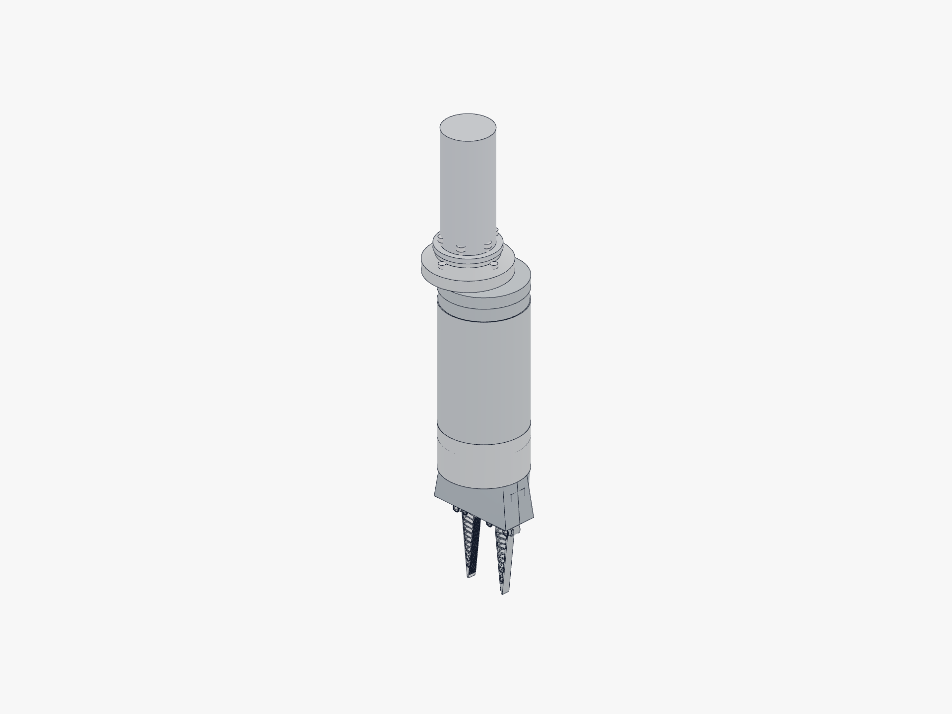
Figure 11.1 Reach Bravo 7 wrist adapter (RB-1054, Ø71 mm plate, 6× M6 + 2× Ø3 dowels). The adapter shown is the Fugro / Woodside reference target.
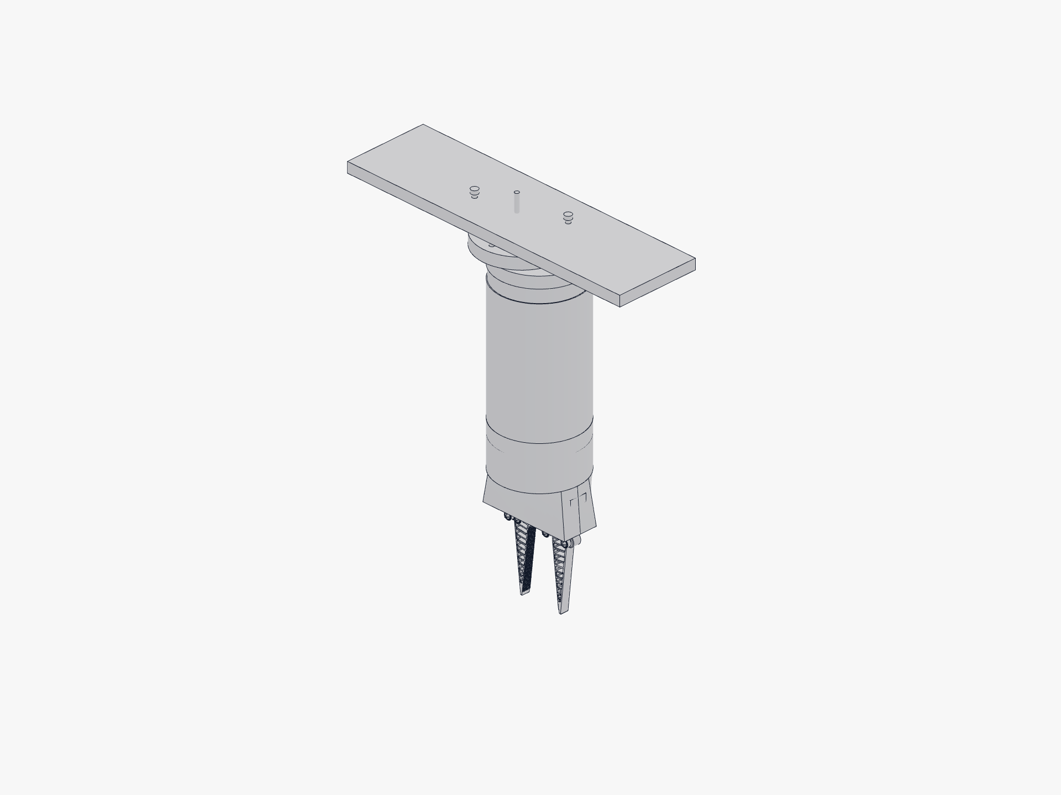
Figure 11.2 BlueROV2 bottom-Newton adapter, modelled to the published BR2 bolt pattern.
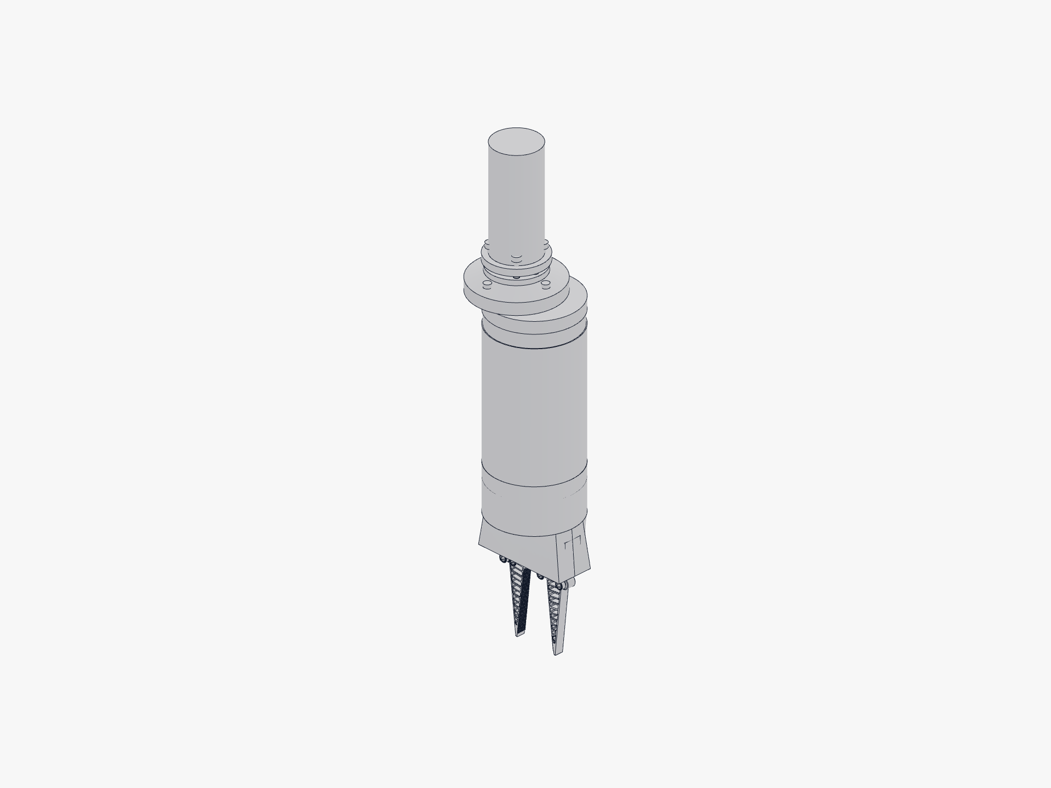
Figure 11.3 ISO 9409-1 Type 50-4-M6 cobot flange adapter. It drops straight into any standard cobot end effector mount.
Adapter | Target | Status
adapter_bravo7 | Reach Bravo 7 RB-1054 wrist | Modelled. Bolt circles are estimates pending NDA dimensions.
adapter_iso9409_50_4_M6 | ISO 9409-1 Type 50-4-M6 cobot flange | P0-ready. Standard published dimensions.
adapter_iso9409_80_6_M8 | ISO 9409-1 Type 80-6-M8 cobot flange | Modelled.
adapter_br2_bottom_newton | BlueROV2 bottom-panel Newton footprint | P0-ready.
adapter_br2_roof_rack | BlueROV2 roof rack | Modelled.
adapter_br2_payload_skid | BlueROV2 payload skid | Modelled.
adapter_iso13628_d_handle | ISO 13628 D-handle override (diver-operable) | Modelled.

Two non-negotiables
- T2 still needs a thin pressure canister, even for the IP68 XW540 (IP68 is rated for 1 m freshwater only; 30 m is 3.1 bar plus seawater corrosion). The flooded gripper itself has no shaft seal and no dry cavity, so the sealing job falls entirely on the actuator.
- The motor current limit must be set to T_safe in firmware. Without it, a strong servo's stall torque shears the printed teeth. The current limit is both the grip-force command and the gear-protection ceiling at once.

13. Testing, validation, and the bench plan
The simulation stack closes in software. The bench plan closes it in hardware. The items below are the explicit gates that move SoftSense from in-software to bench-validated.

Final QA: what we already passed in software
Check | Result | Key numbers
Kinematics monotonic, no dead-point | PASS | base_gap 9.86 to 62.0 mm; tip_gap 9.86 to 123.8 mm; finger_rot 0 to −20.1°; transmission angle 71.7° to 34.6°
Interference across motion | PASS | 0 flagged pairs > 0.5 mm³ at open ∈ {0, .25, .5, .75, 1.0}
Pin vs non-receiving part | PASS | All intersection volumes 0.000 mm³ at open ∈ {0, 0.5, 1.0}
Finger-to-finger at closed pose | PASS | 0.000000 mm³ at open = 0
Retention geometry present | PASS | Counterbore shoulder 1.05 mm + lip catch 0.6 mm; 4 clips, 1.15 mm engage
Manifold (all STLs) | PASS | 9 of 9 watertight, single body, vol > 0, 0 degenerate faces
Walls vs FDM minimum | PASS | All functional walls ≥ 1.0 mm; sub-1.5 mm items all by-design
Vents and flood paths | PASS | 8 bottom + 2 side drains + 4 windows + 4 axle-flood + 3 cover vents; every part single shell
Finger-scale parametric (0.7, 1.0, 1.6) | PASS | Builds clean; mount interface scale-invariant
Assembly order feasibility | PASS | Dowels-before-cover; fingers attach last from above

The bench plan
Test | Pass criterion
Static current-to-force calibration vs load cell | Residual < 0.15 N over 1 to 20 N; blind-set error < 0.3 N
Repeatability (3 cycles) | Hysteresis band < 0.3 N
Slip-onset detection vs the grip object set | Detect slip within 100 ms on 6 of 7 object classes
Thermal re-check (cold bath) | Error < 0.5 N after a 15 °C step
Printed coupon snap-fit (cover clip + finger-pin counterbore) | Insertion strain < material allowable on real material; insertion force tractable by hand
Printed coupon torque-to-failure (crown tooth) | The true T_safe ceiling; bench number replaces the 2D FEA upper bound
7-day soak test (TPU finger, ether-TPU, seawater) | Mass uptake < 2 %; grip-tooth dimensions within ±0.05 mm; no visible biofilm in the channels
Hyperbaric test (PETG body, simulated 30 m) | No visible deformation; pressure sensor reads ambient correctly; pad sensors recover squeeze reading
Cyclic fatigue (finger, 10,000 grip cycles) | No visible crack initiation at rib roots; grip force at 12 N test drops < 10 %
Full-system pool dive (BlueROV2 chassis) | Recover an instrumented test object from a 5 m sand-bottom site without slip or release

Reproduce every simulation
All commands assume the project venv is sourced. Outputs land in fea/iterations/, grip/iterations/, motor/iterations/ (per-run JSON) and grip/pictures/ plus motor/pictures/ (figures).
cd fea/scripts && python eval_finger.py myfinger production '{}' full
cd ../../grip/scripts && python baseline_validate.py # must pass first
python sensitivity.py 1500 # 50 % sensitivity, all families
python texture_fea.py # Tier-2 plane-strain contact FEA
cd ../../motor/scripts && python kinematics_chain.py # torque-force chain + travel
python gear_fea.py # gear-tooth FEA -> T_safe

14. TRL self-assessment and operating boundaries
At Woodside's request we say where SoftSense sits today on the NASA Technology Readiness Level scale and what would move it forward. We also spell out the operating boundaries so a customer knows what we are and aren't promising.

Current TRL position
TRL | Level description | SoftSense status
1 | Basic principles observed and reported. | Done. Pressure feedback principle established.
2 | Technology concept and application formulated. | Done. 4-finger pressure-sensing gripper specified.
3 | Experimental proof of concept. | Done. Working scaled prototype with all four innovations integrated; bench-tested against the 4-object artefact set.
4 | Technology validated in lab. | Partially done. FEA validates fingers and texture; bench plan in §13 closes the remaining gaps. Soak and hyperbaric tests are scheduled before Korea.
5 | Technology validated in relevant environment. | Future. Requires pool dive on a BlueROV2 chassis with a real artefact analog at depth.
6 to 9 | Demonstration, full system, qualified, real-world deployment. | Future.

Where we sit now: TRL 3 to 4. The valley of death (TRL 3 to 7) that Woodside warned us about is the gap we're crossing right now. The bench plan in §13 is how we cross it.

Operating boundaries (1:1 production target)
Parameter | Boundary
Operating depth | 0 to 50 m (T2 actuator + 30 m canister rating) for the shipped configuration; T3 magnetic-coupling pod extends to 200+ m as a future option.
Operating temperature | −2 to +30 °C water temperature (covers WA continental shelf summer and Antarctic Peninsula summer).
Residency time in water | Continuous immersion up to 30 days per the PETG soak-test result; rinse with fresh water between deployments.
Salinity | Full marine (35 ppt) to brackish; fresh water also acceptable.
Payload | 2 to 5 kg per Patrick Morrison's archaeology use case; structural test required to certify above 5 kg.
Grip force per finger | 0.14 to 0.73 N (shipped gears, conservative) or 4.2 to 8.7 N (proposed re-size).
Maintenance interval | Visual inspection every dive; pin replacement annually or after visible creep; finger replacement at 10,000 grip cycles or first visible TPU crack.
Storage | Dry, room temperature, out of direct UV; PETG yellows in sustained sun over months.

15. Test data from the FLL bench set
We tested the scaled prototype against four artefact-analog objects we picked for their range of shapes: a bone, an anchor, a vase, and a treasure chest. The bone and the anchor are both long. The anchor has natural grip features (holes), while the bone has none. The chest and the vase are both stout. The chest has rectangular grooves that are easy to grip, and the vase is smooth with only the head to grab onto.

Results (4 finger vs 2 finger configuration)
Object | Attempts (4 fingers) | Attempts (2 fingers) | Pressure to grip
Bone | 2 | 4 | 26 gf
Anchor | 5 | 4 | 96 gf
Vase | 3 | 5 | 411 gf
Chest | 3 | 3 | 288 gf

Reading the results
The 4-finger configuration beats 2-finger on smooth or round shapes (vase) and on shapes with poor grip features (bone), and it ties on regular-feature shapes (anchor, chest). That's how it goes for soft pads with sensors: when the artefact has natural features for a rigid jaw to bite, you can't really do better than 3 attempts. When the artefact is smooth or featureless, the 4-pad layout wraps it and the 2-jaw layout slips off it. The bone is the clearest example: 2 attempts versus 4.
The pressure values span an order of magnitude, from 26 gf (bone) to 411 gf (vase). That's direct empirical support for the per-artefact preset architecture in innovation 2: a single global pressure threshold would either crush the bone (if set high enough to lift the vase) or fail to lift the vase (if set low enough to spare the bone). Different shapes need different presets, and the per-pad sensor system can deliver them.

16. Expert validation and outreach
SoftSense has been reviewed by working subsea engineers, working archaeologists, and major Australian subsea-industry operators. We list them here because the credibility of the design rests on these people taking it seriously.

Engineering and industry validation
Reviewer | Role | What they validated or contributed
Tim MacDonald | Subsea engineer, Inkfish / DSV Limiting Factor | Confirmed the pressure-sensing innovation is genuine. Materials guidance: 3D printed plastics, avoid titanium. Oil-filled enclosure trick for cheap pressure boundary. Original CF-N12 recommendation, since superseded by our PETG-HF reevaluation. Suggested expert outreach etiquette (calendar invites).
Patrick Morrison | Assistant Curator of Maritime Heritage, WA Shipwrecks Museum | Site visit 14 May 2026. Validated archaeology problem at 50 to 60 m+ depths. Fail-safe (grip on power loss), foam-at-depth concerns, oil-fill or encoder alternatives, wet connects, marine-grade stainless, payload 2 to 5 kg, $1 to 2 K pricing reasonable.
Fiona Stachowiak + Woodside subsea team | Woodside Energy | Engineering review 20 April 2026. CF-N12 water absorption flagged (drove our PETG switch). Magnetic-coupling reference (Advanced Navigation Hydrus). TRL self-assessment ask. Operating-boundaries ask. Innovation filter (novel + value + real problem).
Elaine Pankhurst | Fugro Australia | Meeting 23 April 2026. Confirmed pressure-feedback parallel to Fugro's own ROV valve work. Sponsorship for Korea trip arranged. Docs routed internally to Simon (Fugro ROV manager) and the Fugro tooling team for engineering feedback.
Damien Singh | TMT | SoftSense documentation routed to TMT's CEO 23 April 2026 for engineering feedback.
David Howard | Regionals judge / mentor | Identified ambient-pressure confounder (subtracted in code via second pressure sensor).

Experts emailed during the Nationals round
Dr John McCarthy. Associate Professor Jonathan Benjamin. Chelsea Wiseman. Michael O'Leary (UWA). Jerem Leach. Ingrid Ward. Hiro Yoshida.

Institutions emailed
Australasian Institute for Maritime Archaeology. Minderoo-UWA Deep Sea Research Centre. Western Australian Museum.

Post-Nationals outreach pipeline
Channels we have open, either in flight or scheduled: Australian National Maritime Museum, International Marine Contractors Association (IMCA), Schilling Robotics / TechnipFMC (Titan 4 manufacturer), UWA Engineering (Mechanical, Mechatronics, Oceans Graduate School), Curtin Underwater Sensing and Robotics Lab, CSIRO Oceans and Atmosphere, Australian Institute of Marine Science (AIMS), NOAA Ocean Exploration, OpenROV / Sofar Ocean, Monterey Bay Aquarium Research Institute (MBARI). We picked each one for a specific gap in our knowledge base: industrial gripper failure modes, marine-conservation sample handling, deep-sea exploration practice, or low-cost ROV community engineering.

17. Scaling to artefact size: the 1.5× and 2.0× build
The gripper this document describes is small on purpose. At full open the fingertips part by about 124 millimetres, and the drivetrain delivers well under a newton per finger. That's the right size for the FLL bench and the scaled test objects, but it's too small and too gentle to recover a real amphora, anchor fluke, or ballast stone off the seafloor. Every archaeologist we showed it to asked the same question: can you make it bigger? The answer is yes, and the way we built it means bigger is one parameter, not a redesign.

One parameter, the whole gripper
A single environment variable, GRIPPER_SCALE, multiplies every linear dimension of the model by a factor k. We built and re-simulated two larger sizes from it, 1.5× and 2.0×. The word that matters is self-similar: the linkage, the gears, the finger walls, the enclosure, the input shaft, the mounting flange, and the snap clips all scale together. Because the lengths, the radii, and the wall thicknesses grow by the same factor, every ratio and every angle is preserved. This is true mechanical similitude. We checked it: the finger rotation is identical at −20° at all three sizes, and the jaw opening scales exactly with k.
A few things are held constant on purpose, because they're set by physics or by the printer rather than by the size of the part. The print and running clearances stay at about 0.3 millimetres, because they're governed by the 0.4 mm nozzle, not the part. The fastener sizes stay put. An M4 bolt is an M4 at any scale, and only the positions of the bolt holes move. The flood and drain hole radii are sized by bubble and surface-tension physics, so they hold while their positions scale. And at a scale factor of 1.0 the scaled model reproduces the shipped gripper byte for byte, so the original design is preserved as the reference.

Size and reach
Here's what the two larger sizes actually measure, read straight from the scaled CAD. All parts still fit the 256 mm bed of the Bambu P1S at both sizes.
Quantity | 1.0× | 1.5× | 2.0×
Finger blade length | 90 mm | 135 mm | 180 mm
Jaw opening at the fingertips | 124 mm | 186 mm | 248 mm
Jaw opening at the base | 62 mm | 93 mm | 124 mm
Closed jaw gap | 9.9 mm | 14.8 mm | 19.7 mm
Printed mass (filament, 100 % dense) | ~65 g | ~0.23 kg | ~0.54 kg
Print plates on the 256 mm P1S bed | 3 | 3 | 4

Why the bigger finger actually grips
This is the part that makes the scale-up worth doing rather than just enlarging a drawing. The Fin Ray finger is a compliant blade with thin internal walls. An earlier study scaled the blade on its own and held the wall thicknesses fixed, and it found that above about 1.1× the finger went floppy. The walls were now too thin relative to the bigger blade, so the finger bent instead of squeezing, and its universal grasp score collapsed from 0.65 at 1× to 0.44 at 1.5× and 0.37 at 2×. That's the failure mode this document's earlier finger-scale figures (0.7×, 1.0×, 1.6×) were warning about.
Self-similar scaling fixes exactly that, because the walls scale with the blade. The wall-to-blade stiffness ratio stays constant, so the bigger finger is as stiff relative to its size as the validated 1× finger. On a matched modulus the universal grasp score now holds flat, at 0.63, 0.60, 0.62 across the three sizes, and the finger reaches the 12 N stress-probe at every size. On the softer measured Bambu modulus the score edges up rather than down as the finger grows, because the larger finger develops more absolute grip at the same proportional closure. Either way, the floppy-finger failure of naïve scaling is gone.
We're precise about what this does and doesn't fix. It fixes the under-grip, floppy failure mode, but it doesn't change the conformance ceiling. A passive single-piece finger still can't curl tightly around a small round object at any scale. That's an architecture limit, not a size limit. And the von Mises safety margin dips a little as the finger grows, from about 9× at 1× to about 5× at 2× on flat objects, but it stays comfortably above yield.

Force still follows the gears, not the size
Scaling changes the structural and force numbers by clean power laws, and we confirmed them to three significant figures on the self-similar gear FEA. The gear ceiling T_safe grows with the cube of scale, the deliverable per-finger force grows with the square of scale, the mechanical advantage falls as 1/k, and the gear ratio and efficiency are scale-invariant because the tooth counts and angles are held.
Quantity (and how it scales) | 1.0× | 1.5× | 2.0×
Gear ceiling T_safe (∝ k³) | 0.013 N·m | 0.044 N·m | 0.105 N·m
Per-finger force band (∝ k²) | 0.14–0.28 N | 0.31–0.64 N | 0.55–1.13 N
Smallest servo over-torque vs T_safe | 224× | 67× | 28×
Underwater crush peak vM at 100 m | 12.6 MPa | 12.6 MPa | 12.6 MPa
The reading is honest but bounded. The selected servos still clear the gear ceiling by between 28× and 725× at every size, so the gripper stays gear-limited and the firmware current limit remains its protection, exactly as at 1×. Force grows about four-fold at 2×, but off a sub-newton base, so a 248 mm jaw that can reach around an amphora still only squeezes it with around a newton. If the real need is squeezing strength, scaling is only half the answer. The other half is the proposed gear re-size in §8, which raises T_safe by ten to thirty times independent of size. Combined with 2× scaling it would put the per-finger force into the multi-newton range. That's the next design decision, and we've deliberately left it as a decision rather than folding it in here.

Underwater and grip at the new sizes
The underwater crush result is scale-invariant, which is what similitude predicts. The von Mises field and the material-yield depth don't move with size. Peak von Mises is about 12.6 MPa at 100 m and the through-Z material yields near 177 m at every scale, and only the displacement scales with k. A flooded finger stays at essentially zero von Mises at any size and any practical depth.
The wet grip is more nuanced, and our own re-analysis corrected an over-simple first assumption. The cited-physics core of the grip model, the elastomer-friction and drainage terms, is scale-invariant to within half a percent, because the crosshatch channels grow to 0.81 mm at 1.5× and 1.08 mm at 2.0×, both well above the roughly 0.3 mm where wet drainage saturates. But the full surrogate score softens by about 12 % at 1.5× and 22 % at 2.0×, because the bigger posts mean fewer skin-breaking edges per unit area at a fixed print resolution. That's a real if low-confidence effect rather than an artefact. The ranking and the printability are preserved, and a finer-relative texture could be reintroduced at 2× to recover the edge density if a future build wants it.

What changes when you scale, and what to watch
- Assembly gets stiffer to seat. The snap-pin and cover-clip insertion force scales with the square of scale, roughly 2.25× at 1.5× and about 4× at 2×, even though the bending strain is scale-invariant, so the clips don't over-strain, they just take more push. At 1.5× the parts are still hand-pressable. At 2× expect to need a clamp or a small arbor press to seat the snap pins and click the cover home.
- The mounting interface scales with everything else. The flange bolt pattern and the D-coupler grow with the rest of the gripper, so the seven printed mounting adapters in §12 have to be re-scaled to re-mate. At 2× the flange bolts are worth stepping up from M4 to M5 or M6 for the higher loads.
- The materials and the build sequence don't change. Same PA-class rigid parts, PETG snap pins, and TPU fingers, same orientations, and the input shaft still installs from below, pinion first. A larger gripper is a bigger print, not a different assembly.
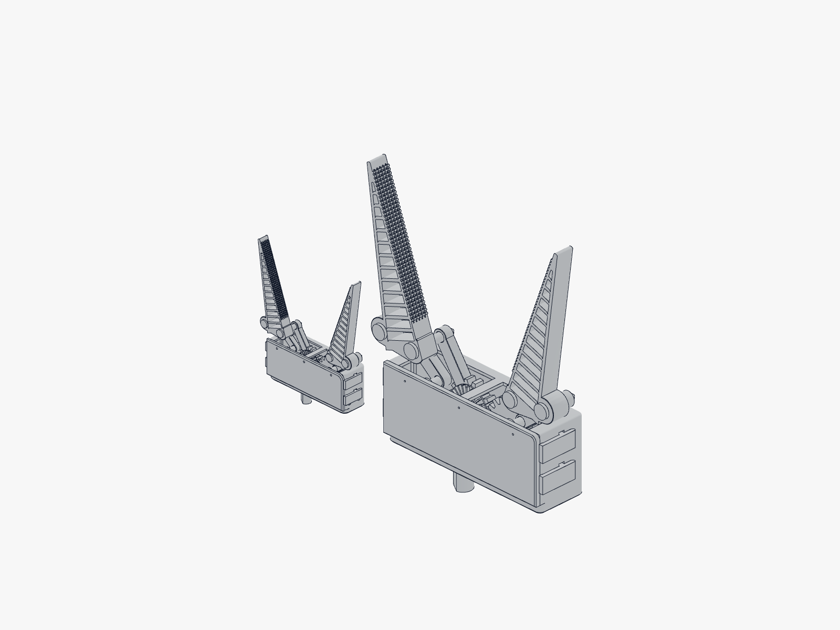
Figure 17.1 The shipped 1× gripper beside the 2.0× self-similar build, both in the open pose. Every linear dimension, including linkage, gears, finger walls, and enclosure, scales by the same factor, so the geometry, the gear timing, and the wrap behaviour are preserved while the jaw opening grows from 124 mm to 248 mm at the fingertips.
One caveat on provenance. These re-runs were done locally at screen fidelity, because the high-resolution simulation node was unavailable for the campaign. The comparative rankings are sound, since the self-similar 1× run reproduces the shipped finger's score, which anchors the comparison, but a publication-grade re-run on the render node is the follow-up, and a fresh blade-only control at the larger sizes would make the stiff-versus-floppy contrast fully airtight. We flag it rather than bury it.

18. What is proven, what is not, and what comes next

Established
- We understand each of the four innovations on its own. The bench test set (bone, anchor, vase, chest) shows the 4-finger plus pressure-sensor setup does better than 2 finger on smooth, featureless objects, and the per-artefact pressure preset makes sense because grip force spreads across an order of magnitude over the test set (26 to 411 gf).
- The Fin Ray finger wraps around things gently and works on a wide range of shapes at the 12 N stress-probe load, with peak stress near 2.7 MPa. That's ten times below TPU strength in both the 2D and 3D FEA. At the operating force the margin works out to roughly 100 to 300 times.
- The crosshatch grip texture is the best tileable, printable, no-speculation choice across the 7-condition wet object battery, and that result holds up under a 50 % coefficient perturbation. Tier-2 FEA backs up the contact-mechanics sub-models and the post-root durability margin (14 to 24 times).
- The ported gripper part builds with zero interference at full closure, at every finger scale (0.7, 1.0, 1.6).
- The drivetrain torque-force chain and the 122.7° travel are exact kinematics. We've documented the actuator selection ranking and how well it holds up under 50 % perturbation across depth tiers, and the actuator class flips with depth: a smart serial servo at T1 and T2, and a magnetic-coupling pod at T3.
- The printed crown-pinion is the structural limit that binds first, at T_safe ≈ 0.013 to 0.034 N·m on the shipped gears. The motor current limit is the firmware-enforced protection for it.
- The gripper is single-shell everywhere, with no enclosed void, so it floods and drains whatever way you hold it. Net buoyancy is gently negative in seawater, so no ballast is needed.
- Self-similar scale-up to 1.5× and 2.0× (§17). One parameter scales the whole gripper. The bigger finger stays stiff because the walls scale with the blade, and the gear ceiling, the tip force, and the mechanical advantage follow clean k³, k², and 1/k power laws. The gripper stays gear-limited at every size. We've established this in software at screen fidelity, and the high-resolution re-run is the open item.

Not established yet (the bench plan closes these)
- Absolute holding force in newtons on real artefacts.
- Absolute depth rating, which the actuator canister sets, not the gripper itself.
- Long-term wet service: TPU swelling, biofilm growth in the grip channels, and edge abrasion.
- Whether the clearance on the proposed gear re-size is buildable inside the current housing envelope.
- Current-to-force calibration accuracy on real hardware. The calibration rig in §7.7 is built, but we haven't validated it against a load cell yet.
- How the pressure sensors respond to hyperbaric pressure at 30 m simulated depth.

The roadmap to Korea Open
- Finish the bench plan (§13): current-to-force calibration, snap-fit coupon, T_safe coupon, soak test, hyperbaric test, and fatigue test.
- Validate the proposed gear re-size in CAD (CROWN_RC 11, module 1.83, 12/6 teeth, face 8) and re-run check_drivetrain.py. If it clears, we ship it. The per-finger force band rises from 0.35 to 0.73 N up to 4.2 to 8.7 N.
- Do a pool dive on a BlueROV2 chassis with the BR2 bottom-Newton adapter. Recover an instrumented test artefact from a 5 m sand-bottom site.
- Korea Open Invitational, Seoul, July 2026. We'll present SoftSense, the simulation campaign behind it, and the bench-validated calibration curve from the actuator-as-sensor work.
- Re-run the scale-up at full resolution and pick a deployment size. Repeat the 1.5× and 2.0× FEA on the render node with a fresh blade-only control, then settle on a production size with the proposed gear re-size folded in, so reach and squeezing strength get decided together.
We converged the design in software first, with validated models and explicit notes on fidelity, instead of printing and iterating blindly. Then we wrote down what we don't yet know.

19. Sources and citation provenance
Every coefficient and ordering in this report traces back to a published source or a reproducible simulation. Here's the literature behind the grip-texture model:
- Persson (2001). Rubber friction and wet skid: the framework for elastomer friction on a contaminated surface.
- Briscoe and Tabor (1978). Interfacial shear of polymers. τ = τ₀ + α·p; sources for TAU0 and ALPHA in the model.
- Barnes, Federle, Drotlef (2006 to 2013). Tree-frog hexagonal wet adhesion; the precedent for the hexpad ordering.
- Tramacere and Baik (2013 to 2017). Octopus sucker wet attachment; the concentric reference μ.
- Pneumatic tyre tread drainage literature for the MU_FILM wet-skid floor and the squeeze-film drainage ordering.
- Bayer / Covestro Snap-Fit Joints for Plastics: the cantilever surface-strain model ε = 3·t·δ / (2·L²) and the one-time-assembly allowables.
- Bambu TPU 95A HF Technical Data Sheet V1.0: ISO 527 printed-specimen Young’s modulus 9.8 / 7.4 MPa and tensile strength 27.3 / 22.3 MPa (in-plane / through-Z), elongation above 650 %, density 1.22, water absorption 1.08 %, nozzle 220 to 240 °C, bed 30 to 35 °C, dry 70 °C for 8 h, and max volumetric flow about 12 mm³/s.
- Bambu Studio profile schema (github.com/bambulab/BambuStudio): Generic TPU and 0.20 mm Standard @BBL X1C base profiles; P1S machine profile.
- Blue Robotics product catalogue for the acrylic locking tube canister BOM (around USD 130 assembled).
- ROBOTIS DYNAMIXEL XW540-T260-R and XM540-W270-R datasheets.
- Feetech STS3250 and STS3215 datasheets.
- ISO 9409-1 Type 50-4-M6 and 80-6-M8 mechanical interfaces for cobot end effectors.

Subsea industry and archaeology literature
- Sivčev et al. (2018a) and Sivčev et al. (2018, Underwater manipulators: a review).
- Antonelli (2014). Underwater Robots.
- Petillot et al. (2019). Underwater robots: from remotely operated vehicles to intervention-autonomous underwater vehicles.
- Bogue (2015). Underwater robots: a review.
- Schilling Robotics Titan 4 manipulator damage and risk study (ScienceDirect 2023).

Software and tooling
- build123d 0.10.0 (parametric CAD): the source of truth for every dimension in this document.
- gmsh 4.x for triangle meshing of the 2D and 3D finger cross-sections.
- scikit-fem for the 2D plane-strain finite-strain precursor.
- NumPy / SciPy for sparse direct solvers (scipy.sparse.linalg.spsolve).
- CuPy / CUDA for the GPU mirror of the 3D corotational solve (numerically identical results).
- trimesh 4.12.2 for STL audit (watertight, winding, body count, volume, and degenerate-face check).
- Bambu Studio for the P1S print profiles (filament + process), importable from profiles/.

Public-facing documentation
- Team site: lebob.com.au
- Robot mission code: github.com/prawny-boy/FLL-Lebob-Unearthed
- Onshape CAD: cad.onshape.com/documents/47a3be0d6a2fdc65e8e54697 (live, with every revision logged)

