1. **Project Description**

Project is a web page to manage walk-in clinic activities. Features described below:

**Enable features based on login privileges:** There are two levels of privileges. “Administrator” can access all the functionalities in the system, including “Add User”, “Remove User” and “Profit”. Employees are divided into three groups (“Doctor”, “Secretary” and “Other”), and have access only to functionalities related to patients and agenda. User login is the email address.

**Include new patients:** All users can add new patients. All the fields are mandatory, if one field is missing or with wrong input, a message is showed to the user above the wrong field. The correct fields will keep the value. Email is unique and different users can not have the same email.

The follow rules are used for validation:

* “First Name”, “Last Name”, and “City” are text fields that allow only 30 characters.
* “Email” accepts 50 characters and must be a valid email address and cannot be duplicated in system.
* “Phone Number” allows only numbers and cannot be bigger than 15 characters.
* “Address” is a text field that allows 100 characters.
* “Zip code” is a text field that allows 10 characters.

**Update and visualize patients:** show all patients in a table. This feature allow user to search for a patient by the last name or retrieve all patients. “Edit” action is used to update a patient information following the same fields rules for add new patient.

**Include new users:** Only administrators can use this functionality. All fields are mandatory, and the email address will be used as user login. It is not allowed to a user have the same email address than other. “Permission level” just have two values: “Administrator” that have all access in system, and “Employee” that have only access in patient and agenda functionalities. “Description” field is used to identify the type of employee, this is used in new appointment functionality.

The follow rules are used for validation:

* “First Name” and “Last Name” are text fields that allow only 30 characters.
* “Email” accepts 50 characters and must be a valid email address and cannot be duplicated in system.
* “Password” allows only 20 characters.

**Update and visualize users:** Only administrators can use this functionality. This is similar to patient functionality. User can modify information about users in “Edit” action link, but email and password are not allowed to change. All the fields follow the same rules from add new user functionality. Search filter is based on user`s function.

**Agenda:** functionality that shows all appointments. Two actions are allowed to execute, “Confirm” that confirms the appointment and only this will be showed in “Profit” page. “Cancel” action cancels the appointment and keep in database but will not showed in “Profit” page. Filter is based on appointment date. “All” button shows all registers without filter.

**Include new appointments:** Allow all users create an appointment. This functionality uses all the tables to populate form fields. All patients in databased is listed in patient combo box, and the same rule is applied for doctors and exams combo box. Only doctors are listed on doctor combo box. Just one exam is allowed to be included in each appointment. For more exams, need to include more entries in the same day.

**Profit:** Only accessible by administrator. Show all the exams that is in “Confirmed” status and sum up all the values of each exam to give a total amount. User can search for specific periods including a begin and an end date. “All” button remove filter.

Web pages was developed using HTML, CSS, and PHP.

The folder structure is divided in “Entity” (Entity files), “View” (web pages pages), “Utility” that contains “Model” (DAOs), “Session” (Session Manager), and “Validator” (Files to validate inputs from user). “**TeamNumber05.php**” is the main page that contains login page. Controllers are located outside of “inc” folder.

Script to create and populate initial database is located inside the folder “sql”. This script will create 4 tables (Patient, User, ServiceType and Exam). Database name is **projectAPi47025**.

Script contains initial users, and all the user and password is located above each user. For administrator login the username is [**douglascollege@college.com**](mailto:douglascollege@college.com)and password is **douglascollege**.

1. **Class Diagram**

1. **Meeting minutes**

Not applicable

1. **User Manual**

**1 -** In login page user need to enter with your username(email) and password. If the input is wrong, a message appears.

**2 -** For administrator all the options in left panel will appears. For other users, only functionalities related to agenda and patient will be showed.

**3 –** “Patient” functionality shows all the patients in the database. Search filter is based in the last name of patient. To remove the serach filter use “All” button. Use “Edit” action to edit patient information.

**4 –** To add new patient use “New Patient” functionality. Email must be unique.

**5 –** “Agenda” functionality shows all the appointments with information about patient, doctor, exam, date and status. A new appointment is created in “Open” status, and user need to confirm or cancel the appointment. Search filter is based on date. To clean search, user need to use “All” button.

**6 –** To add new appointment use “New Appointment” functionality. Selecting doctor, patient, exam and date.

**7 -** “User” functionality shows all the users in the database. Search filter is based in the function. To remove the search filter use “All” button. Use “Edit” action to edit user information. Email and password is not allowed to edit.

**8 -** To add new user use “New User” functionality. Email must be unique. Administrator level will allow user to access all the functionalities. For restrict functionalities user should be select in permission level as “Employee”.

**9 –** “Profit” functionality shows all the exams that are in “Confirmed” status and sum up all the values giving a total amount to the user. Filter is based on date begin and date end. To clean search filter use “All” button.

**10 –** Logout redirects user to the login page.

All the pages are bellow as reference (check numbers in pages and in description above).

**

**2**

**3**

**4**

**5**

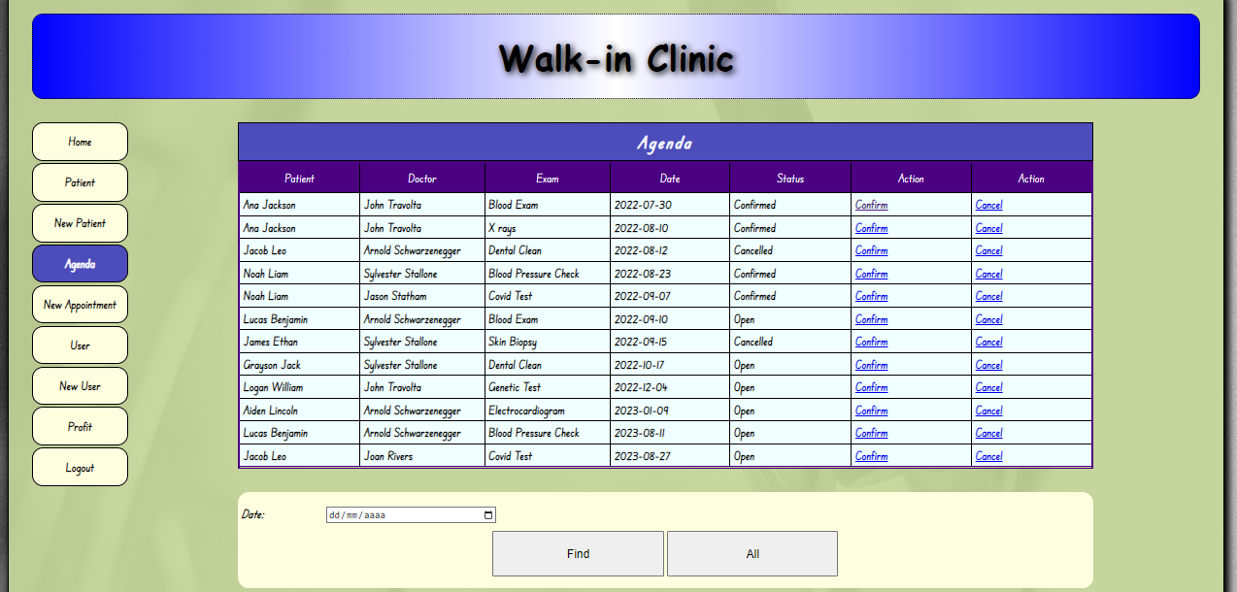

**6**

**7**

**8**

**9**

