**Andre Piccolo**

**Multimedia Web Development**

**CSIS 1280 – 004**

**Final Project**

1. **Title of the Project**

Kids 4 Fun Playground.

1. **Brief Description of the Project**

An indoor playground website that you can get information of indoor playground with photos and videos. Make reservations for parties. Check schedules in a calendar. Calculate prices based on type of party (Economic package, Classic Package, Premium Package). Contact indoor playground in different channels.

1. **Sitemap**

1. **Wireframe/Structure of each web page**

“Home” page only has some information about the indoor playground

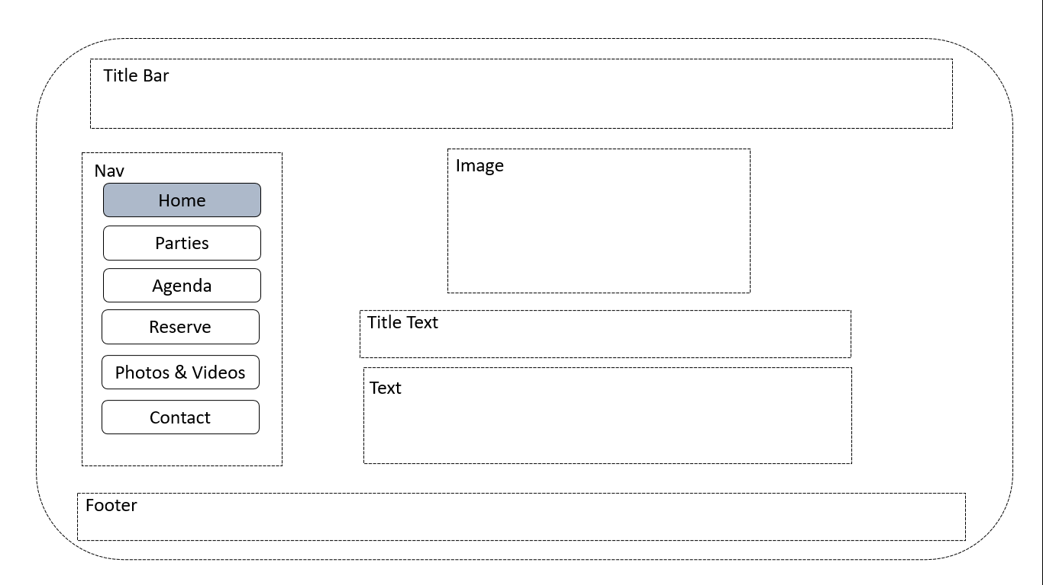

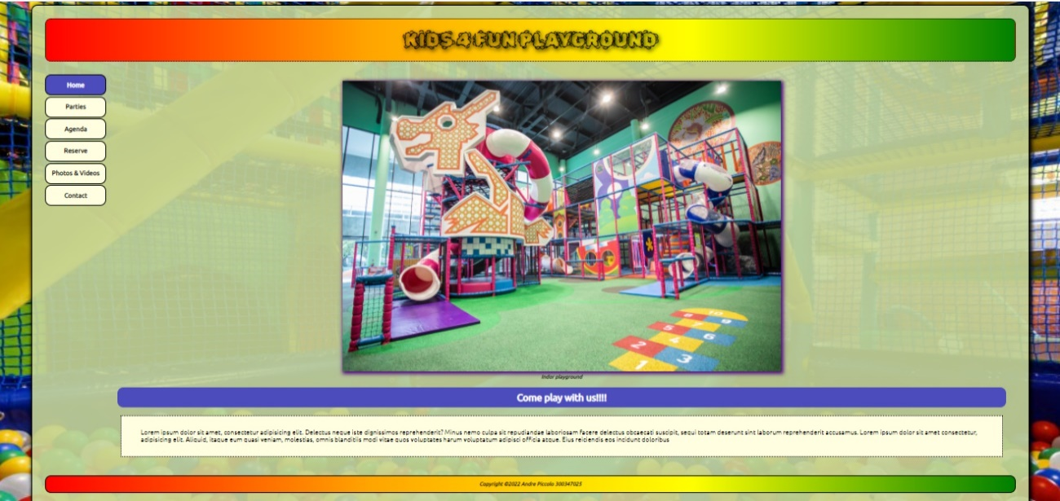

“Parties” page shows all the party options and user can calculate each value based on the number of guests

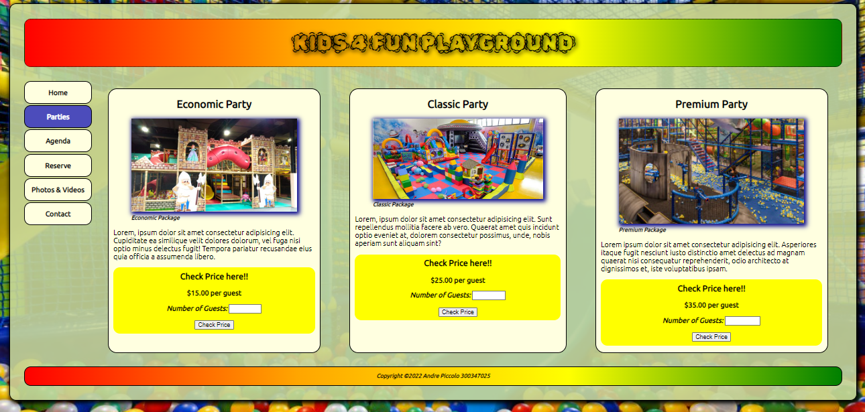

If the button “Check the price” is pressed without a number of guest or smaller than 0, an alert will be shown

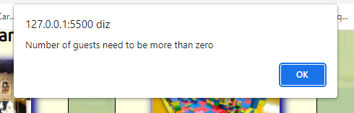

If number of guests is valid, an alert shows the total price with the type of selected party

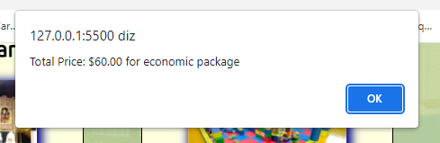

“Agenda” page shows the reserved parties during a selected period. The reserved date will be shown in yellow with the first name and last name of the user. It is allowed to see any previous or advanced month.

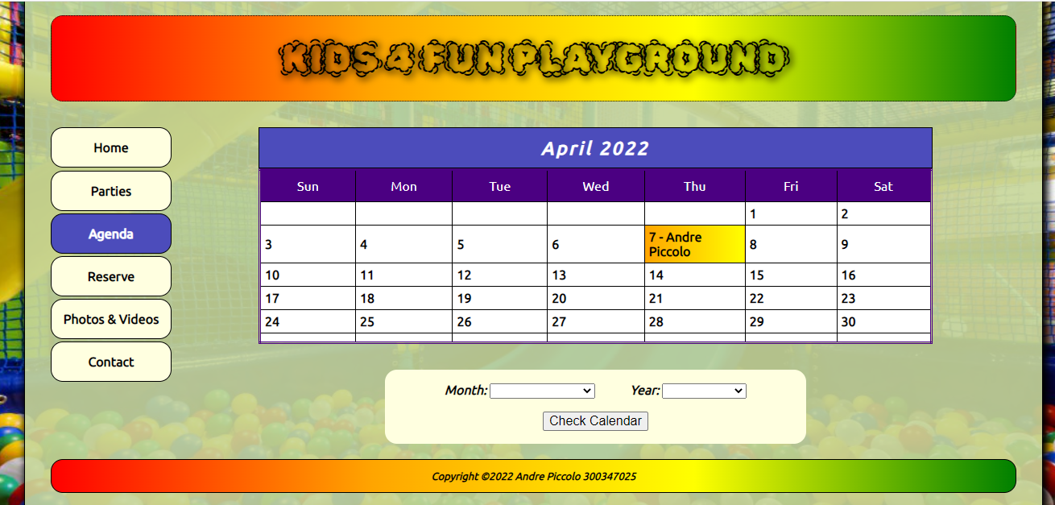

“Reserve” page allow user to make a reservation for a party, all the information is required, except “comment” field. If user try to reserve a date that was reserved for other user, an alert will be shown to inform that specified date is not available, only one party is allowed per day. If date is before or the same than the current day, an alert is shown to inform the user that just future dates are allowed. If all the conditions are ok, an alert will inform user about the reserve success.

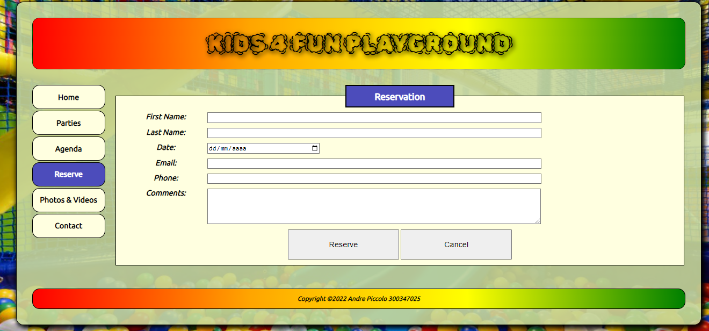

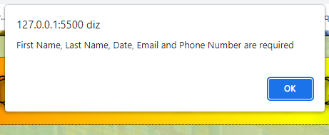

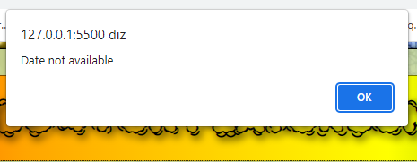

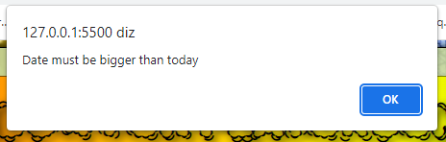

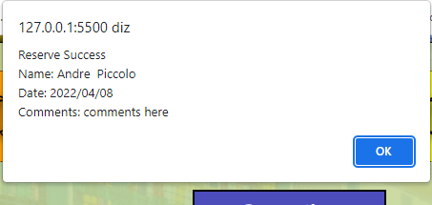

“Photos & Videos” page just show some pictures and videos from the indoor playground like a gallery.

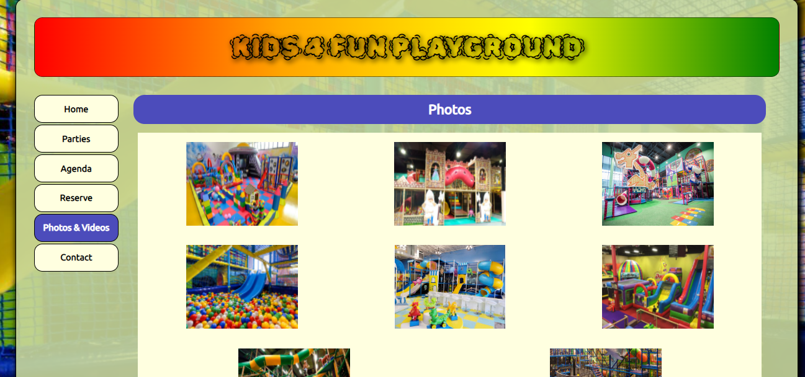

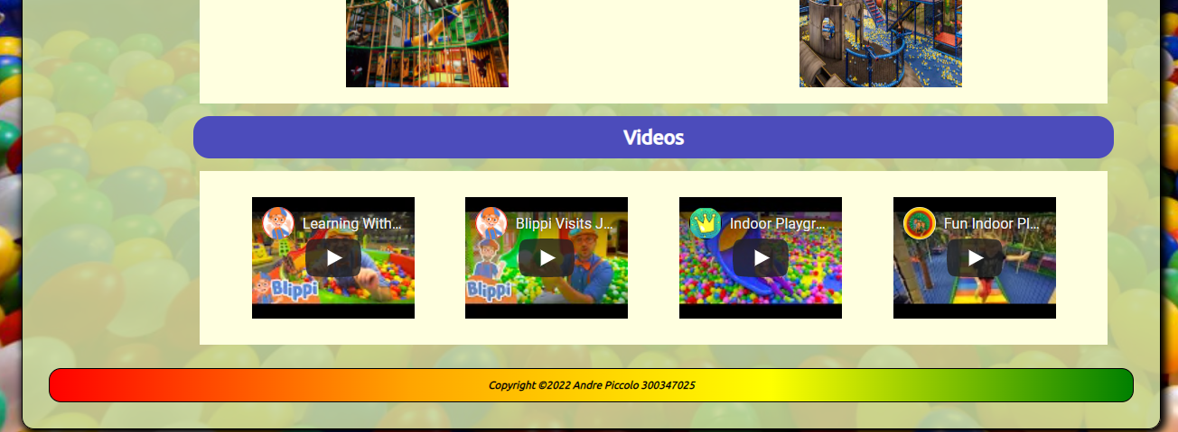

“Contact” page redirects all types of contacts allowed. “Call us” tries to call to a phone number. “Email us” tries to open an email tool to send the email. “Visit us” opens a new window in google maps showing localization.

