## Task.

1)Create database from nation.sql script

2)Using the data from nation database create the table ‘countryRank’ that will display

Ranking of countries by its area from largest to smallest. Ranking shold be calculated for regions and continent.

a)National holiday field shouldn’t contain NULL values, put ‘no data insead’

b)If notional holiday contains the date in future it should be changed to current date

c)Get rid of the duplicates

Provide sql scrpits and screenshots as evidence.

3)Answer the question – what can be done on a database level to avoid problems with duplicates and Null values?

The expected result should look like this.

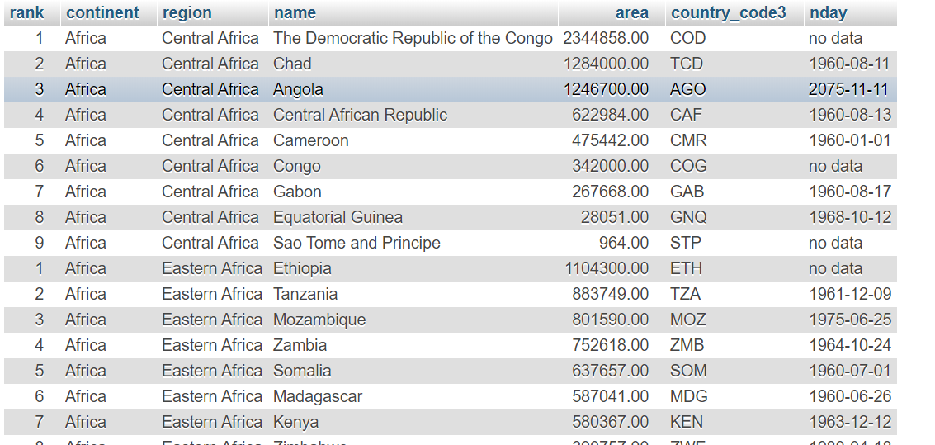

**CREATE** **OR** **REPLACE** **TABLE** countryRank

**SELECT**

**RANK** () **OVER**(**PARTITION** **BY** r.region_id, c2.continent_id **ORDER** **BY** area **DESC**) **as** **rank**,

c2.name **as** continent, r.name **as** region,c.name , c.area ,c.country_code3 , **CAST**(c.national_day **as** **VARCHAR**(10)) **as** nday

**FROM** countries c

**JOIN** regions r **ON** c.region_id = r.region_id

**JOIN** continents c2 **ON** r.continent_id = c2.continent_id

**ORDER** **BY** c2.name , r.name , **rank**;

**UPDATE** countryRank

**SET** nday = 'no data'

**WHERE** nday **IS** **NULL**;

**UPDATE** countryRank

**SET** nday = **CAST**(**CURDATE**() **as** **VARCHAR**(10))

**WHERE** nday >= **CAST**(**CURDATE**() **as** **VARCHAR**(10));

**ALTER** **IGNORE** **TABLE** countryRank **ADD** **UNIQUE** **INDEX**(`name`);

**ALTER** **TABLE** nation.countryRank **MODIFY** **COLUMN** nday **varchar**(10) **DEFAULT** 'no data' **NOT** **NULL**;

**SELECT** *

**FROM** countryRank cr;

-2-

**CREATE OR REPLACE TABLE countryRank**

**SELECT**

**RANK () OVER(PARTITION BY r.region_id, c2.continent_id ORDER BY area DESC) as rank,**

**c2.name as continent, r.name as region,c.name , c.area ,c.country_code3 , CAST(c.national_day as VARCHAR(10)) as nday**

**FROM countries c**

**JOIN regions r ON c.region_id = r.region_id**

**JOIN continents c2 ON r.continent_id = c2.continent_id**

**ORDER BY c2.name , r.name , rank**

-a-

**UPDATE countryRank**

**SET nday = 'no data'**

**WHERE nday IS NULL**

-b-

**UPDATE countryRank**

**SET nday = CAST(CURDATE() as VARCHAR(10))**

**WHERE nday >= CAST(CURDATE() as VARCHAR(10));**

-c-

**ALTER IGNORE TABLE countryRank ADD UNIQUE INDEX(`name`);**

-3-

To avoid problems with duplicates we can set UNIQUE constraint or create a UNIQUE INDEX

To avoid problems with NULL values we should set NOT NULL constraint