Operating System Concepts

Mini Project 1

Andre Ripley

|  |  |  |  |  |
| --- | --- | --- | --- | --- |
| Participants name | Code section | Report Section | Documentation Sec | Presentation Sec |
| Andre Ripley | 100% | 100% | 100% | 100% |

To track the amount of syscalls made while xv6 is running, changes were made to syscall.h, syscall.c, sysfunc.h, user.h, usys.S, sys.proc.c, makefile, and user.h. All these files were modified slightly by adding howmanysys to each file. This allowed the howmanysys.c to call howmanysys()(the system call). One file was created howmanysys.c to return and validate how many syscalls were made.

File created

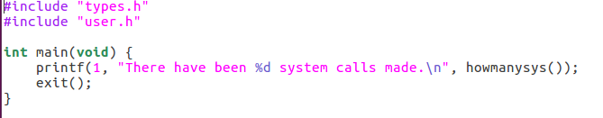

howmanysys.c

The first thing to implement was the driver function. This allowed to test if the syscall would work or not and if it did print out how many syscalls there are.

Files Modified

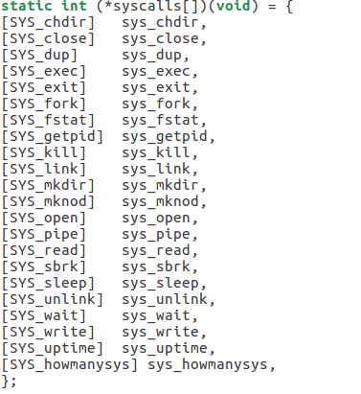

syscall.c

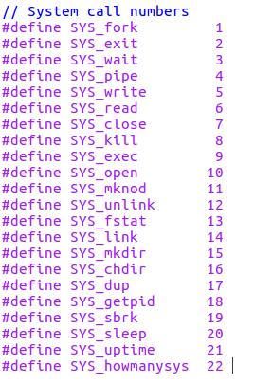

syscall.h

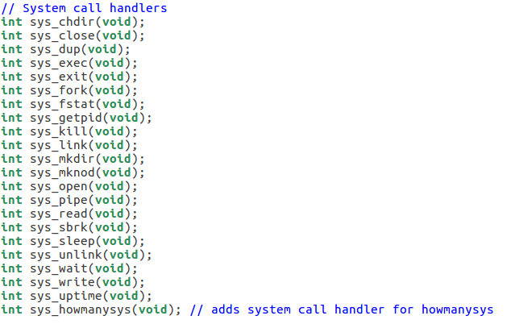

sysfunc.h

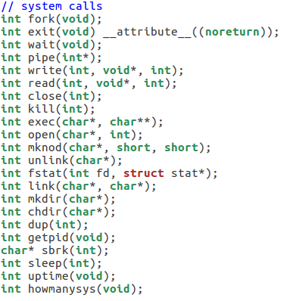

user.h

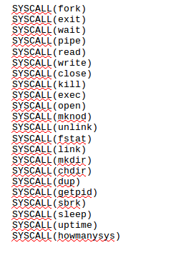

usys.S

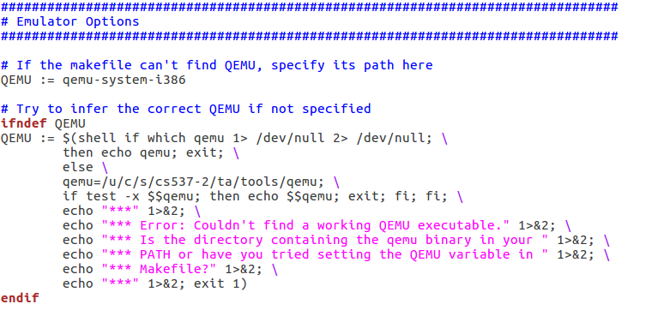

The makefile had to be updated by adding QEMU:= qemu-system-i1386

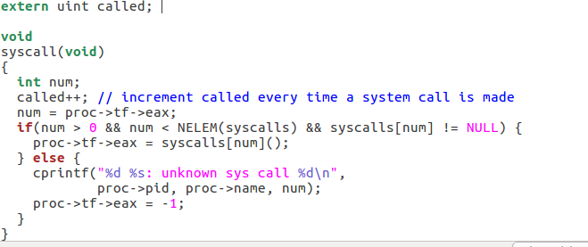

syscall.c

Syscall.c was modified again to increment every time a system call was made. This will will give us the appropriate value of the system calls.

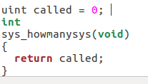

sysproc.c

Sysproc.c initializes the called so every time the called is incremented from syscall.c it will return the value of called.

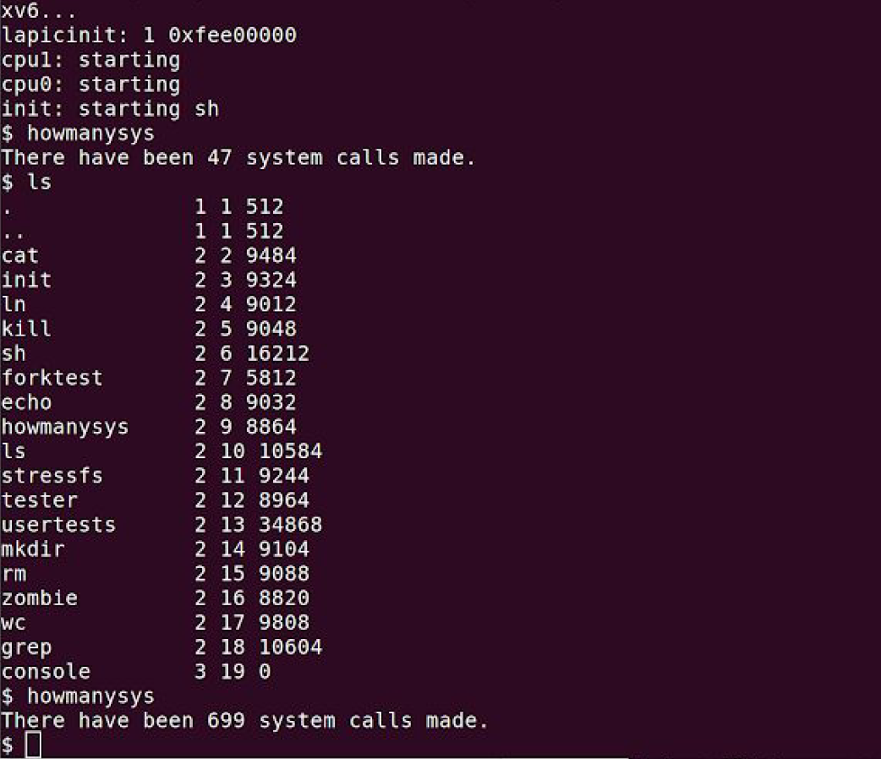

Output

As you can see after going into the xv6 folder and typing “make qemu” and then “howmanysys” it shows the number of system calls made.

Conclusion:

Working with xv6 was a bit of a task to create syscalls. It was a lot of trial and error to get it to compile. I had a hard time considering I was running it Ubuntu on a jetson because performance on my VM was incredibly low. I took me some time to realize I didn’t install qemu and that was causing most of the problems as well as adding a handler in sysfunc.h. Not adding the handler returned compile problems for howmanysys(). In the end after those issues were resolved it compiled and ran smoothly outputting the number of system calls made.