Operating System Concepts

COP4610.02

Mini Project 3

Noah Baldwin

Cody Carroll

Paul Teleweck

**Work Breakdown:**

|  |  |  |  |  |
| --- | --- | --- | --- | --- |
| **Names** | **Code** | **Report** | **Documentation** | **Presentation** |
| Noah Baldwin | 33.33% | 33.33% | 33.33% | 33.3% |
| Cody Carroll | 33.33% | 33.33% | 33.33% | 33.3% |
| Paul Teleweck | 33.33% | 33.33% | 33.33% | 33.3% |

**Abstract:**

In this project, you'll be changing xv6 to support a feature virtually every modern OS does: causing an exception to occur when your program dereferences a null pointer. The goals of the project are as follows:

* To familiarize you with the xv6 virtual memory system.
* To add a few new Virtual Memory (VM) features to xv6 that are common in modern OSs.

**Changes made:**

**vm.c**

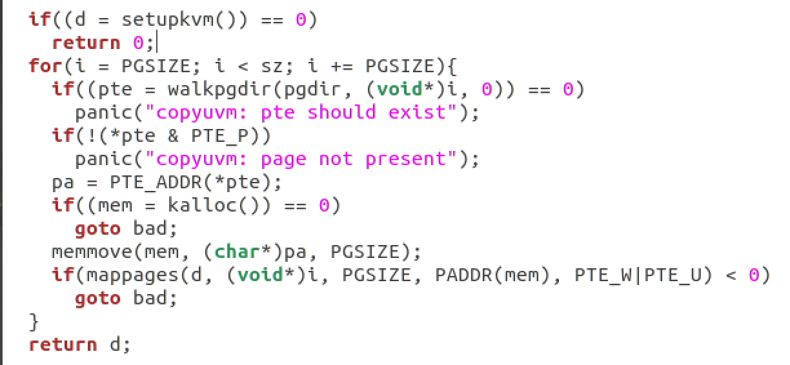

The for loop was initially i=0 and we changed this loop to equal PGSIZE. This forces program to start on the next available page.

**exec.c**

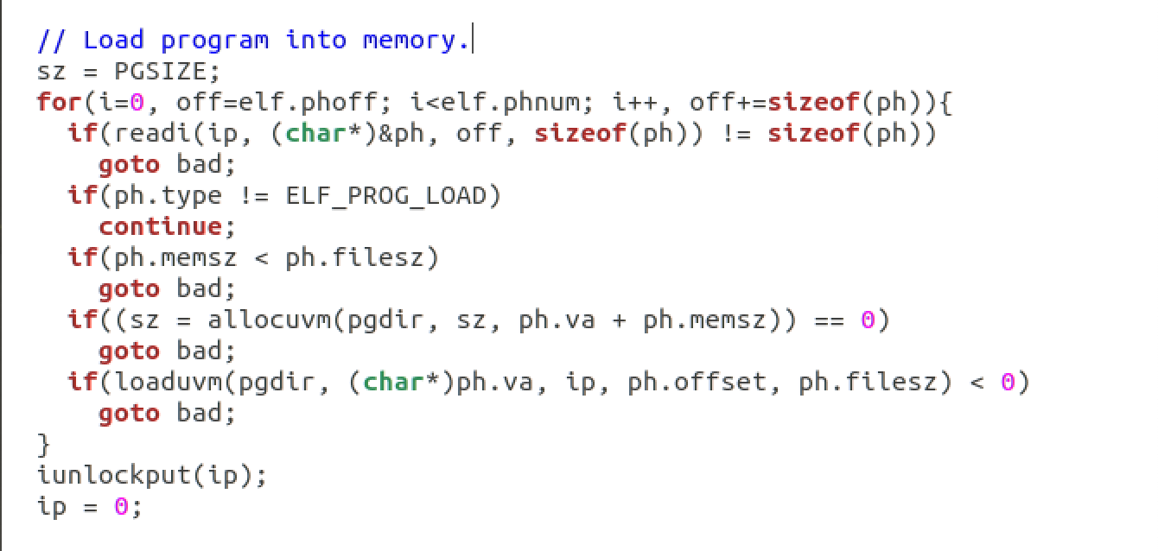

Changed sz = 0 to sz = PGSIZE. Setting size to allocuvm, sz corresponds to the current location. Ph.va + ph.memsz corresponds to the expected location.

**syscall.c**

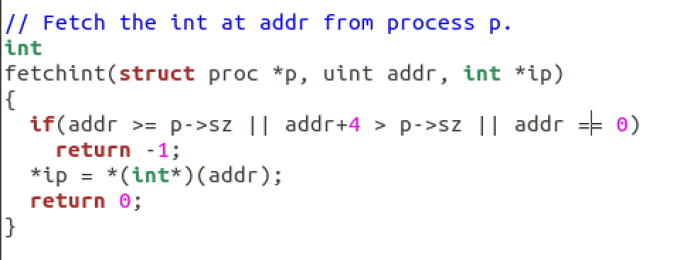

Within syscall.c we added piping to set the address == 0 initially.

**makefile.mk**

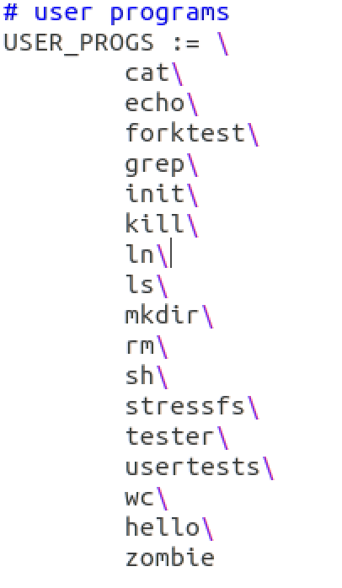

Added user program “hello”

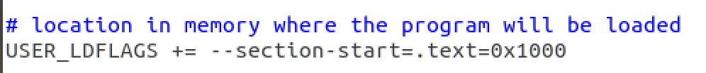

Change text section start from 0 to 4096 (1000 in hex)

Setting the address to 0x1000 makes the program start on a different page (not 0).

**hello.c**

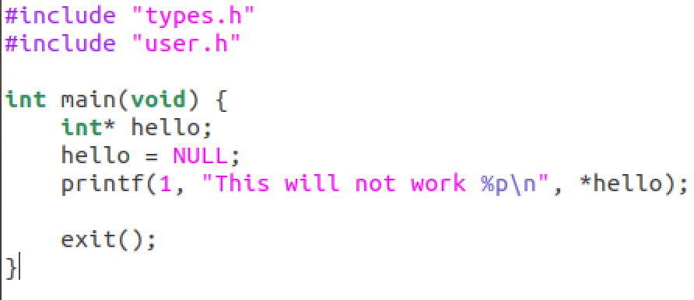

Created a user program that adds a pointer for the system call.

**Output**

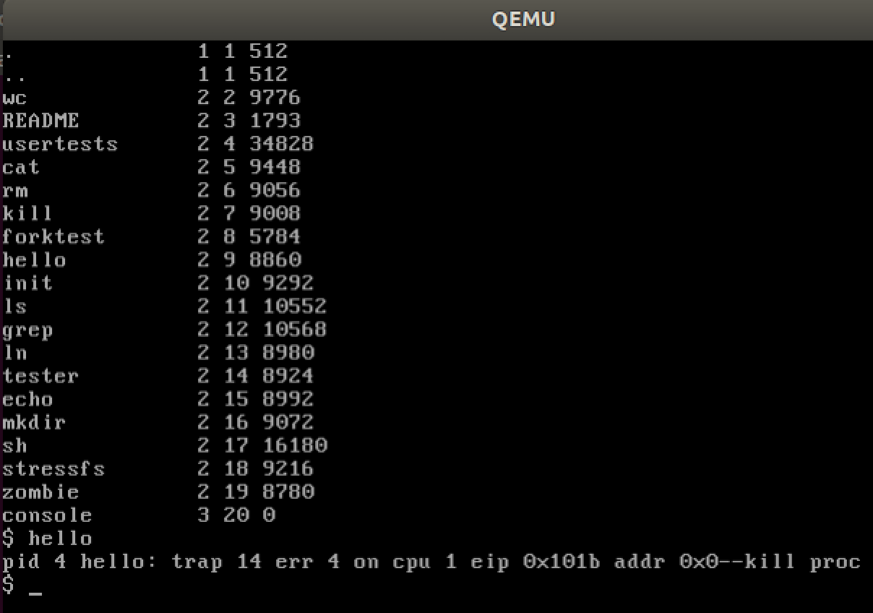

Causes an error because we are attempting to access a location that does not exist (De-referencing a NULL pointer).