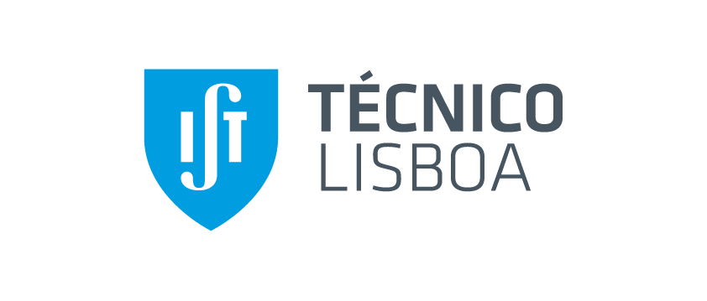
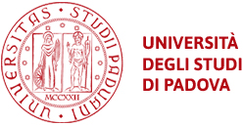

UNIVERSIDADE DE LISBOA

INSTITUTO SUPERIOR TÉCNICO

Università degli Studi di Padova
Joint European Research Doctorate in Fusion Science and Engineering

A software architecture for data acquisition, process and storage

André Sancho Cabral Guilhoto do Vale Duarte

Supervisor: Doctor Bernardo Brotas de Carvalho

Thesis specifically prepared to obtain the PhD Degree in
Technological Physics Engineering

Draft

June 2016

