CHEM 123 Lecture Notes – 1

# Energy and Thermochemistry

## Energy

* **Energy $E$** : the capacity to do work
  + **Work** is done when motion occurs against a force
  + A reaction that gives out E and heats its surroundings is **exothermic**
  + A reaction that takes E and cools its surroundings is **endothermic**
* **Internal energy $U$** : total kinetic + potential energy in the system
  + **Kinetic energy $E_{k}$** : energy of a system from its motion
  + **Potential energy $E_{p}$** : energy of a system from its position/configuration

## Systems

* **Open system**: matter and energy can be exchanged with surroundings
* **Closed system**: fixed matter, energy can be exchanged
* **Isolated system**: no matter or energy can be exchanged
* **Diathermic**: boundary permits heat to be transferred between system and surroundings
* **Adiabatic**: boundary does not permit heat to be transferred between system and surroundings

## Heat

* **Heat**: energy transferred between system and its surroundings as a result of a temperature change
  + **Heat capacity $C$** : quantity of heat required to change temperature of system by one degree (Celsius or Kelvin)
  + **Molar heat capacity $\overline{C}$** : quantity of heat required to change temperature of one mole of a substance by one degree
  + **Specific heat capacity $c$** : quantity of heat required to change temperature of one gram of a substance by one degree
* For pure substances, the **quantity of heat $q$** :

$$q=m×c×∆T=C×∆T$$

$C (heat capacity)=m (mass)×c (specific heat capacity)$

### Law of Conservation of Energy

$$q_{system}+q_{surroundings}=0$$

## Heats of Reaction (Calorimetry)

$$q_{r}+q_{calorimeter}=0→q_{r}=-q_{calorimeter}$$

* $q_{r}<0$– reaction is **exothermic**
* $q_{r}>0$– reaction is **endothermic**
* An **enthalpy change $∆H$** is the energy E transferred at constant pressure P
* Energy may also be transferred as a result of work $w$– pressure in atm, volume in L
$$w=-P×∆V$$

* A system loses energy (w < 0) when:
  + It does work
  + It transfers heat to surroundings (exothermic)
* A system gains energy (w > 0) when:
  + Work is done on it
  + It gains heat from surroundings (endothermic)

### First Law of Thermodynamics

* The **internal energy** of an isolated system is constant: $∆U_{isolated}=0$
* For a closed system, $∆U=q+w$ (where $w=-P×∆V$)
  + For a reaction at constant volume, $∆V=0,$ hence $∆U=q_{v}$
  + For a reaction at constant pressure, $$∆U=q_{p}+w=q_{p}-P×∆V$$
 $$q_{p}=∆U+P×∆V=∆H$$

 + For systems containing no gases, $∆U≈∆H$
  + When ideal gases are involved ( $PV=∆n_{gas}RT$),
$$∆H=∆U+∆n_{gas}RT$$

* The value of $∆H$ depends on temperature, pressure, and physical state of components

E.g. $∆_{r}H_{298}^{°}$ = heat of reaction under standard conditions ($P=1 bar=100 kPa$, pure components at concentration of 1 mol/L) at 298 K

* + follows stoichiometric coefficients (e.g. of coefficients halved, $∆H$ halved)
  + $∆H$ changes sign when a reaction is reversed

### Hess’s Law of Constant Heat Summation

For a process that occurs in steps, $∆_{overall}H=∑∆_{individual step}H$

Heat of reaction is equal to the heat of formation of its products minus that of its reactants:

$$∆_{r}H^{°}=∑v_{P}∆_{f}H^{°}\left(products\right)-∑v_{R}∆_{f}H^{°}\left(reactants\right)$$

* $v$ is the stoichiometric coefficient

# States of Matter and Phase Changes

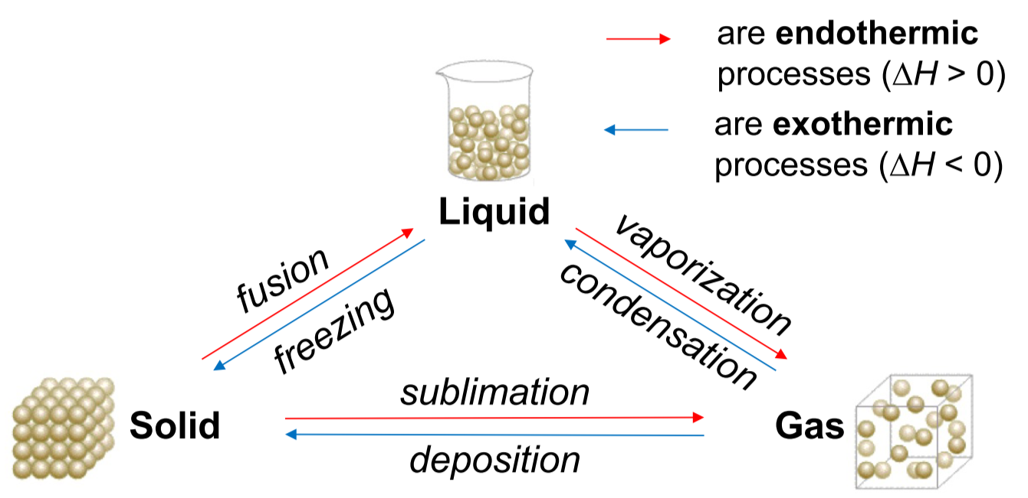



$∆_{fus}H^{°}=-∆_{freezing}H^{°}$

$∆_{vap}H^{°}=-∆_{cond}H^{°}$

$∆_{sub}H^{°}=-∆_{deposition}H^{°}=∆_{fus}H^{°}+∆_{vap}H^{°}$

### Clausius-Clapeyron Equation

Relates the heat of vaporization of a substance at two different pressures and temperatures

$$\ln{\frac{P_{2}}{P_{1}}}=-\frac{∆_{vap}H^{°}}{R}\left(\frac{1}{T_{2}}-\frac{1}{T_{1}}\right)$$

* To find the **boiling point**, set $P=P_{ext}$
* If $P_{ext}=1 atm (760 Torr)$, $T$ is the **normal boiling point**

# Intermolecular Forces

The types of intermolecular forces are:

* **London dispersion forces** (instantaneous dipole-induced dipole forces)
* **Dipole-dipole** **interactions**
* **Hydrogen bonds**
* Polar compounds: molecular dipole moment $μ≠0$
* Non-polar compounds: molecular dipole moment $μ=0$

Important factors:

* Polar bonds (covalent bonds between atoms with unequal electronegativity)
* Molecular shape (linear, bent, pyramidal, tetrahedral)
* Unshared valence electrons

### London Dispersion Forces

* Exists in all molecules; compounds with greater molecular mass have greater LDF
* Temporary dipoles due to uneven distribution of electrons, as they are constantly moving
* Polarizability (ability of electron cloud to be distorted) is very important
  + Depends on number of electrons and molecular shape
* As electron cloud charge $↑$, LDF $↑$
* For molecules with same molecular mass, elongation $↑$, LDF $↑$

### Dipole-Dipole Interactions

* Only exists in polar molecules ($μ≠0)$
* Dipoles tend to line up head-to-tail, with positive end of one molecule directed to negative end of neighbouring molecule
* Stronger intermolecular attraction = stronger dipole-dipole

### Hydrogen Bonds

* Very strong dipole-dipole interaction between molecules containing H and N, O, or F

As intermolecular interactions $↑$:

* Surface tension, viscosity, boiling point, melting point $↑$
* Vapor pressure $↓$

The **solubility** of ionic solids $↑$ as ionic bond strength $↓$, aka as **charge $↓$** and **molecular mass $↑$**

# Entropy and Gibbs Energy

* **Entropy $S$** : the amount of dispersal of matter and energy in a system
  + $S$ measures the randomness/disorder in a system
  + As the energy $E$ of a system increases, the entropy $S$ of the system will increase because there are more microstates
* The more **degrees of freedom** (DOF, translational/rotational/vibrational motions) there are, the greater $S$ is
  + DOF increases as **molecular complexity increases**

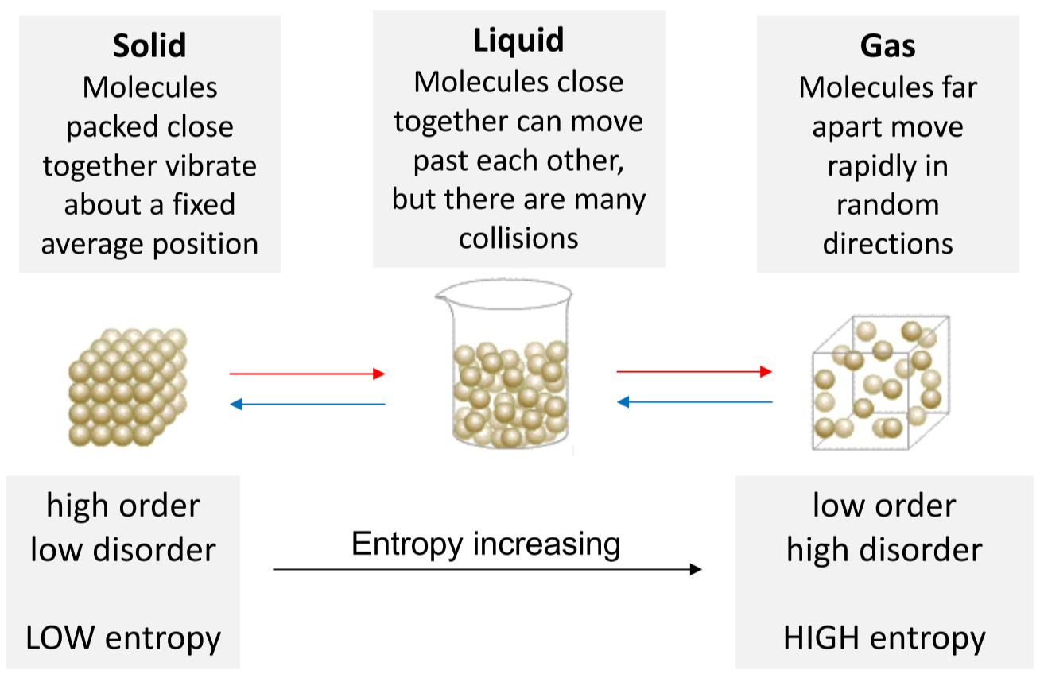

For a chemical process:

$$∆_{r}S°=∑v_{P}S°\left(products\right)-∑v_{R}S°\left(reactants\right)$$

**Phase transition**:

$∆_{tr}H°$ = the heat of transition, $T_{tr}$ is in Kelvin

$$∆S=\frac{∆_{tr}H°}{T_{tr}}$$

**Heating/cooling at constant P**:

$C_{P}$ = heat capacity at pressure P

$$∆S=C_{P}\ln{\frac{T_{f}}{T_{i}}}$$

**Change in ideal gas state from ($T_{i}, P_{i}$) to ($T_{f}, P_{f}$):**

$$∆S=C_{P}\ln\left(\frac{T_{f}}{T_{i}}\right)-nR\ln\left(\frac{P_{f}}{P_{i}}\right)$$

### Second Law of Thermodynamics

**Spontaneous** processes increase the total entropy of the universe

* $∆S_{total}=∆S_{system}+∆S_{surroundings}>0$– **spontaneous** reaction
* $∆S_{total}=∆S_{system}+∆S_{surroundings}=0$– process is at **equilibrium**
* $∆S_{total}=∆S_{system}+∆S_{surroundings}<0$– **non-spontaneous** reaction

$$∆S_{total}=∆S_{universe}=∆S_{system}+∆S_{surroundings}$$

## Gibbs Energy

The change in Gibbs energy of a system is denoted by:

$$∆G_{system}=∆H_{system}-T∆S_{system}=-T∆S_{total}$$

Where $∆S_{total}=∆S_{universe}$

* $∆G_{system}<0$– **spontaneous** reaction
* $∆G_{system}=0$– process at **equilibrium**
* $∆G_{system}>0$– **non-spontaneous** reaction

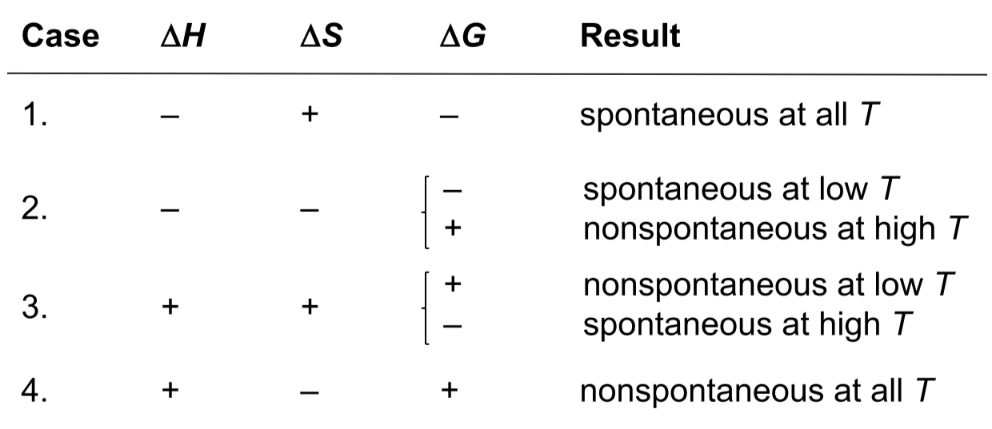

The change in Gibbs energy for a reaction is given by:

$$∆_{r}G°=∑v_{P}∆_{f}G°\left(products\right)-∑v_{R}∆_{f}G°\left(reactants\right)$$

Where $∆_{f}G°$ = change in Gibbs energy when 1 mol of a compound is formed

* A **negative $∆G$**  is a necessary but not sufficient condition for a reaction to occur
* For a reaction to occur, must factor in **Gibbs Energy of Activation $∆^{‡}G$**

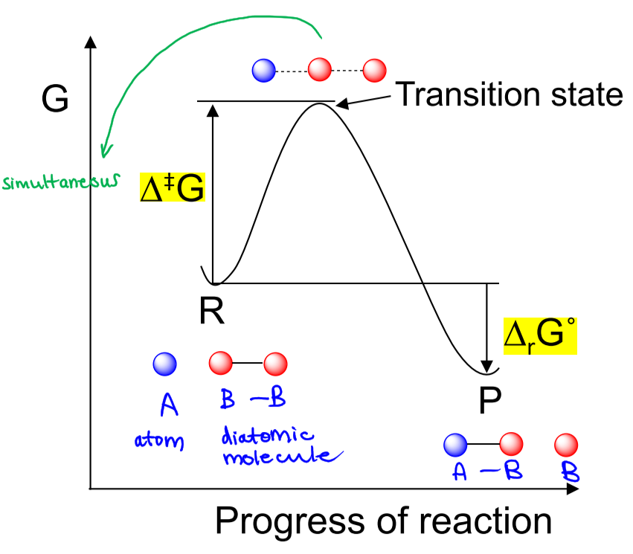

# Chemical Kinetics

* The quantitative study of reaction rates, to determine how reactants are converted into products
* **Rate of reaction** – how fast the concentration of R or P changes with time (always positive)
  + Expressed as change of concentration per unit time (mol/L/s):  
    For $R→P$, $-\frac{∆\left[R\right]}{∆t}=\frac{∆\left[P\right]}{∆t}$ is the **average rate** and $-\frac{d\left[R\right]}{dt}=\frac{d\left[P\right]}{dt}$ is the **instantaneous rate**
  + For gaseous reactions, rates are often measured in terms of change in pressure (atm/s):  
    For $A\left(g\right)→P(g)$, $-\frac{∆P_{A}}{∆t}$

The rate of reaction varies with:

* **Concentration**: as concentration $↑$, collision frequency $↑$, so rate $↑$
* **Temperature**: as temperature $↑$, number of molecules with enough kinetic energy for reaction to occur $↑$, so rate $↑$
* **Catalyst**: increases rate of reaction

For a general reaction $aA+bB→yY+zZ$:

$$rate of reaction=-\frac{1}{a}\frac{∆\left[A\right]}{∆T}=-\frac{1}{b}\frac{∆\left[B\right]}{∆T}=\frac{1}{y}\frac{∆\left[Y\right]}{∆T}=\frac{1}{z}\frac{∆\left[Z\right]}{∆T}$$

## The Rate Law

Mathematical expression showing the relationship between rate of reaction and concentration of reactants

For a reaction $aA+bB+cC+…→products$:

$$rate of reaction=k{\left[A\right]}^{m}{\left[B\right]}^{n}{\left[C\right]}^{p}…$$

* $k$ = the **rate constant** of the reaction
* $m,n,p$ = the **order of the reaction** with respect to $A, B, C$, respectively
  + The **overall order of the reaction $=m+n+p+…$**
  + These values are determined experimentally, not related to stoichiometric coefficients

### Method of Initial Rates

Determines the initial rate of reaction for a set of different starting concentrations of reactants:

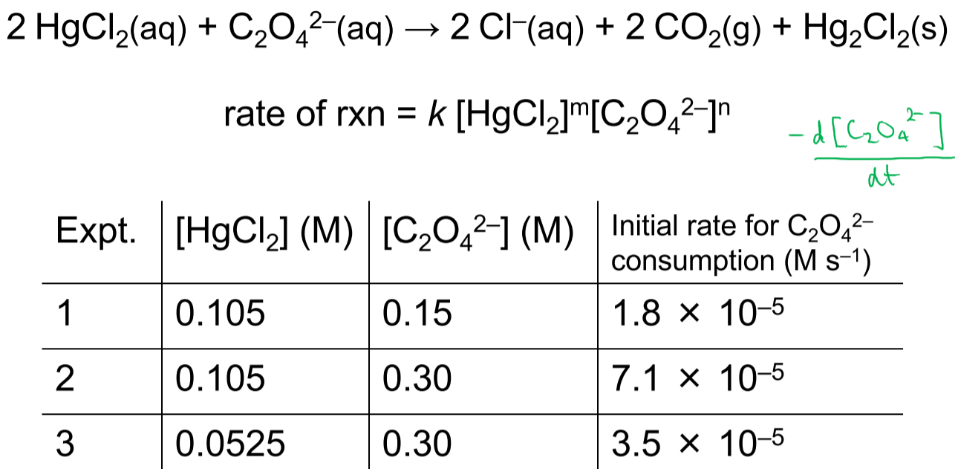

$$\frac{rate_{expt 2}}{rate_{expt 1}}=\frac{k{\left(0.105\right)}^{m}{\left(0.30\right)}^{n}}{k{\left(0.105\right)}^{m}{\left(0.15\right)}^{n}}=\frac{7.1×{10}^{-5}}{1.8×{10}^{-5}} \\ \frac{{\left(2×0.15\right)}^{n}}{{\left(0.15\right)}^{n}}=4 \\ 2^{n}=4$$

Hence, the reaction is order 2 with regards to $C_{2}O_{4}^{2-}$

$$\frac{rate_{expt 2}}{rate_{expt 3}}=\frac{k{\left(0.105\right)}^{m}{\left(0.30\right)}^{n}}{k{\left(0.0525\right)}^{m}{\left(0.30\right)}^{n}}=\frac{7.1×{10}^{-5}}{3.5×{10}^{-5}} \\ \frac{{\left(2×0.0525\right)}^{n}}{{\left(0.0525\right)}^{n}}=2 \\ 2^{n}=2$$

Hence, the reaction is order 1 with regards to $HgCl_{2}$

Then, $rate of reaction=k{\left[HgCl_{2}\right]}^{1}{\left[C_{2}O_{4}^{2-}\right]}^{2}=-\frac{1}{2}\frac{d\left[HgCl_{2}\right]}{dt}=\frac{d\left[C_{2}O_{4}^{2-}\right]}{dt}$ and the overall order of reaction is 3

* Any experiment can be used to calculate $k$
* The units of $k$ vary depending on the order of the reaction: $$rate of reaction units=\frac{M}{s} \\ units of k: \frac{M}{s}=k{\left(\frac{M}{s}\right)}^{1}{\left(\frac{M}{s}\right)}^{2}→k=\frac{\frac{M}{s}}{\frac{M^{3}}{s}}=\frac{M^{-2}}{s}$$

## Integrated Rate Laws

Determines how the concentration of reactant changes over time

### Zero-order reactions $(n=0)$

$$rate=k{\left[A\right]}^{0}=-\frac{d\left[A\right]}{dt} \\ d\left[A\right]=-k dt$$

Integrating,

$\int_{0}^{t}{d\left[A\right]}=-k\int_{0}^{t}{dt}$

$${\left[A\right]}_{t}-{\left[A\right]}_{0}=-k\left(t-0\right)$$

$${\left[A\right]}_{t}={\left[A\right]}_{0}-kt$$

* Units of $k=\frac{M^{-1}}{s}$
* In a plot of $\left[A\right] vs. t$, slope is **negative ($-k$)**

### First-order reactions $(n=1)$

$$rate=k{\left[A\right]}^{1}=-\frac{d\left[A\right]}{dt} \\ \frac{1}{\left[A\right]}d\left[A\right]=-k dt$$

Integrating,

$\int_{0}^{t}{\frac{1}{\left[A\right]}d\left[A\right]}=-k\int_{0}^{t}{dt}$

$$\ln{{\left[A\right]}_{t}}-\ln{{\left[A\right]}_{0}}=-k(t-0)$$

$$\ln{\frac{{\left[A\right]}_{t}}{{\left[A\right]}_{0}}}=-kt→\frac{{\left[A\right]}_{t}}{{\left[A\right]}_{0}}=e^{-kt}$$

* Units of $k=\frac{1}{s}$
* In a plot of $\ln{[A]} vs. t$, slope is **negative ($-k$)**

### Second-order reactions $(n=2)$

$$rate=k{\left[A\right]}^{2}=-\frac{d\left[A\right]}{dt} \\ -\frac{1}{{\left[A\right]}^{2}}d\left[A\right]=k dt$$

Integrating,

$\int_{0}^{t}{-\frac{1}{{\left[A\right]}^{2}}d\left[A\right]}=k\int_{0}^{t}{dt}$

$$\frac{1}{{\left[A\right]}_{t}}-\frac{1}{{\left[A\right]}_{0}}=k(t-0)$$

$$\frac{1}{{\left[A\right]}_{t}}=\frac{1}{{\left[A\right]}_{0}}+kt$$

* Units of $k=\frac{M}{s}$
* In a plot of $\frac{1}{\left[A\right]} vs. t$, slope is **positive ($+k$)**

**To determine order of reaction from concentration data over time:**

Calculate $k_{0th}, k_{1st}, k_{2nd}$ to determine which one is **constant (linear)**

$k_{0th}=\frac{{\left[A\right]}_{t}-{\left[A\right]}_{0}}{t}$

$k_{1st}=\frac{\ln{{\left[A\right]}_{t}}-\ln{{\left[A\right]}_{0}}}{t}$

$k_{2nd}=\frac{\frac{1}{{\left[A\right]}_{t}}-\frac{1}{{\left[A\right]}_{0}}}{t}$

## Half Life

The time it takes $[A]$ to decrease to half of its initial value:

At $t_{1/2 }, {\left[A\right]}_{t}=\frac{1}{2}{\left[A\right]}_{0}$

### Zero-order reactions $(n=0)$

$${\left[A\right]}_{t}={\left[A\right]}_{0}-kt$$

$$\frac{1}{2}{\left[A\right]}_{0}={\left[A\right]}_{0}-kt_{1/2}$$

$$t_{1/2}=\frac{{\left[A\right]}_{0}}{2k}$$

* $t_{1/2}$**depends on how much reactant** we start with
* Each subsequent $t_{1/2}$ is **half** the previous one

### First-order reactions $(n=1)$

$${\left[A\right]}_{t}={\left[A\right]}_{0}e^{-kt}$$

$$\frac{1}{2}{\left[A\right]}_{0}={\left[A\right]}_{0}e^{-kt_{1/2}}$$

$$t_{1/2}=-\frac{\ln{\frac{1}{2}}}{k}=\frac{\ln{2}}{k}$$

* $t_{1/2}$**does not depend on how much reactant** we start with
* Each subsequent $t_{1/2}$ is **same** as the previous one

### Second-order reactions $(n=2)$

$$\frac{1}{{\left[A\right]}_{t}}=\frac{1}{{\left[A\right]}_{0}}-kt$$

$$\frac{1}{\frac{1}{2}{\left[A\right]}_{0}}=\frac{1}{{\left[A\right]}_{0}}-kt_{1/2}$$

$$t_{1/2}=\frac{1}{k{\left[A\right]}_{0}}$$

* $t_{1/2}$**depends on how much reactant** we start with
* Each subsequent $t_{1/2}$ is **double** the previous one