CHEM 123 Lecture Notes – 2

# Reaction Mechanisms

* **Concerted reaction**: 1 elementary step
* **Multistep reaction**: 2+ elementary steps

## Concerted Reactions

* For concerted reactions, order of reaction = stoichiometric coefficient

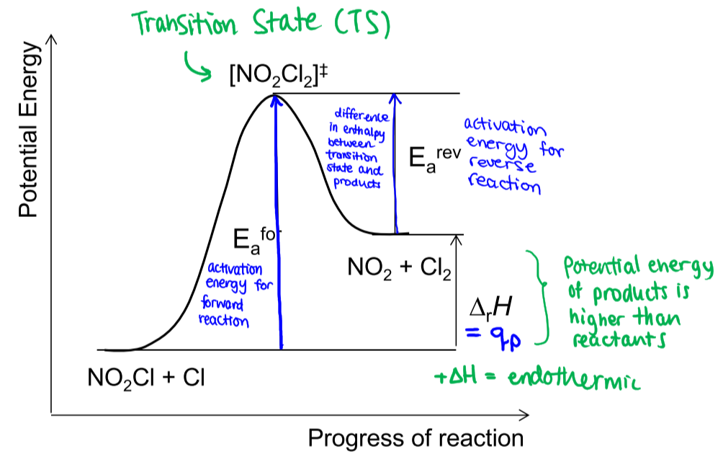

* **Collision theory**: predicts the rate of an elementary process
* Rate is proportional to:
  + Collision frequency ()
  + Fraction of collisions with
  + Fraction of collisions with proper orientation

### Arrhenius Equation

* As increases, decreases



### Transition State Theory

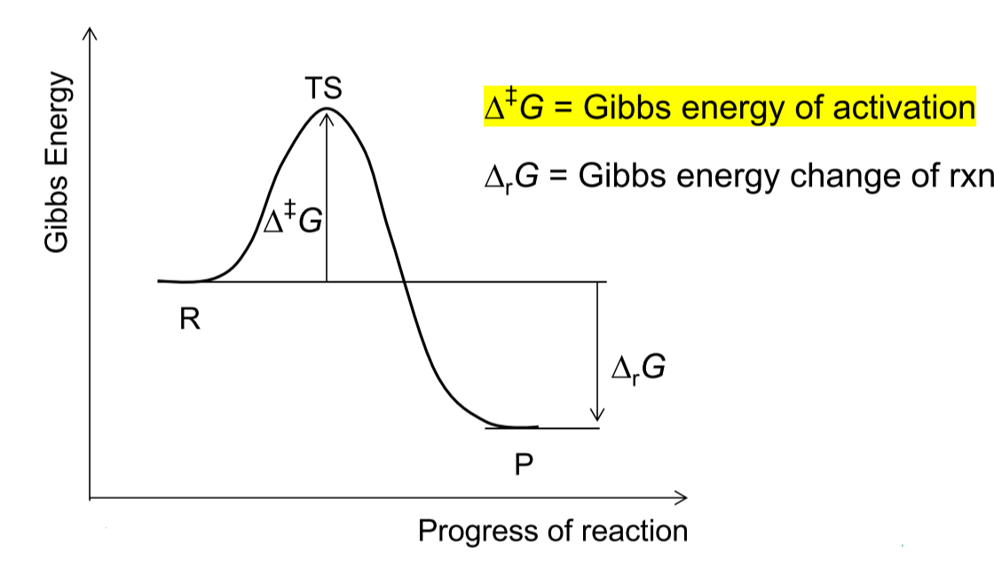

* Since , and

## Multistep Reactions

* **Rate-controlling step**: the transition state (TS) with highest E

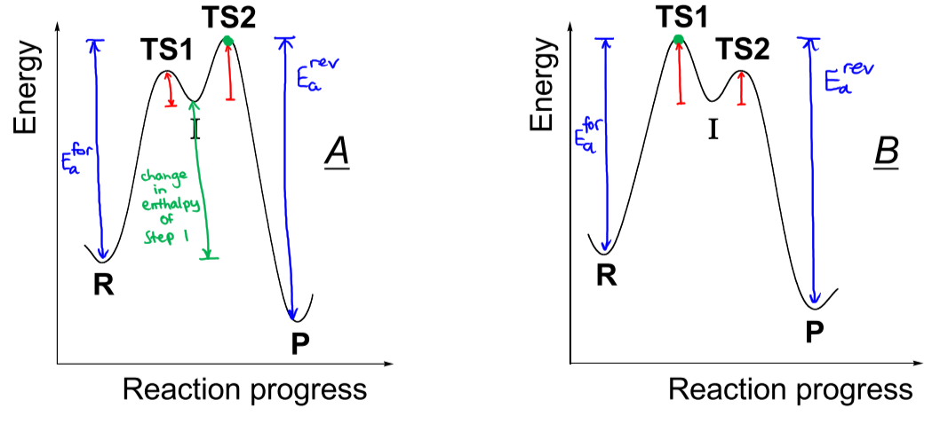

* – step 2 is rate-controlling
* – step 1 is rate-controlling
* # TS = # elementary steps
* # intermediates = # elementary steps – 1
* For rate, only care about steps up to and including **slow step**
* **Equilibrium constant**
* For fast reactions, forward rate = reverse rate

## Steady-State Approximation

* Rate of formation of intermediate = rate of consumption of intermediate
* Concentration of intermediate is relatively constant and low
* Write equations for rate of formation and rates of consumption of intermediate
* Change in concentration = rate of formation – rate of consumption
* SSA: change in concentration 🡪 0, solve for concentration

## Catalysts

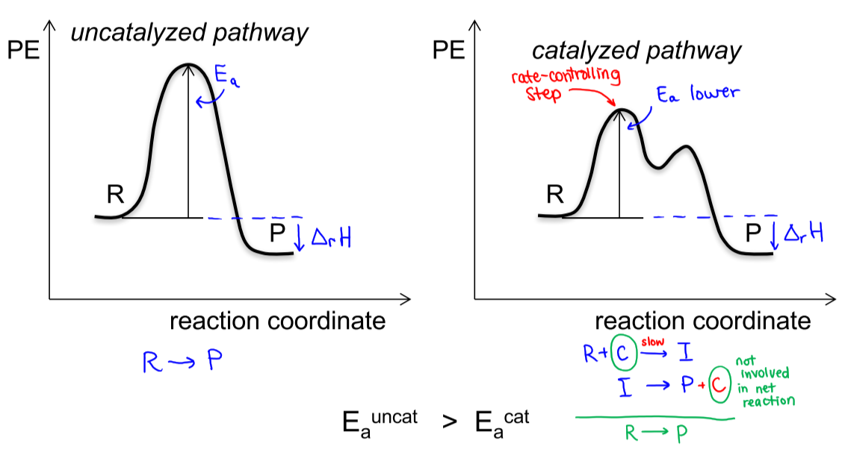

* Catalyst changes the mechanism of a reaction to one with **lower activation energy**

# Principles of Chemical Equilibrium

## Equilibrium Constant

For a reaction , with forward rate constant and reverse rate constant :

* For a 1-step process,
* For an n-step process,
* The **equilibrium activity** of pure solids/liquids and liquid solvents = 1
* The equilibrium activity of gases = partial pressure

For a reaction with ideal gases :

Recall that

* At equilibrium, and , so
* or

For a system at equilibrium, :

* If , reaction must go **left** to reach equilibrium
* If , reaction must go **right** to reach equilibrium
* If is very large (), the reaction will go nearly to completion
* If is very small (), the reaction will not proceed much in the forward direction
* Reverse a reaction: **invert K**
* Multiply coefficients by a common factor: **raise K to power of factor**
* Divide coefficients by a common factor: **factor root of K**
* Add individual equations: **multiple individual K values**

### 5% Rule

A concentration is considered small with respect to another concentration if

## Le Chatelier’s Principle

When a system at equilibrium is subjected to a disturbance, it responds to minimize the disturbance

* When the volume of an equilibrium mixture of gases (pressure increases), net reaction occurs to side that produces **fewer moles of gas**
* When the volume (pressure decreases), net reaction occurs to side that produces **more moles of gas**

## Van’t Hoff Equation

* If , then
* : shift in direction of **endothermic reaction**
* shift in direction of **exothermic reaction**

## Effect of a Catalyst on Equilibrium

* Catalysts do not affect condition of equilibrium or
* It affects the rate at which equilibrium is obtained

# Acids and Bases

### Bronsted-Lowry Theory

* **Acids ()**: H+ donors
* **Bases ()**: H+ acceptors
* All acid-base reactions consist of acid-base pairs

## Acid-Base Equilibria

### For an acid:

as

* **Strong acids** have high , low
* **Weak acids**: only some HA molecules ionize

### For a base:

as

* **Strong bases** have high , low
* **Weak bases**: only some B molecules ionize

## Self-Ionization of Pure Water

* at
* As
* : **acidic** solution
* : **neutral** solution
* : **basic** solution

## Strong Acids/Bases

* Species that **ionize completely (100%)** – write IF instead of ICE table
* Common strong acids: HClO4, HI, HBr, HCl, HNO3, H2SO4
* Common strong bases:
  + Very soluble: NaOH, LiOH, KOH, RbOH, CsOH
  + Sparingly soluble: Mg(OH)2, Ca(OH)2, Sr(OH)2, Ba(OH)2

## Weak Acids/Bases

* **Less than 100% ionization** – must write ICE table
* Look at to see if 5% rule can be used

## Conjugate Acid/Base Pairs

* **Conjugate pairs** differ by **one H+**
* For any conjugate pair:
  + /
  + This means that stronger acid (larger ) weaker base (smaller )
    - The conjugate of a **weak acid** is a weak base
    - Theconjugate is **strong acid** a very weak base

### pH of Salt Solutions

* Knowing the or of a compound, can calculate the pH of the acid’s corresponding base (salt):
  + E.g. 🡪 use
  + E.g. 🡪 use

## Monoprotic/Polyprotic Acids

* **Monoprotic**: only one ionizable H atom
* **Polyprotic**: more than one ionizable H atom
  + Multiple values for each ionization step; usually,
  + If the acid is weak (), only **the first ionization step** contributes to pH
  + If the acid is strong, need to first **write IF table, then ICE table**

## Molecular Structure and Acid/Base Strength

### Acids

* means that   
  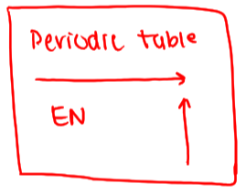
  + The higher # of EN elements,
  + The closer the EN elements are to the hydrogen,
* – will result in stronger acid ( / ) than



* **Resonance effect**: higher # of resonance forms, more stable anion, so

### Bases



* means that (weaker base), since holds on to electrons more tightly
  + will result in stronger base ( / ) than

## Ionization of a Weak Acid & Le Chatelier’s Principle

For :

* **Dilution**: % ionization as concentration
* **Common ion effect (addition of H3O+ or A-)**: causes net reaction left, so % ionization
  + Likewise, for ionization of a weak base, common ion effect (addition of NH4+ or OH-) shifts the equilibrium left, to form more of the weak base:

## Neutralization

* Reaction between weak acid and strong base / strong acid and weak base, essentially goes to completion (), until one of the reactants runs out
* NEUTRALIZATION 1st, EQUILIBRIUM 2nd

### Buffer Solutions

* Solution that contains comparable amounts of weak acid (HA) and its conjugate base (A-), or weak base (B) and its conjugate acid (HB+)
* Can maintain a relatively constant pH when small amounts of strong acid/base are added
* **Buffer capacity**: amount of acid/base that a buffer can neutralize before its pH changes appreciably
  + Buffer capacity as [buffer] and [acid] = [conjugate base]
* **Buffer range**: pH range over which a buffer maintains a fairly constant pH

## Acid-Base Titrations

* Establish concentration of unknown solution, using solution of known concentration
* **Titrant**: solution of known concentration, added to unknown solution
* **Titration curve**: pH vs. volume of titrant added plot
* **Equivalence point**: point at which enough titrant has been added to react with all the acid/base
  + **Half-equivalence point**: , because

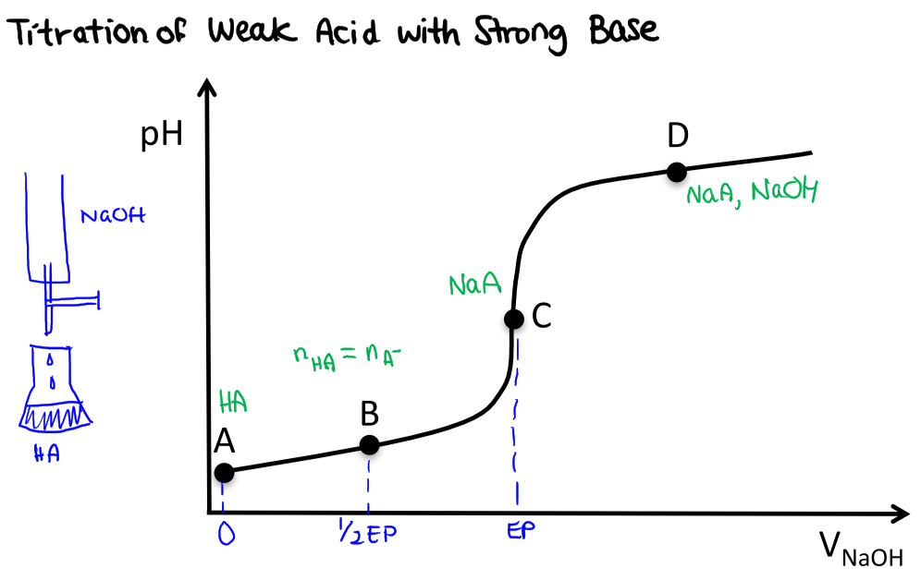



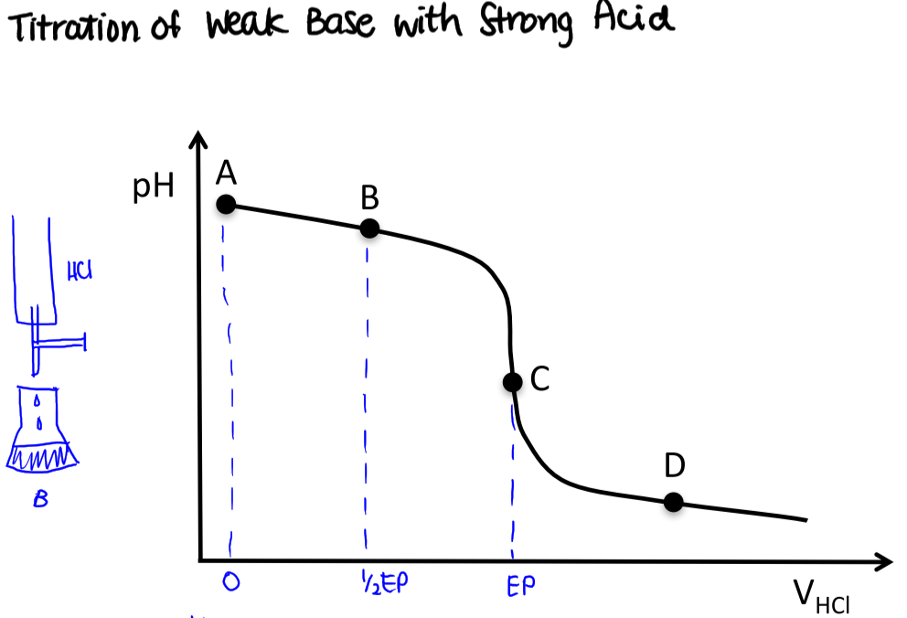



# Solubility Equilibria

* **Solubility Product Constant**: , lower = less soluble
* **Molar Solubility of a solute**:

For : , the reaction quotient

* Criteria for precipitation:
  + : **supersaturated**, precipitation should occur (net reaction left)
  + : **saturated** (equilibrium)
  + : **unsaturated**, precipitation cannot occur (net reaction right)
* Consider dilutions first, before criteria for precipitation

### Calculating from Solubility

Example: It is found that 0.0159 mol of lead (II) chloride () dissolves in 1L of aqueous solution at 25°C. What is the solubility product constant at this temperature?

### Calculating Solubility from

Example: Calculate the molar solubility of lead (II) iodide () in water at 25°C. at this temperature.

Larger doesn’t necessarily mean more soluble salt – depends on stoichiometry

## The Common Ion Effect & Le Chatelier’s Principle

Example: Calculate the molar solubility of lead (II) iodide () in a 0.01 M KI aqueous solution at 25°C. at this temperature.

* With added , equilibrium shifts to form more

### Equilibria Involving Complex Ions

Example: Calculate the solubility of in 0.100 M .

Example: A solution is made by dissolving 0.10 mol in 1.00L of 0.50 mol/L . What is the equilibrium concentration ?

## Fractional Precipitation

Example: Suppose a solution is 0.10 M () and 0.10 M (). When we slowly add a concentrated solution of :

1. Which precipitate forms first, or ?  
   , since it is less soluble (lower )
2. What is just before the 2nd cation begins to precipitate?
3. What concentration of the 1st cation to precipitate remains in solution just before the 2nd cation begins to precipitate?

Example: Suppose a solution is 0.10 M () and 0.10 M (). When we slowly add a concentrated solution of :

1. Which precipitate forms first, or ?

For :   
For :   
Hence, will form first, since it requires less .

1. What is just before the 2nd anion begins to precipitate?  
   Calculated in a), (and )
2. What concentration of the 1st anion to precipitate remains in solution just before the 2nd anion begins to precipitate?

# Electrochemistry

* Electron transfer/oxidation-reduction (redux) reactions
  + **Oxidation**: electrons are lost
  + **Reduction**: electrons are gained
* Electrochemical cell: properly connected combination of two half-cells
  + **Galvanic/voltaic**: spontaneous redox reaction – current generated spontaneously
  + **Electrolytic**: non-spontaneous redox reaction – need external current to force reaction

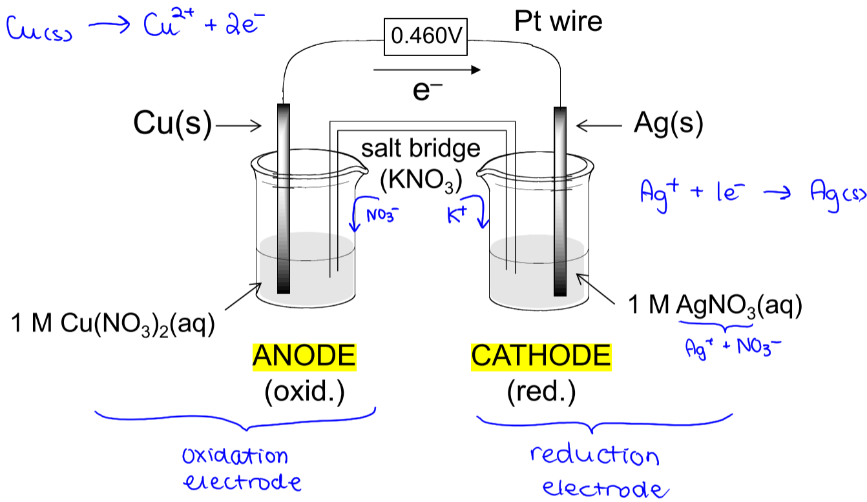

* **Cathode**: half-cell where reduction occurs
* **Anode**: half-cell where oxidation occurs
* **Salt bridge**: prevents charge build-up – positive ions flow towards cathode, negative ions flow towards anode
* **e-** flow from anode to cathode

Shorthand notation: Cu(s) | Cu2+(aq) || Ag+(aq) | Ag(s)  
 ANODE CATHODE

## Cell Potential

* Work produced by/supplied to an electrochemical cell, **per coulomb** of charge (J/C = V)
* Depends on:
  + Half-cells involved
  + Reaction conditions (T, P, concentration)
    - **Standard conditions**: 25°C, 1 M solutions, 1 atm gases

### Standard Hydrogen Electrode (SHE)

**Anode**:

**Cathode**:

To measure the standard potential () of a cell:

* Connect half-cell to SHE
* Measure cell potential and determine direction of e- flow
* As a reduction reaction:
  + : half-cell is cathode when connected to SHE
  + : half-cell is anode when connected to SHE
* When coupling two half-cells, the one with more positive will proceed as reduction

### Oxidizing and Reducing Agents

* **Oxidizing agent**: has high affinity for e-, causes another substance to be oxidized
* **Reducing agent**: has very low affinity for e-, causes another reaction to be reduced
  + Very positive : very good oxidizing agent, very poor reducing agent
  + Very negative : very poor oxidizing agent, very good reducing agent

### Reaction Potentials

* Reversing a reaction – **changes sign**
* Multiplying a reaction by constant – **does not change**
* Add two half-reactions together – add two values
  + number of e-
  + Faraday’s constant
  + cell potential

## Nernst Equation

Describes how E changes with concentration, at 25°C only

* reaction quotient – use concentration (M) for solutions, partial pressure (atm) for gases
* number of e- transferred

### Relationship between and

* **Voltage**: measures tendency of a redox reaction (e­‑ transfer) to occur
* At equilibrium, no net e­‑ transfer, so and

### Relationship between and

* Solve for molar solubility using Nernst equation, then calculating from

Example: Pb(s) | Pb2+ (saturated PbI2) || Pb2+ (0.100 M) | Pb(s),

## Electrolytic Cells and Electrolysis

* **Electrolysis**: use external voltage source to force a non-spontaneous redox reaction
* Useful for converting oxidized metals back to metals

Example: A solution of Cu(NO3)2(aq) is electrolyzed for 7.0 minutes using an external current of 0.60 amperes (1 ampere = 1 C/s). How many moles of Cu(s) are produced?

Charge on 1 e- = 1.602e-19 C  
Charge on 1 mol e- = 96485 C (=F, Faraday’s constant)

1. Quantity of charge:
2. Moles of e-:
3. Moles of Cu produced: