SCI 238 Lecture Notes

# Lecture 1: The Sky

## Motions in the Sky

* Daily rotation of Earth
* Motion of Moon from one day to the next – change in phase
* Motion of Sun from one day to the next
  + Stars appear to lie on a **celestial sphere** around the Earth, even though they lie at different distances
  + Earth’s rotation makes the celestial sphere appear to rotate from East to West, which makes the stars appear to move
* Motion of planets

## Location in the Sky

* In order to locate things in the celestial sphere, on Earth, we use **latitude and longitude**, angles with respect to the centre of the Earth
  + **Latitude** measures N/S angular distance; 0° latitude = Equator
  + **Longitude** measures E/W angular distance; 0° longitude = Greenwich, England

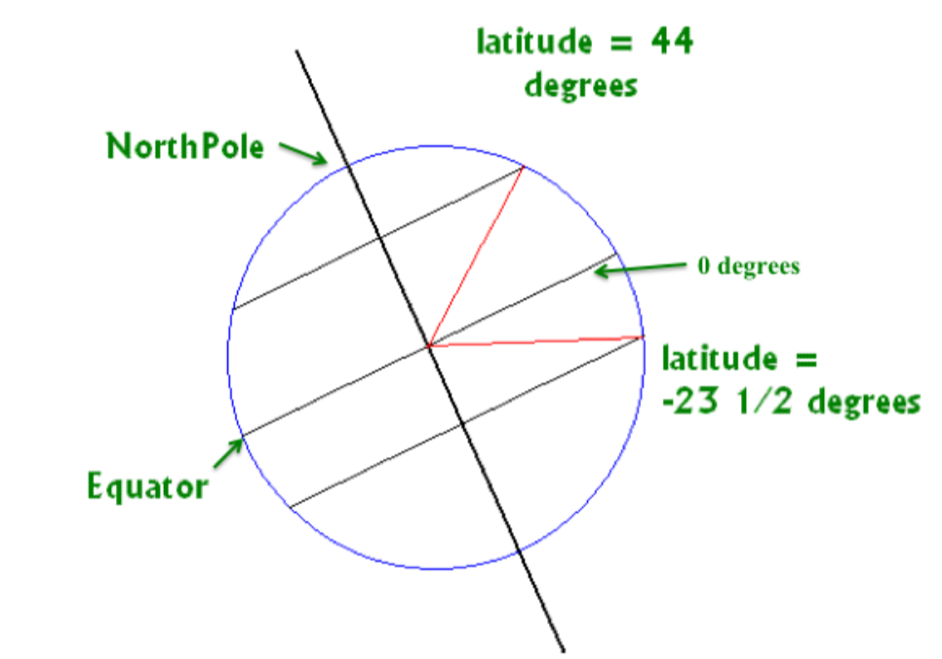

## Measuring Positions in the Sky

* **Angular position** is measured in degrees, arcminutes, and arcseconds
  + 1 degree = 60 arcminutes (60’) = 3600 arcseconds (3600”)
* The sky’s coordinate system is latitude and longitude on Earth, extended into space
  + Latitude 🡪 **declination** – angular distance of a point relative to the celestial equator
  + Longitude 🡪 **Right Ascension** – arbitrary fixed zero point in the sky; the position of the Sun at the instant that Spring starts (vernal Equinox)

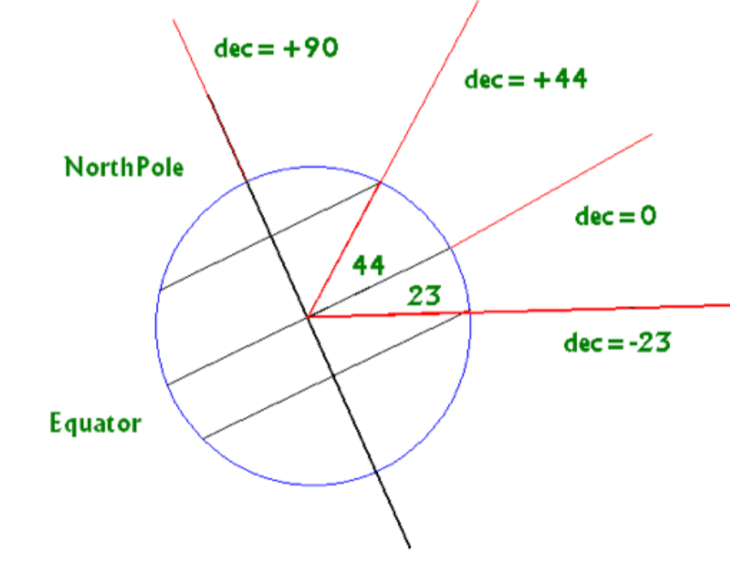

### The Sky Seen from a Fixed Position on Earth

* Where we see things in the sky, depends on where we are on Earth, the time of day, and where Earth is in its orbit around the Sun
* Local coordinates:
  + **Altitude/elevation**: 0° = horizon, 90° = zenith
  + **Azimuth**: 0° = due North, 90° = due East
* **North celestial pole altitude**: observer’s altitude
  + The sky we see varies with latitude, which determines the altitude of “centre” of sky

Example: How high is the Sun at noon in “your” sky, if you are at a latitude of 44°, and the Sun is at a declination of -23.5° (i.e. it would be seen directly overhead at noon at latitude -23.5°)?

Altitude of Sun in “your” sky = 180° - 90° - 44° - 23.5° = 22.5°

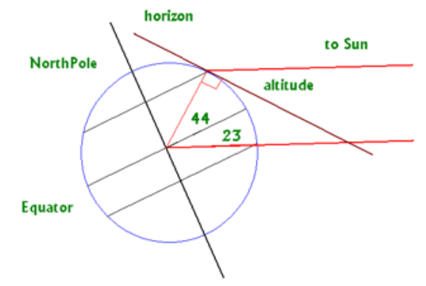

# Lecture 2: The Origins of Astronomy

## Angles and Separation in the Sky

* **Angular separation**: the distance between us and objects in the sky, measured in arcseconds
  + Usually, objects are much closer to each other than to us, so we assume they are the same distance from us

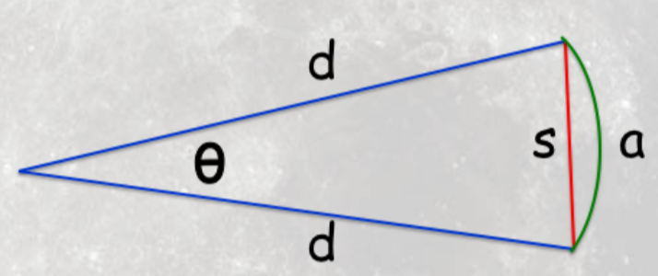

* + = arc-length
  + = radius of circular arc
* **Small angle approximation**: for small angles,

Example: What is the value of for and ?

For small angles, :

Example: The Moon is about 30 arcminutes across. By eye, the largest Maria (dark spot) is the Moon’s diameter. If the distance to the moon is 400,000 km, how big is a Maria’s diameter?

### Projections of a Sphere onto a Plane

* Mercator projection (most common)
* Aitoff projection
* Cylindrical projection

## The Sun’s Position Through the Year

* The Sun’s path travels through the zodiac constellations
* **Vernal Equinox**: first day of spring (March 22) – Sun is directly above the equator, moving North to South

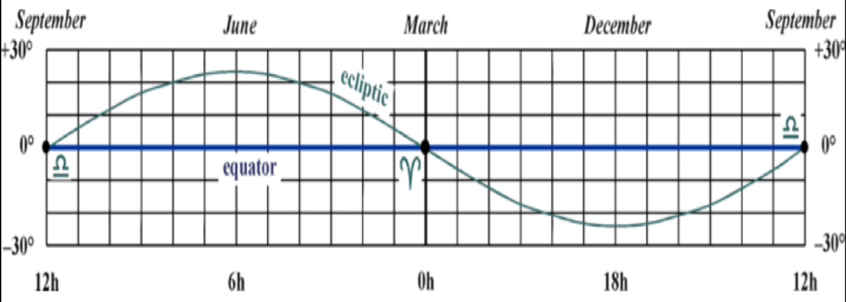

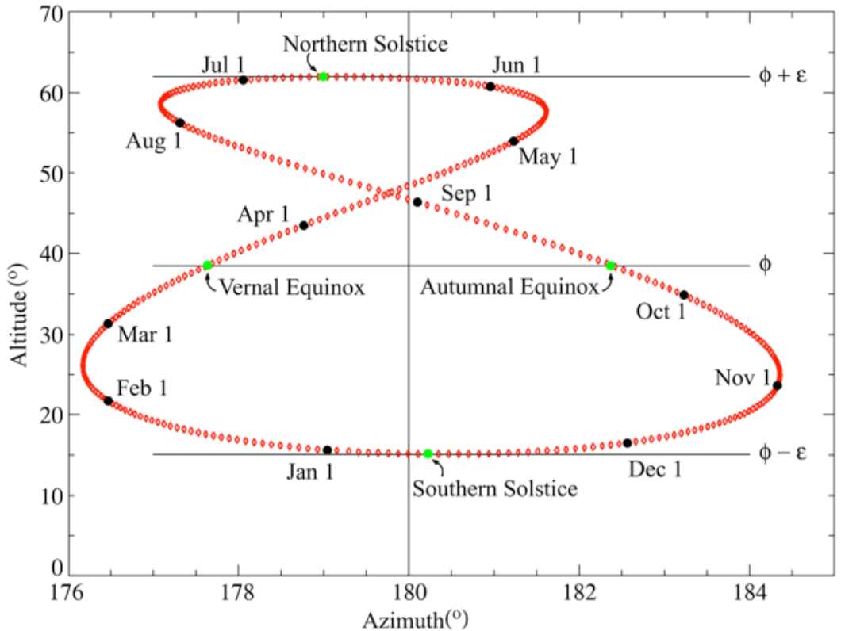

## The “Ecliptic”

* **Ecliptic**: Sun’s path through the sky, opposite the Earth’s motion around the Sun
  + Equator plane is set by rotation of Earth
  + Equator and ecliptic are inclined to each other by 23.5°
    - This inclination is the primary cause of seasons (not distance from Sun!)
    - Time of day also depends on the Earth’s axial tilt and the season

DEC 22 vs. MARCH 22

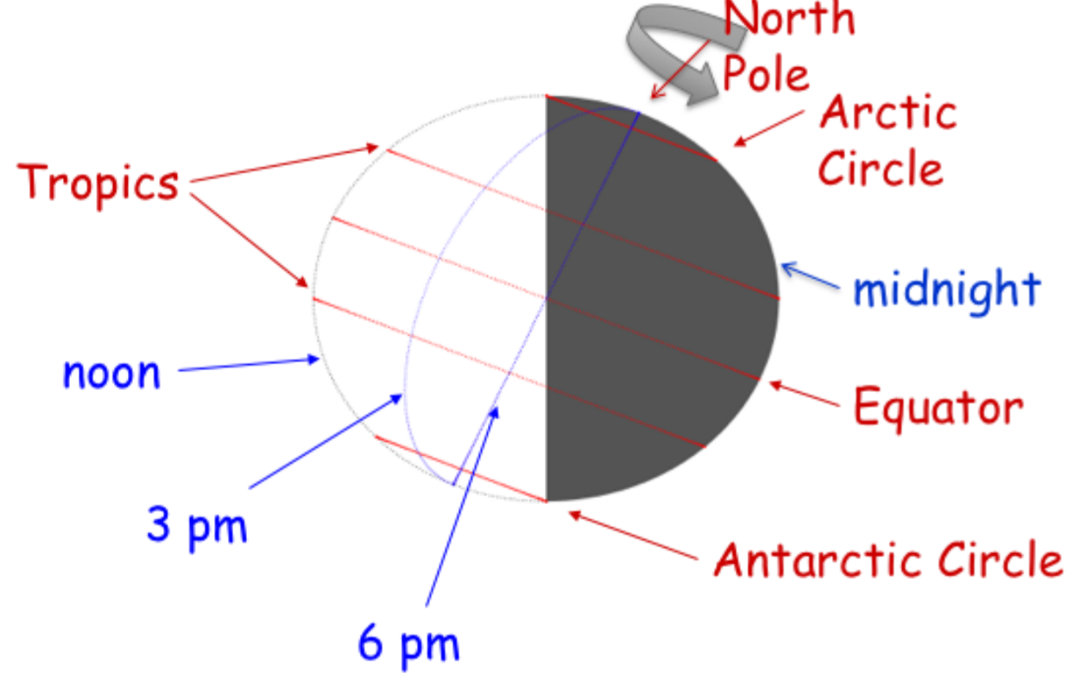

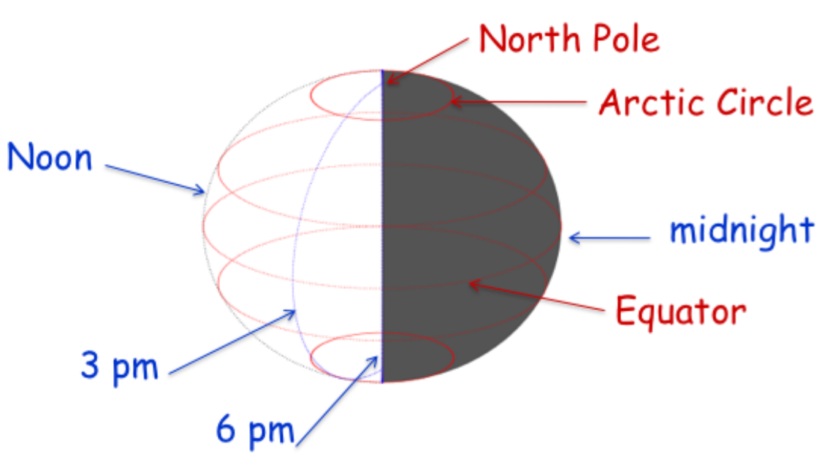



* The path of each planet across the sky is closely along the path followed by the Sun over a year
* The orbits of all planets are in very nearly the same plane in the sky

## Time Measurement

* **Sidereal time**: time according to the stars
* **Synodic time**: time according to the Sun
* Every century, the length of a day increases by 1.8 milliseconds
* A **solar day** (length of time from noon to noon) is ~4 minutes (1/360 of 24 hours) longer than a **sidereal day** (time for Earth to rotate on its axis relative to the stars)
  + Since Earth travels ~1°/day in its orbit, so one solar day requires ~361° of rotation

### Many Kinds of Time

* **Measuring by stars**: one sidereal day = 23 hours, 56 minutes, 4.091 seconds
* **Apparent Solar Time**: time measured by Sun’s position in the sky
* **Mean Solar Time**: average length of a solar day
* **Standard Time**: all places on Earth in a 15° longitude wide time zone use the same mean solar time
* **Sidereal Year**: time for Earth to complete one orbit (against the stars) = 365.6366 Mean Solar Days
* **Tropical Year**: time from one spring equinox to the next (against the Sun) = 365.242199 Mean Solar Days

### The Moon and its Phases

* What causes the moon’s phases? Our perception of its half-illuminated surface

## The Calendar

* **Sidereal month**: 27.32 days
* **Synodic month**: 29.53 days
* Calendars:
  + Roman calendar: 13th month every 3 years
  + Julian calendar: 12 months, 30 or 31 days per month, with leap year every 4 years
    - Every year was short 11 minutes and 14 seconds, so by 1582 the calendar was 10 days short
  + Gregorian calendar: century years aren’t leap years unless divisible by 400

## Eclipses

* **Lunar eclipse**: Moon passes through Earth’s shadow (Earth between Sun and Moon), Earth blocks sunlight from illuminating Moon, so it disappears
  + Can only happen at full moon
* **Solar eclipse**: Earth passes through Moon’s shadow (Moon between Sun and Earth), so the Sun disappears
  + Can only happen at new moon

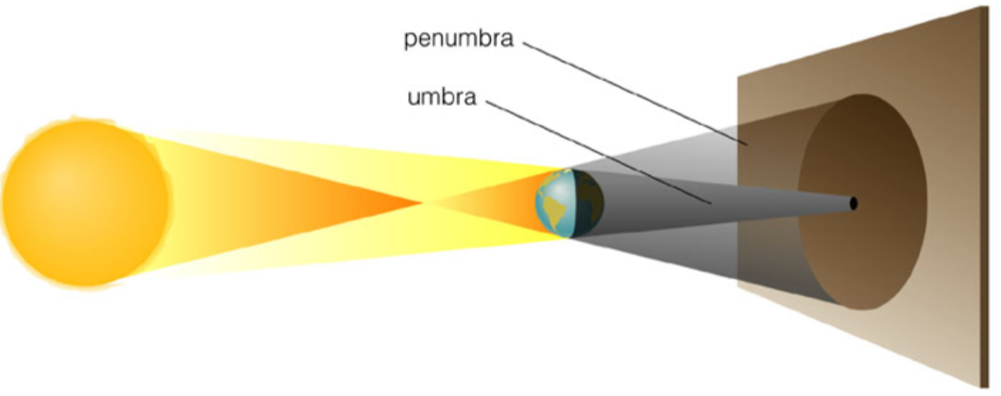

* **Umbra**: region where sunlight is completely blocked
* **Penumbra**: region where sunlight partially blocked

## Astronomy Origins

### Stone-Age Astronomy

* Mark seasons, special times of the year
  + Standing stones (e.g. Stonehenge)
  + Pyramids
  + Medicine Wheels
  + Sundials to mark time

### Ancient Greek Astronomy

* The world consisted of the Sun, Moon, and planets, in a fixed sky
  + 7 planets (Sun, Moon, Mercury, Venus, Mars, Jupiter, and Saturn) – the ones visible to the naked eye
* Astronomy philosophers:
  + Philolaus: Earth moves around central fire, “counter Earth” on opposite of fire
  + Pythagoras: heavenly bodies are spherical
  + Aristotle
    - Geocentric universe
    - Correctly explained phases of Moon and eclipses
    - Sun is more distant than the Moon
    - Earth is spherical
  + Aristarchus of Samos
    - Found that the Sun was 18-20 times further away from Earth than the Moon
      * Measured length of time for Moon to travel from third quarter to first quarter
    - Determined relative sizes of Earth, Sun, and Moon (Moon is 1/3 times, Sun is 7 times diameter of Earth)
  + Eratosthenes
    - Measured size of Earth from sun angles – distance between Syene (zenith) and Alexandria (7° from zenith)
  + Hipparchus
    - Invented trigonometry
    - Measured positions and brightness of 850 stars with high precision
    - Celestial coordinate system, magnitude system, and discovered precession (change in rotational axis orientation)
    - Estimated Moon’s size and distance
    - Measured length of year
    - Explained eclipses
    - Invented epicycles
  + Ptolemy
    - Parallax: measured distance to the Moon, by measuring angle to centre of Moon from two positions on Earth at the same time
    - Epicyclic theory of solar system – used epicycles to explain retrograde motion in a geocentric solar system

## Retrograde Motion

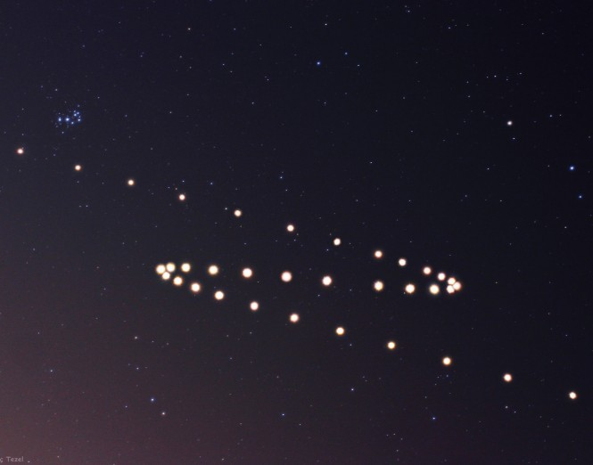

* Normally, planets appear to move from West to East in the sky
* Superior planets reverse direction briefly – **retrograde motion** – before resuming EW motion
  + Happens because planets more distant from the Sun orbit more slowly

## Pre-Scientific Astronomy in the Rest of the World

* **Hindu**: measured Moon, created system of numbers
* **Islamic**: algebra, positions of planets, eclipse records
* **Babylonians, Assyrians, Egyptians**: calendar, time-keeping, surveying
* **Chinese**: records of comets, meteorites, and supernova, first star catalogue in 350BC

# Lecture 3: Astronomy as a Science

## Planetary Positions/Motions

* **Superior planet**: planet that is further from the Sun than Earth
* **Inferior planet**: planet that is closer to the Sun than Earth
* **Elongation**: angle of planet with respect to the Sun
* **Astronomical Unit (AU)**: the mean distance from the Earth to the Sun

### Superior Planet

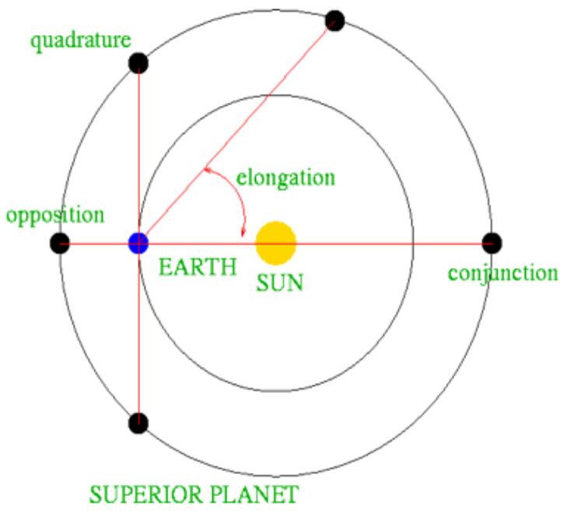

* **Conjunction**: elongation of 0°
* **Opposition**: elongation of 180° (opposite side of the Sun, from Earth)
* **Quadrature**: elongation of 90°

### Inferior Planet

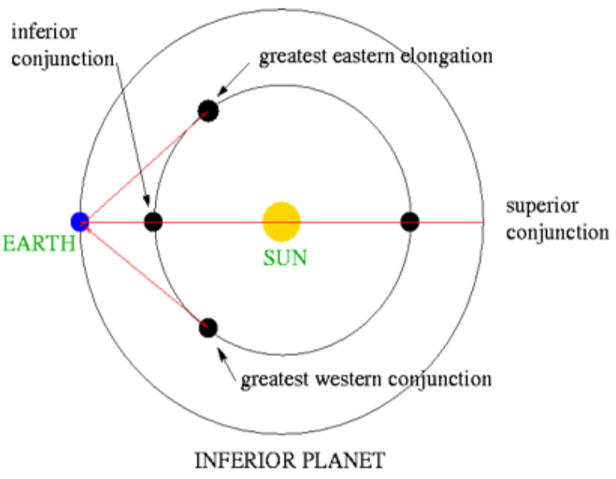

* **Superior conjunction**: elongation of 0°, behind the Sun
* **Inferior conjunction**: elongation of 0°, in front of the Sun
* **Greatest Eastern/Western elongation**: largest elongation of an inferior planet (90° angle between Earth and Sun)

## European Development of Astronomy

### Copernicus

* Heliocentric model
* Planets closer to the Sun than Earth orbit faster
* The Earth rotates on its own axis
* All planet orbits are circular
* Sidereal vs. synodic periods
* Relative distances of planets

## Sidereal vs. Synodic Periods

* Sidereal period =
* Synodic period =
  + In years, Earth goes around the Sun times
  + If another planet takes years to orbit the Sun, then in years, the planet will make trips around the Sun
* **Superior planet**:
* **Inferior planet**:

## Relative Distances of Planets

### Inferior Planets

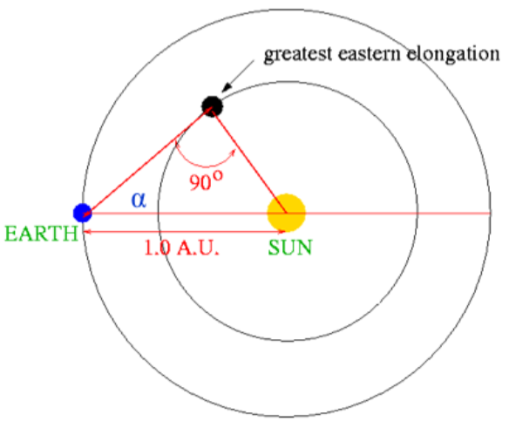

* Consider the greatest elongation , where the planet makes a 90° angle with Earth and the Sun
* Distance from the Sun to the planet

### Superior Planets

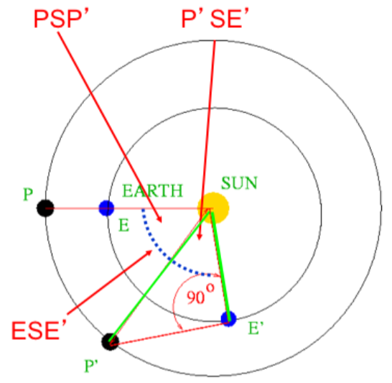

* Knowing the sidereal period
* Earth-planet relative position goes from opposition (180°) to quadrature (90°), making angles and (calculate from orbital period and elapsed orbit time)
  + Angle
  + Distance from the Sun to the planet

### Bode’s Law

Distance from Sun to planet, where is the order of the planet from the Sun

## European Development of Astronomy Continued

### Tycho Brahe

* **Parallax** of comets and supernova
* Extremely detailed, high precision observations, using own instruments

### Kepler

* Analyzed Mars’ orbit and determined three laws:
  1. Orbits are elliptical
  2. Equal areas are swept in equal time
  3. , where period (in years) and orbital semimajor axis (in AU)

## Properties of Ellipses

### Kepler’s First Law

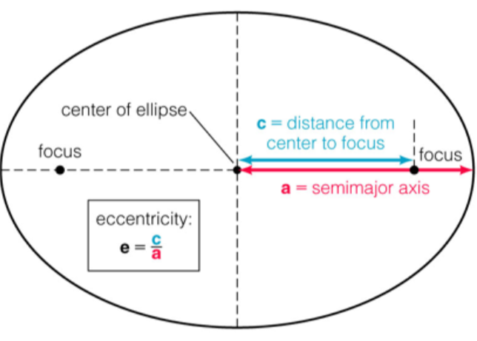

* **Semimajor axis**: average distance of a body from the orbit’s focus
* **Focus**: the location of the centre of mass of the system

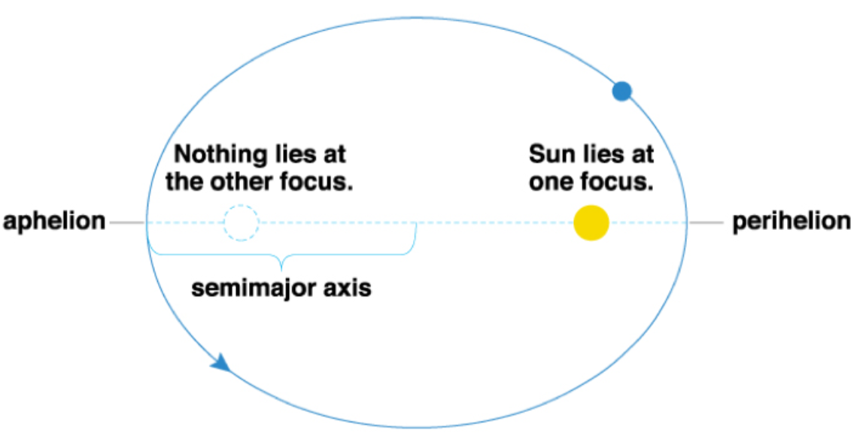

* **Perihelion**: point in orbit closest to the Sun
* **Aphelion**: point in orbit furthest from the Sun

Example: A comet has an orbit with semimajor axis of 20 AU. If the eccentricity of the orbit is 0.80, how close will it be to the Sun at perihelion?

### Kepler’s Second Law

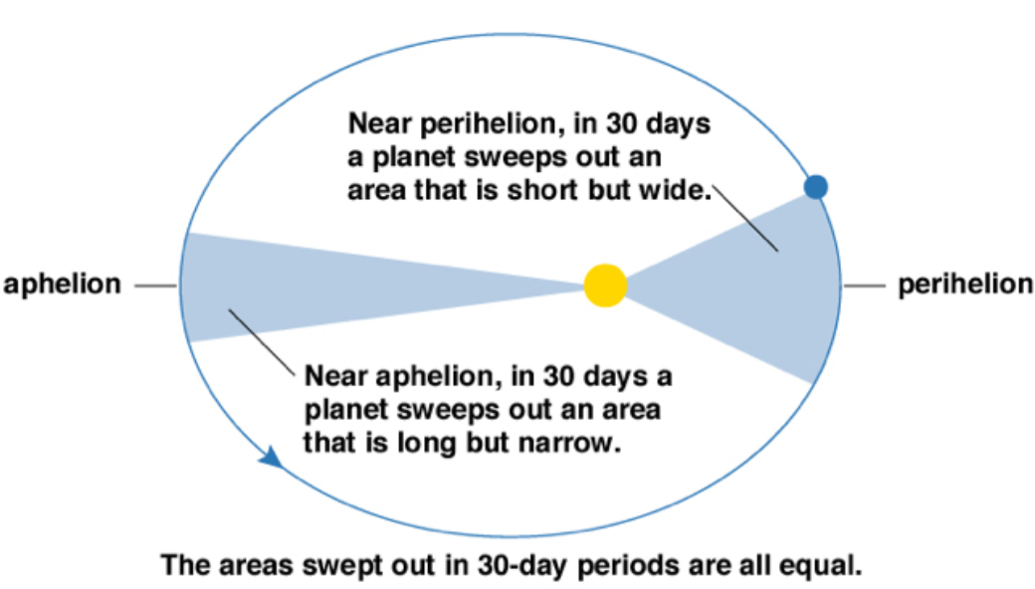

### Kepler’s Third Law

Example: A comet has an orbit with semimajor axis of 20 AU. What is the period of the comet’s orbit?

## European Development of Astronomy: New Technology

### Galileo

* First person to use telescope for astronomy
  + Phases of Venus 🡪 Venus must orbit the Sun
  + Mountains on Moon
  + Sunspots
  + Moons of Jupiter 🡪 objects can orbit a moving body
  + Milky Way is made up of stars

### Newton

* First universal rules that governed motions of planets and everyday objects on Earth
  + Laws of Motion:
  + Law of Gravity:
* Optics
* Calculus

### Einstein

* Energy is stored in matter
* **Mass-energy** is released if an amount of mass is converted to energy
* Theories of relativity:
  + **Special relativity**: speed of light is independent of motion of observer
  + **General relativity**: theory of gravity, where mass simply curves spacetime and objects move along curvature

## Atomic Theory of Matter

* Atoms consist of a nucleus made up of protons and neutrons, and a set of electrons that surround it
  + In a normal element, the number of electrons = the number of protons
  + The number of neutrons is similar to the number of protons, but **isotopes** have same # of protons, different # of neutrons
    - E.g. hydrogen and deuterium (extra neutron)
  + The mass is mostly contained in the nucleus, however electron cloud is much larger size
* There are many other subatomic particles (quarks, muons, neutrinos)

### Electron Orbits

* Electrons can gain or lose energy while in orbit
  + However, they may only gain or lose specific amounts of energy
  + Each element has its own set of energy levels
* **Ground state**: electrons have lowest possible energy
* **Excited state**: electrons have energy > lowest energy
* **Ionized**: electrons have enough energy to escape orbit

# Lecture 4: Gravity and Motion

## Temperature vs. Heat

* **Temperature**: measures the heat energy content per particle, usually in Kelvins
  + Measure of the average random energy
  + Does not measure directed (e.g. kinetic) energy
  + Also measures the excitation of atoms and molecules
    - Electronic excitation of atoms
    - Vibrational or rotational excitation of molecules
* **Heat**: measure of the total random energy
* **Thermal equilibrium**: “state” of material is given by temperature and energy, in relationship described by the Boltzmann Distribution equations
  + Boltzmann’s constant

## Pressure and Density

* **Pressure**: force per unit area
* **Gas pressure**: gases exert pressure through collisions of atoms/molecules with surfaces or other atom/molecules
  + **Ideal gas law**:
    - number density (# atoms/molecules per volume)
    - Boltzmann’s constant
    - temperature (K)
* **Density**: mass density is usually
  + **Number density**: the number of particles in a given volume

Example: The density of Earth’s atmosphere is at sea level. What is the force of an air column acting on of the surface, with a high atmosphere?

Example: Assuming Earth’s atmosphere is primarily nitrogen, and one molecule has mass , what is the number density of the atmosphere? What is the temperature?

### Pressure and Gravity

* Gravity pulls everything in the universe together
* Pressure pushes everything apart – but only if they are touching
  + Gas pressure depends on both temperature and density – e.g. if temperature drops, so does pressure

## Properties of an Ellipse

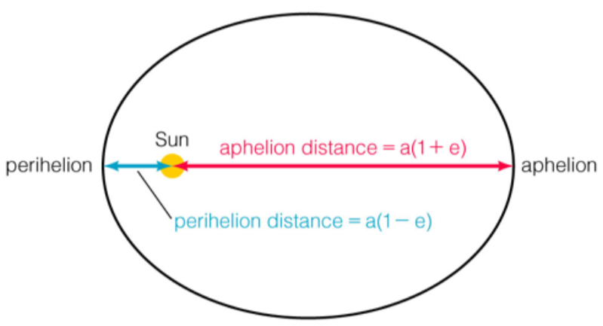

* The Sun is close to, but not exactly on the centre of the focus of the ellipse
  + At **perihelion**:
  + At **aphelion**:

## Center of Mass

* Objects orbit, in an ellipse, around the center of mass (CM)
* The location of the CM depends on relative masses:  
  + In an equal mass system, CM is midway between the masses
  + In the solar system, the mass of the Sun is much larger than the planets, so the CM is inside or close to the Sun
* A more generalized form of Kepler’s Third Law:
* Like how CM depends on mass ratio, so does **relative orbit size**

## Energy

### Types of Energy

* **Kinetic energy**:
* **Potential energy**:
  + At
  + As decreases (i.e. objects get closer together), gets smaller

### Conservation of Energy

* Energy can neither be created nor destroyed:   
  , if no external forces exist
  + Since as distance , orbital kinetic energy/velocity must increase () as
* Energy is either exchanged between objects, or changes forms
* The Universe’s total energy content was determined by the Big Bang, and remains the same today

### Conservation of Angular Momentum

* remains constant unless there are external forces
  + Hence, if

## Vis Viva Equation

* Derived from Kepler’s Third Law
  + velocity of orbiting object
  + distance between the two objects
  + semimajor axis of orbiting object
* Circle (:

### Three Forms of Kepler’s Third Law

Example: A planet orbits a star with mass , with a period of 20 years. What is its orbital semimajor axis?

, since

Hence, since

Then,

Example: A planet orbits a star with mass , with a period of 20 years. What is its orbital semimajor axis?

, since

Then,

Example: The Moon and the Earth are in mutual orbit with a period of 27.3 days and a mean separation of 384,400 km. If the mass of the Earth is , what is the mass of the Moon? What are the semimajor axes of the Moon and Earth’s orbits?

## Orbital Energy

### Circular orbit ()

* This means
* Orbital kinetic energy decreases as distance from center of mass increases
* This pattern is valid for any system where orbits are dominated by a large central mass

### Bound orbit ()

### Unbound orbit

## Orbital Elements

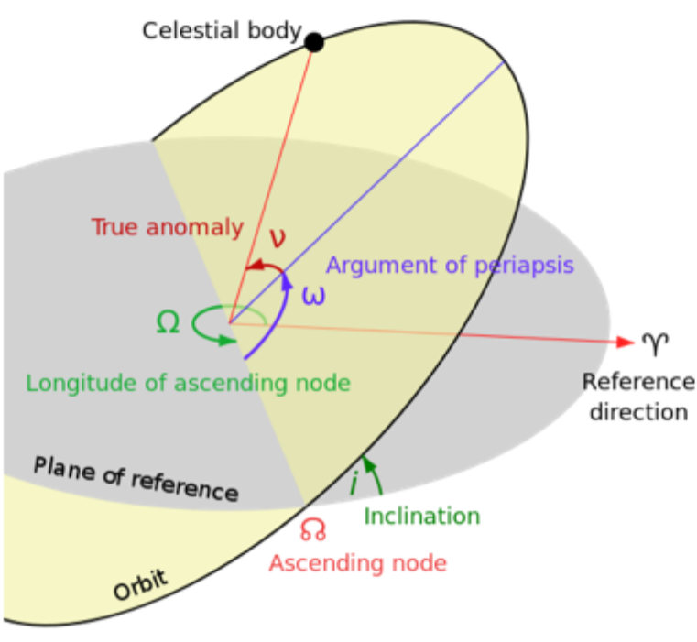

* **Inclination**: of orbital plane from reference plane
* **Ascending node/descending node**: where the two planes cross
  + **Longitude of ascending node**: position of ascending node relative to reference direction
* **Argument of periapsis**: point in path of orbiting body closest to the body it is orbiting
* **True anomaly**: where the orbiting body is at a given instant
* Orbits can be altered by exchanges of energy:
  + Collisions
  + Multi-body or tidal effects (near encounters)

## Tides

* Force of gravity varies as
* Difference between gravitational forces varies as
* The ocean tides on earth varies with alignment of Earth, Sun, and Moon
* **Tidal friction** is slowing Earth’s rotation and increasing the distance between the Earth and the Moon
  + Tidal forcesare important whenever differential gravitational forces are large enough

### Gravity Waves

* Einstein’s theory of General Relativity predicts that gravitational radiation should carry energy through space
* This was indirectly detected in binary pulsar by Taylor and Hulse
* **Laser Interferometer Gravitational-Wave Observatory (LIGO)** – merger of two black holes

# Lecture 5: Light

## Astronomers “Observe”

* Astronomers capture the light coming from the Universe, and all its contents
* They measure the **brightness** of light from a source, but brightness is proportional to

## Light

* Wavelike phenomenon that carries bundles of electromagnetic energy as **photons**
  + wavelength (meters)
  + frequency (Hz)
* In astronomy, **colour** usually means difference in amount of light (source brightness) at two different wavelengths
* **Spectrum**: spreading out light to show brightness variation with wavelength

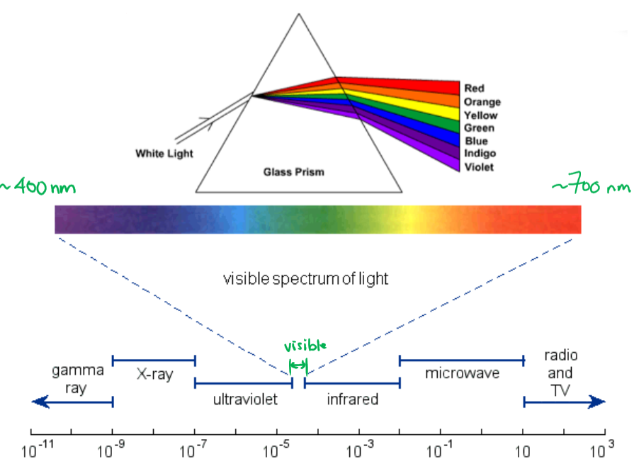

* + Wavelength increases to the right
  + Frequency and energy increase to the left

## Blackbody Radiation

* **Blackbody**: absorbs and emits light at all wavelengths
  + Perfect absorber
  + Emissions depends on temperature of blackbody
  + Blackbodies do not emit the same amount of light at each wavelength
* Wavelength of **emission peak** given by Wein’s Law:
  + Hotter blackbody:
    - Brighter at shorter wavelength
    - Higher intensity
    - Wider range
    - Total light energy = area under Planck curve increases
* **Total emission** (of all wavelengths) per second per unit area, is given by Stefan’s Law:
* Types of spectrums observed: continuous, emission, absorption

Example: Consider four sources of temperatures: 50000K, 5000K, 500K, 50K; assume their emitted radiation approximates a black body. What is the wavelength at which each emits the most energy?

Example: Two stars have the same temperature, but one is observed to emit a total energy 10,000 times greater than the other. What is causing its difference? How can we explain it?

* By Stefan’s Law, difference must be in surface area of star
* Assuming perfect spheres,
  + Hence, the more luminous star has radius 100 times larger

Example: Two stars have identical temperature and size, but one appears 10,000 times greater than the other. What is causing its difference? How can we explain it?

* The observed brightness of an object depends on the energy it emits and its distance from us
* Observed brightness decreases as , so the less bright star must be times more distant

## Doppler Shift

* When the source of a wave or the detector is moving, the wavelength measured is not the same as the wavelength emitted
* **Line of sight**: relative velocity between source and detector, along direction that wave is moving
* For
* This effect can be used to measure the **radial velocity** of objects in the universe
  + **Red shift**: objects moving away from detector produce longer wavelength
  + **Blue shift**: objects moving toward detector produce shorter wavelength

Example:

a) A star has . What is the observed wavelength for a hydrogen line with ?

b) Six months later, the same star is observed to have . This pattern repeats every 6 months, varying from 45 to 105. What is the cause of this change?

The Earth is moving around the Sun

c) How fast is the Earth moving?

Hence, and

## Astronomical Instrumentation

* **Cameras**: collect light over large range of wavelengths
* **Spectrometers**: collect light from small range of wavelength
* **Polarimeters**: light can be polarized

### Optics and Telescopes

* Reflection and refraction of light useful for making instruments
  + **Refraction**: lenses are made of material such as glass, which cause light to bend; correct lens shape will bring light from a point source to a focus point, where all of the light emitted can be detected by an instrument
  + **Reflection**: mirrors reflect all wavelengths the same, so all wavelengths have same focus
* Large collecting area collects more photons – can detect fainter objects
* Resolving power: ability to separate objects close to each other, or distinguish fine detail
* Resolution: due to diffraction of light, proportional to wavelength/diameter
  + - wavelength
    - diameter of lens
* Different wavelengths require different instruments
* The atmosphere isn’t transparent to all wavelengths of light

### Interferometer

* Uses two small telescopes some distance apart, but linked to allow simultaneous detection

# Lecture 6: Overview of the Solar System and The Earth

## Orbital Properties of Major Planets

* Distance from Sun increases
* Orbital period increases
* decreases
* Inclination larger in Mercury and Venus, smaller in superior planets
* Most planetary orbits are nearly circular and coplanar (except Mercury)
  + Orbital plane ~Sun’s equatorial plane
  + Rotational axes ~perpendicular to orbital plane (except Uranus)
  + Rotation direction same for all planets (except Venus)
  + All have same orbital direction

## Orbital/Physical Properties of Dwarf Planets

* Slower orbit than planets
* Mass much smaller than Moon
* Intermediate density (not rocky or gaseous)

## Terrestrial vs. Jovian Planets

### Terrestrial Planets

* Located in inner part of solar system
* Small and rocky (high density), with distinct surfaces
* Few moons
* No rings

### Jovian/Giant Planets

* Located in outer part of solar system
* Large and gaseous (low density), no distinct surfaces
* Many moons
* Rings
* Rapid rotators

## Earth

* **Differentiated interior** – material type, density, etc. change quickly across short distances
* Strong magnetic field
* Active surface (volcanoes, liquid water, continental plates)
* Atmosphere: nitrogen, oxygen, and minor amounts of other gases + greenhouse effect

## Planetary Interiors

How do we know what is inside a planet?

* **Seismic waves**: seismographs on the surface, with impulsive source of waves
  + Pressure waves and transverse waves
  + Refraction occurs – depends on type/frequency of wave and material
  + Outer core: fluid
  + Inner core: solid
  + Density: highest in core, decreases towards surface
* **Magnetic fields**: rotating, molten, metallic interior
* **Surface features**: interior of planet coming outwards (e.g. volcanos, rift valleys)
* **Gravitational deviations**: orbits of satellites will deviate from expect paths due to a planet’s mass distribution

How are planetary interiors heated?

* **Accretion**: gravitational potential energy 🡪 kinetic energy 🡪 thermal energy
* **Differentiation**: light materials rise to surface, dense materials fall to core, converting gravitational potential energy 🡪 thermal energy
* **Radioactive decay**: mass-energy in nuclei converted to thermal energy
* Heat generated is proportional to planet’s mass:

How are planets cooled?

* **Convection**: hot rock rises, cooler rock falls – creates mantle convection cell
* **Conduction**: conduction carries heat from convection through lithosphere to the surface
* **Radiation**: surface energy radiated into space
* Heat generated is proportional to planet’s mass
* Heat escapes through planet’s surface:

This means that larger bodies cool more slowly

## Planetary Magnetic Fields

* Rotating metallic core will produce a magnetic field
* Earth’s magnetic field arises from motion of charged particles in its outer liquid core
  + Geographic N/S poles are 11.5 degrees apart
  + The position of the magnetic North pole is moving
* **Solar winds** affect shape of magnetosphere (e.g. aurora borealis)

## Planetary Surfaces: Earth

* **Continental drift** causes constant changes to Earth’s surface
* Erosion of surface due to water and wind
* Meteorite impacts
* Tectonic plate motion, driven by convection in upper mantle, causes subduction and sea floor spreading
  + Can compress or stretch Earth’s crust
  + When plates pull apart, crust thins, forming **rift valleys**
  + Earthquakes mostly occur at **plate boundaries**

### Volcanism

* “Upwelling” of magma (molten rock) from deep within the planet, up through the surface
  + Can cover up old surface features and create new ones
  + Can introduce additional gas into atmosphere

### Impact Cratering

* Impacts produce craters
  + Features depend on speed, angle of impact, impactor, and surface material
  + Small craters are bowl-shaped; large craters usually have central peak, and largest show concentric rings

### Erosion

* Wind (atmosphere) and surface water act to level the surface
* Acts on all scales, small or large
* Occurs due to moving of material and chemical reactions

## Planetary Atmospheres

### Earth

* Earth is illuminated and heated by the Sun
* Atmosphere blocks some wavelengths of light, transmits others
* Layers:
  + **Exosphere**: heated by solar UV and x-ray light; region of greatest escape
  + **Thermosphere & ionosphere**: x-rays heat and ionize
  + **Stratosphere**: heated by UV light, no convection
  + **Troposphere**: clouds, trapping of IR light from surface (greenhouse effect); radiation and convection
* **Greenhouse effect**:
  + Earth’s atmosphere is transparent to visible light from the Sun, which heats the surface
  + Surface cools by emitting IR light
  + CO2 absorbs/traps some IR wavelengths, heating lower atmosphere
* **CO2 cycle**:
  + Acts as thermostat through negative feedback
  + When atmospheric temperature low, less precipitation 🡪 CO2
  + When hot, more precipitation 🡪 CO2

### Escape of Atmosphere

* Atmospheres lose mass by: thermal escape, solar wind, condensation, chemical reactions, atmospheric cratering
  + Gas temperature correlates with particle velocity 🡪 escape probability
* Atmospheric gases can escape if they have low mass
* To retain a gas of mass m on a planet with mass M and radius R (relative to Earth):
  + If temperature is higher, gas will escape
* Atmospheres gain gas due to: outgassing, evaporation, impacts

### Atmospheric Heating

* **Circulation cell** in each hemisphere – warm air near equator rises, cools as it moves toward poles, moving back toward equator
  + Earth’s rotation deflects the motion
* **Coriolis** **effect**: circulation cells divide, into 3 cells per hemisphere

# Lecture 7: Terrestrial Planets

## Mecury

* Surface is heavily cratered – **Caloris Basin** (large impact feature)
* Surface also shows cracks, ridges, scarps, evidence of lava flow
  + Long cliffs indicate cooling and shrinking
* Solid interior, weak magnetic field

## Venus

* Dense, hot atmosphere – 96.5% CO2, extreme greenhouse effect
  + High winds at sulfuric cloud tops, but not at surface
  + At surface, very high atmospheric pressure (90x Earth)
* No magnetic field (possibly due to slow rotation)
* Very few craters, though surface has some continents and maybe volcanoes

## Mars

* Two tiny moons, Phobos and Deimos
* Very thin atmosphere, 95.3% CO2
  + At surface, very low atmospheric pressure (0.01x Earth)
  + Water clouds move around due to wind patterns
  + Dust storms, due to frozen CO2 sublimating
  + Low surface temperature
* Very weak magnetic field
* Surface:
  + Red from iron oxides
  + Long canyons evidence of tectonic stresses in the past
  + Olympic Mons – largest volcano in solar system
  + Polar caps have frozen CO2

## The Moon

* Mass is around 1/83 mass of Earth – largest moon/planet ratio in the SS
* No atmosphere
* Heavily-cratered surface, especially side away from earth – due to impact events
  + **Maria**: darker surface – huge impact basins flooded with lava
  + **Highlands**: lighter surface – ancient, heavily-cratered
  + Surface density of craters increases with age
* Tidally locked: rotation always lines up with Earth (we always see the same side)
* Differentiated interior, but not as extreme as Earth

## Comparative Planetology

* Interiors:
  + All terrestrial bodies are differentiated
* Atmospheres:
  + Larger terrestrial planets cool more slowly – easier to retain atmosphere
  + Planets closer to the Sun have higher temperature – harder to retain atmosphere
  + Higher rotation = more weather (cloud patterns)
* Surfaces – liquid water, lava, tectonics, impacts, surface age
  + Terrestrial surfaces have different ages
  + Volcanoes wipe out craters
  + Fewer impact craters on massive planets

# Lecture 8: The Giant Planets

* Giant planets are large, rapidly-rotating balls of fluid
* Although gravity pulls fluid into sphere, rotation flattens it into an “ellipsoid”
* All have **differentiated interiors**
* All have **strong magnetic fields** and huge magnetospheres
  + Auroral zones near magnetic poles
* 3/4 have internal heat sources
* Their atmospheres have same structure, different , pressure, and composition

## Jupiter

* **Interior**: going deeper, pressure , temperature , density
  + Mostly hydrogen/helium interior with metallic hydrogen and rocky core
  + Peak temperature: 20,000 K at core
  + Peak pressure: 100,000,000 bar at core
* **Atmosphere**:
  + Going up in lower parts, temperature
  + Going up in outer parts, temperature
  + Since Jupiter rotates really fast, clouds change really fast
  + Bands in the atmosphere are a result of heat, convection, and rotation
    - White = ammonia
    - Red = ammonia hydrosulphide
    - Blue = water ice
* **Great Red Spot**: high-pressure storm region (Earth-sized hurricane)
* No true surface
* Hotter than expected, but not from greenhouse effect

## Saturn

* Similar to Jupiter, but smaller
* Layer-banded atmosphere
  + Mostly hydrogen/helium, with methane and ammonia
* Metallic hydrogen and rocky core
* Also has bands and storms, but less prominent

## Uranus

* Blue colour from **methane** absorbing red wavelengths and reflecting blue
* Faint features, blue atmosphere
  + Hydrogen, helium, and methane clouds
* Hydrogen (not metallic), rocky core
* Rotation axis tilted 98 degrees 🡪 strong seasonal effect

## Neptune

* Blue colour from **methane** absorbing red wavelengths and reflecting blue
* Very similar to Uranus, but some unknown molecule makes colour a deeper blue
* Has large storm features, like Jupiter

## Jovian Satellittes

* Jupiter: 69, Saturn: 62, Uranus: 17, Neptune: 14
* Some formed with planet, some captured

### Jupiter

* **Io**: geologically active volcanoes – constantly changing surface appearance
  + Io’s tidal interaction and eccentric orbit heat its interior through tidal stretching
  + Charged particles escape to interact with Jupiter’s magnetosphere
* **Europa**: smooth surface, water ice
  + Below surface – liquid water or warm, convecting ice
* **Ganymede**: largest moon in SS, water ice over surface
  + Smooth surface and cracked terrain result of tidal heating of icy composition
* **Callisto**: heavily cratered, concentric circular ridges
  + Oldest surface of the four satellites
* Surface ageincreases, and mean density decreases with distance from Jupiter

### Saturn

* **Titan**: largest of Saturn’s moons
  + Dense, thick nitrogen atmosphere
  + Icy “rocks”, “river” valleys
* Moons interact with rings
* Innermost moons tidally locked to planet

### Uranus

* More than 20 small moons, some irregular shape, some retrograde
* Five mid-sized: Miranda, Ariel, Umbriel, Titania, Oberon
  + Miranda has very fractured surface
* All icy, with varied geological history

### Neptune

* Five small inner moons near ring system
* Two larger, icy
* Five small outer, retrograde
* **Triton**: much larger than any Neptune moon
  + Thin nitrogen atmosphere
  + Surface: nitrogen geysers
  + Retrograde orbit, spiraling inward towards Neptune

## Rings

* Moons are strongly affected by tidal forces
* If a moon comes too close to the planet, tidal force will be greater than cohesive forces holding moon together
* **Roche limit**:
  + Closest distance that a moon can get to a planet’s surface

### Saturn

* Within Roche limit – large rocks break up due to tidal effects
* **Cassini’s Division**: major rings with gaps between them
* Composed of icy particles, sizes between 1 micron to 10 meters
* Rings are very wide, thin (at most tens of meters), and complex
* **Shepherd moons** control width of rings and make gaps
* **Spokes**: charged particles briefly suspended above the plane

### Other Planet Rings

* **Neptune** has narrow, bright rings with dusty regions
* **Jupiter and Uranus** also have rings around them (small and dark)

# Lecture 9: Small Bodies of the Solar System

## Asteroids

* **Asteroids**: small rocky bodies that orbit the Sun – most have diameter < 1km
  + Often found as star trails
* No atmosphere
* **Asteroid Belt**: 30,000 asteroids, mostly low eccentricities
* A few have Earth-crossing orbit, most have semimajor axes 2-3.5 AU
* **Orbital resonances** with Jupiter alter asteroid orbits
  + Distribution of orbits has peaks and gaps in orbital period, due to this
* Three types: carbonaceous (75% of all asteroids, dark carbon), siliceous (15%, silicates), metallic (rare, iron)

## Meteors and Meteorites

* **Meteor**: interplanetary debris that falls toward Earth
* **Meteorite**: meteor that survives heating up in the atmosphere to hit surface of Earth
  + Primitive meteorites: unchanged since formation
  + Processed meteorites: evidence of change since original formation
* Three types: mostly the same as asteroid types
* **Meteor shower**: meteors radiate from same part of the sky during the same time each year
  + Occurs due to Earth passing through debris left behind by a passing comet
  + Perseids: largest meteor shower (August 12)
* Some meteors come from cometary nuclei, and some break up before impact
* Crater size correlates with impactor size
* Gravity field of Jovian planets reduce number of inner solar system impacts, by altering paths of outer solar system objects

## Comets

* Distinguished by their appearance
  + **Coma**: formed as comet approaches Sun and ice vaporizes
  + **Tails (two or more)**: material in coma accelerated by solar wind and light pressure from Sun
    - Dust tail: materials slightly change orbit
    - Plasma or ion tail: gases ionize and point along solar wind, away from Sun
  + **Nucleus**: dirty snowball – frozen, with some dust and small rocks mixed in; usually tens of km in length
    - Active region with jets of material shooting out the sunward side
    - Often hidden by surrounding coma
* Bright ones aren’t very common
* Two populations, both with eccentric orbits:
  + Short period (< 200 years), from Kuiper Belt (30-50 AU)
  + Long period (> 200 years), from Oort Cloud (~50,000 AU)
* Relatively low-mass objects – most of mass in the form of ice (water, CO2)
* **Halley’s Comet**: comes near earth every 76 years; **Giotto** one of five missions to it
* Comet’s appearance changes with distance from Sun

## Dwarf Planets

* Orbit around the Sun
* Massive enough to be nearly spherical
* Has not cleared its neighbourhood
* Current members: Ceres, Pluto, Eris, etc.
* Lower density than terrestrial planets but greater density than giant planets
* Moons are common

### Pluto

* Has more elliptical and inclined orbit than any major planet
* Orbital resonance between Neptune and Pluto prevent them from colliding
  + For 20 years out of 248-year orbit, it is closer to Sun than to Neptune
* **Charon**: Pluto’s moon, 6.4-day orbit
  + Pluto’s density is larger than expected
  + Charon is less dense – theory: Charon formed from large impact, when Pluto lost lower density outer layers

**Eris**: outer solar system object larger than Pluto

## Kuiper Belt

* Extends from 30 to 50 AU
* Over 1000 objects catalogued, but probably more than 70,000 larger than 100km
* Objects in stable, close to circular orbits; scattered disk objects have very eccentric orbits
  + Small, probably icy bodies
* Kuiper belt + scattered disk objects = **Trans-Neptunian objects (TNOs)**

# Lecture 10: Formation of the Solar System + Extrasolar Planets

## Formation of the Solar System

There are four major characteristics of our solar system to be explained by a formation model:

1. Large SS bodies have orderly motions
2. There are two major types of planets
   * Small, rocky terrestrial inner planets
   * Large, hydrogen-rich giant outer planets
3. Asteroids, comets, dwarf planets, and other small bodies exist in various regions of the solar system
4. There are exceptions to these patterns

### Nebular Model of Solar System Formation

* Solar system formed from giant, swirling cloud of gas and dust that contracted
  + Depends on law of gravity and conservation of angular momentum
* **Solar nebula**: interstellar gas cloud; SS formed when it collapsed under its own gravity
  + Initially, solar nebula spherical and a few parsecs in diameter
  + Began to contract when gravity overcame pressure
  + As nebula shrank, gravity increased, causing collapse
    - Clumps of gas collide and merge; their velocities average to nebula’s rotation
    - Spinning nebula assumes shape of disk
  + As nebula fell inward, gravitational potential energy converted to heat that was radiated
* Sun formed in center of nebula; planets formed in rest of disk

## Forming the Planets

* Why are there two kinds of major planets?
  + Depends on temperature in different parts of the solar nebula, and what materials are available there to incorporate into planets
* **Condensation temperature**: elements and compounds condense/solidify based on their temperature
* **Frost line**: only rocks and metals condensed within 3.5 AU of the Sun; hydrogen compounds condense beyond frost line
* **Accretion**: small grains stick to each other via electromagnetic force, until big enough to attract via gravity
  + Forms **planetesimals**, small bodies that orbit the Sun
  + These combine near the Sun to form rocky planets, and combine beyond frostline to form icy planetesimals, which capture H/He from Sun to form gas planets
* **Solar wind**: charged particles streaming out of Sun cleared away leftover gas of solar nebula
  + Solar wind cannot move objects much larger than a small grain of dust
  + All rocks and larger in the SS are not affected by solar wind

### Origin of Asteroids and Comets

* Solar wind did not clear leftover planetesimals
* Leftover **rocky planetesimals** that did not accrete into planets became asteroids
  + Most inhabit asteroid belt between Mars and Jupiter – Jupiter’s gravity prevented planet from forming there
* Leftover **icy planetesimals** that did not form planets became comets
  + Those located between Jovian planets were captured or flung into the Oort cloud
  + Those located beyond Neptune’s orbit remained in the Kuiper Belt
* **Heavy Bombardment**: period when leftover planetesimals collided with newly-formed planets and moons, during the first **108 years** of the SS

### Origin of the Moon

* Earth is the only terrestrial planet with a moon
* Theory: Mars-sized “leftover” slammed into Earth, blasting rock from Earth’s outer layers into orbit, which accreted to form Moon

## Exceptions

* Why do some moons orbit opposite their planet’s rotation? – **Captured** **moons** (e.g. Triton)
* Why are some rotation axes tilted? – **Impacts** knocked them over
* Why do some planets rotate more quickly? – **Impacts** spin them up

## Other Solar Systems

* **Extrasolar planets/exoplanets**: planets that orbit other stars
* Until recently, none have been directly observable – angle between star and its planets too small to resolve with biggest telescopes
  + Furthermore, contrast in brightness between Sun and planet would mean planet lost
* They have been found through indirect methods that look at orbital effects

### Doppler Shift (Radial Velocity) Studies

* Measures radial velocity by Doppler shift induced in star’s spectra from planet gravitational pull
  + Periodic velocity variations 🡪 mass
  + Most planets discovered this way are Jupiter-mass or larger
  + **Hot Jupiters**: planets size of Jupiter but really close to star – contradicts theory of our SS
    - Suggests that standard model may be incomplete – maybe planets form far from star and migrate towards it
* Found that orbits of extrasolar planets are often quite eccentric, small, and large planet masses

### Transit Studies

* Planets passing in front of star blocks some of the light, making star appear fainter
  + Size of planet can be estimated by amount of starlight it blocks
* Transits are relatively rare because the range of possible angles is small to view along the plane of the planet’s orbit
* This method tells us the **mass and radius** of planets
* Most planets found so far are low-density

## Kepler – NASA Mission

* Uses transit studies
* In February 2011, announced discovery of 1235 candidate terrestrial exoplanets
  + **Kepler-11**: star almost identical to Sun, 6 low-density planets
  + **Kepler-10b**: first terrestrial exoplanet to be found

### Which stars make good Suns?

* Must be old enough that life could arise in a few hundred million years
* Must allow stable planetary orbits – rules out multi-star systems
* Must have relatively large **habitable zone**: region where large terrestrial planets could have surface temperature that allow water to exist as a liquid (273-373 K)

### Kepler-22b: First exoplanet in the habitable zone of a Sun-like star

* December 2011, Kepler discovered planet not much bigger than Earth
  + Radius 2.38x Earth’s radius
  + Mass <124x Earth’s mass
  + Equilibrium temperature = 262 K

### Kepler-452b: Near-Earth-size planet orbiting habitable zone of a Sun-like star

* 385-day orbital period
* Mass 5x Earth
* Kepler 452 is about 6 billion years old, 20% more luminous than Sun

### Infrared Emission from Extrasolar Planets

* Stars are fainter at IR wavelengths, while emission from planets is strongest in IR
* During orbit of planet around star, see phases of planet as small change in infrared emission
  + **Primary eclipse**: measure size of planet by stars radiation transmitted through planet’s atmosphere
  + **Secondary eclipse**: see planet thermal radiation disappear and reappear

## Planet Migration

* At early times, due to other material in inner disk:
  + Small planets can move inwards
  + Large planets can move out if far from star, otherwise move inwards
* At later times, due to planet-planet and planet-outer disk
  + Jovian planets initially close together move apart
  + Uranus and Neptune move outwards, exchange positions

# Lecture 11: The Sun

## The Sun’s Properties

* Mass = (solar mass)
* Radius = (solar radius)
* Density: – slightly denser than water
  + Composition: 74% H, 25% He, 1% other stuff
* Surface temperature: 5800 K
* Rotation period = 25 days at equator
* Strong magnetic field

## The Sun’s Atmosphere

### Photosphere

* **Photosphere**: Sun’s “apparent” surface – lowest and densest region of its atmosphere
* Fine structure called **granulation** – evidence of convection
* **Sunspots**: regions of strong magnetic fields – dark spots that move across the surface
  + Sunspots are cooler than surrounding photosphere
  + The Sun is “boiling” – hotter gas rises, cooler air falls
  + Fraction of visible surface that sunspots cover varies periodically
    - Sunspots migrate in latitude over ~11-year cycle
  + Paris of sunspots are connected by tightly wound magnetic field lines

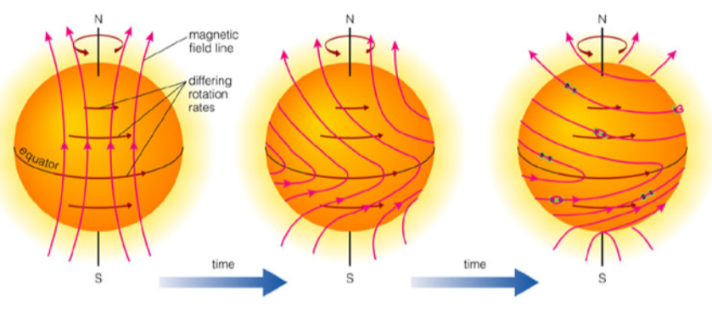

* The Sun rotates more rapidly at equator than at the poles
  + Ionized equatorial gas drags magnetic field lines in twisted configuration
  + Sunspots form where twisted lines break the surface

### Solar Chromosphere

* Transition region above photosphere and below outer corona
* Only visible during an eclipse
* Less dense than photosphere – fainter
* Temperatures between and
* Features flares, prominences, loops
  + **Solar prominence**: magnetic field lines trap ionized gas above photosphere
  + **Solar flares**: whentwisted magnetic field lines “snap”

### Solar Corona

* Outermost part of Sun’s atmosphere
* Low density – very faint
* Temperature
* **Solar wind**: outer parts of corona escape the Sun

## The Sun’s Interior

* **Nuclear fusion**: energy source when hydrogen converts to helium
  + Theory: by-product of reaction is creation of neutrinos (hard to detect)
* Internal pressure (outward) balances gravity (inward):
  + Constant luminosity and temperature means energy emitted = energy produced
* The balance of gravity and pressure and the loss of energy emitted (luminosity) are the principle processes governing all stars
  + Pressure depends on temperature (energy); stars constantly lose thermal energy, which needs to be replenished, or gravity will win
* Luminosity:
  + Constant means constant
  + Constant means and that energy emitted = energy produced
    - Hence, knowing Sun’s age and luminosity, can calculate total energy Sun has produced so far
* **Chemical reactions**:
* **Gravitational potential energy**:
* **Nuclear fusion:**
  + If only 10% of Sun’s H is converted to He:
  + Current solar system age estimate is

### Nuclear Fusion

* In centre of Sun, it is so hot that all atoms have their electrons removed – ionized gas (plasma)
* Most of the gas is hydrogen, so all that’s left is one proton
  + Protons are positively charged, repel each other strongly
  + However, due to high temperature of Sun, protons are moving fast enough to occasionally overcome repulsion and get close enough for **nuclear fusion** – forms helium
    - 4 hydrogen atoms 🡪 1 helium atom + 2 gamma rays, 2 neutrinos, 2 positrons

## Model Predictions and Tests

* Inner => radiation transport, outer => convection
* Helioseismology has shown that the Sun’s outer convection zone extends inward ~1/3 of the radius
* Most of Sun’s mass and energy generation are in a small, central core region
  + Density and temperature peaked at Sun’s core
* **Neutrino detector**: Ray Davis (2012), Arthur McDonald (2015)
* **Solar Neutrino Problem**: detectors found only 1/3 of expected neutrinos

# Lecture 12: Properties of Stars

## Stellar Parallax

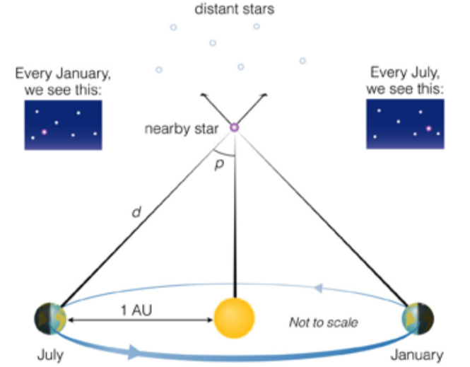

* Motion of Earth around the Sun (once per year) causes an apparent motion of nearby stars relative to more distant background stars
  + Far away stars don’t move around
* Stars appear to move in a loop around the sky once per year
* **Stellar parallax**: angle of motion of stars in reflex to Earth’s movement
  + The closer the star, the larger parallax angle
  + Nearest stars have parallax < 1 arcsec
* Unit of distance: parsec
  + ,
  + Objects with a parallax = 1 arcsec are at a distance of 1 parsec

Example: The distance of 61Cygni is 1.7pc, what is its parallax?

## Stars Closest to the Sun

* Most are within from the Sun
* Not very crowded, lots of binary stars (two stars in orbit around same center of orbit)

## Brightness vs. Luminosity of Stars

* **Brightness**: total light energy collected from an object
  + Depends on distance from emitting object to collecting detector
  + Can also be affected if things block (absorb/scatter) some of the light
* **Luminosity**: total intrinsic light emitted by the object
  + Only depends on properties of emitting object (surface emission properties/surface area)
* – proportional to
  + Further 🡪 same amount of light is spread out over larger area, so energy of light falling on any one square is less for squares further from the source

## The Magnitude System

* Defined by Hipparcos, refined by Ptolemy
* Scale for naked-eye stars – **first magnitude** = brightest stars, **sixth magnitude** = faintest stars visible (larger number = fainter)
* Quantified by Herschel and Pogson:
  + First magnitude star is 100x brighter than a sixth magnitude star (5 magnitudes)
    - 10 magnitudes = brighter
    - 15 magnitudes = brighter
    - Logarithmic scale converts equal ratios of actual intensity to equal intervals of perceived intensity
* **Apparent magnitude**: observed brightness
* **Absolute magnitude (M)**: brightness, in magnitudes, that a star would have at distance ; relates directly to luminosity of star

## The Colours of Stars

* A star’s colour is a direct measure of its temperature (independent of distance)
  + Red stars (x103 K) are cooler than blue stars (x104 K)
* Processes can change the colour of light, especially dust grains in space – reddens starlight
* Measure brightness in particular range of wavelengths, then compare – e.g. brightness in blue vs. red
  + If a star is measured to be brighter in blue than in red, then then star is blue – it is hotter

### Blackbody Spectra

* Peak is shorter for hotter T
* Hotter sources emit more energy (brighter) at all wavelengths
* The Sun (surface temperature 5700K) is brightest in green wavelengths

### Measuring the Colours of Stars

* Colour: ratio of brightness in two wavelengths (magnitude difference)
* **Ratio**: gives the same numerical measure of star’s colour, regardless of distance
* Wavelength response curves for ultraviolet, blue, visible, and eye:
  + UV lowest, eye highest wavelength peak
  + Eye’s best response is in red wavelength; dark eye bluer
* Spectral lines cause a star’s spectra, shape to deviate slightly from BB curve
  + In general, more in red than blue

## Stellar Spectra

* **Continuous**: emission at all wavelengths formed by hot solid or hot high-pressure gas
* **Emission line**: each element, hot low-pressure gas, emits at unique set of wavelengths
* **Absorption line**: each element, as cool low-pressure gas, absorb a unique set of wavelengths from continuous spectrum
* Stars can produce all three spectra, but most produce an absorption spectrum
  + Wavelength patterns in lines: elements in cooler outer layers of star
  + Strengths of lines tell us about density and temperature
* Spectra of hot stars dominated by H, He lines
* Spectra of cooler stars dominated by lines of metals, molecules
  + OBAFGKM – highest to lowest temperature range
  + Decimal number subtypes
  + Roman numerals – differences in widths of spectral lines
  + The Sun – G2V

### The Brown Dwarfs

* Very cool, low in mass, very low in luminosity – do not fit in spectral classification system
* **L dwarfs**
  + Cooler than M9 stars
  + Strong lines of metal hydrides (FeH, CaH, CrH)
  + Water absorption
* **T dwarfs**
  + Even cooler (T < 1400K)
  + Dominated by lines of water and methane

### Stellar Spectra vs. Photometry

* **Spectra**
  + Shows detailed lines and line structure
  + Can determine chemical abundance, rotation, magnetic field strength, radial velocity, etc.
  + Spreads star’s light out to see detail – needs bigger telescopes
  + Good for more detailed information
* **Photometry**
  + Estimates temperature
  + Rough chemical abundances
  + Can use smaller telescopes and observe more stars
  + Good for big, large-scale surveys

## HR Diagrams: Absolute Magnitude vs. Spectral Type

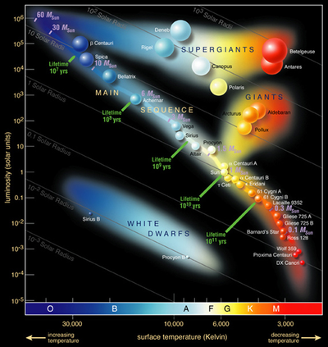

* Vertical axis: luminosity ( = absolute magnitude in V)
* Horizontal axis: **spectral type** (T, colour)
* Modern HR diagram:
  + vs. B-V
    - Absolute magnitudes based on parallax distances from Hipparcos satellite
    - Colours = density of points
* Schematic HR diagram:
  + Most stars lie along a **main sequence (MS)** mass sequence
  + Giant, supergiant, and white dwarfs are different evolutionary stages with wide range of masses
  + Diagonal radius lines
  + For a spherical BB: – luminosity depends on both energy emitted per area and surface area
  + Stars with same surface temperature but different luminosities have different radii and different densities
* HR diagram of nearest stars:
  + **Sample bias = distance**
  + Nearest stars are mostly faint MS – low mass, less massive than Sun
  + Few white dwarfs
  + Few brighter MS stars
  + No giants, supergiant, or massive MS stars

### Nearby Binary System: Sirius A, B

* **Sirius A**: hot MS star with
* **Sirius B**: hot white dwarf star with

### Main Sequence

* Place where stars spend most of their lifetime
* Most massive stars = most luminous (brightest) and hottest (blue)
* Lowest-mass stars are faint and cool (red)
* Stars stay close to one spot on the MS for most of their lives

## Stellar Motions

* Stars must be in motion, since they pull each other together
* **Radial velocity** (Doppler shift) **vs. transverse velocity** (across line of sight) – can only measure transverse motion
* Motions of stars tell us about how gravity acts on the stars – **more motion (higher velocity) = stronger gravity (larger mass)**

## Binary Stars

* Two or more stars in orbit around a common centre of mass
* Useful for measuring mass of stars
* Varieties:
  + **Visual binary**: both stars visibly orbit each other
  + **Astrometric binary**: only one star is visible, moves around sky in loop or wave
  + **Spectroscopic binary**: only one star is visible, no visible motion, but spectrum shows regular periodic motions from doppler shifts
  + **Eclipsing binary**: one star passes in front of the other, blocking some light from reaching us and causing a change in system brightness
* >90% of stars have mass < 1MSun

### Visual Binary System

* Binary systems can be used to measure mass of stars
* In visual binary systems, stars are resolved
* Period determined from motion of one star about the other
* Mass ratio from relative orbital scales – need to know distance to determine true masses

### Spectroscopic Binary System

* Observe periodic changes in spectral wavelengths
* Timescale 🡪 orbital period
* Amplitude 🡪 orbital scale
* Amplitude ratio 🡪 mass ratio

### Eclipsing Binary System

* Observe eclipses – periodic changes in brightness
* Timescale 🡪 orbital period
* Eclipse timing 🡪 ratio of radii
* Eclipse depth/radius 🡪 temperature, luminosity ratios
* Knowledge of distance isn’t needed if system is both eclipsing and spectroscopic

## Mass-Luminosity Relationship

* The most luminous stars are those with the most mass
* The lifetime of stars depends on:
  + Amount of fuel/mass
  + Luminosity: rate at which the star uses up the fuel

# Lecture 13: Stars and Star Clusters

## Major Assumption in Stellar Astrophysics

* If two stars have the same spectra and are on the Main Sequence, then they are identical:
  + Same surface temperature, luminosity, radius, mass
  + Same age?

## Star Clusters

* **Cluster**: group of stars held together by mutual gravity
* Assumption: all stars in a cluster are roughly the **same age** (i.e. formed together at the same time, from the same gas cloud)
* Three types of clusters:
  + **Associations** – 100 stars, probably short-lived
  + **Open clusters** – many thousands of stars
  + **Globular clusters** – spherical balls of 105-106 stars, last longest

### Pleiades (Open Cluster)

* Young open cluster,
* HR diagram:
  + MS region below
  + **Turnoff age** = 108 years (most massive star on MS)

### Globular Clusters

* Oldest identifiable stellar population
* White stars are at a late stage of stellar evolution
* **M80**: Old () and massive ()
* **M4**: , turnoff at

## Using Star Clusters to Estimate Distance

* Offset in brightness between two clusters must be due to distance
* E.g. Pleiades is 7.5x fainter than Hyades
  + Since
  + Hyades must be further away than Pleiades

## Variable Stars

* Stars whose luminosity varies on short timescales
* Most common cause of a variable star is **pulsation** – star increases then decreases in radius
  + Surface temperature also varies during the pulse
  + **Light curve**: luminosity as a function of time
    - Since luminosity depends on both radius and surface temperature, this can result in a variety of light curves
    - As radius increases, surface area increases, but as radius decreases, temperature get hotter
* Main types:
  + **Pulsating**
    - **Cepheid**: period 3-50 days, vary by ~0.2 magnitude, very bright – very identifiable light curve shape
      * Longer period = brighter
      * Very bright, short-lived stars
    - **RR Lyrae**: period < 1 day, absolute magnitude 1.0
    - **Mira**: period 80-600 days, long range in brightness
  + **Eruptive variables**: flare stars, novae/supernovae
  + **Rotating “spotted”** **stars**

### Variable Star Light Curves

* Plot of luminosity as a function of time
* Shape of light curve tells us about the kind of variations in radius and surface temperature that the star is undergoing

## Period-Luminosity Law of Cepheids

* Cepheid variable stars have a simple relationship between period and luminosity
* **Standard candle**: object with well-determined luminosity
  + Knowing and , we can find distance, since
  + Knowing period and luminosity for any Cepheid, we know its distance
  + Powerful, since P/L relation is tight and Cepheids are quite luminous

## Novae

* **Nova** = new star
* Very rare, but once in awhile a star will become ~10,000 times brighter, then fade to less than its original brightness
* Some stars will repeat this behaviour decades or centuries later

## Supernovae

* Estimated that each large galaxy has one supernova every 100-300 years
* A supernova is brighter than all of the rest of the stars in its parent galaxy combined
* Has predictable pattern, so supernova (SNIa) are also standard candles

### Supernova 1987A

* In 1987, first supernova detected with the naked eye in over 300 years

### Supernova Remnants

* We have found leftover remnants after supernova occurrences in the past few centuries
* We have found older remnants too, but we don’t know when they occurred, so age is rough
* **Crab nebula**: Chinese astronomers recorded this star exploding in 1054
* Tycho Brahe described a stellar explosion in 1572

# Lecture 14: Star Formation and the Main Sequence

## The Interstellar Medium (ISM)

* Gas and dust between the stars
* 99% gas, mostly hydrogen; 1% dust that blocks star light
* Interstellar gas is only visible when heated to thousands of degrees by nearby hot, luminous stars
* Dust particles scatter shorter wavelengths more
  + Dust scatter blue wavelengths more, which makes sky blue
  + Dust is less effective at scattering IR radiation

### Dense Interstellar Clouds

* Low-density clouds (lower mass, higher temperature) are generally gravitationally stable
* Higher-density clouds (colder) have enough dust to block visible light from stars
  + **Molecular clouds**: darker, higher-density clouds dominated by molecules (mostly molecular hydrogen) – place where star formation starts
* IR images show star formation, which is hidden in visible light – many stars form from one cloud

### Why Do Interstellar Clouds Collapse?

* Gravity and pressure become unbalanced
  + Gravity depends on mass and distance from mass
  + Pressure depends on density and temperature
* Clouds will collapse if
* **Jeans Mass ()**: maximum stable mass of a star
  + number of particles / cm3

## Cloud Collapse

* A dense cloud contracts and **fragments** to make stars
* Gravity must overcome gas pressure to form stars – cloud must be cool and dense
* If cloud mass is greater than , then gravity wins
  + As a cloud shrinks, increases so decreases; at one point, the cloud will contract because mass becomes greater than

## Main Stages of Star Formation

* **Collapse ()** 
  + Shockwave from supernovae, star-forming region, cloud collision
  + Temperature constant in early stages
* **Fragmentation**
  + Higher cloud density means smaller masses can contract
  + Many cores formed from a single cloud
* **Core to protostar**
  + Gas falling to central core
  + Initially cools, gradually heats
* Cloud core collapses to a disk, and **bipolar outflow** forms along disk rotation axis
  + Contracting fragment always has some overall rotation
  + Conservation of angular momentum means that rotation speeds up as cloud collapses
  + Resistance to collapse in plane perpendicular to rotation axis forms disk
  + Energy lost through jets along rotation axis, slows rotation of protostar
* **Protostar** (luminosity dominated by **accretion**)
  + Central star + accretion disk
  + Bipolar outflow decreases core rotation
  + increase; dust acts as shield and coolant
  + Accretion ends when it gets hot enough to form protostellar wind
* **Pre-main sequence star** (luminosity dominated by **contraction of star**)
  + Surface cooling allows further collapse
  + increase markedly – causes more cooling, collapse
  + Eventually hot enough for H 🡪 He fusion, ending pre-main sequence
  + balances gravity, contraction ends

### Star formation is inhibited by

* Magnetic fields
* Radiation from nearby hot stars

## Star Formation Facts

* **Timescale** more rapid for high-mass stars
* **Upper, lower mass limits**
  + Low mass: allows H 🡪 He fusion
  + High mass: prevents accretion
* Single stars are rare, usually in **clusters** or **associations**
* **First generation stars** lack dust that cools, can have very different formation process

* **Stellar Initial Mass Function/Distribution**: far more low-mass stars are produced than high-mass ones

## Life of Stars on the MS

* Fusion of H to He gradually changes core chemical abundance, from mostly H to mostly He
* As core H is used up and core He increases, reaction rate drops (density of H nuclei is less)
  + This means less energy produced, so core readily contracts to regain balance
  + MS stars maintain slow/steady compensation as long as there is enough H to provided required energy
* **Proton-Proton Cycle (H 🡪 He)**: colliding protons create deuterium 🡪 helium-3 🡪 helium-4
* **CNO Cycle**: in massive stars, core temperature high enough for H 🡪 He reactions with carbon as a catalyst – higher reaction rate, accentuating energy rate difference between low and high-mass stars
* MS lifetime determined by how long H fuel supply lasts
* Reaction rate very temperature-sensitive – more massive stars (hotter cores) produce energy faster
* PP-cycle occurs in small-mass stars, CNO cycle dominates if
* MS stars reach balance between gravity (in) and pressure (out)
  + Luminosity, Radius, Temperature relatively stable – change very slowly
* The MS lifetime of the Sun (a **G2** star) is

### Inside and Outside Changes

* Slow, steady core contraction 🡪 core temperature
  + **Convection** occurs when temperature difference too large for effective radiation, mixes gases in the star
    - High mass: convective core, radiative envelope
    - Intermediate mass: radiation, then outer convection zone
    - Low mass: convective to the core
  + The Sun’s core is **not convective**, so **not mixed**
* Hotter core 🡪 hotter envelope (region outside core)
* Hotter envelope expands 🡪 MS star becomes larger and more luminous

### End of MS Life

* Core contraction accelerates when too little core H to sustain H 🡪 He fusion
* Star’s envelope becomes hotter, expands more rapidly
* Star moves away from MS locale, to next stage

# Lecture 15: Stellar Evolution – Middle Age and Death

## Post-Main Sequence Evolution

* Successive fusion cycles continue until T, needed for next reactions can’t be achieved
* Shorter and shorter core burning stage due to low fuel supply / more T sensitive
* Each stage includes: core collapse, shell heating / fusion reactions, envelope expansion, contraction
* Eventually, envelope shed, leaving core behind

### Differences due to Mass

* : as star expands and cools, moves higher and to the right in HR diagram
* **Low mass** : core struggles to get hot enough for He fusion
  + When core contracts enough, becomes hot and dense enough for helium to form carbon – helium flash
  + Core expands and cools, causing H shell to stop burning; envelope cools and shrinks

## After He Burning

* **Low mass** : not enough mass to make core hot enough for C, O burning
* **High mass** : C, O burning can happen
* **Intermediate mass** :
  + Core collapses – no further fusion
  + To giant branch a second time – 2 shells, H and He burning
  + : core remnant = white dwarf
  + : core remnant = neutron star or black hole

## End of Life

### Low-Mass Star

**Core H-burning** MS star 🡪 **H shell burning red giant** 🡪 **core He-burning** star 🡪 **H, He shell burning** red giant 🡪 **white dwarf / planetary nebula**

* Star runs out of He in the core – core is mostly composed of carbon
* He fusion continues in shell around core, and H fusion continues in shell further from centre
* Carbon core contracts, and envelope of star expands
* Before core gets hot/dense enough for other reactions, star envelope ejected
  + Driven by instability and high temperature dependence of shell reactions
* Core remnant: **white dwarf**
* Expanding envelope: **planetary nebula**

### High-Mass Star

**Core H-burning (CNO cycle)** MS star 🡪 **red H shell burning supergiant** 🡪 **blue core He-burning supergiant** 🡪 **supernova**

* Core becomes hot/dense enough for further reactions
  + Many possible reactions – often use He and C, since core H completely used up
  + Reactions tend to release energy
    - Fusion of elements below iron (e.g. He, C, O) produces energy
    - Elements beyond iron (e.g. lead, uranium) require energy
* Star responds to each additional “burning stage” by re-adjusting overall structure
* Core is eventually composed of iron, which **cannot fuse** to produce more energy
* Core contracts, envelope expands
  + As core gets hotter/denser, burning shells around core produce energy at much higher rate
  + Star explodes as core implodes, forming a **supernova**
  + Protons in core forced to turn into neutrons – star emits huge number of neutrinos, accelerating exploding star outside of core
  + Core left as a pure ball of neutrons

## The Origin of the Elements

* When a star explodes, a lot of energy available – many high-energy particles (especially neutrons) flying through stellar material
* When a supernova explodes, it expels heavy elements into space and produces new elements

## Stellar Remnants

* Small, dense, no fusion
* Masses from to
* Constant radii, gravity-pressure balance

### White Dwarfs

* **Progenitor mass**:
* **Black hole mass**:
* No internal energy source, so white dwarf cools
* Supported by electron degeneracy pressure
* depends only on density and number of electrons (not dependent on T)
* The more massive the star is, the smaller it is

### Neutron Stars

* **Progenitor mass**:
* **Black hole mass**:
* Smaller, denser than white dwarf
* Core remnant of supernova
* Supported by neutron degeneracy pressure
* neutron star = few km in diameter
* **Pulsar**: rapidly-rotating, magnetized neutron star
  + Radiation beams from magnetic poles, which aren’t in the same places as the rotation poles

### Black Holes

* **Progenitor mass**:
* **Black hole mass**:
* So dense that light cannot escape -
  + Theoretical end to evolution of massive stars
  + Theoretically, there are mini-black holes from formation of Universe
  + Centres of galaxies believed to have supermassive black holes

## Stellar Evolution and Binary Stars

* As a star expands, mass transfer to its companion star is possible
* Three consequences:
  + **System with “massive star” and white dwarf** – white dwarf initially the more massive component
  + **Nova** – sudden ignition of surface fusion of material from companion
  + **Type Ia Supernova** – white dwarf mass exceeds Chandrasekhar limit, ignition of C burning

### Evolution of a Close Binary System

* More massive star evolves to giant then supergiant
* Outer envelope mass transferred from expanded star to less massive companion, which can eventually become the more massive one
* Two types of supernova:
  + Type I – binary system
  + Type II – massive single star collapse

### Neutron Star Binaries

* Not stable – lose energy by gravitational radiation, spiral together, and merge
* Explosion results

# Lecture 16: The Milky Way

## The Interstellar Medium

* Made up of:
  + **Hydrogen**: most common – 3 states: molecular H2, neutral HI, ionized HII
  + **Other elements**: common molecules, neutrals, ions
  + **Other components**
    - Cosmic rays: energetic protons, neutrons, nuclei
    - Magnetic fields:
    - Dust: solid phase material
* Diatomic, triatomic, and even larger molecules discovered in ISM

### Interstellar Dust

* 1% of ISM, by mass
* Obscures, reddens, and polarizes visible light (by scattering bluer photons)
* Dust grains size: 10–200 nm
* Dust grains are probably the site of many **chemical reactions** – severe depletion of C, N, O
* They are also good infrared radiators – makes them good coolants

### ISM Structures

* **Diffuse interstellar clouds**: low extinction, HI clouds
* **Molecular clouds**: high extinction
  + Densest, coolest part of ISM (~10K) – place where stars are made
  + Most of mass of clouds are H2 and He, then CO
* **Diffuse intercloud medium**: warm and hot component
* **HII regions**: massive, hot, short-lived stars – birth sites of massive stars; emit UV, ionizing nearby hydrogen
* **Supernova remnants**: only ~150 known in the Galaxy – responsible for chemical evolution

### The Cosmic Cycle of the Elements

Star formation 🡪 stellar burning (heavy element formation) 🡪 supernovae/stellar winds 🡪 hot bubbles 🡪 atomic-hydrogen clouds 🡪 molecular clouds 🡪 repeat

* Stars form from interstellar gas
* Stars convert elements to heavier elements
* When stars die, they put some enriched gas back into ISM
* Next generation of stars form more enriched materials
* As a result, “metallicity” of universe is constantly increasing

## Distance Scale in the Milky Way

* **Trigonometric parallax**: good to 10pc from ground, 1000pc from satellite
* **Kinematic distances**: knowing rotation curve of Galaxy, infer distance from radial velocity; useful for HI gas in Milky Way disc
* **Standard candles**: objects whose intrinsic luminosity (absolute magnitude) is known
  + Useful for general direction beyond 1kpc
  + Main sequence fitting: compare observed HR diagram to calibrated HR diagram
  + Variable stars: Cepheid and RR Lyrae variables (calibrated period-luminosity relations), Supernovae Ia for larger distances

### The Scale and Structure of the Milky Way

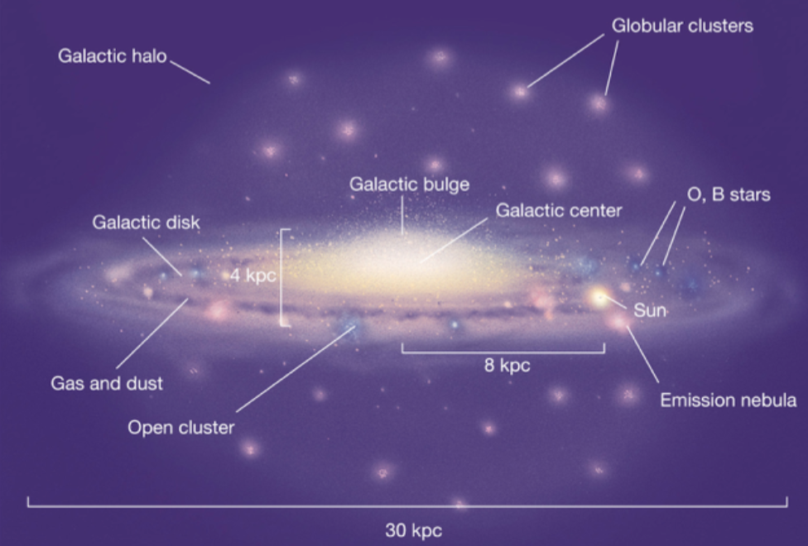

* Observations of RR Lyrae, then MS fittings of globular cluster CMDs estimate that Earth is ~F (24,000 light years) from center of Galaxy
* **Galactic disc**: young and old stars, gas, dust
  + We live in its outskirts
  + Objects in the disc have almost-circular orbits in nearly the same plane
  + Objects oscillate due to pull of disc
  + Contains **spiral arms**: bright, patchy features that spiral out from near the centre of the Galaxy to the edge
    - Interstellar material and star formation concentrated in spiral arms
* **Galactic halo**: old stars only
  + Objects in the halo have more random, elliptical orbits – no systematic motion
  + Objects regularly pass through the disc
* Orbit speed/distance based on mass

### Rotation Curves

* Plot of orbital velocity (rotation) vs. distance from centre of mass of orbit
* drops rapidly as distance increases
* **Solid bodies (e.g. spiral galaxy discs)**: rotate so that all parts share the same amount of rotation
  + Hence, parts further from centre of rotation must move faster

### Rotation Curve of the Milky Way

* Large mass = larger orbital velocity to travel in a circular orbit at a given distance
* Larger distance (for fixed mass) requires small velocity for circular orbit
* Rotation curve of Milky Way is nearly flat out to 20kpc
  + Estimated that
  + **Total visible mass**:
  + Why do we detect 10-20x more mass than we see? Dark matter

## Dark Matter

* Matter detected gravitationally, but no light detected from these objects
* Possible candidates (no explanation so far):
  + Dark/brown dwarfs
  + Planets
  + Rocks
  + Exotic particles
* **Gravitational lenses**: new technique expected to tell us more about nature and distribution of matter in Universe

### Spiral Density Wave Model

* **Winding Dilemma**: spiral arms in a differentially rotating disc will wind up in a few rotation periods – arms should be getting tighter quickly
* Stars and gas pass through wave where they slow down temporarily, as they orbit the Galaxy
* Area where material moves more slowly will have higher density
* Stars and gas closer to centre move faster, creating density waves that lead to star formation
* The centre of the Milky Way is thought to be a **supermassive black hole**,

# Lecture 17: Galaxies

## Types of Galaxies

* **Spirals**: (e.g. Milky Way) disks, bulges, spherical halos, spiral arms; gas and dust, active star formation
  + Spiral arm structure can vary greatly
* **Lenticulars**: disks, bulges, halos, no spiral arms; little gas and dust, no star formation
* **Ellipticals**: large, rounded ball of stars, no disks; little gas and dust, no star formation
  + Classified by “ellipticity” – e.g. E3 more elliptical than E2
  + Vary greatly in size ()
* **Barred spiral**: spiral galaxy with bar in the middle
* **Irregulars**: no obvious structure, lots of gas and dust, star formation

## The Extragalactic Distance Scale

* **Cepheid variable stars**: good up to distances of 25Mpc
* **Hubble Law**: expansion of universe
* **Tulley-Fisher**: more massive galaxies are more luminous
* **Type Ia Supernovae**: larger distances

### Cosmic Distance Scale

* Radar ranging – solar system
* Parallax – nearby stars
* MS fitting – Milky Way
* Cepheid variable stars – nearby galaxies
* Distant standards – galaxy clusters

## Hubble Law

* A galaxy’s radial velocity correlates with distance to the galaxy
  + Virtually all galaxies are moving away from Milky Way
  + Distances between galaxies are increasing
* Plot radial velocity vs. distance – slope = Hubble’s constant
* Galaxy radial velocity often referred to as **redshift** : fractional change in measured wavelength ( is very large change in wavelength)

## Peculiar Galaxies

* Some galaxies are very bright at an unusual wavelength
* Some galaxies are very bright in one place
* **Tidal tail**: caused by interaction with another galaxy
* **Starburst galaxy**: star formation triggered by merging of two galaxies

### Active Galaxies

* Extremely high luminosity – usually luminous at radio wavelengths
  + Common at large distances, rare close to us
  + Large radio structures or high luminosity in infrared wavelengths, are signs
    - Many galaxies are radio sources
* **Quasars**: most extreme – very distant, young objects
  + Redshift – extremely distant
  + Compact = very luminous galactic nuclei
  + Spectra contains both thermal and non-thermal components
* Plasma emitted from energetic galactic centre moves at nearly the speed of light
* **Radio galaxy**: double-lobed structure, various scales and shapes

### Active Galactic Nuclei (AGN) Model

* Supermassive black holes create radio jets via interactions between electrons and strong magnetic fields
* Evidence suggests all large galaxies have central supermassive black holes that correlate with galaxy’s mass
  + Accretion disc surrounding a supermassive black hole

### Galaxy Clusters

* 30-50 galaxies within 1pc
* Galaxies are found in groups, clusters, and superclusters
* The number of galaxies >> number of stars in the Milky Way
* **The Local Group**: small group of galaxies containing Milky Way
* Hickson 67, Abell 1185 are other galaxy clusters
* **Hubble Deep Field Image**: “deepest” image ever taken by humanity

# Lecture 18: The Expanding Universe

## Measuring Galaxy Masses

* **Rotation curve**: works well for nearby, spiral galaxies; best measured from HI or HII gas
  + Force of gravity from a spherical mass is the same, regardless if mass is small or large in volume
  + Force of gravity from inside a spherical mass is zero
  + For flat rotation curve, mass increases with distance
  + Luminous galaxies sit within more massive dark matter halos
* **Velocity dispersion**: measures spread in velocities from width of spectral lines – spread depends on mass
  + The wider the spectral line, the faster stars move relative to each other
* **Motions of galaxies in orbit** around each other or in a cluster
  + Pairs of galaxies orbit each other – only radial velocity (no transverse motion)
* **Doppler Shift**: can measure the rate at which galaxies rotate – rate determined by mass

### Measuring the Mass of a Cluster

1. Measure speeds and positions of galaxies within cluster
   * Measure orbital velocities about and distance from cluster centre
   * Apply Kepler’s Law to calculate mass of cluster
2. Measure temperature and hot gas distribution between galaxies
   * Hot gas between galaxies emit X-rays
   * From X-ray spectrum, calculate temperature 🡪 average speed of gas particles
   * Mass estimate = mass required to retain the hot gas
3. Observe how clusters bend light as gravitational lenses
   * Based on Einstein’s Theory of Relativity – massive objects distort spacetime
   * Massive clusters bend light approaching it
   * Angle that light is bent at depends on mass of galaxy
     + **Strong lensing**: large, distorted images; needs good alignment
     + **Weak lensing**: more subtle effect; more common, but harder to measure

### Gravitational Lensing

* One galaxy in the foreground can act as a lens for galaxies in background
* **Einstein Cross**: background quasar lensed by foreground galaxy

## Mass-to-Light Ratio

* Mass of galaxy divided by its luminosity (both in Solar units)
  + Within orbit of Sun, for Milky Way
  + Inner regions of elliptical galaxies:
* Including outer regions of galaxies, increases dramatically – for most galaxy clusters,
* This means that most of the matter in galaxies aren’t stars, but **dark matter**

## Dark Matter

* What is it made up of?
  + Possibly **baryonic matter**: protons, neutrons, and electrons
  + Some or all dark matter could be made up of **non-baryonic matter** – particles we have yet to discover
  + **WIMPs**: weakly interacting massive particles – theoretical
* Dark matter is found in the halo and far beyond the luminous regions of galaxies
* Visible galaxy is embedded in dark matter halo

## Expanding Universe – The Big Bang

* The scale of the Universe is growing
* The Universe used to be much smaller – galaxies were much closer together
* Gravity must act to slow expansion by pulling things together
  + Expansion should’ve been faster in the past, get slower in the future
* The Universe started out very dense, expanding at a high rate, similar to an explosion
* The Universe was very hot at the beginning, then cooled as it expanded

### The Critical Density

* Gravitational attraction between galaxies can overcome expansion of the Universe in localized regions
* **Critical density**: mass density required for gravitational pull to equal kinetic energy of the Universe
  + If mass density < critical density, Universe will expand forever (**open**)
  + If mass density > critical density, Universe will stop expanding, then contract (**closed**)
* If constant expansion rate (empty Universe), then
* If at critical density (flat Universe), then
  + Lower age because gravity slowed expansion rate
  + tells us the current kinetic energy of the Universe

### Does Gravity Alone Influence Expansion?

* Recent observations of white dwarf supernovae in very distant galaxies () found that the supernovae appeared fainter than expected
* At larger distances, looking further into the past – hence, if Universe is slowing down, galaxies should move faster the further back we look
* However, high-redshift supernovae moving slower than even the models of an ever-expanding (empty) Universe predict
* This means there must be a yet-unknown **dark energy** – force that repels galaxies

## Four Models for the Future of the Universe

1. **Re-collapsing Universe**: expansion will halt someday and reverse
2. **Critical Universe**: no collapse, expand more slowly over time
3. **Coasting Universe**: expand forever with little slowdown
4. **Accelerating Universe\***: expansion will accelerate with time

* Acceleration affects age, since is only current rate of expansion:
  + Accelerating Universe is older than
  + Decelerating Universe is younger than

# Lecture 19: The Big Bang

## Evidence for the Big Bang Model

* Two predictions that have been verified since 1960s:
  + Leftover heat of initial explosion is still at a temperature of 3K and appears as a blackbody would – strongest emission at microwave wavelengths
  + Expected helium abundance in the Universe

### Cooling Universe

* Temperature of universe has cooled over time
* Its BB spectrum has become redder – now strongest in radio wavelengths

## Cosmic Microwave Background

* When universe cooled to ~3000K, free electrons became bound to H and He
* Photons from recombination were emitted, travelled unhindered throughout universe
* Universe became transparent (before, it was filled with particles that absorb photons)
* Universe has expanded / red shift by a factor of 1000, as universe cooled from 3000K to 3K
  + **Microwave** emission from every direction, brightness consistent with temperature of 3K

### Radiation from Universe at ~380,000 Years Old

* **COBE**: Cosmic Background Explorer mapped the entire sky 1989-1993
* **WMap**: higher CMB resolution
* **Planck Satellite**: bigger telescope, even finer resolution
  + Measured all 8 fundamental parameters of the Universe very accurately – little evidence that more precision is needed
* CMB slightly hotter by ~0.003 K in one direction than the other – due to Earth’s relative motion to it
  + Smooth and uniform
* After subtracting Earth’s motion, there were slight temperature variations on a few parts of 100,000
  + Any point in the sky is within +/-0.00001 of mean brightness
  + Fluctuations show that early universe was not perfectly smooth
* Position of peak of multipole moments gives age of Universe: 13.798 +/- 0.037 billion years

## Composition of Universe

* 68.3% dark energy
* 26.8% dark matter
* 4.1% free hydrogen and helium
* 0.5% stars

## Early Universe Conditions

* Most distant galaxies – when Universe was a few billion years old
* CMB prevents us from viewing light before Universe was 380,000 years old
* Running the current conditions/expansion of Universe backwards, can predict temperature/density of Universe at any time in its history
  + At earliest times, Universe was so hot and dense that forces of nature acted differently than they do today
  + Universe is dominated by energy, not matter – very high energy photons (gamma rays)

### The Creation of Matter

* Early Universe was filled with radiation and subatomic particles
* Matter can be converted into energy:

### The Destruction of Matter

* When two identical particles of matter and antimatter collide, they form **gamma photons**
* During first few moments of Universe, matter and radiation (energy) were constantly converting into each other
  + Total amount of mass-energy remained constant

## History of the Universe

### Planck Era ()

* All four natural forces (gravity, electromagnetic, strong nuclear force, weak force) unified during this era

### Grand Unified Theory (GUT) Era ()

* Two natural forces: gravity and GUT force (electromagnetic, strong nuclear force, and weak force, unified)
* By end of era, Universe had cooled to
  + Strong force “froze out” of GUT force
  + Energy released caused sudden and dramatic inflation of Universe size

### Electroweak Era ()

* Three natural forces: gravity, strong, and electroweak
* By end of era, Universe had cooled to
  + Electromagnetic and weak forces separated

### Particle Era ()

* Four distinct natural forces
* Particles as numerous as photons
* Quarks combined to form protons, neutrons, and their anti-particles
* By end of era, Universe had cooled to
  + Remaining particles and anti-particles annihilated each other into radiation
  + Slight imbalance in number of protons and neutrons allowed matter to remain
* Electrons and positrons still being formed from photons

### Era of Nucleosynthesis ()

* Protons and neutrons start fusing, but also torn apart from high temperatures
* By end of era, Universe had cooled to – fusion stopped, stable nuclei
  + 75% hydrogen nuclei
  + 25% helium nuclei
  + Trace amounts deuterium and lithium nuclei
* Around 7:1 proton-neutron ratio

### Era of Nuclei ()

* Universe is hot plasma of H and He nuclei and electrons
* By end of era, Universe had cooled to
  + Electrons combined with nuclei to form stable H and He atoms
  + Universe went from opaque to transparent, became dominated by matter

### Era of Atoms ()

* **Cosmic Dark Ages** – Universe filled with atomic gas
* Density enhancements in gas + gravitational attraction by dark matter form protogalactic clouds
  + First star formation
  + Provokes formation of galaxies

### Era of Galaxies ()

* First galaxies existed ~1 billion years after Big Bang

## Shortcomings of Big Bang Model

1. *Why is the large-scale Universe so smooth?*
   * Traditional Big Bang model doesn’t explain how two disparate parts of the Universe can have the same temperature – uniform CMB in all directions
   * **Inflation**: rapid and large-scale change – explains smoothness and flatness of Universe
     + When strong force froze out of GUT force, should’ve released enough energy to expand universe by times in less than seconds
2. *Why is the density of matter almost the critical density?*
   * Gravitational pull of Universe balances kinetic energy of expansion
     + If matter were 10% more dense, Universe would’ve collapsed
     + If matter were 10% less dense, galaxies would’ve never formed
   * According to General Relativity, imbalance of energies would curve spacetime
   * Rapid inflation balances/flattens spacetime
3. *Where does structure come from?*
   * Density of matter in early Universe had to differ slightly from place to place, or galaxies would never have formed
   * Inflation likely magnified quantum ripples – large ripples in energy are seeds for density enhancements

* Overall geometry of Universe is flat
* **Dark matter** makes up ~25% of critical density
* **Baryonic matter** makes up ~5% of critical density
* This implies that **dark energy** makes up remaining 69%
* Age of universe:

# Lecture 20: The Formation of Structure in the Universe

## The Large Scale Strcuture of the Universe

* Large surveys of many galaxies can be used to map out distribution of galaxies
* Galaxy survey strategies:
  + Pencil beam: survey small area but go deep
  + Slice: survey large area but not as deep
* Long chains/sheets of galaxies and galaxy clusters (superclusters) surrounding great voids
  + Chains come from initial regions of density enhancement
  + Voids come from initial regions of density depletion
* At some very large scale, Universe is uniform; at smaller scales, galaxies not spread uniformly

## Modelling Galaxy Formation

* Current telescopes can’t see back to when galaxies were formed – must use theoretical computer models
* Assumptions:
  + Universe was uniformly filled with H and He during first million years after Big Bang
  + Some regions were slightly denser than others
* At first, all H and He gas expanded with the Universe
* After , denser regions slowed down and began to collapse under self-gravity, forming **protogalactic clouds**
  + Clumping + collapse aided by presence of dark matter – forms **halo stars**
  + Remaining gas forms into spinning disk
  + Billions of years later: ongoing star formation inside disk, none outside due to lack of gas in halo
* Structure develops in many places independently, then merges

### What Determines Galaxy Type?

* Initial conditions of protogalactic cloud
  + **Protogalactic spin**: initial angular momentum – how fast a cloud will form a disk before it is completely turned into stars
  + **Protogalactic cooling**: initial density – how fast cloud can form stars before it collapses into a disk
* Later interactions with other galaxies
  + When two spiral galaxies collide, tidal forces randomize orbits of stars
  + Gas either falls to the centre (forms stars) or is stripped out of galaxies (disk removed)
  + Resulting galaxy becomes **elliptical**
  + **Ring galaxy** – ring = gas shocked by intruder
  + **Polar ring galaxy** – disk galaxy disrupted by capture of gas from nearby galaxy
* Combination of both
* Central black hole mass correlates with galaxy luminosity
  + Hence, initial gravitational potential must also play a part

### Models of Galaxy Formation

* **Hierarchical**: lots of small galaxies form, then merge to make bigger ones
  + Problem: simulation leaves too many small ones around
* **Monolithic**: large clouds of inter-galactic gas collapse to form large galaxies
  + Problem: difficult to make large clouds of gas in such short time
* Combinations

# Lecture 21: Extraterrestrial Life

## Astrobiology

* Recent advances in astronomy and biology has renewed interest in life on other worlds
  + Discovery of extrasolar planets
  + Indications that liquid water can exist on other worlds
  + Organic molecules found throughout solar system and galaxy
* Astrobiology explores:
  + Is there intelligent life in our galaxy?
  + Can we communicate with other forms of life?
  + How did life originate in our planet?
    - Endogenous – spontaneously
    - Exogenous – carried to Earth by something
* It is easy to produce building blocks of life (e.g. amino acids), but hard to turn them into life
  + Life can exist under very harsh conditions
    - But water is common factor
  + Evidence that life appeared early in Earth’s history
* **Dense interstellar clouds**
  + Dusty, cold, and dark – nearly everything freezes to microscopic grains
  + When UV and cosmic rays bombard, breaks bonds into more complex organic molecules
* **Murchison Meteorite**: evidence of organic matter shows that chemical evolution occurred elsewhere
* But exploration of solar system reveals no sign of large civilizations – instead, search for microbial life

### Mars – Best Candidate for Extraterrestrial Life?

* Was apparently warm and wet for some periods in distant past
* Conditions similar to Earth, made it possible for life to evolve
* Had chemical ingredients for life
* Had significant amounts of water ice
* Pockets of underground liquid water may exist if there is still volcanic heat
* **Viking Lander** searched for life on Mars – found products of respiration/metabolism but no organic molecules
* **Martian meteorites** landed on Earth contained complex organic molecules and crystal chains like those produced by bacteria on Earth
  + Could’ve been contaminated by Earth bacteria
  + Structures could also be formed by chemical or geological processes

### Life on Jovian Moons?

* Europa may have ocean of liquid water beneath its surface, kept warm from tidal heat
* Ganymede and Callisto may also have subsurface oceans
* Titan has thick atmosphere of methane and ethane, and frozen water

### Life in Other Planetary Systems

* What are requirements for planet to produce life as we know it?
  + Liquid water
  + Old enough for life to evolve
  + Star survives long enough for life to evolve
  + Development of planetary crust – planet has to cool
  + Stability of life-sustaining conditions
* Which stars make good Suns?
  + Must be **old enough** for life to arise in a few – rules out O and B MS stars
    - Best bet:
  + Must allow **stable planetary orbits**
    - Binary star systems are not good places for life
  + Must have relatively large **habitable zones** (region where large terrestrial planet can have surface temperature allowing water to exist as liquid)
    - Below , habitable zone shrinks rapidly

## Earth-Life Planets

* Too small to be resolved with current technology
* **Kepler mission** measured light curves to look for transits of Earth-sized planets, and looked at orbits to see if they were within star’s habitable zone
  + At least one billion habitable zone planets
  + However, M dwarfs (most common stars) often exhibit flaring that can erode planetary atmospheres and shower planets with X-rays
* **Terrestrial Planet Finder** – interferometer that will take spectra of Earth-sized extrasolar planets to look for absorption lines of ozone and water

### Rare-Earth Hypothesis

* Life on Earth resulted from series of lucky coincidences
  + Terrestrial planets can only form around stars with large amounts of heavy elements
  + Jupiter shields Earth from comets and asteroids
  + Earth has plate tectonics to allow CO2 cycle – stabilizes climate
  + Moon, result of chance impact, keeps Earth’s axis stable
* Life may be rare because there are so many factors that must be overcome to allow life to thrive

## Drake Equation

* Estimates the number of civilizations detectable at radio wavelengths
  + rate of forming of stars
  + fraction of stars with planets
  + number of planets in habitable zone
  + fraction where life developed
  + fraction where intelligent life developed
  + fraction that communicate
  + lifetime of communicating civilization
* number of habitable planets in Milky Way ()
* fraction of habitable planets that have life (could be close to 1 or 0)
* fraction of planets with life capable of interstellar communication
* fraction that exist now

### Search for Extraterrestrial Intelligence (SETI)

* If we are typical of intelligent species and there are many intelligent species out there, then some of them may also be interested in making contact
* Use radio telescopes to listen for encoded radio signals
  + Scan millions of frequencies at once

## Fermi Paradox

* Assuming most civilizations take ~5 billion years to arise – where are the aliens?
* Possible solutions:
  + Life is rare – they are nowhere and nowhen
  + Intelligent life is rare
    - Great Filter may restrict evolution
  + Intelligent life is abundant but quiet – not interested or too difficult to communicate
* Interstellar travel is difficult – distance between stars is huge, and we will most likely be limited by speed of light
  + Require new engines and new energy sources to travel to stars within human’s lifetime
    - Nuclear-powered engines – not fast enough
    - Matter-antimatter engines – but antimatter does not exist naturally
    - Ships that do not carry own fuel – harness photon pressure from sunlight
* **Anthropic principle**
  + Weak: existence of life imposes selection effect on where and when we observe the Universe
  + Strong: presence of observers imposes constraints on physical constants of Universe