Output to multiple doc formats

Like HTML and Word and PDF

Katy Perry

Jeremy Allen

2023-07-07

This publication is NOT the annual National Marine Fisheries Service (NMFS) yearbook of fishery statistics for the United States for 2020. It’s a grab-bag of pieces put together for demo purposes only. The report provides, maybe, data on U.S. recreational catch and commercial fisheries landings and value as well as other aspects of U.S. commercial fishing. In addition, data are reported on the U.S. fishery processing industry, imports and exports of fishery-related products, and domestic supply and per capita consumption of fishery products.

Contents

# 2020 FISHERIES OF THE UNITED STATES

## Status of Stocks - how to get rich quick

Status of Stocks is an annual report to Congress on the status of U.S. fisheries and is required by the Magnuson-Stevens Fishery Conservation and Management Act.[1] This report, which is published each spring, summarizes the number of stocks on the overfished, overfishing, and rebuilt lists for U.S. federally managed fish stocks and stock complexes. The report also shows trends over time, discusses the value and contributions of our partners, and highlights how management actions taken by NOAA Fisheries have improved the status of U.S. federally managed stocks.(Hallegraeff, Enevoldsen, and Zingone 2021; Song, Zhang, and Yu 2021)

|  |
| --- |
| Fish Stocks |

## Fisheries of the United States

Fisheries of the United States, published each fall, has been produced in its various forms for more than 100 years. It is the NOAA Fisheries yearbook of fishery statistics for the United States. It provides a snapshot of data, primarily at the national level, on U.S. recreational catch and commercial fisheries landings and value. In addition, data are reported on U.S. aquaculture production, the U.S. seafood processing industry, imports and exports of fishery-related products, and domestic supply and per capita consumption of fishery products.

|  |
| --- |
| Map |

## Island Reporting

Data were collected and made available by [Dr. Kristen Gorman](https://www.uaf.edu/cfos/people/faculty/detail/kristen-gorman.php) and the Palmer Station, Antarctica LTER, a member of the [Long Term Ecological Research Network](https://lternet.edu/).

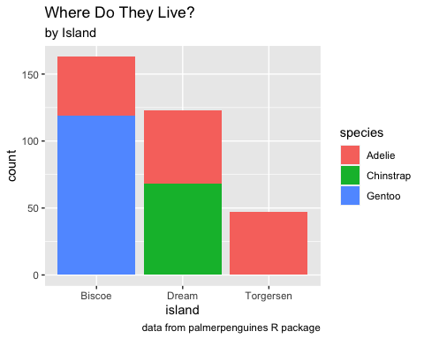

## U.S. Marine Recreational Fisheries

NOAA Fisheries’ Marine Recreational Information Program (MRIP) is the state-regional federal partnership that develops, improves, and implements a national network of surveys to estimate how many fish anglers catch and how many trips they take. It provides a snapshot of data, primarily at the national level, on U.S. recreational catch and commercial fisheries landings and value. In addition, data are reported on U.S. aquaculture production, the U.S. seafood processing industry, imports and exports of fishery-related products, and domestic supply and per capita consumption of fishery products. The report also shows trends over time, discusses the value and contributions of our partners, and highlights how management actions taken by NOAA Fisheries have improved the status of U.S. federally managed stocks.

## Acknowledgments

I am grateful for the insightful comments offered by the anonymous peer reviewers at Books & Texts. The generosity and expertise of one and all have improved this study in innumerable ways and saved me from many errors; those that inevitably remain are entirely my own responsibility.

### References

Hallegraeff, Gustaaf, Henrik Enevoldsen, and Adriana Zingone. 2021. “Global Harmful Algal Bloom Status Reporting.” *Harmful Algae* 102 (February): 101992. <https://doi.org/10.1016/j.hal.2021.101992>.

Song, Xiuxian, Yue Zhang, and Zhiming Yu. 2021. “An Eco-Environmental Assessment of Harmful Algal Bloom Mitigation Using Modified Clay.” *Harmful Algae* 107 (July): 102067. <https://doi.org/10.1016/j.hal.2021.102067>.

1. The real report is here https://www.fisheries.noaa.gov/resource/document/fisheries-united-states-2020, but I copied and jumbled a lot of the text and graphics for demo purposes.