Machine Learning Approaches for Early Diabetes Risk Detection
A comparative analysis on the Pima Indians Diabetes Dataset

1. Introduction
Diabetes mellitus is one of the most prevalent chronic conditions worldwide, affecting more than 530 million adults globally according to the International Diabetes Federation. Early identification of at-risk individuals is critical because lifestyle interventions started before clinical diagnosis can delay or prevent the onset of type 2 diabetes. Traditional risk scoring relies on a small number of hand-picked variables; machine learning offers an opportunity to combine many indicators at once and produce calibrated, individual-level risk estimates.
This project evaluates whether standard supervised learning models can predict diabetes status from eight routine health indicators, and which features the models rely on. The research question is: can machine learning models accurately predict diabetes risk based on patient health indicators?

2. Dataset
The Pima Indians Diabetes Dataset contains 768 female patients of Pima Indian heritage aged 21 or older, with eight clinical features and a binary outcome (diabetes diagnosed: yes / no). Roughly 35 % of patients in the dataset are diabetic.
Variables:
- Pregnancies — number of times pregnant
- Glucose — plasma glucose concentration after a 2-hour oral glucose tolerance test (mg/dL)
- BloodPressure — diastolic blood pressure (mm Hg)
- SkinThickness — triceps skinfold thickness (mm)
- Insulin — 2-hour serum insulin (mu U/ml)
- BMI — body mass index (kg/m²)
- DiabetesPedigreeFunction — genetic risk score derived from family history
- Age — age in years
- Outcome — 1 if diabetes was diagnosed within five years, 0 otherwise
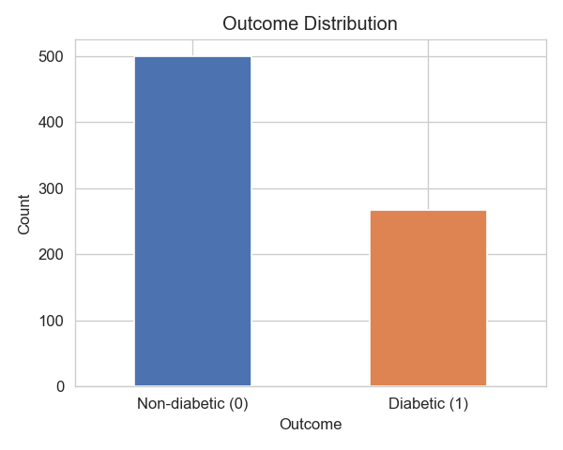
Figure 1. Outcome class balance — approximately 65 / 35 non-diabetic to diabetic.

3. Methodology

3.1 Data cleaning
Inspection revealed that five physiological columns — Glucose, BloodPressure, SkinThickness, Insulin, and BMI — contained zero values that are biologically implausible (a living patient cannot have BMI = 0). These zeros were treated as encoded missing values and replaced with NaN. Missing values were then imputed using the column median, which is more robust to the right-skewed distributions of Insulin and SkinThickness than the mean.

3.2 Exploratory analysis
Histograms and boxplots compared the distributions of each feature across the two outcome classes. Diabetic patients show markedly higher glucose and BMI than non-diabetic patients; age and insulin show smaller but visible shifts. The correlation matrix confirms Glucose as the variable most strongly associated with the outcome.
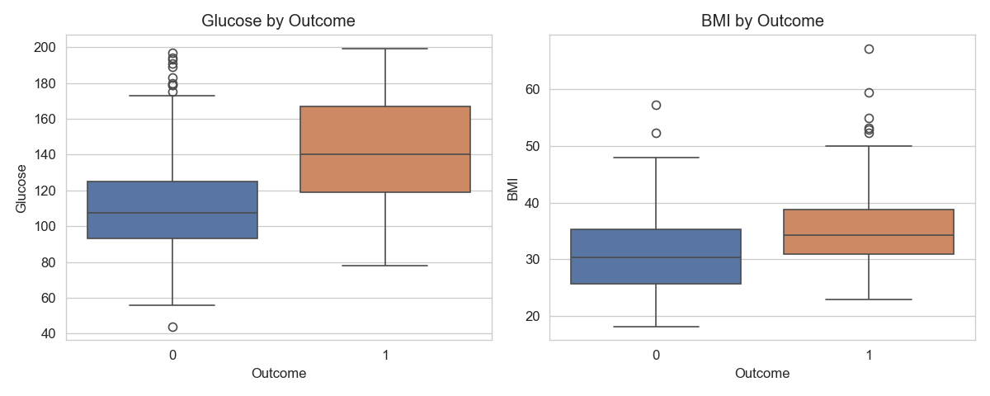
Figure 2. Glucose and BMI distributions by outcome.
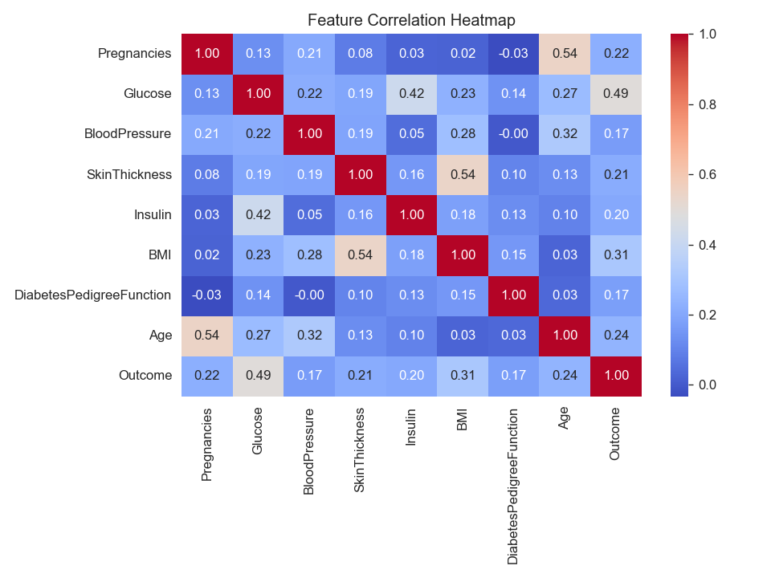
Figure 3. Pairwise feature correlations.

3.3 Preprocessing and split
Features were separated from the outcome and the data was split 80 / 20 into training and held-out test sets, stratified by outcome to preserve the class balance. Features were standardized (mean 0, variance 1) for the Logistic Regression model; the Random Forest was trained on raw values, as tree-based models are invariant to monotonic feature transformations.

3.4 Models
Two models were trained and compared:
- Logistic Regression — a linear baseline favoured in healthcare for its interpretability (each coefficient is a log-odds contribution).
- Random Forest — an ensemble of 200 decision trees, which captures non-linear interactions between features and yields out-of-the-box feature importance scores.
The original project plan also included an XGBoost gradient-boosted classifier. It was excluded from this run because the local environment lacks the libomp system library required by the XGBoost binary; integrating it remains a straightforward future extension.

3.5 Evaluation metrics
Models were evaluated using accuracy, precision, recall, F1-score, and ROC-AUC on the held-out test set. In a clinical screening context recall (sensitivity) and ROC-AUC are the most important metrics: a false negative — failing to flag an at-risk patient — carries a higher cost than a false positive, which can be resolved by a follow-up test.

4. Results

4.1 Performance summary
Model | Accuracy | Precision | Recall | F1 | ROC-AUC
Logistic Regression | 0.7078 | 0.6000 | 0.5000 | 0.5455 | 0.8130
Random Forest | 0.7403 | 0.6522 | 0.5556 | 0.6000 | 0.8166

Random Forest outperformed Logistic Regression on every metric. It achieved an accuracy of 0.740, recall of 0.556, and ROC-AUC of 0.817 versus Logistic Regression's accuracy of 0.708, recall of 0.500, and ROC-AUC of 0.813. The gap in ROC-AUC is small but consistent.

4.2 ROC curves
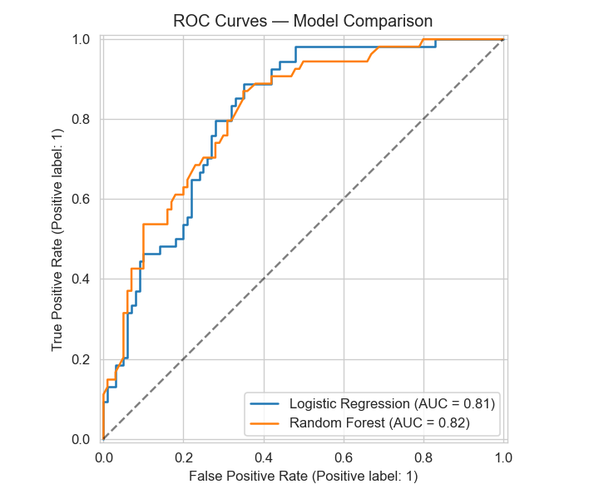
Figure 4. ROC curves for both models on the held-out test set.

4.3 Confusion matrix (Random Forest)
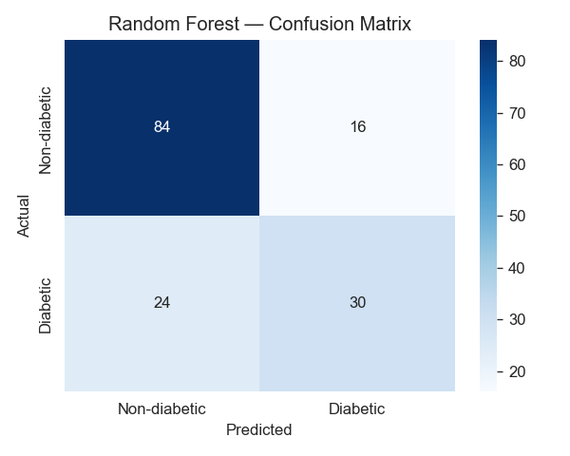
Figure 5. Random Forest confusion matrix. The bottom-left cell represents diabetic patients the model failed to identify — the clinically expensive error.

4.4 Feature importance
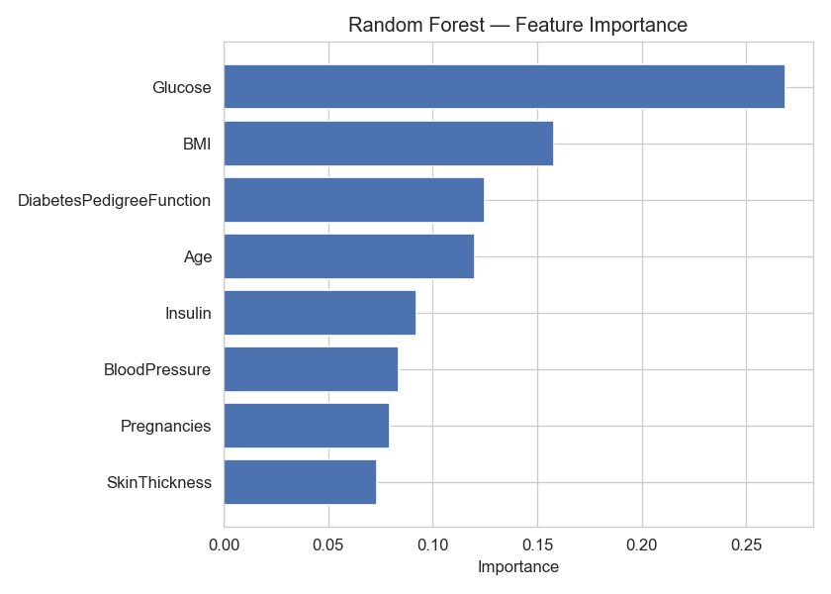
Figure 6. Random Forest feature importance.
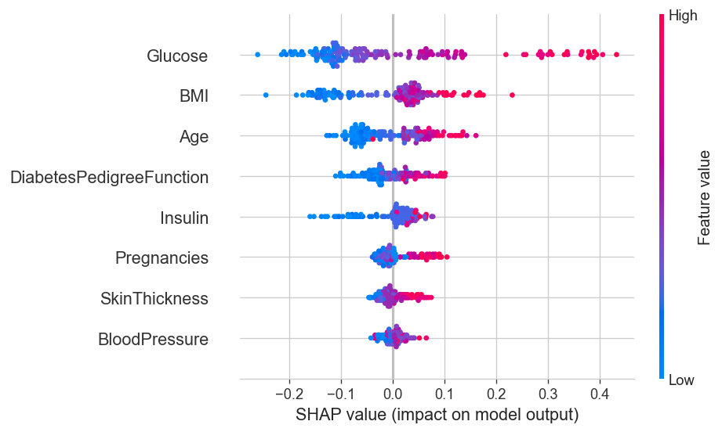
Figure 7. SHAP summary plot. Red = high feature value, blue = low. Glucose, BMI, and Age are the dominant drivers of predicted risk.

5. Discussion
Glucose was the single most influential predictor across both the Random Forest importance ranking and the SHAP attribution, which is consistent with the clinical definition of diabetes — fasting plasma glucose is the basis of the diagnostic criteria. BMI and Age were the next strongest drivers, again matching established epidemiological risk factors. The agreement between the model's learned signal and prior medical knowledge is reassuring: the model is not picking up spurious correlations specific to the dataset.
Random Forest's modest improvement over Logistic Regression suggests that the relationship between these eight features and diabetes status is mostly linear, with some non-linear interaction left for the tree ensemble to capture. The headline number that should worry a clinician is the recall on the diabetic class: at the default 0.5 threshold the model misses roughly four in ten diabetic patients. In a real deployment we would lower the decision threshold to push recall higher, accepting more false positives in exchange for fewer missed diagnoses.

6. Limitations
- Dataset scope — 768 patients, all female Pima Indians aged 21+. The model should not be assumed to generalize to other demographics without retraining and revalidation.
- Encoded missingness — five columns used zero as a missing-value sentinel. Median imputation is a defensible default but discards information about why values were missing.
- Model coverage — only two models were trained. The original plan included XGBoost, which was excluded due to a local library dependency.
- No external validation — performance is reported on a single 20 % held-out split. Cross-validation and validation on an independent cohort would give a more reliable estimate of generalization.
- Not a clinical tool — the dashboard is a teaching artifact. Any clinical use would require regulatory approval and prospective validation.

7. Conclusion
Machine learning models trained on eight routine health indicators were able to discriminate diabetic from non-diabetic patients with ROC-AUC around 0.82. Random Forest narrowly outperformed Logistic Regression and was chosen as the final model, with Glucose, BMI, and Age identified as the dominant drivers of predicted risk. The trained model is deployed as an interactive Streamlit dashboard for exploration. The work demonstrates that even simple, off-the-shelf models can produce clinically plausible risk estimates from a small tabular dataset — though larger, more diverse cohorts and prospective validation would be required before any real-world use.

