**SRINIVAS UNIVERSITY**

**INSTITUTE OF ENGINEERING & TECHNOLOGY MANGALURU MUKKA,**



**MICKY MOUSE PICTURE**

**(using html&css)**

For the Academic year 2023-2024

Submitted by

1.MOOLYA NISHMITHA NARAYANA(01SU23EC016)

2. NANDEESHA C L (01SU23ECO17)

3.NAZAF MUHAMMED K P (01SU23EC018)

4.P AKASH (01SU23EC019)

5.PANCHAMI (01SU23EC020)

Submitted to

Miss.Priyanka



**CONTENTS:**

**Preface**

**Aim of the project**

**Objectives**

**Project Code**

**Output & Conclusion**

**References**

**Preface:**

This project has been composed with the aim of covering a part of B. Tech (II Sem) under IBM course as prescribed by Srinivas University, Mukka. It is with great enthusiasm that we present this report, which represents collective efforts **Nishmitha,Nandeesha,Nazaf ,Akash,Panchami**

The running project has been presented through Google Chrome .We extend our sincere gratitude to IBM HAMI for providing us with the opportunity to present this project.

**Aim of the project:**

## TO CREATE MICKY MOUSE PICTURE USING HTML & CSS CODE

**Objectives:**

## The objective of a Mickey Mouse HTML project could vary depending on the context, but typically it's designed to teach HTML coding skills in a fun and engaging way, using Mickey Mouse as a theme or subject matter. It could be aimed at beginners to learn the basics of HTML tags, structure, and formatting, while also incorporating elements of creativity and design.

**Prject Code:(Contact us.html)**

<!DOCTYPE html>

<html lang="en">

<head>

<meta charset="UTF-8">

<meta name="viewport" content="width=device-width, initial-scale=1.0">

<title>Document</title>

<link rel="stylesheet" href="mickey.css">

</head>

## <body>

## <div id="mickey">

## <div class="ear left"></div>

## <div class="ear right"></div>

## <div class="head"></div>

## <div class="face">

## <div id="mickey">

## <div class="ear left"></div>

## <div class="ear right"></div>

## <div class="head"></div>

## <div class="face">

## <div class="front left"></div>

## <div class="front right"></div>

## <div class="cheek left"></div>

## <div class="cheek right"></div>

## <div class="chin"></div>

## <div class="mouth-wrapper">

## <div class="mouth">

## <div class="tong1"></div>

## <div class="tong2"></div>

## <body>

## <div id="mickey">

## <div class="ear left"></div>

## <div class="ear right"></div>

## <div class="head"></div>

## <div class="face">

## <div class="front left"></div>

## <div class="front right"></div>

## <div class="cheek left"></div>

## <div class="cheek right"></div>

## <div class="chin"></div>

## <div class="mouth-wrapper">

## <div class="mouth">

## <div class="tong1"></div>

## <div class="tong2"></div>

## </div>

## <div class="lip"></div>

## <div class="line left"></div>

## <div class="line right"></div>

## </div>

## <div class="eyes">

## <div class="eye left">

## <div class="pupil"></div>

## <div class="eyelid-top"></div>

## <div class="eyelid-bottom"></div>

## </div>

## <div class="eye right">

## <div class="pupil"></div>

## <div class="eyelid-top"></div>

## <div class="eyelid-bottom"></div>

## </div>

## </div>

## <div class="topnose"></div>

## <div class="nose"></div>

## </div>

## </div>

## </body>

## </html>

## Style.css

## body {

## margin:0;

## background-color: #c33;

## }

## #mickey {

## margin:0 auto;

## position: relative;

## width:850px;

## height:879px;

## }

## #mickey * {

## position: absolute;

## }

## .head {

## background-color: #000;

## width: 510px;

## height: 525px;

## border-radius: 50%;

## top:260px;

## left: 165px;

## }

## .ear {

## background-color: #000;

## width:280px;

## height: 350px;

## border-radius: 50%;

## }

## .ear.left {

## top: 50px;

## left:50px;

## transform: rotate(20deg);

## }

## .ear.right {

## top:50px;

## right:50px;

## transform:rotate(-20deg);

## }

## .face {

## position:relative;

## width: 520px;

## height: 530px;

## top:280px;

## left:170px;

## }

## .front {

## width: 215px;

## height: 380px;

## background-color: blanchedalmond;

## border-radius: 50%;

## top:15px;

## }

## .front.left {

## left:60px;

## }

## .front.right {

## right:90px;

## }

## .cheek {

## width: 150px;

## height: 270px;

## border: 5px solid #000;

## background-color: blanchedalmond;

## top: 240px;

## border-radius: 50%;

## }

## .cheek.left {

## left:20px;

## transform: rotate(-45deg);

## border-right: 0;

## border-bottom: 0;

## }

## .cheek.right {

## right:40px;

## transform: rotate(45deg);

## border-bottom: 0;

## border-left: 0;

## }

## .chin {

## width:180px;

## height: 100px;

## background-color: blanchedalmond;

## border-radius: 50%;

## border-bottom: 5px solid #000;

## bottom: 0;

## left:170px;

## }

## .mouth-wrapper {

## position: relative;

## width:420px;

## height: 190px;

## left:47px;

## top:315px;

## overflow: hidden;

## }

## .lip {

## width:380px;

## height: 280px;

## background-color: blanchedalmond;

## border-bottom: 10px solid #000;

## bottom:70px;

## left:15px;

## border-radius: 50%;

## }

## .mouth-wrapper .line {

## width:50px;

## height: 20px;

## border-top:5px solid #000;

## top:5px;

## border-radius: 50%;

## }

## .mouth-wrapper .line.left {

## left:0;

## transform:rotate(-20deg);

## }

## .mouth-wrapper .line.right {

## right: 10px;

## transform:rotate(20deg);

## }

## .mouth {

## position: relative;

## overflow: hidden;

## border-width: 5px 10px;

## border-style: solid;

## border-color: #000;

## width:155px;

## height: 200px;

## left: 125px;

## bottom: 0;

## background-color: #000;

## border-radius: 50%;

## }

## .mouth .tong1 {

## width: 100px;

## height: 100px;

## background-color: #F00;

## border-radius: 50%;

## bottom: -50px;

## left:0;

## }

## .mouth .tong2 {

## width: 100px;

## height: 100px;

## border-top: 5px solid #000;

## background-color: #F00;

## border-radius: 50%;

## bottom: -50px;

## right: 0;

## }

## .eyes {

## position: relative;

## width:160px;

## height: 190px;

## top:110px;

## left:170px;

## }

## .eye {

## border-radius: 52%;

## background-color: #FFF;

## border-width: 3px 7px;

## border-style: solid;

## border-color: #000;

## width:60px;

## height: 180px;

## position: relative;

## top: 0;

## overflow: hidden;

## }

## .eye.left {

## transform: rotate(-5deg);

## left:0;

## }

## .eye.right {

## right: 0;

## transform: rotate(5deg);

## }

## .pupil {

## border-radius: 50%;

## background-color: #000;

## width:35px;

## height: 65px;

## bottom: 0;

## }

## .eye.left .pupil {

## left:15px;

## }

## .eye.right .pupil {

## left:10px;

## }

## .eyelid-top {

## animation-delay: 2s;

## animation-duration: 10s;

## animation-iteration-count: infinite;

## animation-name: righteyelidtop;

## animation-play-state: running;

## animation-timing-function: linear;

## border-bottom: 4px solid #000;

## border-radius: 52% 52% 0 0;

## height: 130px;

## left: 0;

## top: -135px;

## width: 60px;

## background-color: blanchedalmond;

## }

## .eyelid-bottom {

## animation-delay: 2s;

## animation-duration: 10s;

## animation-iteration-count: infinite;

## animation-name: lefteyelidbottom;

## animation-play-state: running;

## animation-timing-function: linear;

## border-top: 4px solid #000;

## border-radius: 0 0 50% 50%;

## height: 45px;

## left: 0;

## bottom: -45px;

## width: 60px;

## background-color: #f5f5f5;

## }

## @keyframes righteyelidtop {

## 0% {

## top: -135px;

## }

## 2% {

## top: 0;

## }

## 4% {

## top: -135px;

## }

## 100% {

## top: -135px;

## }

## }

## @keyframes lefteyelidbottom {

## 0% {

## bottom: -45px;

## }

## 2% {

## bottom: 0;

## }

## 4% {

## bottom: -45px;

## }

## 100% {

## bottom: -45px;

## }

## }

## .topnose {

## width: 140px;

## height: 50px;

## border-radius: 50%;

## left:182px;

## top:270px;

## border-top: 8px solid #000;

## background-color: blanchedalmond;

## }

## .nose {

## width: 155px;

## height: 85px;

## background-color: #000;

## border-radius: 48%;

## left:175px;

## top:290px;SSSSSSSSSS

## }**Output:**

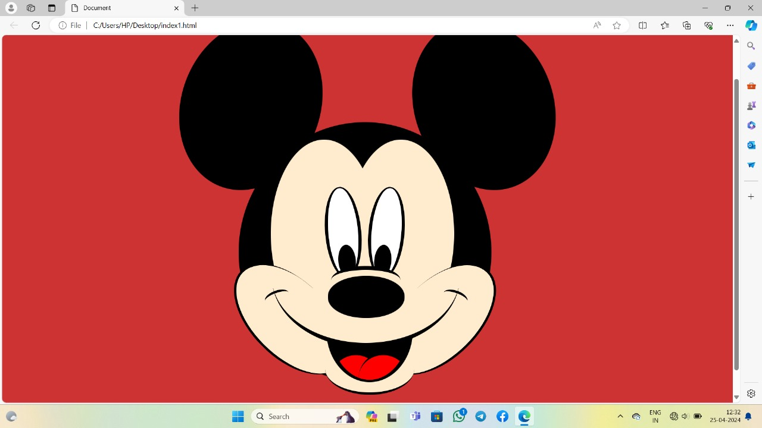

**Contributions:**

**Nishmitha-01SU23EC016 – I help to create html code for a micky mouse picture**

**Nandeesha-01SU23EC017 - I help to create html code for a micky mouse picture**

**Nazaf-01SU23EC018 - I help to create html code for a micky mouse picture and**

**Akash-01SU23EC019 - I help to create css code for a micky mouse picture**

**Panchami-01SU23EC020 – I help to create css scode for a micky mouse picture**

**Conclusion:**

creating the Mickey Mouse face HTML code was an engaging and rewarding experience. Through this project, I gained a deeper understanding of HTML structure, including the use of divs, spans, and CSS styling to create intricate designs. I encountered challenges in achieving the precise positioning and styling of elements to accurately represent Mickey's iconic features, but through experimentation and perseverance, I was able to overcome them.

This project also provided an opportunity to refine my skills in CSS styling, particularly in utilizing properties such as border-radius, background colors, and positioning to bring the design to life. Additionally, I learned the importance of attention to detail and the impact it has on the overall appearance of the final product.

## Moving forward, I see potential for further enhancements to the Mickey Mouse face, such as adding interactivity with JavaScript to animate the eyes or mouth, or incorporating responsive design principles to ensure the face adapts gracefully to different screen sizes.

## Overall, I am proud of the outcome of this project and grateful for the opportunity to apply and expand my HTML and CSS skills. It's been a fun journey, and I look forward to continuing to explore and create with web development.

**References:**

**Bootstrap.com**

**W3schools.com**