AVALON MEMORY-MAPPED INTERFACE

Signal roles define the signals that host/agent ports allow while interfacing with the Avalon bus. Many signal roles are optional, meaning that you can select only the ones necessary to implement the required functionality.

Considering a pipelined read with variable latency Avalon-MM interface, the following signal roles are required:

- address
- read
- readdata
- write
- writedata
- readdatavalid
- waitrequest
- beginbursttransfer (burst operation only)
- burstcount (burst operation only)

The waitrequest signal allows the agent to communicate if it is available to acquire a new operation. By setting waitrequest the agent notifies that it is not able to sample a new operation, thus a valid input signal must be kept constant (otherwise it would be lost). Agent acquires a new operation and sets waitrequest until its completion.

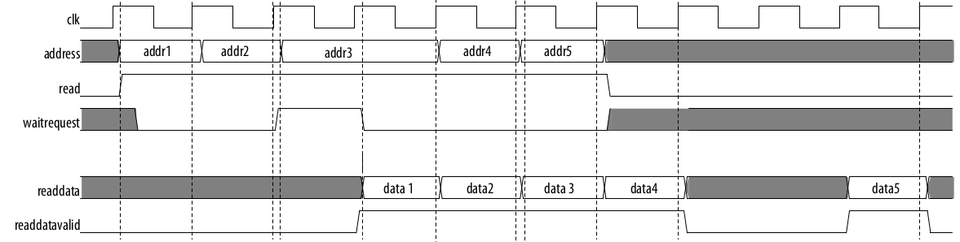

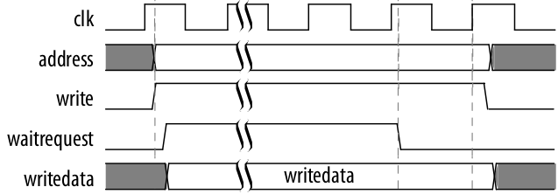

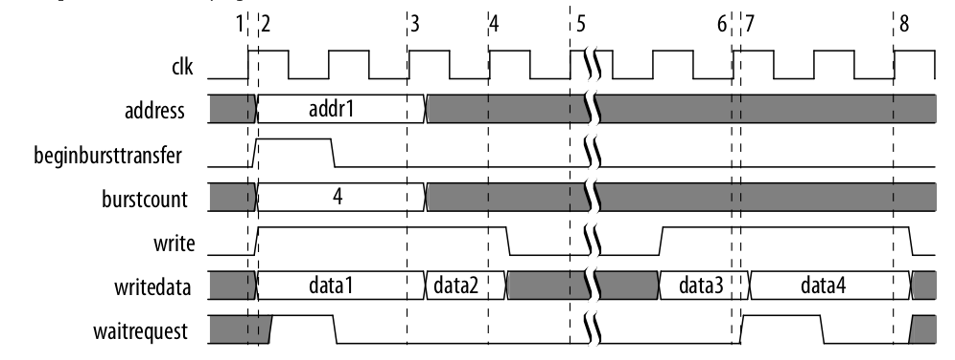

When it comes to a write burst operation, the host can stall the burst transmission deasserting write and re-asserting it later on. Of course, tha same cannot be done while reading a burst, since the host is not in control of the burst transmission (it receives it). In any case, the agent can stall the operation sampling setting waitrequest.
