CREATING CUSTOM IP COMPONENTS

A Platform Designer component includes the following elements:

- Information about the component, such as name, version and author

- HDL description of the component’s hardware

- Constraint files (sdc and/or qip) that define the component for synthesis and simulation

- Component’s interfaces, including I/O signals

- Parameters that configure the operation of the component

Every component is defined with a <component_name>_hw.tcl file that can be created using the Platform Designer Component Editor. It contains relative paths to the other files, so if you move it you should also move all the files associated with it.

A typical component uses the following directory structure (directories names are not significant, with the exception of the ip/ directory which must be named in this way):

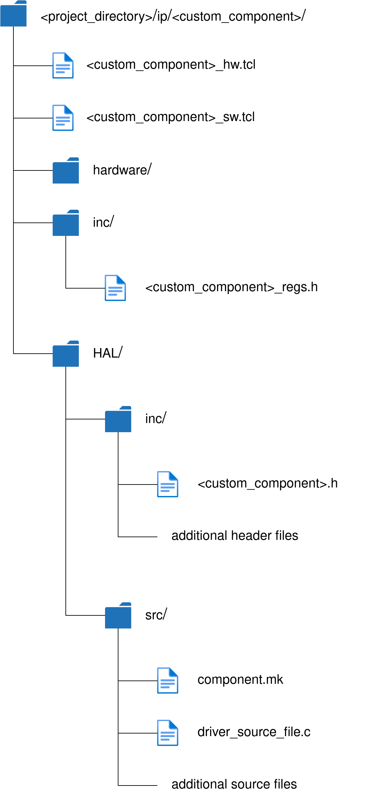
The hardware/ directory contains the HDL files and the constraint files. The best approach consists in entering information, parameters, signals and interfaces in the Component Editor and make it automatically generate the top-level HDL file (in the Files tab, click on Create Synthesis File from Signals), which can be edited to add the logic that describes the component's behavior. Clicking Finish on the Parameters Editor leads to the automatic generation of the <component_name>_hw.tcl file.

The <component_name>_sw.tcl file must be created manually in the following way:

- The first command must be the create_driver command. It is recommended to choose the name <custom_component>_driver for the driver:

create_driver <custom_component>_driver

- Identify the hardware component class the driver is associated with using the set_sw_property command’s hw_class_name argument:

set_sw_property hw_class_name <hardware_class>

- Specify each BSP type supported using the add_sw_property command’s supported_bsp_type argument (in most cases it supports Intel FPGA HAL and Micrium MicroC/OS-II BSP types):

add_sw_property supported_bsp_type hal

- Specify each source file uing the add_sw_property command’s c_source argument:

add_sw_property c_source HAL/src/driver_source_file.c

- Specify each header file uing the add_sw_property command’s include_source argument:

add_sw_property include_source inc/<custom_component>_regs.h
add_sw_property include_source HAL/inc/<custom_component>.h

The header file <component name>_regs.h defines the hardware interface of the component: it provides access to the interface registers by means of suitable IORD/IOWR functions (see Nios II Classic Software Developer’s Handbook → Developing Device Drivers for the hardware Abstraction Layer → Accessing Hardware).

