Graded Problems for Module 5

SELECT Statement Problems
1. For event requests, list the event number, event date (eventrequest.dateheld), and count of the event plans. Only include event requests in the result if the event request has more than one related event plan with a work date in December 2018.

SELECT er.eventno, dateheld, count(planno)
FROM EventRequest er
JOIN EventPlan ep
ON er.eventno = ep.eventno
WHERE (date_format(ep.workdate, '%Y-%m')) = '2018-12'
GROUP BY eventno, dateheld
HAVING count(planno)>1;

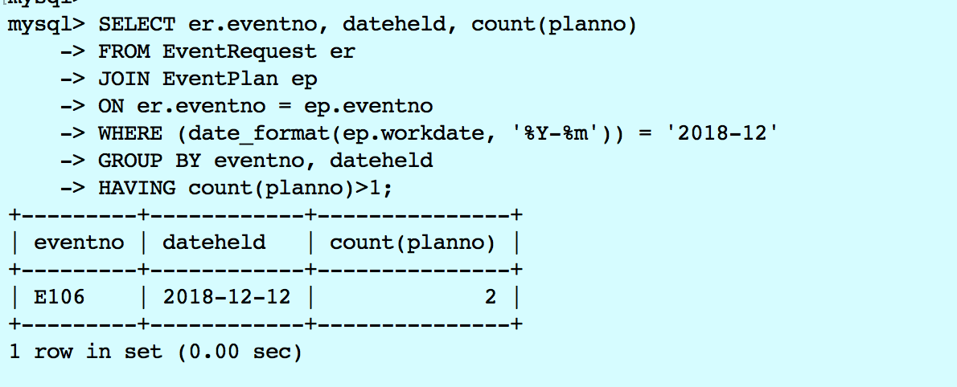

2. List the plan number, event number, work date, and activity of event plans meeting the following two conditions: (1) the work date is in December 2018 and (2) the event is held in the “Basketball arena”. Your query must not use the facility number (“F101”) of the basketball arena in the WHERE clause. Instead, you should use a condition on the FacName column for the value of “Basketball arena”.

SELECT ep.planno, ep.eventno, ep.workdate, ep.activity
FROM EventPlan ep
JOIN EventRequest er
ON ep.eventno = er.eventno
JOIN Facility fac
ON er.facno = fac.facno
WHERE (date_format(ep.workdate, '%Y-%m')) = '2018-12'
AND fac.facname = 'Basketball arena';

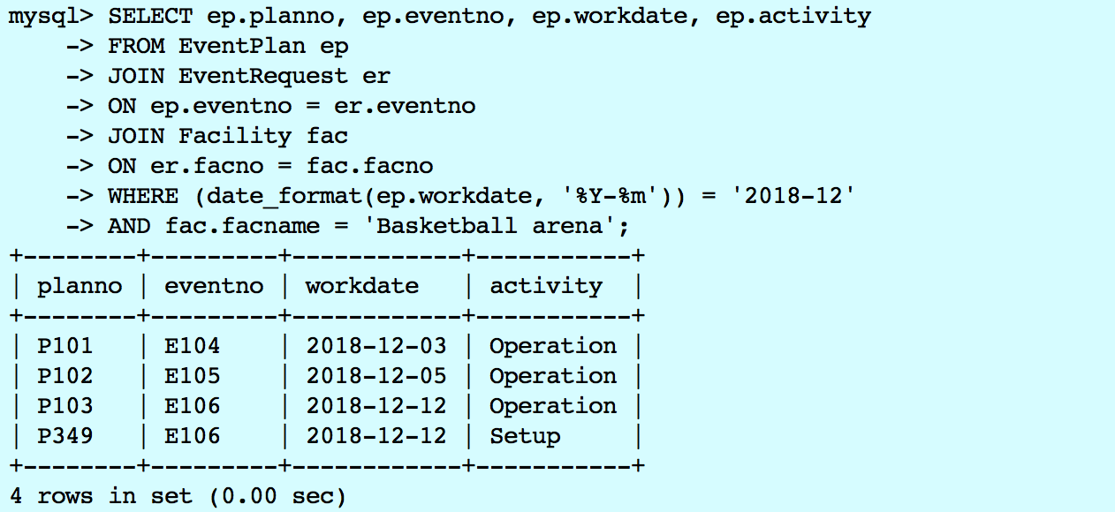

3. List the event number, event date, status, and estimated cost of events where there is an event plan managed by Mary Manager and the event is held in the basketball arena in the period October 1 to December 31, 2018. Your query must not use the facility number (“F101”) of the basketball arena or the employee number (“E101”) of “Mary Manager” in the WHERE clause. Thus, the WHERE clause should not have conditions involving the facility number or employee number compared to constant values.

SELECT er.eventno, er.dateheld, er.status, er.estcost
FROM EventRequest er
JOIN EventPlan ep
ON ep.eventno = er.eventno
JOIN Employee em
ON ep.empno = em.empno
JOIN Facility fac
ON er.facno = fac.facno
WHERE em.empname = 'Mary Manager'
AND (date_format(ep.workdate, '%Y-%m')) BETWEEN '2018-10' AND '2018-12'
AND fac.facname = 'Basketball arena';

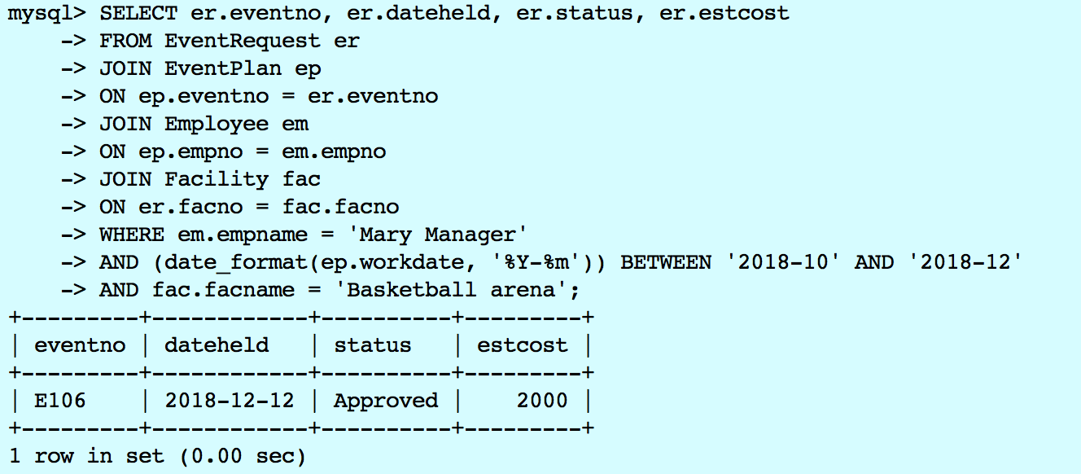

4. List the plan number, line number, resource name, number of resources (eventplanline.number), location name, time start, and time end where the event is held at the basketball arena, the event plan has activity of activity of “Operation”, and the event plan has a work date in the period October 1 to December 31, 2018. Your query must not use the facility number (“F101”) of the basketball arena in the WHERE clause. Instead, you should use a condition on the FacName column for the value of “Basketball arena”.
SELECT epl.planno, epl.lineno, rt.resname, epl.numberfld, loc.locname,
epl.timestart, epl.timeend
FROM EventPlanLine epl
JOIN ResourceTbl rt
ON epl.resno = rt.resno
JOIN Location loc
ON epl.locno = loc.locno
JOIN Facility fac
ON loc.facno = fac.facno
JOIN EventPlan ep
ON epl.planno = ep.planno
WHERE fac.facname = 'Basketball arena'
AND ep.activity = 'Operation'
AND (date_format(ep.workdate, '%Y-%m')) BETWEEN '2018-10' AND '2018-12';

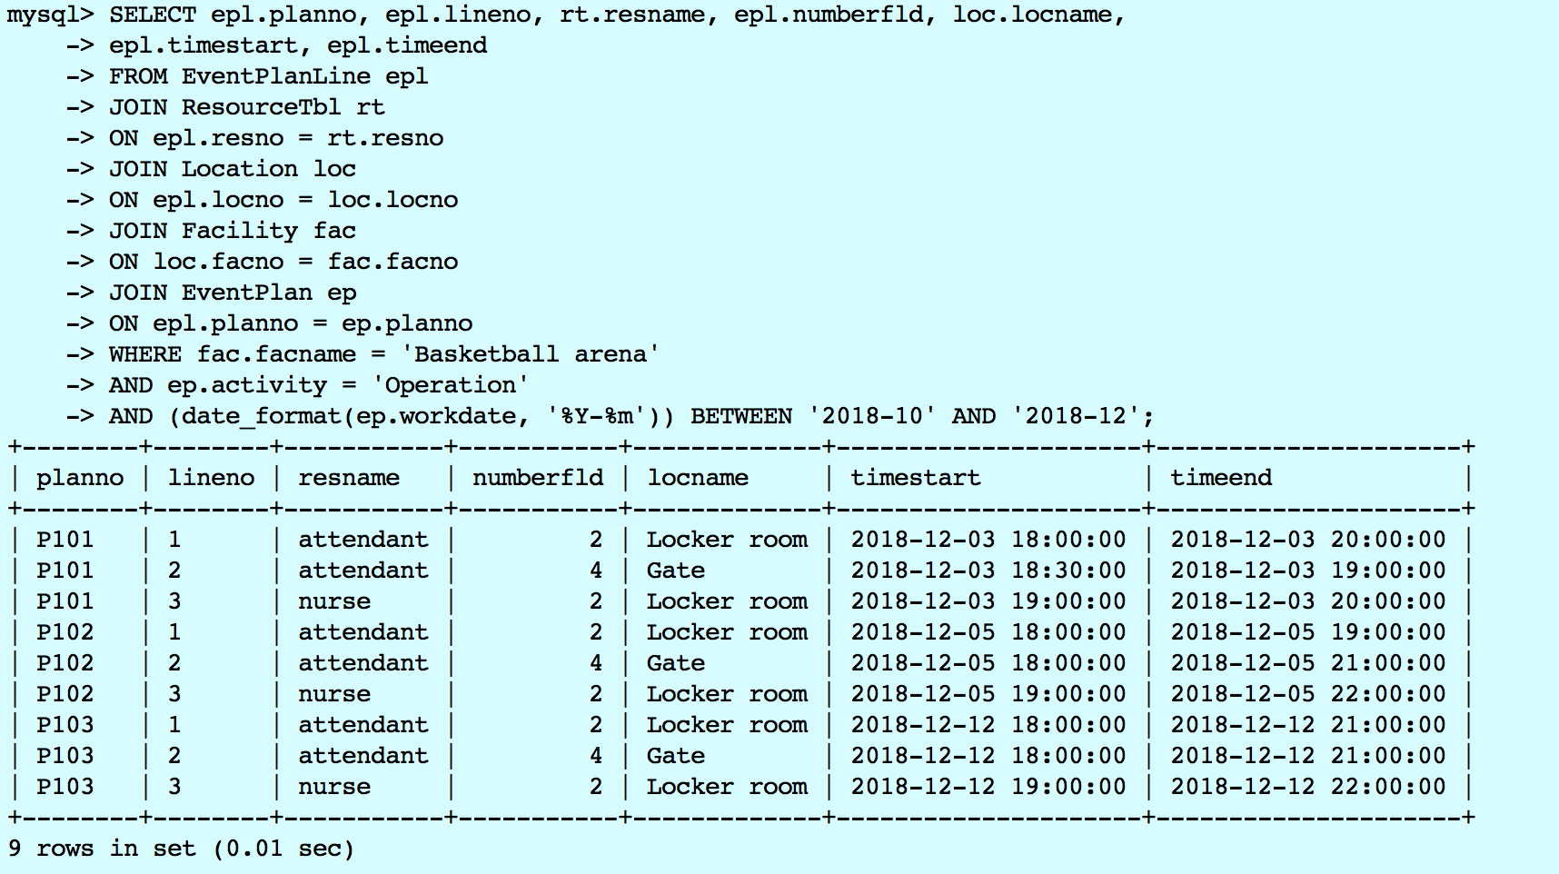

Database Modification Problems
1. Insert a new row into the Facility table with facility name “Swimming Pool”.
INSERT INTO Facility VALUES ('F104', 'Swimming Pool');
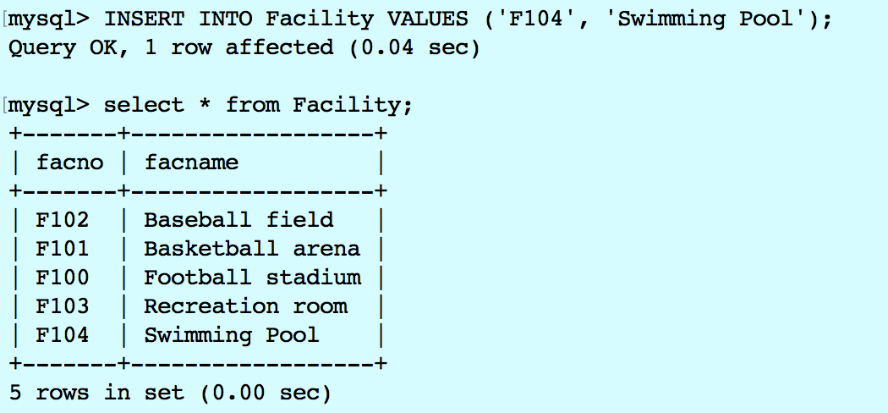
2. Insert a new row in the Location table related to the Facility row in modification problem 1. The new row should have “Door” for the location name.
INSERT INTO Location VALUES ('L107', 'F104', 'Door');
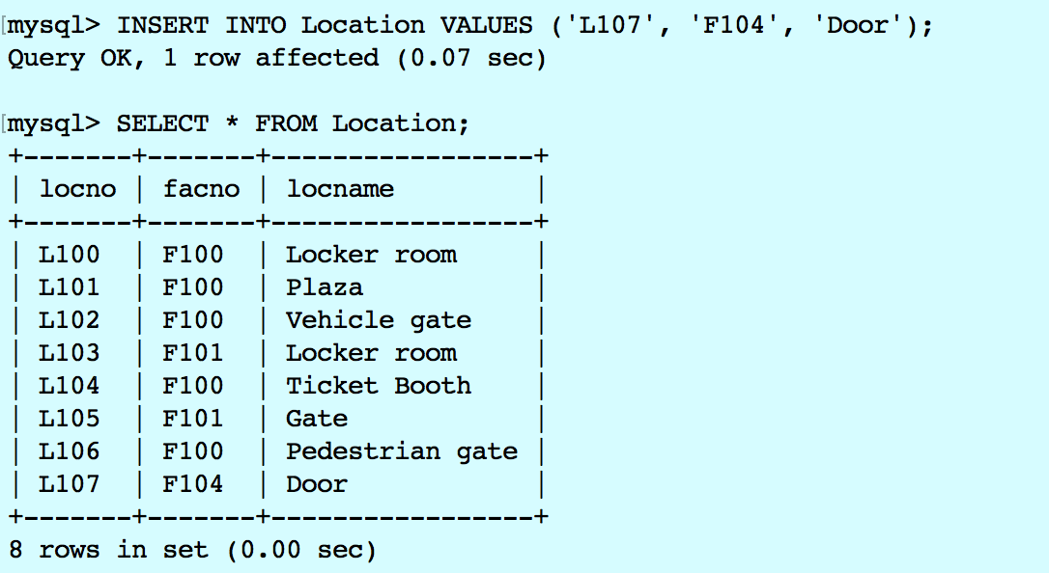
3. Insert a new row in the Location table related to the Facility row in modification problem 1. The new row should have “Locker Room” for the location name.
INSERT INTO Location VALUES ('L108', 'F104', 'Locker Room');
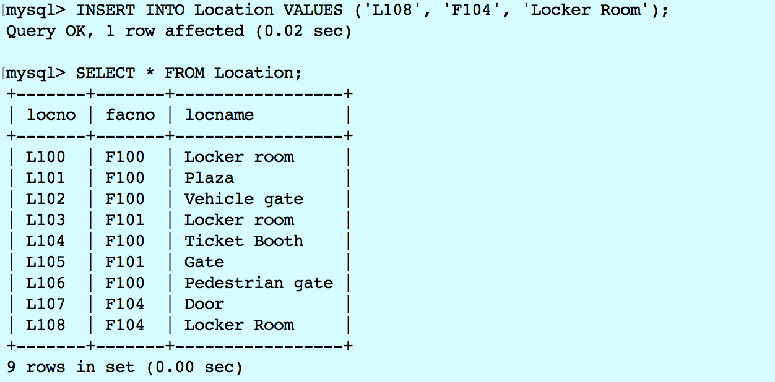

4. Change the location name of “Door” to “Gate” for the row inserted in modification problem 2.
UPDATE Location SET locname = 'Gate' WHERE locno = 'L107';
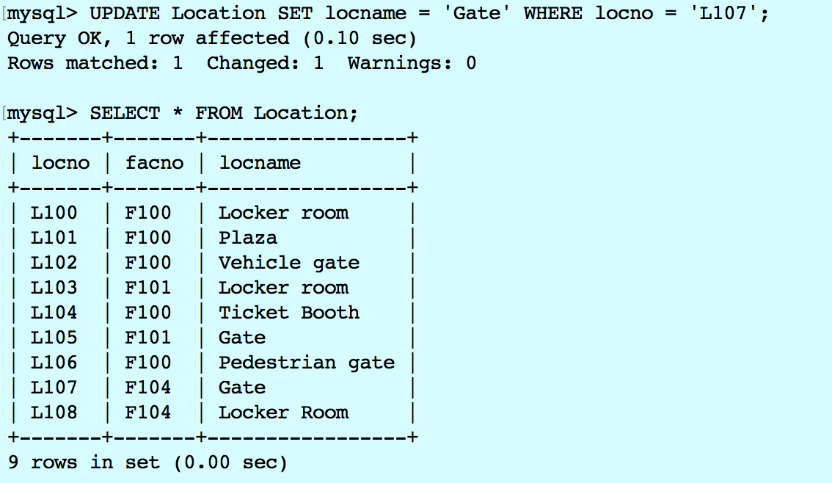

5. Delete the row inserted in modification problem 3.
DELETE FROM Location WHERE locno = 'L108';
