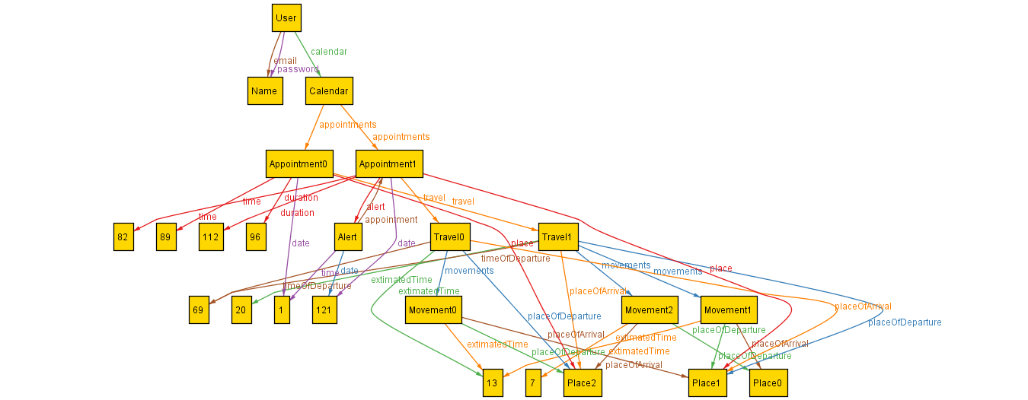The first picture shows a world in which one user has more appointments in his calendar. Each appointment is associated with a travel:

* Travel0: from Place2 to Place1 (location of Appointment1), extimatedTime = 13
* Travel1: from Place1 to Place2 (location of Appointment0), extimatedTime = 20

We notice that:

* Travel0 = Movement0 (Place2 -> Place1, extimatedTime = 13)
* Travel1 = Movement1 (Place1 -> Place0, extimatedTime = 13) + Movement2 (Place0 -> Place2, extimatedTime = 7)

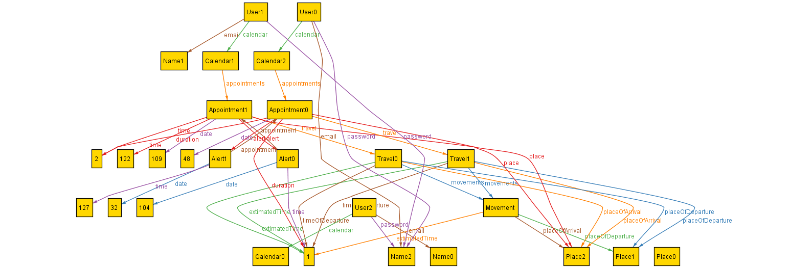

The second picture shows a world with more users.