Andrea Mestre

Pippin Barr

Creative Computation Cart 211

7 November 2017

**Bisexual Erasure Space Invaders:**

Un unknown force is taking over the pong screen and you must stop it before it reaches you, the helpless bisexual.

How the game works:

I want the mechanics of the game to be very similar to my favorite retro 2D game *Space Invaders.* The Helpless Bisexual must defeat the straights, the gays and the mainstream media before their world is completely erased.

The bisexual will shoot at all the enemies and gain power-ups throughout the game if it can hit the patriarchy (the UFO at the top of the screen), while avoiding being destroyed by the opponents. Otherwise, the world will be nothing but a white blank.

Technical Approach:

* The player will be able to move left and right like in space invaders. I’ll use a keyPressed function for this.
* The player will be represented by an avatar of the bisexual pride flag.
* I’m unsure if I want an array for each opponent so that I can have multiple at once or if each opponent will be treated like a boss that needs to be defeated with something indicating their health (most likely some number counting down or a rectangle getting smaller and smaller).
* If I use the array, I’ll have to make the x position change so that they move left and right and the y position change to move down every so often.
* For the Lives being displayed I will just have a number being displayed and gong down
* The Shields that give the Helpless Bisexual cover will fade as they take on more damage, I’m probably going to have to make a color collision or something like that? Because if the Shield disappears after a while, how will the blast know to ignore it?
* Power ups will include giving you the ability to do more damage or some sort of fun picture affect (the avatar will probably turn into a unicorn and/or do the Super Mario Rainbow flashing effect using tint and the music will get happier, maybe the music will get sadder if you lose).
* The power-up will be represented by a different avatar (undecided yet).
* I will use a noise tool to make its appearance random
* If you lose, the screen will go white and the avatar will disappear because bisexuals will cease to exist.
* I will definitely need collisions between the blast shots and the bisexual/opponents (each of them will need their own object class code page).
* I would love to incorporate some sort of music.
* I need to create a start screen and a “you win/you lose” screen and a mouseClicked function for “start Game” and “end Game” buttons.

Inspiration:

Duh: <http://www.pacxon4u.com/space-invaders/>



However, the aesthetics of the game are not at all going to look like this it’ll probably be much more campy like a 14 year old trying to make memes on MSPaint. I’m not sure how I’m going to make the game esthetically pleasing but we’ll give it a try.

Media:

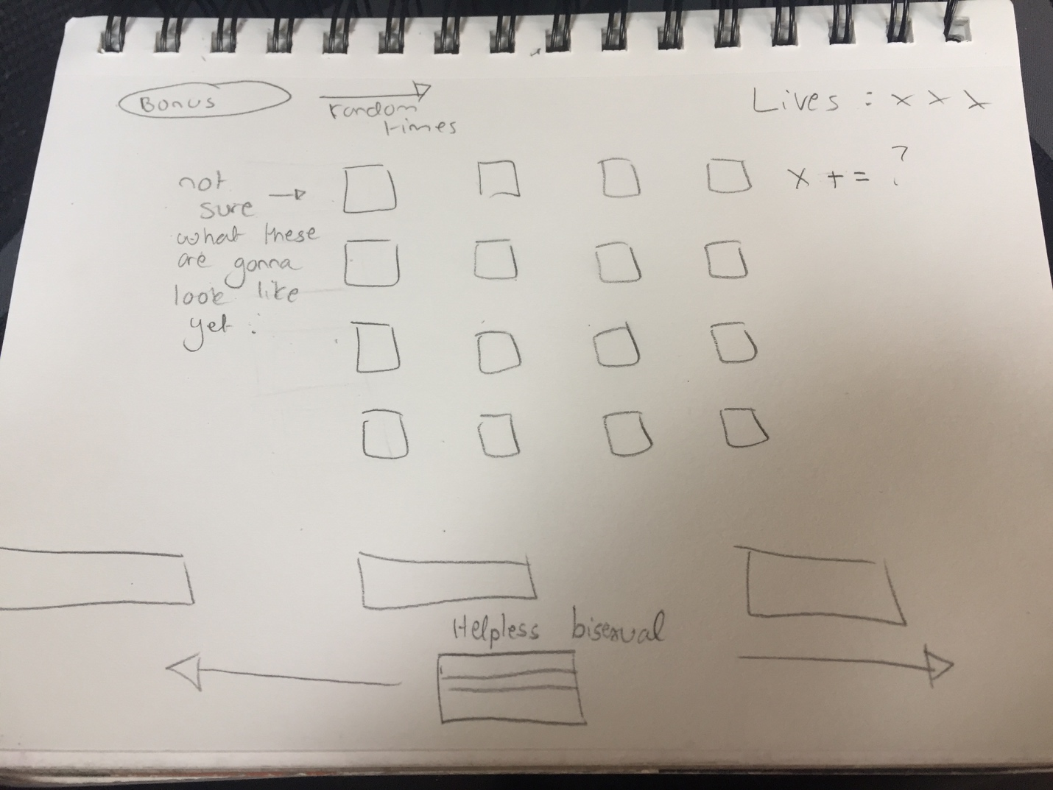

* The Helpless Bisexual is at the bottom of the screen, and there will be three block above it used as cover. When the opponents shoot at them, they’ll slowly start to fade away.
* The Bonus symbolizes the patriarchy and if you hit it you get a power-up of sorts (probably like in Mario when you become invincible and don’t take damage).
* The Helpless Bisexual will have three lives or else its game over and you must restart.
* The opponents will move via the x position and eventually move down the y axis to create the simulation of an invasion.

Technical Research:

Adding sound to processing: <https://www.youtube.com/watch?v=69IuP6uOmRA>

The audio library in processing: <https://processing.org/reference/libraries/sound/index.html>