horizontal line

**Group Members**

Karen McGee

Andrea Morgan

Stacey Smith

Project 2 Proposal

**September 28th, 2019**

**CHOSEN TOPIC**

Our topic for this project is Botulism, specifically, studying trends in historical Botulism case data from 1899-2017. Our initial data search focused on datasets provided by the Centers for Disease Control and Prevention (CDC), where we found the dataset for Botulism that contains case frequency by year, state, type of Botulism, and Botulism toxin type. Background information on Botulism can be found [here](https://www.cdc.gov/botulism/general.htm).

**DATA SET**

The dataset for our study can be found [here](https://data.cdc.gov/Foodborne-Waterborne-and-Related-Diseases/Botulism/66i6-hisz) and looks like this:

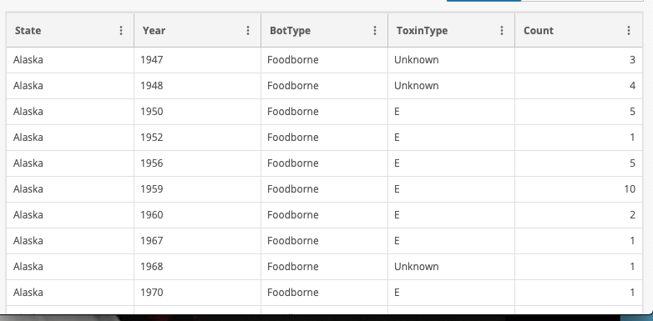

**INSPIRATION AND DESIGN**

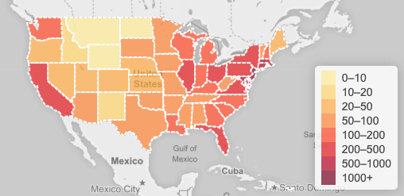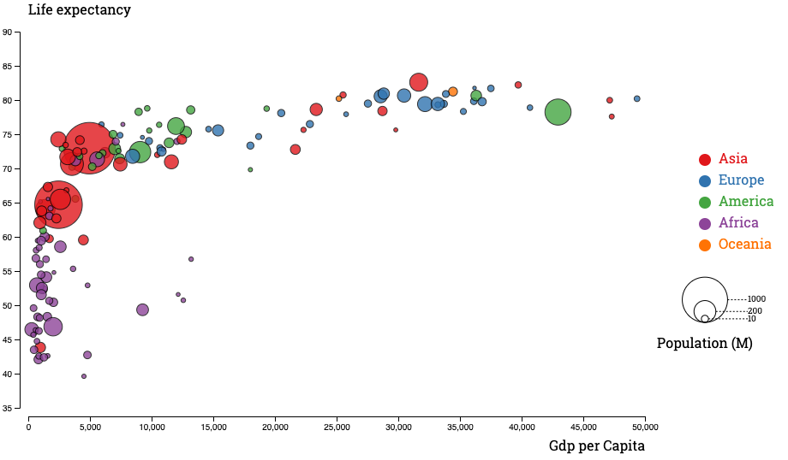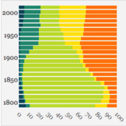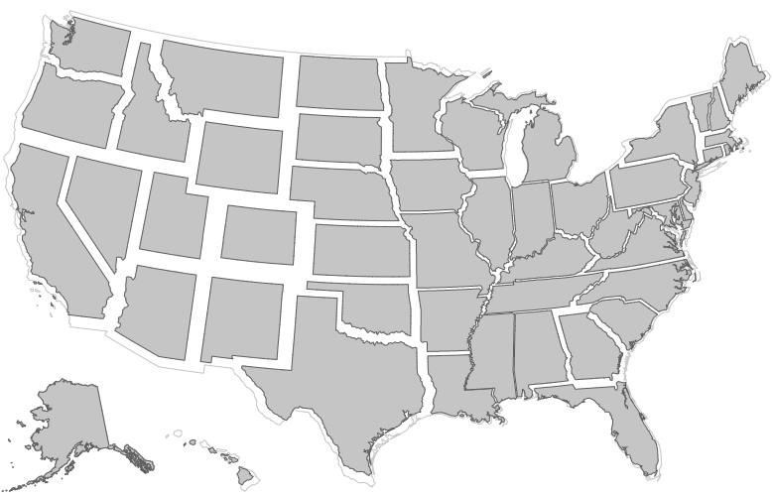

Since our data is historical and has state options, our charts will probably center around time and location. We imagine our final product to be a dashboard that adjusts based on user state choice, or other choices based on the parameters of our data. The JavaScript libraries that we choose to use will be dependent on the types of charts we ultimately decide to create based on our exploration of the dataset.

**GITHUB REPOSITORY**

The GitHub repository for our project can be found [here](https://github.com/AndreaMorgan/Project2).