Projet

Trello  
<https://trello.com/b/EDKXknCy>

Modélisation bdd  
MCD

### UML

MLD

### MLD Textuelle

# Creation bdd

### Concepteur Mysql

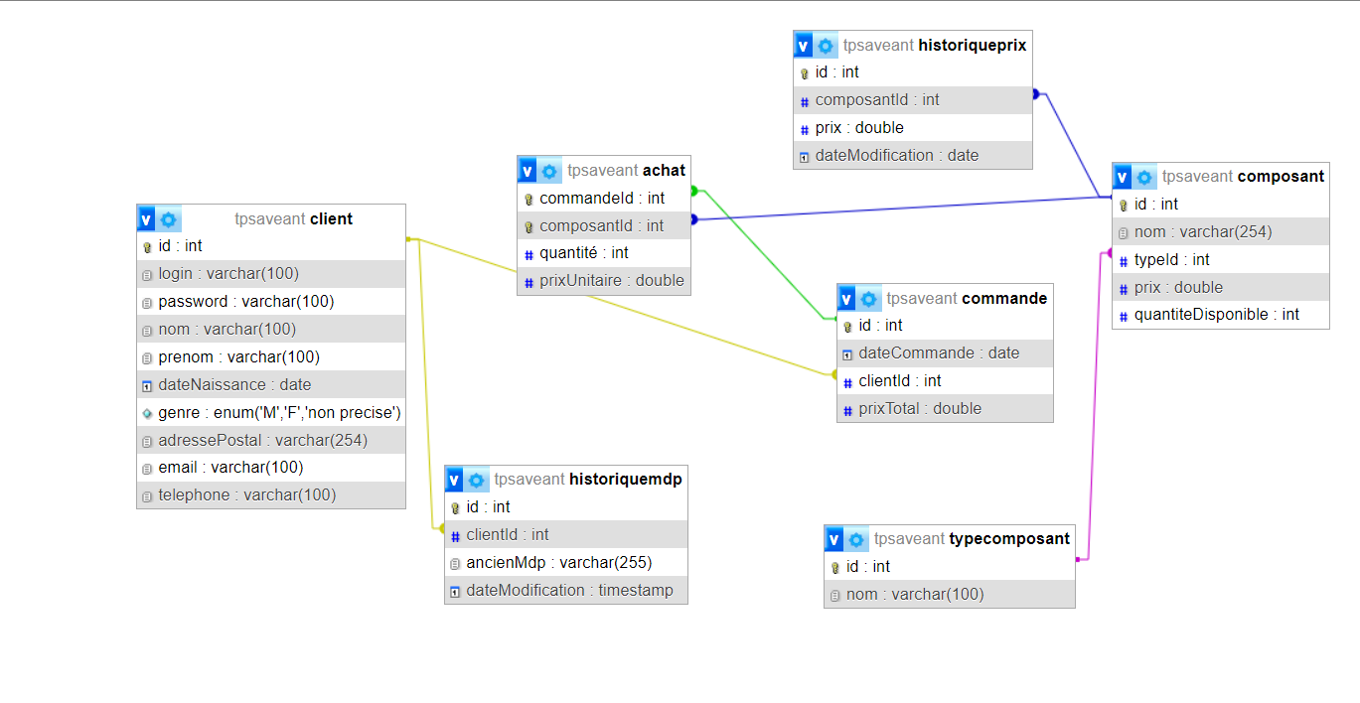

### Automatisation

### Triggers

### Procédures stockés

# Site

