A small study on Eucalyptus spp. regrowth in a restoration project on former farmland in Australia
Andrea Raaschou

Background
In Australia, extensive agricultural activities among other factors have led to a decline in Eucalyptus trees (Jurskis, 2005). This short text will provide an analysis of a dataset that was collected in 2006-2007 investigating regrowth of Eucalyptus spp. on previous agricultural land. The object of the collection of this data was to investigate how to best revegetate private land that previously have been used for grazing farm animals. 18 different landowners in Australia participated in this passive regeneration initiative by removing gracing livestock from the land that was part of the study. The hope was that regeneration of the Eucalyptus spp. would take place without active planting. The surveys were conducted in three rounds, in winter and spring 2006 and in autumn 2007. This analysis will focus on how vegetation composition and cover affect regrowth of eucalyptus by abundance Eucalyptus seedlings. The research question is the following: How does different types of vegetation cover affect regrowth of Eucalyptus spp.?

Methods
The raw data was processed to prepare for data analysis. Observations of the different vegetation types were combined together to get larger functional groups. For example, the groups exotic perennial grass, exotic annual grass and native perennial grass were summed together to form one group for grass cover. Eucalyptus seedling counts were also summed across height groups to form one single observation group. One outlier was removed (88 Eucalyptus seedlings recorded in one square compared to the second to largest value which was 28, a difference of 9.7 standard deviations). Finally, observations containing missing values were omitted (3 out of 351 observation).
After the data was prepared, generalized linear mixed models were fitted to the data using different combinations of fixed and random effects. Akaike Information Criterion (AIC) was used to find the best model fit. To account for overdispersion, the models were fitted using a negative binomial distribution rather than a Poisson distribution.
A process to find the best model using AIC resulted in the model below, in R syntax
$$Eucalyptus seedlings \sim Herb cover+ \left(1 | Property\right)$$

Results
The variability and coverage of the different vegetation types varied heavily, with grasses and herbs ranging from 0 to 99 % and 0 to 85%, respectively. Graminoids, ferns and shrubs had much lower coverage, with a majority of the observations close to 0 % (figure 1).
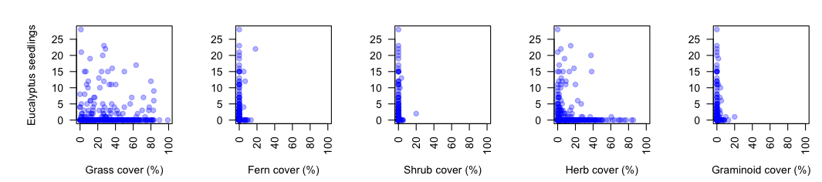
Figure 1. Vegetation cover (%) for the five different vegetation types plotted against number of Eucalyptus seedlings.
To account for variability that could not be explained by vegetation cover, multiple random-effects structures were tested. Four candidate models with three different random effects (property, season and landscape position) were compared using AIC to establish if one or more explained substantial variance in the data. The model only including property as a random intercept had the best support (ΔAIC = 0.00, w = 0.60).
Using this random structure, models using different combinations of vegetation predictors were compared with a null model. The full model with all five vegetation types included was poorly supported (ΔAIC = 7.18, w = 0.02). The best model fit included only herb cover as explanatory variable and property as a random variable (ΔAIC = 0.00, w = 0.59). The parameter estimates from the full model are presented in table 1. Table 2 and figure 1 represents parameter estimates and predictions of the best model fit.

Table 1. Parameter estimates from the negative binomial generalized linear mixed model fitted to model the marginal effects of grass, fern, shrub, herb and graminoid cover with property as a random effect. All units are on the log-scale.
Parameter | Estimates ± SE | Z-value | Random effect SD
Intercept | -0.073 ± 0.53 | - 0.14 | 1.62
Grass cover | 0.0048 ± 0.0077 | 0.63
Fern cover | - 0.020 ± 0.069 | - 0.29
Shrub cover | - 0.049 ± 0.12 | - 0.41
Herb cover | - 0.041 ± 0.015 | - 2.64
Graminoid cover | - 0.046 ± 0.082 | - 0.55

Table 2. Parameter estimates from the negative binomial generalized linear mixed model fitted to model the marginal effects of herb cover with property as a random effect. All units are on the log-scale.
Parameter | Estimates ± SE | Z-value | Random effect SD
Intercept | 0.033 ± 0.46 | - 0.073 | 1.58
Herb cover | - 0.039 ± 0.015 | - 2.62

With a 10 % increase in herb cover, the model predicts a decrease of around 32 % in eucalyptus seedlings. There was large variation between properties that was not explained by differences in vegetation cover. The abundance of eucalyptus seedlings could differ by approximately 4 to 5-fold change between properties with identical vegetation cover (table 2, figure 2).
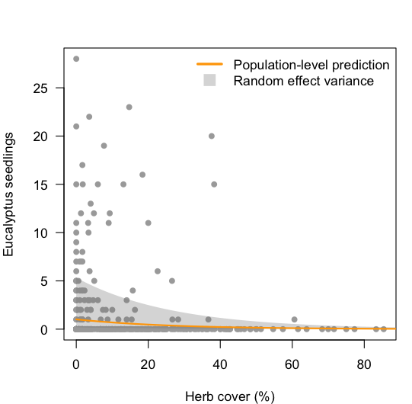
Figure 2. Eucalyptus seedling abundance with increasing percentage of herb cover. The orange line represents the prediction curve for the population-level, and the shaded area reflects the random-effects of different properties (area represents ± one SD).

Conclusions
The data was not sufficient to draw any conclusions about differences in coverage of ferns, shrubs, grasses or graminoids. It was however possible to draw the conclusion that eucalyptus seedling abundance decreased with an increasing ground cover or herbaceous plants. The variation between different properties was large, indicating that vegetation cover was not as important to seedling abundance as other factors. Such factors could be climate, previous land use or management activities. It could not be explained by season or landscape position.
Link to GitHub: https://github.com/AndreaRaaschou/BIOS15/blob/main/midterm/clean_script.R
References
Jurskis, V. (2005). Eucalypt Decline in Australia, and a General Concept of Tree Decline and Dieback. Forest Ecology and Management, 215, 1-20. https://doi.org/10.1016/j.foreco.2005.04.026

