Report on exercise in Game theory
2025-02-13
Andrea Raaschou

Short summary:
Game theory is explored using the iterated Prisoners Dilemma. Strategy dynamics was simulated repeatedly, making it possible to observe how defect strategies can invade and dominate over cooperative strategies.
A trait-based simulation model is explored to answer questions about different key parts such as mutation invasibility, fitness landscapes, niche with and competition and evolutionary branching.
Aim of the exercise:
The aim of this exercise is to understand how game theory can be used to predict stable strategies in interaction such as the Prisoners Dilemma. Another aim is to learn how to make and interpret Pairwise invasibility plots.
In the second part of the exercise (adaptive radiation), the aim is to get familiar with and understand how a trait-based model is bult and how it works. In doing this, the aim is to also understand interactions between mathematics, numerical methods and the simulations outcomes and to be able to interpret these biologically.

Game theory
1)
The Evolutionary Stable Strategy (ESS) in this example is to defect. If the resident strategy is to cooperate, the individuals using the defect strategy will quickly overtake the residents. If the opposite was true (defect was resident strategy), the cooperate strategy would not be able to invade. Further reasoning: if the opponent cooperates, it is better to defect since T>R. If the opponent defects, it is also better to defect since P>S. It is clear that it is better to choose the defect strategy.
3)
Since the resident strategy is set to 1 in the beginning, the most common strategy in the beginning is cooperate. After around 10 generations, the defect strategy becomes more common in the third round. After another 10 generations, the defect strategy becomes more common in the second round while the increase in defect strategy in the third round slows down. After another 15 generations, the defect strategy becomes completely dominant in the first round. In the second and third round, the chosen strategy seems to follow a random pattern after generation 50. While most other players are using cooperate as the strategy, it seems like the ESS is (1, 1, 2), which enables the individual to get some points (R=5) for the first two rounds and the highest point (T=10) in the last round. After some time, more individuals start mutating defect in the second position – which makes it more beneficial to have the strategy (1, 2, _). As the game quits if one of the players use the defect strategy – the third position starts to become insignificant. After even more time, the same evolution starts happening in the first round. Here (after 45-50 generations) it is very clear that the ESS is (2, _, _) since the mean value are around 2, 1.5 and 1.5 for round 1, round 2 and round 3, respectively. As the majority of individuals start playing the defect strategy in the first round, the strategies chosen in the following two rounds become insignificant and are therefore randomly evolving.
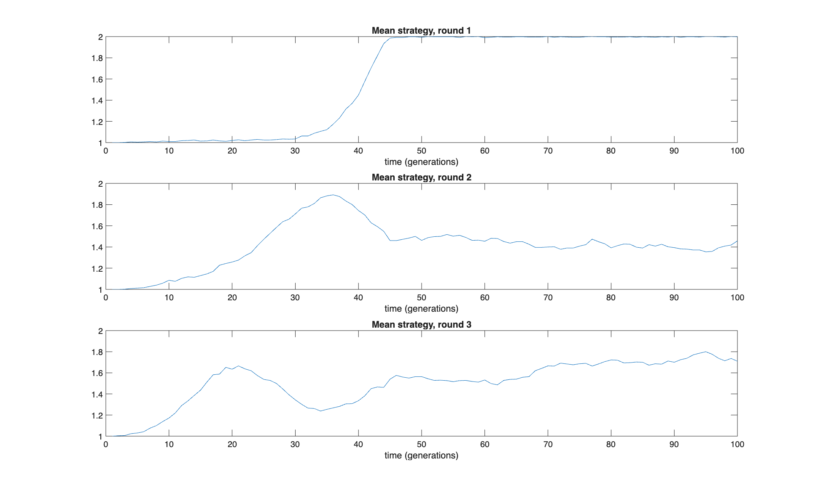
Figure 1. Mean strategies of individuals playing the iterated prisoner’s dilemma game. 1 = cooperate and 2 = defect.

4a)
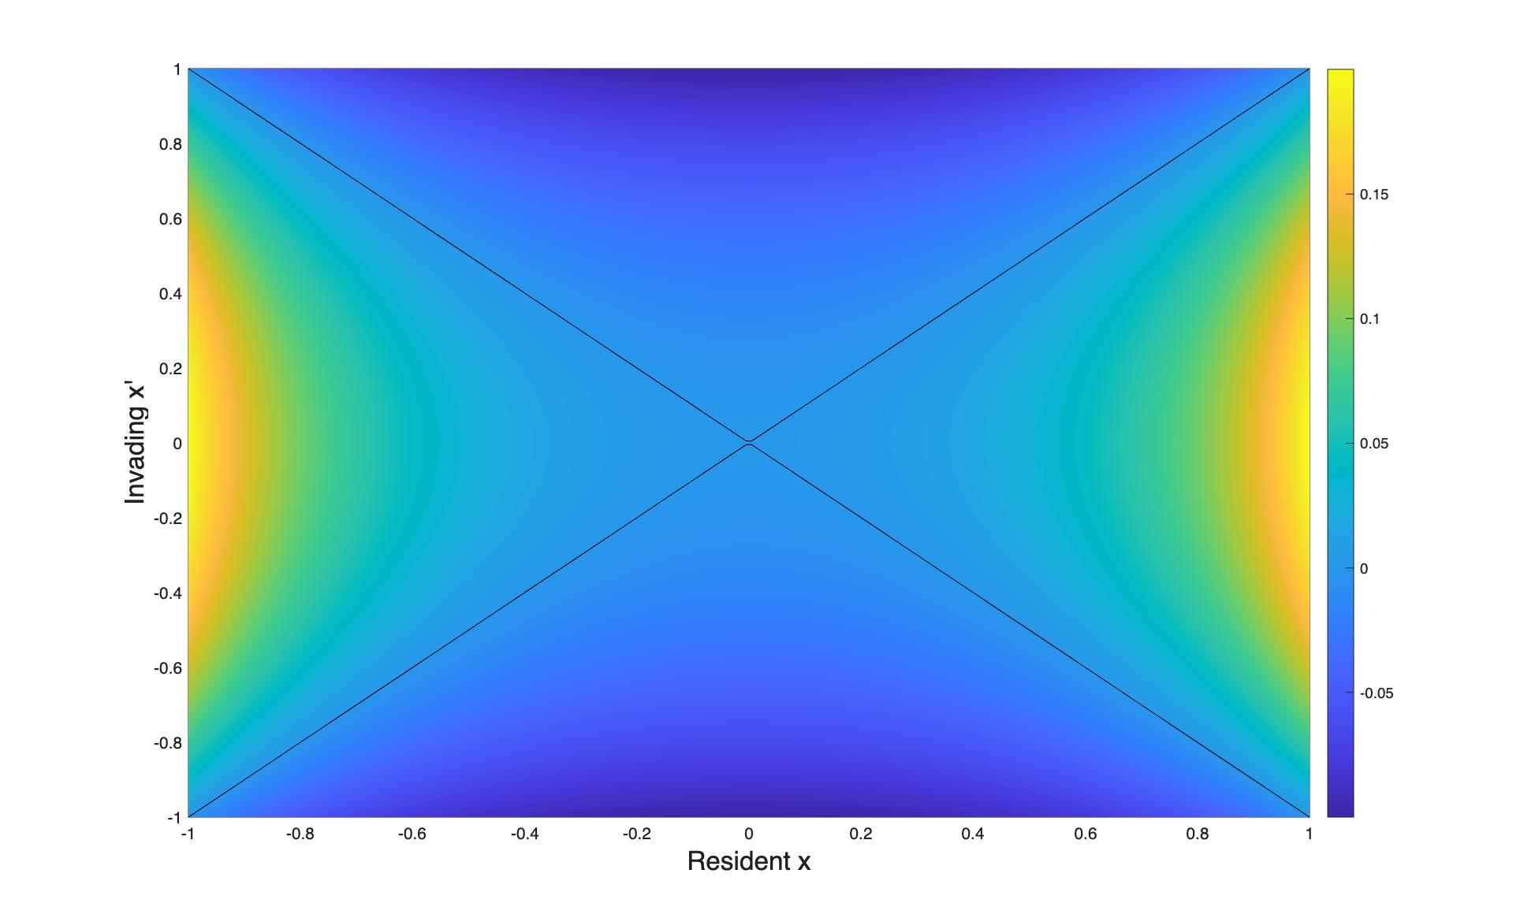
Figure 2. Pairwise Invasibility Plot for the Lotka-Volterra predator-prey model with logistic growth.
4b)
Yes, it is possible to confirm analytically by calculating the invasion fitness when the resident trait $x = 0$.
$$f\left(x^{'},x\right)=μ\left(\frac{a\left(x^{'}\right)}{a\left(x\right)} - 1\right)$$
$$a\left(x\right)=a_{0}-\frac{1}{2}kx^{2}$$
$$f\left(x^{'},0\right)=μ\left(\frac{a\left(x^{'}\right)}{a\left(0\right)} - 1\right) = μ\left(\frac{a_{0}-\frac{1}{2}k{x'}^{2}}{a_{0}} - 1\right) = -\frac{μ k {x^{'}}^{2}}{2a_{0}}$$
Since $μ,k$ and $a_{0}$ are positive constants, the expression will always be negative. I. e. invading traits $x^{'}$ will always have fitness $f\left(x^{'},0\right) < 0$.

5a)
$μ$ is now dependent on $x$ according to the following equation
$$μ\left(x\right)=μ_{0}+\frac{1}{2}m{\left(x-1\right)}^{2}.$$
The fitness function is derived from the consumer per capita growth rate substituting resource density (R) with the recourse equilibrium (R*). The only difference from earlier is that $μ$ is now also dependent on $x$.
$$f\left(x^{'},x\right)=ϵa\left(x^{'}\right)R*\left(x\right)-μ\left(x'\right) = ϵa\left(x^{'}\right)\frac{μ\left(x\right)}{ϵa\left(x\right)}-μ\left(x'\right) = μ\left(x\right)\frac{a\left(x^{'}\right)}{a\left(x\right)}-μ\left(x'\right)$$

5b)
When m = 0, the consumer mortality is constant which means that $μ=μ_{0}$ for all $x$. When plotting, this results in a plot that looks identical to figure 2. A biological interpretation is that m controls the dependency of mortality on $x$.
x= 0 is no longer an ESS. When x = 0, the mortality rate is so high that it negates the positive fitness effect of an optimized attack rate. If one is only looking at the mortality, the mortality function is “optimized” (the mortality is at its lowest point) when x = 1. This models a situation where a trait that increases attack rate also increases mortality. This is a trade-off situation where the new ESS falls somewhere in the middle, numerically looking at the figure, the ESS is now $x ≈ 0.47$.
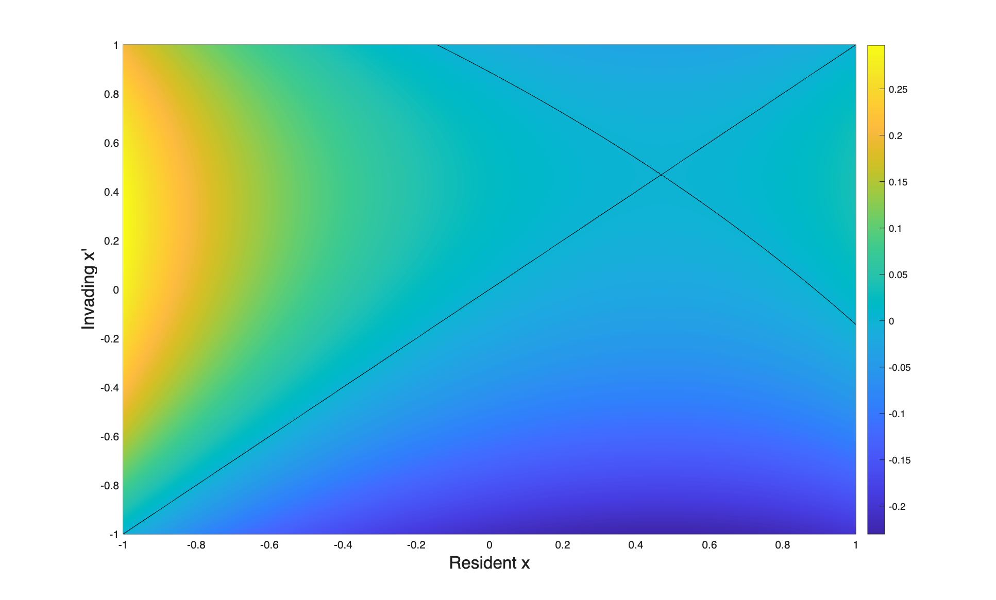
Figure 3. Pairwise Invasibility Plot for the Lotka-Volterra predator-prey model with logistic growth. Attack rate and consumer mortality are functions of $x$ (m = 0).

Adaptive radiation
Continuous trait axis
As given as examples in the exercise instructions, a trait represented on a continuous trait axis could be body size and resource use. Other traits could be height, thickness of fur or number of insulating feathers (making some animals more adjusted to cold temperatures and some better fitted for warmer temperatures), speed, and coloring. It is useful to represent species differences along a continuous axis trait mainly because this reflects reality very well. Most traits are not divided into separate categories. Most traits, such as body size, speed, height, varies in a continuous matter with small to large variations between individuals and populations.
Matching trait to environment
Populations that are poorly matched to the environment will either continue developing to match the environment better, or they will go extinct.
Competition and biological interpretation of sigma_a
Populations that have very similar traits will also be more likely to fill similar biological niches in an ecosystem and compete for the same resources. The parameter sigma_a represents the width of the competition niche. A wider sigma_a results in stronger competition between populations and a more narrow sigma_a results in weaker competition between populations. Both competition niche width (sigma_a) and closeness in traits will determine the strength of competition between populations.
Evolutionary time loop
In each step of the iteration, an evolutionary mutation event is followed by ecological dynamics that determine if the result of the mutation event will be. To do this, the following steps are taken in each iteration. First, the fitness landscape is evaluated to determine the invasion fitness of potential future mutants that will be created later on. The next step is to determine which species will mutate, using mutation probability and population sizes to randomly select species while ensuring that larger populations have a higher chance of mutating. The selected species will then mutate, and the invasion fitness of the new mutant trait is evaluated against the current fitness landscape. If the mutant has positive fitness, it can invade the population and is added to the system. A mutual invasibility test is then performed to determine whether the mutant and the original species can coexist. If mutual invasibility is positive, both the resident species and the mutant will stay in the population, resulting in coexistence (evolutionary branching). After this, the system is updated. In this step, extinct species are removed, species numbers are updated, and abundance and trait vectors are rebuilt.
Classification of functions used in the simulation
- main_ecoevo: This is the main function in the simulation. It initializes parameters, runs the evolutionary time-loop and plots the evolutionary progress.
- mutfit_and_popequi_func: This function evaluates and computes mutation invasion fitness.
- ode_sys: Calculates the growth rates of all populations using the generalized Lotka-Volterra dynamics.
- sim_equilibrium: This function numerically simulates the ecological dynamics
- uppdate_sys_func: This function updates the community/system by rebuilding abundance vectors, removing extinct species and updating different parameters such as species numbers and trait vectors.
Mutations
Larger mutations would result in an outcome that would be more difficult to predict, as chance would play a bigger role in the outcome. Populations with smaller population sizes would be more prone to go extinct.
Meaning of intrinsic growth vector and the interaction matrix
The intrinsic growth vector reflects the intrinsic growth or death rate of a species. This will control what happens to the population without interactions with other species. The interaction matrix describes the strength and type of interaction between species. It determines how different species affect each other’s growth such as effects of competition as well as predator-prey interactions. The competition term is nonlinear since it multiplies population sizes (N) together. It does this since the effect of species i depends on the abundance of both species i and species j as well as the interaction strength A_{ij}.
Numerical approximation approaches
Many potential mutants are created, and all of them needs to be screened to see if they have positive invasion fitness. This is done with the Euler approximation. To measure this, it only necessary to go very few steps (three in the simulation) to see in which direction it evolves. This is done many times during the simulation and if the ode15s was used, the program would very computationally intensive and way to slow. A disadvantage of the Euler approximation is that it not very accurate and can become numerically unstable if it is used for longer simulations.
When a mutant with positive invasion fitness appears, the program must calculate the new ecological equilibrium of the community. This happens less often, and it is important that the result is correct. The advantage of the ode15s is that it is able to accurately solve stiff systems thanks to its adjusted time step. The limitation of ode15s is that it is computationally intensive and slower than the Euler approximation which is very quick and low on computations.
Fitness landscape
Biologically, the invasion fitness represents the possibility of mutants surviving in different biological niches. For example, if there is one type of habitat that is not used by any currently present species, then a mutant that could exploit that habitat will have positive invasion fitness.
In the beginning when there is only one species present, I would expect to see one peak in the fitness landscape near the resident trait. As the simulation progresses, I would expect to see more and more peaks forming as more and more species start to cohabitate and compete for resources.
Positive invasion fitness
Positive invasion fitness means that a mutant that appears will grow in the current resident landscape. Fitness is evaluated when the mutant is rare to mirror biology – when a mutation occurs only one or very few individuals will carry this mutation in the beginning.
Mutual invasibility implies coexistence because this means that both species will have an advantage when they are rare, and they will be able to invade the resident species. Ecologically, this means that the species have a higher intraspecific competition that interspecific competition. This leads to evolutionary branching as the population splits into two coexisting species that will evolve away from each other – which is a key mechanism of adaptive radiation and diversification.
Niche width
Table 1. Simulation results for different values of sigma_a.
Sigma_a | Number of trait clusters | Speed of diversification | Number of types
0.1 | ≈ 45 | Fast | Many
0.5 | 10 | Medium fast | A few
1 | 1 | - | One
A small sigma_a reflects a biological system where competition only occurs between very similar traits. A large sigma_a reflects a biological system where competition also occurs between less similar traits. Narrow niches allow species to thrive in their own niches, as they will not suffer from competition with other species with traits that are very different from theirs. This promotes niche partitioning since species will reduce competition by evolving to using different resources (adaptive radiation). If two species are too similar – they will not be able to coexist since the competition between them will be too high. This will lead to a situation where the weaker/less adapted species will likely go extinct, which is a concept called limiting similarity.
Looking at the results in table 1, when sigma_a = sigma_K = 1, we don’t see any adaptive radiation. This happens because mutants that appear will have negative fitness as they will not be able to find their own niches where the resident type won’t outcompete them. Comparing the simulation result from sigma_a = 0.1 and sigma_a = 0.5, the number of trait clusters with the more narrow niche is much higher. With a more narrow niche, there are more biological niches to use for appearing mutants where they will not be outcompeted by the resident types.

