What to do:
1. Implement the deterministic and the stochastic (Gillespie algorithm) model for the bistable switch.
2. Conduct simulations for both models with initial conditions specified on slides (21, 22, 23) and with parameters specified in Gardner et al. 2000 Figure 5a (Reproduce the results shown in slides 21, 22, 23.)
3. Explain and discuss the outcomes of your model simulations.

Gillespie algorithm:
When will the next molecular reaction occur and what type of reaction?

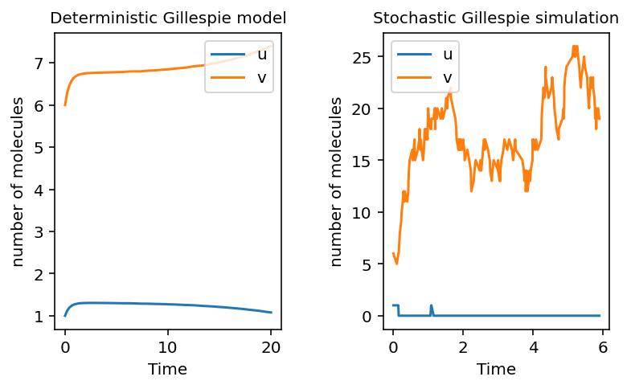
Initial conditions u(0) = 1, v(0) = 6

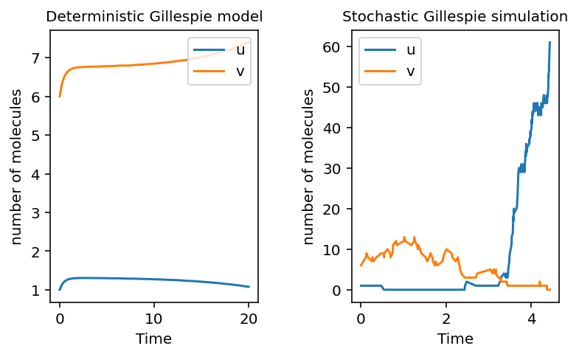
Initial conditions u(0) = 1, v(0) = 6
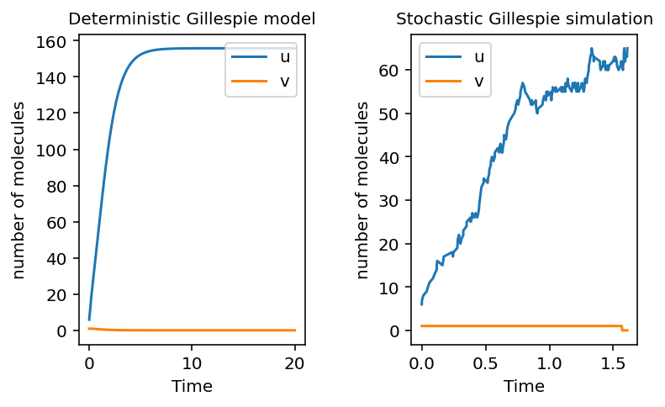
Initial conditions u(0) = 6, v(0) = 1

